MINI PROJECT DOCUMENTATION
MEMORY MATCH CHALLENGE
A Simple Web-Based Memory Card Game

Project Type | Mini Project / Web Game
Development Platform | Replit
Category | Memory and Puzzle Game
Student | Rachupalli Jayanandhini
Course | B.Tech – CSE
College | Gowthami Institute of Technology and Management for Women

1. Introduction
Memory Match Challenge is a simple web-based memory game developed as a mini project. The player turns over two cards at a time and tries to find matching pairs. The game also displays the score, time, moves, matched pairs, and progress.

2. Problem Statement
People often use simple games for entertainment and to improve memory and concentration. A memory matching game is useful because it provides a simple way to practice remembering the position and appearance of cards. The project aims to create an easy, interactive, and enjoyable browser-based game.

3. Objectives
- To develop a simple and interactive memory game.
- To implement card matching logic.
- To provide different difficulty levels.
- To calculate score and display game statistics.
- To track time, moves, and matched pairs.
- To create a user-friendly web interface.

4. Proposed System
The proposed system is a browser-based card matching game. The player selects a difficulty level and starts the game. Two cards can be opened at a time. If the cards match, the pair is kept. If they do not match, they are hidden again. The game continues until all pairs are found.

5. Technologies Used
- HTML – structure of the web page.
- CSS – design, layout, and appearance.
- JavaScript – card matching, game logic, timer, score, and interaction.
- Replit – development and deployment environment.
- Web Browser – used to run the game.

6. Main Features
Feature | Description
Difficulty Levels | Easy, Medium, and Hard modes are available.
Card Matching | Players open two cards and try to find a matching pair.
Score | The game displays the player's score.
Timer | The game records the time taken during the game.
Moves | The number of moves is displayed.
Matches | The number of completed pairs is displayed.
Progress | Pair progress is shown as a percentage.
Restart | The player can restart the game.

7. Difficulty Levels
Level | Cards | Pairs
Easy | 12 | 6
Medium | 16 | 8
Hard | 24 | 12

8. Working of the Game
1. Open the game in a web browser.
2. Select a difficulty level.
3. Click the first card to reveal it.
4. Click the second card to reveal it.
5. If both cards match, the pair is counted as a match.
6. If the cards do not match, they are turned back.
7. Continue until all pairs are matched.
8. View the final score and game statistics.

9. Game Flow
Start Game → Select Level → Flip First Card → Flip Second Card → Check Match → Update Score/Progress → Repeat → Complete All Pairs → View Result

10. Advantages
- Simple and easy to play.
- Improves memory and concentration.
- Provides immediate game statistics.
- Supports multiple difficulty levels.
- Works in a web browser.
- Demonstrates practical JavaScript game logic.

11. Limitations
- The game requires a web browser.
- It is mainly designed for single-player use.
- Online deployment requires internet access.
- The current version has a limited number of levels and card themes.

12. Future Enhancements
- Add sound effects and background music.
- Add player names and a leaderboard.
- Add more card themes.
- Add multiplayer mode.
- Store high scores.
- Add more animations and achievements.
- Improve mobile responsiveness.

13. Testing
Test Case | Input/Action | Expected Result | Status
TC01 | Open game | Game screen loads | Pass
TC02 | Select level | Selected level starts | Pass
TC03 | Flip two cards | Cards are revealed | Pass
TC04 | Match two cards | Pair is counted | Pass
TC05 | Non-matching cards | Cards are hidden again | Pass
TC06 | Complete game | Final result is displayed | Pass
TC07 | Restart game | Game resets | Pass

14. Screenshots
Figure 1: Home Screen
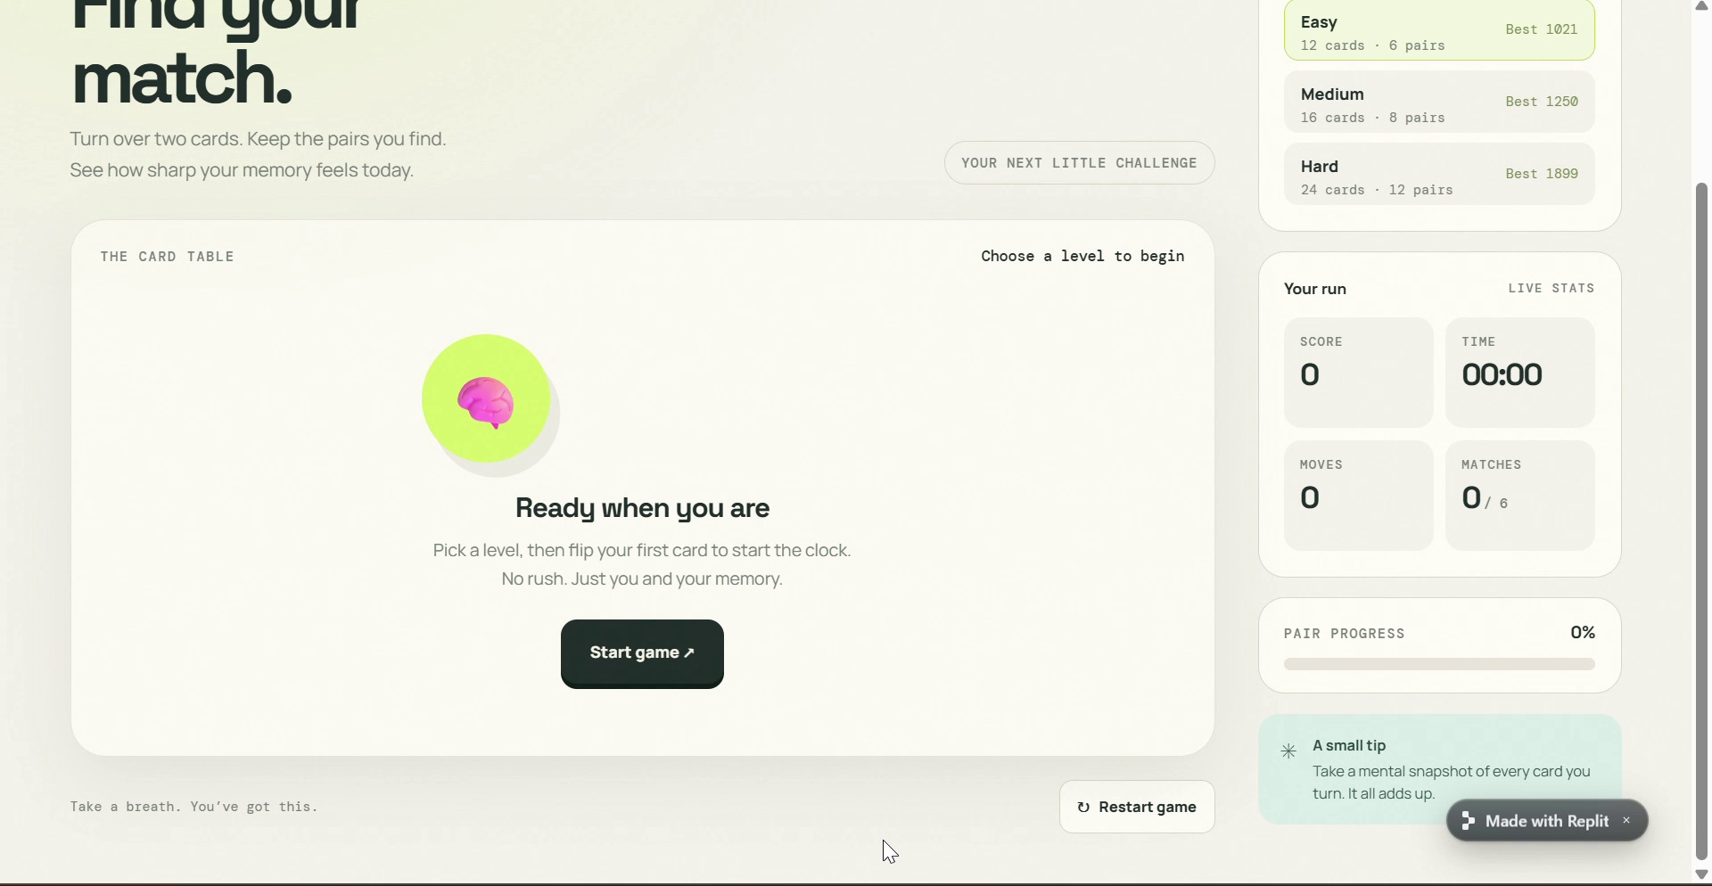
Figure 2: Gameplay
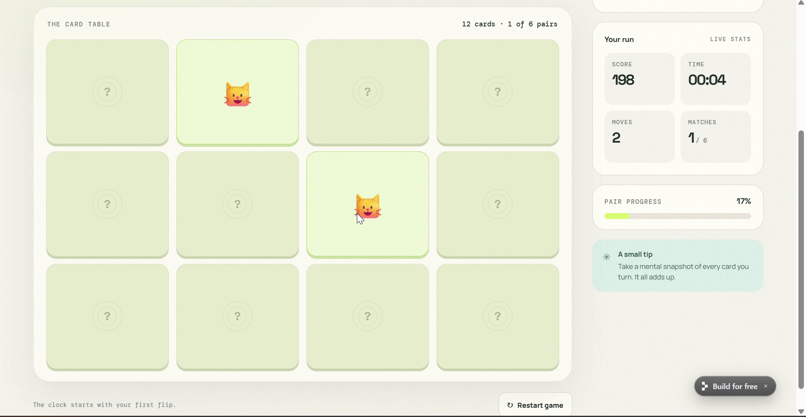
Figure 3: Score and Progress
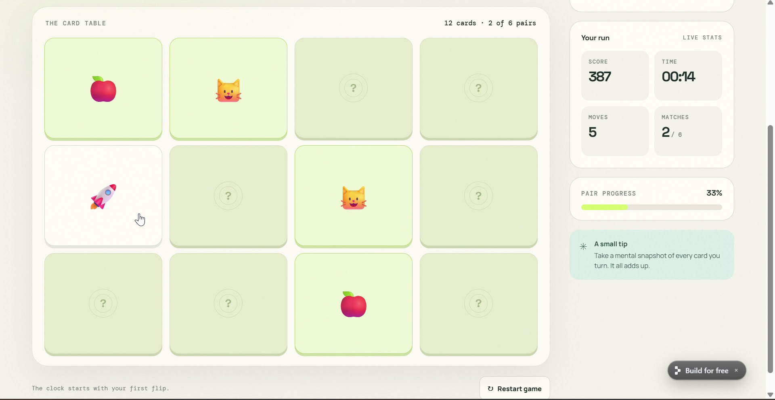

15. Project Link
Add the final deployed Replit project URL here before uploading the documentation to GitHub.

16. Result
The Memory Match Challenge successfully provides an interactive card-matching game with difficulty levels, score, timer, moves, match count, progress tracking, and restart functionality.

17. Conclusion
Memory Match Challenge is a simple and useful mini project that demonstrates the practical use of HTML, CSS, and JavaScript for developing an interactive web game. The project combines memory-based gameplay with score and progress tracking and can be extended with additional features in the future.

