Jade CRPG

version: 1.3

This System

The core rules encompass creating characters as well as playing cards and refreshing exhausted cards. Adventure rules can vary in execution, but rely on the system laid out here.

Concepts

Character Card
This represents a single character and can be built up over multiple adventures. The Jade system focuses on having an extendable campaign system in the form of Encounter decks as well as game books.

Play Cards
The Play Cards define the characters and their abilities as well as mundane and extraordinary items. Some Play Cards are transient, gained and used during a quest, while others are what defines the character.

Core Game Mechanic
The core mechanic in this system is making plays with cards to counter the threats of an encounter. The exact method of how those threats are delivered are based on the framework being used.

Glyphs
These represent the core skills of the characters and the requirements for defeating Threats. There are six Glyphs: Action, Cunning, Fight, Lore, Magic, Navigate.

1.0 The Character Card

Character Level
Character level is used to determine the general experience and power of a character. A higher level character will have stronger attributes, hand size or abilities. Some adventures restrict or suggest certain character levels. Character level is also used to determine how many gem Aspects a character can have. A character may have one gem Aspect per level.

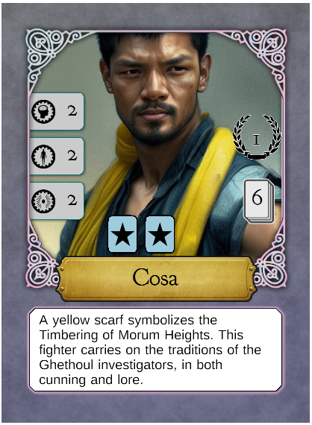

Attributes

Body
Measures the amount of physical harm this character can withstand. Body also determines how many exhausted Play Cards bearing the body icon this character can refresh.
The Peril Injury is damage to the body or extreme fatigue.

Mind
Represents willpower, knowledge and determines the amount of mental anguish the character can tolerate, with the Shock Peril. The mind attribute is used to refresh play cards with mind icon.

Spirit
The spiritual force and emotional robustness is determined by spirit. Spirit is required to refresh play cards with spirit icon. Damage to the spirit is represented by the Despair Peril.

Hand Size
This number represents the number of Aspect Play Cards (marked with a sun) to select when making this character. Hand size is only applicable when creating a character.

Token Limits
Each character can "hold" a certain number of tokens, these are listed in the center of the card, just above the character's name. If the token representation shows a star, that means any type of token can be held. If it bears a Glyph (action, cunning, fight, lore, magic, navigate), the token must be of that type. For instance, if a character has a max of two tokens and one shows a star and one shows a fight Glyph, this character may hold up to two tokens, one of which can only be a fight Glyph.

Special Abilities
Some characters have special abilities to allow discounted refresh costs or other situational bonuses. Consult the character card for details.

2.0 Attribute Cards
These cards are used to track each character’s attributes and the state of that attribute: healthy and injured. When a character takes a Despair, Injury or Shock Peril, one of their attribute cards are flipped over to the damaged side. When creating a character, take as many of each attribute cards as the value shown on the character card.
If a character takes damage, but has no healthy attribute of that type remaining, they are knocked out.
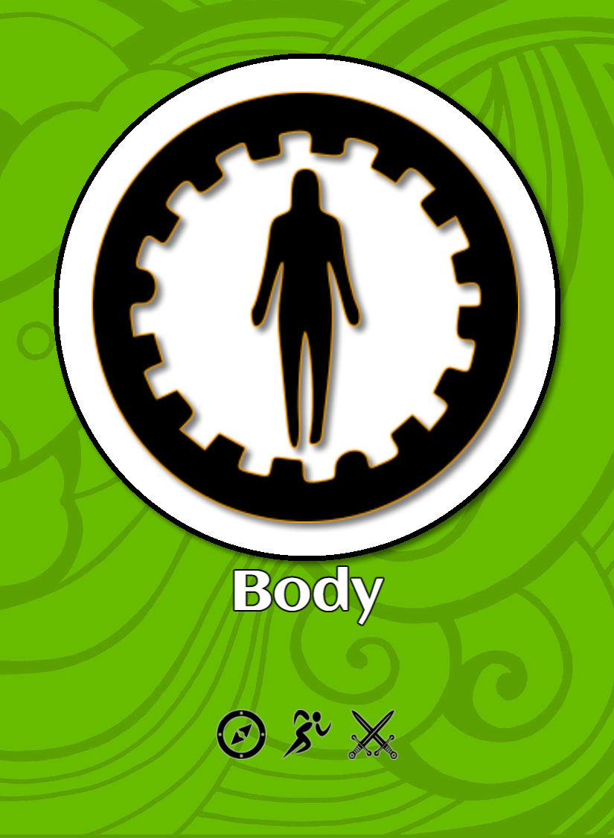
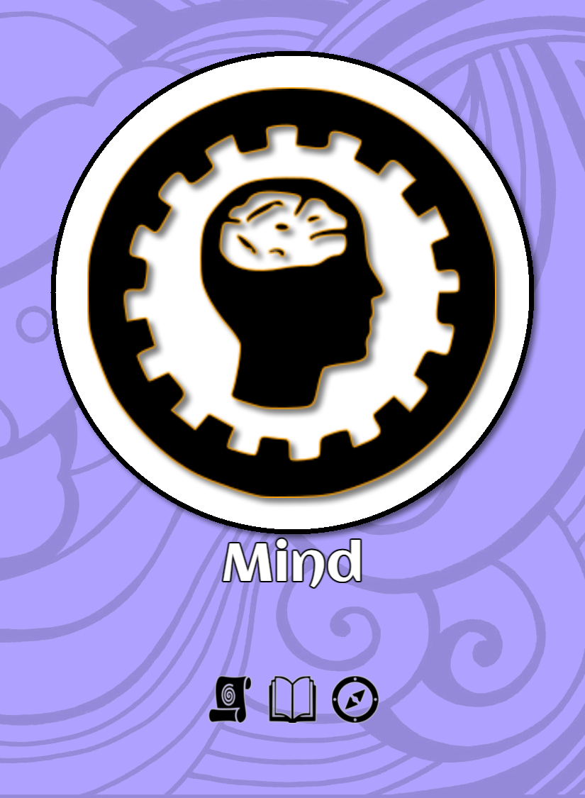
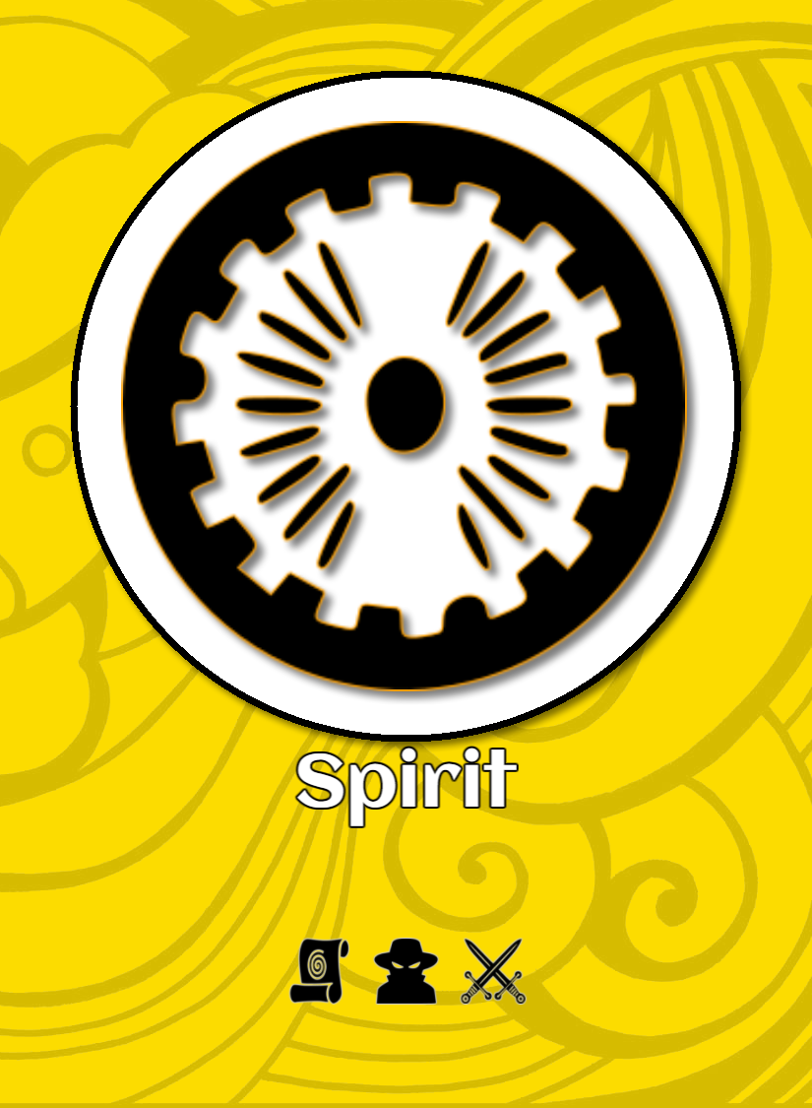
Attribute cards are used to track the health of a character as well as to determine which Play Cards can be refreshed.

Attribute cards do not count towards the character’s hand-size.

3.0 The Play Card
Play Cards represent the way in which the characters interact with the environment and how they deal with their current situation/scenario.
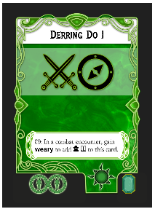

Play Card Types
Aspect - represented by a "sun" icon in the lower right
Token - represented by a "coin" icon in the lower right
Item - represented by a "mallet" icon in the lower right
Archetype - represented by a "ribbon" icon in the lower right

Aspect Play Cards
Aspect cards represent the abilities, skills and characteristics of a character. Aspects are selected during character creation and character improvement.
Aspect Play Cards generally remain with the character. Aspect Play Cards are identified by a sun icon in the lower right. Aspect Cards are limited by hand-size.

Tokens
These are temporary, situational or consumable resources. Tokens can be gained by playing some cards, as rewards for encounters and at the start of an adventure.
Examples include:
- Tonics
- High Morale
- Situational Advantage

Combining Tokens
If an ability allows "combining tokens", this means that two tokens of the same Glyph token can be converted into one token with two Glyphs of that type. Combined tokens cannot be broken into two individual tokens.

Assignment
Tokens are assigned to a specific character unless otherwise noted. A token is a Play Card and will trigger special abilities in the same way as an Aspect Play Card.

Tokens are removed from characters at the start of the next Home Turn.

Items
These represent exceptional items that are magic, reknown or otherwise out of the ordinary. They have a wealth value which can be used outside the adventure (such as in the Home Turn).
Examples include:
- Fading Magic Sword
- Wizard Armor
- Flaming Sword
- Sentient Spear

Characters retain their items between quests unless otherwise stated. More “elaborate” rules will be created for characters and their exceptional items. Such as one “hand item”, one “armor item”, one “trinket” item, etc.

Archetypes
These cards further define a character and have multiple Glyphs. A character may only have one Archetype, which does not count towards the character's hand size upon creation.
The Archetype card can be played as a normal Play Card, however it refreshes automatically after completing the current Setting.

Play Card State

In Hand
This card is ready and available to be played. Abilities that shows the 'in-hand' icon are also available to be invoked.

Exhausted
This card is not able to be played, but is available to be refreshed.

Played
When a card is activated, it is considered to be Played. Once its abilities and Glyphs have been applied, it becomes exhausted.

*Note*
There is a difference between "playing" a card and exhausting a card. If a rule specifies exhausting a card, it does not apply Glyphs or invoke "when played" effects.

*Note*
Some abilities or effects mention "return to hand". In this case, an exhausted Play Card is returned to “in-hand” status, but does not invoke any abilities on any cards.

Gem Play Cards
Some Play Cards show a gem in the lower right corner (or an empty socket, which means no gem). There are multiple types of Gems that can appear on a Play Card. Cards that show a gem (square emerald or round diamond) are limited per character. A character can have one Gem Play Card per character level. A character may only have one diamond Play Card, and no other character in the party can have the same diamond Play Card.

Refresh Cost
The lower left of the Play Card shows the refresh cost. These are the attributes that must be available to move the card from exhausted to in hand. The total number of cards and their cost must not exceed the character's available attribute points. For instance, _Arcanist_ requires 1 spirit, and _Cunning II_ requires 1 spirit. This means, that to refresh both, a character must have 2 spirit.

Refreshing Exhausted Play Cards
When a character exhausts a Play Card, it becomes temporarily unavailable for future actions until refreshed. Refreshing a Play Card allows a character to regain its usefulness and access its abilities once again.

The number of Play Cards a character can refresh depends on the corresponding attribute values. Mind, Body, and Spirit attributes govern the refreshment allotment for Play Cards associated with the attributes.

A character can refresh Play Cards up to the value of their corresponding attribute. For example, a character with a Mind attribute of 3 can refresh Mind-associated Play Cards with a total refresh cost of 3 or less. Similarly, a character with a Body attribute of 2 can refresh up to two Body-associated Play Cards, and so on.

However, some Play Cards may have multiple attribute refresh costs. In such cases, the character must allocate their attribute values strategically to refresh the desired combination of Play Cards. For instance, if a Play Card has a refresh cost of "Mind 2, Spirit 1," the character must allocate at least 2 points from their Mind attribute and 1 point from their Spirit attribute to refresh that specific Play Card.

On the other hand, certain Play Cards may have no refresh cost. These Play Cards do not require attribute allocation for refreshment and can be refreshed freely without needing any attribute points.

Strategic planning and managing your attribute values effectively are crucial to ensure a steady supply of refreshed Play Cards throughout the game. Consider the attribute costs of each Play Card, allocate your attribute points wisely, and make the most out of your resources to overcome Threats.

Refreshing Play Cards occurs during rests.

4.0 Character State Example

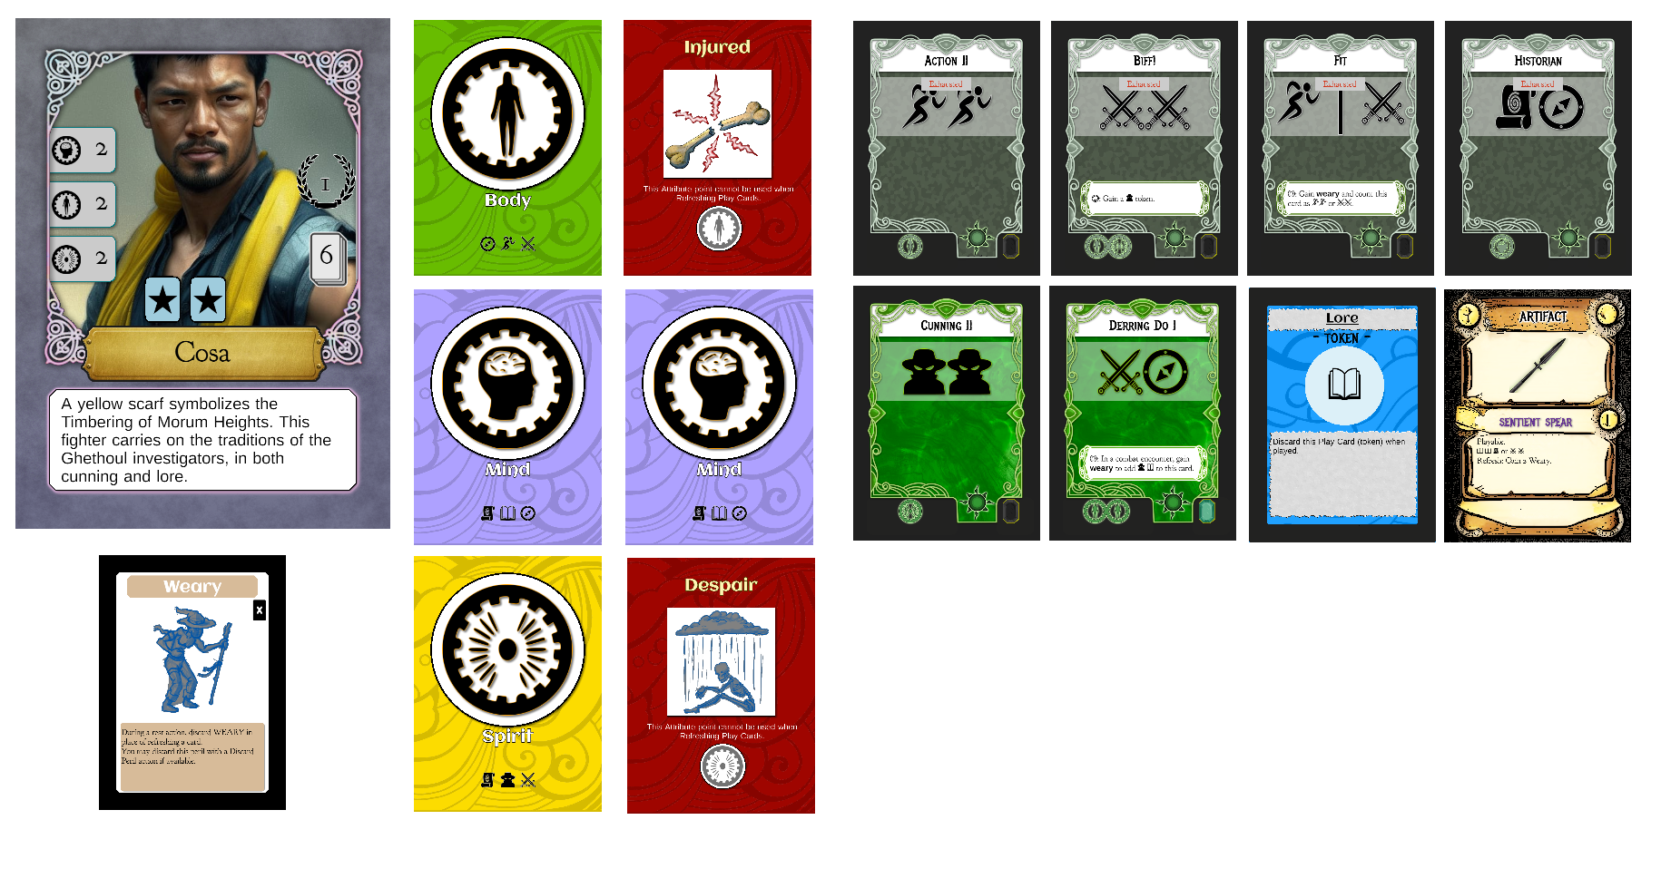
This character has one Weary Peril, one Injured Peril (one body attribute is turned over), one Despair Peril (one spirit attribute is turned over), 4 exhausted Play Cards, two in-hand Play Cards, one lore Token and an Artifact. Cosa effectively has 1 body, 2 mind and 1 spirit. The character is level one and has one Gem Play Card, Derring Do.

5.0 Character Creation
Characters are created by first selecting a character card, and then picking that character’s Aspect Play Cards, up to the character’s hand size. Stronger Play Cards typically have a refresh cost, so take that into account when selecting what Aspects the character will have.
Typically an adventure will use 3 characters, so building synergy between characters can help with resolving encounters.

Step 1
Select a character card to represent this character. Each have different attribute values and special abilities. The level of the character should also be considered – a higher level character will have access to more powerful cards and higher attribute values, making them able to take more damage and refresh more Play Cards per rest.

Step 2
Select Aspect Play Cards to define the character’s base abilities. Be mindful of the refresh costs of the Aspects and how many attribute points the character has. If a character has 1 point of body, you may freely choose 4 Aspects that have a body refresh cost, but you will only be able to recover one of those Play Cards during a rest.

Step 3
Once you have assigned the Aspect cards equal to the character’s hand-size, add one attribute card of each type for each point of attribute. For example, if your character has 3 body points, add 3 body attribute cards to the character.

Step 4
Make 2 more characters and go on a quest!

6.0 Sample Game
Let’s make three very simple characters (level 0), Gendrik, Haiyan and Ortem. These three characters are considerably weaker than the level 1 characters, but ideal for showing how the mechanics work.
Working on the proper game rules first...

7.0 Quests
These determine what the characters are after, how many different settings they need to complete and other requirements.
Quests are in development…

Time
Some Quests must be completed within a certain amount of time. Delay Peril and Settings will advance the time marker forward. This can bring about other events or end the quest in failure.

In general:
- Pick/create the characters to make up the party
- Pick a quest
- Draw two Setting Cards and pick one to be active
- Draw encounters corresponding to the encounter track on the Setting Card one at a time
- Once all
- Once the requirements for the quest are met, the party can complete the quest according to its rules

8.0 Settings
These are used to set the stage for the encounters that the characters must defeat, as well as resources to complete quests.
Each setting has a series of encounter types along the right, referred to as waypoints.
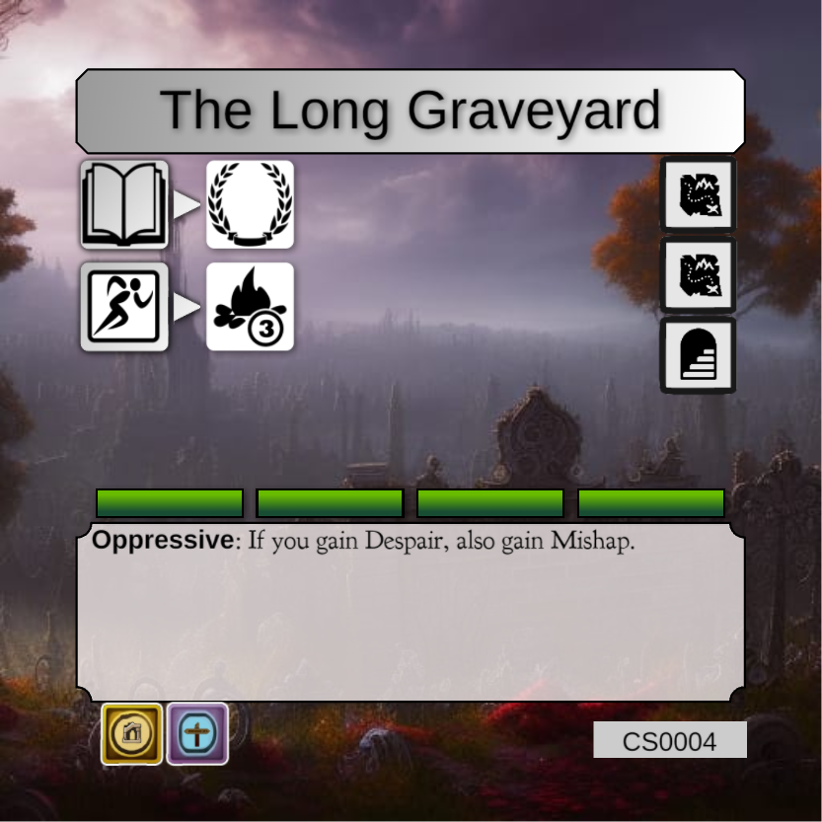

Draw an interior encounter


Draw an overland encounter


Draw an elite encounter


Perform a full rest action

In The Long Graveyard, an action Glyph can be played to gain a rest, this doesn’t make sense. However, making it an action token does (so pretend it is an action token).

Resources
Distance: represented by green bars (one distance point per bar)
Ruin: represented by something that doesn’t look like a ruin at all, so… whatever
Moon: because really, I have no idea what to make these resources – maybe … tablets?
Signpost: maybe just called ‘sign’ or whatever, this one is okay, it can be like… clues.
Mask: artifact-things maybe?
Quests require resources, since you draw two settings and pick which one, you can plan for rests and resources as you move forward in the quest. For instance, if you need a lot of distance points, you can just pick the setting with the most green bars.

Time Passage
Some settings will advance the “time marker” on a quest. If the Setting has a “Time Passes” icon (hourglass), the time on the Quest is advanced once for each icon.

Actions
Settings have actions that can be performed – they have a cost and a result. The cost is on the left and the result is on the right.
For instance:
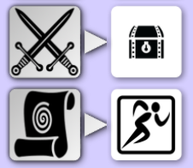
There are two actions available:
Play a card with the fight Glyph and gain a treasure cube (loot).
Play a card with the magic Glyph and gain an action token.

An action can only be played once, and only one action can be played per encounter (after the encounter is complete). Actions can be used in any order.
If a Glyph is bounded by a square as either cost or reward, it indicates a token.

If the cost Glyph shown is a token, then only a token may be used to pay for the action. In this example, the magic Glyph MUST come from a token. In the previous example (fight Glyph for a treasure cube), the fight Glyph can come from any source.
Some icons can appear on either side, as a cost or a reward.
If an hourglass shows for the cost, advance time by one and gain the delay peril.

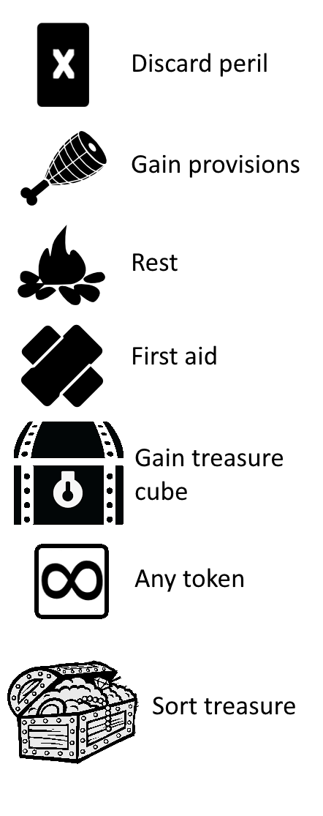
Discard Peril: Discard a peril that bears the discard icon.
Gain Provisions: Add a provisions token to the party. Alternatively, provisions may appear on the left (cost) side as well.
Rest: Perform a rest action for the party.
First Aid: Convert one Despair, Shock or Injury to Weary for one character.
Gain Treasure: Gain a “loot” cube.
Gain Any Token: Select any token and add it to a character. If there is a Glyph in the square, gain that type of token instead.
Sort Treasure: Discard X loot cubes to draw one card from the Treasure Deck.

9.0 Encounters
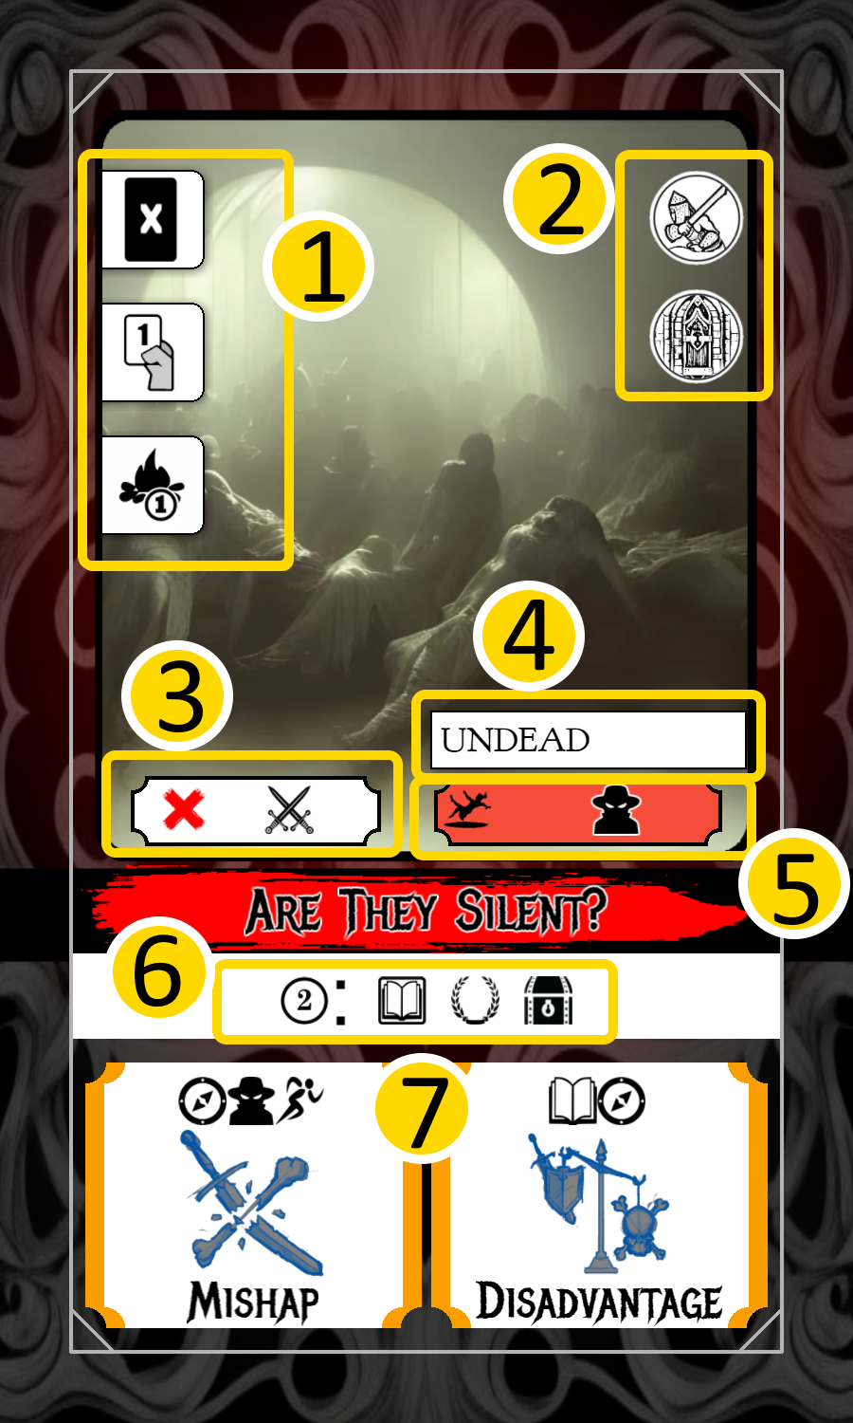
1. Actions allowed
2. Combat and obstacle identifiers
3. Taboo Glyphs
4. Tag
5. Extra difficulty
6. Rewards
7. Threats

Actions Allowed
Each character takes one action during an encounter. Typically, encounters will show multiple options for what a character can do. In the example, a character may discard a peril, play one card or take a rest action.
List the actions available
Icon | Action
 | Play up to as many Play Cards as indicated on this icon. An infinity symbol indicates any number of Play Cards can be played.
 | Discard a peril that bears this matching symbol.
 | Gain a token bearing the same Glyph as indicated.
 | Perform a rest action for one character.
 | Add a treasure cube (loot) to the stash.
 | Perform a first aid action on another character – that character may convert one Despair, Injury or Shock to Weary.
 | Gain a provisions token.
 | Discard X treasure cubes (loot) from the stash to draw from the treasure deck.
 | Collect an item or treasure.

Passing an Encounter

This icon on the encounter card shows how many glyphs must be matched to consider this encounter as passing.

Obstacle and Combat Identifier
Some encounters are considered combat encounters and/or obstacles. These can trigger special rules on characters or settings.

Failing an Obstacle
If you fail an obstacle, you will not gain any of the resources on the Setting. At this point, there are two choices, if a rest action is available, you may take the rest action and encounter the obstacle again, or you may discard the Setting and obstacle and draw a new Setting.

Taboo Glyphs
A Play Card that bears a Glyph that is displayed in the taboo section of the Encounter is considered to have no Glyphs. however When Played effects are still activated. *note: the entire Play Card is considered to have no Glyphs, even ones that are not shown in the taboo section.

Tag
This identifies the card as belonging to a specific class of cards that may have special rules based on the setting, quest or character cards.

Extra Difficulty
If an icon appears on the left of this section and the party has a matching Peril, the Glyphs shown in this section must be matched before the threats can be canceled. The extra difficulty section can be activated by other special rules as well – for instance a setting may state that all Undead are treated as difficult. Super-wild-hard mode: each instance of difficulty requires matching the Glyphs, so if Undead on the setting makes it difficult AND the extra difficulty has an icon of a Peril that the team has, it is twice the cost?

Rewards
The number at the beginning indicates how many Glyphs must be matched to make one selection from the rewards shown after it. In the encounter above, 2 Glyphs must be matched to gain one choice of reward (lore token, prestige, treasure cube “loot”).

Threats
Each encounter has two threats. The team can chose to not play any cards and simply receive the Perils and continue on. If no characters select the “Play Card” action, then any character may take the Perils indicated. This occurs after they perform other actions.
- All threats that have not been canceled (by matching Glyphs) must be applied to characters
- Characters that perform a rest or discard peril cannot be assigned a Peril
- When playing cards against a threat, the Glyphs on the card only apply to one threat and cannot be split between two (one Play Card must be played against, and applies only to one threat), including extra difficulty
- To cancel a threat, play enough cards to match the Glyphs shown on the threat

12.0 Perils
Perils are negative conditions that are applied to the party as a whole or to an individual character. The removal of the card is listed on the peril card. Each attribute card has the associated “damage” peril listed on the reverse side of the card. When a character takes a Despair, Injury or Shock peril you can flip one of the appropriate attributes to reveal the reverse.

12.0 Sample Character Creation
Ortem – this character has very low attributes but a hand-size of 5 and can hold any two tokens.
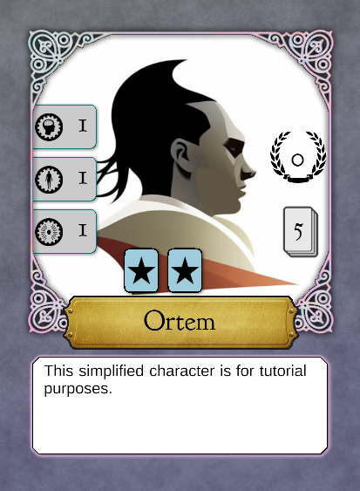
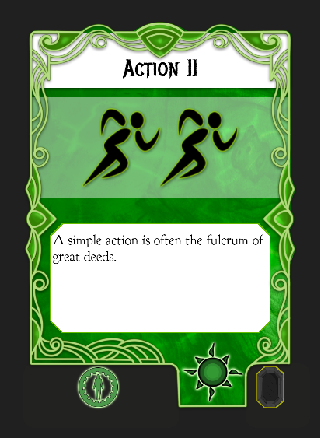
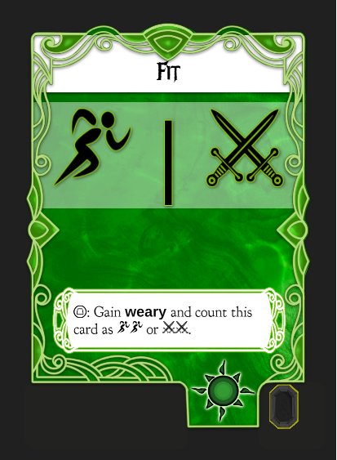
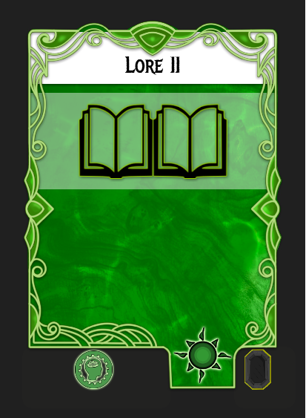
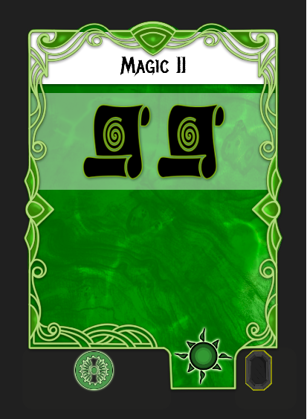
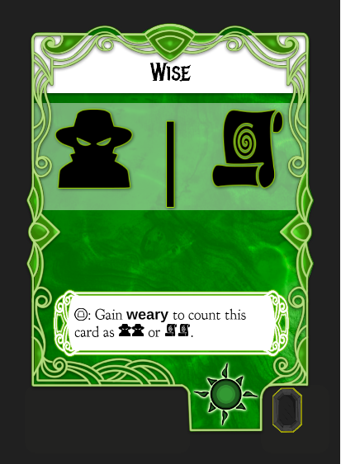
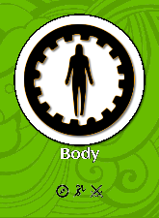
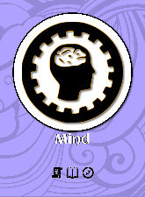
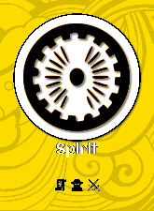
The cards shown here of varying size are only for display purposes. All of the cards that a character uses are the same size to allow the character’s state to be kept between play sessions if needed.

Haiyan – This character has two spirit attribute points, but only a hand-size of 4, she can hold two tokens, but only if one of them is provisions.
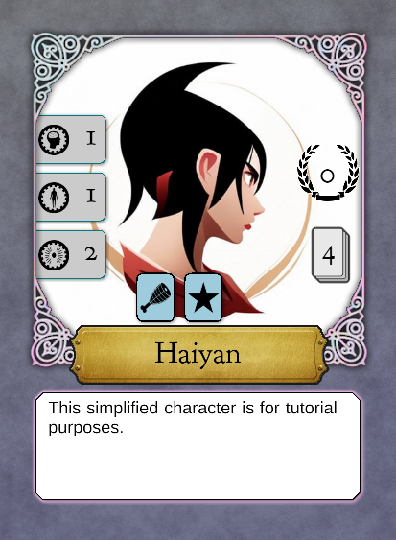
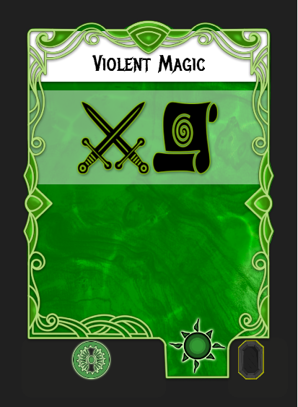
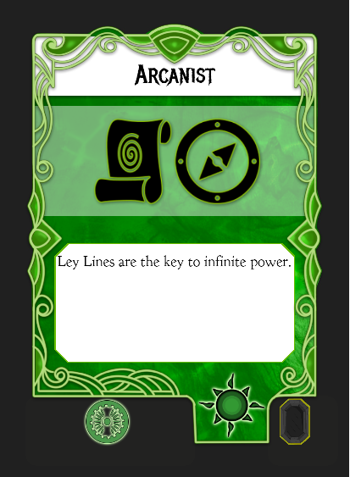
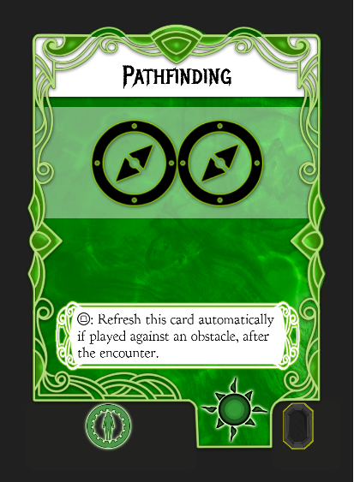
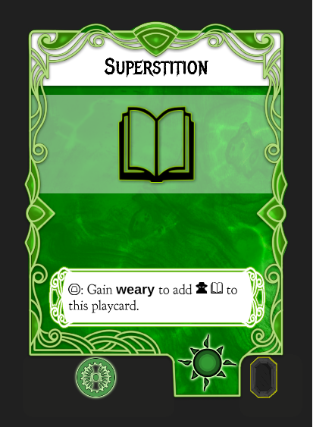

Gendrik – Like Haiyan, Gendrik only has 4 cards and a max of two tokens. He has two body attribute points.
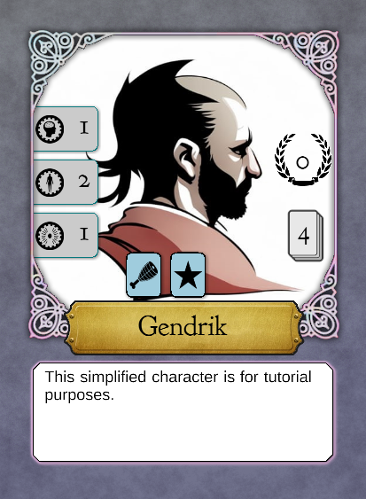
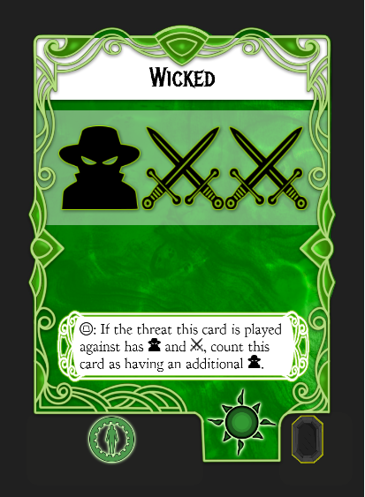
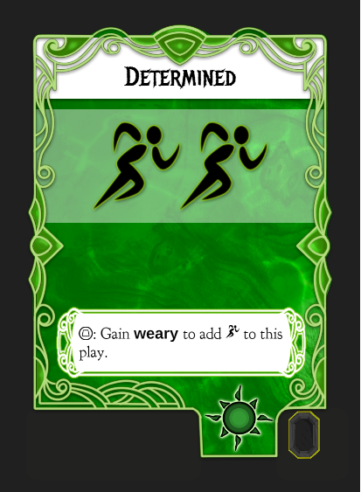
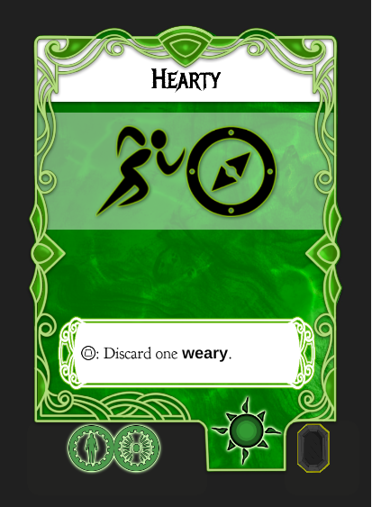
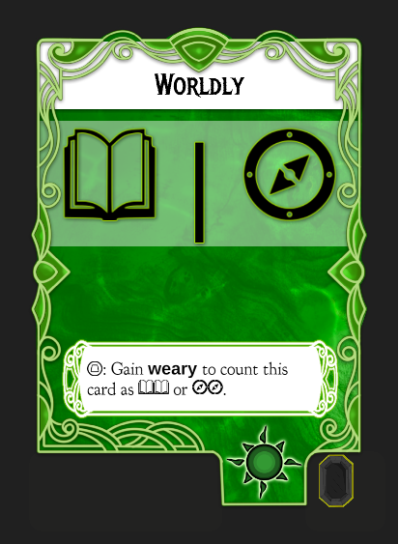

12.0 Let’s Go Adventure

Tutorial Quest

Preparing for Adventure

