Expedition: Beyond, Solo RPG Card Game

version: 1.4

This System

The core rules encompass creating characters as well as playing cards and refreshing exhausted cards. Adventure rules can vary in execution, but rely on the system laid out here.

Gameplay Overview
In this game, you will create characters to send out on quests to gain treasure, items and experience to upgrade the characters.

Concepts

Character Card
This represents a single character and can be built up over multiple adventures. The Expedition:Beyond system focuses on having an extendable campaign system in the form of Encounter decks, Settings and Quests, as well as game books.

Play Cards
The Play Cards define the characters and their abilities as well as mundane and extraordinary items. Some Play Cards are transient, gained and used during a quest, while others are what defines the character.

Core Game Mechanic
The core mechanic in this system is making plays with cards to counter the threats of an encounter. The exact method of how those Threats are delivered are based on the framework being used.

Glyphs
These represent the core skills of the characters and the requirements for defeating Threats. There are six Glyphs: Action, Cunning, Fight, Lore, Magic, Navigate.
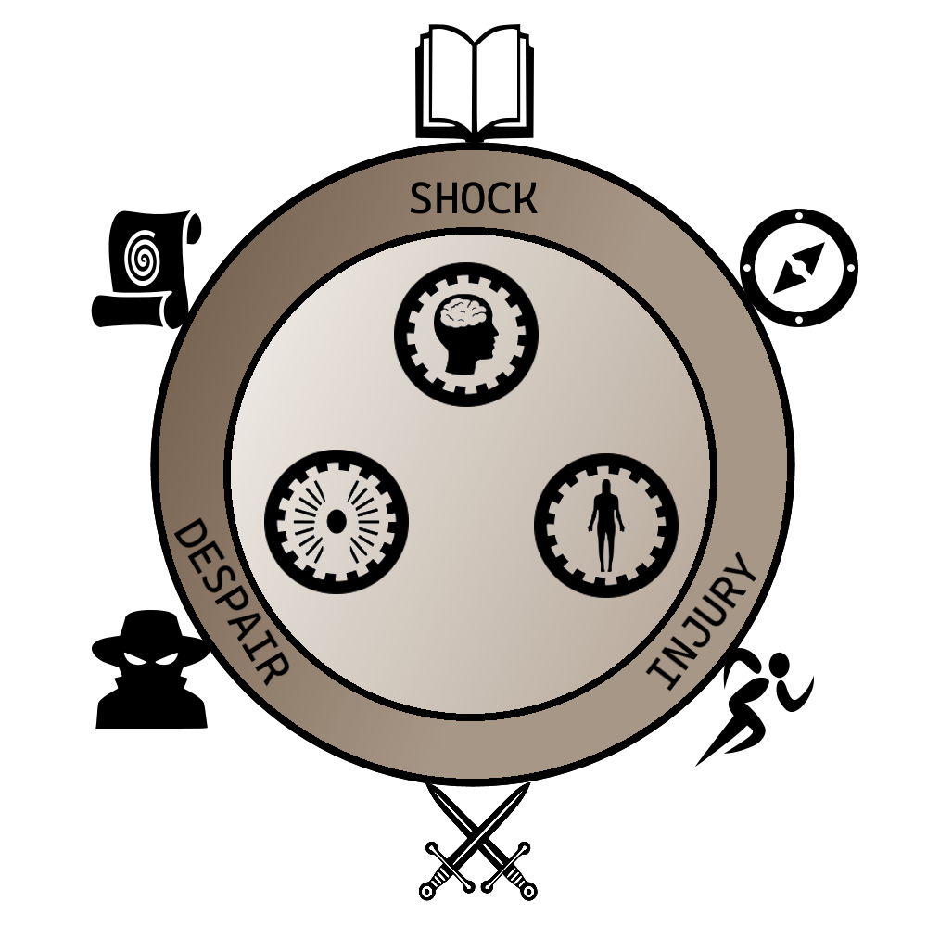
Glyphs also loosely correspond with a character’s Attributes. For instance, the Fight Glyph straddles Spirit and Body. This generally means cards with Fight will require Spirit or Body (or both).

1.0 The Character Card

Character Level
Character level is used to determine the general experience and power of a character. A higher level character will have stronger attributes, hand size or abilities. Some adventures restrict or suggest certain character levels. Character level is also used to determine how many gem Aspects a character can have. A character may have one gem Aspect per level.

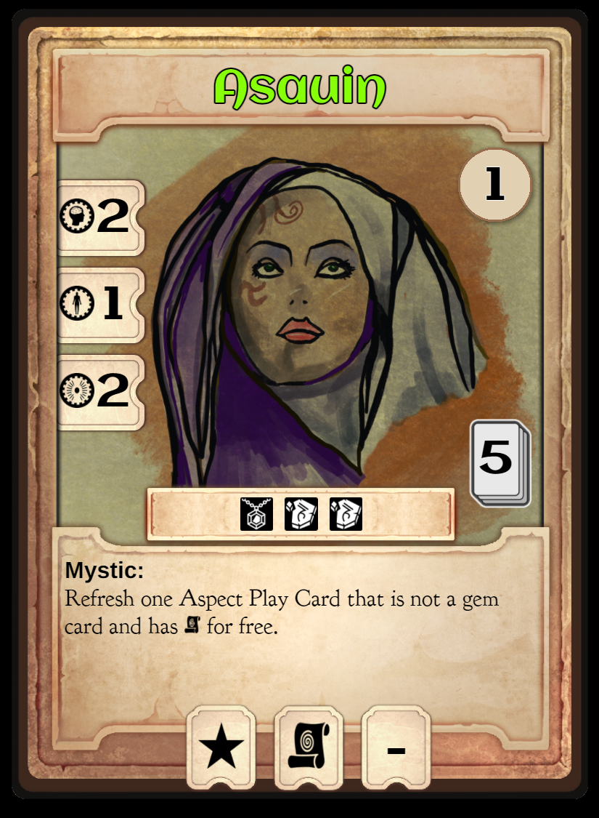

Attributes

Body
Measures the amount of physical harm this character can withstand. Body also determines how many exhausted Play Cards bearing the body icon this character can refresh.
The Peril Injured is damage to the body or extreme fatigue.

Mind
Represents willpower, knowledge and determines the amount of mental anguish the character can tolerate, with the Shocked Peril. The mind attribute is used to refresh play cards with mind icon.

Spirit
The spiritual force and emotional robustness is determined by spirit. Spirit is required to refresh play cards with spirit icon. Damage to the spirit is represented by the Despair Peril.

Hand Size
This number represents the number of Aspect Play Cards (marked with a sun) to select when making this character. Hand size can be increased by gaining a level or as a reward from a quest.

Token Limits
Each character can hold a certain number of tokens, these are listed in the center of the card, just above the character's name. If the token representation shows a star, that means any type of token can be held (also referred to as a utility slot). If it bears a Glyph (action, cunning, fight, lore, magic, navigate), the token must be of that type. For instance, if a character has a max of two tokens and one shows a star and one shows a fight Glyph, this character may hold up to two tokens, one of which can only be a fight Glyph.

Trading Tokens
Characters can freely trade tokens at any time. Once characters have begun trading tokens, no other actions can be taken until trading is completed. When trading is completed, all characters must adhere to their specific token limits.

Doubled Tokens
A “doubled” token is a single card that has two glyphs on it. When a token is gained, the side with the single icon is normally used. Some abilities allow a token to be “doubled” – this means it can be combined with another token that has the same glyph and one of the card will be flipped to show two glyphs. A doubled token cannot be split back into two tokens.

Special Abilities
Some characters have special abilities that allow discounted refresh costs or other situational bonuses. Consult the character card for details.

Advancement Cost
In the center of the card, under the portrait, is the cost of upgrading the character to the next level. Advancing levels always costs prestige (10x new level) plus costs listed on the character card.

Levels
Characters gain levels, either by spending wealth and prestige, or as a reward for quests. When a character is leveled up, swap out their character card with the next higher level. Additional abilities and attributes are gained automatically, however, if the Hand Size is increased, additional Play Cards will have to be gained separately.

2.0 Attribute Cards
These cards are used to track each character’s attributes and the state of that attribute: healthy and injured. When a character takes a Despair, Injured or Shocked Peril, one of their attribute cards are flipped over to the damaged side. When creating a character, take as many of each attribute cards as the value shown on the character card.
If a character takes damage, but has no healthy attribute of that type remaining, that character is slain and removed from the adventure. See Character Death.
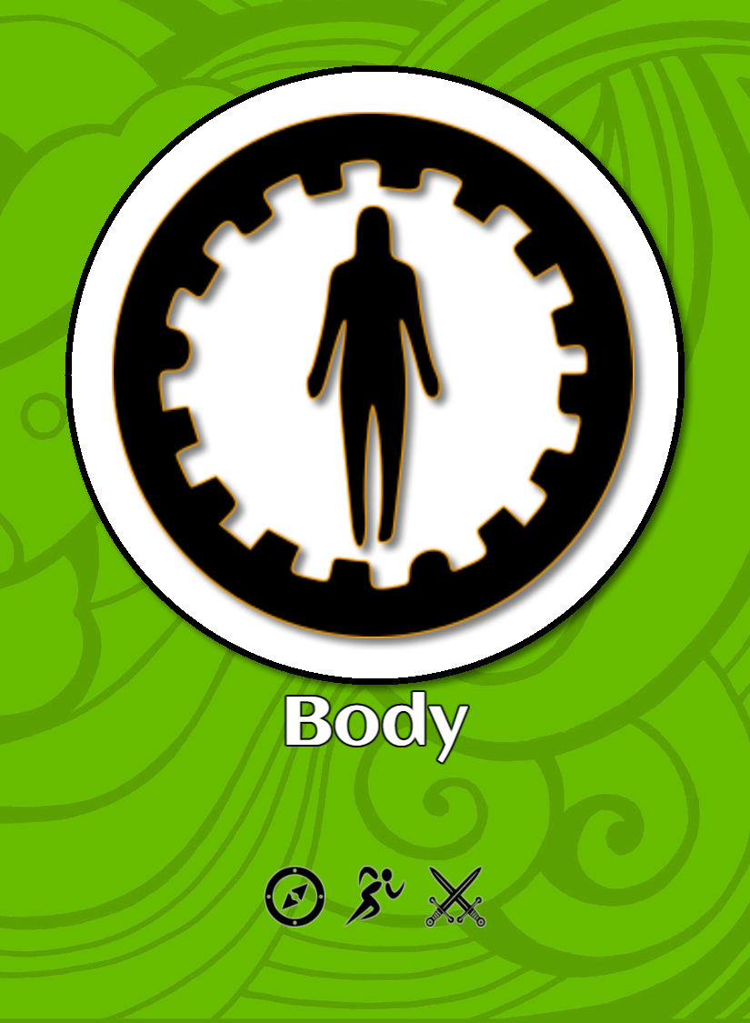
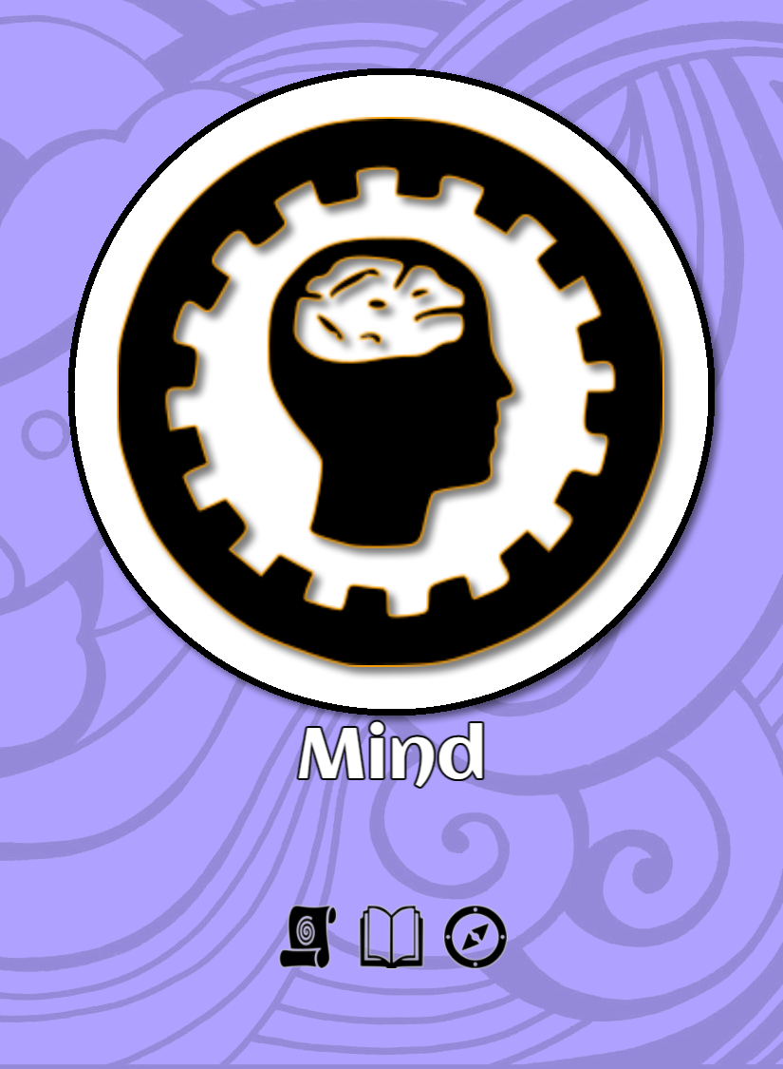
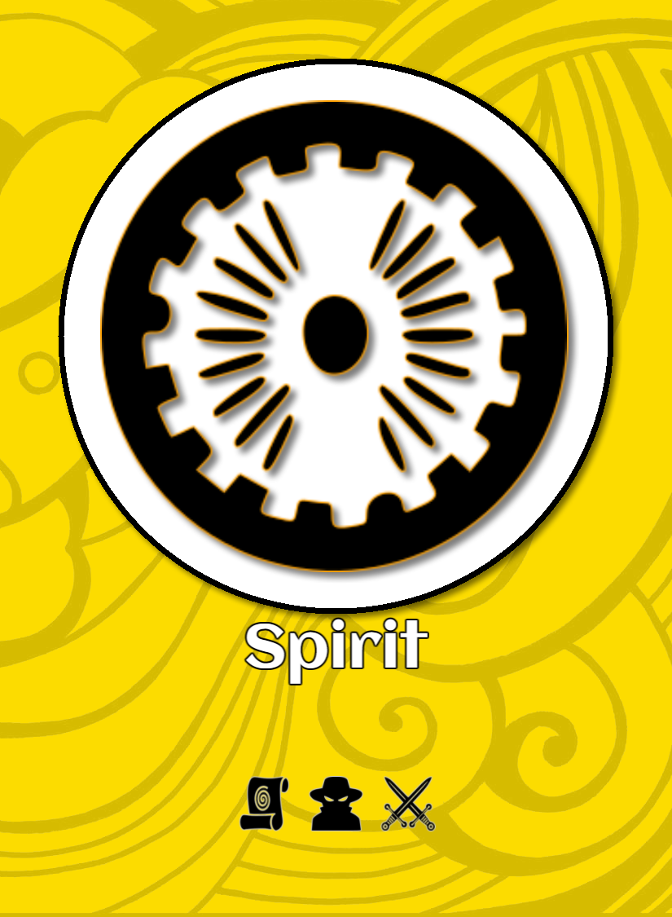
Attribute cards are used to track the health of a character as well as to determine which Play Cards can be refreshed.

Attribute cards do not count towards the character’s hand-size. The reverse side of the attribute cards shows the damaged state of that attribute.

3.0 The Play Card
Play Cards represent the way in which the characters interact with the environment and how they deal with their current situation/scenario.
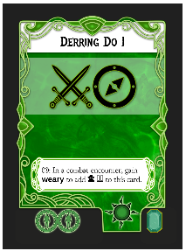

Play Card Types
Aspect - represented by a "sun" icon in the lower right
Token - represented by a "coin" icon in the lower right
Item - represented by a "mallet" icon in the lower right
Archetype - represented by a "ribbon" icon in the lower right

Aspect Play Cards
Aspect cards represent the abilities, skills and characteristics of a character. Aspects are selected during character creation and character improvement.
Aspect Play Cards generally remain with the character. Aspect Play Cards are identified by a sun icon in the lower right. Aspect Cards are limited by hand-size.

Tokens
These are temporary, situational or consumable resources. Tokens can be gained by playing some cards, as rewards for encounters and at the start of an adventure.
Examples include:
- Tonics
- High Morale
- Situational Advantage

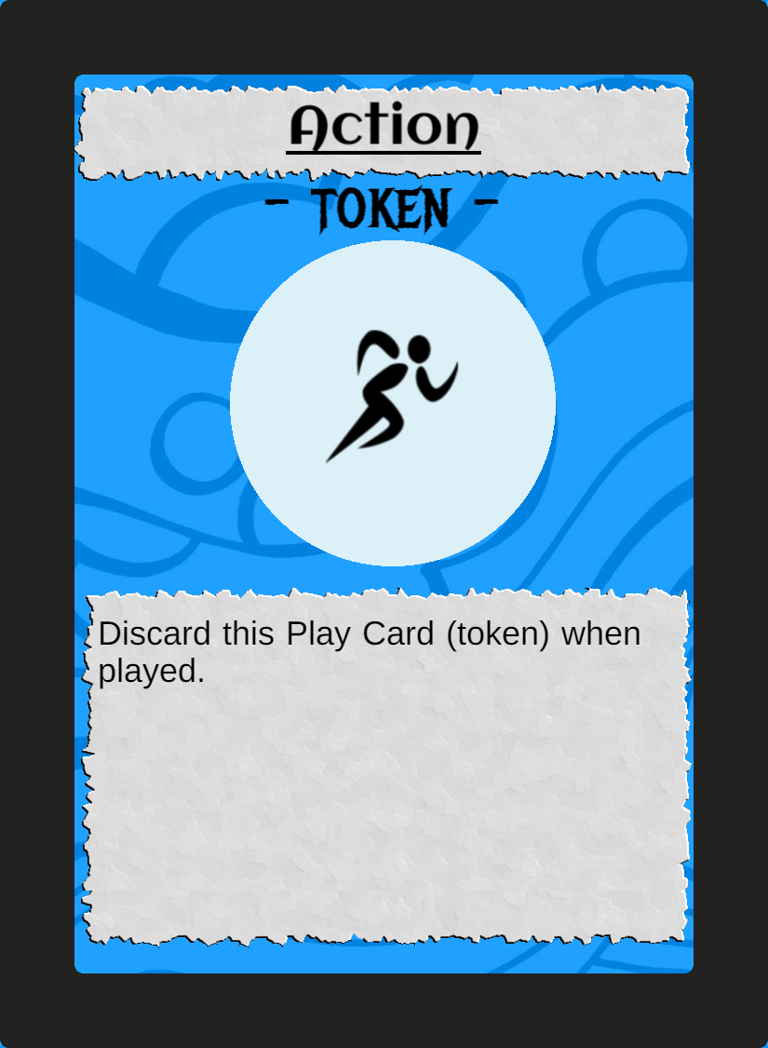Figure 1: Example of an Action Token.

Combining Tokens
If an ability allows "combining tokens", this means that two tokens of the same Glyph token can be converted into one token with two Glyphs of that type. Combined tokens cannot be broken into two individual tokens, but they can be used as a single Glyph and flipped to show the side with one Glyph.

Assignment
Tokens are assigned to a specific character unless otherwise noted. A token is a Play Card and will trigger special abilities in the same way as an Aspect Play Card.

Tokens are discarded at the start of the next Home Turn.

Archetypes
These cards further define a character and have multiple Glyphs. A character may only have one Archetype, which does not count towards the character's hand size upon creation.
The Archetype card can be played as a normal Play Card, however it refreshes automatically after completing the current Setting.

Play Card State

In-Hand
This card is ready and available to be played. Abilities that shows the 'In-Hand' icon are also available to be invoked.

Exhausted
This card is not able to be played, but is available to be refreshed. It should be showing the reverse (dim) side of the card.

Played
When a card is activated, it is considered to be Played. Once its abilities and Glyphs have been applied, it becomes exhausted.

*Note*
There is a difference between "playing" a card and exhausting a card. If a rule specifies exhausting a card, it does not apply Glyphs or invoke "when played" effects.

*Note*
Some abilities or effects mention "return to hand". In this case, an exhausted Play Card is returned to “In-Hand” status, but does not invoke any abilities on any cards.

Icons for Triggering Abilities
Some Play Cards will have a symbol that determines when an ability is activated. Unless otherwise noted, activation of abilities is optional. A Play Card’s ability can be ignored if desired.
Icon
 | In-Hand | While this Play Card is not Exhausted or being played.
 | When Played | When this card is played, the ability may optionally be invoked.
 | When Refreshed | When this card is legally refreshed (not ‘returned to hand’), this ability may optionally be invoked.
 | When Gained | When this card becomes part of the character, through character creation or reward, the effect MUST take place.
 | When Sacrificed | When this card is removed from the character by any means, the effect MUST take place.

Gem Play Cards
Some Play Cards show a gem in the lower right corner (or an empty socket, which means no gem). There are multiple types of Gems that can appear on a Play Card. Cards that show a gem (square emerald or round diamond) are limited per character. A character can have one Gem Play Card per character level. A character may only have one diamond Play Card, and no other character in the party can have the same diamond Play Card. For example, a level 2 character may have one emerald Play card and one diamond Play Card, but not two diamond Play Cards.

Refresh Cost
The lower left of the Play Card shows the refresh cost. These are the attributes that must be available to move the card from exhausted to In-Hand. The total number of cards and their cost must not exceed the character's available attribute points. For instance, Arcanist requires 1 spirit, and Cunning II requires 1 spirit. To refresh both, a character must have at least 2 undamaged spirit.

Refreshing Exhausted Play Cards
When a character exhausts a Play Card, it becomes temporarily unavailable for future actions until refreshed. Refreshing a Play Card allows a character to regain its usefulness and access its abilities once again.

The number of Play Cards a character can refresh depends on the corresponding attribute values. Mind, Body, and Spirit attributes govern the refreshment allotment for Play Cards associated with the attributes.

A character can refresh Play Cards up to the value of their corresponding attribute. For example, a character with a Mind attribute of 3 can refresh Mind-associated Play Cards with a total refresh cost of 3 or less. Similarly, a character with a Body attribute of 2 can refresh up to two Body-associated Play Cards, and so on.

However, some Play Cards may have multiple attribute refresh costs. In such cases, the character must allocate their attribute values strategically to refresh the desired combination of Play Cards. For instance, if a Play Card has a refresh cost of "Mind 2, Spirit 1," the character must allocate at least 2 points from their Mind attribute and 1 point from their Spirit attribute to refresh that specific Play Card.

On the other hand, certain Play Cards may have no refresh cost. These Play Cards do not require attribute allocation for refreshment and can be refreshed freely without needing any attribute points.

Strategic planning and managing your attribute values effectively are crucial to ensure a steady supply of refreshed Play Cards throughout the game. Consider the attribute costs of each Play Card, allocate your attribute points wisely, and make the most out of your resources to overcome Threats.

Refreshing Play Cards occurs during rests. A rest can occur by selecting that action on a Setting or Encounter. When they appear on an Encounter, a single character can perform the rest action.

Doom Rest (optional rule)
In dire times, you may find your crew has no available Play Cards and no way to recover. In this case, you may take a “Doom Rest”. You must have some kind of provisions (Rations, Provisions, Luxury Provisions). You take a normal rest action for the crew and gain a Doom. 3 Doom ends the adventure. Bear in mind that some quests have additional penalties or rules regarding gaining Doom.

Treasure
These represent exceptional items that are magic, renown, valuable or otherwise out of the ordinary.
Examples include:
- Fading Magic Sword
- Wizard Armor
- Flaming Sword
- Sentient Spear

Characters retain treasures between quests unless otherwise stated and are used to perform actions and to fund future quests.

During the home turn, the treasure can be returned to the treasure deck to earn the values on the bottom of the card. These resources can be used to upgrade characters as well as buy tokens for the next adventure.
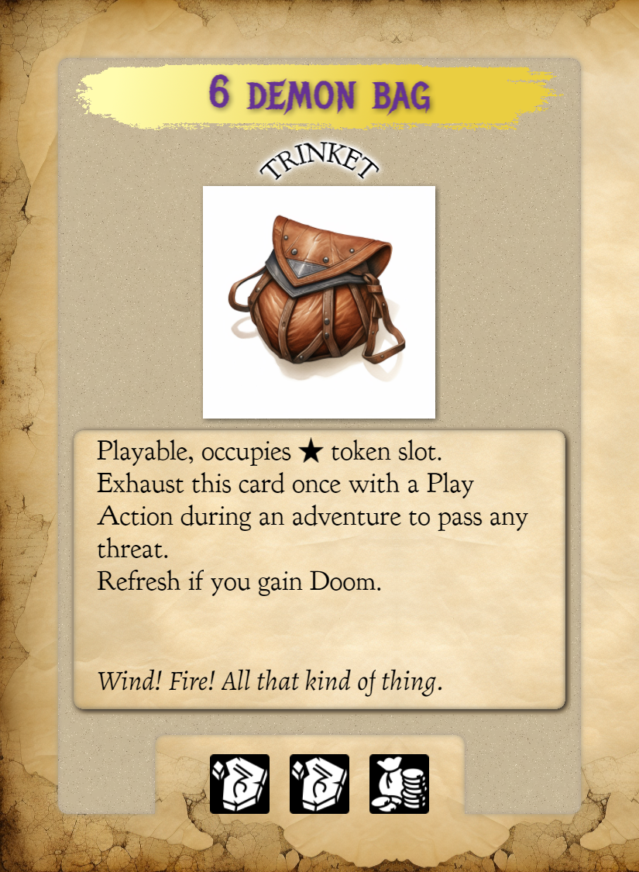Figure 2: Example of a treasure.

4.0 Character State Example

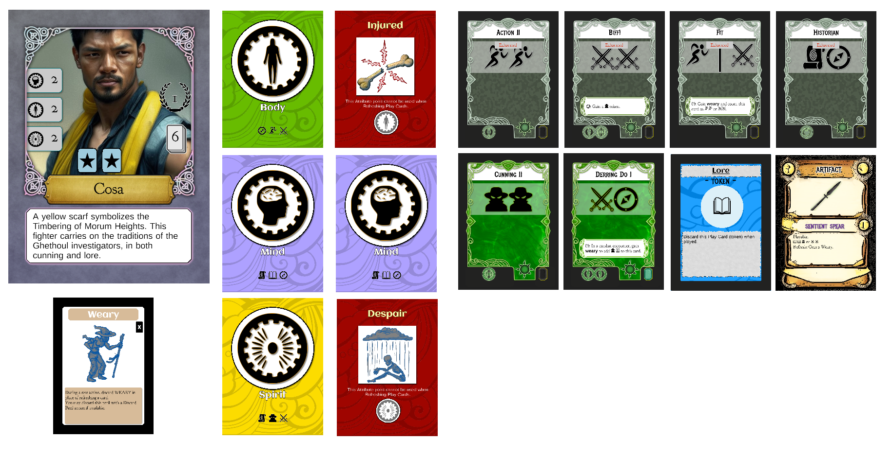
This character has one Weary Peril, one Injured Peril (one body attribute is turned over), one Despair Peril (one spirit attribute is turned over), 4 exhausted Play Cards (top row of Play Cards), two In-Hand Play Cards, one lore Token and a treasure. Cosa effectively has 1 body, 2 mind and 1 spirit. The character is level one and has one Gem Play Card: Derring Do.

5.0 Character Creation
Characters are created by first selecting a character card, and then picking that character’s Aspect Play Cards, up to the character’s hand size. Stronger Play Cards typically have a refresh cost, so take that into account when selecting what Aspects the character will have.
Typically an adventure will use 3 characters, so building synergy between characters can help with resolving encounters.

Step 1
Select a character card to represent this character. Each have different attribute values and special abilities. The level of the character should also be considered – a higher level character will have access to more powerful cards and higher attribute values, making them able to take more damage and refresh more Play Cards per rest.

Step 2
Select Aspect Play Cards to define the character’s base abilities. Be mindful of the refresh costs of the Aspects and how many attribute points the character has. If a character has 1 point of body, you may freely choose 4 Aspects that have a body refresh cost, but you will only be able to recover one of those Play Cards during a rest.

Step 3
Once you have assigned the Aspect cards equal to the character’s hand-size, add one attribute card of each type for each point of attribute. For example, if your character has 3 body points, add 3 body attribute cards to the character.

Step 4
Make 2 more characters and go on a quest!

6.0 Sample Game
Let’s make three very simple characters (level 0), Gendrik, Haiyan and Ortem. These three characters are considerably weaker than the level 1 characters, but ideal for showing how the mechanics work.
Working on the proper game rules first...

7.0 Destinations
Destination cards are similar to Settings except they have a tower symbol in the name.

This icon indicates that it is a quest destination setting. When you select a quest to go on, you set the corresponding Settings aside. Settings that belong to a destination will have a similar name in the lower right of the Setting card.

Distance
Quests are different distances from each starting location. This determines how many Setting cards should be encountered before getting near the quest destination (and using it’s settings).
Distance | # of Setting Cards for Travel | Description
Outside | 0 | The quest is either within the start location, or so near that no lengthy travel is required
Near | 3 | The quest destination is within a few days travel
Distant | 6 | The destination is a month of travel away
Remote | 10 | This site is either unknown, difficult to discover or otherwise of great difficulty to reach.

Once the correct number of Setting Cards for travel have been completed, the team then travels through the Settings near the quest.

For example, the quest The Living Ward is “Distant” from Esa Avte and Bol Herata. The Destination is The Red Tower. Set aside all of the Setting cards that have the destination name in the lower right. Then, shuffle the remaining Setting cards. You will travel through 6 of these random Settings, and then travel through 3 randomly selected The Red Tower Settings.

Time
Some Quests must be completed within a certain amount of time. Delay Peril and Settings will advance the time marker forward. This can bring about other events or end the quest in failure.

In general:
- Pick/create the characters to make up the party
- Pick a quest and starting location
- Set the quest card (indicated by a tower in the name section) aside
- Remove all quest Setting cards from the Settings deck
- Set aside all Settings that have the quest name in the lower right
- Randomly draw the number of Settings Cards shown in the chart for the distance to the quest from your start location
- Draw encounters corresponding to the encounter track (waypoints) on the Setting Card one at a time
- Once you have completed all of the Settings representing travel to the quest, you will use the quest Settings
- Once the requirements for the quest are met, the party can complete the quest according to its rules

8.0 Settings
Settings make up the areas of interest as the party travels or explores the land. Each setting has a series of encounter types along the right, referred to as way points.
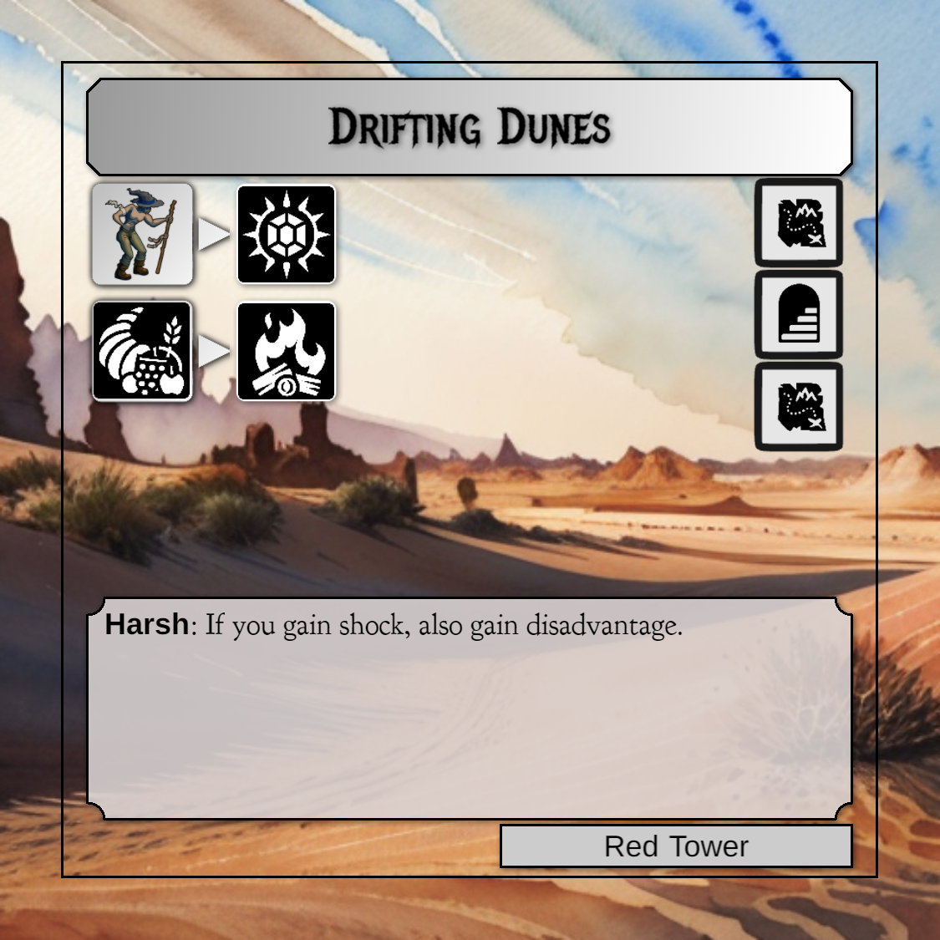

Draw an interior encounter


Draw an overland encounter


Draw an encounter from the Quest if this Setting shares the Quest name in the lower right, otherwise, pick either interior or overland.


Perform a rest action

Time Passage
Some settings will advance the “time marker” on a quest. If the Setting has a “Time Passes” icon (hourglass), the time on the Quest is advanced once for each icon.
Removed for now, keeping around during rules writing.

Actions
Settings have actions that can be performed – they have a cost and a result. The cost is on the left and the result is on the right.
For instance:
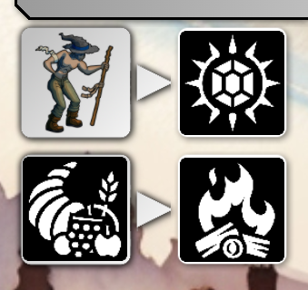
There are two actions available on the setting “Drifting Dunes”:
Gain a Weary Peril to draw a Treasure card.
Discard a provision token to perform a rest action.

An action can only be played once, and only one action can be played per encounter (after the encounter is complete). Actions can be used in any order.
If a Glyph is bounded by a square as either cost or reward, it indicates a Token.

If the cost Glyph shown is a token, then only a token may be used to pay for the action. In this example, the magic Glyph MUST come from a token.
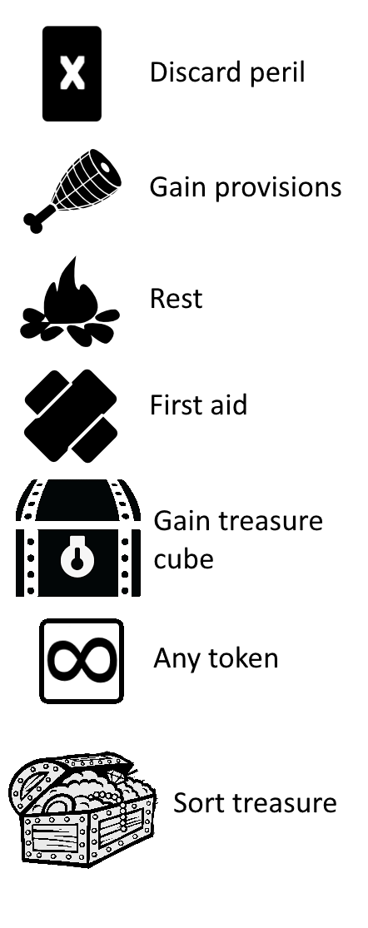Figure 3: Outdated
Some icons can appear on either side, as a cost or a reward.
If an hourglass shows for the cost, advance time by one and gain the delay peril.

Discard Peril: Discard a peril that bears the discard icon.
Gain Provisions: Add a provisions token to the party. Alternatively, provisions may appear on the left (cost) side as well.
Rest: Perform a rest action for the party.
First Aid: Convert one Despair, Shocked or Injured to Weary for one character.
Gain Treasure: Gain a “loot” cube.
Gain Any Token: Select any token an d add it to a character. If there is a Glyph in the square, gain that type of token instead.
Sort Treasure: Discard X loot cubes to draw one card from the Treasure Deck.

9.0 Encounters
Encounters are the obstacles, combats and events that occur during an adventure. An encounter is drawn for each way point the party travels through.
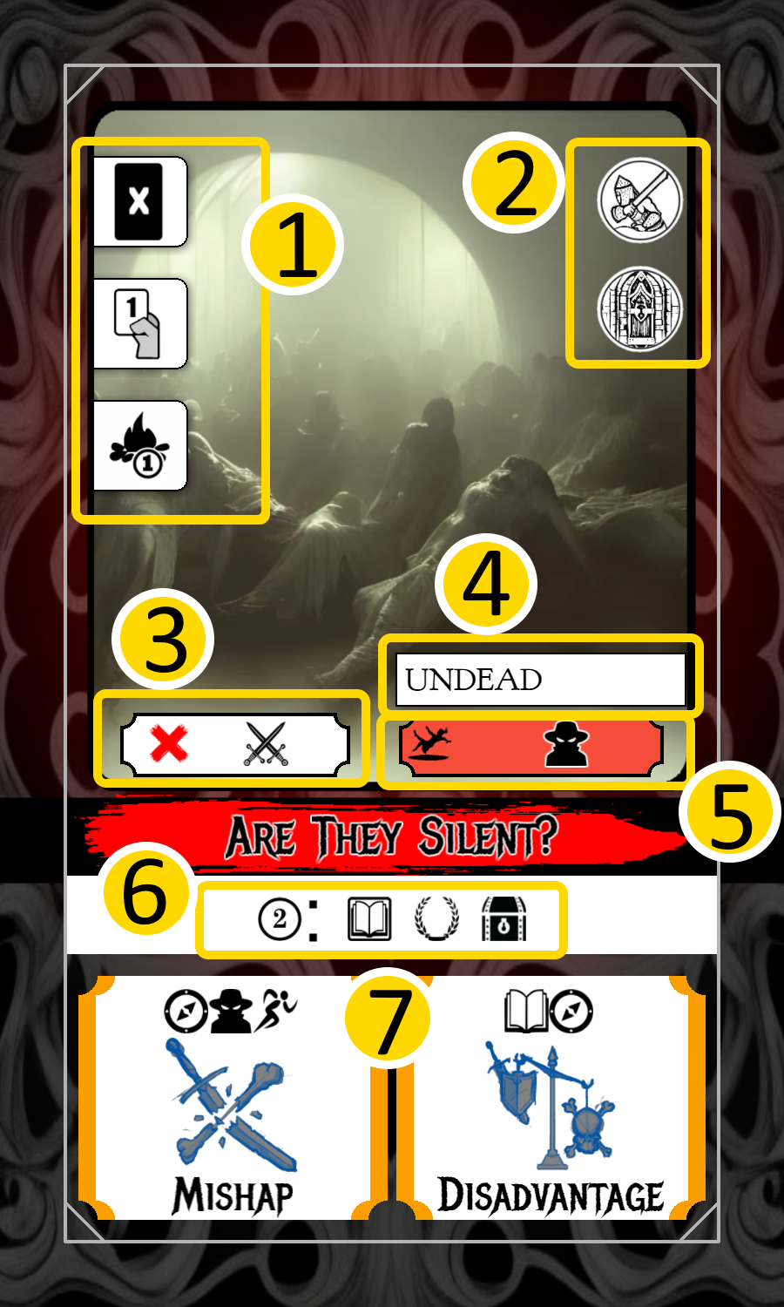
1. Actions allowed
2. Combat and obstacle identifiers
3. Taboo Glyphs
4. Tag
5. Extra difficulty
6. Rewards
7. Threats

Actions Allowed
Each character takes one action during an encounter. Typically, encounters will show multiple options for what a character can do. In the example, a character may discard a peril, play one card or take a rest action.
List the actions available
Icon | Action
 | Play up to as many Play Cards as indicated on this icon. An infinity symbol indicates any number of Play Cards can be played. All Play Cards from a single character are played at the same time, but can be applied to multiple Threats.
 | Discard a peril that bears this matching symbol.
 | Gain a token bearing the same Glyph as indicated. If the Glyph shown is a star, you may select any Glyph.
 | Perform a rest action for one character.
 | Draw a treasure card.
 | Perform a first aid action on another character – the target character may convert one Despair, Injured or Shocked to Weary.
 | Gain a provisions token.
 | Collect an item or treasure.

Passing an Encounter

This icon on the encounter card shows how many glyphs must be matched to consider this encounter as passing. “Passing” an encounter may be removed, it may not be required or meaningful in the grand scheme of things. Unless an encounter is an obstacle, it may not matter. It is generally viewed as “Passed, with consequences” if the threats cause damage.

Obstacle and Combat Identifier
Some encounters are considered combat encounters and/or obstacles. These can trigger special rules on characters or settings.

Failing an Obstacle
If you fail an obstacle, you will need to find a new path forward. At this point, there are two choices, if a rest action is available on the Setting, you may take the rest action and encounter the obstacle again, or you may discard the Setting and obstacle and draw a new Setting.
If the Setting is a quest specific setting, and an obstacle blocks the team, drawing a new Setting is not allowed, gain Doom instead. If that happens, draw another Encounter.

Taboo Glyphs
A Play Card that bears a Glyph that is displayed in the taboo section of the Encounter is considered to have no Glyphs. When Played effects are still activated. *note: the entire Play Card is considered to have no Glyphs, including ones that are not shown in the taboo section.

Tag
This identifies the card as belonging to a specific class of cards that may have special rules based on the setting, quest or character cards.

Extra Difficulty
If an icon appears on the left of this section and the party has a matching Peril, the Glyphs shown in this section must be matched before the threats can be canceled. The extra difficulty section can be activated by other special rules as well – for instance a setting may state that all Undead are treated as difficult. Super-wild-hard mode: each instance of difficulty requires matching the Glyphs, so if Undead on the setting makes it difficult AND the extra difficulty has an icon of a Peril that the team has, it is twice the cost?

Rewards
The number at the beginning indicates how many Glyphs must be matched to make one selection from the rewards shown after it. In the encounter above, 2 Glyphs must be matched to gain one choice of reward (lore token, prestige, treasure cube “loot”).

Threats
Each encounter has two threats. The team can chose to not play any cards and simply receive the Perils and continue on. If no characters select the “Play Card” action, then any character may take the Perils indicated. This occurs after they perform other actions.
- All threats that have not been canceled (by matching Glyphs) must be applied to characters
- Characters that perform a rest or discard peril cannot be assigned a Peril
- When playing cards against a threat, the Glyphs on the card only apply to one threat and cannot be split between two (one Play Card must be played against, and applies only to one threat), including extra difficulty
- To cancel a threat, play enough cards to match the Glyphs shown on the threat

12.0 Perils
Perils are negative conditions that are applied to the party as a whole or to an individual character. The removal of the card is listed on the peril card. Each attribute card has the associated “damage” peril listed on the reverse side of the card. When a character takes a Despair, Injured or Shocked peril you can flip one of the appropriate attributes to reveal the reverse.

List of Perils

Afflicted
This Peril represents a lasting condition that negatively impacts a character’s abilities. When this Peril is gained by a character, place it on one In-Hand Aspect or Archetype play card that has a refresh cost. Discard Afflicted during a rest action. When discarded, exhaust that Play Card that was Afflicted and gain the Peril Weary. If there are no valid Play Cards, gain Doom instead.

Delay
Advance the time on the Quest. This card can cause challenges to be more difficult. Discard it after a team rest action, or if it shows in the difficulty section on an encounter. You can only have one Delay Peril, if you gain a second, gain Doom instead.

Despair
Flip over one Spirit Attribute to show the damaged side. If there are no undamaged Spirit Attribute points remaining, the character is slain.

Disadvantage
Unless otherwise stated by the Quest being played, include the extra difficulty Glyphs as though they were in each Threat. When the encounter is complete, if any Glyphs in the extra difficulty section were matched, remove one Disadvantage. Otherwise it remains. Additional Disadvantage Perils make it more difficult to remove. If the team gains a 3rd Disadvantage, gain Doom instead.

Doom
If the team accrues 3 Doom, the adventure ends with all progress lost.

Ensnared
Action, Fight and Navigate Glyphs are taboo for the Ensared character until the end of the next encounter, unless another character plays Action and Fight (which do not count towards a Threat).

Incapacitated
In the next encounter, this character may only discard Incapacitated as their action.

Injured
Flip over one Body Attribute to show the damaged side. If there are no undamaged Body Attribute points remaining, the character is slain.

Loss
Do the first action possible:
* Discard 2 random treasures
* Discard all Tokens
* Gain a Doom

Lost
Reset all encounter progress on the Setting. Threats with Navigate Glyphs cost an additional Navigate. Discard after the next Encounter.

Mishap
Double the cost of a Threat (that does not have a Mishap Peril) in which this character takes part (by playing a Play Card). This character MUST play Mishap if they play any cards. Discard after taking part in an Encounter. A second Mishap on one character results in Doom instead.

Shocked
Flip over one Mind Attribute to show the damaged side. If there are no undamaged Mind Attribute points remaining, the character is slain.

Weary
During a rest action, discard Weary in place of refreshing a valid Play Card.

12.0 Sample Character Creation
Ortem – this character has very low attributes but a hand-size of 5 and can hold any two tokens.
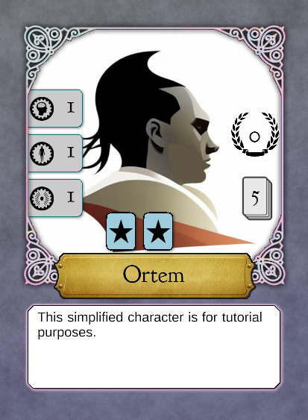
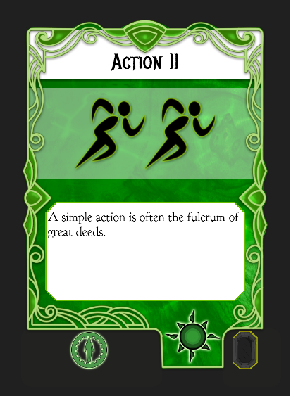
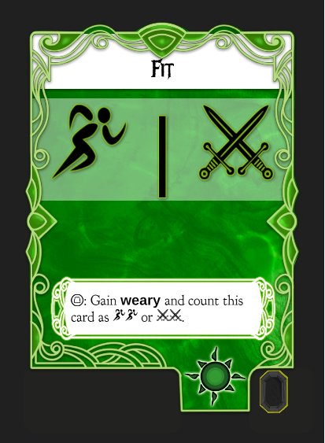
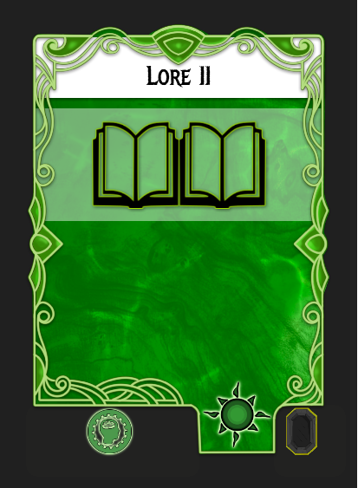
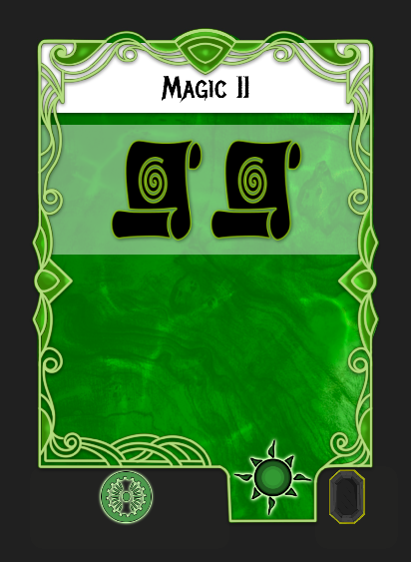
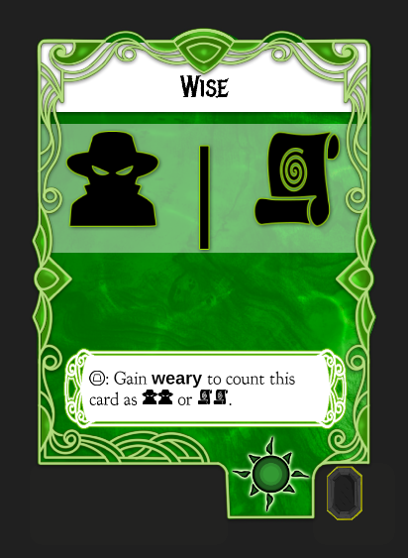



The cards shown here of varying size are only for display purposes. All of the cards that a character uses are the same size to allow the character’s state to be kept between play sessions if needed.

Haiyan – This character has two spirit attribute points, but only a hand-size of 4, she can hold two tokens, but only if one of them is provisions.
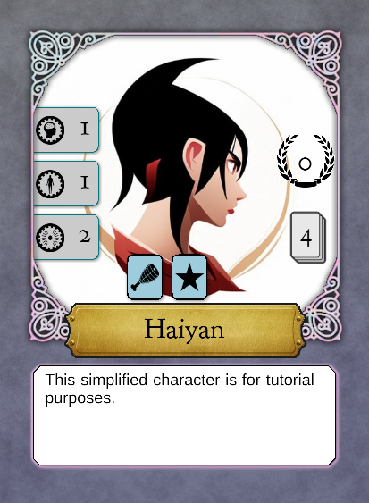
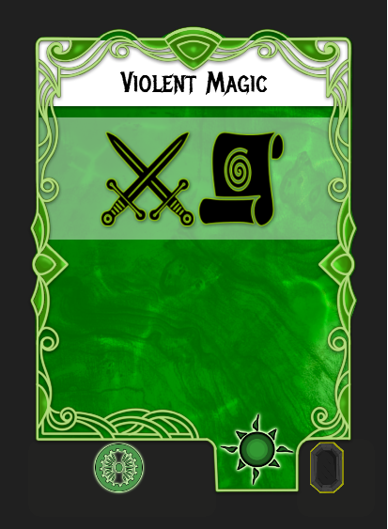
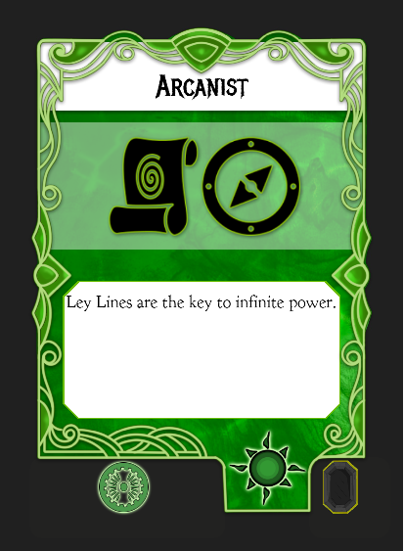
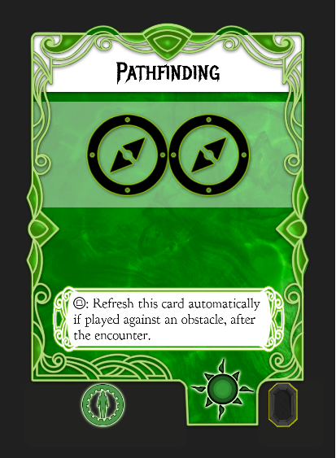
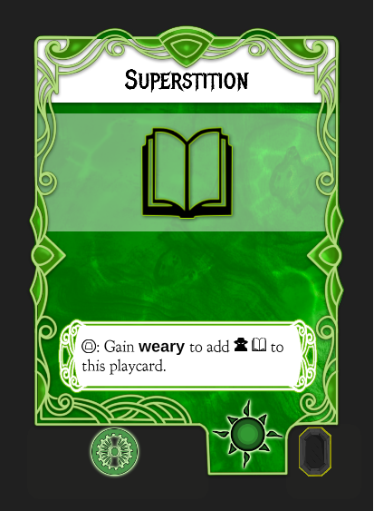

Gendrik – Like Haiyan, Gendrik only has 4 cards and a max of two tokens. He has two body attribute points.
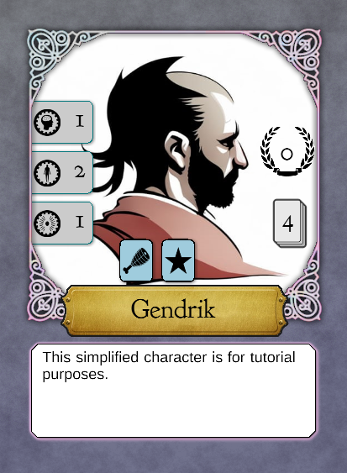
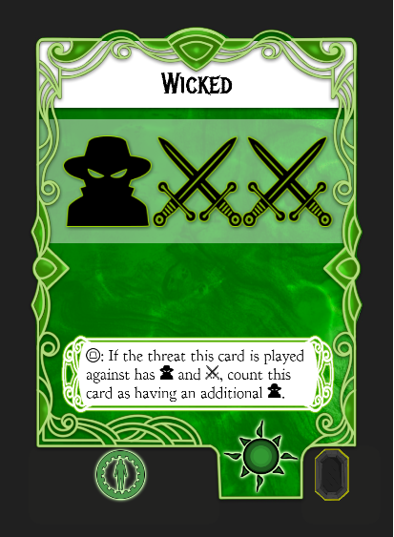
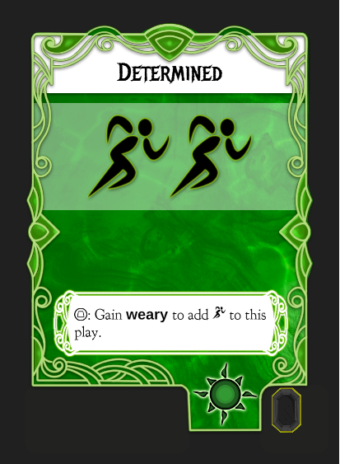
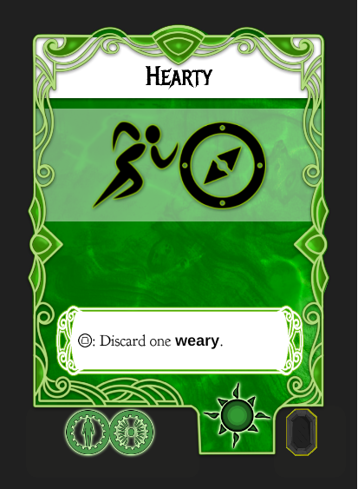
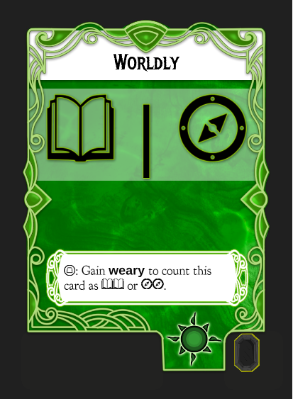

13.0 Skill Tests
(Move this to a subsection)
Some effects call for a skill test.
* All characters with less than 2 spirit take Injured
* All characters with no Magic Glyphs In-Hand take Shocked (not to include tokens)
Some Play Cards and special abilities allow characters to exhaust cards or tokens to increase their

12.0 Let’s Go Adventure

Tutorial Quest

Preparing for Adventure

Clarification
The rules you've provided seem comprehensive and well-structured for creating a solo RPG card game with various encounters, threats, and perils. However, there are a few areas that could potentially benefit from additional clarification or expansion:
- Character Progression and Improvement: While the rules touch on character creation and attribute cards, they don't delve into how characters can improve or progress over time. Consider adding a section on how characters can gain experience, level up, and acquire new abilities, as well as how they can spend attribute points to enhance their capabilities.
- Treasure and Rewards: The rules briefly mention treasure cubes ("loot") and provisions, but you could expand on the types of treasures adventurers might find, their uses, and potential rewards for collecting them. Additionally, you could provide more details on how treasures can be used outside of encounters.
- Quests and Objectives: The rules mention quests and how they may involve completing different settings, but they don't go into detail about the variety of quests, objectives, and potential rewards for completing them. Adding more information about the types of quests and the overarching goals of the adventurers could enhance the narrative and direction of the game.
- Character Abilities and Play Card Effects: While the rules explain the different types of play cards (Aspect, Token, Item, Archetype), it might be helpful to provide examples of specific abilities or effects that these cards can have. This could help players better understand the range of actions and interactions available to them.
- Sample Scenarios or Campaign Structure: Providing a sample scenario or a basic campaign structure could help players understand how the different elements of the game come together. This could include a series of encounters, quests, and potential outcomes that showcase the flow of gameplay.
- Gameplay Flow and Turn Structure: While the rules touch on how encounters and settings work, you could further elaborate on the overall gameplay flow, including how turns are structured, how resting and refreshing play cards fit in, and how players progress from one encounter to the next.
- Unify iconography by type (Glyph, Action, etc.) and shape

