Encounters Set 2, Yagishamot

#1 Yicht
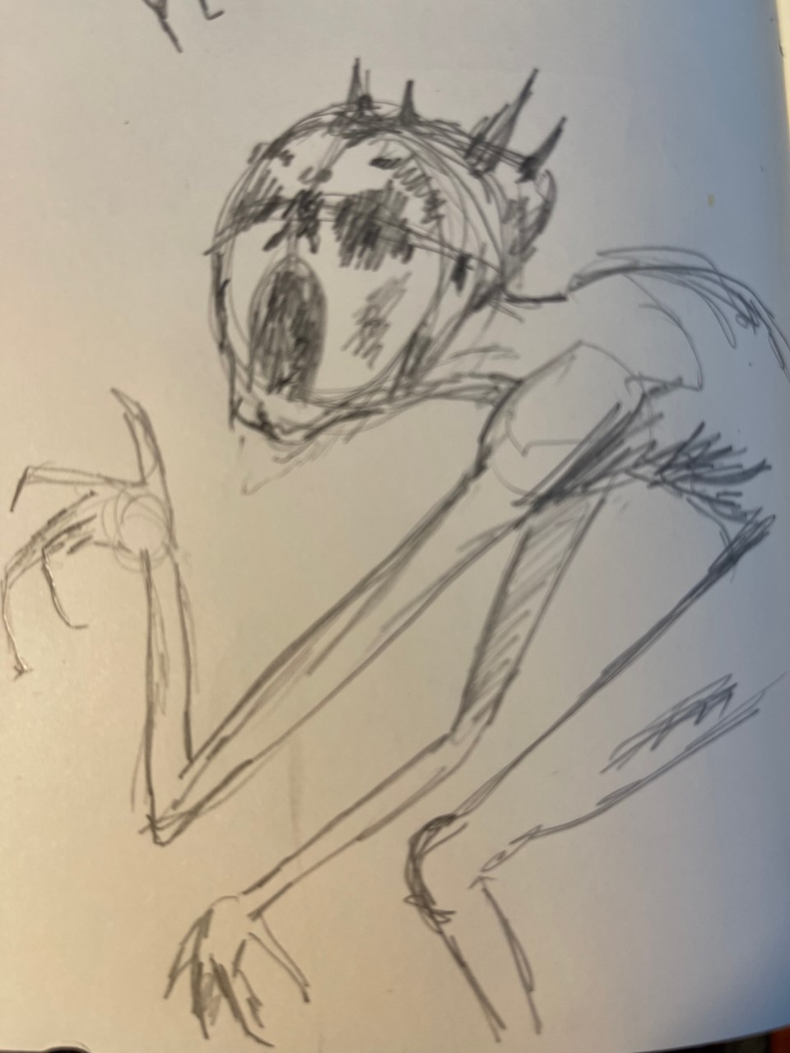Figure 1: very bad sketch of Yicht
Yicht is one of Ursamao's five wanderers.
Yicht exists in a state of perpetual disfigurement, a grotesque fusion of sinew, flesh, and bone that defies human proportions. Its very existence is a blasphemous aberration against the natural order, a jarring amalgamation of disparate anatomical fragments fused together. The creature's shape is in a constant flux, as its bones break and reform in a grotesque symphony of agony, allowing it to move in unsettling, unnatural ways.

Its skeletal structure is a macabre spectacle, as its jagged bones pierce through its skin in a perverse parody of anatomy. With each bone fracture, Yicht emits a cacophony of sickening cracks, echoing through the desolate tombways. But what is most revolting is the way its shattered bones regrow and interlock, defying the boundaries of mortality, knitting together with a disturbing sentience that mocks the coherence of mortal understanding.

Its visage is a maddening paradox, simultaneously repulsive and captivating. The sight of its broken, reassembling form is an affront to the very concept of life, a grim reminder that Ursamao is a malevolent entity that delights in perverting the laws of existence.

#2 Lash Slug

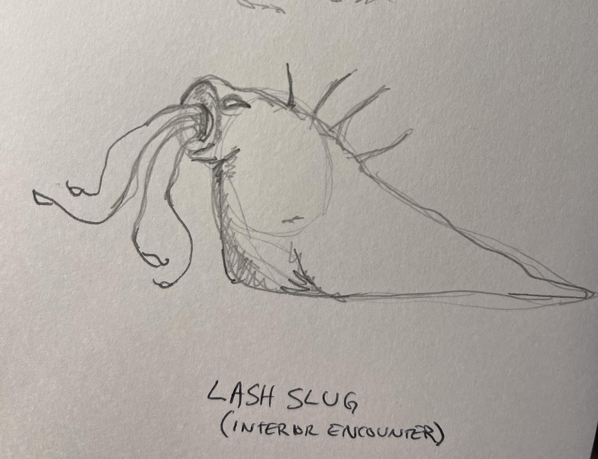
The Lash Slug is a substantial creature, measuring about ten feet in length from its tapered head to the end of its muscular, slimy tail. Its elongated body undulates along the ground, leaving a trail of sticky mucus in its wake. The slug's skin is a sickly shade of grayish-green, resembling a mix of decaying vegetation and putrid slime. The surface of its body is coated in a slimy mucus, providing the creature with protection and making it difficult for anything to gain a firm hold.

The slug's upper section swells to a considerable girth, housing its immense maw, which is surrounded by a ring of fleshy, writhing tentacles. These tentacles, varying in length and thickness, possess a sickly pinkish hue and are covered in small, suction cup-like protrusions. Each tentacle twitches with an unsettling rhythm, as if they possess a grotesque sentience of their own.

The Lash Slug's maw is a dark, gaping orifice lined with rows of jagged teeth that protrude menacingly. Its jaws are capable of unhinging to a surprising degree, allowing the creature to swallow prey larger than its own size. Inside its maw, a slimy, phosphorescent glow emanates, casting an eerie illumination onto its surroundings.

#3 Creature of Wjen
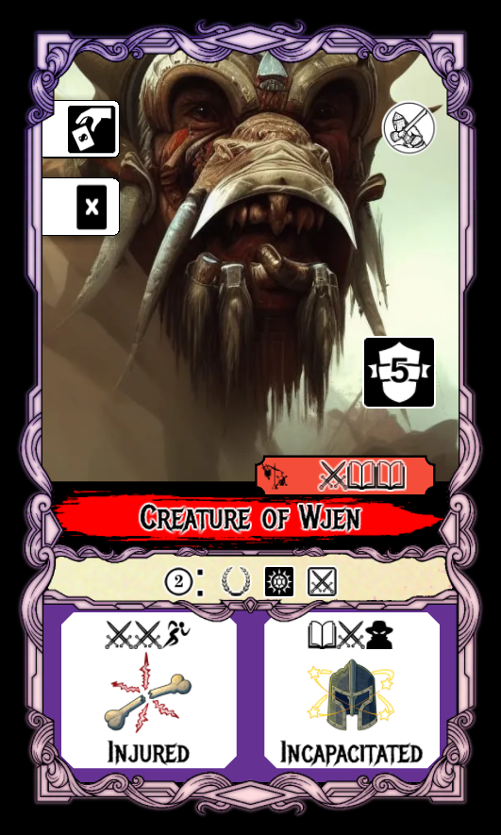
The Creatures of Wjen are long corrupted beasts. While sentient, they are savage, misshapen and ruthless. They stand up to 7 feet tall and often have wispy beards. They are tusked with beady eyes and adorn their faces with sharp armored coverings.

#4 Tentacle Monster
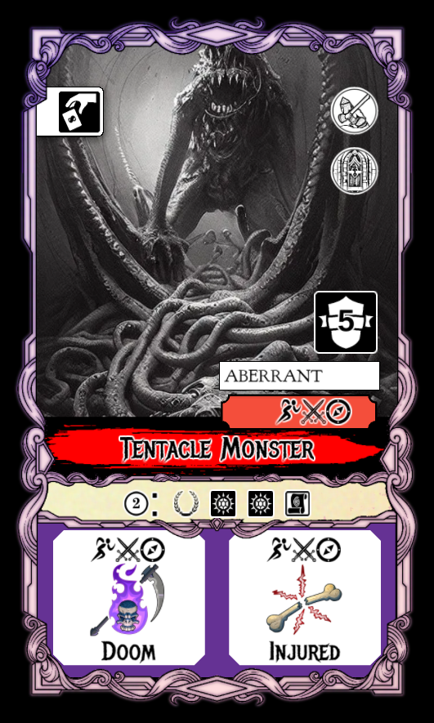
This huge monstrosity guards the path through the hallway – it’s maw is enormous and seems to jut directly from the torso. It has two arms, and legs, but also a slew of tentacles reaching down the hallway. This is an epic foe. Black and white is good for this one.

