Encounter Batch

Behlgor Horror Horde

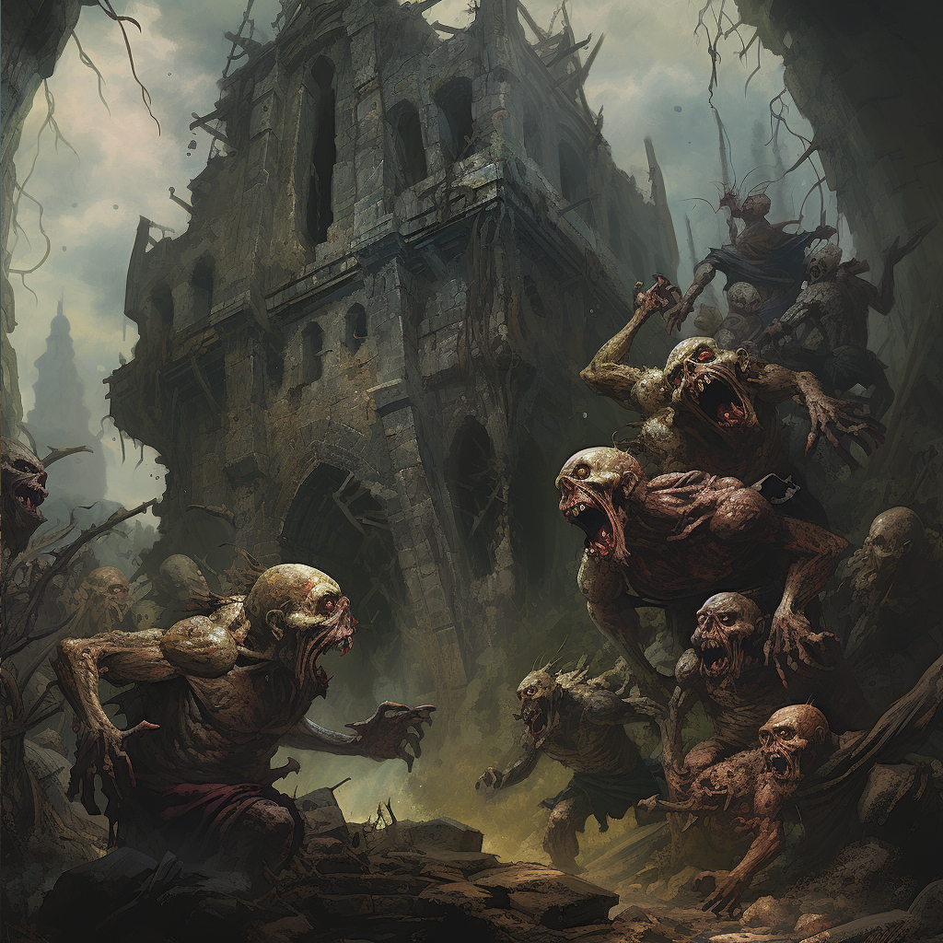
The Behlgorh Horror Horde is an encounter that the party needs to escape from, the misbegotten enemies are too numerous to fight directly and each crewmember will need to make a skill check to not be injured. The horrors should be spilling out from a ruined structure, crawling over each other in a mad scramble to tear the characters to pieces. They are not undead, but should have a ghoulish and wild appearance.

Cannibal Poltergeist

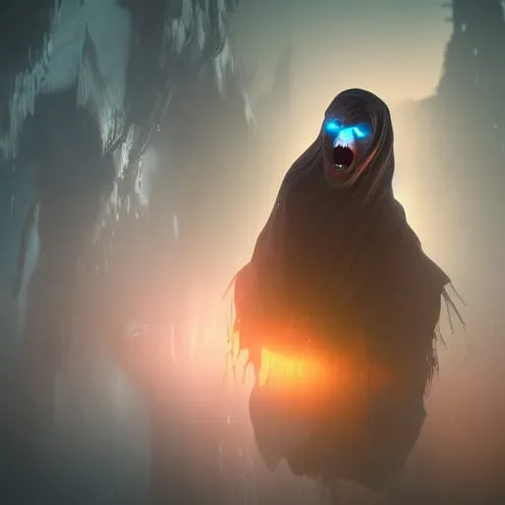
This is an evil spirit and a difficult encounter. The Cannibal Poltergeist should look as though it is suffering, though relentlessly pushing forward.

Clamoring Dead

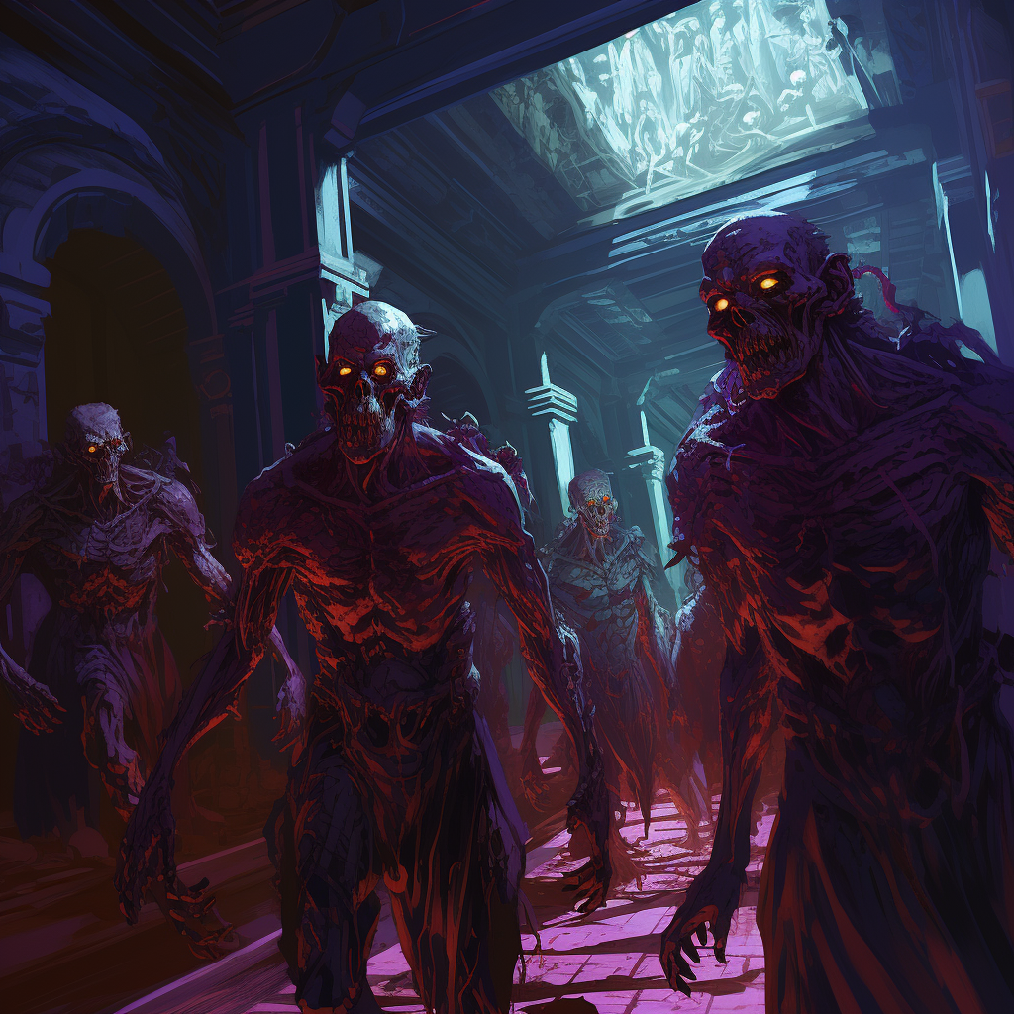
Shuffling undead, they should be armed with spears and swords and in multiple states of decay. They should be in an interior setting, such as a ruin, or hall. I don’t need glowing eyes, and probably can get rid of that.

Dread Guardian

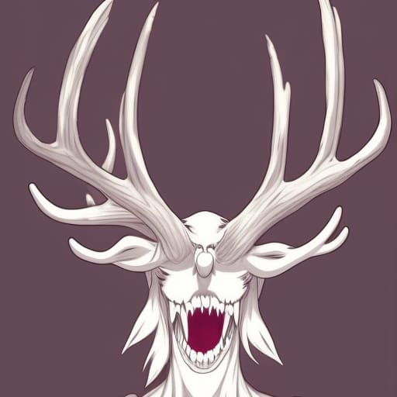

This creature should be… well, weird. I love that the antlers are growing from the eye sockets. The gaping mouth and somewhat deer-like appearance would be good.

