The Red Tower Settings

Devouring Sands
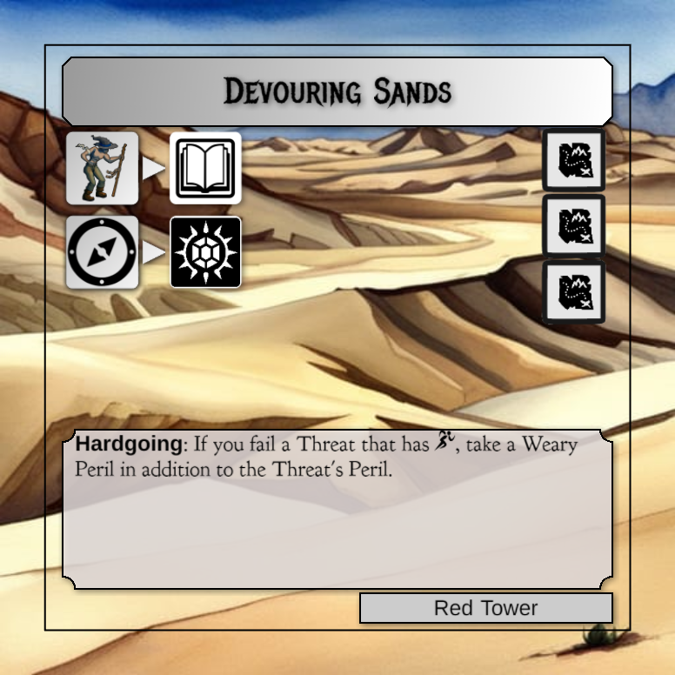
This setting could have driving wind and large sand dunes. There should be no structures, except possibly the hint of something buried underneath the sands in the distance which is what the two actions on the left represent: Take a fatigue to gain a lore token (book) and spend navigation to get a treasure (glowing gem).

Drifting Dunes
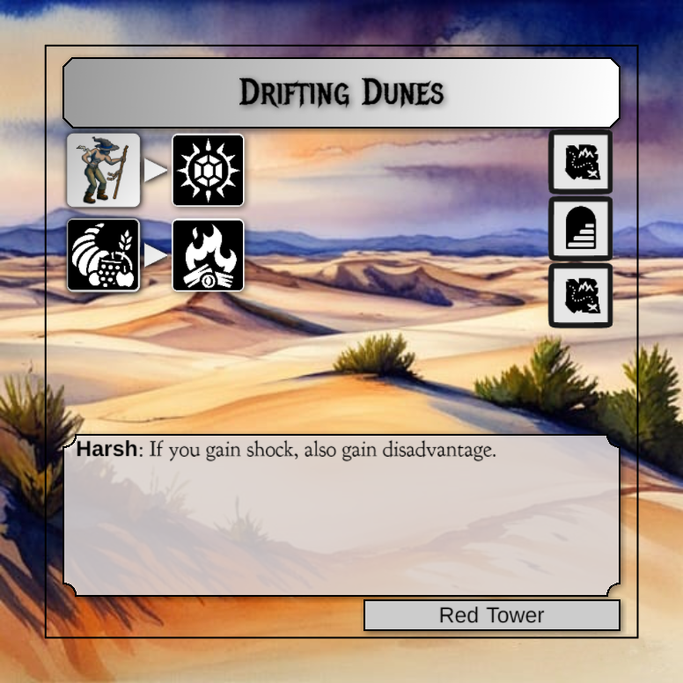
Another difficult setting, though there are some places to rest. This might have a small ruin way in the distance as can be seen by the stairs icon on the right (this has an outdoor encounter, an inside encounter and then another outdoor encounter).

Keligorn Ruins
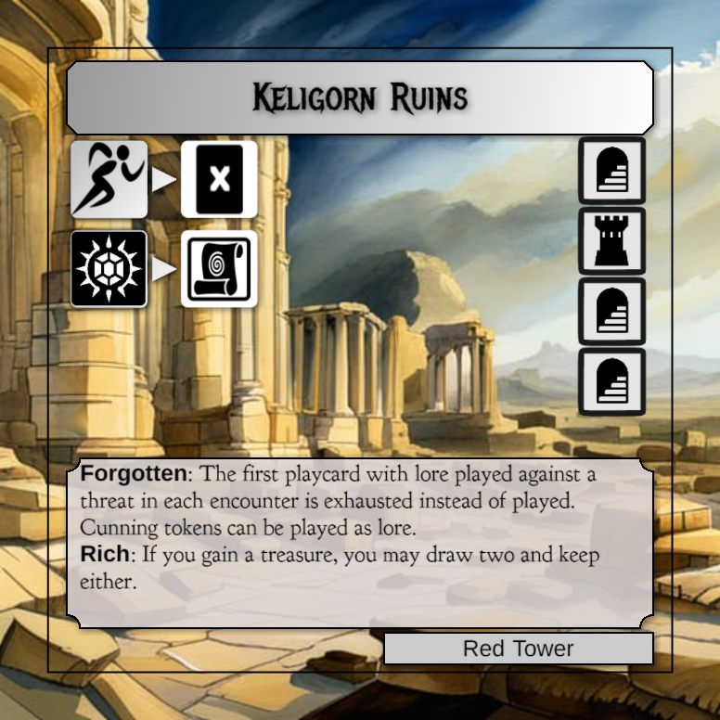
This should be an expansive monolithic ruin. All of the encounters are generally interior, so there could be many entrances and such.

Stone Forest

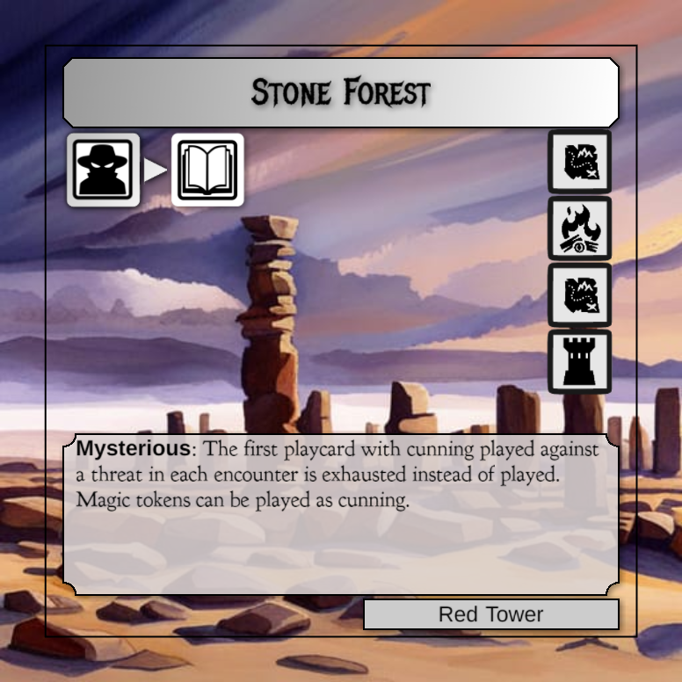

The stone forest is a series of stacked monolithic stones, maybe it was a structure of some kind, maybe naturally formed. I’d like there to be MORE of them, and maybe a tighter space between.

