**Panic Driven Human Motion**

Ananth Rama Varma 2012PH10829

Rachit Madan 2012PH10866

Supervisor : Dr. Sujin B. Babu

**Abstract : The project aims to study and understand panic driven human minds and to simulate their motion. Simulations done with point object approximations. Cases covered- Single exit, Multiple exit. Theoretical research also done for non-stationary point of origin for panic. This report takes the reader through the need for the study of panic, the research done and how the theory has been applied. It will be clear how panic studies can be beneficial in saving multiple lives given the current state of the world where panic related death tolls are skyrocketing with natural disasters and terror attacks happening with greater frequency with every passing year.**

[ananthramavarma@gmail.com](mailto:ananthramavarma@gmail.com)

rachitmdn42[@gmail.com](mailto:madanrachit@gmail.com)

**--------------------------------------**

(Signature of the Supervisor(s))

**Name of the supervisor:**

**Date:**

**INTRODUCTION**

People, by nature, are a social being, but a panic situation is one such thing which changes this basic nature of humans causing mass deaths. One of the most life-threatening of mass human interactions is a crowd stampede. Traditionally believed to be unpredictable, a stampede can often increase the problems that caused the original life threatening situation.[5]

In a calm situation, people seem to be rational with an ability to think. An increase of people in a crowd is not synonymous with a loss of rational thought. A simple look at any crowded area such as the numerous markets and malls in Delhi itself show mass crowd moving in orderly fashion. So why is it that during an event people seem to lose the ability to think? It could be a question of physiology. However it could be possible to predict the motions of this seemingly erratic a crowd.

Simple observation makes it obvious that many characteristics of escape panics parallel the characteristics of particle interactions. Particles bouncing off each other, for example, are similar to people pushing and fighting to escape. The main objective of the project is to understand this panic driven motion of people under different conditions. We aim to understand the problem by modeling the motion of a panic driven group which tends to make rash collective decisions and possibly come up with strategic solutions to minimize the trouble caused due to panic related rush. We use real-world information by analyzing YouTube videos and calculating velocities of people in such situations and also simulate panic situations my modelling particle interactions with single and multiple exits.

**THEORY**:

Destructive panic behaviour has always been observed in life-threatening situations such as fires in crowded buildings. Panicking individuals tend to clearly showcase maladaptive and relentless mass behaviour like jamming and life-threatening overcrowding which has often been attributed to social contagion [1] The characteristic features of collective panic driven human motion studied in socio-psychological studies along with systematic quantitative theories can be summarized as follows [2], [3], [4]:

1.People attempt to move considerably faster than normal.

2.Individuals start pushing vehemently, and interactions among various people become physical in nature.

3.Moving and, in particular, passing of a bottleneck becomes uncoordinated and hence extremely slow.

4.At exits, arching and clogging are observed.

5.Jams build up and the physical interactions in these jammed crowds add up and cause dangerous pressures which can rise up to 4,450 Nm-1. Such high pressures can bend steel barriers or push down brick walls.

6.Escape is further slowed by fallen or injured people acting as ‘obstacles’ further slowing down the movements of people.

7.People show a tendency towards collective behavior.

8.Alternative exits are often overlooked or not efficiently used in escape situations.

We model the collective phenomenon of escape panic in the framework of self-driven many-particle systems. The crowd dynamics of these systems are based on a force model. We model physical and psychological forces between particles and walls using the following mathematical equations [4] which we use as a starting point for our simulations.

Each of *N* persons *i* with mass $m_{i}$ moves with a certain desired speed $v_{i}^{0}$ in a certain direction $e_{i}^{0}$ with a certain characteristic time $τ_{i}$. Simultaneously the person tries to maintain a velocity dependant distance from other pedestrians *j* and the wall *W.* This can be modelled by interaction forces $f_{ij} and f_{iW}$ respectively. Thus, in mathematical terms, we have the following acceleration equation.

${m_{i}\frac{dv_{i}}{dt}=m_{i} \frac{v_{i}^{0}(t)e_{i}^{0}(t)-v_{i}}{τ_{i}} +\sum_{j≠i}{}f_{ij}+\sum_{W}{}f_{iW} (1)}_{}$

We have the position vector $r_{i}(t)$ and the normalised vector $n_{ij}= {(r}_{i}-r_{j})/d_{ij}$ pointing from person i to j. Now we have the following two equations:

$f_{ij} = \{A_{i}exp[(r_{ij}-d_{ij})/B_{i}] + kg(r_{ij}-d_{ij})\}n_{ij}+κg(r_{ij}-d_{ij})Δv_{ij}^{t}t_{ij} (2)$

$f_{iW} = \{A_{i}exp[(r_{iW}-d_{iW})/B_{i}] + kg(r_{i}-d_{iW})\}n_{iW}-κg(r_{i}-d_{iW})(v_{i}.t_{iW})t_{iW} (3)$

Here $A_{i} and B_{i}$ are constants, g(x) = 0 if pedestrians don’t touch each other and is otherwise equal to the argument x, $d_{ij} or d_{iW}$ is the distance between two persons and that between a person and a wall respectively. Lastly, $t_{ij}$ is the tangential direction and $Δv_{ij}^{t}{ = (v_{j} - v_{i}).t}_{ij}$ is the tangential velocity difference while $k and κ$ represent large constants.

The above equations give the following results shown in Fig 1 given below.

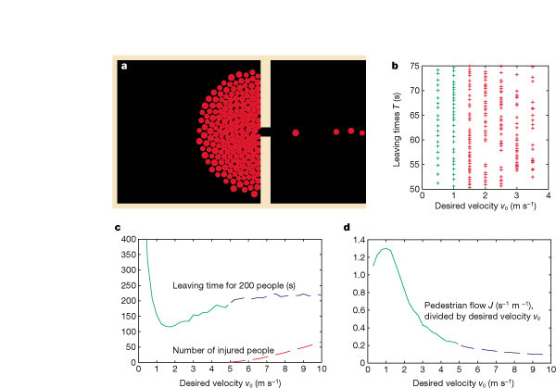

Fig 1[4] a. Expected result of simulation for panic motion with a single exit.

b. leaving times for people with different desired velocities

c. graph depicting the leaving times for 200 people with increase in desired velocities.

d. graph depicting the changes due to pushing, causing friction.

From the above Fig 1(c), we see that the leaving time for a group of 200 people initially decreases dramatically with the increase in velocity and the increases almost linearly with the number of injuries increasing. Fig 1 (c) and (d) combined together show the root cause of deaths in a panic based stampede where there is significant levels of pushing and a tendency to rush and increase the velocity is prevalent.

**WORK DONE**:

**Before Mid-Semester Evaluation:**

We have successfully implemented a program using C++ and OpenCV library which takes in a video and calculates the optical flow or the velocity with which the objects are moving in the video. This would allow us to cross reference real world situations with our simulation.

***Lucas Kanade algorithm with image pyramids*** has been used for calculating the optical flow which yields velocities which have accuracy upto fraction of pixels. The results are shown in Figure 2(a) given below.

On executing the MATLAB program, we can either select click on a point to track, or automatically initialize points to track everything that is moving. The program also outputs the corresponding velocities of the feature points (shown as green circles in Fig 2(a)). It also has the option to clear and re-initialize all the points while the video is running.

We had also managed to reproduce results from Dirk Helbing et al. [1] which involve single exits (See Fig 2(c)). This code has been written in MATLAB with a graphical user interface, GUIDE that enables an intuitive and fast handling of the features.

**After Mid-Semester evaluation:**

We have perfected the earlier code adding pressure indicator as seen in Fig 2(b). The agent changes color from green to red depending on the pressure applied on it. We have managed to successfully extend our code for multiple exit models using the research mentioned above (See Fig 2(b)). This is primarily done by assuming a simple attractive pull for each person who is approximated by a particle to its nearest exit point. It is clear that for any given person in a panic state, the direction of movement can take 3 different values. either (i) $e_{i}(t)$, the current direction of motion, (ii) ${<e_{j}^{0}(t)>}_{i}$ which is the average direction of the neighbours; or (iii) the direction leading to the nearest exit. Both (ii) and (iii) add up giving us a clear solution of simulating single exit problem for each and every particle assuming the only exit to be the nearest exit. We have also managed to run simulations using the code, plotting the leaving time, defined by the exit time of the last person leaving the room. The results of the simulation are plotted in Fig 2(d).

Finally, we have also devised the algorithm of incorporating the direction vector $e_{i}(t)$ pointing directly away from the point of panic for any moving/expanding point of panic. This is done with the assumption of the increasing panic parameter as the point of panic approaches the individual persons. This increasing panic forces the people(particles) to move directly away from the panic range instead of just following the mob.

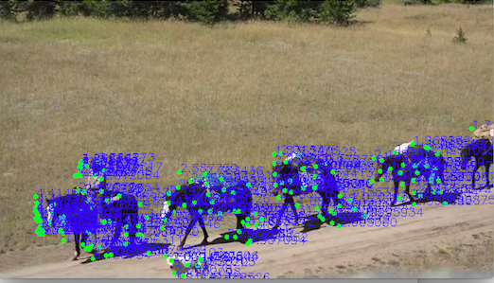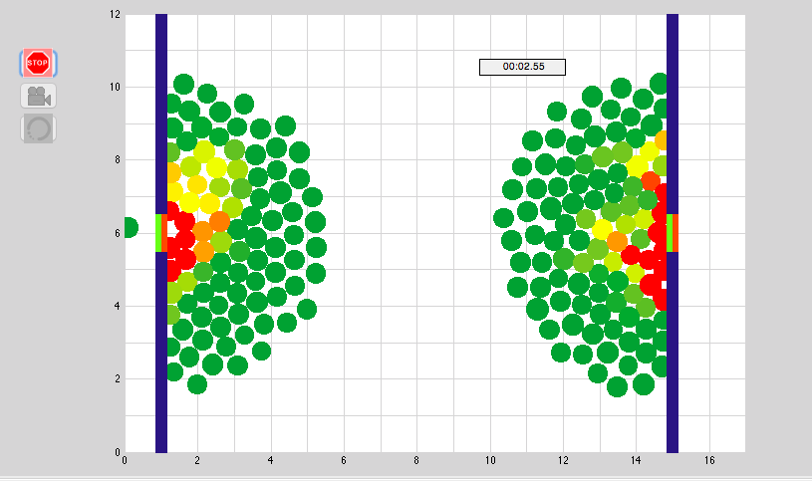

(a) (b)

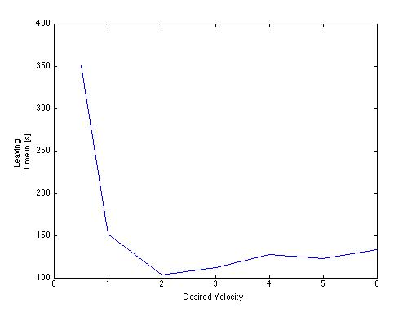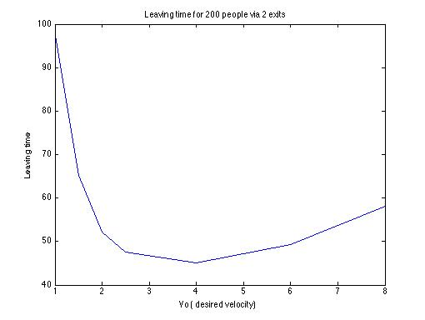

(c) (d)

Fig 2(a) shows the velocity profile of the computer vision code implemented by us. (b) screenshot of panic simulation for multiple exits. (c) Leaving time vs desired velocity graph from simulations for single exit. (d) Leaving time vs desired velocity graph from simulation for two exits..

**RESULTS AND DISCUSSION:**

From the above simulations and equations, we observe that the leaving time as calculated using our simulations for 200 agents in a 15 x 15 room in case of 2 symmetrically placed exits at desired velocity of 4 m/s is 48 sec as compared to ~135 sec for single exit, **which is 64.4% faster!**. Considering India’s perspective, we see that given our large population and recent developments of having large scale events, there is a high chance of developing panic situations and hence, we must be properly equipped with counter-measures. Escape route planning, disaster management drills, terror attack drills etc need to be implemented which require such simulations as a basis for all the actions to be taken.

**FUTURE SCOPE/PLANS FOR NEXT SEMESTER:**

Panic situations are highly diverse and occur with multiple parameters which vary profusely. The simulations for the non-stagnant point of panic needs to be done. There are several other areas which need to be explored, such as, the visibility(which becomes a key factor in fire related stampedes), obstacles(both non living debris and dead humans who block the way), dimensions and shape of the room under observation which would increase/decrease the friction element in the equations.

**ACKNOWLEDGMENTS:**

We would like to thank Dr. Sujin B. Babu for providing us with the opportunity of working on such an interesting and impactful topic, and guiding us through the course of our research.

We would also like to thank the Department of Physics, IIT Delhi for initiating such practical skill enhancing courses to help us in our growth as B.Tech students.

**REFERENCES:**

[1] *Keating, J. P. The myth of panic. Fire J. 5761, 147 (May 1982)*

[2] *Mintz, A. Non-adaptive group behavior. J. Social Psychol. 46, 150159 (1951)*

[3] *Kelley, H. H., Condry, J. C. Jr, Dahlke, A. E. Hill, A. H. Collective behavior in a simulated panic situation. J. Exp. Social Psychol. 1, 2054 (1965)*

[4] *Helbing, Dirk, Ill ́es Farkas, and Tamas Vicsek. ”Simulating dynamical features of escape panic.” Nature 407.6803 (2000): 487-490*

[5] J.D. Sime, Crowd Psychology and Engineering, Safety Science 21, 1994.