Colonisation failure, not habitat loss, drives range contraction in steppe birds

Raúl Contreras-Martín¹,²*, Carlos A. Martín ¹, Guillermo Fandos¹*
¹ Departamento de Biodiversidad, Ecología y Evolución, Universidad Complutense de Madrid, 28040 Madrid, Spain
² Departamento de Biodiversidad y Biología Evolutiva, Museo Nacional de Ciencias Naturales (MNCN-CSIC), C/ José Gutiérrez Abascal 2, 28006 Madrid, Spain

* Corresponding authors: Raúl Contreras-Martín; Guillermo Fandos (gfandos@ucm.es)

ORCID:
Guillermo Fandos: https://orcid.org/0000-0003-1579-9444
Raúl Contreras-Martín: https://orcid.org/0009-0008-8707-9562
Carlos A. Martín: https://orcid.org/0000-0002-6865-9376

Running head: Demographic trap in Iberian steppe birds
Target journal: Global Change Biology
Keywords: dynamic occupancy models, colonisation–extinction asymmetry, eBird, imperfect detection, range dynamics, steppe birds, citizen science, extinction debt
Word count (main text): ~6,300

Abstract
Range contractions may persist even when available habitat remains if recolonisation is insufficient to offset local extinction. Standard monitoring frameworks record occupancy patterns but not the underlying colonisation and extinction rates and therefore cannot determine whether observed ranges are demographically sustainable and remain stable over time.
We fitted dynamic occupancy models to seven years of citizen-science data collected across more than 4,000 5 × 5 km grid cells for four threatened steppe birds in mainland Spain (the great bustard, little bustard, and pin-tailed and black-bellied sandgrouse), which holds 19–97% of their European breeding populations. Models estimated colonisation (γ) and extinction (ε) explicitly while correcting for imperfect detection. Estimates revealed colonisation rates that were too low to offset extinction across all four species, and this asymmetry held across the full uncertainty distribution. Equilibrium occupancies implied by current colonization and extinction rates fall far below observed distributions, indicating substantial extinction debt. These conclusions were robust to survey design and to spatial autocorrelation in the data.
Current demographic rates cannot sustain the observed ranges of the species studied. Where colonisation is this low, range contraction may continue even if habitat loss slows, because remaining available habitat is too isolated to be reoccupied on management-relevant timescales. Preventing local extinction at occupied sites therefore would have a greater demographic outcome than promoting recolonisation under current conditions. More broadly, this kind of colonisation limitation, detectable only with detection-corrected demographic decomposition, may represent an under-recognised driver of biodiversity decline even under slow or moderate environmental change.

1. Introduction
Under rapid environmental change, colonisation can weaken faster than habitat disappears. When that happens, species persist in ranges whose demography they can no longer sustain: local extinctions accumulate, empty patches go unreoccupied, and the range distribution drifts toward an equilibrium far below what current habitat could support (Hanski et al., 2006; Kuussaari et al., 2009). Whether a declining species is in this non-equilibrium state or is still tracking habitat availability and can be recovered through protection and restoration, is not detectable from occupancy patterns alone. Yet, the two regimes require different conservation approaches (Briscoe et al., 2021; Tilman, 1994), and distinguishing them requires estimating colonisation and extinction separately, directly, not as a net outcome.
Farmland and steppe birds in Europe are among the best-documented casualties of landscape change. European farmland bird populations collectively have declined by more than half since 1980, driven mainly by agricultural intensification (Brlík et al., 2021; Chamizo et al., 2025; Donald et al., 2001; Gómez-Catasús et al., 2025; Gregory et al., 2019; Rigal et al., 2023; Rosenberg et al., 2019; Traba & Morales, 2019). Steppe specialists sit at the extreme end of this collapse. Four of them, great bustard (Otis tarda), pin-tailed sandgrouse (Pterocles alchata), black-bellied sandgrouse (P. orientalis) and little bustard (Tetrax tetrax) concentrate 19–97% of their European breeding populations in the agro-steppe landscapes of the Iberian Peninsula (Table S1). Despite decades of species protection, their ranges have contracted by 20–60% (Alonso & Palacín, 2022; SEO/BirdLife, 2022), with the Portuguese little bustard population collapsing by 77% between 2006 and 2022 (Silva et al., 2023), the Spanish population roughly halving between 2005 and 2016 (García De La Morena et al., 2018),and the black-bellied sandgrouse showing sustained decline in Iberia, its main continental stronghold (Benítez-López et al., 2017;); the most recent national survey documents a 63% decline between 2005 and 2019 (Mougeot et al., 2024). Available steppe habitat persists across the Iberian meseta, and yet many patches remain unoccupied years after local extinction, a pattern consistent with widespread extinction debts and colonisation credits documented at continental scales (Haddou et al., 2022). Whether this reflects ongoing habitat loss or a failure of recolonisation is unresolved.
Atlas surveys, trend indices and correlative distribution models record the net outcome of colonisation and extinction, not the processes themselves, and so cannot determine whether range recovery is demographically feasible (Kéry & Royle, 2021; Zurell et al., 2022). Empirical demonstrations of strong colonisation-extinction asymmetry from large-scale monitoring data remain rare (but see Briscoe et al., 2021). A further complication is imperfect detection: at the probabilities typical of citizen-science data, missed presences generate spurious turnover, overestimating colonisation and underestimating extinction. The result is a systematic bias that makes demographic decline appear less serious than it is (Guillera‐Arroita, 2017; Schmidt et al., 2023). Whether steppe bird ranges are actively maintained by ongoing demographic processes, or whether they represent non-equilibrium relicts of past landscape configurations, has not been established and this issue is of relevance for conservation. If colonisation has already failed, habitat protection alone cannot halt decline and different interventions are needed.
Dynamic occupancy models that estimate colonisation (γ) and extinction (ε) as separate processes, while correcting for detection probability, provide a direct way to diagnose which regime is operating (Bailey et al., 2014; Kelleher et al., 2025; MacKenzie et al., 2003). In contrast to static distribution models or trend indices, they decompose occupancy dynamics into the two constituent rates, permitting formal comparison against the equilibrium occupancy ψ* = γ/(γ + ε). When applied to large-scale citizen-science data, dynamic occupancy models can reveal whether a distribution is actively maintained or contracting toward a much lower equilibrium even while available habitat persists (Fig. 1) (Briscoe et al., 2021; Kéry et al., 2013). This framework requires imperfect detection to be accounted for explicitly: citizen-science data are heterogeneous in effort, and without a detection submodel the rate estimates that motivate all downstream inference are unreliable (Guillera‐Arroita, 2017; Isaac et al., 2014; Johnston et al., 2021).
Using citizen-science data we fitted dynamic occupancy models to seven years of eBird data across more than 4,000 5×5 km[ grid cells, estimating colonisation and extinction while correcting for imperfect detection. We addressed three questions: i) whether extinction consistently exceeds colonisation to a degree that makes current ranges demographically unsustainable; ii) whether detection correction alters the qualitative diagnosis of range dynamics; and iii) whether climate and land-use variables act on different demographic processes, and therefore with distinct management implications. Together, these questions ask whether ongoing range contractions reflect habitat loss, limited recolonisation, or both, and whether standard monitoring can distinguish between them.

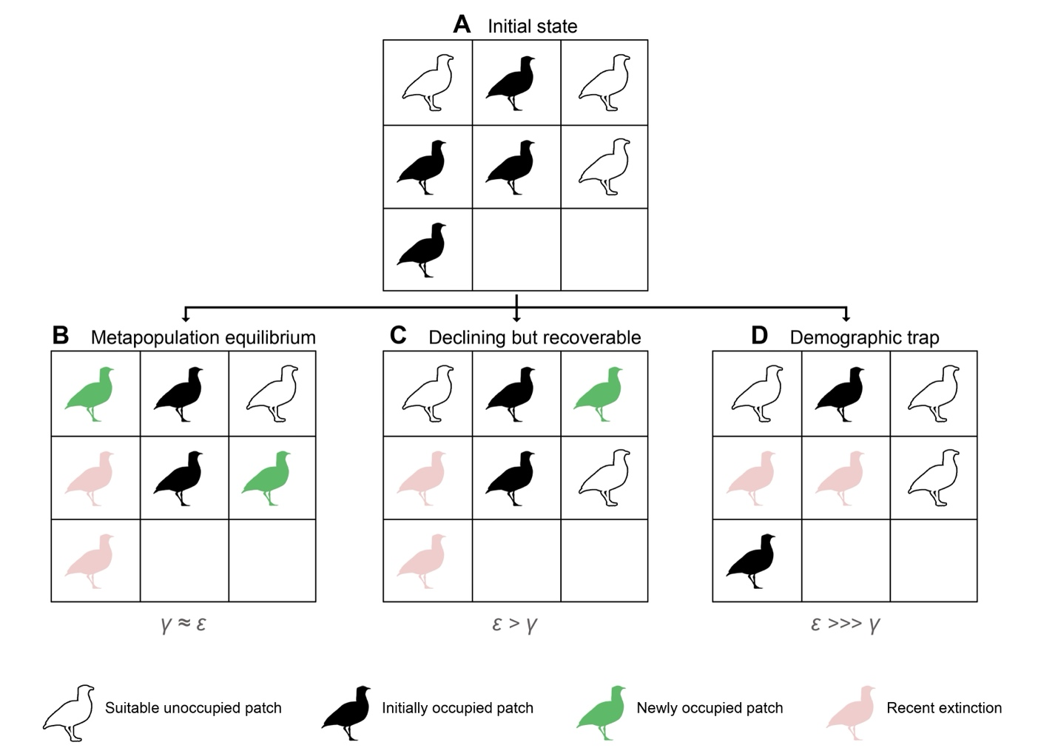

Figure 1. Conceptual framework of metapopulation dynamics under contrasting colonisation–extinction regimes. Starting from the same initial occupancy (A), three outcomes emerge depending on the balance between colonisation (gamma) and extinction (epsilon). (B) Metapopulation equilibrium (gamma ≈ epsilon): extinctions (pink) are offset by new colonisations (green). (C) Declining but recoverable dynamics (epsilon > gamma): occupancy contracts but colonisation persists. (D) Demographic trap (epsilon ≫ gamma): colonisation collapses and suitable patches remain empty. Filled silhouettes denote occupied patches, outline silhouettes suitable but unoccupied patches, and blank cells unsuitable habitat.

2. Methods

2.1 Study area and species
The study covers mainland Spain (494,011 km²), divided into a regular 5×5 km UTM 30N grid yielding more than 19,000 cells. We focused on four species spanning a gradient of habitat specificity and mobility within mainland Spain’s agro-steppe guild (Figure S1, Table S1): the great bustard (Otis tarda; Near Threatened in Spain, 83% of European population, site-faithful, breeding April–June), the pin-tailed sandgrouse (Pterocles alchata; Vulnerable, 97%, semi-nomadic, May–August), the black-bellied sandgrouse (P. orientalis; Endangered, 19%, semi-nomadic, May–August), and the little bustard (Tetrax tetrax; Endangered, 34%, site-faithful, April–June). Relevant trait differences are discussed where they affect the interpretation of model results.

2.2 eBird data and filtering
Occurrence data were obtained from the eBird Basic Dataset (Sullivan et al., 2009) for mainland Spain, 2017–2023. We retained only complete checklists with a duration of five hours or less, a travel distance of five kilometres or less and no more than ten observers, ensuring valid zero-filling (Johnston et al., 2021). Each checklist was assigned to its corresponding 5×5 km grid cell. Only grids with a minimum of three checklists across the study period were retained. Repeated visits within the same cell and breeding season were used to construct the detection histories used for occupancy estimation. Since the number of eBird checklists submitted in Spain increased by 256% between 2017 and 2023, we tested for effort confounding by computing Spearman correlations between naive cell-level occupancy and annual checklist count. No significant correlation was detected for three of four species (rho = −0.25 to 0.37, all P > 0.10). However, for P. alchata, a marginally significant correlation was observed (rho = 0.64, P = 0.05); therefore, colonisation estimates for this species are treated with additional caution throughout. Because detection histories were assembled within each species’ breeding-season window, the two bustards (surveyed April–June) and the two sandgrouse (May–August) each share a common set of surveyed cells and checklists; per-year checklist totals therefore coincide within each pair (rising by 256% and 201%, respectively, over 2017–2023).

2.3 Environmental covariates
We used a two-scale covariate design separating the determinants of long-run habitat suitability from the drivers of realised annual demographic turnover. Static covariates for initial occupancy (ψ₁) were drawn from WorldClim 1970–2000 climatic normals (Fick & Hijmans, 2017) (BIO1: mean annual temperature; BIO2: mean diurnal temperature range) and from Global Land Cover Facility data (tree cover, herbaceous cover), supplemented by terrain variables (slope, aspect, elevation). Variables were retained after hierarchical cluster analysis, removing pairwise correlations with r > 0.7.
Dynamic covariates for colonisation (γ) and extinction (ε) were derived from three annual data products computed for each species' breeding season: minimum and maximum temperature and cumulative precipitation from TerraClimate (Abatzoglou et al., 2018), with a resolution of 0.04 degrees CMG; NDVI from MODIS MOD13A3 (Didan, 2021), 1 km SIN grid; and proportional land-cover classes from MODIS MCD12C1 IGBP (Friedl & Sulla-Menashe, 2015), 0.05 degrees CMG, including water bodies (LC0), closed shrubland (LC6), open shrubland (LC7), grassland (LC10), cropland (LC12), urban/built-up (LC13) and cropland/natural vegetation mosaics (LC14). All dynamic covariates were standardised using training-set scaling parameters.
NDVI presents a collinearity challenge: approximately 50% of interannual NDVI variance is explained by climate variables (mean within-site temporal R² = 0.51, computed from site-level regressions of annual NDVI on precipitation and temperature across the seven-year study period). Variance inflation factors remained below 5 (max VIF = 4.43), but pairwise correlations between precipitation and maximum temperature (|r| = 0.70–0.71) reduce the precision of individual climate coefficients in submodels retaining both. For P. orientalis, NDVI was retained in the extinction submodel (preferred by ΔAIC = 60 over the alternative) but is classified as ‘climate-adjacent’ in the attribution analysis. A sensitivity model excluding NDVI is provided in Supplementary S4; full VIF diagnostics for all submodels appear in Supplementary S4.

2.4 Dynamic occupancy models
All analyses were conducted in R (R Core Team, 2024). We used the colext framework (MacKenzie et al., 2003; Royle & Kéry, 2007) implemented in the unmarked R package (Fiske & Chandler, 2011; Kellner et al., 2023) to estimate four simultaneous processes: initial occupancy (ψ₁), colonisation probability (γ), extinction probability (ε) and detection probability (p). The state process follows a first-order Markov chain: ψᵢ,ₜ₊₁ = (1 − ψᵢₜ) × γᵢ + ψᵢₜ × (1 − εᵢ). Detection is modelled as a Bernoulli trial conditional on the true occupancy state (MacKenzie et al., 2002), with visit-level covariates (survey duration, transect length, number of observers, and time of day, derived from eBird checklists), and observation-period NDVI and precipitation, accounting for heterogeneous detectability across checklists. One dimension of detection heterogeneity is not captured by these per-visit covariates: the position of each checklist within its 5-km cell relative to the pseudo-steppe patches where the focal species are detectable. We addressed this potential confounder through a dedicated robustness analysis (Section 2.5; Appendix S29).
Model selection used AIC over candidate covariate sets for each submodel, constrained so that static WorldClim covariates entered only ψ₁ and dynamic annual covariates entered only γ and ε. Complete separation was diagnosed in the P. alchata colonisation submodel (16 observed colonisation events across 2,521 site-year opportunities, 0.6%); this submodel is excluded from counterfactual attribution. Near-separation was diagnosed in the P. alchata extinction submodel (18 events; SE > 11). These data limitations do not invalidate the inclusion of P. alchata: the directional finding (γ ≪ ε) holds despite wide confidence intervals. Model fit was assessed by parametric bootstrap goodness-of-fit (parboot, n = 500); all four species showed adequate fit (P = 0.28–0.93; Table S23). More broadly, the modest number of observed colonisation and extinction events per species (Table S1) constrains the precision of covariate effects on the transition processes; the colonisation–extinction asymmetry itself, however, is a difference of orders of magnitude and is robust to these data limitations (Appendix S29).
Equilibrium occupancy ψ* = γ/(γ + ε) was computed as the expected long-run proportion of sites occupied under current steady-state conditions, assuming that colonisation and extinction rates remain at their estimated baseline values (i.e., a stationary Markov chain). The ε/γ ratio provides a dimensionless measure of demographic asymmetry that is less sensitive to wide uncertainty in the absolute value of γ than ψ*. Uncertainty was propagated via parametric bootstrap: 5,000 coefficient vectors were drawn from the multivariate normal approximation to the estimated coefficient distribution, from which annual γ and ε were predicted at mean dynamic covariate values. Expected recolonisation time (1/γ) and persistence time (1/ε) are reported in years with 95% bootstrap CI. We also computed the colonisation rate required to achieve a target equilibrium of ψ* = 0.10 for each species, as γ_needed = 0.10 × ε / 0.90, quantifying the gap between current performance and a minimum viable metapopulation benchmark (Hanski, 1999). Equivalently, this is the colonisation rate a species would need, given its estimated extinction, to keep even 10% of sites occupied at equilibrium.
We compared naive transition rates, computed directly from detection histories as the proportion of observed site-year transitions, against detection-corrected estimates from the best colext models. For naive estimation, a site was classified as colonised if it had zero detections in year t and at least one in year t+1, and as locally extinct if the reverse was observed. These naive rates do not account for the probability that an occupied site was undetected in one or more visits.

2.5 Validation and robustness
The colext framework assumes independent residuals across sites, an assumption violated when residual spatial autocorrelation is present. To assess whether autocorrelation confounds covariate inference, we fitted spatio-temporal occupancy models using the stPGOcc function from the spOccupancy R package (Devarajan et al., 2020; Doser et al., 2022), incorporating a nearest-neighbour Gaussian process (NNGP) spatial random effect with an exponential correlation function and an AR(1) temporal random effect. Models were run for 200,000 iterations per chain across three chains, with 100,000 iterations of burn-in and thinning by 100 (n.neighbors = 10). These models serve as a robustness check: if covariate effects estimated under spatial dependence are consistent in direction and relative magnitude with colext estimates, then colext inference is not an artefact of spatial confounding. Convergence was assessed using the Gelman–Rubin Rhat statistic (<1.1) and the effective sample size (ESS > 100).
Predicted initial occupancy was validated against the III Atlas of Breeding Birds in Spain (SEO/BirdLife, 2022) using spatially blocked five-fold cross-validation (blockCV; Valavi et al., 2019) with a block size of 270 km, exceeding the largest estimated spatial range across species. Predictive performance is reported using Spearman rho, AUC, TSS and the uniform AUC (uAUC; Jiménez‐Valverde, 2022), which corrects for the representativeness effect that inflates standard AUC when prevalence is low and makes discrimination statistics non-comparable across species. External validation is restricted to ψ₁; transition rates have no equivalent independent benchmark at the 5-km grid-cell scale.
We assessed the sensitivity of colonisation estimates to detection model structure, covariate complexity, and likelihood surface shape using profile likelihood, events-per-variable diagnostics, and intercept-only models (Appendices S16–S18). Key robustness checks addressing the main potential sources of bias in estimating the colonisation–extinction asymmetry are provided in Appendices S6 (naive vs. detection-corrected rates), S10 (simulation-based validation), S15 (likelihood resolution), and S16–S18 (parameter identifiability).
eBird checklists are spatially biased at fine scales, with observers preferentially sampling accessible, species-rich or otherwise attractive locations (Johnston et al., 2021). Within a 5-km cell, the pseudo-steppe patches where the focal species occur may therefore be surveyed with an intensity that changes over time, generating a time-varying detection bias that per-visit effort covariates do not absorb. To test this, we constructed a steppe-representativeness covariate (stepRep): for each checklist we computed the proportion of a 500-m buffer occupied by pseudo-steppe pixels under a CORINE 2018 mask (Level-3 classes 211, 231, 321 and 333), aggregated it to the cell-year level, and added it to the detection submodel (full construction in Appendix S29). Within-cell steppe representativeness rose over the study period in occupied cells while the peninsular baseline remained flat, and it was uncorrelated with aggregate checklist effort, confirming that this structure is not captured by the existing effort covariates. Including stepRep produced a positive and highly significant detection effect in all four species (standardised β = 0.61 to 0.89, all P < 0.001), and the colonisation–extinction asymmetry was preserved in every species under the resulting specification (Appendix S29). The headline diagnosis is therefore not an artefact of within-cell sampling structure.

2.6 Counterfactual attribution
We implemented a factorial counterfactual design with four scenarios: S0 (all dynamic covariates fixed at 2017 values), S1 (climate observed, land use fixed at 2017), S2 (land use observed, climate fixed at 2017) and S3 (all covariates observed). Attribution effects were computed as S1 − S0 (climate effect), S2 − S0 (land-use effect) and S3 − S1 − S2 + S0 (interaction term). NDVI was classified as 'climate-adjacent' for O. tarda and P. orientalis (the two species retaining NDVI in their transition submodels, because a substantial fraction of its interannual variance is explained by climate; mean R² ≈ 0.51, Figure S2). Uncertainty was propagated using parametric bootstrap (n = 1,000 replicates).

3. Results

3.1 Detection heterogeneity and survey coverage
Baseline detection probability at mean survey effort ranged from 13.3% (P. orientalis) to 34.9% (T. tetrax), with O. tarda and P. alchata at intermediate levels (25.3% and 23.2%, respectively). Detection increased with survey duration for all four species (beta = 0.17–0.90, all P < 0.01) and with transect distance for three species (all but xx ¿para que especie no se cumple lo anterior?). Time of day reduced detection for three species (beta = −0.17 to −0.44, P < 0.01), consistent with declining activity later in the morning. These rates imply that most true presences are missed on any single visit, with direct consequences for the accuracy of naive transition rates.
Final detection histories comprised 3,745 to 4,130 5-km grid cells with at least three repeat visits. Observed colonisation events were rare across all species (11–22 site-year transitions), while observed extinction events ranged from 9 (T. tetrax) to 29 (O. tarda).

3.2 Detection correction reverses the qualitative assessment
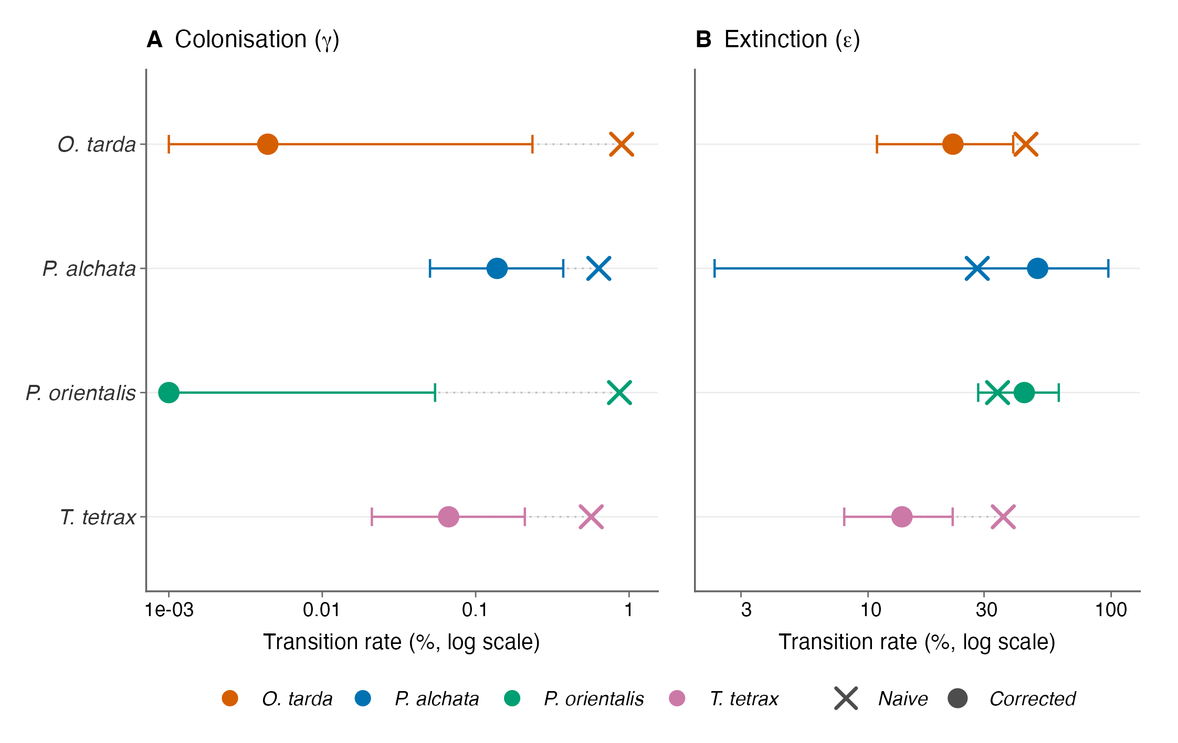
Figure 2. Detection correction reverses the qualitative assessment of demographic balance. Naive (crosses) versus detection-corrected (filled circles, bootstrap median with 95% CI) colonisation (γ, left) and extinction (ε, right) rates on a log₁₀ scale. Species distinguished by colour. ⁺ P. alchata corrected ε exceeds naive ε due to near-separation instability (18 events; SE > 11); interpret with caution.
Without detection correction, apparent colonisation rates (0.57–0.89% per site-year) fell in a range that could, in principle, compensate for local extinction, a range consistent with demographic recovery, however slow. Detection-corrected estimates were 5- to 22,000-fold lower (Fig. 2; Table S25). For P. orientalis, corrected colonisation was effectively zero (γ < 0.001%). Corrected extinction rates were lower than naive estimates for three species (correction ratios 0.38–0.78), because missed detections at occupied sites inflate apparent extinction; for P. alchata, the MLE of ε on the logit scale was large due to near-separation (18 events, SE > 11), yielding a backtransformed estimate that exceeded the naive rate (ratio 1.72). This estimate should be treated as directionally informative rather than precise. Naive and corrected estimates lead to opposite conclusions.

3.3 The demographic trap: extinction dominates colonisation by orders of magnitude
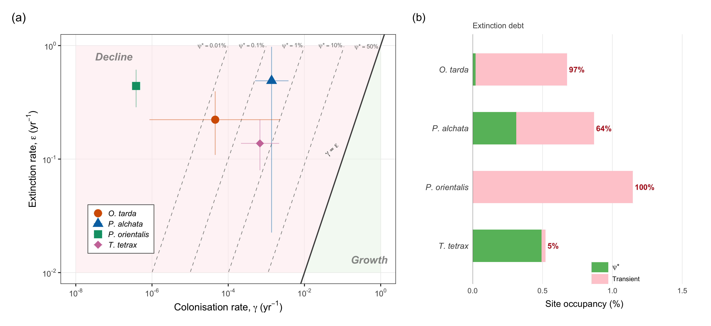
Figure 3. All four species occupy the decline zone of demographic state space. (a) Detection-corrected colonisation (γ) versus extinction (ε) on log₁₀ axes, with equilibrium occupancy isoclines (ψ* contours) and the γ = ε diagonal. 95% bootstrap CI crosshairs (n = 5,000). (b) Extinction debt: green = equilibrium occupancy (ψ*), pink = transient fraction of current occupancy (Table S26).
Across all four species, detection-corrected extinction rates exceeded colonisation rates by two to six orders of magnitude (Table 1, Fig. 3). The asymmetry was robust across the full bootstrap distribution: even at the lower 95% CI of ε and the upper 95% CI of γ, the ratio remained above 14 for every species, and is consistent with a real demographic asymmetry rather than a precision artefact. The probability that ε/γ exceeds 100 ranged from 81.4% (P. alchata) to 99.3% (P. orientalis).

Table 1. Baseline demographic rates, ε/γ asymmetry, and equilibrium occupancy. ε/γ is the number of extinction events expected per colonisation event at mean current conditions. ψ* = γ/(γ + ε) with 95% bootstrap CI (n = 5,000). P(ratio > 100): proportion of bootstrap replicates in which ε/γ exceeds 100.
Species | γ (%) | ε (%) | ε/γ ratio | P(ratio > 100) | ψ* median (%) | ψ* 95% CI (%)
O. tarda | 0.0045 | 22.2 | 4,870 | 97.7% | 0.02 | 0.0004–0.93
P. alchata | 0.137 | 48.9 | 319 | 81.4% | 0.31 | 0.08–6.50
P. orientalis | ~0 | 44.1 | 1,054,932 | 99.3% | 0.0001 | 0–0.17
T. tetrax | 0.068 | 13.8 | 201 | 89.0% | 0.49 | 0.16–1.62

The P. orientalis point estimate of ε/γ ≈ 1,054,932 requires epistemic qualification: baseline γ ≈ 3.8 × 10⁻⁷ sits near the boundary of estimability given the number of observed colonisation events. What the data support is not the precise ratio, but that the asymmetry lies well beyond any level compatible with metapopulation recovery.
Equilibrium occupancy under current rates falls far below observed occupancy for all four species (Table S26), implying extinction debts ranging from 5% (T. tetrax) to effectively 100% (P. orientalis) (Fig. 4). The delta-gamma analysis quantifies the gap: achieving even 10% equilibrium occupancy would require colonisation rates at least an order of magnitude above current estimates for T. tetrax, and several orders of magnitude above for the other species (Table S27).

3.4 Spatial expression of the demographic trap
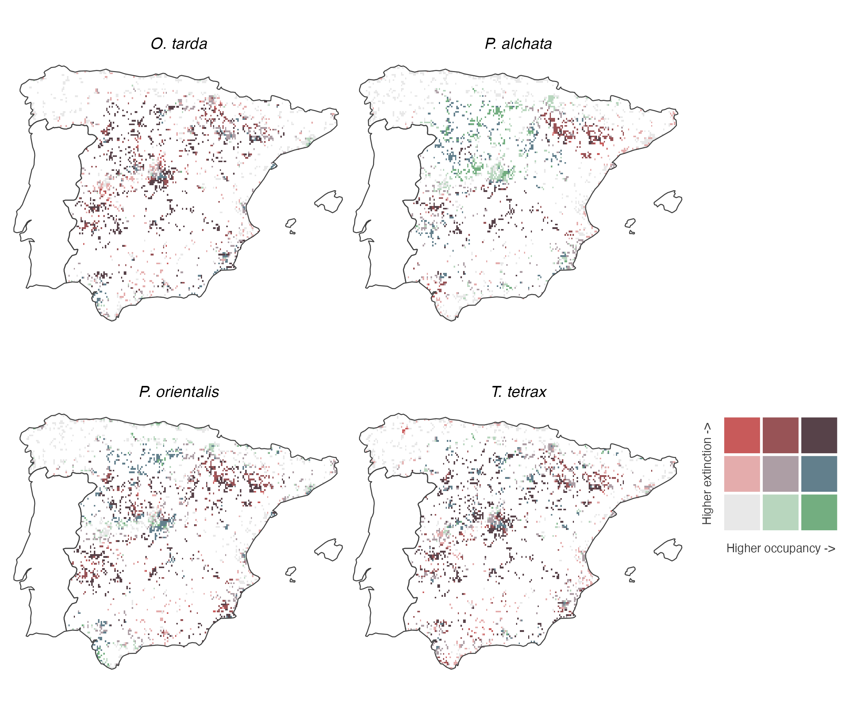
Figure 4. Bivariate map of conservation priority. Each cell is classified by initial occupancy (ψ₁, teal axis) and extinction probability (ε, red axis) using quantile breaks (3 × 3). Dark cells (high ψ₁ + high ε) identify areas where species currently persist but face the highest extinction risk, representing the most urgent conservation priorities. Green/teal cells indicate safe strongholds (high occupancy, low extinction); red cells indicate marginal populations (low occupancy, high extinction).
The demographic trap is not uniformly distributed across mainland Spain. Bivariate maps classifying each grid cell by initial occupancy (ψ₁) and extinction probability (ε) estimated from the best-supported model for each species (Section 2.4) reveal where species currently persist but face the highest extinction risk (Fig. 4). For O. tarda, the highest-priority cells (high ψ₁, high ε) concentrate around expanding urban peripheries of central meseta cities, spatially consistent with the strong LC13 extinction effect identified in the covariate model. For P. orientalis, high-risk cells extend across the entire species’ range, with southwestern populations combining high occupancy and severe extinction pressure. For P. alchata, the Ebro Valley populations occupy the highest-risk category. T. tetrax shows the broadest distribution of safe strongholds (high ψ₁, low ε), consistent with its near-equilibrium demographic state, although pockets of high extinction risk persist in peripheral populations. Cells combining high occupancy with high extinction probability identify the most urgent conservation priorities: sites where species are present but where, given the near-zero colonisation rates documented above, local extinction would represent permanent range loss.

3.5 Environmental drivers by demographic process
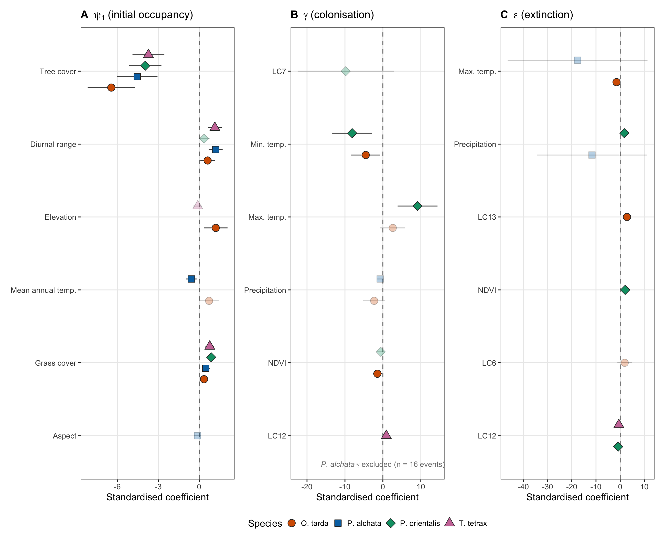
Figure 5. Environmental drivers of occupancy dynamics. Three-panel forest plot of standardised coefficients for (A) initial occupancy ψ₁, (B) colonisation γ, and (C) extinction ε. Species distinguished by shape and colour. P. alchata γ excluded (complete separation, n = 16 events). NDVI marked with ⁺ denotes 'climate-adjacent' classification. LC6 being closed shrublands, LC7 open shrublands, LC12 croplands and LC13 urban and built-up lands.
Environmental drivers showed clear species-specific signatures (Fig. 5; full coefficients in Supplementary S3), with a cross-species pattern that partitions drivers by demographic process. Climate variables dominated the colonisation submodels for three of four species. For O. tarda, NDVI (climate-adjacent; beta = −1.45, P < 0.05) and minimum temperature (beta = −4.52, P < 0.05) constrain colonisation, suggesting that vegetation encroachment and cold-season severity limit establishment at new sites. For P. orientalis, minimum and maximum temperature entered the colonisation submodel with opposing signs (β_tmmn = −8.11; β_tmmx = +9.14), but these predictors are correlated (|r| = 0.70–0.71) and individual coefficients are therefore unreliable; the joint signal indicates sensitivity to the diurnal temperature range during breeding rather than independent effects of minimum and maximum temperature. T. tetrax was the exception: cropland (LC12) was the sole significant colonisation driver (beta = +0.90, P < 0.05), with no climate variable retained.
Land-use variables played a more prominent role in extinction, but in species-specific configurations. Urban encroachment (LC13) was the dominant extinction driver for O. tarda (beta = +2.80, P < 0.001). For P. orientalis, NDVI strongly increased extinction (beta = +2.05, P < 0.001; climate-adjacent), while cropland simultaneously reduced it (LC12, beta = −0.83, P = 0.02); agricultural mosaics appear to buffer local extinction risk. For T. tetrax, cropland reduced extinction (LC12, beta = −0.57, P < 0.05), making it the only species for which a single management variable (maintaining agricultural land use through agri-environment schemes) that simultaneously increases colonisation and reduces extinction.

3.6 Counterfactual attribution
Climate had larger and more consistent effects on colonisation than land use for three species, while land-use change drove both processes for T. tetrax (Table 2). The attribution magnitude for this seven-year window is modest in absolute probability units (< 0.01), as expected; its value is comparative across species and driver classes rather than as an estimate of total accumulated change. Two important caveats apply. First, the static land-cover covariates were entered into ψ₁ by design, thereby concentrating the explanatory variance attributable to long-run habitat structure in the initial state rather than in the turnover submodels. Second, interannual variance in TerraClimate variables structurally exceeds that of MODIS land-cover classes over seven years, meaning that the relative dominance of climate in attribution reflects the covariate design as much as the underlying ecology. These constraints mean that attribution results should be read as indicative of driver identity rather than as precise partitioning of variance.

Table 2. Attribution summary: mean Δψ per scenario relative to S0 baseline. *P. alchata γ excluded (complete separation). NDVI decomposition amplified the climate signal for P. orientalis ε by 3× but did not change dominant-driver classification for any species (Supplementary S9).
Species | Dominant driver | Δγ climate | Δγ land-use | Δε climate | Δε land-use
O. tarda | Climate | −6.1×10⁻⁴ | 0 | 7.4×10⁻⁴ | −1.1×10⁻³
P. alchata | Climate* | excl. | excl. | −1.3×10⁻³ | 0
P. orientalis | Climate | −3.4×10⁻⁴ | −1.8×10⁻⁴ | 5.7×10⁻³ | −2.1×10⁻⁴
T. tetrax | Land use | 0 | −1.0×10⁻⁶ | 0 | 9.0×10⁻⁶

3.7 Robustness to spatial autocorrelation
Spatio-temporal occupancy models (stPGOcc) achieved adequate convergence for detection and ecological parameters (all Rhat < 1.07, ESS > 200 for β coefficients; full diagnostics in Supplementary S11). The NNGP spatial random effect effectively absorbed residual autocorrelation: Moran’s I on stPGOcc residuals was near zero for all species (−0.06 to −0.04, all P > 0.99), compared with 0.29–0.49 (all P < 0.001) under colext.
The direction and relative magnitude of ecological covariate effects were consistent between colext and stPGOcc across all four species. Tree cover exerted a strong negative effect on occupancy in both frameworks (stPGOcc β: −2.97 to −3.77; colext ψ₁: same sign and comparable magnitude). Temperature range (bio2) was positive in both, and maximum temperature showed the same species-specific pattern. This concordance demonstrates that the colonisation–extinction asymmetry diagnosed by colext is not a statistical artefact of residual spatial dependence.

3.8 External validation
Spatially blocked cross-validation against the III Atlas of Breeding Birds confirmed predictive skill for initial occupancy across all species (Table S28). Standard AUC ranged from 0.81 (P. orientalis) to 0.88 (O. tarda), but uniform AUC values were systematically lower (uAUC 0.61–0.76), with the largest inflation in the two lowest-prevalence species (P. alchata: AUC 0.86, uAUC 0.61; O. tarda: AUC 0.88, uAUC 0.69) and modest differences for the two higher-prevalence species (P. orientalis: uAUC 0.73; T. tetrax: uAUC 0.76). This pattern is consistent with the representativeness effect described by Jiménez-Valverde (2022): standard AUC overestimates discriminative ability when absences vastly outnumber presences, as is the case for rare steppe specialists. All uAUC values remained above 0.5, confirming real discriminative ability. Calibration slopes on the logit scale (0.57–0.62) indicate moderate overdispersion, a common feature of occupancy models at coarse spatial resolution and not unexpected given the mismatch between the eBird training grid and atlas polygon boundaries.

4. Discussion
Colonisation failure as a driver of range contraction
Range contractions are often interpreted as the spatial footprint of habitat loss. Habitat loss is real and ongoing in Iberian agro-steppe landscapes (Gómez-Catasús et al., 2025; Herrando et al., 2026; Marques et al., 2020; Silva et al., 2023; Traba & Morales, 2019), but, according to our results, it alone cannot explain the magnitude of range contraction documented here. Across four steppe specialists that collectively hold 19–97% of their European breeding populations on the Iberian Peninsula, detection-corrected colonisation rates were orders of magnitude lower than extinction, and current distributions are not maintained by ongoing demographic processes. Even where available habitat persists, it is increasingly fragmented and functionally inaccessible: at current occupancy levels, available patches are too isolated for colonisation to offset local extinction, and range contraction outpaces habitat loss.
This distinction matters for conservation. Habitat loss drives local extinction, but range contraction can outpace it if colonisation collapses simultaneously. Species then persist transiently in landscapes where occupancy reflects past conditions rather than current processes (Hanski, 1998; Kuussaari et al., 2009; Tilman, 1994), and source–sink dynamics can further decouple realised occupancy from available habitat (Goel et al., 2022). The relevant question is therefore not only how much available habitat remains, but whether it is of suitable quality and sufficiently connected for the demographic processes that maintain range extent to operate. It is important to note that the design of our study allows us to analyze the effect of habitat availability (land-cover classes) but not the quality and suitability of that available habitat on occupancy, colonization, and extinction. Changes in habitat quality and suitability -caused primarily by the intensification of agricultural management (overuse of herbicides and insecticides, crop homogenization, inappropriate tillage intensity and/or phenology, disappearance of fallow fields and margins, etc.)- can greatly influence the habitat’s capacity to support sustainable populations of steppe birds (Gómez-Catasús et al. 2025).

A demographic trap across the guild
The colonisation–extinction imbalance was consistent across all four species and insensitive to uncertainty. Even under the most optimistic parameter combinations (upper 95% CI of γ paired with lower 95% CI of ε), extinction exceeded colonisation by at least an order of magnitude for every species. A comparable colonisation–extinction asymmetry has been reported in fragmented bird communities (Crooks et al., 2001; Gaston et al., 2002) and during climatic stress in other assemblages (Toledo-Lima et al., 2020; White et al., 2018). Simulations indicate that colonisation rates compatible with demographic persistence would have been recovered under the current sampling design, ruling out estimation artefacts. The conclusion does not depend on precise estimates of γ, but on the scale of the imbalance relative to ε, which is unequivocal.
This pattern differs from classical extinction debt. In that framework, populations persist temporarily after habitat loss because demographic responses lag behind environmental change (Kuussaari et al., 2009; Ovaskainen & Hanski, 2002; Tilman, 1994). Such debts are widespread across US breeding bird communities , driven primarily by historical land-cover change (Haddou et al., 2022). Here, habitat loss continues across the distribution, but the range is contracting faster than habitat disappears. The system is moving towards a much lower equilibrium because habitat loss and depauperated colonisation act in concert: the total area of available habitat shrinks while the remaining patches become increasingly isolated, reducing colonisation rates below the threshold needed to offset extinction.
The mechanism cannot be resolved directly from occupancy data, but the structure of Iberian agro-steppe landscapes and the rarity of colonisation events point to dispersal limitation as the most plausible primary constraint. The progressive loss of over one million hectares of fallow land in Spain over 15 years (Traba & Morales, 2019), combined with a 37% decline in sheep numbers since 1992, an indicator of the contraction of extensive grazing systems (Traba & Pérez-Granados, 2022), has transformed the agricultural matrix through which these species disperse. Known natal dispersal distances constrain the plausibility of this hypothesis. In O. tarda, median natal dispersal among dispersing juveniles is 18.1 km (range 5–178 km, n = 392; Martín et al., 2008), with strong female philopatry (0.5–5 km) and male-biased long-distance movements (Martín et al., 2002). These movements occur largely between already-occupied areas: dispersing individuals settle where conspecifics are present rather than in suitable but empty habitat, so natal dispersal does not by itself generate colonisation (Lane et al., 2001). For T. tetrax, natal dispersal averages ~7 km (range 0.1–137 km; González del Portillo et al., 2025; Ponjoan et al., 2012), a scale consistent with recent individual-based simulations showing that combined habitat management and mortality reduction are needed for population recovery (Crispim-Mendes et al., 2025). Published natal dispersal data for Iberian sandgrouse do not exist; seasonal GPS movements reach 30–60 km but are not equivalent to natal dispersal. At current occupancy levels (3–5% of grid cells), mean nearest-neighbour distances between occupied patches on the 5-km grid are 20–40 km, exceeding the median natal dispersal of O. tarda and T. tetrax, and plausibly limiting for the sandgrouse given their unknown but likely shorter effective dispersal. This pattern echoes the climate-tracking lag documented in French breeding birds, where dispersal limitation generated a 182-km deficit behind shifting isotherms (Devictor et al., 2008). At current patch densities and inter-patch distances, successful encounters between dispersers and vacant habitat are likely too infrequent to sustain recolonization (González del Portillo et al., 2025). Allee effects at low densities and sub-threshold habitat degradation remain viable contributing processes, but both would reinforce, rather than replace, a system primarily limited by dispersal. The combination of extremely low colonisation rates, persistent available habitat, and known dispersal constraints converges on dispersal limitation as a primary constraint, even if these alternative processes cannot be excluded from occupancy data alone. All three mechanisms point in the same direction: restoring colonisation is harder than preventing local extinction.
Landscape structure is not the only constraint on recolonisation. Both bustards have a lek mating system in which breeding aggregates at sites selected on the basis of conspecific distribution and predation risk rather than habitat availability alone (Alonso et al., 2012), a settlement rule that makes the occupation of suitable but empty ground slow and improbable. All four species are gregarious for most of the year, and sandgrouse in particular form large, whose anti-predator and foraging benefits accrue only above a threshold group size (Martín et al., 2010); such dependence on conspecifics further raises the threshold for establishing where the species is absent. These behavioural traits act in the same direction as dispersal limitation, reinforcing rather than replacing the demographic trap.
Detection correction as a prerequisite for diagnosis
Imperfect detection is central to the interpretation of these results, not a technical footnote. Without correction, colonisation rates appeared low but compatible with slow recovery. Detection-corrected estimates reversed that conclusion entirely. The bias is directional and predictable: undetected presences in year t register as colonisation in t+1, while missed detections at occupied sites inflate apparent extinction. The net effect is to make systems with severe demographic imbalance appear demographically viable.
That this pattern emerges across four species with detection probabilities spanning 13–35%, and across the full range of eBird effort heterogeneity (Hochachka et al., 2023), indicates it is a structural property of unmodelled citizen-science data rather than a species-specific artefact. Monitoring frameworks that do not explicitly account for detection risk systematically misdiagnosing systems in which recolonisation has already failed.
Environmental drivers as process-specific signals
The covariate design constrains causal interpretation. Long-term habitat structure enters initial occupancy by construction, while interannual variability dominates turnover processes. Environmental effects should therefore be interpreted as indicative of process-specific sensitivity rather than definitive attribution, given the limited temporal variability in land-use predictors over the seven-year window.
Within those limits, species differ in how demographic processes respond to environmental variation, and the differences carry management implications. T. tetrax shows a system still responsive to land-use management: cropland influences both colonisation and extinction in directions that favour occupancy, making it the only species for which a single agri-environment instrument plausibly acts on both demographic rates. For O. tarda, the dominant extinction signal is urban encroachment, pointing to land-use planning around breeding areas as the primary lever. P. orientalis presents a qualitatively different challenge: colonisation patterns track temperature-envelope variables while extinction responds to vegetation dynamics, suggesting that conventional habitat management may be insufficient to restore colonisation capacity (Benítez-López et al., 2015, 2017). These differences argue against treating the guild as a single management unit. The severity ranking (P. orientalis most extreme, T. tetrax least) is driven by habitat-landscape configuration rather than by mobility or body size, reinforcing the need for species-specific demographic assessment (Gómez-Catasús et al., 2025).
Robustness and limitations
Absolute estimates of colonisation are uncertain where events are rare (11–22 across >4,000 sites), and profile likelihood analysis confirms that γ is well identified for P. alchata and T. tetrax (95% CI spanning <1 order of magnitude) but poorly resolved for O. tarda and P. orientalis (>3 orders of magnitude; Appendix S16). Events-per-variable ratios (3.4–8.0; Appendix S17) fall below conventional thresholds for all species, and intercept-only γ models confirm that covariate-based estimates are sensitive to model specification for O. tarda and P. orientalis but stable for T. tetrax (14.6% change). Even at the resolution boundary of the estimator, the minimum ε/γ ratio remains well above values compatible with demographic persistence; even the most generous intercept-only γ estimates remain orders of magnitude below ε (Appendix S17). The inference therefore does not depend on precise estimation of γ, but on the scale of its imbalance relative to ε. Simulation analyses confirm that colonisation rates compatible with persistence would have been detectable under the empirical sampling design (Appendix S10), and the simulation study demonstrates that the estimator does not artefactually suppress colonisation when it exists; however, it tests the estimator under the assumed Markov structure, not under alternative data-generating processes such as episodic or density-dependent colonisation. Whether γ is exactly zero or merely too low to offset ε on any management-relevant timescale, the practical consequence is identical: current rates cannot maintain the range.
The seven-year window captures current rates but not their trajectory; whether colonisation has recently deteriorated or has long been negligible remains unresolved. External validation against the III Spanish Breeding Bird Atlas confirmed predictive skill for initial occupancy (AUC = 0.82–0.88), but no independent benchmark exists for transition rates at the 5-km scale, limiting confidence in absolute values while leaving the ratio robust. Residual spatial autocorrelation in the colext models (Moran’s I = 0.29–0.49) was absorbed by spatio-temporal Bayesian models (Doser et al., 2022), and consistency between spatial and non-spatial frameworks indicates that the core result is not an artefact of spatial structure (Supplementary S11). The constant-rate formulation averages colonisation over years. If colonisation is episodic, concentrated in climatically favourable years, the mean rate would underestimate peak capacity. However, with 11–22 observed colonisation events distributed across seven years (1.5–3 events per species-year), year-specific estimation is not feasible; even partitioning events by year yields 0–5 events per species-year, insufficient to identify temporal pulses. Whether colonisation is consistently negligible or episodically active but masked by temporal averaging cannot be resolved without longer time series. Closure violations from within-season movements are most plausible for the semi-nomadic sandgrouse, but such movements would inflate apparent γ, making this bias conservative with respect to the central finding.
Implications for conservation
Where colonisation is this low, habitat protection alone cannot halt decline. Preventing local extinction at occupied sites carries substantially greater demographic leverage than promoting recolonisation under current conditions. For T. tetrax, agri-environment policy that maintains extensive agricultural land use acts on both demographic rates simultaneously, consistent with evidence linking extensive farmland management with steppe bird persistence at the national scale (Crispim-Mendes et al., 2025; Mañosa et al., 2023; Sanz-Pérez et al., 2019, 2021, 2022; Traba & Pérez-Granados, 2022), although current CAP greening measures have been criticised as insufficient to reverse farmland bird declines at the European scale (Pe’er et al., 2014). For the remaining species, reducing mortality and encroachment at occupied sites seems the actionable priority. The rapid expansion of utility-scale solar photovoltaic installations across mainland Spain since 2019 represents an additional and largely unquantified threat to steppe bird habitat (Benítez-López et al., 2026; Medrano‐Vizcaíno et al., 2026; Serrano et al., 2020); its interaction with the demographic processes documented here warrants urgent assessment. Interventions aimed at restoring γ (translocation, assisted establishment) depend on identifying the mechanisms that suppress it and cannot be evaluated from occupancy data alone.
Spatial prioritisation is nevertheless clear. Areas combining high occupancy with high extinction-to-colonisation ratios identify where currently occupied habitat is most at risk of near-term loss, and recent analyses of shifting steppe bird hotspots confirm that these priorities require periodic reassessment (Gómez-Catasús et al., 2025). In these systems, conservation effectiveness depends less on the total amount of available habitat than on maintaining occupied sites and the landscape connectivity that links them. Existing action plans for Iberian and European steppe birds converge on prioritising habitat protection at occupied sites and maintaining extensive agricultural mosaics (Pérez-Granados et al., 2025; Traba & Morales, 2019), and scenario analyses of CAP reform pathways indicate that current greening instruments are insufficient to reverse farmland bird declines without substantive policy change (Pe’er et al., 2020).
Beyond steppe birds
The pattern described here is unlikely to be unique to Iberian steppe birds. Where environmental change disrupts dispersal or establishment before habitat disappears, species may persist in landscapes that no longer support viable range dynamics. Detecting this requires separating colonisation and extinction while accounting for imperfect detection, an analytical framework now mature (Kelleher et al., 2024; MacKenzie et al., 2003; Zurell et al., 2022) and demonstrated to identify non-equilibrium dynamics across diverse assemblages (Briscoe et al., 2021; Nordén et al., 2020). Recent continental-scale analyses reveal that local colonisations and extinctions of European birds are poorly predicted by climate suitability alone (Howard et al., 2023), and that citizen-science platforms can now track local persistence probability at continental scales (Acevedo‐Charry et al., 2025; Isaac et al., 2020). As large-scale monitoring data become increasingly available, incorporating demographic decomposition into monitoring frameworks will be essential for distinguishing between systems in recoverable decline and those that have already crossed into demographic non-equilibrium.

Acknowledgements
We thank the thousands of eBird contributors whose observations made this study possible. GF has received funding from the European Union's Horizon 2020 research and innovation programme under the Marie Skłodowska-Curie grant agreement No 847635, and from the INTRADISP project (UCM Doctores Emergentes programme). RC has received funding from Consejo Superior de Investigaciones Científicas (PIE Grant 20243AT022)

Data Availability Statement
The eBird data used in this study are available from the eBird Basic Dataset (https://ebird.org/science/use-ebird-data). Environmental covariates were derived from publicly available sources: TerraClimate (https://www.climatologylab.org/terraclimate.html), MODIS MOD13A3 and MCD12C1 (https://lpdaac.usgs.gov), and WorldClim (https://www.worldclim.org). Derived detection histories, fitted model objects, and all analysis scripts are archived at Zenodo (DOI: [to be assigned upon acceptance]).

References

Abatzoglou, J. T., Dobrowski, S. Z., Parks, S. A., & Hegewisch, K. C. (2018). TerraClimate, a high-resolution global dataset of monthly climate and climatic water balance from 1958–2015. Scientific Data, 5(1), 170191. https://doi.org/10.1038/sdata.2017.191
Acevedo‐Charry, O., Ponciano, J. M., Poli, C. L., Jeffery, B. M., Fletcher, R. J., Echeverry‐Galvis, M. Á., Loiselle, B. A., Robinson, S. K., & Acevedo, M. A. (2025). Monitoring population extinction risk with community science data. Journal of Applied Ecology, 62(9), 2133–2147. https://doi.org/10.1111/1365-2664.70108
Alonso, J. C., Álvarez-Martínez, J. M., & Palacín, C. (2012). Leks in ground-displaying birds: Hotspots or safe places? Behavioral Ecology, 23(3), 491–501. https://doi.org/10.1093/beheco/arr215
Alonso, J. C., & Palacín, C. (2022). Alarming decline of the Great Bustard Otis tarda world population over the last two decades. Bird Conservation International, 32(4), 523–530. https://doi.org/10.1017/S095927092200003X
Bailey, L. L., MacKenzie, D. I., & Nichols, J. D. (2014). Advances and applications of occupancy models. Methods in Ecology and Evolution, 5(12), 1269–1279.
Benítez-López, A., Casas, F., Mougeot, F., García, J. T., Martín, C. A., Tatin, L., Wolff, A., & Viñuela, J. (2015). Individual traits and extrinsic factors influence survival of the threatened pin-tailed sandgrouse (Pterocles alchata) in Europe. Biological Conservation, 187, 192–200. https://doi.org/10.1016/j.biocon.2015.04.022
Benítez-López, A., Maeso-Pueyo, L., Martín, C. A., Medrano-Vizcaíno, P., & Mougeot, F. (2026). Current and future exposure of sandgrouse populations to utility-scale photovoltaic power plants within their main European breeding range. Biological Conservation, 315, 111726. https://doi.org/10.1016/j.biocon.2026.111726
Benítez-López, A., Viñuela, J., Mougeot, F., & García, J. T. (2017). A multi-scale approach for identifying conservation needs of two threatened sympatric steppe birds. Biodiversity and Conservation, 26(1), 63–83. https://doi.org/10.1007/s10531-016-1222-7
Briscoe, N. J., Zurell, D., Elith, J., König, C., Fandos, G., Malchow, A.-K., Kéry, M., Schmid, H., & Guillera-Arroita, G. (2021). Can dynamic occupancy models improve predictions of species’ range dynamics? A test using Swiss birds. Global Change Biology, 27(18), 4269–4282. https://doi.org/10.1111/gcb.15723
Brlík, V., Šilarová, E., Škorpilová, J., Alonso, H., Anton, M., Aunins, A., Benkö, Z., Biver, G., Busch, M., & Chodkiewicz, T. (2021). Long-term and large-scale multispecies dataset tracking population changes of common European breeding birds. Scientific Data, 8(1), 21.
Chamizo, D., Tarjuelo, R., Morales, M. B., & Seoane, J. (2025). Range contractions of farmland and steppe birds over two decades in relation to agricultural management in Spain. Biological Conservation, 311, 111437. https://doi.org/10.1016/j.biocon.2025.111437
Crispim-Mendes, T., Marques, A. T., Valerio, F., Godinho, S., Pita, R., & Silva, J. P. (2025). Using spatially explicit individual-based models to prioritize conservation strategies: A case study on the little bustard. Journal of Environmental Management, 379, 124790. https://doi.org/10.1016/j.jenvman.2025.124790
Crooks, K. R., Suarez, A. V., Bolger, D. T., & Soulé, M. E. (2001). Extinction and colonization of birds on habitat islands. Conservation Biology, 15(1), 159–172. https://doi.org/10.1111/j.1523-1739.2001.99379.x
Devarajan, K., Morelli, T. L., & Tenan, S. (2020). Multi-species occupancy models: Review, roadmap, and recommendations. Ecography, 43(11), 1612–1624. https://doi.org/10.1111/ecog.04957
Devictor, V., Julliard, R., Clavel, J., Jiguet, F., Lee, A., & Couvet, D. (2008). Functional biotic homogenization of bird communities in disturbed landscapes. Global Ecology and Biogeography, 17(2), 252–261.
Didan, K. (2021). MODIS/Terra vegetation indices monthly L3 global 0.05 Deg CMG V061. NASA EOSDIS Land Processes Distributed Active Archive Center (DAAC) Data Set, MOD13C2-061.
Donald, P. F., Green, R. E., & Heath, M. F. (2001). Agricultural intensification and the collapse of Europe’s farmland bird populations. Proceedings of the Royal Society of London. Series B: Biological Sciences, 268(1462), 25–29. https://doi.org/10.1098/rspb.2000.1325
Doser, J. W., Finley, A. O., Kéry, M., & Zipkin, E. F. (2022). spOccupancy: An R package for single‐species, multi‐species, and integrated spatial occupancy models. Methods in Ecology and Evolution, 13(8), 1670–1678. https://doi.org/10.1111/2041-210X.13897
Fick, S. E., & Hijmans, R. J. (2017). WorldClim 2: New 1-km spatial resolution climate surfaces for global land areas. International Journal of Climatology, 37(12), 4302–4315.
Fiske, I., & Chandler, R. (2011). unmarked: An R Package for Fitting Hierarchical Models of Wildlife Occurrence and Abundance. Journal of Statistical Software, 43(1), 1–23. https://doi.org/10.18637/jss.v043.i10
Friedl, M., & Sulla-Menashe, D. (2015). MCD12C1 MODIS/Terra+ Aqua land cover type yearly L3 global 0.05 Deg CMG V006. (No Title). https://cir.nii.ac.jp/crid/1880020693313741824
García De La Morena, E., Bota, G., Mañosa, S., & Morales, M. (2018). El sisón común en España. II Censo Nacional (2016). SEO/BirdLife. https://doi.org/10.31170/0062
Gaston, K. J., Blackburn, T. M., Greenwood, J. J. D., Gregory, R. D., Quinn, R. M., & Lawton, J. H. (2002). Large-scale dynamics in colonization and extinction for breeding birds in Britain. Journal of Animal Ecology, 71(3), 390–399. https://doi.org/10.1046/j.1365-2656.2002.00607.x
Goel, N., Van Vleck, E. S., Aleman, J. C., & Staver, A. C. (2022). The mismatch between range and niche limits due to source-sink dynamics can be greater than species mean dispersal distance. The American Naturalist, 200(3), 432–444. https://doi.org/10.1086/720420
Gómez-Catasús, J., Benítez-López, A., Díaz, M., González Del Portillo, D., Pérez-Granados, C., Alonso, J. C., Arroyo, B., Abril-Colón, I., Barrero, A., Barrientos, R., Bolonio, L., Bota, G., Brambilla, M., Brotons, L., Bustillo-de La Rosa, D., Cabodevilla, X., Carrascal, L. M., Carricondo, A., Casas, F., … Bravo, C. (2025). Alarming conservation status of Western European steppe birds and their habitats: An expert-based review of current threats, traits and knowledge gaps. Biological Conservation, 311, 111414. https://doi.org/10.1016/j.biocon.2025.111414
Gómez‐Catasús, J., Morales, M. B., Giralt, D., Del Portillo, D. G., Manzano‐Rubio, R., Solé‐Bujalance, L., Sardà‐Palomera, F., Traba, J., & Bota, G. (2024). Solar photovoltaic energy development and biodiversity conservation: Current knowledge and research gaps. Conservation Letters, 17(4), e13025. https://doi.org/10.1111/conl.13025
González del Portillo, D., Arroyo, B., García de la Morena, E. L., Bota, G., Silva, J. P., Marques, A. T., Gameiro, J., Soares, F. C., & Morales, M. B. (2025). Migration strategies, connectivity and corridor features of the partial migrant little bustard (Tetrax tetrax) across the Iberian Peninsula. Movement Ecology, 13(1), 71. https://doi.org/10.1186/s40462-025-00595-w
Gregory, R. D., Skorpilova, J., Vorisek, P., & Butler, S. (2019). An analysis of trends, uncertainty and species selection shows contrasting trends of widespread forest and farmland birds in Europe. Ecological Indicators, 103, 676–687. https://doi.org/10.1016/j.ecolind.2019.04.064
Guillera‐Arroita, G. (2017). Modelling of species distributions, range dynamics and communities under imperfect detection: Advances, challenges and opportunities. Ecography, 40(2), 281–295. https://doi.org/10.1111/ecog.02445
Haddou, Y., Mancy, R., Matthiopoulos, J., Spatharis, S., & Dominoni, D. M. (2022). Widespread extinction debts and colonization credits in United States breeding bird communities. Nature Ecology & Evolution, 6(3), 324–331.
Hanski, I. (1998). Metapopulation dynamics. Nature, 396, 41–49. https://doi.org/10.1038/23876
Hanski, I. (1999). Metapopulation ecology. Oxford University Press. https://doi.org/10.1093/oso/9780198540663.001.0001
Hanski, I., Saastamoinen, M., & Ovaskainen, O. (2006). Dispersal-related life-history trade-offs in a butterfly metapopulation. Journal of Animal Ecology, 75(1), 91–100. https://doi.org/10.1111/j.1365-2656.2005.01024.x
Herrando, S., Pocull, G., Fraixedas, S., Gamero, A., Martí, D., Solà, O., Villero, D., Keller, V., Voříšek, P., Klvaňová, A., Gargallo, G., Ajder, V., Anton, M., Aunins, A., Balmer, D., Brambilla, M., Chodkiewicz, T., Chylarecki, P., Domșa, C., … Brotons, L. (2026). Providing regular and frequent maps of losses and gains of farmland birds based on European monitoring data. Conservation Biology, e70268. https://doi.org/10.1111/cobi.70268
Hochachka, W. M., Ruiz-Gutierrez, V., & Johnston, A. (2023). Considerations for fitting occupancy models to data from eBird and similar volunteer-collected data. Ornithology, 140(4), ukad035. https://doi.org/10.1093/ornithology/ukad035
Howard, C., Marjakangas, E.-L., Morán-Ordóñez, A., Milanesi, P., Abuladze, A., Aghababyan, K., Ajder, V., Arkumarev, V., Balmer, D. E., & Bauer, H.-G. (2023). Local colonisations and extinctions of European birds are poorly explained by changes in climate suitability. Nature Communications, 14(1), 4304.
Isaac, N. J. B., Jarzyna, M. A., Keil, P., Dambly, L. I., Boersch-Supan, P. H., Browning, E., Freeman, S. N., Golding, N., Guillera-Arroita, G., Henrys, P. A., Jarvis, S., Lahoz-Monfort, J., Pagel, J., Pescott, O. L., Schmucki, R., Simmonds, E. G., & O’Hara, R. B. (2020). Data Integration for Large-Scale Models of Species Distributions. Trends in Ecology & Evolution, 35(1), 56–67. https://doi.org/10.1016/j.tree.2019.08.006
Isaac, N. J. B., Van Strien, A. J., August, T. A., De Zeeuw, M. P., & Roy, D. B. (2014). Statistics for citizen science: Extracting signals of change from noisy ecological data. Methods in Ecology and Evolution, 5(10), 1052–1060. https://doi.org/10.1111/2041-210X.12254
Jiménez‐Valverde, A. (2022). The uniform AUC: Dealing with the representativeness effect in presence–absence models. Methods in Ecology and Evolution, 13(6), 1224–1236. https://doi.org/10.1111/2041-210X.13826
Johnston, A., Hochachka, W. M., Strimas‐Mackey, M. E., Ruiz Gutierrez, V., Robinson, O. J., Miller, E. T., Auer, T., Kelling, S. T., & Fink, D. (2021). Analytical guidelines to increase the value of community science data: An example using eBird data to estimate species distributions. Diversity and Distributions, 27(7), 1265–1277. https://doi.org/10.1111/ddi.13271
Kelleher, S., Guillera-Arroita, G., Elith, J., & Briscoe, N. (2024). Twenty years of dynamic occupancy models: A review of applications and look to the future. Biodiversity. https://doi.org/10.32942/X28S5X
Kelleher, S., Guillera-Arroita, G., Elith, J., & Briscoe, N. J. (2025). Twenty years of dynamic occupancy models: A review of applications and look to the future. Ecography, e07757. https://doi.org/10.1002/ecog.07757
Kellner, K. F., Smith, A. D., Royle, J. A., Kéry, M., Belant, J. L., & Chandler, R. B. (2023). The unmarked R package: Twelve years of advances in occurrence and abundance modelling in ecology. Methods in Ecology and Evolution, 14(6), 1408–1415. https://doi.org/10.1111/2041-210X.14123
Kéry, M., Guillera‐Arroita, G., & Lahoz‐Monfort, J. J. (2013). Analysing and mapping species range dynamics using occupancy models. Journal of Biogeography, 40(8), 1463–1474. https://doi.org/10.1111/jbi.12087
Kéry, M., & Royle, J. A. (2021). Applied hierarchical modeling in ecology—Modeling distribution, abundance and species richness using R and BUGS. Volume 2: Dynamic and Advanced Models. Academic Press.
Kuussaari, M., Bommarco, R., Heikkinen, R. K., Helm, A., Krauss, J., Lindborg, R., Öckinger, E., Pärtel, M., Pino, J., Rodà, F., Stefanescu, C., Teder, T., Zobel, M., & Steffan-Dewenter, I. (2009). Extinction debt: A challenge for biodiversity conservation. Trends in Ecology & Evolution, 24(10), 564–571. https://doi.org/10.1016/j.tree.2009.04.011
Lane, S. J., Alonso, J. C., & Martín, C. A. (2001). Habitat preferences of great bustard Otis tarda flocks in the arable steppes of central Spain: Are potentially suitable areas unoccupied? Journal of Applied Ecology, 38(1), 193–203. https://doi.org/10.1046/j.1365-2664.2001.00577.x
MacKenzie, D. I., Nichols, J. D., Hines, J. E., Knutson, M. G., & Franklin, A. B. (2003). Estimating site occupancy, colonization, and local extinction when a species is detected imperfectly. Ecology, 84(8), 2200–2207.
MacKenzie, D. I., Nichols, J. D., Lachman, G. B., Droege, S., Andrew Royle, J., & Langtimm, C. A. (2002). ESTIMATING SITE OCCUPANCY RATES WHEN DETECTION PROBABILITIES ARE LESS THAN ONE. Ecology, 83(8), 2248–2255. https://doi.org/10.1890/0012-9658(2002)083%5B2248:ESORWD%5D2.0.CO;2
Mañosa, S., Bota, G., Giralt, D., & Bretagnolle, V. (2023). Modelling the effectivity of a land sparing strategy to preserve an endangered steppe-land bird population in cereal farmland. Biological Conservation, 287, 110386. https://doi.org/10.1016/j.biocon.2023.110386
Marques, A. T., Santos, C. D., Hanssen, F., Muñoz, A.-R., Onrubia, A., Wikelski, M., Moreira, F., Palmeirim, J. M., & Silva, J. P. (2020). Wind turbines cause functional habitat loss for migratory soaring birds. Journal of Animal Ecology, 89(1), 93–103. https://doi.org/10.1111/1365-2656.12961
Martín, C. A., Alonso, J. C., Alonso, J. A., Palacín, C., Magaña, M., & Martín, B. (2008). Natal dispersal in great bustards: The effect of sex, local population size and spatial isolation. Journal of Animal Ecology, 77(2), 326–334. https://doi.org/10.1111/j.1365-2656.2007.01349.x
Martín, C. A., Alonso, J. C., Alonso, J., Pitra, C., & Lieckfeldt, D. (2002). Great bustard population structure in central Spain: Concordant results from genetic analysis and dispersal study. Proceedings of the Royal Society of London. Series B: Biological Sciences, 269(1487), 119–125.
Martín, C. A., Casas, F., Mougeot, F., García, J. T., & Viñuela, J. (2010). Positive interactions between vulnerable species in agrarian pseudo‐steppes: Habitat use by pin‐tailed sandgrouse depends on its association with the little bustard. Animal Conservation, 13(4), 383–389. https://doi.org/10.1111/j.1469-1795.2010.00349.x
Medrano‐Vizcaíno, P., Mougeot, F., Arroyo, B., Bota, G., Giralt, D., Maeso‐Pueyo, L., Martín, C. A., Morales, M. B., Olea, P. P., Traba, J., & Benítez‐López, A. (2026). Identifying the exposure of taxonomic, functional, and phylogenetic diversity of steppe birds to renewable energy development. Conservation Biology, e70291. https://doi.org/10.1111/cobi.70291
Mougeot, F., Fernández-Tizón, M., Tarjuelo, R., Benítez-López, A., & Jiménez, J. (2024). Population decline of the Black-bellied Sandgrouse Pterocles orientalis in continental Spain, a main western Palearctic stronghold. Bird Conservation International, 34, e11. https://doi.org/10.1017/S0959270924000066
Nordén, J., Harrison, P. J., Mair, L., Siitonen, J., Lundström, A., Kindvall, O., & Snäll, T. (2020). Occupancy versus colonization–extinction models for projecting population trends at different spatial scales. Ecology and Evolution, 10(6), 3079–3089. https://doi.org/10.1002/ece3.6124
Ovaskainen, O., & Hanski, I. (2002). Transient Dynamics in Metapopulation Response to Perturbation. Theoretical Population Biology, 61(3), 285–295. https://doi.org/10.1006/tpbi.2002.1586
Pe’er, G., Bonn, A., Bruelheide, H., Dieker, P., Eisenhauer, N., Feindt, P. H., Hagedorn, G., Hansjürgens, B., Herzon, I., Lomba, Â., Marquard, E., Moreira, F., Nitsch, H., Oppermann, R., Perino, A., Röder, N., Schleyer, C., Schindler, S., Wolf, C., … Lakner, S. (2020). Action needed for the EU Common Agricultural Policy to address sustainability challenges. People and Nature, 2(2), 305–316. https://doi.org/10.1002/pan3.10080
Pe’er, G., Dicks, L. V., Visconti, P., Arlettaz, R., Báldi, A., Benton, T. G., Collins, S., Dieterich, M., Gregory, R. D., Hartig, F., Henle, K., Hobson, P. R., Kleijn, D., Neumann, R. K., Robijns, T., Schmidt, J., Shwartz, A., Sutherland, W. J., Turbé, A., … Scott, A. V. (2014). EU agricultural reform fails on biodiversity. Science, 344(6188), 1090–1092. https://doi.org/10.1126/science.1253425
Pérez-Granados, C., Benítez-López, A., Díaz, M., Gameiro, J., Lenzner, B., Roura-Pascual, N., Gómez-Catasús, J., Tarjuelo, R., Barrero, A., Bolonio, L., Bota, G., Brambilla, M., Bravo, C., Brotons, L., La Rosa, D. B., Cabodevilla, X., Búrdalo, A. C., Carricondo, A., Casas, F., … Marques, A. T. (2025). Key conservation actions for European steppes in the context of the Post-2020 Global Biodiversity Framework. Sustainability Science, 20(2), 499–509. https://doi.org/10.1007/s11625-024-01602-6
Ponjoan, A., Bota, G., & Mañosa, S. (2012). Ranging behaviour of little bustard males, Tetrax tetrax, in the lekking grounds. Behavioural Processes, 91(1), 35–40. https://doi.org/10.1016/j.beproc.2012.05.005
R Core Team. (2024). R: A Language and Environment for Statistical Computing. R Foundation for Statistical Computing. https://www.R-project.org/
Rigal, S., Dakos, V., Alonso, H., Auniņš, A., Benkő, Z., Brotons, L., Chodkiewicz, T., Chylarecki, P., de Carli, E., del Moral, J. C., Domşa, C., Escandell, V., Fontaine, B., Foppen, R., Gregory, R., Harris, S., Herrando, S., Husby, M., Ieronymidou, C., … Devictor, V. (2023). Farmland practices are driving bird population decline across Europe. Proceedings of the National Academy of Sciences, 120(21), e2216573120. https://doi.org/10.1073/pnas.2216573120
Rosenberg, K. V., Dokter, A. M., Blancher, P. J., Sauer, J. R., Smith, A. C., Smith, P. A., Stanton, J. C., Panjabi, A., Helft, L., Parr, M., & Marra, P. P. (2019). Decline of the North American avifauna. Science, 366(6461), 120–124. https://doi.org/10.1126/science.aaw1313
Royle, J. A., & Kéry, M. (2007). A Bayesian state-space formulation of dynamic occupancy models. Ecology, 88(7), 1813–1823.
Sanz-Pérez, A., Giralt, D., Robleño, I., Bota, G., Milleret, C., Mañosa, S., & Sardà-Palomera, F. (2019). Fallow management increases habitat suitability for endangered steppe bird species through changes in vegetation structure. Journal of Applied Ecology, 56(9), 2166–2175. https://doi.org/10.1111/1365-2664.13450
Sanz-Pérez, A., Sardà-Palomera, F., Bota, G., Sollmann, R., Pou, N., & Giralt, D. (2021). The potential of fallow management to promote steppe bird conservation within the next EU Common Agricultural Policy reform. Journal of Applied Ecology, 58(7), 1545–1556. https://doi.org/10.1111/1365-2664.13902
Sanz-Pérez, A., Tarjuelo, R., Giralt, D., Sardà-Palomera, F., Mougeot, F., Santisteban, C., Pérez, M., & Bota, G. (2022). High-resolution tracking data highlight the importance of fallow land during a seasonal habitat bottleneck for a steppe-land specialist. Agriculture, Ecosystems & Environment, 340, 108162. https://doi.org/10.1016/j.agee.2022.108162
Schmidt, B. R., Cruickshank, S. S., Bühler, C., & Bergamini, A. (2023). Observers are a key source of detection heterogeneity and biased occupancy estimates in species monitoring. Biological Conservation, 283, 110102. https://doi.org/10.1016/j.biocon.2023.110102
SEO/BirdLife. (2022). III Atlas de aves en época de reproducción en España (B. Molina, A. Nebreda, A. R. Muñoz, J. Seoane, R. Real, J. Bustamante, & J. C. Del Moral, Eds.). SEO/BirdLife. https://atlasaves.seo.org/
Serrano, D., Margalida, A., Pérez-García, J. M., Juste, J., Traba, J., Valera, F., Carrete, M., Aihartza, J., Real, J., Mañosa, S., Flaquer, C., Garin, I., Morales, M. B., Alcalde, J. T., Arroyo, B., Sánchez-Zapata, J. A., Blanco, G., Negro, J. J., Tella, J. L., … Donázar, J. A. (2020). Renewables in Spain threaten biodiversity. Science, 370(6522), 1282–1283. https://doi.org/10.1126/science.abf6509
Silva, J. P., Marques, A. T., Carrapato, C., Machado, R., Alcazar, R., Delgado, A., Godinho, C., Elias, G., & Gameiro, J. (2023). A nationwide collapse of a priority grassland bird related to livestock conversion and intensification. Scientific Reports, 13(1), 10005. https://doi.org/10.1038/s41598-023-36751-8
Sullivan, B. L., Wood, C. L., Iliff, M. J., Bonney, R. E., Fink, D., & Kelling, S. (2009). eBird: A citizen-based bird observation network in the biological sciences. Biological Conservation, 142(10), 2282–2292. https://doi.org/10.1016/j.biocon.2009.05.006
Tilman, D. (1994). Competition and Biodiversity in Spatially Structured Habitats. Ecology, 75(1), 2–16. https://doi.org/10.2307/1939377
Toledo-Lima, G. S., Macario, P., Lyra-Neves, R. M., Telino-Júnior, W. R., & Pichorim, M. (2020). Local extinctions exceed colonization rates in a bird community during dry years in the Brazilian Caatinga. Ornithology Research, 28, 65–77. https://doi.org/10.1007/s43388-020-00016-z
Traba, J., & Morales, M. B. (2019). The decline of farmland birds in Spain is strongly associated to the loss of fallowland. Scientific Reports, 9(1), 9473. https://doi.org/10.1038/s41598-019-45854-0
Traba, J., & Pérez-Granados, C. (2022). Extensive sheep grazing is associated with trends in steppe birds in Spain: Recommendations for the Common Agricultural Policy. PeerJ, 10, e12870.
Valavi, R., Elith, J., Lahoz‐Monfort, J. J., & Guillera‐Arroita, G. (2019). Block CV : An r package for generating spatially or environmentally separated folds for k ‐fold cross‐validation of species distribution models. Methods in Ecology and Evolution, 10(2), 225–232. https://doi.org/10.1111/2041-210X.13107
White, H. J., Montgomery, W. I., Pakeman, R. J., & Lennon, J. J. (2018). Contribution of local rarity and climatic suitability to local extinction and colonization varies with species traits. Journal of Animal Ecology, 87(5), 1332–1343. https://doi.org/10.1111/1365-2656.12881
Zurell, D., König, C., Malchow, A.-K., Kapitza, S., Bocedi, G., Travis, J., & Fandos, G. (2022). Spatially explicit models for decision-making in animal conservation and restoration. Ecography, 2022(4), e05787. https://doi.org/10.1111/ecog.05787

Figure Legends
Figure 1. Conceptual framework of metapopulation dynamics under contrasting colonisation–extinction regimes. Starting from the same initial occupancy (A), three outcomes emerge depending on the balance between colonisation (gamma) and extinction (epsilon). (B) Metapopulation equilibrium (gamma ≈ epsilon): extinctions (pink) are offset by new colonisations (green). (C) Declining but recoverable dynamics (epsilon > gamma): occupancy contracts but colonisation persists. (D) Demographic trap (epsilon ≫ gamma): colonisation collapses and suitable patches remain empty. Filled silhouettes denote occupied patches, outline silhouettes suitable but unoccupied patches, and blank cells unsuitable habitat.
Figure 2. Detection correction reverses the qualitative assessment of demographic balance. Naive (crosses) versus detection-corrected (filled circles, bootstrap median with 95% CI) colonisation (γ, left) and extinction (ε, right) rates on a log₁₀ scale. Species distinguished by colour. ⁺ P. alchata corrected ε exceeds naive ε due to near-separation instability (18 events; SE > 11); interpret with caution.
Figure 3. All four species occupy the decline zone of demographic state space. (a) Detection-corrected colonisation (γ) versus extinction (ε) on log₁₀ axes, with equilibrium occupancy isoclines (ψ* contours) and the γ = ε diagonal. 95% bootstrap CI crosshairs (n = 5,000). (b) Extinction debt: green = equilibrium occupancy (ψ*), pink = transient fraction of current occupancy (Table S26).
Figure 4. Bivariate map of conservation priority. Each cell is classified by initial occupancy (ψ₁, teal axis) and extinction probability (ε, red axis) using quantile breaks (3 × 3). Dark cells (high ψ₁ + high ε) identify areas where species currently persist but face the highest extinction risk, representing the most urgent conservation priorities. Green/teal cells indicate safe strongholds (high occupancy, low extinction); red cells indicate marginal populations (low occupancy, high extinction).
Figure 5. Environmental drivers of occupancy dynamics. Three-panel forest plot of standardised coefficients for (A) initial occupancy ψ₁, (B) colonisation γ, and (C) extinction ε. Species distinguished by shape and colour. P. alchata γ excluded (complete separation, n = 16 events). NDVI marked with ⁺ denotes 'climate-adjacent' classification. LC6 being closed shrublands, LC7 open shrublands, LC12 croplands and LC13 urban and built-up lands.

