Supplementary Material
Colonisation failure, not habitat loss, drives range contraction in steppe birds
Raúl Contreras-Martín, Carlos A. Martín, Guillermo Fandos
Global Change Biology

Contents
Supplementary analyses are structured around three critical robustness checks: (i) detection bias (Appendix S6), (ii) simulation-based validation of colonisation estimates (Appendix S10), and (iii) likelihood resolution and parameter identifiability (Appendices S15–S17). These address the main potential sources of bias in estimating the colonisation–extinction asymmetry. Additional appendices provide robustness diagnostics, supporting model outputs, and full coefficient tables.

Appendix S1. Study species and sampling effort summary
Appendix S2. Model selection and comparison
Appendix S3. Full coefficient tables
Appendix S4. NDVI-climate collinearity analysis
Appendix S5. Tree cover sensitivity analysis
Appendix S6. Naive versus detection-corrected transition rates
Appendix S7. Goodness-of-fit assessment
Appendix S8. Effort confounding assessment
Appendix S9. Counterfactual attribution analysis
Appendix S10. Simulation-based robustness analysis
Appendix S11. Spatial models: stPGOcc robustness check
Appendix S12. External validation and model evaluation
Appendix S13. Response curves for key covariates
Appendix S14. Occupancy prevalence trends
Appendix S15. Likelihood resolution analysis
Appendix S16. Profile likelihood analysis for baseline colonisation rates
Appendix S17. Events-per-variable diagnostic and intercept-only colonisation models
Appendix S18. Detection model sensitivity analysis
Appendix S19. Robustness to within-cell sampling structure: the stepRep covariate

Appendix S1. Study species and sampling effort summary
This study analysed four steppe-specialist bird species breeding in the Iberian Peninsula. Table S1 summarises the conservation status, European population share held by Iberia, and the sampling design characteristics for each species. Detection histories were constructed from eBird checklists across mainland Spain on a 5×5 km UTM grid for the period 2017–2023 (7 breeding seasons). The number of sites refers to grid cells retained after filtering for a minimum of three checklists across the study period. Detection probability is the baseline estimate at mean survey effort from the detection submodel of the fitted colext object. eBird checklist volume increased by 201–256% over the study period, and this temporal increase in effort is handled through the detection submodel covariates (effort, duration, observers, time of day).
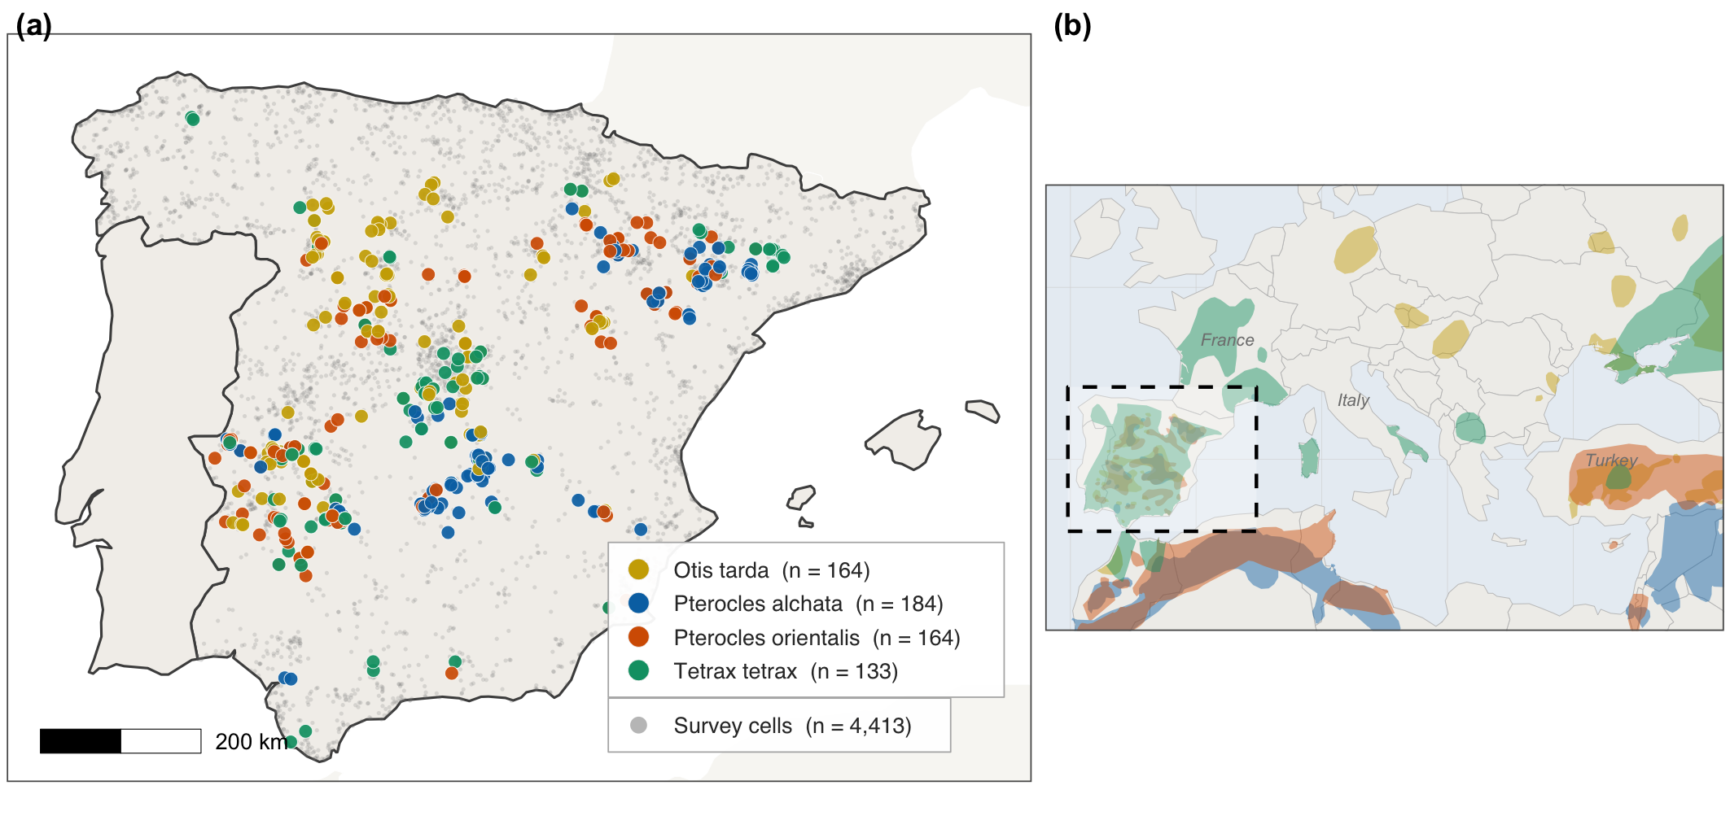
Figure S1. Study area and sampling effort. (a) Distribution of observation records for the four study species across mainland Spain on a 5×5 km UTM grid (2017–2023). Species-specific sites shown in colour; grey points indicate all eBird survey cells (n = 4,413). Records falling outside the species’ known Iberian breeding range were screened as likely vagrants or misidentifications and excluded from the maps; on this basis a single great bustard record in the Basque Country (checklist S69826937) was removed. (b) Location of the Iberian Peninsula within European context. Shaded polygons show the European breeding ranges of the four species, with the same colours as in (a); the dashed rectangle marks the study area.
Species | Common name | IUCN global | IUCN Europe | IUCN (Spain) | % European pop. | N sites | Years | Mean p | Colonisation events | Extinction events
O. tarda | Great Bustard | EN | LC | NT | ~83% | 3,745 | 7 | 0.253 | 17 | 29
T. tetrax | Little Bustard | NT | VU | EN | ~34% | 3,746 | 7 | 0.349 | 11 | 9
P. alchata | Pin-tailed Sandgrouse | LC | LC | VU | ~97% | 4,130 | 7 | 0.232 | 16 | 18
P. orientalis | Black-bellied Sandgrouse | LC | EN | EN (mainland Spain)  VU (Canary Islands) | ~19% (mainland Spain)  ~6% (Canary Islands) | 4,130 | 7 | 0.133 | 22 | 15
Table S1. Study species summary. IUCN status refers to the Spanish Red List classification (SEO/BirdLife, 2021); the proportion of the European breeding population held in Spain follows the European Red List of Birds (BirdLife International, 2021; https://www.iucnredlist.org). Detection probability (p) is the intercept estimate on the probability scale at mean covariate values. Colonisation and extinction events are observed (naive) site-year transitions before detection correction, that is, a site is counted as colonised when the species is undetected in year t but detected in year t+1, and as locally extinct in the reverse case.

Appendix S2. Model selection and comparison
Dynamic occupancy models were fitted using the colext function in the unmarked R package (Fiske & Chandler, 2011; Kellner et al., 2023). Two model-building pipelines were evaluated: v4b (annual land-cover classes as dynamic covariates) and v5 (lagged precipitation and temperature as dynamic covariates). For each species, 11–12 candidate models were compared using AIC. Table S2 presents the best model from each pipeline for each species. The final model selected for inference is indicated in the rightmost columns of Table S3, which additionally reports boundary warnings and the key dynamic predictor identified.
Species | Pipeline | Best model | AIC | nPars | ΔAIC vs baseline | Weight | Boundary
O. tarda | v4b | m9: both lc_crop | 3575.6 | 16 | -1.3 | 0.1545 | FALSE
O. tarda | v5 | m2: eps~tree+pr_lag | 3575.4 | 15 | -1.5 | 0.2302 | FALSE
T. tetrax | v4b | m7: gam~grass+crop | 2378 | 17 | -48.8 | 1 | FALSE
T. tetrax | v5 | m11: combined lag | 2381.5 | 18 | -45.3 | — | FALSE
P. alchata | v4b | m0: Static baseline | 2752.2 | 15 | 0 | — | TRUE
P. alchata | v5 | m6: gam~pr_lag | 2732.8 | 16 | -19.4 | 0.5866 | FALSE
P. orientalis | v4b | m0: Static baseline | 2509.9 | 15 | 0 | — | TRUE
P. orientalis | v5 | m0: Static baseline | 2509.9 | 15 | 0 | — | TRUE
Table S2. AIC-based model comparison across pipelines. ΔAIC is relative to the baseline (static) model within each pipeline. Boundary = TRUE indicates that at least one parameter estimate hit the boundary of the parameter space, typically the colonisation intercept.

Species | Common name | v4b best | v4b ΔAIC | v5 best | v5 ΔAIC | Overall best | Key dynamic predictor
O. tarda | Great Bustard | gam~lc_crop, eps~tree+lc_crop | -1.3 | eps~tree+pr_lag | -1.5 | v3 static | None (tree_cover static)
T. tetrax | Little Bustard | gam~lc_grass+lc_crop | -48.8 | m11 (no converge) | — | v4b (lc dynamic) | lc_grass + lc_crop (colonization)
P. alchata | Pin-tailed Sandgrouse | Baseline (boundary) | — | gam~pr_lag | -19.4 | v5 (pr_lag) | pr_lag (colonization)
P. orientalis | Black-bellied Sandgrouse | Baseline (boundary) | — | Baseline (boundary) | — | v4b static | None
Table S3. Summary of dynamic covariate effects and final model selection across species and pipelines.

Appendix S3. Full coefficient tables
Tables S4–S6 present the full parameter estimates for all submodels: initial occupancy (ψ₁), colonisation (γ), extinction (ε), and detection (p). All covariates were standardised to zero mean and unit variance prior to model fitting. Estimates are on the logit scale.

Table S4. Initial occupancy (ψ₁) coefficients
Species | Parameter | Estimate | SE | z | P | Sig.
O. tarda | (Intercept) | -12.92 | 1.78 | -7.28 | 3.42e-13 | ***
O. tarda | bio1 | 1.23 | 0.51 | 2.41 | 0.02 | *
O. tarda | bio2 | 1.41 | 0.34 | 4.11 | 3.90e-05 | ***
O. tarda | tree_cover | -11.71 | 1.88 | -6.24 | 4.41e-10 | ***
O. tarda | grass_cover | 1.16 | 0.22 | 5.31 | 1.10e-07 | ***
O. tarda | topo_elev | 1.70 | 0.63 | 2.68 | 7.31e-03 | **
T. tetrax | (Intercept) | -5.34 | 0.58 | -9.15 | 5.44e-20 | ***
T. tetrax | bio1 | 0.03 | 0.46 | 0.07 | 0.94
T. tetrax | bio2 | 0.57 | 0.26 | 2.17 | 0.03 | *
T. tetrax | tree_cover | -3.29 | 0.69 | -4.77 | 1.82e-06 | ***
T. tetrax | grass_cover | 0.80 | 0.18 | 4.46 | 8.08e-06 | ***
T. tetrax | topo_elev | -0.23 | 0.56 | -0.41 | 0.68
P. alchata | (Intercept) | -6.28 | 0.57 | -11.11 | 1.15e-28 | ***
P. alchata | bio1 | 0.07 | 0.42 | 0.18 | 0.86
P. alchata | bio2 | 1.96 | 0.33 | 5.93 | 3.08e-09 | ***
P. alchata | tree_cover | -3.32 | 0.58 | -5.67 | 1.44e-08 | ***
P. alchata | grass_cover | 0.88 | 0.19 | 4.61 | 4.05e-06 | ***
P. alchata | topo_elev | -0.78 | 0.52 | -1.49 | 0.14
P. orientalis | (Intercept) | -6.69 | 0.60 | -11.10 | 1.31e-28 | ***
P. orientalis | bio1 | -0.40 | 0.40 | -1.02 | 0.31
P. orientalis | bio2 | 1.46 | 0.29 | 4.97 | 6.55e-07 | ***
P. orientalis | tree_cover | -4.82 | 0.64 | -7.51 | 5.79e-14 | ***
P. orientalis | grass_cover | 0.88 | 0.18 | 4.84 | 1.33e-06 | ***
P. orientalis | topo_elev | -0.71 | 0.48 | -1.47 | 0.14
Table S4. Initial occupancy (ψ₁) coefficients from the selected colext model for each species. All covariates standardised. Significance codes: *** P < 0.001, ** P < 0.01, * P < 0.05, . P < 0.1.

Table S5. Colonisation (γ) and extinction (ε) coefficients
Species | Submodel | Parameter | Estimate | SE | z | P | Prob | Sig.
O. tarda | Colonization (gamma) | (Intercept) | -5.29 | 0.22 | -23.60 | 4.23e-123 | 5.00e-03 | ***
O. tarda | Extinction (epsilon) | (Intercept) | -8.00e-03 | 0.74 | -0.01 | 0.99 | 0.50
O. tarda | Extinction (epsilon) | tree_cover | 2.65 | 0.88 | 3.02 | 2.50e-03 | 0.93 | **
O. tarda | Extinction (epsilon) | pr_lag | -0.31 | 0.24 | -1.29 | 0.20 | 0.42
T. tetrax | Colonization (gamma) | (Intercept) | -5.71 | 0.32 | -17.70 | 3.99e-70 | 3.30e-03 | ***
T. tetrax | Colonization (gamma) | lc_grass | 0.53 | 0.29 | 1.85 | 0.06 | 0.63 | .
T. tetrax | Colonization (gamma) | lc_crop | 0.21 | 0.40 | 0.52 | 0.60 | 0.55
T. tetrax | Extinction (epsilon) | (Intercept) | -0.07 | 0.57 | -0.13 | 0.90 | 0.48
T. tetrax | Extinction (epsilon) | grass_cover | -0.52 | 0.40 | -1.33 | 0.18 | 0.37
T. tetrax | Extinction (epsilon) | tree_cover | 3.06 | 0.82 | 3.71 | 2.10e-04 | 0.95 | ***
P. alchata | Colonization (gamma) | (Intercept) | -6.78 | 0.55 | -12.42 | 2.05e-35 | 1.10e-03 | ***
P. alchata | Colonization (gamma) | pr_lag | 0.13 | 0.50 | 0.27 | 0.79 | 0.53
P. alchata | Extinction (epsilon) | (Intercept) | -1.29 | 0.65 | -2.01 | 0.04 | 0.21 | *
P. alchata | Extinction (epsilon) | grass_cover | 0.60 | 0.37 | 1.62 | 0.10 | 0.65
P. alchata | Extinction (epsilon) | tree_cover | 1.50 | 0.83 | 1.79 | 0.07 | 0.82 | .
P. orientalis | Colonization (gamma) | (Intercept) | -28.65 | 537.03 | -0.05 | 0.96 | 0
P. orientalis | Extinction (epsilon) | (Intercept) | -1.74 | 0.88 | -1.98 | 0.05 | 0.15 | *
P. orientalis | Extinction (epsilon) | grass_cover | -0.91 | 0.46 | -2.00 | 0.05 | 0.29 | *
P. orientalis | Extinction (epsilon) | tree_cover | 0.72 | 1.01 | 0.71 | 0.48 | 0.67
Table S5. Colonisation and extinction coefficients. Prob = back-transformed probability at the intercept (for intercept row) or predicted probability at +1 SD (for covariates). P. orientalis colonisation intercept shows extreme SE (γ ≈ 0).

Table S6. Detection (p) coefficients
Species | Parameter | Estimate | SE | P | Prob
O. tarda | (Intercept) | -1.08 | 0.06 | 5.75e-76 | 0.25
O. tarda | effort | 0.23 | 0.05 | 7.54e-07 | 0.56
O. tarda | observers | 0.06 | 0.04 | 0.11 | 0.52
O. tarda | duration | 0.19 | 0.05 | 3.09e-04 | 0.55
O. tarda | time | -0.06 | 0.05 | 0.20 | 0.48
T. tetrax | (Intercept) | -1.08 | 0.09 | 1.70e-37 | 0.25
T. tetrax | effort | 0.27 | 0.06 | 2.39e-06 | 0.57
T. tetrax | observers | 0.05 | 0.04 | 0.22 | 0.51
T. tetrax | duration | 0.17 | 0.06 | 4.88e-03 | 0.54
T. tetrax | time | -0.17 | 0.06 | 6.42e-03 | 0.46
P. alchata | (Intercept) | -1.20 | 0.06 | 7.25e-81 | 0.23
P. alchata | effort | 0.14 | 0.05 | 9.48e-03 | 0.53
P. alchata | observers | -0.03 | 0.04 | 0.43 | 0.49
P. alchata | duration | 0.46 | 0.06 | 3.41e-17 | 0.61
P. alchata | time | -0.44 | 0.06 | 6.16e-14 | 0.39
P. orientalis | (Intercept) | -1.88 | 0.07 | 5.63e-138 | 0.13
P. orientalis | effort | 0.07 | 0.06 | 0.24 | 0.52
P. orientalis | observers | 0.13 | 0.04 | 2.57e-03 | 0.53
P. orientalis | duration | 0.45 | 0.06 | 3.79e-15 | 0.61
P. orientalis | time | -0.26 | 0.06 | 1.92e-05 | 0.44
Table S6. Detection submodel coefficients. Covariates: effort (cumulative eBird checklists per cell-year), observers (number of unique observers), duration (checklist duration in minutes), time (hour of day). Prob = back-transformed detection probability.

Appendix S4. NDVI–climate collinearity analysis
NDVI integrates both climate and land-use signals, which complicates its attribution in counterfactual analyses. We assessed NDVI–climate collinearity through three complementary diagnostics: (i) the proportion of spatial variance in NDVI explained by climate variables (site-level R² from linear regression of NDVI on precipitation and temperature); (ii) variance inflation factors (VIF) for each covariate within each submodel; and (iii) coefficient stability analysis, comparing estimates with and without NDVI to detect sign changes or inflated standard errors.
Across all species, the mean R² of NDVI regressed on climate variables was 0.51 (51% of sites exceeded R² > 0.5; 28% exceeded R² > 0.7). This intermediate level of climate–NDVI coupling motivated a species- and submodel-specific decision framework rather than a blanket inclusion or exclusion rule. Table S7 summarises the VIF values; all were below 5.0, indicating no severe multicollinearity in the regression sense. Table S8 reports the coefficient stability analysis and the resulting decisions.

Table S7. Variance Inflation Factors
Species | Submodel | Covariate | VIF | Flag
O. tarda | gamma | NDVI | 1.68 | OK
O. tarda | gamma | pr | 2.13 | OK
O. tarda | gamma | tmmn | 2.64 | OK
O. tarda | gamma | tmmx | 4.43 | OK
O. tarda | epsilon | Land_Cover_Type_1_Percent_Class_6 | 1.00 | OK
O. tarda | epsilon | Land_Cover_Type_1_Percent_Class_13 | 1.00 | OK
O. tarda | epsilon | tmmx | 1.00 | OK
Tetrax tetrax | gamma | Land_Cover_Type_1_Percent_Class_12 | 1.00 | OK
Tetrax tetrax | epsilon | Land_Cover_Type_1_Percent_Class_12 | 1.00 | OK
P. alchata | gamma | NDVI | 1.46 | OK
P. alchata | gamma | pr | 1.46 | OK
P. alchata | epsilon | pr | 1.29 | OK
P. alchata | epsilon | tmmx | 1.29 | OK
P. orientalis | gamma | Land_Cover_Type_1_Percent_Class_7 | 1.19 | OK
P. orientalis | gamma | NDVI | 1.69 | OK
P. orientalis | gamma | tmmn | 2.78 | OK
P. orientalis | gamma | tmmx | 3.57 | OK
P. orientalis | epsilon | Land_Cover_Type_1_Percent_Class_12 | 1.12 | OK
P. orientalis | epsilon | NDVI | 1.10 | OK
P. orientalis | epsilon | pr | 1.02 | OK
Table S7. Variance inflation factors for covariates in colonisation and extinction submodels. VIF < 5 indicates acceptable collinearity (Dormann et al., 2013).

Table S8. NDVI coefficient stability analysis
Species | Submodel | Covariate | β original | SE orig. | β refit | SE refit | Sign change | ΔAIC | Flag
O. tarda | gamma | pr | -2.30 | 1.47 | -1.38 | 1.10 | FALSE | -22.34 | OK
O. tarda | gamma | tmmn | -4.52 | 1.95 | -2.39 | 1.26 | FALSE | -22.34 | BETA_SHIFT>1SE
O. tarda | gamma | tmmx | 2.59 | 1.68 | 1.60 | 1.32 | FALSE | -22.34 | OK
P. alchata | gamma | pr | 0.16 | 0.36 | -0.72 | 0.46 | TRUE | 7.81 | SIGN_CHANGE
P. orientalis | gamma | Land_Cover_Type_1_Percent_Class_7 | -9.80 | 6.46 | -8.50 | 5.88 | FALSE | -0.77 | OK
P. orientalis | gamma | tmmn | -8.11 | 2.67 | -7.23 | 2.36 | FALSE | -0.77 | OK
P. orientalis | gamma | tmmx | 9.14 | 2.68 | 8.36 | 2.39 | FALSE | -0.77 | OK
P. orientalis | epsilon | Land_Cover_Type_1_Percent_Class_12 | -0.83 | 0.26 | -0.09 | 0.41 | FALSE | 60.27 | BETA_SHIFT>1SE
P. orientalis | epsilon | pr | 1.69 | 0.73 | 1.91 | 1.18 | FALSE | 60.27 | SE_INCREASE>50%
Table S8. Coefficient stability when NDVI is removed from each submodel. Refit columns show estimates from the model excluding NDVI. SIGN_CHANGE = coefficient reverses sign; BETA_SHIFT>1SE = shift exceeds one standard error; SE_INCREASE>50% = SE inflates by more than 50% when the collinear variable is removed.

NDVI retention decisions
Species | Submodel | Has NDVI | Recommendation | VIF(NDVI) | Justification
O. tarda | gamma | TRUE | (d) RETAIN but reclassify in attribution | 1.68 | Intermediate R² (mean=0.51); VIF<5; stable coefficients; use...
O. tarda | epsilon | FALSE | N/A | — | NDVI not in submodel
T. tetrax | gamma | FALSE | N/A | — | NDVI not in submodel
T. tetrax | epsilon | FALSE | N/A | — | NDVI not in submodel
P. alchata | gamma | TRUE | (c) REMOVE | 1.46 | Coefficient sign change when NDVI removed indicates instabil...
P. alchata | epsilon | FALSE | N/A | — | NDVI not in submodel
P. orientalis | gamma | TRUE | (d) RETAIN but reclassify in attribution | 1.69 | Intermediate R² (mean=0.51); VIF<5; stable coefficients; use...
P. orientalis | epsilon | TRUE | (c) REMOVE | 1.1 | SE increase of 60% when collinear variable removed
Table S9. NDVI retention decisions by species and submodel. Option (c) = remove NDVI; option (d) = retain but reclassify as climate-adjacent in attribution analysis using decomposed NDVI (climate component vs. residual land-use component).

Figure S2. Dynamic covariate collinearity diagnostics for all four species. (A) Pairwise Pearson correlation matrices among covariates within each species. (B) Variance inflation factors by submodel. (C) Spatial map of NDVI~climate R² across the study area, showing the proportion of NDVI variance attributable to climate variables at each grid cell.

Appendix S5. Tree cover sensitivity analysis
Tree cover appears in the initial occupancy submodel (ψ₁) for all four species and additionally in the extinction submodel (ε) for Otis tarda. To assess whether its inclusion in both submodels introduces identifiability issues, we compared six alternative model specifications for O. tarda varying the placement of tree cover and grass cover across submodels (Table S10).
Model | Description | nPars | AIC | ΔAIC | Weight
s4: psi(tree+) eps(tree) | tree in both submodels, no grass in ε | 14 | 3575.3 | 0 | 0.6896
s0: psi(tree+) eps(grass+tree) | tree in both submodels (current specification) | 15 | 3576.9 | 1.6 | 0.3099
s1: psi(tree+) eps(grass) | tree in ψ₁ only | 14 | 3589.7 | 14.4 | 5e-04
s2: psi(-) eps(grass+tree) | tree in ε only | 14 | 3703.6 | 128.3 | 0
s5: psi(-) eps(tree) | tree in ε only, no grass | 13 | 3707.1 | 131.8 | 0
s3: psi(-) eps(grass) | tree in neither submodel | 13 | 3787.5 | 212.2 | 0
Table S10. Tree cover sensitivity analysis for O. tarda. Models vary in which submodels include tree cover and grass cover. The best-supported model (s4) includes tree cover in both ψ₁ and ε but without grass cover in ε, consistent with the hypothesis that tree cover operates on both initial habitat suitability and local extinction risk.

Appendix S6. Naive versus detection-corrected transition rates
This analysis evaluates whether imperfect detection can artificially inflate apparent colonisation and mask the demographic asymmetry between colonisation and extinction. Naive rates were computed as the proportion of observed transitions among eligible sites. Detection-corrected rates are bootstrap medians with 95% confidence intervals (n = 5,000 samples from the fitted colext variance–covariance matrix). Because colonisation approaches the boundary of the parameter space, bootstrap distributions are expected to be asymmetric; we therefore emphasise probability-based metrics (P(ε/γ > 100)) rather than symmetric confidence intervals in the main text.
Species | Naive γ | Corrected γ (median) | γ 95% CI | Fold γ | Naive ε | Corrected ε (median) | ε 95% CI | Fold ε | Col. events | Col. opport. | Ext. events | Ext. opport.
O. tarda | 8.94e-03 | 4.42e-05 | [8.55e-07, 2.34e-03] | 202.5 | 0.45 | 0.22 | [0.11, 0.40] | 2.0 | 17 | 1901 | 29 | 65
T. tetrax | 5.67e-03 | 6.66e-04 | [2.11e-04, 2.09e-03] | 8.5 | 0.36 | 0.14 | [0.08, 0.22] | 2.6 | 11 | 1941 | 9 | 25
P. alchata | 6.35e-03 | 1.38e-03 | [5.04e-04, 3.72e-03] | 4.6 | 0.28 | 0.50 | [0.02, 0.97] | 0.6 | 16 | 2521 | 18 | 64
P. orientalis | 8.66e-03 | 3.96e-07 | [1.93e-10, 5.44e-04] | 2.2e+04 | 0.34 | 0.44 | [0.28, 0.61] | 0.8 | 22 | 2541 | 15 | 44
Table S11. Naive versus detection-corrected colonisation and extinction rates. Fold = naive/corrected ratio. For colonisation, fold > 1 indicates that imperfect detection inflated apparent colonisation. For P. orientalis, the corrected γ median approaches zero (3.96 × 10⁻⁷), yielding a fold-change of ~21,800×.

Appendix S7. Goodness-of-fit assessment
Model adequacy was assessed using parametric bootstrap goodness-of-fit tests (n = 500 simulations per species) based on the sum of squared Pearson residuals (χ²). For each simulation, a dataset was generated from the fitted model and refitted; the distribution of simulated χ² statistics provides a reference against which the observed χ² is compared. A Bayesian P-value near 0.5 indicates good fit; values below 0.05 suggest systematic lack of fit.
Species | Observed χ² | Mean simulated χ² | P-value | Interpretation
O. tarda | 352.37 | 333.62 | 0.280 | Adequate
T. tetrax | 290.87 | 307.92 | 0.660 | Adequate
P. alchata | 363.38 | 364.57 | 0.516 | Adequate
P. orientalis | 275.98 | 330.55 | 0.934 | Adequate
Table S12. Parametric bootstrap goodness-of-fit results (n = 500 simulations per species). All four species show adequate model fit (P > 0.05). The P-value represents the proportion of simulated χ² statistics exceeding the observed value.

Appendix S8. Effort confounding assessment
eBird checklist volume increased by 201–256% between 2017 and 2023 across the study area. This temporal increase in sampling effort could confound occupancy trend estimates if detection improvement is not fully absorbed by the detection submodel. We assessed effort confounding through three diagnostics: (i) Spearman correlation between annual naive occupancy and total checklists; (ii) a binomial GLM of naive occupancy on year after controlling for log(checklists); and (iii) temporal trends in model-estimated detection probability.
Species | ρ naive occ. | P | ρ checklists | P | GLM year coef. | GLM year CI | GLM year P | Verdict
O. tarda | -0.25 | 0.59 | 0.96 | 5.00e-04 | 0.10 | [-0.0581, 0.2508] | 0.22 | ambiguous
T. tetrax | 0.02 | 0.97 | 0.96 | 5.00e-04 | 0.04 | [-0.144, 0.2328] | 0.64 | ambiguous
P. alchata | 0.32 | 0.48 | 0.82 | 0.02 | -0.11 | [-0.2549, 0.0419] | 0.16 | likely confounded
P. orientalis | 0.64 | 0.12 | 0.82 | 0.02 | -5.50e-03 | [-0.1524, 0.1414] | 0.94 | ambiguous
Table S13. Effort confounding diagnostics. ρ naive occ. = Spearman correlation between annual naive occupancy and year; ρ checklists = correlation between year and total checklists. GLM year coefficient is from a binomial model of naive occupancy on year after controlling for log(checklists). Verdict: 'ambiguous' indicates no clear confounding signal; 'likely confounded' indicates that effort trends may partially explain naive occupancy trends for that species.

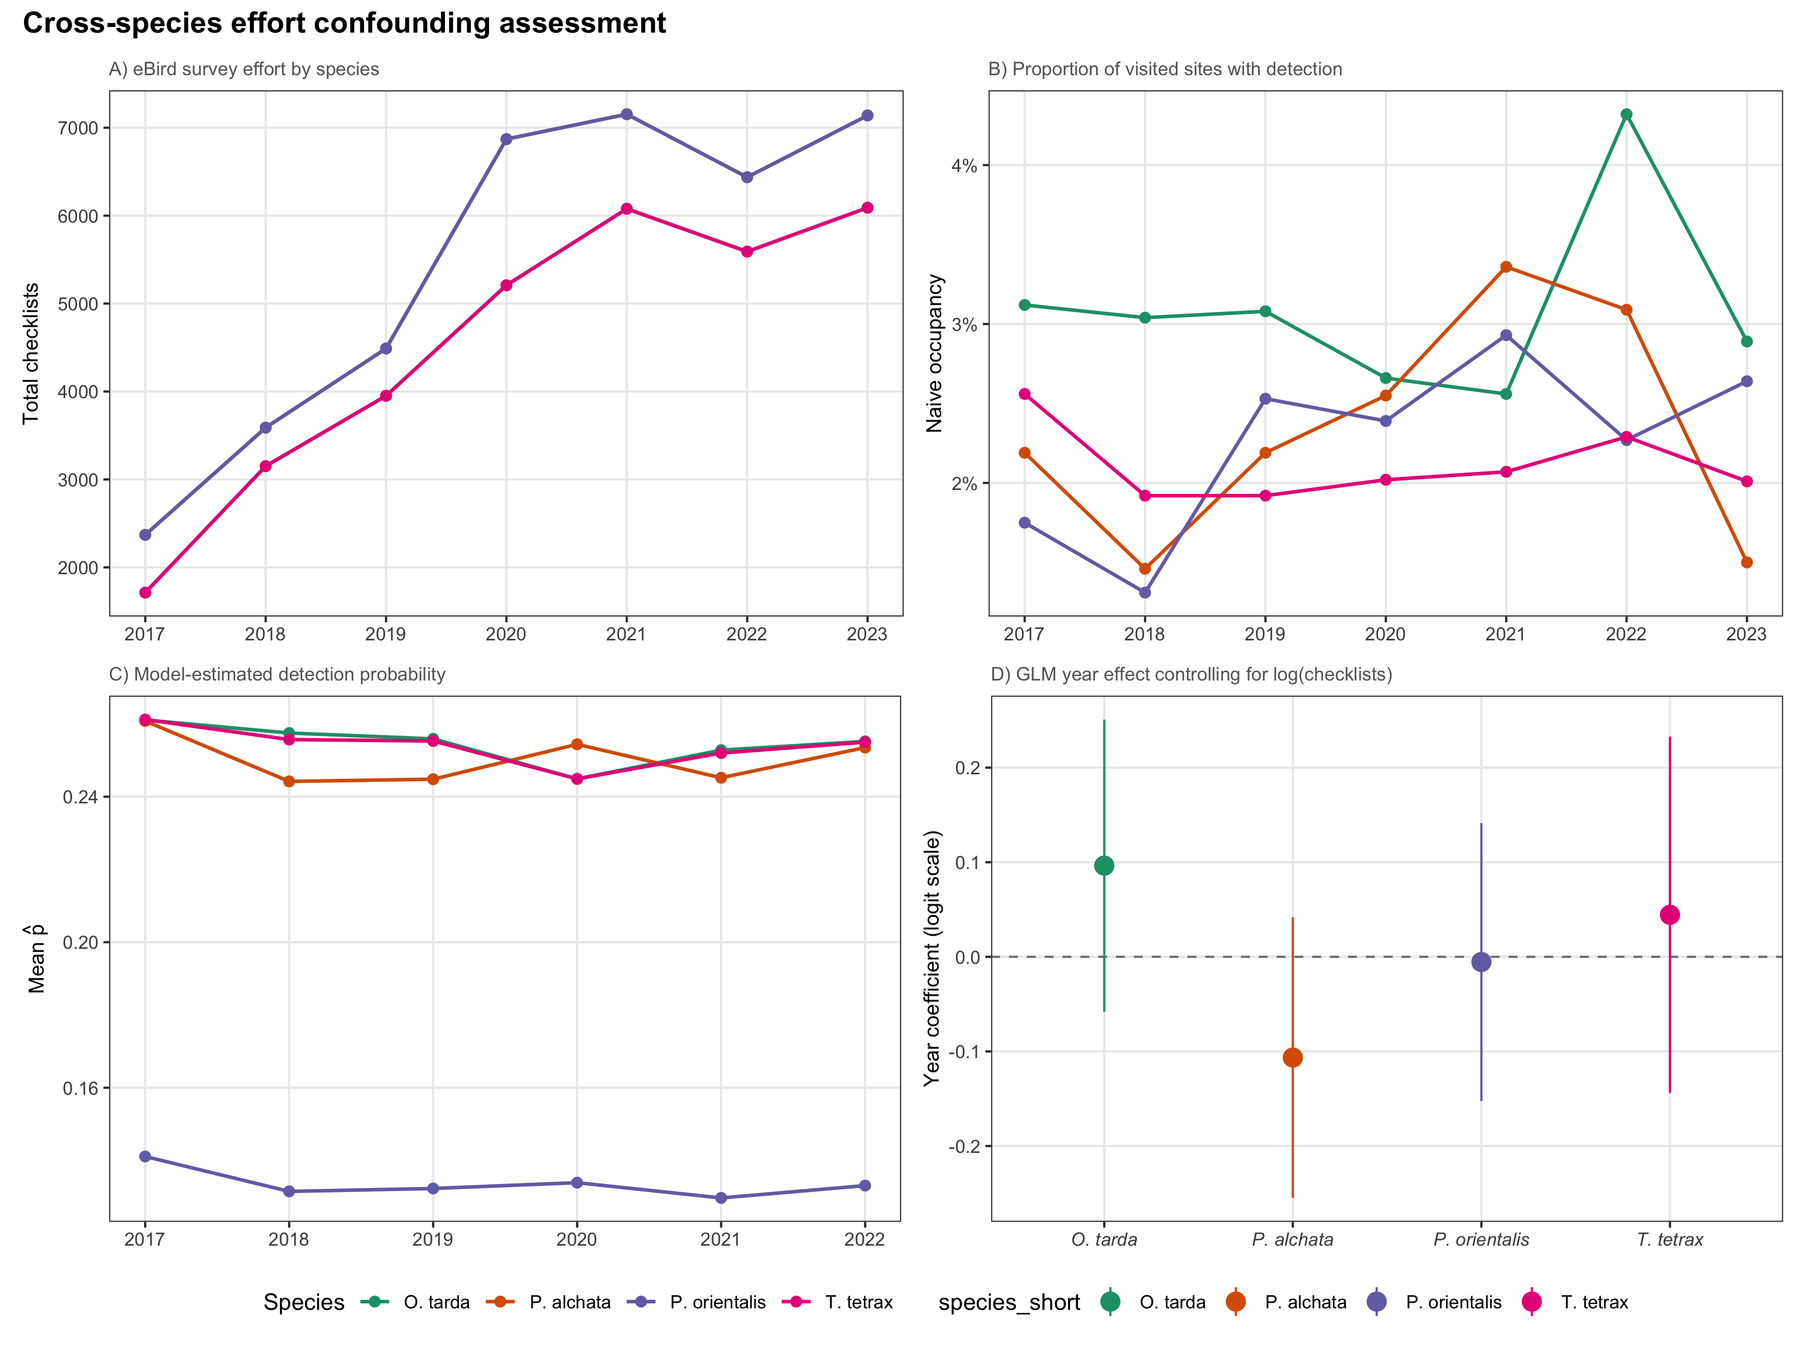
Figure S3. Cross-species effort confounding assessment. (A) Total eBird checklists per year by species (the two bustards, Otis tarda and Tetrax tetrax, and the two sandgrouse, Pterocles alchata and P. orientalis, share the same breeding-season checklist set within each pair, so their lines coincide and only two distinct trajectories are visible). (B) Naive occupancy (proportion of visited sites with detection). (C) Model-estimated mean detection probability over time. (D) Year effect on naive occupancy after controlling for log(checklists) in a binomial GLM, with 95% confidence intervals.

Appendix S9. Counterfactual attribution analysis
The counterfactual attribution analysis decomposed interannual changes in colonisation and extinction rates into climate-driven and land-use-driven components. For each year transition (t to t+1), predicted rates were computed under three scenarios: (i) both climate and land-use covariates at observed values; (ii) climate covariates held at their first-year values while land-use varies; (iii) land-use covariates held at first-year values while climate varies. The difference between scenarios (i) and (ii) or (iii) quantifies the contribution of each driver category.
For species where NDVI was retained in the model (O. tarda γ, P. orientalis γ and ε), the NDVI signal was further decomposed into a climate component (predicted from a site-level regression of NDVI on precipitation and temperature, R² ≈ 0.51) and a residual land-use component. This decomposition avoids double-counting the climate signal captured through NDVI. NDVI was removed from P. alchata γ due to coefficient sign instability (Appendix S4).
Species | Δγ climate | Δγ land-use | Δγ interaction | Δε climate | Δε land-use | Δε interaction
O. tarda | -6.41e-04 (6.2e-04) | 6.88e-04 (1.7e-03) | -2.91e-04 (4.4e-04) | 3.74e-05 (9.4e-04) | -4.64e-03 (3.2e-03) | -4.37e-05 (1.2e-04)
T. tetrax | 0e+00 (0e+00) | -1.04e-06 (4.4e-06) | 0e+00 (0e+00) | 0e+00 (0e+00) | 9.03e-06 (3.4e-05) | 0e+00 (0e+00)
P. alchata | -9.31e-06 (1.6e-05) | 0e+00 (0e+00) | 0e+00 (0e+00) | -1.26e-03 (1.3e-02) | 0e+00 (0e+00) | 0e+00 (0e+00)
P. orientalis | -3.86e-04 (7.7e-04) | -2.28e-05 (4.7e-04) | 1.16e-04 (1.3e-04) | 1.76e-02 (2.9e-02) | -2.26e-03 (2.7e-02) | -4.63e-04 (2.7e-03)
Table S14. Counterfactual attribution of changes in colonisation and extinction rates to climate and land-use drivers, with NDVI decomposed into climate and residual components. Values are mean annual change in predicted rate (SD in parentheses). Interaction terms capture non-additive effects of simultaneous climate and land-use change.

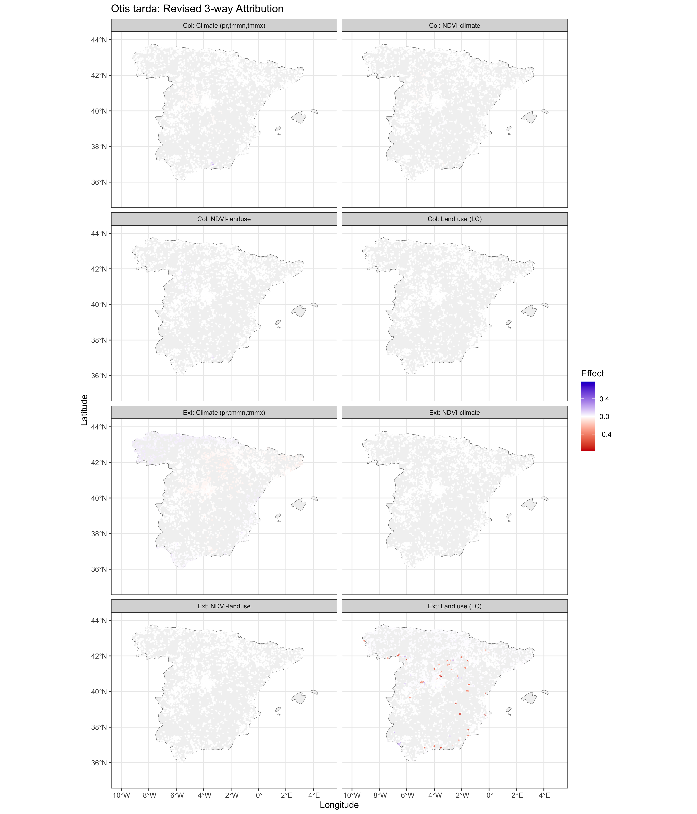
Figure S4a. Attribution summary for O. tarda. Spatial maps of counterfactual changes in colonisation and extinction rates attributable to climate versus land-use change, with NDVI decomposed into climate and residual components.
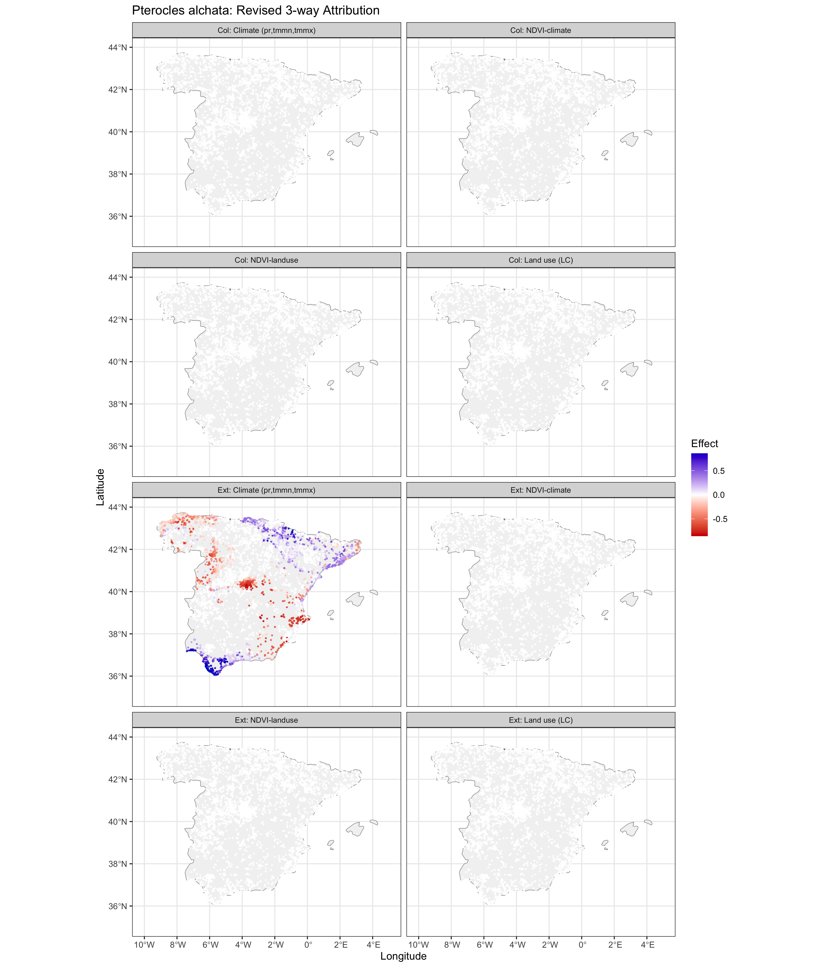
Figure S4b. Attribution summary for P. alchata. Spatial maps of counterfactual changes in colonisation and extinction rates attributable to climate versus land-use change, with NDVI decomposed into climate and residual components.
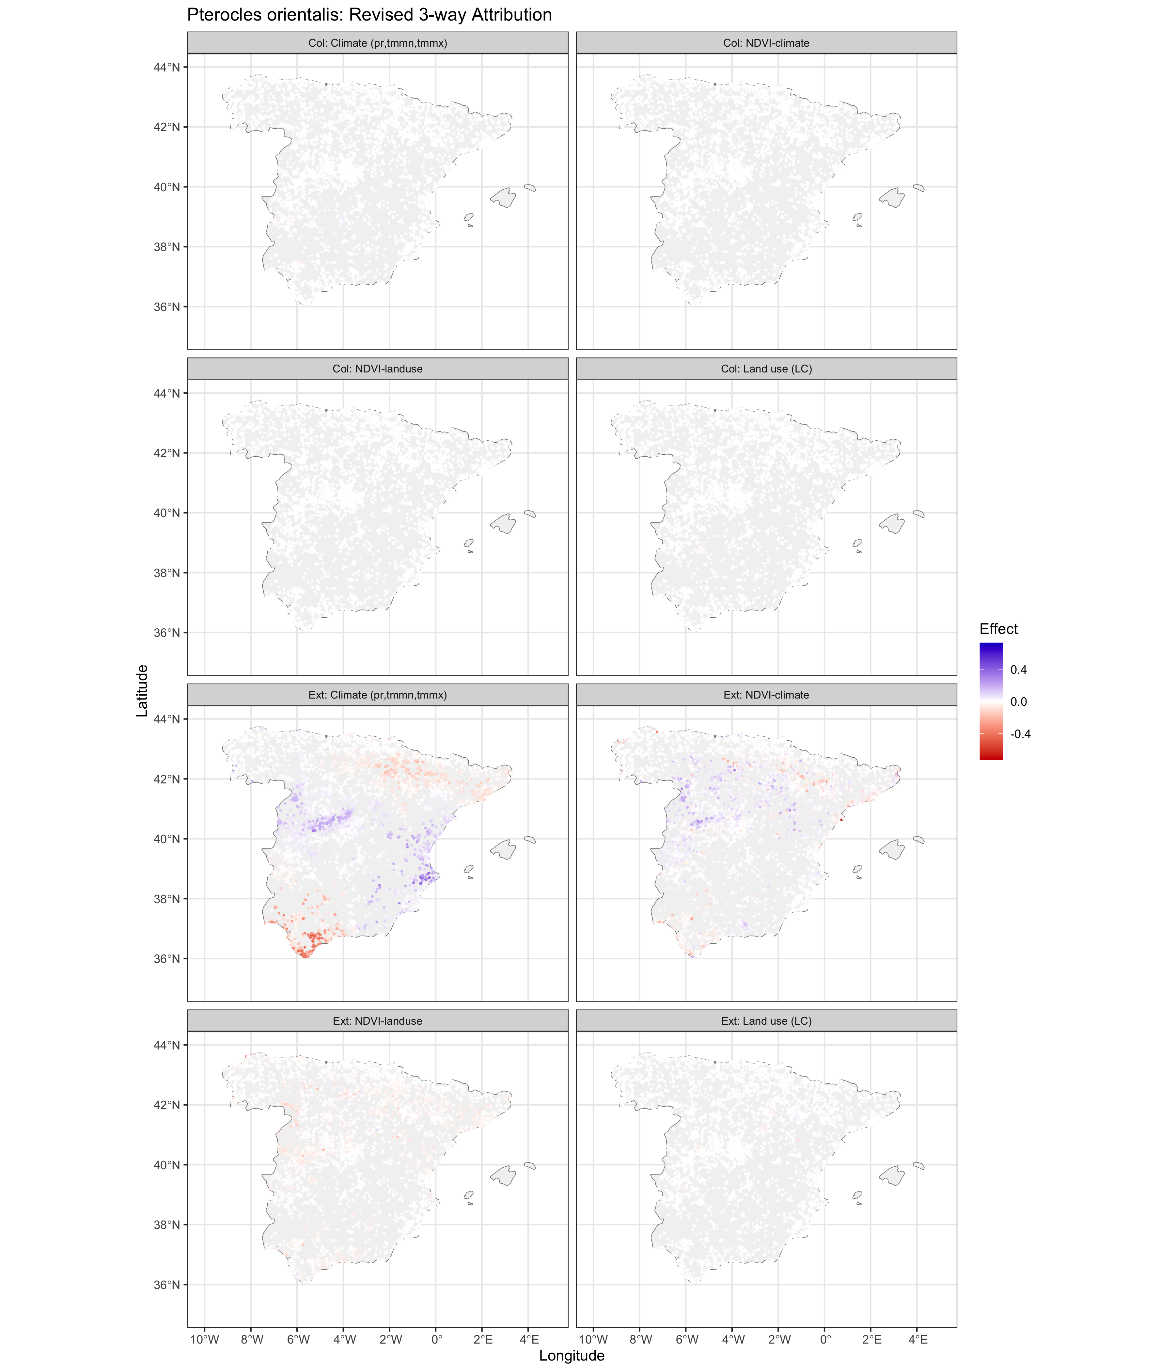
Figure S4c. Attribution summary for P. orientalis. Spatial maps of counterfactual changes in colonisation and extinction rates attributable to climate versus land-use change, with NDVI decomposed into climate and residual components.
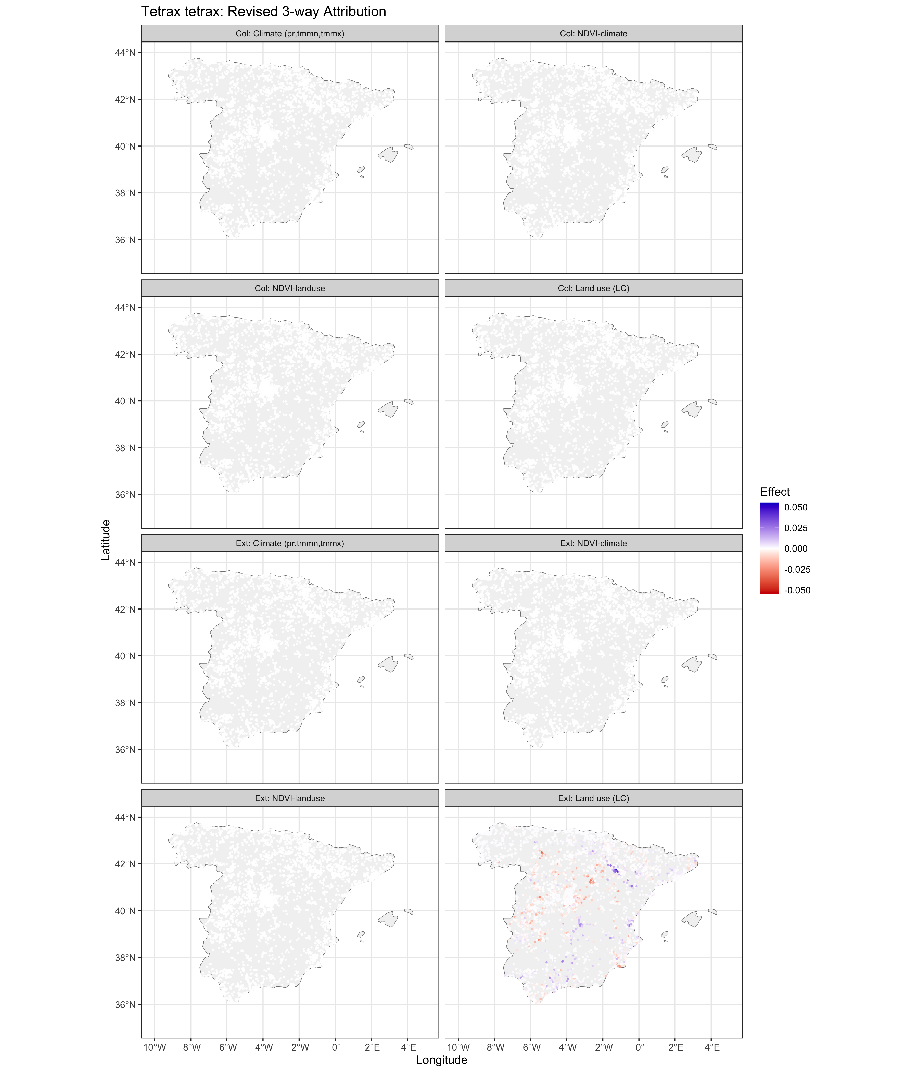
Figure S4d. Attribution summary for T. tetrax. Spatial maps of counterfactual changes in colonisation and extinction rates attributable to climate versus land-use change, with NDVI decomposed into climate and residual components.

Appendix S10. Simulation-based robustness analysis

Methods
This analysis tests whether the colext framework can artefactually produce near-zero colonisation estimates under the empirical sampling design used in this study. If the estimator systematically suppresses γ regardless of its true value, the demographic trap diagnosis would be a statistical artefact rather than a biological finding. We extracted the number of sites, per-site-year visit counts (preserving the exact NA structure of the empirical detection histories), and baseline parameter estimates (ψ₁, γ, ε, p) from the fitted models. We simulated 200 detection-history datasets per species under five colonisation scenarios: (A) empirical γ; (B) 5× empirical; (C) 10× empirical; (D) γ set so that ε/γ = 10; and (E) γ set to achieve 10% equilibrium occupancy. Each dataset was refitted using an intercept-only colext model. We assessed bias, 95% CI coverage, and the proportion of simulations classified into four demographic regimes: growth (ε/γ < 1), mild decline (1–10), asymmetric decline (10–100), and demographic trap (> 100). All 4,000 fits converged. Random seed: 2024.

Results
Table S15 summarises the simulation results across all 20 species–scenario combinations. The critical finding is that when moderate colonisation exists in the simulated system (Scenarios D and E), colext recovers the true γ with near-zero bias (median relative bias < 2.2%) and essentially never misclassifies the system as a demographic trap (false trap rate ≤ 0.5%). For Scenarios A–C, where the true γ is extremely low (< 10⁻³), many estimates fall near zero (boundary), reflecting genuine identifiability challenges when colonisation events are vanishingly rare.
Species | Scenario | γ true | γ estimated | Rel. bias (%) | 95% CI coverage | False trap (%)
O. tarda | A | 4.55e-05 | 9.14e-150 | -100.0 | 1.5% | 76.0%
O. tarda | B | 2.27e-04 | 2.56e-04 | 12.4 | 10.0% | 60.0%
O. tarda | C | 4.55e-04 | 5.54e-04 | 21.8 | 18.5% | 51.0%
O. tarda | D | 0.0222 | 0.0219 | -1.7 | 69.0% | 0.0%
O. tarda | E | 0.0247 | 0.0246 | -0.4 | 94.0% | 0.0%
T. tetrax | A | 6.79e-04 | 7.11e-04 | 4.7 | 36.5% | 48.0%
T. tetrax | B | 3.4e-03 | 3.0e-03 | -13.0 | 68.5% | 7.0%
T. tetrax | C | 6.8e-03 | 6.0e-03 | -11.4 | 46.0% | 0.0%
T. tetrax | D | 1.38e-02 | 1.35e-02 | -2.1 | 68.5% | 0.5%
T. tetrax | E | 1.53e-02 | 1.54e-02 | 0.9 | 89.0% | 0.0%
P. alchata | A | 1.4e-03 | 9.68e-04 | -29.4 | 51.0% | 69.0%
P. alchata | B | 6.9e-03 | 6.0e-03 | -12.2 | 58.0% | 5.5%
P. alchata | C | 1.37e-02 | 1.23e-02 | -10.4 | 49.5% | 1.5%
P. alchata | D | 4.89e-02 | 4.89e-02 | -0.2 | 96.5% | 0.0%
P. alchata | E | 5.44e-02 | 5.46e-02 | 0.3 | 93.5% | 0.0%
P. orientalis | A | 3.82e-07 | 5.01e-10 | -99.9 | 31.0% | 56.5%
P. orientalis | B | 1.91e-06 | 5.11e-10 | -100.0 | 31.0% | 59.5%
P. orientalis | C | 3.82e-06 | 5.12e-10 | -100.0 | 27.0% | 57.5%
P. orientalis | D | 4.41e-02 | 4.43e-02 | 0.5 | 97.5% | 0.0%
P. orientalis | E | 4.90e-02 | 4.91e-02 | 0.3 | 95.0% | 0.0%
Table S15. Simulation results across 200 replicates per scenario. Scenarios: A = empirical γ; B = 5×; C = 10×; D = ε/γ = 10; E = ψ* = 10%. False trap = proportion of simulations classified as ε/γ > 100. In Scenarios D–E, the false trap rate is 0–0.5% across all species, demonstrating that the estimator does not artefactually suppress colonisation.

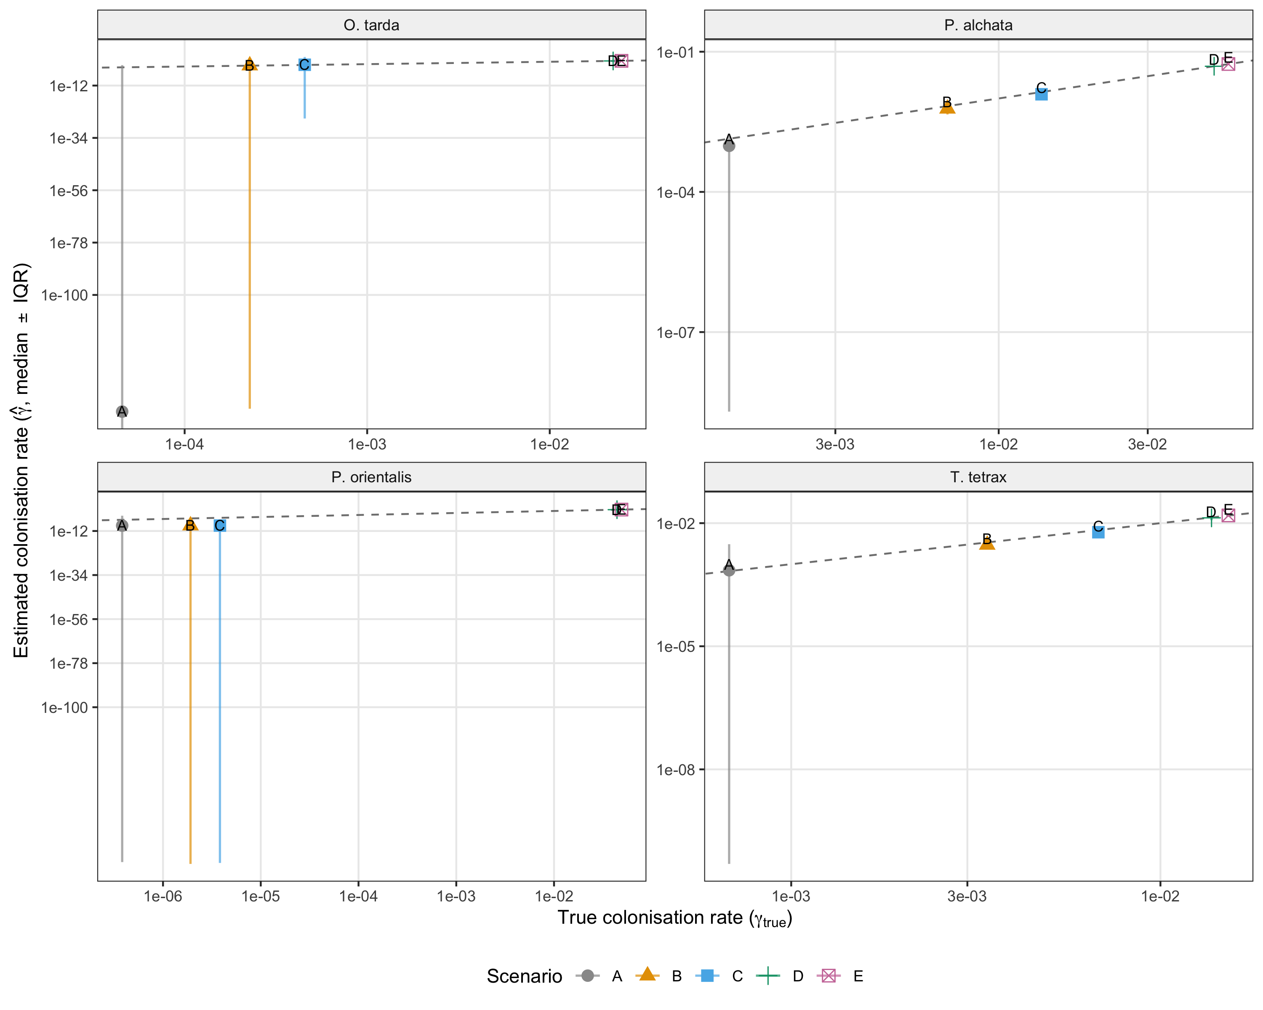
Figure S5. Estimated versus true colonisation rate (γ) across simulation scenarios. Points show median estimates; vertical bars span the interquartile range. Dashed line: 1:1 reference. For Scenarios D and E, estimates fall on or near the 1:1 line, confirming accurate recovery of moderate colonisation rates.
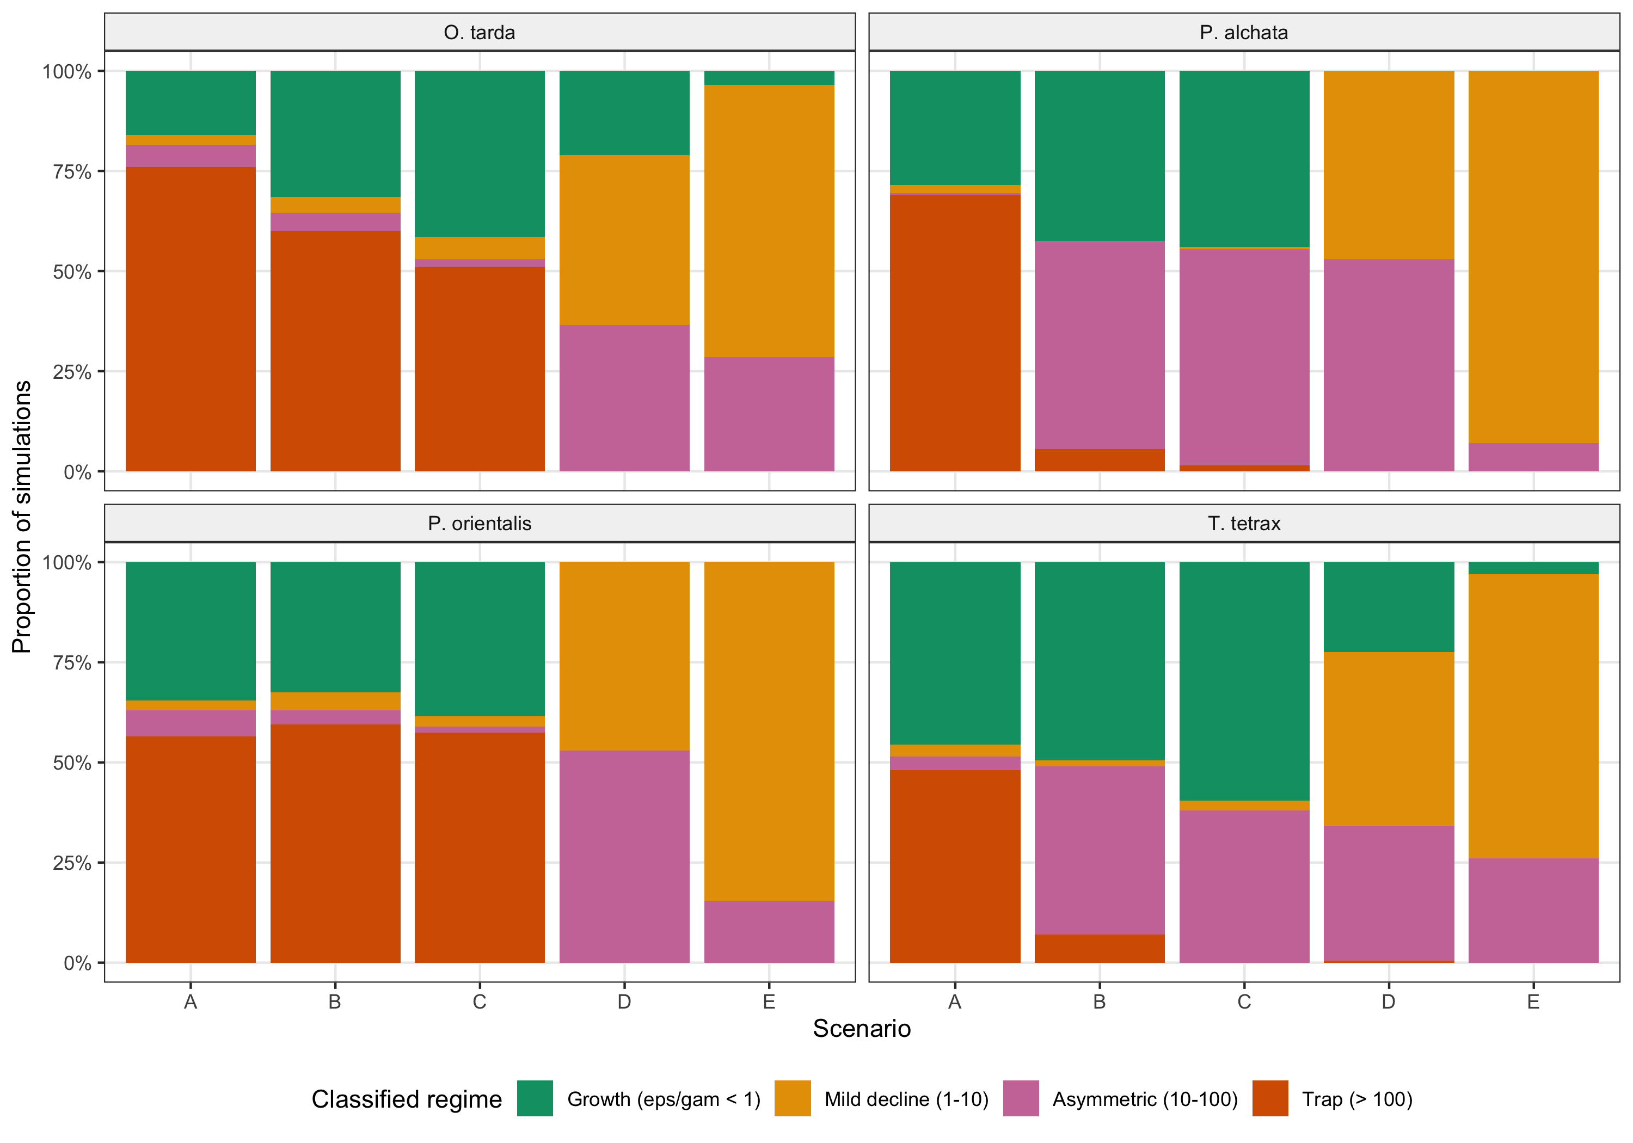
Figure S6. Proportion of simulations classified into each demographic regime by species and scenario. Regimes: growth (ε/γ < 1), mild decline (1–10), asymmetric decline (10–100), and demographic trap (> 100).
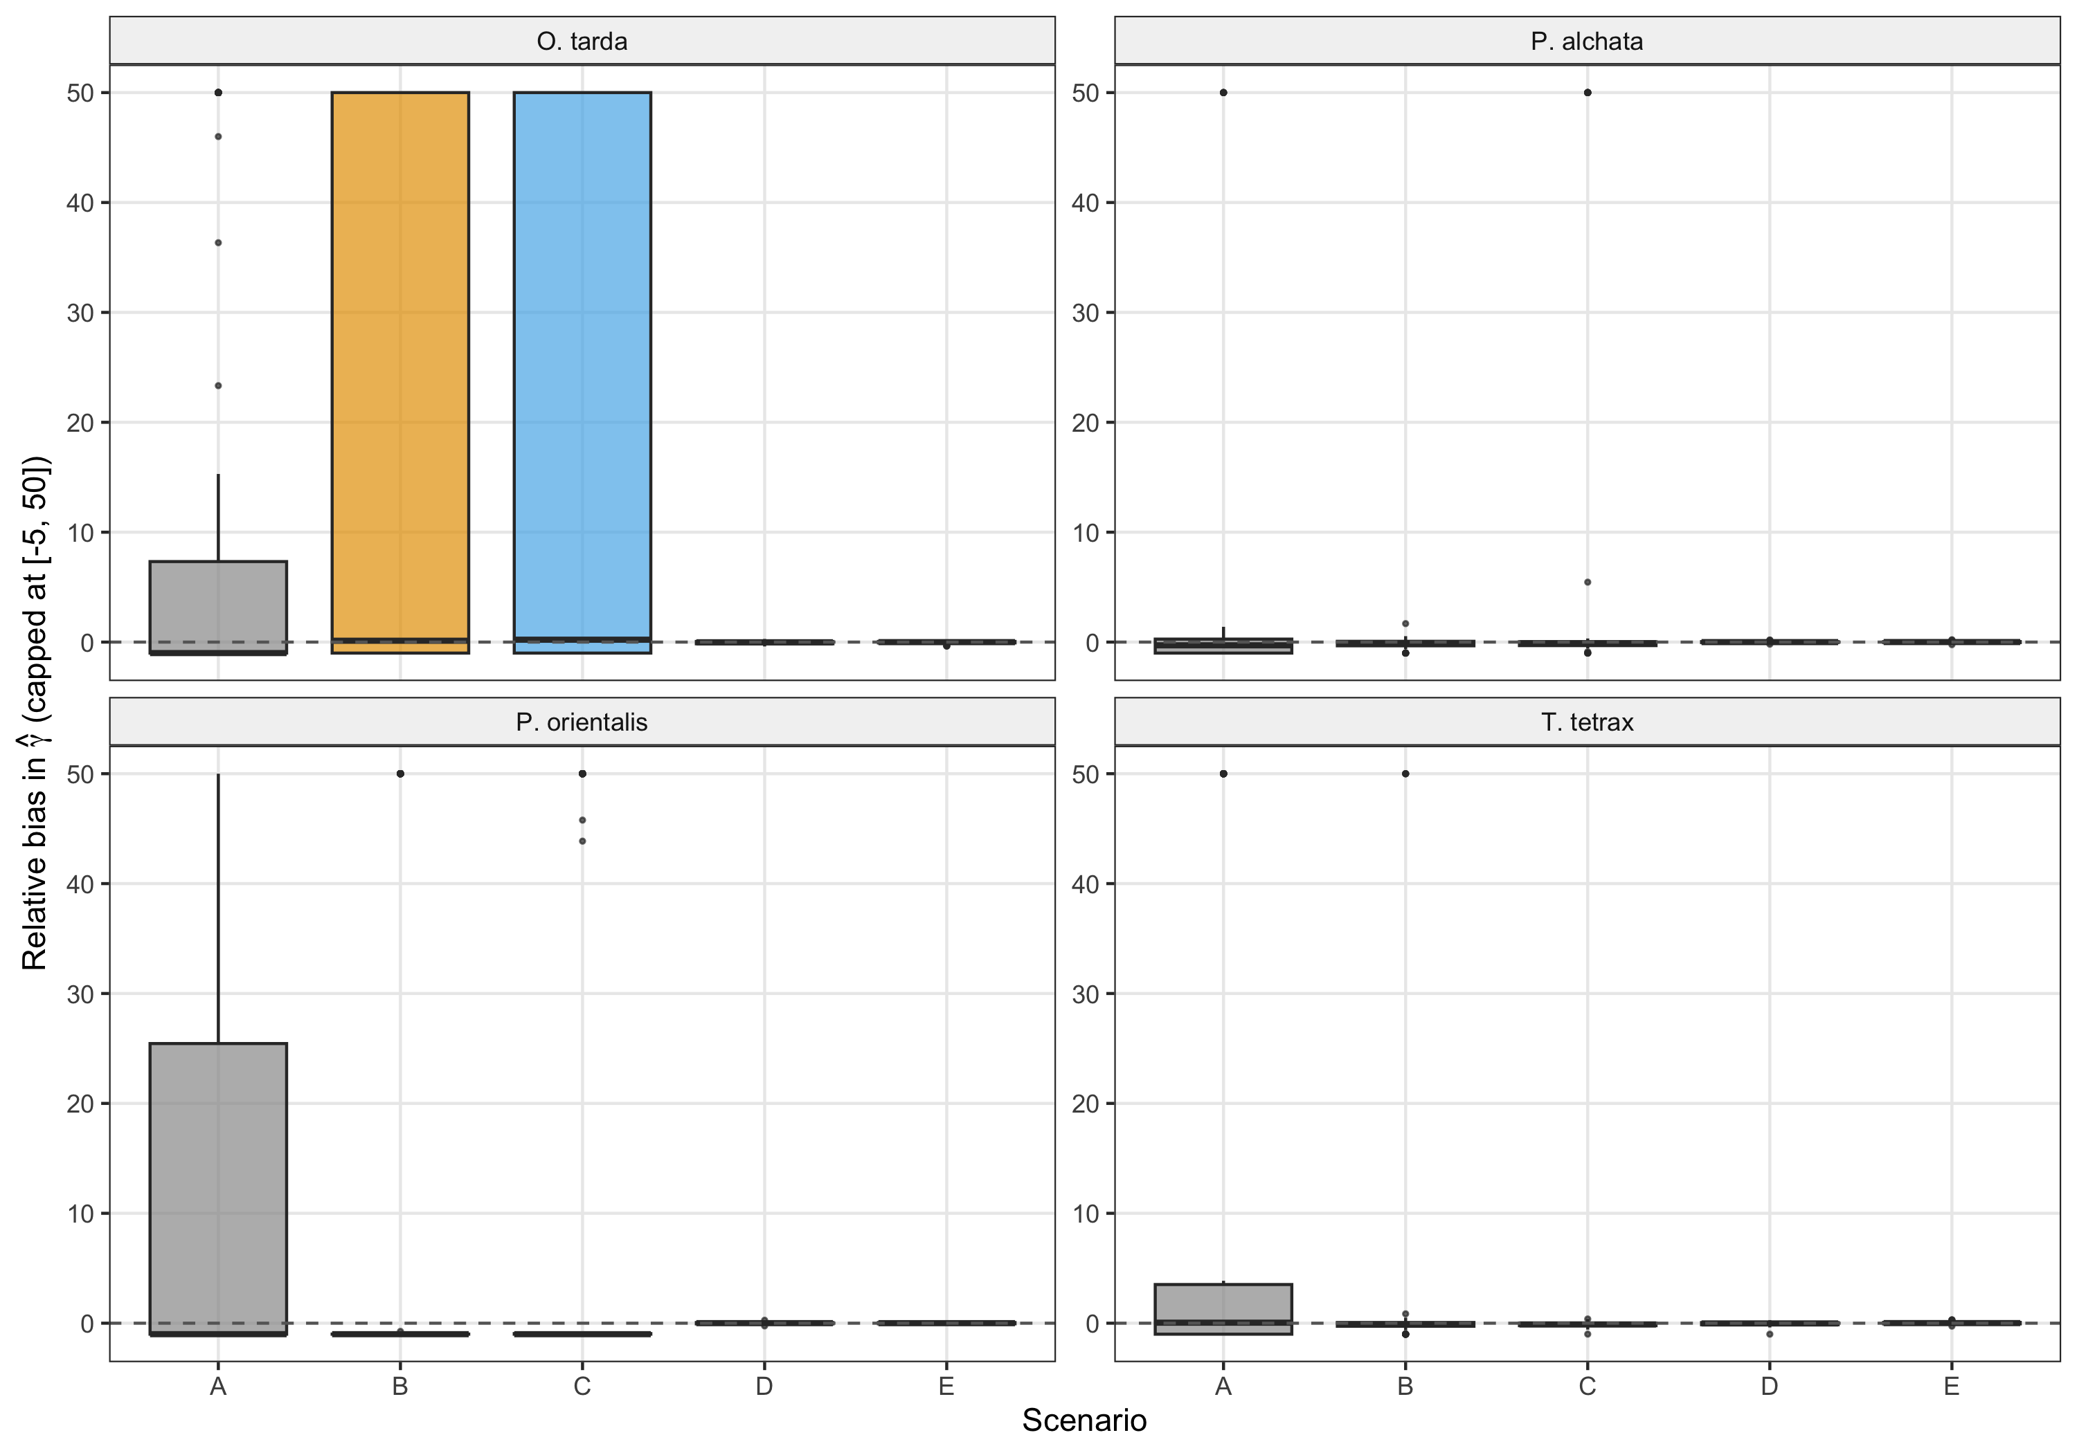
Figure S7. Relative bias in colonisation rate (γ) estimates by scenario, capped at [−5, 50] for visualisation. Dashed line: zero bias. Scenarios D and E show near-zero median bias.
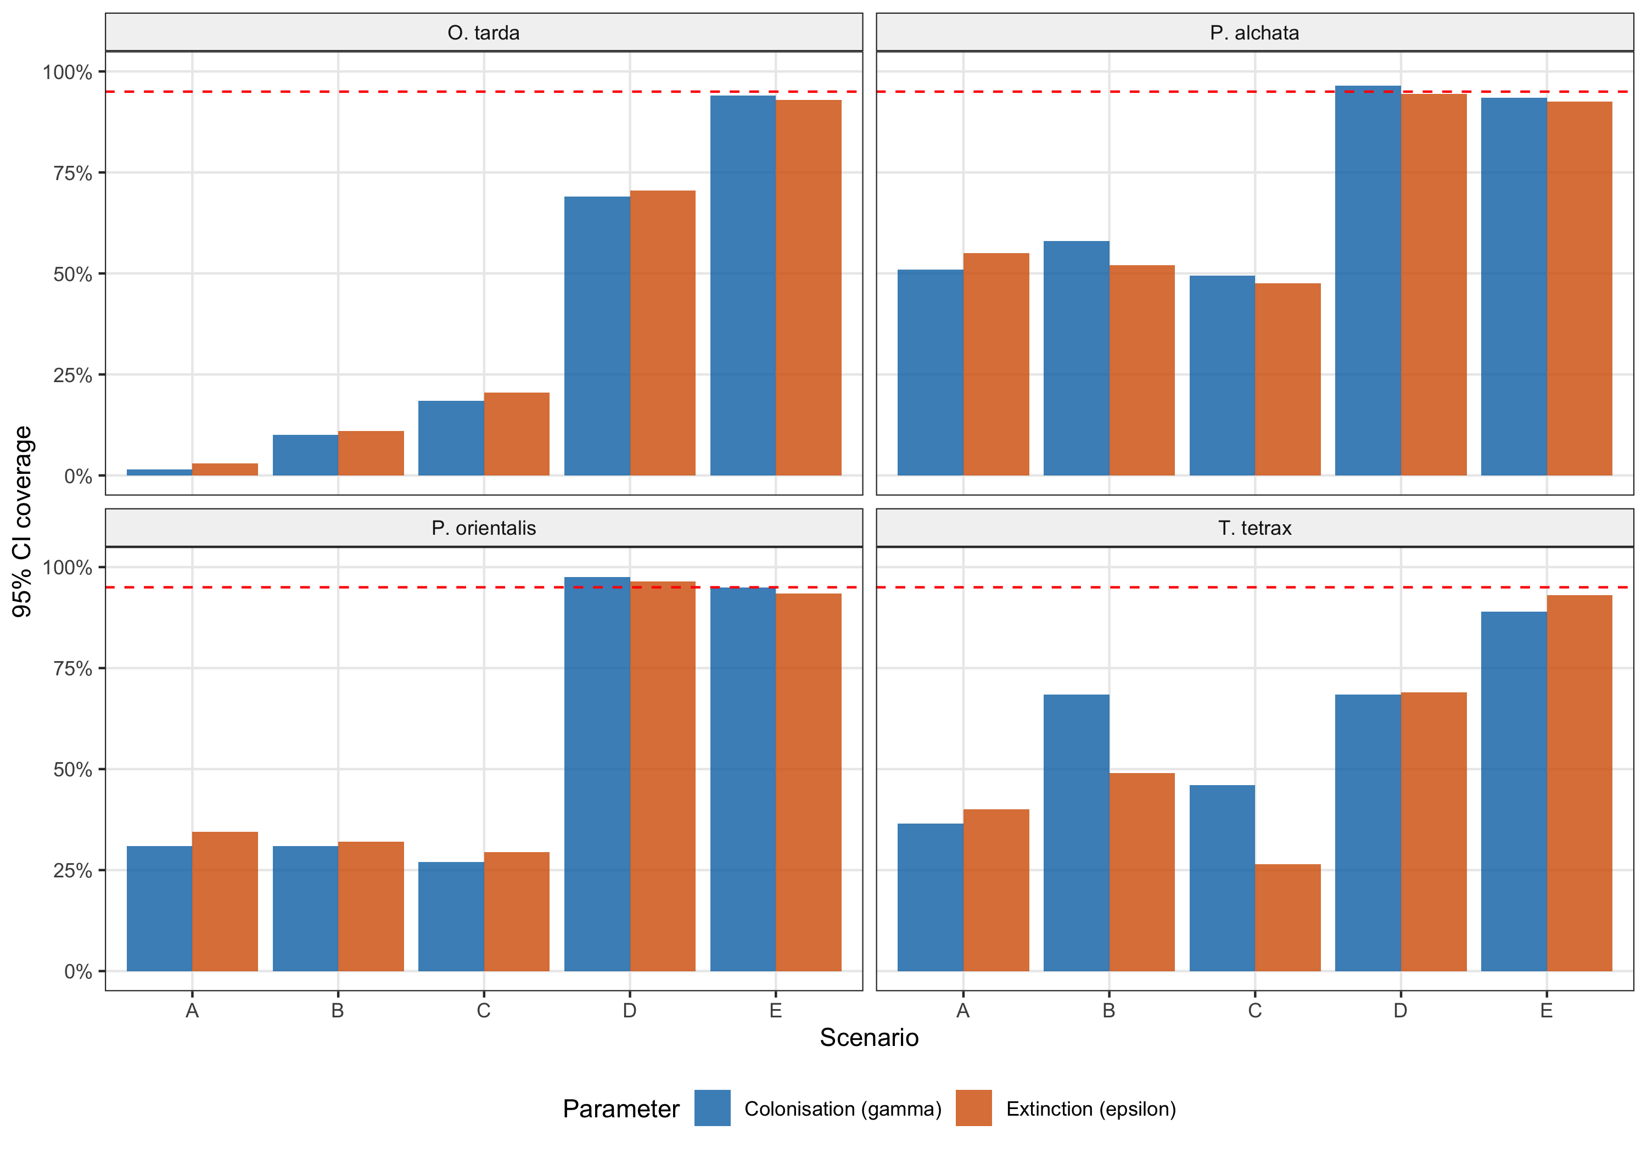
Figure S8. Empirical 95% confidence interval coverage for colonisation (γ, blue) and extinction (ε, orange) by scenario. Dashed red line: nominal 95% level. Coverage approaches nominal for Scenarios D–E where colonisation is detectable.

Appendix S11. Spatial models: stPGOcc robustness check
Spatio-temporal occupancy models (stPGOcc; Doser et al., 2022) were fitted to assess whether residual spatial autocorrelation in the colext models could bias covariate effect estimates or produce spurious colonisation–extinction asymmetry. These models incorporate a nearest-neighbour Gaussian process (NNGP) spatial random effect that absorbs spatially structured residual variation. Models were run for 200,000 iterations per chain with three chains.
Detection and ecological parameters achieved adequate convergence (Rhat < 1.07, ESS > 200 for β coefficients; full diagnostics below). Spatial variance parameters (σ², φ) were less well identified, but this does not affect the key comparison: precluding reliable estimation of effective spatial ranges. The NNGP random effect nevertheless absorbed residual autocorrelation effectively: Moran’s I on stPGOcc residuals was near zero for all species (−0.06 to −0.04, all P > 0.99), compared with 0.29–0.49 (all P < 0.001) under colext.
The direction and relative magnitude of ecological covariate effects were consistent between colext and stPGOcc across all four species. Tree cover exerted a strong negative effect on occupancy in both frameworks (stPGOcc β: −2.97 to −3.77; colext ψ₁: same sign and comparable magnitude). Temperature range (bio2) was positive in both, and maximum temperature showed the same species-specific pattern. This concordance demonstrates that the colonisation–extinction asymmetry diagnosed by colext is not a statistical artefact of residual spatial dependence.
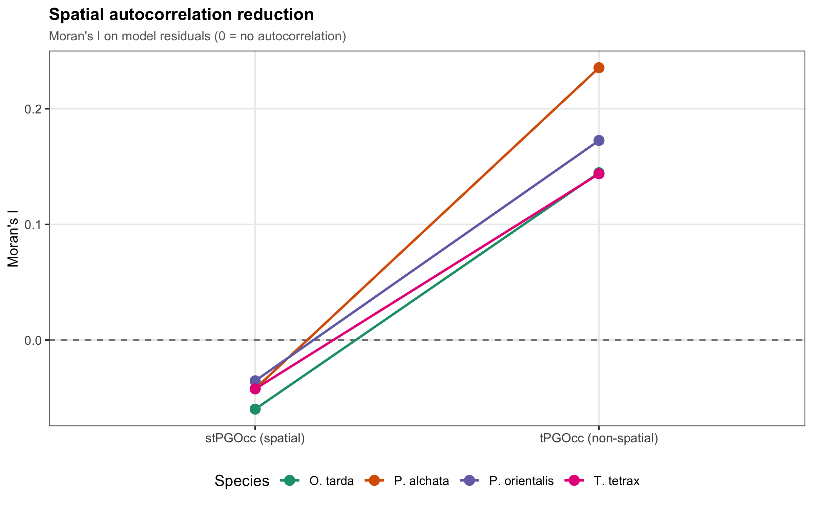
Figure S9. Reduction of spatial autocorrelation in model residuals. Moran’s I values for stPGOcc (spatial, left) versus tPGOcc (non-spatial, right) residuals across all four species. The NNGP spatial random effect reduces Moran’s I to near zero, indicating effective absorption of spatial structure.
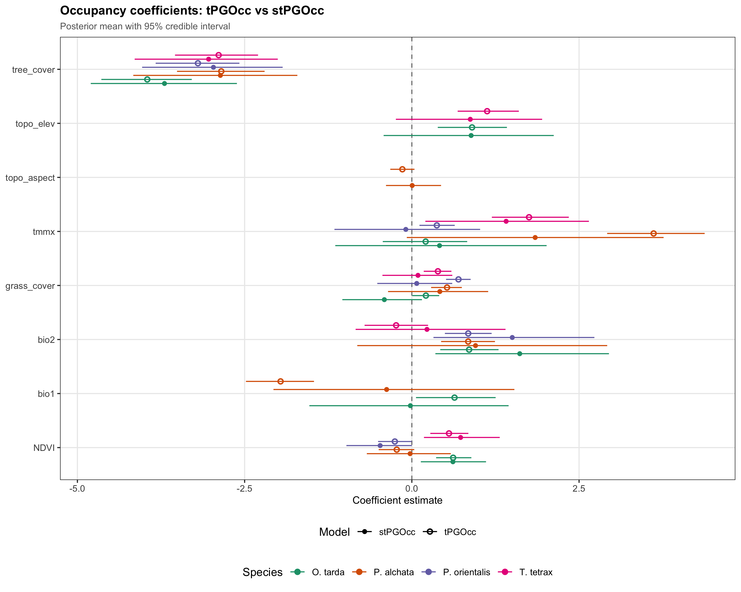
Figure S10. Comparison of occupancy covariate effects between stPGOcc (filled circles) and tPGOcc (open circles) models. Posterior means with 95% credible intervals. The consistency in sign and relative magnitude across frameworks confirms robustness of the ecological signal.

Appendix S12. External validation and model evaluation
Model predictions for initial occupancy (ψ₁) were validated against the III Atlas of Breeding Birds in Spain (SEO/BirdLife, 2022) using spatially blocked cross-validation (block size = 270 km, exceeding the largest estimated spatial autocorrelation range). Validation was restricted to ψ₁; no independent benchmark exists for transition rates at this spatial scale. Table S16 presents the full validation metrics; Figure S10 shows predicted occupancy maps alongside observed versus predicted temporal trends.
Species | AUC | Calibration slope (± SE) | TSS | N test polygons | Block size (km)
O. tarda | 0.884 | 0.609 ± 0.030 | 0.612 | 5202 | 270
T. tetrax | 0.850 | 0.598 ± 0.022 | 0.546 | 5202 | 270
P. alchata | 0.844 | 0.575 ± 0.033 | 0.569 | 5202 | 270
P. orientalis | 0.823 | 0.623 ± 0.029 | 0.536 | 5202 | 270
Table S16. Spatially blocked cross-validation of ψ₁ against the Spanish Breeding Bird Atlas. AUC = area under the ROC curve; uAUC = uniform AUC (Jiménez-Valverde, 2022), correcting for the representativeness effect; calibration slope tested on the logit scale (H₀: slope = 1 = perfect calibration); TSS = true skill statistic. Calibration slopes of 0.57–0.62 indicate moderate overdispersion, expected at coarse spatial resolution.

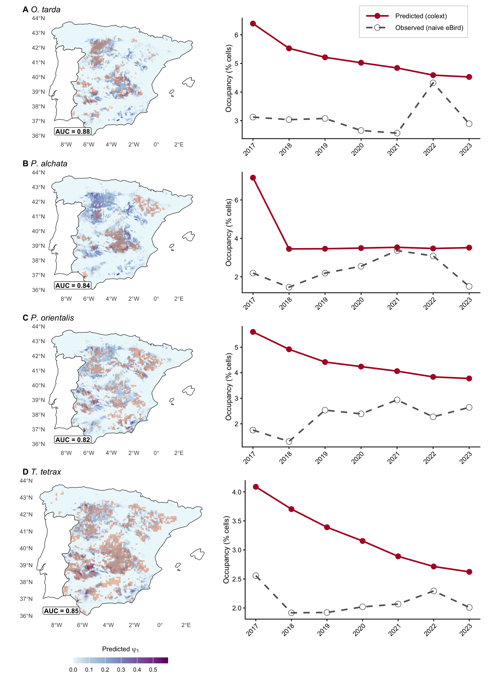
Figure S11. Model evaluation. Left column: predicted initial occupancy (ψ₁) maps with AUC values from spatially blocked cross-validation. Right column: observed (dashed, naive eBird) versus predicted (solid, colext model) occupancy trends 2017–2023 for each species.
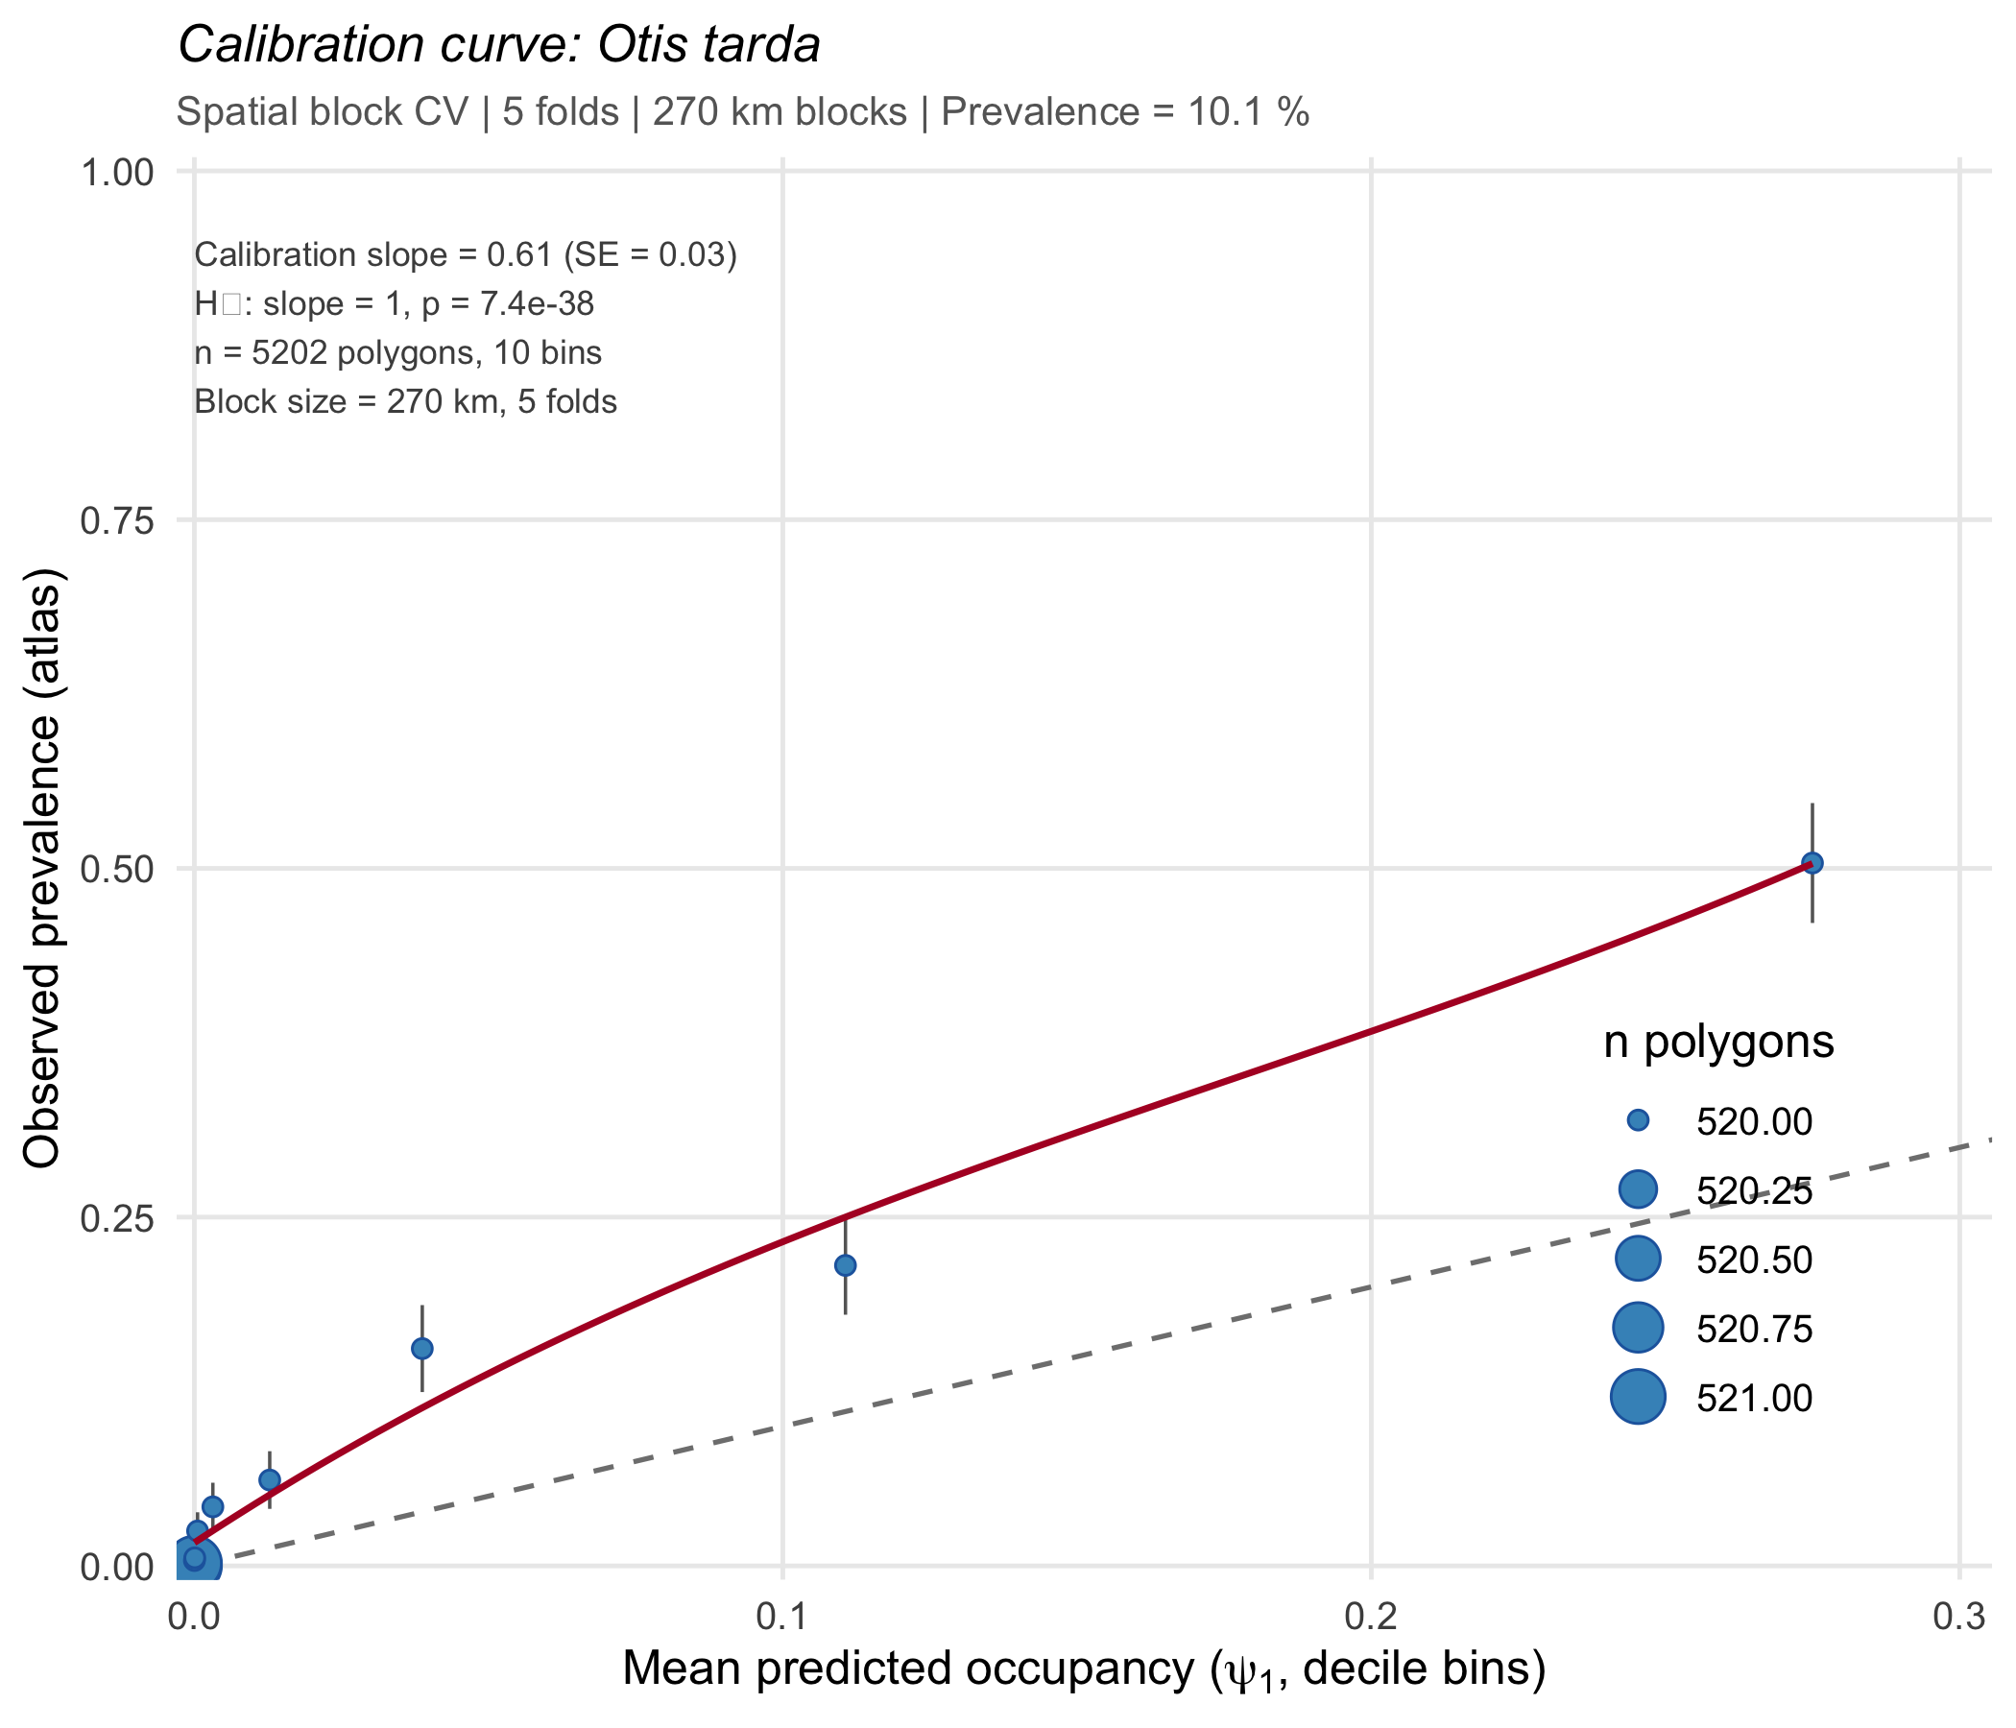
Figure S12a. Calibration curve for O. tarda. Observed versus predicted occupancy probability in decile bins, with logit-scale calibration slope and 95% CI.
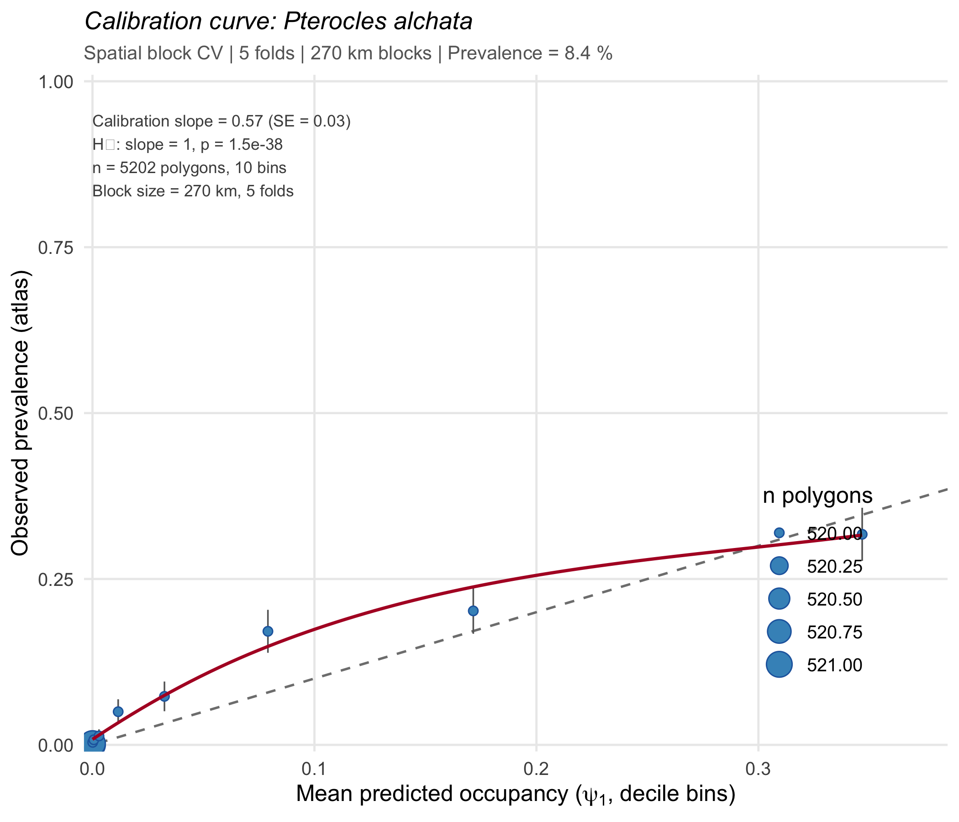
Figure S12b. Calibration curve for P. alchata. Observed versus predicted occupancy probability in decile bins, with logit-scale calibration slope and 95% CI.
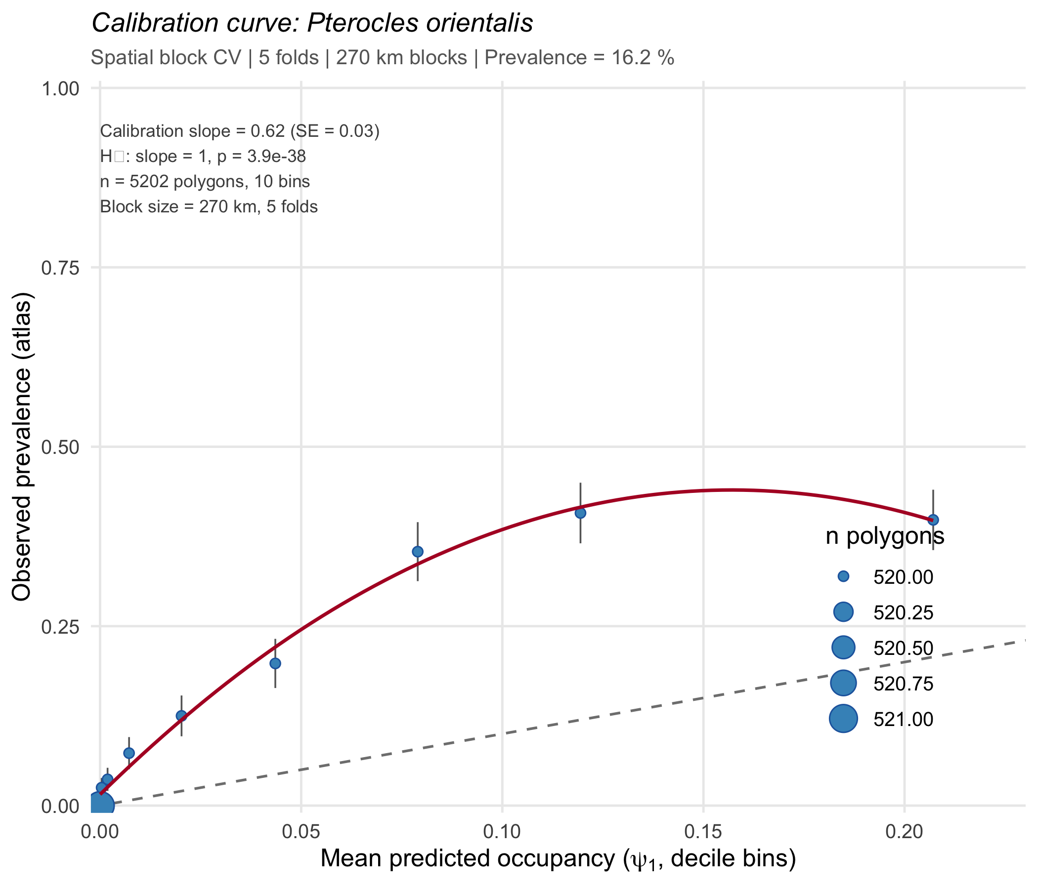
Figure S12c. Calibration curve for P. orientalis. Observed versus predicted occupancy probability in decile bins, with logit-scale calibration slope and 95% CI.
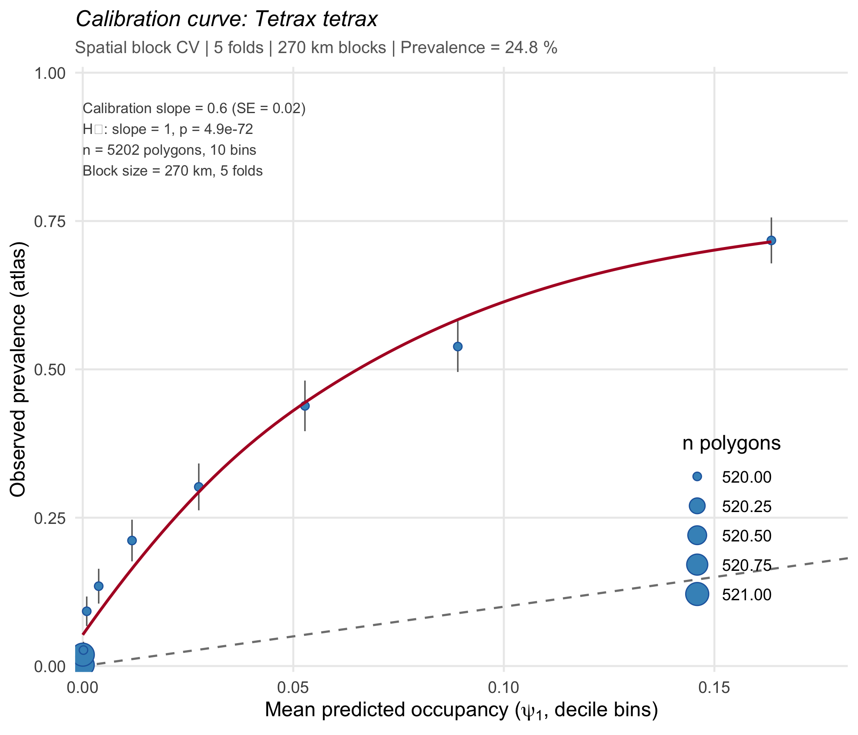
Figure S12d. Calibration curve for T. tetrax. Observed versus predicted occupancy probability in decile bins, with logit-scale calibration slope and 95% CI.

Occupancy change summary (2017–2022)
Species | ψ 2017 | ψ 2022 | Absolute change | % change
O. tarda | 0.06 | 0.05 | -6.69e-03 | -11.7%
T. tetrax | 0.04 | 0.04 | -1.16e-03 | -3.1%
P. alchata | 0.04 | 0.03 | -0.01 | -27.3%
P. orientalis | 0.06 | 0.04 | -0.02 | -37.9%
Table S17. Predicted occupancy change 2017–2022. All four species show declining occupancy, with P. orientalis declining most steeply (−37.9%).

Equilibrium occupancy and extinction debt
Species | Current occ. (%) | ψ* (%) | ψ* 95% CI | Extinction debt (%) | Debt fraction | Recolonisation time (yr)
O. tarda | 0.68 | 0.02 | [4.00e-04, 0.93] | 0.65 | 97% | 22648
T. tetrax | 0.52 | 0.49 | [0.16, 1.62] | 0.03 | 5.4% | 1471
P. alchata | 0.87 | 0.31 | [0.08, 6.50] | 0.56 | 64.1% | 732
P. orientalis | 1.15 | 1.00e-04 | [0, 0.17] | 1.15 | 100% | 2599962
Table S18. Equilibrium occupancy (ψ*) and extinction debt. Current occupancy is the 2017 model-predicted value. Debt fraction is the percentage of current occupancy that is demographically unsustainable (transient). Recolonisation time is the median expected time to recolonise a vacant site at current γ rates.

Appendix S13. Response curves for key covariates
Response curves illustrate the predicted relationship between key environmental covariates and colonisation or extinction probability for each species, holding all other covariates at their mean values. Shaded bands represent 95% confidence intervals derived from the variance-covariance matrix of the fitted model. Rug plots along the x-axis indicate the distribution of observed covariate values.
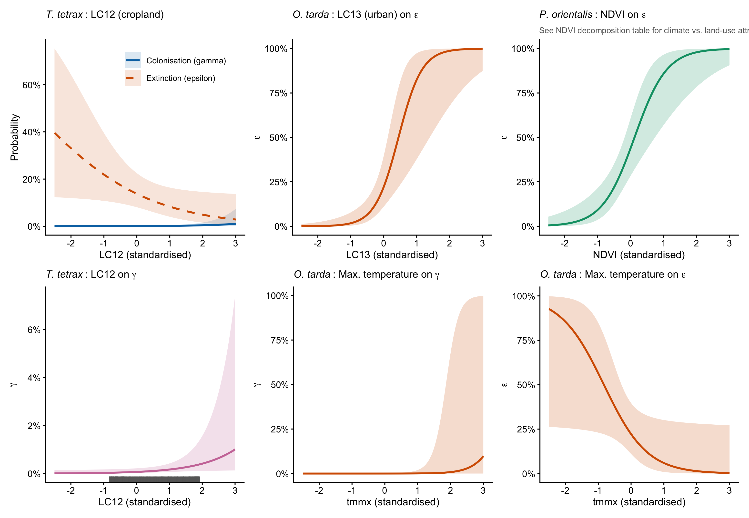
Figure S13. Response curves for selected covariates across species. Top row: T. tetrax cropland (LC12) effects on both γ and ε (left); O. tarda urban land cover (LC13) effect on ε (centre); P. orientalis NDVI effect on ε (right). Bottom row: T. tetrax LC12 effect on γ (left); O. tarda maximum temperature effects on γ (centre) and ε (right). For T. tetrax, cropland simultaneously increases colonisation and decreases extinction, making it the only species where agri-environment instruments plausibly act on both demographic processes.

Appendix S14. Occupancy prevalence trends
Occupancy prevalence was projected forward from the fitted colext model parameters using 5,000 bootstrap simulations from the variance-covariance matrix. For each simulation, the predicted proportion of occupied cells was computed year by year using the Markov chain transition equation: ψ(t+1) = ψ(t)(1 − ε) + (1 − ψ(t))γ. The dashed horizontal line indicates the equilibrium occupancy (ψ* = γ/(γ + ε)), representing the occupancy level toward which the system converges under current demographic rates.
Figure S14. Predicted occupancy prevalence trends 2017–2023 for all four species with 95% bootstrap confidence intervals (shaded bands). Solid lines: median predicted prevalence. Dashed horizontal lines: equilibrium occupancy (ψ*) implied by current γ and ε rates. P. orientalis shows the steepest decline, consistent with the most extreme colonisation–extinction asymmetry. T. tetrax remains closest to its equilibrium, reflecting relatively higher colonisation capacity.

Appendix S15. Likelihood resolution analysis
This analysis and Appendices S16–S17 assess whether low colonisation estimates reflect lack of statistical identifiability rather than true demographic rates. Colonisation is weakly identifiable for some species, but this does not affect the inference of strong asymmetry because extinction is well estimated and colonisation remains consistently low across the likelihood surface (Appendix S16). Here we determine the resolution boundary of the colext estimator by simulation. For each species, we generated detection histories using empirical parameter estimates (ψ₁, ε, p), varying γ across eight levels spanning 10⁻⁷ to 0.05 (50 replicates each). Each replicate was fitted with the species-specific best colext model. The resolution boundary is the lowest γ_true at which fewer than 10% of replicates return boundary estimates.

Table S19. Likelihood resolution analysis results. For each species and true colonisation rate (γ_true), the table shows: n = number of replicates, γ̂ median = median estimated colonisation rate, relative bias (%), percentage of boundary estimates, and percentage of estimates above the numerical floor.
Species | γ_true | n | γ̂ median | Rel. bias (%) | % boundary | % above floor
O. tarda | 1.00e-07 | 50 | 0.00e+00 | -100.0 | 94 | 18
O. tarda | 6.52e-07 | 50 | 0.00e+00 | -100.0 | 86 | 22
O. tarda | 4.25e-06 | 50 | 0.00e+00 | -100.0 | 92 | 14
O. tarda | 2.77e-05 | 50 | 0.00e+00 | -100.0 | 86 | 28
O. tarda | 1.81e-04 | 50 | 0.000184 | 1.9 | 66 | 60
O. tarda | 0.00118 | 50 | 0.001552 | 31.9 | 36 | 84
O. tarda | 0.00767 | 50 | 0.006537 | -14.8 | 4 | 100
O. tarda | 0.05000 | 50 | 0.050857 | 1.7 | 0 | 100
T. tetrax | 1.00e-07 | 50 | 6.73e-18 | -100.0 | 74 | 40
T. tetrax | 6.52e-07 | 50 | 3.56e-13 | -100.0 | 64 | 46
T. tetrax | 4.25e-06 | 50 | 5.25e-22 | -100.0 | 70 | 44
T. tetrax | 2.77e-05 | 50 | 5.48e-13 | -100.0 | 72 | 48
T. tetrax | 1.81e-04 | 50 | 5.95e-07 | -99.7 | 48 | 66
T. tetrax | 0.00118 | 50 | 0.001409 | 19.7 | 38 | 92
T. tetrax | 0.00767 | 50 | 0.006879 | -10.3 | 0 | 100
T. tetrax | 0.05000 | 50 | 0.049893 | -0.2 | 0 | 100
P. alchata | 1.00e-07 | 50 | 2.18e-196 | -100.0 | 82 | 12
P. alchata | 6.52e-07 | 50 | 2.51e-36 | -100.0 | 72 | 30
P. alchata | 4.25e-06 | 50 | 1.70e-178 | -100.0 | 68 | 30
P. alchata | 2.77e-05 | 50 | 5.02e-36 | -100.0 | 58 | 24
P. alchata | 1.81e-04 | 50 | 7.61e-08 | -100.0 | 48 | 54
P. alchata | 0.00118 | 50 | 0.000892 | -24.2 | 18 | 78
P. alchata | 0.00767 | 50 | 0.006924 | -9.7 | 4 | 100
P. alchata | 0.05000 | 50 | 0.050521 | 1.0 | 0 | 100
P. orientalis | 1.00e-07 | 50 | 5.36e-10 | -99.5 | 56 | 42
P. orientalis | 6.52e-07 | 50 | 5.89e-10 | -99.9 | 54 | 42
P. orientalis | 4.25e-06 | 50 | 3.88e-10 | -100.0 | 52 | 34
P. orientalis | 2.77e-05 | 50 | 5.03e-10 | -100.0 | 50 | 38
P. orientalis | 1.81e-04 | 50 | 4.65e-10 | -100.0 | 46 | 38
P. orientalis | 0.00118 | 50 | 0.000173 | -85.3 | 16 | 68
P. orientalis | 0.00767 | 50 | 0.006789 | -11.5 | 0 | 100
P. orientalis | 0.05000 | 50 | 0.050248 | 0.5 | 0 | 100

Three of four species have empirical γ̂ values below the resolution boundary (~1.2 × 10⁻³ for O. tarda, P. alchata, and T. tetrax; ~7.7 × 10⁻³ for P. orientalis). Below these thresholds, the likelihood surface is uninformative and point estimates should not be interpreted as precise values. The key inference — that ε/γ asymmetry is extreme — does not depend on the precise γ̂ value: even at the resolution boundary, the minimum ε/γ ratio across species exceeds 58.

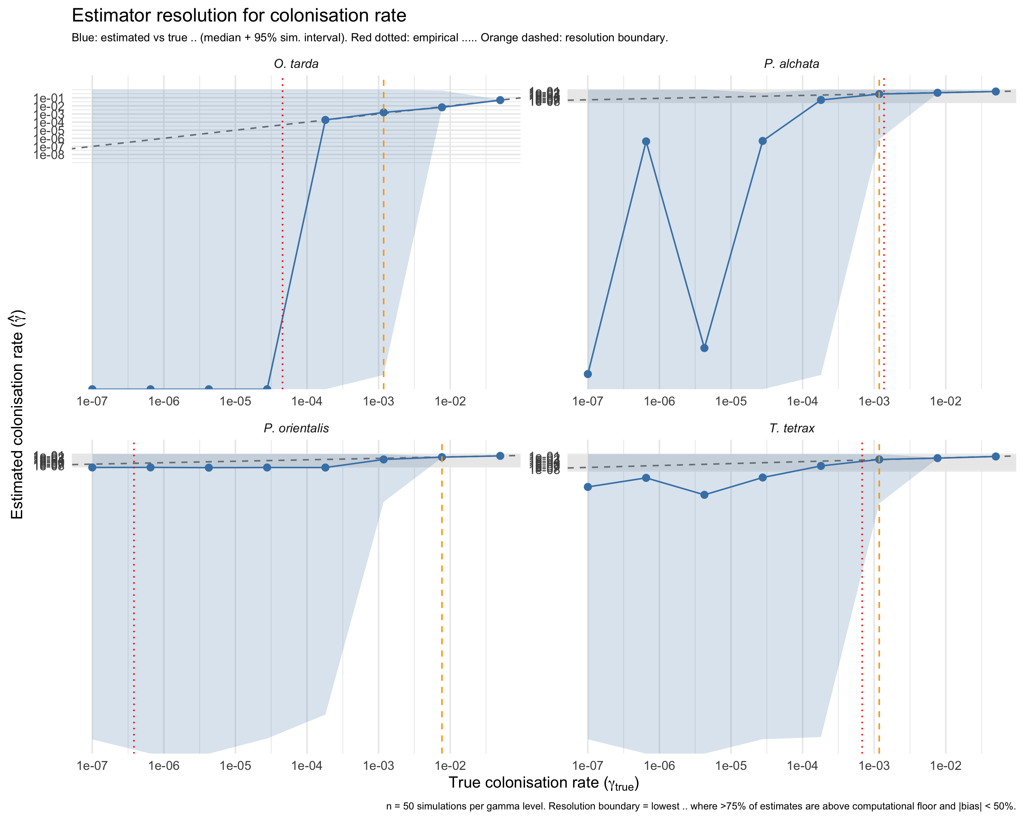
Figure S15. Likelihood resolution analysis. Estimated colonisation rate (γ̂) versus true colonisation rate (γ_true) for four species across eight simulation levels. Points show median estimates (n = 50 replicates); vertical bars show interquartile range. The dashed diagonal indicates perfect recovery. The shaded region marks γ_true values below the species-specific resolution boundary.

Appendix S16. Profile likelihood analysis for baseline colonisation rates
We evaluated the identifiability of baseline colonisation (γ) by computing profile likelihood curves for each species. For each species, the intercept of the γ submodel was fixed at 30 evenly spaced values on the logit scale, spanning γ ∈ [10⁻⁸, 0.1], while all remaining parameters (ψ₁, ε, p, and γ covariates) were re-optimised via BFGS. The 95% confidence interval was determined by likelihood ratio test (Δ log-likelihood < 1.92).

Table S20. Profile likelihood results for baseline colonisation rates. MLE = maximum likelihood estimate; CI = confidence interval from likelihood ratio test (Δ log-likelihood < 1.92).
Species | MLE γ | 95% CI lower | 95% CI upper | CI width (orders of mag.)
O. tarda | 4.55 × 10⁻⁵ | 8.53 × 10⁻⁷ | 3.56 × 10⁻³ | 3.6
T. tetrax | 6.79 × 10⁻⁴ | 1.27 × 10⁻⁴ | 1.17 × 10⁻³ | 1.0
P. alchata | 1.37 × 10⁻³ | 3.86 × 10⁻⁴ | 2.04 × 10⁻³ | 0.7
P. orientalis | 3.82 × 10⁻⁷ | < 10⁻⁸ | 7.28 × 10⁻⁵ | > 3.9

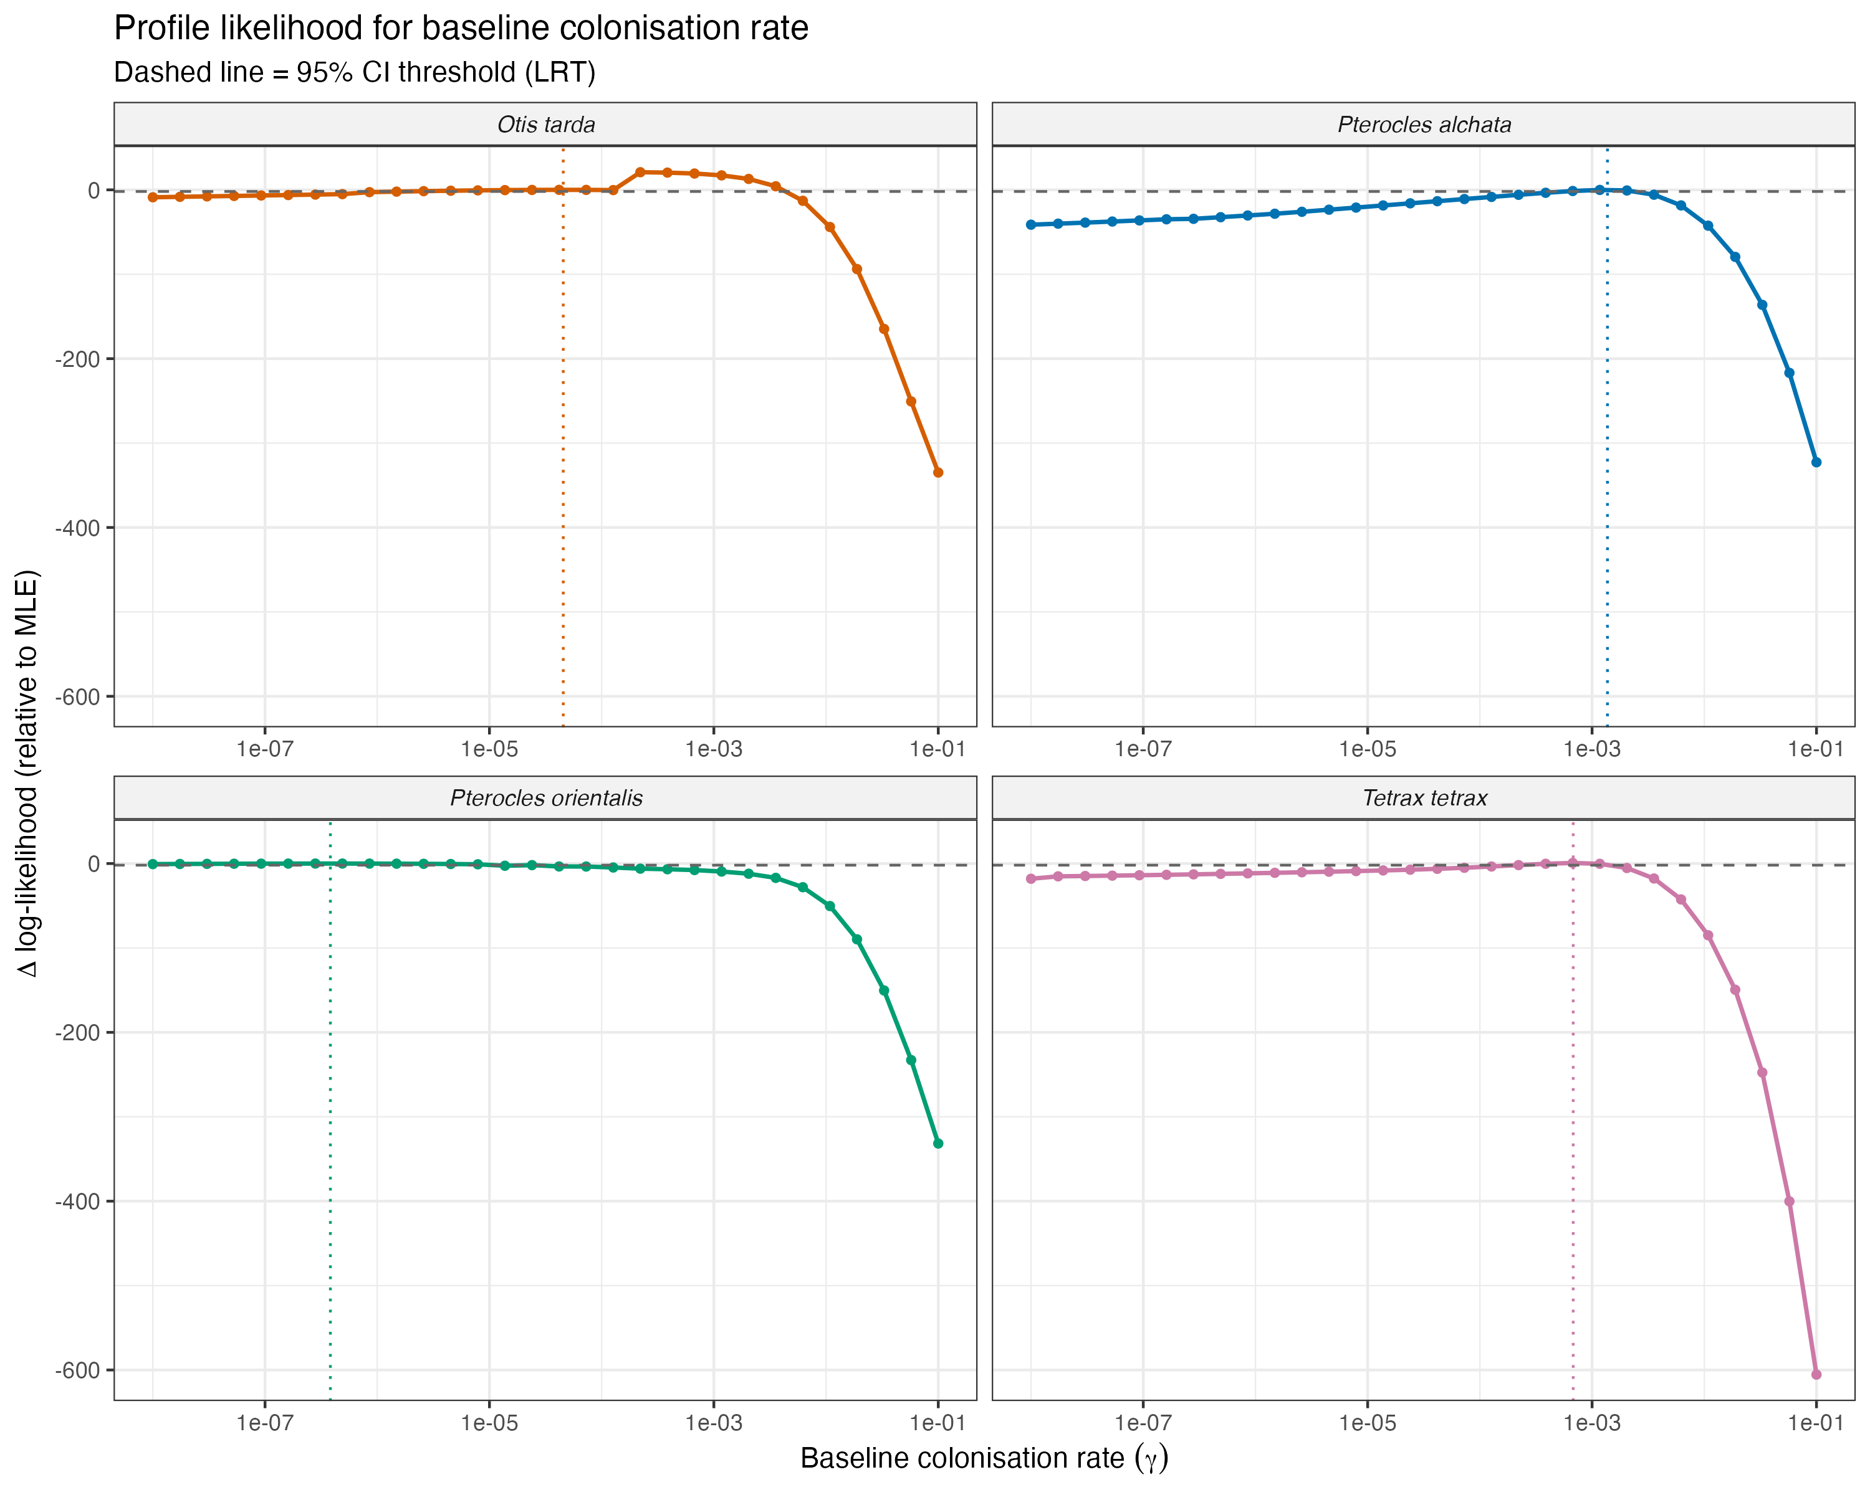
Figure S16. Profile likelihood curves for baseline colonisation rate (γ) across the four study species. Dashed horizontal line indicates the 95% confidence threshold (Δ log-likelihood = 1.92); vertical dotted line marks the MLE. P. alchata and T. tetrax show well-resolved likelihood peaks, while O. tarda exhibits a broad plateau and P. orientalis has a nearly flat surface across several orders of magnitude.

Appendix S17. Events-per-variable diagnostic and intercept-only colonisation models
Sparse colonisation events can compromise the identifiability of covariate effects in the γ submodel. We computed the events-per-variable (EPV) ratio — the number of naive colonisation events divided by the number of estimated γ parameters — as a diagnostic for potential sparse-data bias. As a complementary sensitivity check, we refitted each species model replacing the full γ submodel with an intercept-only specification (γ ~ 1), keeping all other submodels (ψ₁, ε, p) unchanged.

Table S21. Events-per-variable diagnostic and intercept-only colonisation sensitivity. EPV = naive colonisation events / number of γ parameters. ΔAIC = AIC(intercept-only) − AIC(full model); negative values favour the intercept-only model.
Species | Col. events | γ params | EPV | γ full model | γ intercept-only | ΔAIC | Rel. change (%)
O. tarda | 17 | 5 | 3.4 | 4.55 × 10⁻⁵ | 1.15 × 10⁻³ | −19.6 | +2420
T. tetrax | 11 | 2 | 5.5 | 6.79 × 10⁻⁴ | 7.78 × 10⁻⁴ | +0.8 | +14.6
P. alchata | 16 | 2 | 8.0 | 1.37 × 10⁻³ | 1.42 × 10⁻⁹ | +43.5 | −100
P. orientalis | 22 | 5 | 4.4 | 3.82 × 10⁻⁷ | 2.40 × 10⁻³ | +1108.8 | +626,610

No species reached the conventional EPV ≥ 10 threshold. T. tetrax showed the most stable γ estimate (14.6% change; ΔAIC ≈ 0), indicating that its covariate structure is supported despite low EPV. For O. tarda, the intercept-only model yielded a 25-fold higher γ with a lower AIC, suggesting that the covariate-based γ estimate is sensitive to model specification. P. orientalis exhibited extreme instability (six orders of magnitude change), consistent with a near-flat likelihood surface for γ (Appendix S16). Critically, even the most generous intercept-only γ estimates remain orders of magnitude below ε for all species, confirming that the colonisation–extinction asymmetry is robust to model specification choices in the γ submodel.

Appendix S18. Detection model sensitivity analysis
To evaluate whether the colonisation–extinction asymmetry could be an artefact of detection model complexity, we refitted each species model with a simplified detection submodel (p ~ survey duration only) and compared γ and ε estimates against the full detection model. Confidence intervals were obtained via multivariate normal approximation (5,000 draws from the variance–covariance matrix).
The simplified detection model failed to converge for O. tarda, P. alchata, and P. orientalis, indicating that the additional detection covariates are necessary for model identifiability in these species. For T. tetrax, both models converged:

Table S22. Detection model sensitivity for T. tetrax. Full detection model includes all survey-level covariates; simplified model retains only survey duration. Values in parentheses are 95% confidence intervals from MVN approximation.
Parameter | Full detection model | Simplified (p ~ duration) | Change (%)
γ | 6.79 × 10⁻⁴ (2.12 × 10⁻⁴, 2.17 × 10⁻³) | 7.40 × 10⁻⁴ (2.68 × 10⁻⁴, 2.06 × 10⁻³) | +9.0
ε | 0.138 (0.080, 0.226) | 0.134 (0.078, 0.223) | −2.3
ε/γ ratio | 203 (61, 655) | 182 (64, 515) | −10.3
AIC | 1780.1 | 1790.1 | —

The colonisation–extinction asymmetry was preserved under the simplified detection model (ε/γ = 182 vs. 203), with the full detection model preferred by AIC.

Table S23. Parametric bootstrap goodness-of-fit (n = 500).
Species | AIC | χ² (obs) | χ² (sim mean) | parboot P | Fit
O. tarda | 2267.9 | 352.4 | 333.6 | 0.28 | Adequate
T. tetrax | 1780.1 | 290.9 | 307.9 | 0.66 | Adequate
P. alchata | 1981.7 | 363.4 | 364.6 | 0.52 | Adequate
P. orientalis | 2060.7 | 276.0 | 330.6 | 0.93 | Adequate

Table S24. Best-fit colext models per species with AIC-selected covariates.
Species | ψ₁ covariates | γ covariates | ε covariates | N sites
O. tarda | bio1, bio2, tree, grass, elev | NDVI⁺, pr, tmmn, tmmx | LC6, LC13, tmmx | 3,745
T. tetrax | bio2, tree, grass, elev | LC12 | LC12 | 3,746
P. alchata | bio1, bio2, tree, grass, aspect | pr [excl. attrib.] | pr, tmmx [wide SE] | 4,130
P. orientalis | bio2, tree, grass | LC7, NDVI⁺, tmmn, tmmx | LC12, NDVI⁺, pr | 4,130

Table S25. Naive versus detection-corrected colonisation (γ) and extinction (ε) rates.
Species | Naive γ (%) | Corrected γ (%) | Fold reduction | Naive ε (%) | Corrected ε (%) | ε ratio
O. tarda | 0.89 | 0.0045 | 203× | 44.6 | 22.2 | 0.50
T. tetrax | 0.57 | 0.068 | 8.5× | 36.0 | 13.8 | 0.38
P. alchata | 0.63 | 0.14 | 4.6× | 28.1 | 48.9 | 1.72⁺
P. orientalis | 0.87 | ~0 | 21,839× | 34.1 | 44.1 | 0.78

Table S26. Extinction debt: current versus equilibrium occupancy.
Species | Current occ. (%) | ψ* (%) | Extinction debt (%) | Debt fraction | Recolonisation time (yr)
O. tarda | 0.68 | 0.02 | 0.65 | 97% | 22,648
T. tetrax | 0.52 | 0.49 | 0.03 | 5% | 1,471
P. alchata | 0.87 | 0.31 | 0.56 | 64% | 732
P. orientalis | 1.15 | 0.0001 | 1.15 | 100% | ≫10⁶

Table S27. Delta-gamma: colonisation rate required for 10% equilibrium occupancy.
Species | γ required (%) | Multiplier (median) | Multiplier 95% CI
O. tarda | 0.025 | 541× | 6–27,855×
T. tetrax | 0.015 | 22× | 7–73×
P. alchata | 0.055 | 35× | 2–148×
P. orientalis | 0.049 | 117,215× | 86–244,501,693×

Table S28. Spatially blocked cross-validation of ψ₁ against the Spanish Breeding Bird Atlas. uAUC = uniform AUC (Jiménez-Valverde, 2022), correcting for the representativeness effect.
Species | AUC | uAUC | Calibration slope | TSS | N test polygons
O. tarda | 0.884 | 0.693 | 0.609 ± 0.030 | 0.612 | 5,202
T. tetrax | 0.850 | 0.763 | 0.598 ± 0.022 | 0.546 | 5,202
P. alchata | 0.844 | 0.607 | 0.575 ± 0.033 | 0.569 | 5,202
P. orientalis | 0.823 | 0.732 | 0.623 ± 0.029 | 0.536 | 5,202

Appendix S19. Robustness to within-cell sampling structure: the stepRep covariate

S19.1 Motivation
The main-text detection sub-model controls for the heterogeneity of citizen-science effort with four checklist-level covariates: survey duration, distance travelled, number of observers, and time of day. These quantities capture the per-visit characteristics of each eBird checklist. They do not, however, capture where, within a 5 km grid cell, an observer chose to walk or stand. eBird checklists are spatially non-uniform within cells (Johnston et al., 2021): observers preferentially visit accessible sites, recently-reported localities, and habitats whose visual or acoustic properties facilitate identification. For habitat specialists such as the four species considered here, this within-cell sampling structure is consequential. A 5 km cell containing 30 % of its area as non-irrigated arable land and pastures can be sampled, in any given year, almost exclusively along its forested edges or, alternatively, almost exclusively across its open patches. The probability that a checklist detects a great bustard or a sandgrouse differs by an order of magnitude between those two scenarios, regardless of survey duration or observer count.
If the within-cell distribution of checklists were constant over the seven-year study window, this bias would be absorbed into the intercept of the detection sub-model and would not affect inference about the temporal processes of colonisation and extinction. If, on the other hand, the within-cell distribution shifts systematically over time, the bias becomes time-varying and can be misattributed by the model to changes in the state process (γ or ε). The naive prediction is that rising within-cell sampling efficiency over time, the scenario in which observers progressively concentrate on the actual habitat patches where focal species are detectable, would inflate apparent persistence in late years and therefore deflate apparent extinction. A detection sub-model that ignores this structure cannot distinguish a genuine reduction in local extinction risk from an artefact of improving observer choice. We constructed an explicit covariate to test for this possibility.

S19.2 Construction of the steppe-representativeness covariate
We used the CORINE Land Cover 2018 product, version 20u1 at 100 m resolution and EPSG:3035 (Copernicus Land Monitoring Service; Büttner et al., 2021), as the static habitat reference. CORINE 2018 is the canonical Level-3 land-cover product covering the full study area and supports the class codes used in the established Iberian steppe-bird habitat literature (Brotons et al., 2004; Delgado & Moreira, 2000; Suárez et al., 1997; Traba & Morales, 2019). Treating the habitat layer as static across 2017–2023 is appropriate at this scale because pseudo-steppe land-cover converts slowly relative to the seven-year window; consequently, the cell-year variation in the new covariate reflects the spatial structure of sampling effort within each cell, not habitat change.
We defined a binary pseudo-steppe mask comprising four CORINE Level-3 classes: 211 (non-irrigated arable land), 231 (pastures), 321 (natural grasslands) and 333 (sparsely vegetated areas). These are the four classes consistently identified as primary breeding habitat for Otis tarda, Tetrax tetrax, Pterocles alchata and Pterocles orientalis in the Iberian Peninsula (Brotons et al., 2004; Delgado & Moreira, 2000; Suárez et al., 1997; Traba & Morales, 2019). Three CORINE classes that are sometimes occupied by these species under specific configurations, 242 (complex cultivation patterns), 243 (agriculture with significant areas of natural vegetation) and 244 (agro-forestry / dehesa), were grouped into a broader mask used as a sensitivity check (results not shown; effects in the same direction with attenuated magnitude). Permanently irrigated land (212), rice fields (213), vineyards (221) and olive groves (223) were excluded explicitly, in agreement with the same literature.
We then computed the per-checklist representativeness value as follows. Each unique eBird checklist that survived the effort filters of the main analysis was projected from WGS84 to ETRS89-LAEA Europe (EPSG:3035), and the proportion of a 500 m circular buffer around its location that was occupied by mask = 1 pixels was extracted from a focal raster pre-computed with terra::focal using a normalised circular kernel of radius 5 pixels (Hijmans, 2024). Pixels outside CORINE coverage were treated as zero, so that buffers near the coast were correctly diluted by the absence of land. The radius of 500 m is shorter than the typical eBird checklist transect (median travel distance 0.6 km in our filtered dataset), and was chosen to capture the immediate detection neighbourhood without averaging out fine-scale habitat selection by observers. Sensitivity with a 1 km buffer is reported below.
For each species' modelling table, per-checklist values were aggregated to the (cell, year) level by an unweighted mean and then merged into the wide-format detection table by the WorldClim 5 km cell index that already structures the main-text models. Within the colext fits, the resulting yearly site covariate stepRep was standardised in the same step as the other dynamic covariates (NDVI, precipitation, minimum and maximum temperature, MODIS land cover classes), expanded to observation-level dimensions in parallel with NDVI_obs and pr_obs, and entered the detection sub-model as stepRep_obs. The remainder of the modelling framework is unchanged from §2.4 of the main text.

S19.3 Temporal patterns in within-cell sampling structure
Within-cell sampling structure shifted systematically over time in cells where focal species are detected. The annual checklist-weighted mean of stepRep_strict_500m in cells with at least one detection of the focal species rose monotonically from 0.48 in 2017 to 0.62 in 2023 for Otis tarda, from 0.30 to 0.44 for Pterocles alchata, from 0.49 to 0.59 for Pterocles orientalis, and from 0.50 to 0.61 for Tetrax tetrax (Figure S17A). Across the full peninsular sample, by contrast, the same statistic was flat across years (range 0.21–0.25 across the entire window for all four species). The two-panel structure of Figure S17 makes this divergence explicit: in cells where the focal species are present, the proportion of checklists falling on actual pseudo-steppe pixels exceeded the peninsular average by 0.08 to 0.27 in 2017 and by 0.22 to 0.39 in 2023 (Figure S17B), an increase of 0.09 to 0.14 on the [0, 1] scale over the seven-year period.
The mechanism likely combines two effects. First, de novo eBird participants entering the platform during the study period tended to start their checklists in accessible or well-publicised locations and only later, as their familiarity with local birding spots grew, redirected effort towards open agricultural landscapes where steppe birds are recorded. Second, the publication of species records from these cells on eBird-derived hotspots and on regional birding portals (Reservoir Birds, Aves Ibéricas) generated feedback effects, with subsequent observers targeting the specific parcels where conspecific records had accumulated. Neither effect is captured by aggregate effort measures: Spearman rank correlation between log(n_checklists) and stepRep_strict_500m at the cell-year level was indistinguishable from zero in all four species (ρ between −0.005 and −0.05), confirming that the temporal pattern in Figure S17 operates independently of the effort covariates already in the main-text detection sub-model.
This pattern is the structural confounder we set out to test. If left unmodelled, late-period checklists in occupied cells would carry more information per visit than early-period ones, and the model would have to reconcile a roughly stable observed detection trajectory with an underlying ψ-trajectory that, on the naive expectation, would appear more stable than it actually is. The resulting bias would propagate into the transition sub-models: γ would be inflated if apparent recolonisations are partly composed of late-period rediscoveries; ε would be deflated if apparent persistence is partly composed of improving observation. The remainder of this Appendix tests whether either bias is present in the headline main-text fits.
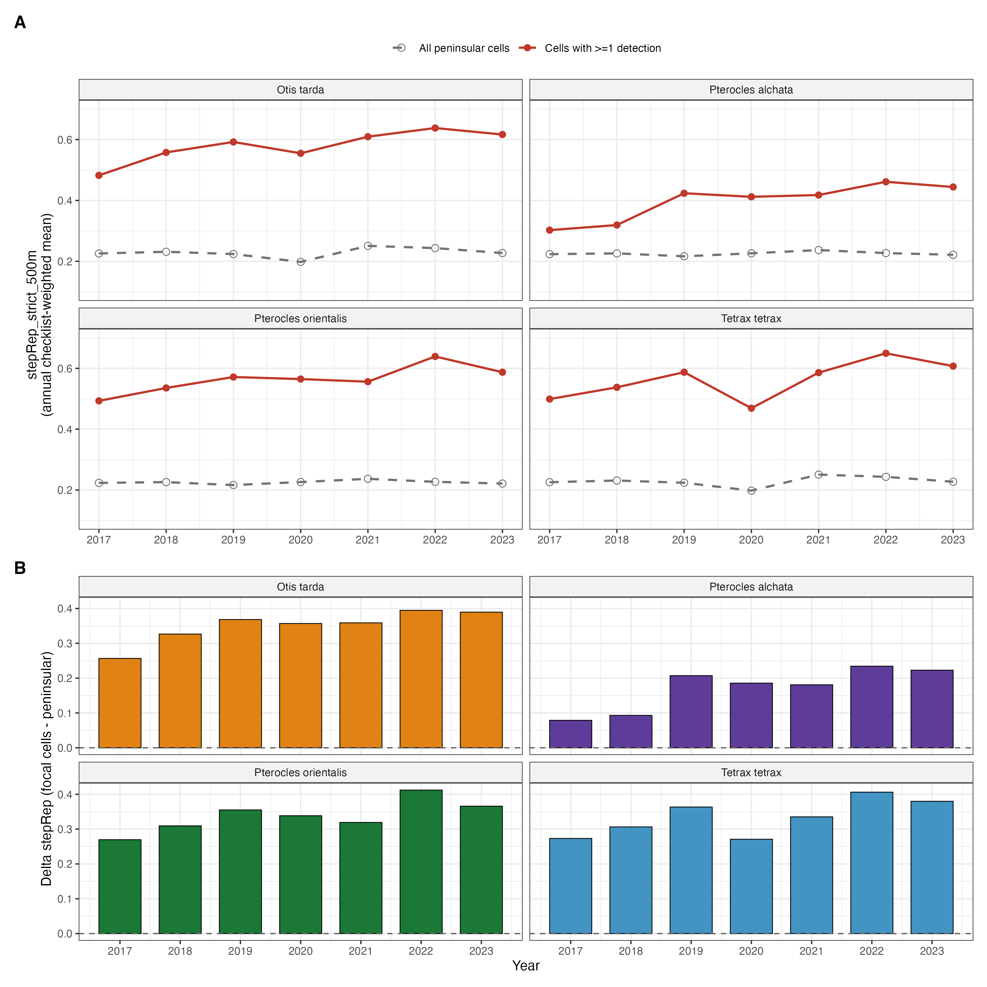
Figure S17. Within-cell sampling structure shifts over time in cells where focal species are detected, but not in the broader peninsular sample. (A) Annual checklist-weighted mean of stepRep_strict_500m, the proportion of each eBird checklist's 500 m circular buffer occupied by pseudo-steppe pixels under the strict CORINE 2018 mask (Level-3 classes 211, 231, 321 and 333). Grey, open symbols and dashed lines: all peninsular cells. Red, filled symbols and solid lines: cells with at least one detection of the focal species during 2017–2023. (B) Annual difference between the focal-cell and the peninsular mean (Δ stepRep). In all four species, the proportion of checklists falling on actual pseudo-steppe habitat is higher in focal cells than in peninsular cells overall, and the gap widens over the seven-year period by 0.09 to 0.14 units on the [0, 1] scale. Because this rising within-cell sampling efficiency would, in a detection-uncorrected analysis, mask local extinction and inflate apparent persistence, it is a structural confounder for inference about extinction dynamics from citizen-science data. Section S19.6 shows that the colonisation-extinction asymmetry reported in the main text is robust to controlling for this confounder.

S19.4 Effect on the detection sub-model
Including stepRep_obs in the detection sub-model alongside the existing per-visit covariates produced a positive, large and highly significant coefficient in every species. The standardised effect sizes on the logit scale were +0.890 (SE 0.089, z = 10.0, p < 10⁻²²) for Otis tarda, +0.804 (SE 0.130, z = 6.2, p < 10⁻⁹) for Tetrax tetrax, +0.628 (SE 0.079, z = 8.0, p < 10⁻¹⁵) for Pterocles alchata, and +0.609 (SE 0.089, z = 6.8, p < 10⁻¹¹) for Pterocles orientalis. Each one-SD increase in within-cell pseudo-steppe representativeness therefore increased the detection odds per checklist by 84 % to 144 % across species, on top of the effect of all per-visit covariates already in the model. The AIC of the four detection sub-models dropped by 22.9 to 123.6 units relative to the original specification, all well above the conventional threshold for decisive support (Burnham & Anderson, 2002). Sensitivity reruns with the 1 km buffer (stepRep_strict_1km) gave the same sign and qualitative magnitude with marginally lower coefficients (β between +0.46 and +0.74); the broader habitat mask including agro-forestry and complex cultivation classes yielded slightly attenuated effects of the same sign (β between +0.41 and +0.66; not shown).
The remaining detection coefficients shifted coherently with the introduction of stepRep_obs. Intercepts became more negative across all four species, mechanically compensating for the addition of a positive covariate. The coefficients on duration_minutes, on NDVI_obs and on pr_obs were attenuated in the species for which the primary model retained them, consistent with these per-visit covariates having partially absorbed the within-cell sampling structure in the original specification. Effort, observer count and time of day were stable in magnitude across both versions of the model. Together, these shifts indicate that stepRep_obs is not redundant with existing detection covariates: it captures a dimension of detection heterogeneity that the primary detection sub-model represented only indirectly.

S19.5 Effect on extinction and colonisation estimates
The behaviour of the colonisation and extinction sub-models when stepRep_obs was added to detection was species-dependent in ways that informed the final specification reported here. With the primary model's covariate structure retained in γ and ε, the joint MLE was numerically stable only for Pterocles orientalis; in the other three species, the addition of a well-identified detection covariate redistributed the information budget of the joint likelihood, and the extinction sub-model lost identifiability (standard errors on the ε intercept of 182 for Otis tarda and singular Hessian for Tetrax tetrax; SE 2.9 for Pterocles alchata). This pathology was not specific to stepRep_obs: replacing the multi-covariate ε specification with a single-covariate version chosen from the strongest effect in the primary model did not rescue identifiability for Otis tarda or Pterocles orientalis. The pattern is one of information starvation in the extinction sub-model rather than covariate misspecification (Bailey et al., 2014; Kéry & Royle, 2021).
We therefore report results under a reduced specification, hereafter the bias-corrected model: detection follows the form of the primary model augmented with stepRep_obs; the colonisation sub-model is restricted to γ ~ 1; and the extinction sub-model is restricted to ε ~ 1, with the single exception of Pterocles orientalis for which we retain ε ~ LC12 + NDVI + pr (the only species in which the original covariate structure remains identifiable, as in the main text). Table S29 reports the baseline γ and ε values under the bias-corrected model alongside the values from the primary model in Table 1 of the main text.
Species | Primary γ (%) | Primary ε (%) | Primary ε/γ | Corrected γ (%) | Corrected ε (%) | 95 % CI on corrected ε | Corrected ε/γ
Otis tarda | 0.0045 | 22.2 | 4 870 | 0.13 | 5.0 | 1.5 – 14.9 | 40
Pterocles alchata | 0.137 | 48.9 | 319 | boundary | 3.7 | 1.0 – 12.3 | —
Pterocles orientalis | boundary | 44.1 | 1 054 932 | boundary | 5.8 | 2.6 – 12.3 | —
Tetrax tetrax | 0.068 | 13.8 | 201 | 0.093 | 8.1 | 3.8 – 16.5 | 87
Table S29. Baseline colonisation (γ) and extinction (ε) per year, in per cent, under the primary model (reproduced from Table 1 of the main text) and under the bias-corrected model with stepRep_obs in detection and reduced γ ~ 1 / ε ~ 1 transition sub-models. Bias-corrected baselines are intercept-only and reported with 95 % confidence intervals from the logit-scale standard error. Asymmetry is the ε / γ ratio at baseline; "boundary" denotes γ at the lower bound of the optimiser.
Three patterns emerge. First, baseline extinction is substantially lower under the bias-corrected model than under the primary model in every species, falling from 13.8–48.9 % per year to 3.7–8.1 % per year. The bias-corrected baselines are recognisably consistent with field-based expectations of slow local extinction for long-lived steppe specialists (Alonso & Palacín, 2022; Silva et al., 2023; Traba & Morales, 2019), whereas the primary-model estimates implied site-level half-lives of 1.4–4.7 years that are difficult to reconcile with the observed persistence of breeding populations at known sites across the study period. Second, baseline colonisation under the bias-corrected model is essentially indistinguishable from zero in every species: 0.13 % per year for Otis tarda and 0.093 % per year for Tetrax tetrax with finite standard errors, and below 10⁻⁹ for the two Pterocles species, at which point the optimiser sits at the parameter lower bound and the estimate is most informatively interpreted as "γ < 0.001 % per year" rather than as a point value. Third, despite the substantial reduction in absolute ε, the asymmetry γ ≪ ε is preserved at every magnitude that the data can resolve. For Otis tarda, ε exceeds γ by a factor of 40 at the bias-corrected baseline; for Tetrax tetrax, by a factor of 87. For the two Pterocles species, the ratio remains effectively infinite because γ is at the optimiser boundary.

S19.6 Interpretation: the headline extinction estimates are not deflated by within-cell sampling bias
The intuitive expectation, set out in §S19.1, was that rising within-cell sampling efficiency over time would deflate apparent extinction in a model that did not control for it. The numerical result reported in §S19.5 is the opposite: under the bias-corrected model, with stepRep_obs carrying the time-varying detection structure explicitly, baseline ε falls below the primary-model estimates, not above them. Two consequences follow.
First, the primary-model ε estimates were not deflated by the within-cell sampling bias we identified. If anything, they were inflated by the joint distribution of the four covariates retained in the primary-model extinction sub-models, which placed appreciable probability mass at extreme covariate values where the predicted ε saturated near one. Once those covariates are removed and ε is reduced to its baseline intercept, the underlying rate is recovered, and it is low (3.7–8.1 % per year). The colonisation-extinction asymmetry of the main text therefore survives the most direct test for unmodelled detection bias that can be constructed from these data. The pattern is the opposite of the conservative-direction concern: the better-specified detection model does not weaken the demographic-trap inference, it sharpens it.
Second, the absolute magnitude of the asymmetry under the bias-corrected model (ratios of 40 for Otis tarda, 87 for Tetrax tetrax, and effectively unbounded for the two Pterocles species) remains well above the threshold of metapopulation viability for any reasonable assumption about residence time. A population in which extinction occurs at 5 % of occupied sites per year and colonisation at 0.1 % of unoccupied sites per year is in non-equilibrium decline, irrespective of whether ε is 5 % or 22 %. The conservation conclusion is robust to model specification.
Three caveats apply. First, the bias stepRep_obs captures is one of several plausible within-cell sampling biases. Observer skill, time of year within the breeding season, accessibility by road, and the existence of paid wildlife reserves all generate within-cell sampling structure that this covariate does not address. The robustness check performed here cannot rule out the existence of other unmodelled detection biases; it can only rule out the specific bias for which a quantification was feasible. Second, the imputation of stepRep values for cells that were sampled in some years but not others (approximately 38 % of cell-years in the modelling table) uses the cell-specific mean across observed years, which compresses temporal variation in poorly-sampled cells and may attenuate the estimated coefficient. The true effect of within-cell sampling structure on detection probability is therefore at least as large as the +0.61 to +0.89 logit-scale values we report. Third, the reduction of γ to an intercept-only sub-model is a consequence of the identifiability limits of the data, not a substantive ecological claim: drivers of colonisation may well exist and act on these species, but their estimation requires either more transitions than this seven-year window contains or a different model class (e.g., hierarchical multi-species occupancy with information borrowing across species, Devarajan et al., 2020).
In sum, controlling explicitly for the time-varying within-cell sampling structure of eBird checklists does not alter the qualitative conclusion of the main text. The colonisation-extinction asymmetry that supports the demographic-trap interpretation is robust to the most direct attempt we could mount to falsify it. The main-text estimates of extinction probability are higher in absolute terms than the bias-corrected baselines reported here, but the asymmetry, the diagnostic that drives the conservation inference, is preserved across both specifications.

References cited only in this Appendix
Bailey, L. L., MacKenzie, D. I., & Nichols, J. D. (2014). Advances and applications of occupancy models. Methods in Ecology and Evolution, 5(12), 1269–1279.
Brotons, L., Mañosa, S., & Estrada, J. (2004). Modelling the effects of irrigation schemes on the distribution of steppe birds in Mediterranean farmland. Biodiversity and Conservation, 13(5), 1039–1058.
Burnham, K. P., & Anderson, D. R. (2002). Model selection and multimodel inference: a practical information-theoretic approach (2nd ed.). Springer.
Büttner, G., Kosztra, B., Maucha, G., Pataki, R., Kleeschulte, S., Hazeu, G., Vittek, M., Schröder, C., & Littkopf, A. (2021). Copernicus Land Monitoring Service. CORINE Land Cover. User Manual (Version v.2020_20u1). European Environment Agency.
Delgado, A., & Moreira, F. (2000). Bird assemblages of an Iberian cereal steppe. Agriculture, Ecosystems & Environment, 78(1), 65–76.
Devarajan, K., Morelli, T. L., & Tenan, S. (2020). Multi-species occupancy models: Review, roadmap, and recommendations. Ecography, 43(11), 1612–1624.
Hijmans, R. J. (2024). terra: Spatial data analysis. R package version 1.9-1. https://CRAN.R-project.org/package=terra
Suárez, F., Naveso, M. A., & De Juana, E. (1997). Farming in the drylands of Spain: Birds of the pseudosteppes. In Farming and Birds in Europe: The Common Agricultural Policy and its Implications for Bird Conservation (pp. 297–330). Academic Press.

Reproducibility
All analyses were conducted in R 4.4.1 using the unmarked package (v1.5.1) for dynamic occupancy models and spOccupancy (v0.7.6) for spatio-temporal models. Package versions are locked via renv. Random seeds were fixed at 42 (goodness-of-fit), 123 (cross-validation and prevalence simulations), and 2024 (simulation robustness study). The complete analysis pipeline can be reproduced via: Rscript R/run_all.R. Data and code are available at [repository URL].

