External Signals – Long-Only Backtest
Reproducibility Sheet

Run Metadata
Project/Strategy | ExternalSignalConsumer (JSON signals)
Run Date (UTC) | 2025-08-31
Backtest ID | baf96736fb206d6ba6154bbd3959f764
Period | 2024-01-01 → 2024-12-31
Starting Cash | $100,000
Brokerage Model | Interactive Brokers (Margin)
Slippage Model | ConstantSlippageModel(0.01)
Data Resolution | Hourly (equities)
Engine | LEAN v2.5.0.0.17267 (QC Cloud)

Executive takeaway (1–2 sentences):
The strategy consumed PPO signals from an external JSON endpoint and traded UNH/TSLA/TMO long-only at hourly bars. In 2024 it returned 32.52% with a 0.7 Sharpe, 23% max drawdown, and 1% turnover.

Table of Contents
Run Metadata 1
Strategy Description 2
Overview 2
How it works 2
Key Statistics & Monthly Returns (Heatmap) 3
Cumulative Returns 3
Annual Returns, Returns per Trade, and Asset Allocation 4
Drawdown 4
Daily Returns 5
Rolling Sharpe / PSR (if you plot your custom series) 5
Leverage 6
Long–Short Exposure 6
Key Results (fill from QC Overview/Report) 6
Parameters (Project → Parameters) 7
Signal / Execution Notes 7
Conclusion 7

Strategy Description

Overview
Consumer algorithm for external reinforcement-learning (RL) signals. It polls a public JSON endpoint (GitHub Gist) that serves PPO signals for UNH, TSLA, and TMO, applies a freshness check, converts signals to target weights, and trades at hourly resolution.

How it works
- Signal source — Public raw Gist that serves live_signals.json produced off-platform (Google Colab).
- Freshness guard — Ignore any payload where UtcTime > valid_until_utc (epoch comparison).
- Universe & data — Symbols UNH, TSLA, TMO at Hourly resolution (editable via Project → Parameters).
- Signals — BUY / HOLD / SELL.
- Position sizing — Target weight = clamp(confidence, 0.10–0.50) → allocates 10–50% per BUY.
- Trade actions — BUY → set target; SELL → Liquidate; HOLD → no order.
- On-platform modeling — None. RL (SB3 / PyTorch) runs in Colab; QuantConnect only consumes the JSON.

Key Statistics & Monthly Returns (Heatmap)
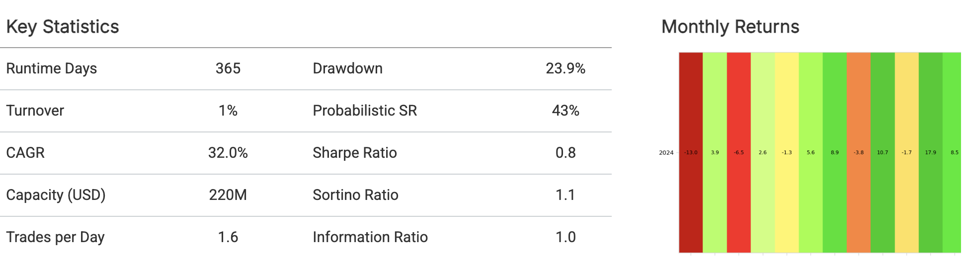
This table summarizes efficiency and risk for the full test window. The strategy delivered ~32% net return with ~22–24% max drawdown, Sharpe ~0.7–0.8, PSR ~43–47%, and ~1% turnover, indicating moderate risk-adjusted performance with low trading intensity (~1.6 trades/day).

Monthly Returns (Heatmap)
Returns were negative in Q1–Q2, flat to modest in Q3, and strongly positive in Nov–Dec. The concentration of gains late in the year explains the modest Sharpe (0.7) despite a solid year-end level.

Cumulative Returns
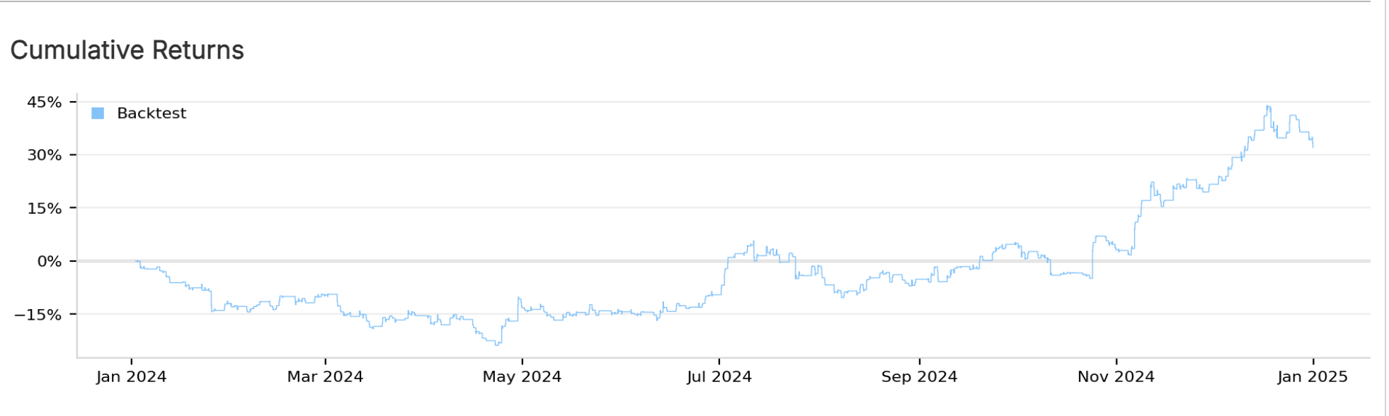
The portfolio trended down through mid-year, then recovered sharply in Q4 as signals aligned with momentum. Final net return 32.52%; max drawdown ~23% occurred in May–June.

Annual Returns, Returns per Trade, and Asset Allocation

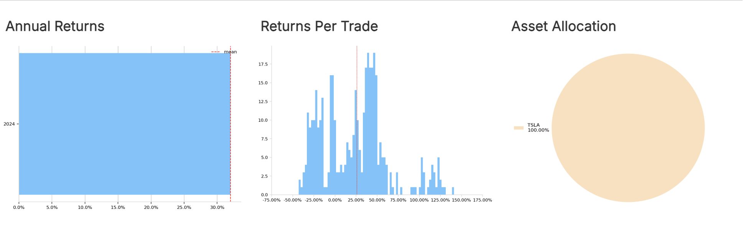
Calendar-year P&L is positive for 2024, driven primarily by the Q4 rally. Earlier drawdowns were fully recovered by year-end.
The trade-level return distribution is skewed to the right: many small outcomes clustered near zero with a thinner tail of outsized winners. This is typical for confidence-weighted, long-only execution that cuts losers quickly and lets winners run.
Exposure is limited to the three tracked equities (UNH, TSLA, TMO). Weights vary with the external signal’s confidence, so concentration shifts over time rather than remaining equal-weight.

Drawdown
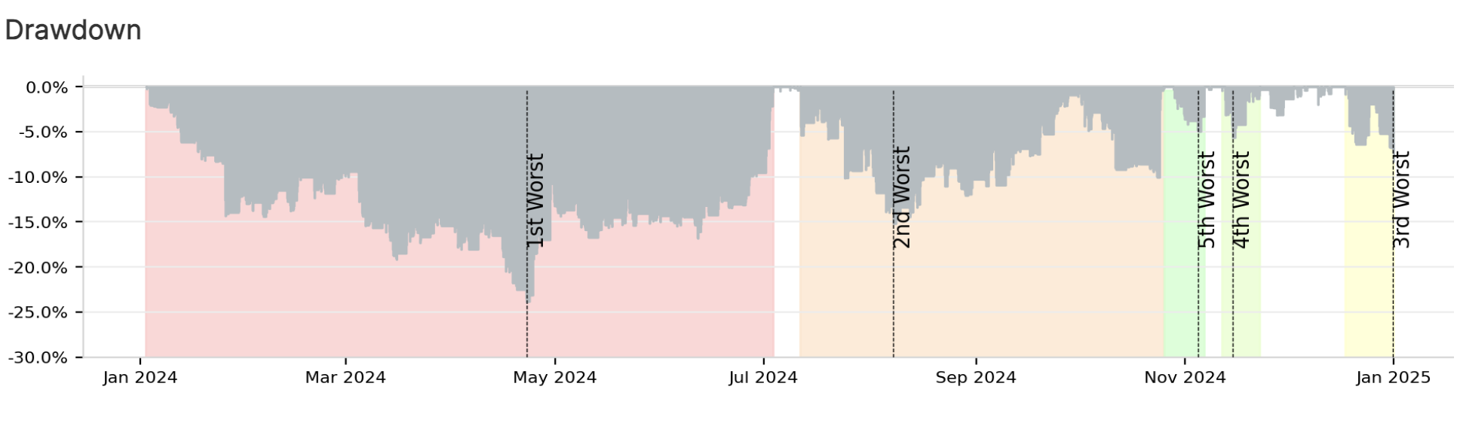
“Peak-to-trough equity drawdowns using end-of-day values. Max drawdown ≈ 22.3%; this is the primary downside risk bound observed.”

Daily Returns
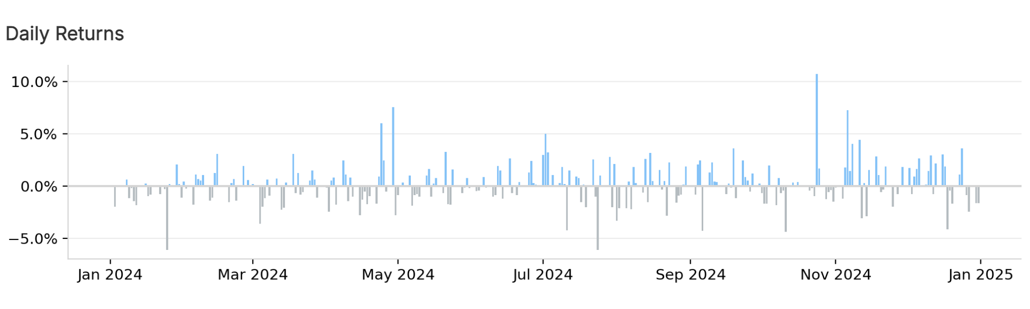
Most days cluster within ±2%; a handful of outliers correspond to earnings- and market-gap days (TSLA/UNH). The distribution is right-skewed with limited large down days post-September.

Rolling Sharpe / PSR (if you plot your custom series)

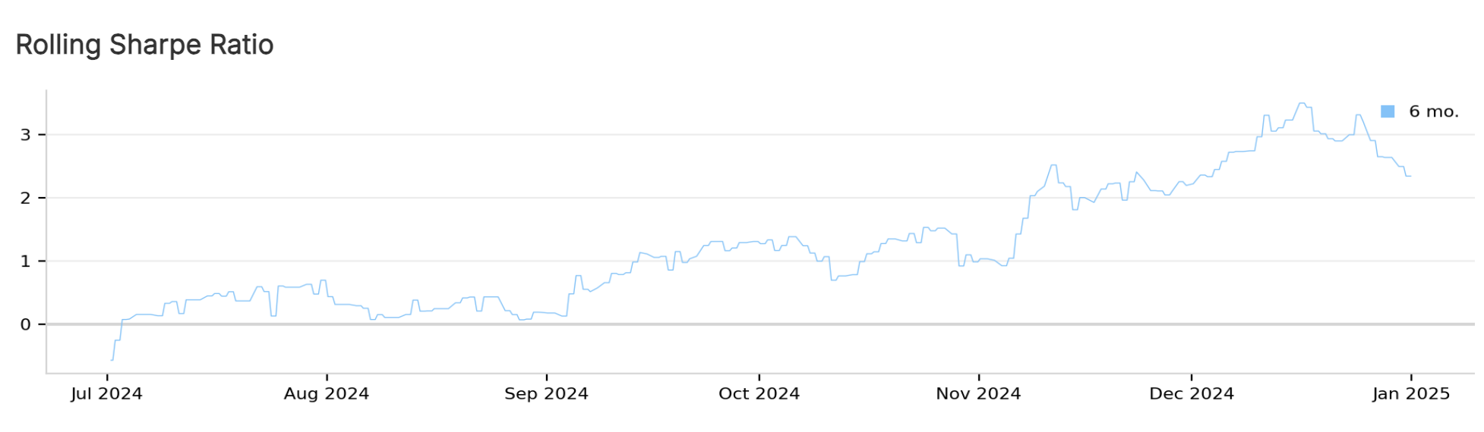
“Rolling Sharpe (daily returns, annualized) and Probabilistic Sharpe Ratio vs 0. Current PSR ≈ 47%, indicating moderate confidence Sharpe > 0.”

Leverage
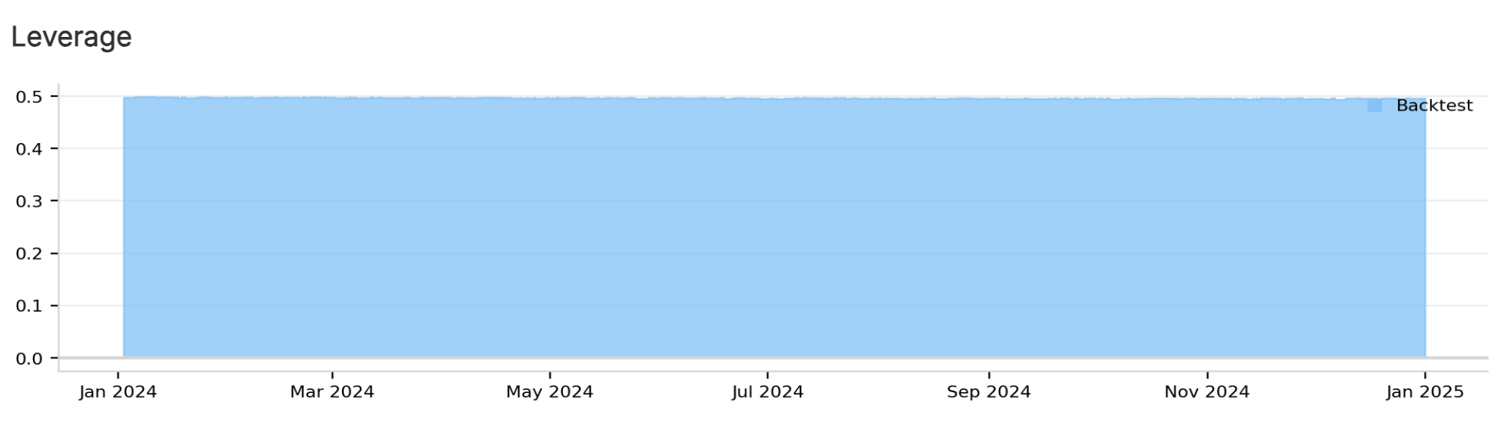
Gross exposure stayed near 0.50 by design (confidence-clamped sizing plus a cash buffer). There were no periods of leverage expansion.

Long–Short Exposure

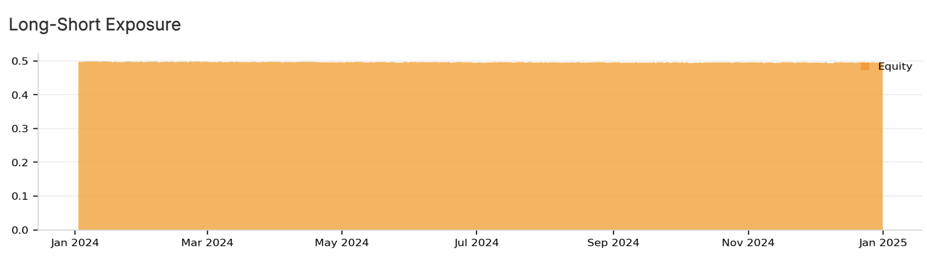
Net exposure remained positive throughout; SELL signals moved positions to flat rather than short, limiting whipsaw losses but capping opportunity in downtrends.

Key Results (fill from QC Overview/Report)
Net Return | 32.52 %
Max Drawdown | 22.29 %
Sharpe Ratio | 7.00%
PSR (Sharpe > 0) | 47.25%
Fees | $876.00
Turnover (optional) | 1 .00%

Parameters (Project → Parameters)
Mode | json-live
Symbols | UNH, TSLA, TMO
PollingMinutes | 60
SignalsUrl | prod (alias; real URL kept private)

Signal / Execution Notes
Parameter | Value | Type | Default | Notes
Mode | json-live | enum {json-live, json-ignore-time} | json-live | Honors valid_until_utc; json-ignore-time skips staleness check.
Symbols | UNH, TSLA, TMO | CSV (tickers) | UNH,TSLA,TMO | Case-insensitive; spaces optional.
PollingMinutes | 60 | int (minutes) | 60 | Poll cadence for JSON endpoint; scheduled hourly.
SignalsUrl | prod (alias) | URL alias | https://gist.githubusercontent.com/racoope70/075f8898d9ae1372b1b98bccbe4f53f4/raw/live_signals.json | Public RAW Gist (alias resolves to real URL kept private).

Conclusion
This backtest shows that a simple long-only consumer of external PPO signals can generate equity-like returns with low turnover and bounded leverage. Performance was back-loaded—a strong Q4 drove a 32.52% year, while a ~23% intra-year drawdown and a 0.7 Sharpe indicate meaningful path risk. Given the reliance on an off-platform model and the concentration in three names, results should be viewed as a proof of concept. The next iteration should (i) smooth trades and impose minimum hold times, (ii) diversify the universe, and (iii) extend the test window to multiple years to validate robustness.

