

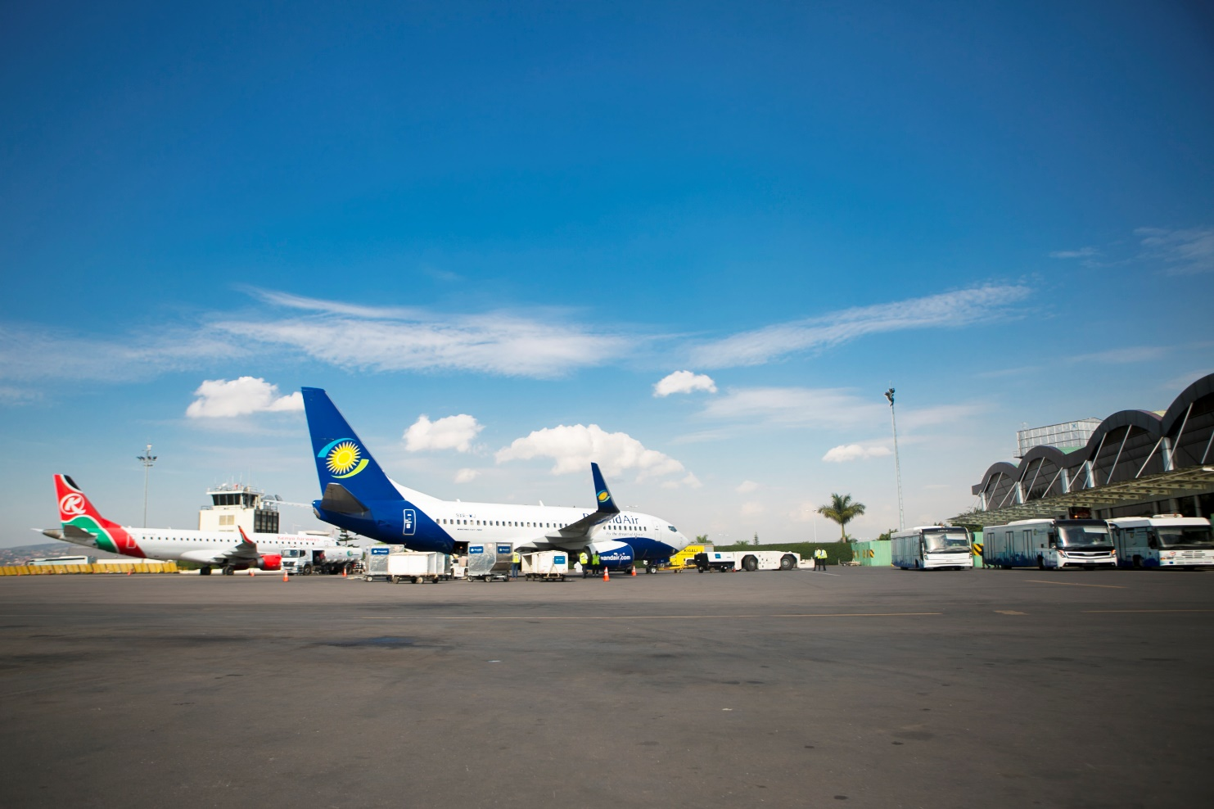

Rwanda Airports Company P.O. Box 1171 Kigali-Rwanda Tel: (+250)252585555

Kigali International Airport Terminal Building 2nd Floor [www.rac.co.rw](http://www.rac.co.rw) [info@rac.co.rw](mailto:info@rac.co.rw)

|  |  |  |  |
| --- | --- | --- | --- |
| **OUTPUT** | **QUARTER 1 TARGET** | **IMPLEMENTATION STATUS** | **PROGRESS INDICATOR** |
| **Procurement bidding portal** | * Frontend and backend Environment Setup (to accommodate microservices development approach) | * + - Nx Monorepo set up to host bidding frontend codebase     - Backend service set up with Laravel graphQl server (lighthouse)     - Docker installed and backend service image created and built (for containerization)     - Run test on graphQl api server (basic queries and mutations) |  |
| **Innov’ ATM UTM project** | **Work package 3 completed and read to be deployed**  **Work package 5 install of sensor completed.**  **Zipline integrate has wait for legal data charging framework.** | **Work package 3 completed and read to be deployed**  **Work package 5 install sensor installation is completed.**  **Zipline integrate is at 60% in endpoint development.** |  |
| **Base Version 2** | **Upgrade biodata, items tracking and access control system to new framework system with new technology of micro-frontend and micro-backend using laravel , react and graphql** | * + - Backend service set up with Laravel graphQl server (lighthouse) completed     - Docker installed and backend service image created and built (for containerization) is completed     - Backend endpoints for in graphQL is completed. |  |

**Implementation Status of Non-Imihigo Projects/ Other achievements**