Team: Iteration Station

Project: SongDB

Team names: Nico Espina, Fernando Cuevas, Ricardo Carrillo

# Motivation:

We want to revolutionize the way people choose to listen to music by helping people make informed decisions on what songs they should listen to. Our database was created for music aficionados and common listeners alike, and is intended to be easy to use and easily expanded. In the future we plan to add user created critiques and we will like to potentially make into an app.

# Application:

The SongDB’s purpose to allow for users and artists to rate their favorite songs. The application works very similar to imbd or Netflix databases. The application area of the database is to store information related to music releases. For each song, album and artists there will be a ratings system out of 5 stars. The database tracks ratings, songs, artists, discography, albums, release dates, playlists, etc. The SongDB is intended to be used form any computer of mobile device.

# Methodology:

### **Database management system**

mySQL was employed for its ease of use and compatibility with many database tools. mySQL workbench was used to create the Song DB database and ER Diagram.

### Original ER Diagram:

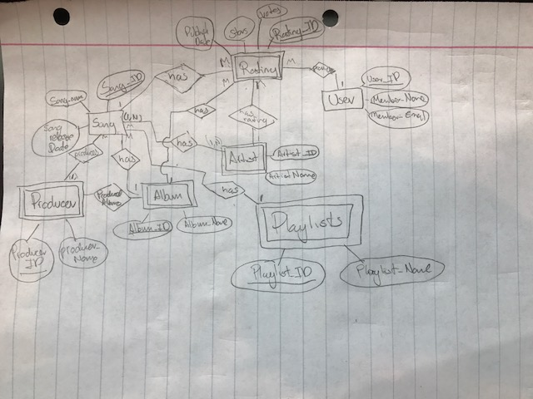

### Normalization

|  |  |  |  |
| --- | --- | --- | --- |
| **Table** | **General Attributes and Data Types** | **Explanation** | **Form** |
| **Album** | Album_ID ->PK  Album Release Month  Album Release Day  Album Release Year  Artist_ID: FK  Producer_ID: FK  Album Name | Album_ID -> Album Release Month  Album_ID -> Album Release Day  Album_ID -> Album Release Year  Album_ID -> Producer_ID  Album_ID -> Album Name | 3NF,  all of the attribute are fully dependent on the Album_ID and there are no transient dependencies. |
| **Album_Rating** | Album_ID: PK/FK  User_ID: PK/FK  Stars | Album_ID -> Stars  User_ID -> Stars | 3NF, all of the attribute are fully dependent on the Album_ID and there are no transient dependencies. |
| **Artist** | Artist_ID: PK  Artist_Name | Artist -> Artist Name | 3NF, all of the attribute are fully dependent on the Artist_ID and there are no transient dependencies. |
| **Artist_Rating** | Artist_ID: PK/FK  User_ID: PK/FK  Stars | Artist_ID -> Stars  User_ID -> Stars | 3NF, all of the attribute are fully dependent on the  and there are no transient dependencies. |
| **Playlist** | Playlist_ID: PK  Playlist_Name  User_ID: FK | Playlist ID -> Playlist_Name  Playlist ID ->User_ID | 3NF, all of the attribute are fully dependent on the Playlist_ID  and there are no transient dependencies. |
| **Playlist_Entry** | Playlist_ID: PK/ FK  Song_ID: PK/FK | Playlist_ID -> Song_ID  Song_ID -> Playlist_ID | 3NF, all of the attribute are fully dependent on the Playlist_ID and there are no transient dependencies. |
| **Playlist_Rating** | Playlist_ID: PK/FK  User_ID: PK/FK  Stars: DECIMAL (5,2) | Playlist_ID -> Stars  User_ID -> Stars | 3NF, all of the attribute are fully dependent on the Playlist_ID and there are no transient dependencies. |
| **Producer** | Producer_ID: PK  Producer_Name | Producer_ID ->Producer_Name | 3NF, all of the attribute are fully dependent on the Producer_ID and there are no transient dependencies. |
| **Song** | Song_ID: PK  Song_Name  Song Release Month  Song Release Day  Song Release Year  Artist_ID : FK  Producer_ID: FK | Song_ID -> Song_Name  Song_ID -> Song Release Month  Song_ID -> Song Release Day  Song_ID -> Song Release Year  Song_ID -> Artist_ID  Song_ID -> Producer_ID | 3NF,all of the attribute are fully dependent on the Song_ID and there are no transient dependencies. |
| **Song_Rating** | Song_ID: PK/FK  User_ID: PK/FK  Stars | Song_ID -> Stars  User_ID -> Stars | 3NF, all of the attribute are fully dependent on the Song_ID and there are no transient dependencies. |
| **User** | User_ID: PK  User_Name  User_Email | User_ID -> User_Name  User_ID -> User_Email | 3NF, all of the attribute are fully dependent on the User_ID and there are no transient dependencies. |

### Final ER Diagram after Normalization:

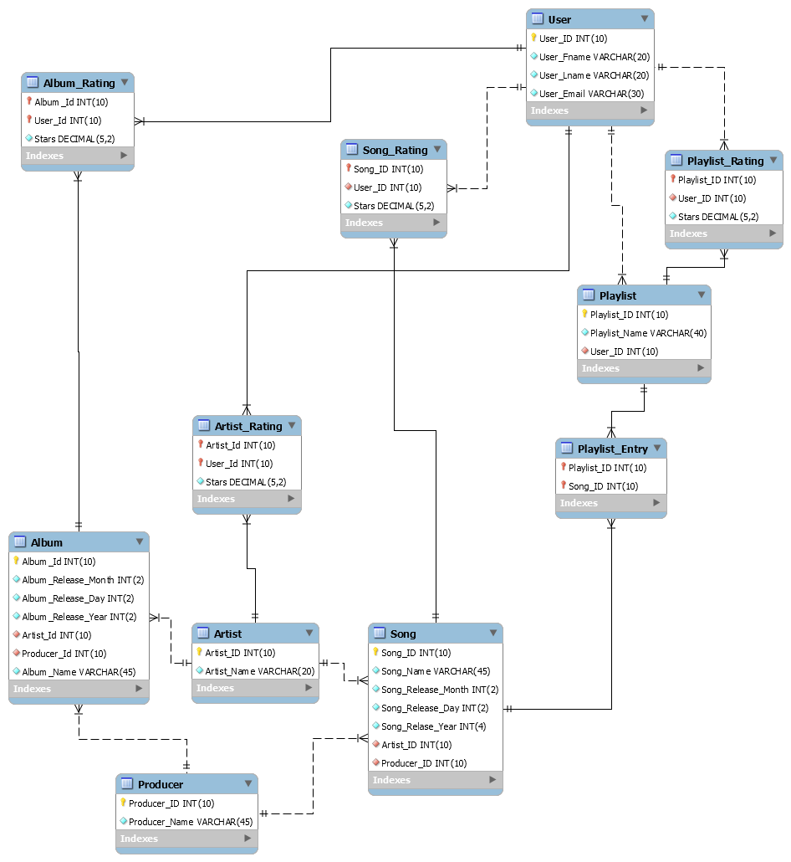

### Final Entities

|  |  |  |  |
| --- | --- | --- | --- |
| **Entity** | **General Attributes and Data Types** | **DataType** | **Constraints** |
| **Album** | Album_ID: PK  Album Release Month  Album Release Day  Album Release Year  Artist_ID: FK  Producer_ID: FK  Album Name | Int(10)  Int(2)  Int(2)  Int(2)  Int(10)  Int(10)  varchar(45) | Album_Artist_ID ->int(10)  Album_Producer_ID -> FK int(10) |
| **Album_Rating** | Album_ID: PK/FK  User_ID: PK/FK  Stars | Int(10)  Int(10)  DECIMAL(5,2) | Album_RateID  Album_UserID |
| **Artist** | Artist_ID: PK  Artist_Name | Int(10)  varchar(20)  varchar(20) |  |
| **Artist_Rating** | Artist_ID: PK/FK  User_ID: PK/FK  Stars | Int(10)  Int(10)  DECIMAL(5,2) | Artist_RateID  Artist_UserID |
| **Playlist** | Playlist_ID: PK  Playlist_Name  User_ID: FK | Int(10)  varchar(40)  Int(10) | Playlist_User_ID |
| **Playlist_Entry** | Playlist_ID: PK/ FK  Song_ID: PK/FK | Int(10)  Int(10) | Entry_PlaylistID -> FK  Entry_SongID -> FK |
| **Playlist_Rating** | Playlist_ID: PK/FK  User_ID: PK/FK  Stars: DECIMAL (5,2) | Int(10)  Int(10)  DECIMAL(5,2) | Playlist_RateID ->FK  Playlist_UserID ->FK |
| **Producer** | Producer_ID: PK  Producer_Fname  Producer_Lname | Int(10)  varchar(20)  varchar(20) |  |
| **Song** | Song_ID: PK  Song_Name  Song Release Month  Song Release Day  Song Release Year  Artist_ID - Int: FK  Producer_ID: FK | Int(10)  varchar(45)  Int(2)  Int(2)  Int(4)  Int(10)  Int(10) | Song_Artist_ID  Song_Producer_ID |
| **Song_Rating** | Song_ID: PK/FK  User_ID: PK/FK  Stars | Int(10)  Int(10)  DECIMAL(5,2) | Song_RateID  Song_UserID |
| **User** | User_ID: PK  User_Fname  User_Lname  User_Email | Int(10)  varchar(20)  varchar(20)  varchar(20) |  |

### Database Populated using Mackaroo.com

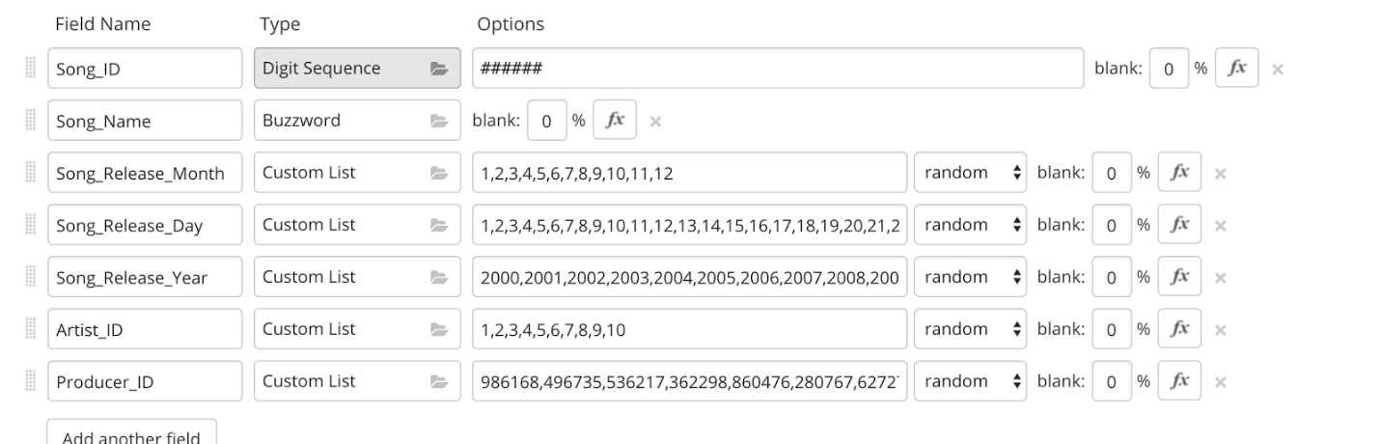

### **Database Hosting**



The SQL server and webpage was hosted on Amazon webservices including:

* AWS relational Database Service:

Hosted SQL server

* AWS elastic cloud computing:

Running on Linux, installed Apache web server and connected to AWS relational database service. Server also help the php GUI

Host name: testiterationstation.cz5jcu0pis3s.us-west-2.rds.amazonaws.com

Port - 3306                    [reference Figure 1.1]

Username

IterationStation                           [Capital I and S]

Password

nicorichardfernando                  [ALL lowercase]

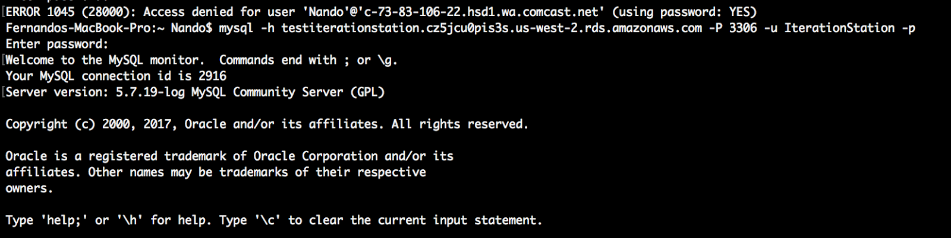

### **UI Tools**

HTML and php were used to display content.

Link to final web page: [ec2-54-218-50-196.us-west-2.compute.amazonaws.com/WebPage.php](http://ec2-54-218-50-196.us-west-2.compute.amazonaws.com/WebPage.php)

### UI Examples

