Group Delta

Delta: Mark Berkery, Tyler O'Riley, Brett Stovall, Rachel White

Milestones 3

May 9, 2023

###### **Assignment: Milestone #3**

Read through the case study again, and determine what information, retrieved from the tables (basically a report), will be helpful in making the business decisions listed in the case study. There should be a minimum of three reports. Provide a description of the report, write the Python script to create the report, and take a screenshot of each report (result of query). The deliverables for this Milestone are: The Python script(s) and a Word document that has your group name at the top, members of the team, description of the reports, and screenshot(s) of the results of running the queries.

**Reports**

1.Supply Inventory  
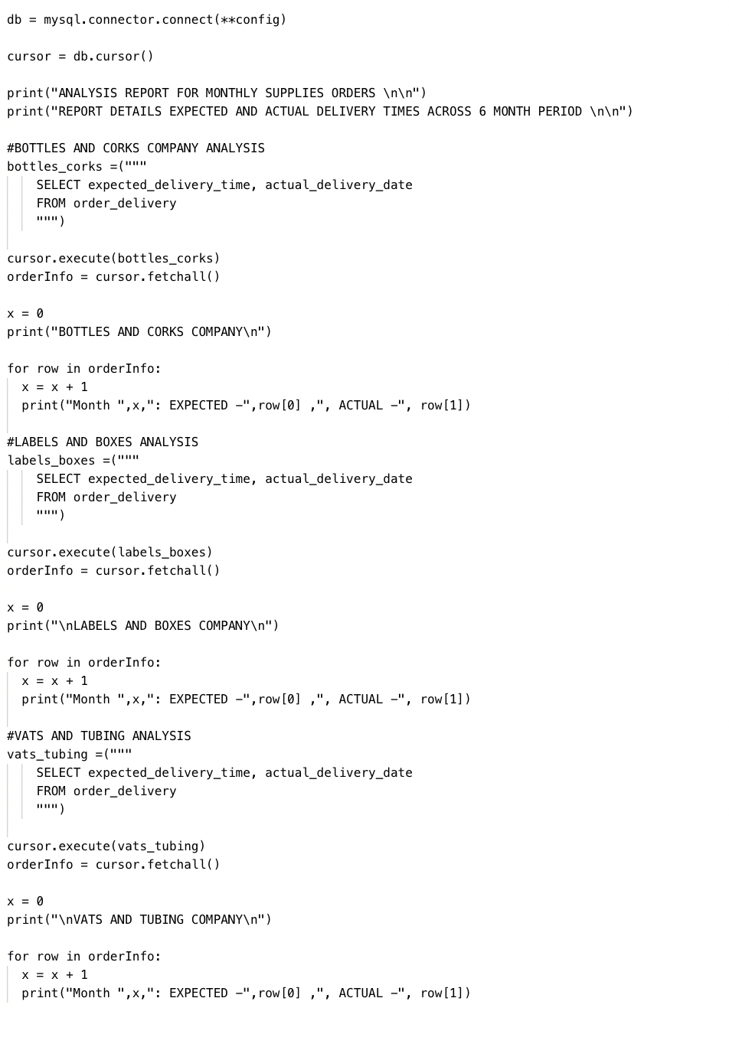 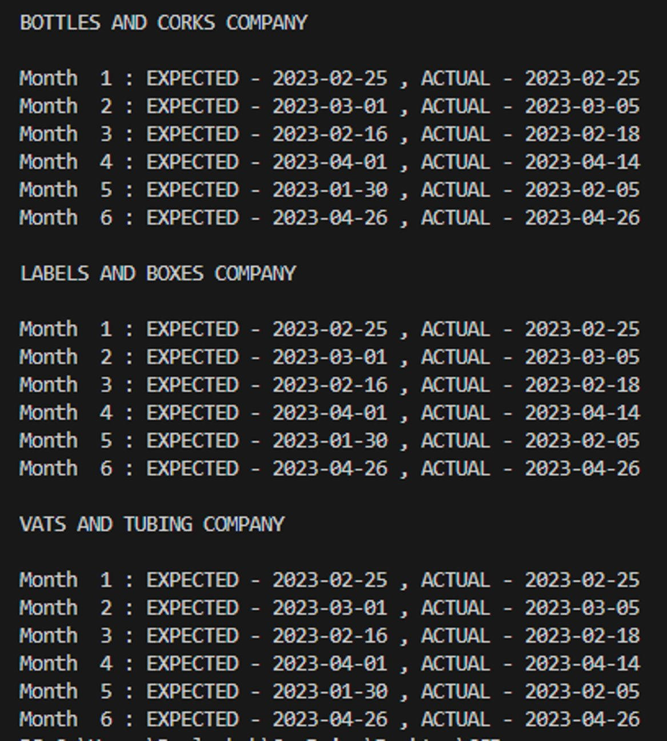

2.Customers/Distributors Delivery Tracking   
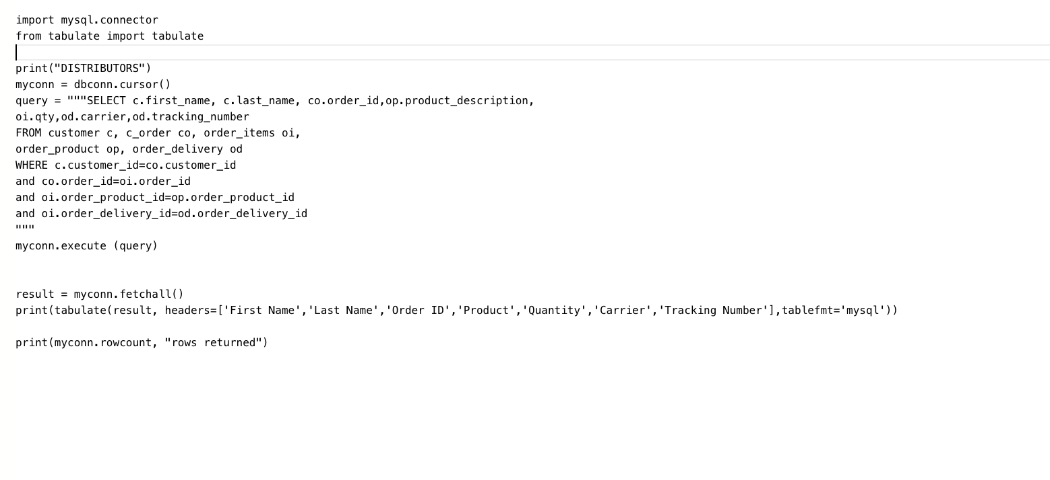

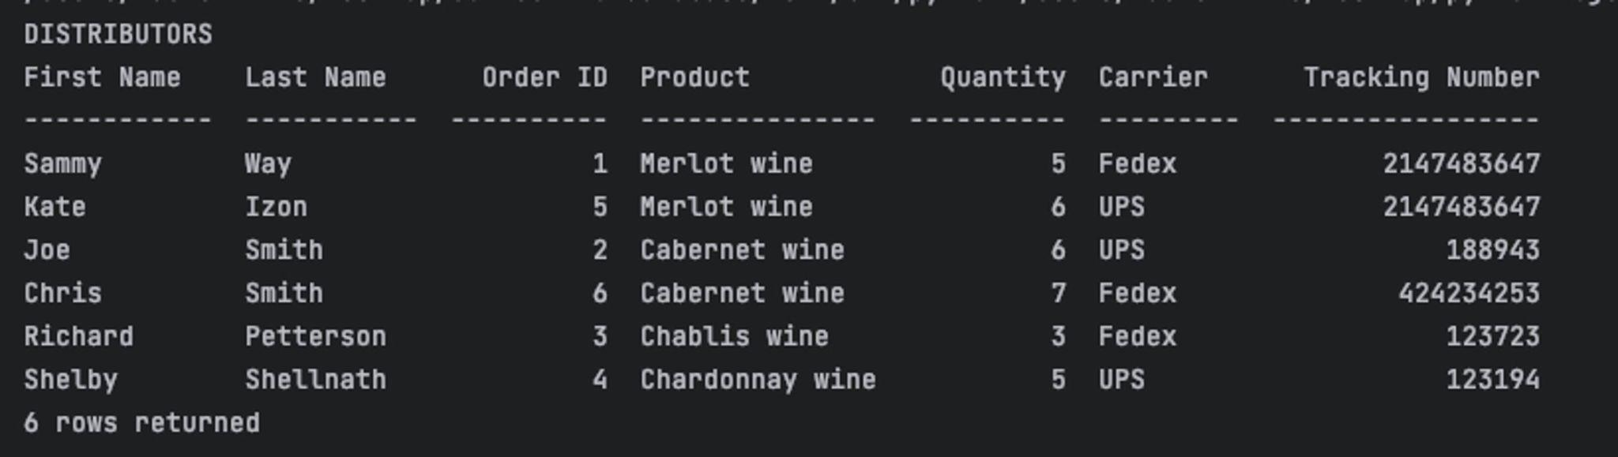

3. Employee Work Hours

