Introduction and Purpose
GLAH is an Open GL framework for C++ with the intention of making 2D games development (graphics, input and sound) easy for the developer. This document attempts to outline the structure of the GLAH library and provide information for installing and using the framework for 2D game development.

Breif
GLAH is compiled as two static libraries. One for release mode GLAHLib.lib and one for debug builds GLAHLib_d.lib. It defines data structures and component interfaces to aid in 2D games development. The below table gives a concise overview of the component interfaces in GLAH

Public Constants

Constant | Definition
Input keys enum | Input keys are all defined in GLAHGame.h, these can be used to pass to IsKeyDown() etc. In GLAHInput for user input checking
SpriteBlendModes | GLAHGame.h, defines all of the sprite blend modes that OpenGL can use. At time of writing it is currently hardcoded in framework as _ONE_MINUS_SRC_ALPHA. This may be used in a future release.

Class Diagram

Below is a visual UML example of how a developers game project can tie into the GLAH framework. See GLAH_class_diag.dia document for a high res version.
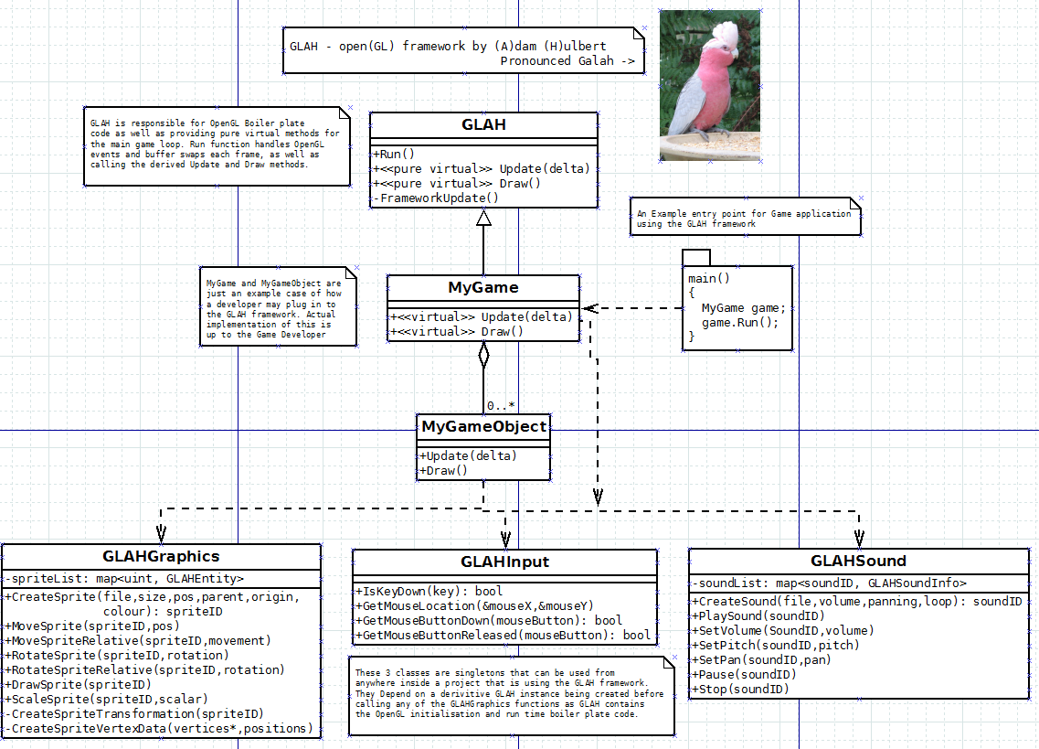

A Detailed Look at GLAH's Component Interfaces

GLAH
Public
void Run();
The public entry point to the GLAH Framework game loop. Responsible for calling Update and Draw on the derived class.
Protected
the following are only accessible inside a class derived from GLAH
GLAH(int width_, int height_, bool fullscreen_ = false, const char* windowTitle_ = nullptr);
This protected constructor must be called in the initialise list in the derrived class. Pass in the width and height of the window, fullScreen is currently not used (reserved for future release), and the windowTitle.

virtual void Update(float delta) = 0;
Must be overriden by the derrived class. Called once per frame inside of Run() before Draw()

virtual void Draw() = 0;
Must be overriden by the derrived class. Called once per frame inside of Run() after Update()

void SetBackgroundColour( SColour BGColour_ );
Set the Background Colour of the canvas to BGColour_

double GetDeltaTime()
Get time since last frame expressed as seconds

double FPS();
Get Frames Per Second

GLAHGraphics
This is a singleton class.
Public
static GLAHGraphics* Instance();
Retreive the single Instance to the GLAHGraphics class
unsigned int CreateSprite(const char* textureName_,
int width_, int height_,
int x_, int y_,
unsigned int parentSpriteID_ = 0,
Vector3 originOffset_ = Vector3(0.f,0.f,0.f),
float circleColliderRadius_ = 0.f,
SColour colour_ = SColour(0xFF,0xFF,0xFF,0xFF));
returns a handle to the sprite as an unsigned int.
Pass in the path (textureName_),
size (width_ and height_),
position (x_ and y_),
parent sprite for rotation and position parenting (parentSpriteID_)
Origin point to rotate sprite around (originOffset_) pass in half of width and height for centre. Bottom left is default.
Circle collision radius(circleColliderRadius) this is not currently used. May be removed in a future release
Sprite hilight colour (colour_) defaults to white. Only need to define this if we want to hilight a sprite with a colour.

void MoveSprite(unsigned int spriteID_, float xPos_, float yPos_ );
Move the sprite spriteID_ in world space to the absolute coordinate xPos_, yPos_
void MoveSpriteRelative(unsigned int spriteID_, float xMovement_, float yMovement_ , float rotation_);
Move the sprite spriteID_ relative to its current position and rotation by xMovement_, yMovement_. Rotation can also be applied although defaults to 0.

void RotateSprite(unsigned int spriteID_, float rotation_);
rotate the sprite spriteID_ to this absolute rotation rotation_

void RotateSpriteRelative(unsigned int spriteID_, float rotation_);
Rotate the sprite spriteID_ relative to current rotation rotation_ i.e. Add to existing rotation

void DrawSprite(unsigned int spriteID_);
Draw the sprite spriteID_ to the screen

void ScaleSprite(unsigned int spriteID_, float scalar_);
Scale the sprite spriteID_ by a scalar scalar_

GLAHEntity GetGLAHEntity(unsigned int spriteID_);
Get stored information (scale, rotation, parent, position, size etc.) about the sprite spriteID_ managed by the GLAH framework

GLAHInput
This is a singleton class. The purpose is to handle user input events from the keyboard and the mouse.
Public
static GLAHInput* Instance();
Get the single instance to the GLAHInput class
bool IsKeyDown(int key_);
Test for user keyboard input. Key enums defined in GLAHGame.h
void GetMouseLocation(double& mouseX_, double& mouseY_);
Inserts mouse x and y positions into the reference parameters mouseX_ and mouseY_

bool GetMouseButtonDown(int mouseButtonToTest);
Tests for mouse button down 0=LMB 1=RMB 2=CMB

bool GetMouseButtonReleased(int MouseButtonToTest_);
Returns true on mouse button release (not yet implemented)

GLAHSound
This is a singleton class. The purpose is to provide a uniform way to handle creating and playing sound inside the GLAH framework
Public
static GLAHInput* Instance();
Get the single instance to the GLAHSound class
unsigned int CreateSound(std::string path_, bool loop_, bool play_, float vol_, float pan_);
Create and return a handle (return as an unsigned int) to a sound object.
Parameters – path_ - the path to the sound file to load
loop_ - true to loop the sound, false to play sound once
play_ - true to play immediately after loading, false to only load and return the instance
vol_ - volume to play sound at (valid range between 0.0f and 1.0f)
pan_ - L/R stereo pan (valid range -1.0f FULL LEFT to +1.0f FULL RIGHT)
void Play(unsigned int sound_);
Play the sound
void Stop(unsigned int sound_);
Stop the sound
void Pause(unsigned int sound_);
Pause the sound
void SetPitch(unsigned int sound_, float freq_ = 44100.f);
Set the pitch of the sound, default frequency is 44100. Lower than this will reduce pitch, higher to increase pitch
void SetVolume(unsigned int sound_, float vol_ = 0.2f);
Set the volume of the sound between 0.0f and 1.0f
void SetPan(unsigned int sound_, float pan_ = 0.0f);
Set the stereo panning of the sound between (-1.0f Left speaker only, and +1.0f Right Speaker Only)

Vector2/Vector3/Vector4
Vector classes are used within the GLAH framework to represent positions in space, velocity, and angles. I will breifly outline the available methods and operators below.
Vector2();||Vector3()||Vector4();
Default constructor, vector members in default constructor are initialised to 1.0f
Vector2(float x, float y);
Vector4(float x, float y, float z);
Vector4(float x, float y, float z, float w);
Non default constructor, class variables set to params
const float GetMagnitude();
Get the "length" of the vector
+, -, /, *, +=, -=, *=, /= operators
Common arithmetic operators are overloaded for Vector classes and function as expected
//scalar multiplication
Vector& operator*=(const float& vec);
Vector operator*(float vec);
void Normalise();
Normalise this vector
Vector2 GetNormal()
Return a normalised copy of this vector i.e. Do not modify this vector
float Dot(Vector2 vec_);
Return the dot product of this vector and vec_
float AngleBetweenVectors(Vector2 vec_);
Return the angle between this vector and vec_ (only available in Vector2)
//comparison
bool operator > (float vec);
bool operator!=(const Vector2& vec);
bool operator==(const Vector2& vec);

Vector3 Cross(Vector3 vec_)
Return the Cross product of this vector and vec_ (only available in Vector3)

Matrix3x3
The Matrix3x3 class is used within the GLAH framework to represent sprite transformations (scale, position and rotation). And cummulative multiplication between other Matrix instances for the use of parenting sprites, projections etc. You can use the GLAH framework without using the Matrix3x3 class, the GLAHGraphics uses it internally to handle sprite transformation and provides helper functions.

