GLAH Framework Setup And Use Tutorial

Requirements
The following tutorial guides you through the process of setting up a game using the C++ language and the GLAH framework. The following steps were written and tested using Visual Studio 2012. The libraries inside the GLAHLib.zip file were all compiled for VS2012, as a result using VS2012 is a requirement to successfully setup the GLAH framework at this stage. It may be possible to compile the source under a different compiler which will be available seperately on Perforce.
An OpenGL 4.0 or higher complient graphics card and software are required as the internal OpenGL implementation uses this version and will not work on older hardware and drivers.

Create A New Project
Open Visual Studio 2012 and create a new Win32 Console Application
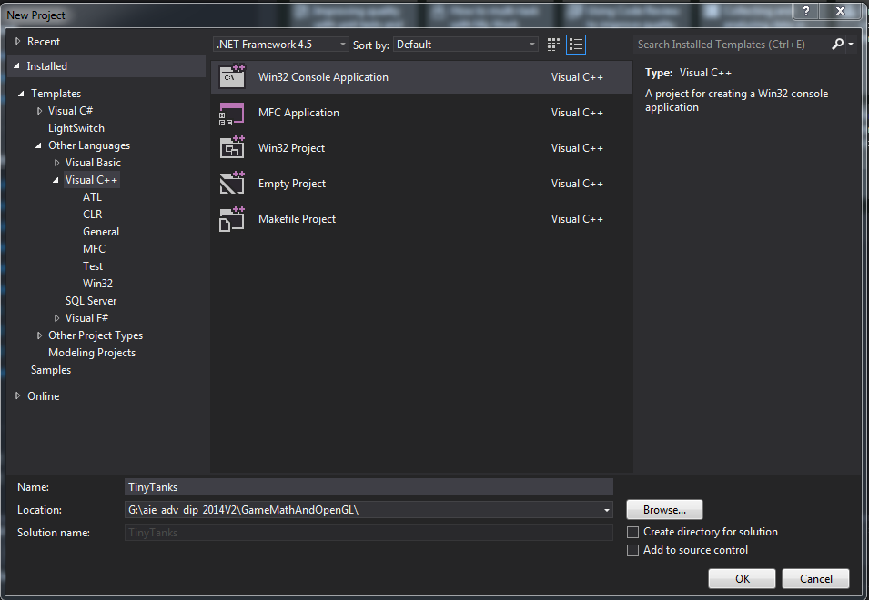
Give it a name and a location and click OK

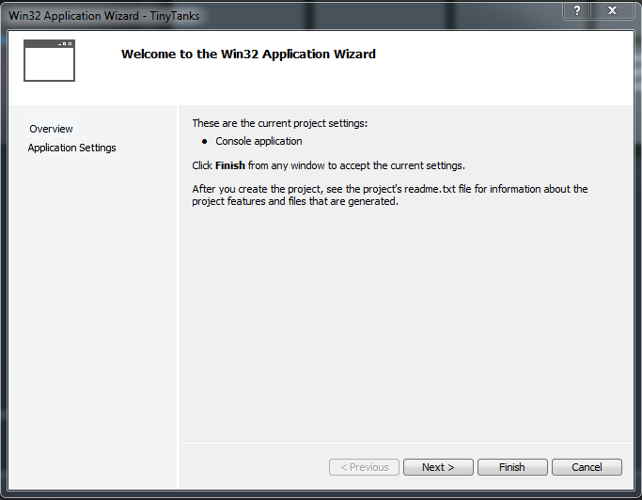
^^Click Next

Untick Precompiled Header, Tick Empty Project, Finish
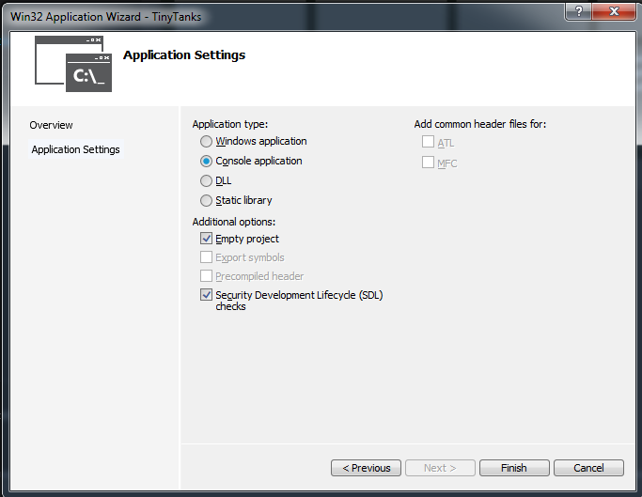

Configure Project Folder
Create source, include, lib and resources folders inside your project directory
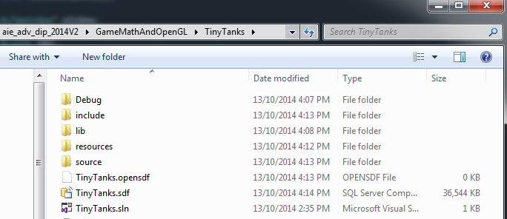

Extract the contents of the GLAHLib.zip include directory into your include directory
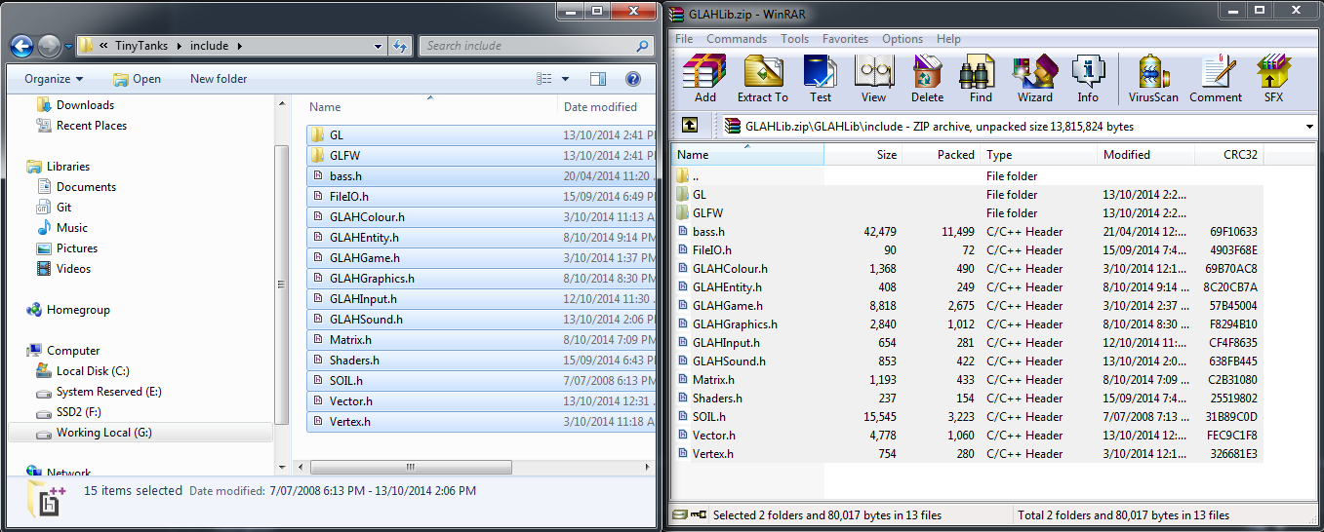

Extract the contents of the GLAHLib.zip lib directory into your lib directory
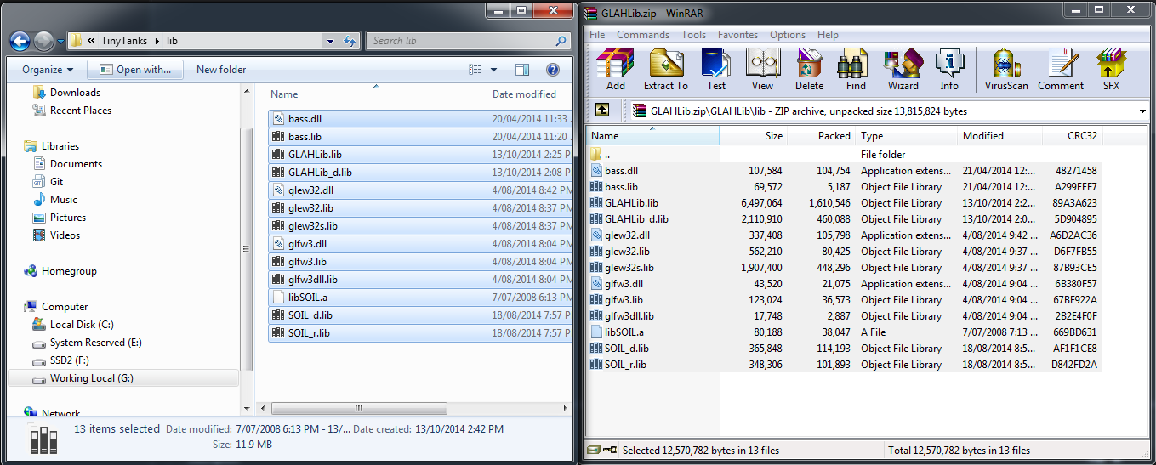
Extract the contents of the GLAHLib.zip resources directory into your resources directory

Now go back to Visual Studio 2012

Configure VS2012 to include and link to GLAH library
Tick show all files in VS2012 and confirm that ou can see the files in the picture below
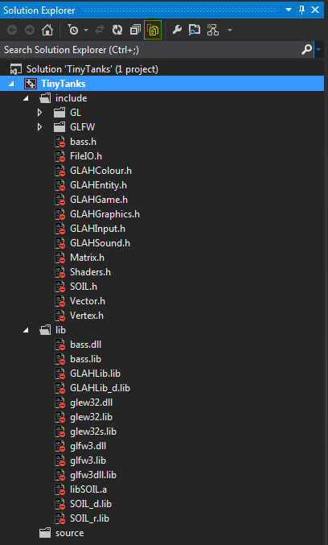
Go to your project properties. We need to add the include directory, lib directory, and dependant libs.
Set configuration drop down to All Configurations
Under configuration properties, click C/C++ -> General. Add ./include to Additional Include Directories and apply
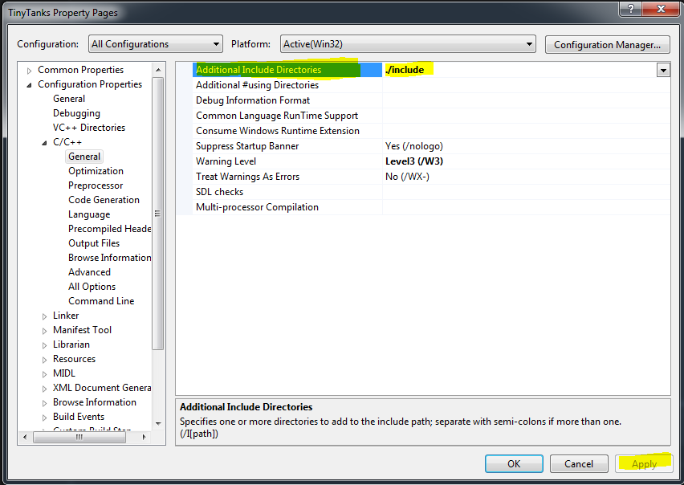

VC++ Directories -> Include Library Directories -> add ./lib
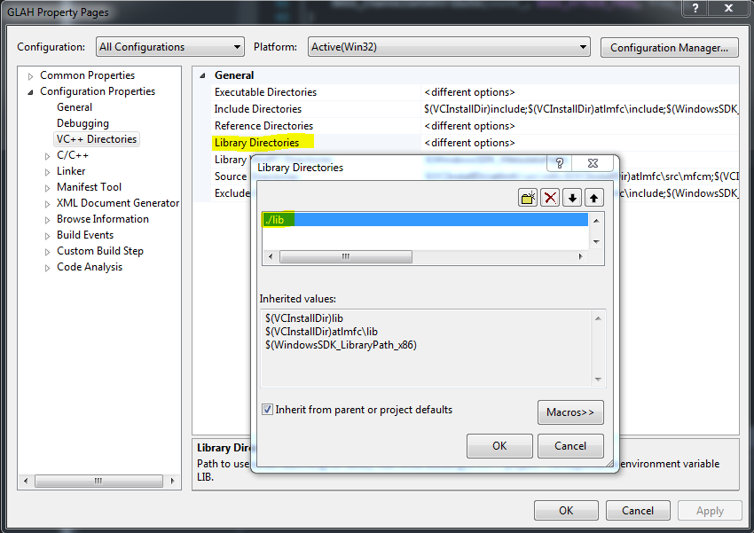

Apply changes and Change configuration back to Debug
Go to Linker -> Input -> Additional Dependancies and copy/paste the following:
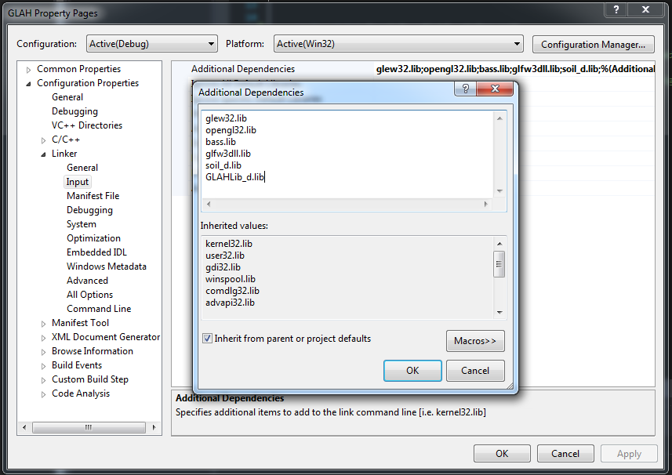
glew32.lib
opengl32.lib
bass.lib
glfw3dll.lib
soil_d.lib
GLAHLib_d.lib

Apply Changes then switch to Release

Under the same Additional Dependancies setting (release mode) copy paste the following:

glew32.lib
opengl32.lib
bass.lib
glfw3dll.lib
soil_d.lib
GLAHLib.lib

Create a sample game using GLAH
Create a new MyGame class, #include GLAHGame.h and inherit from the Game class
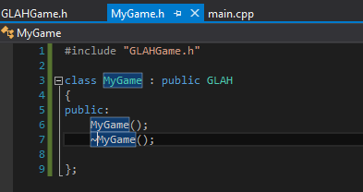
The GLAH class is an interface and we are forced to provide implementations for the Update and Draw methods. So lets declare those now.
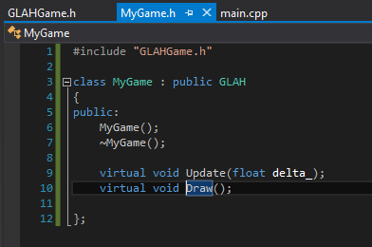
We will also need pointers to the graphics engine and the input engine, so we will need to include the relevant headers and declare the pointers in the private section of the class. Finally, we will reserve an unsigned int handle for our heroSprite
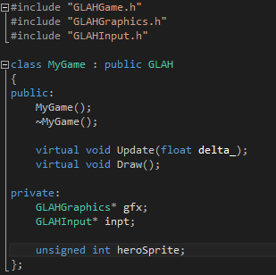
First of all, in our MyGame.cpp, we will need to define a couple of constants
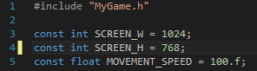

In our MyGame.cpp, lets define our constructor by calling the GLAH base constructor and setting up our graphics and input instances, then creating a sprite
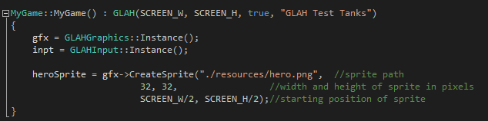
The "hero.png" should have copied over when you extracted the contents of the zip.

Because the sprite is tracked by the GLAHGraphics engine, we can allow it to do the work in regards to remembering where our on screen hero is. This allows us to call the MoveSpriteRelative function to only give the movement for the current frame only. Below will be our Update method implementation that is responsible for handling user input and moving the sprite.
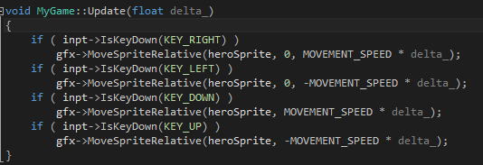
If we want complete control, we can always store the position in our own class and use the MoveSprite method, which will move the sprite in world space.

Our Draw implementation is simple, since there is only one sprite to draw. It looks like this:
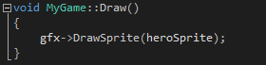

Finally, we need to tell our game to run, which can be acheived by calling Run on the GLAH object (MyGame's parent) we will do this in the main.cpp
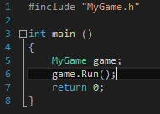
The complete source code and project file for this example can be found in the GLAHLib.zip file.

Our Hero -
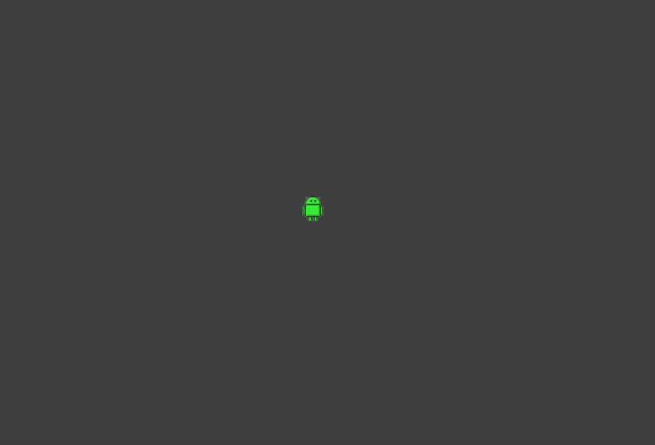
Video Here: http://gyazo.com/37cc5b2cee11bc7f5691aca792c3ffe1

