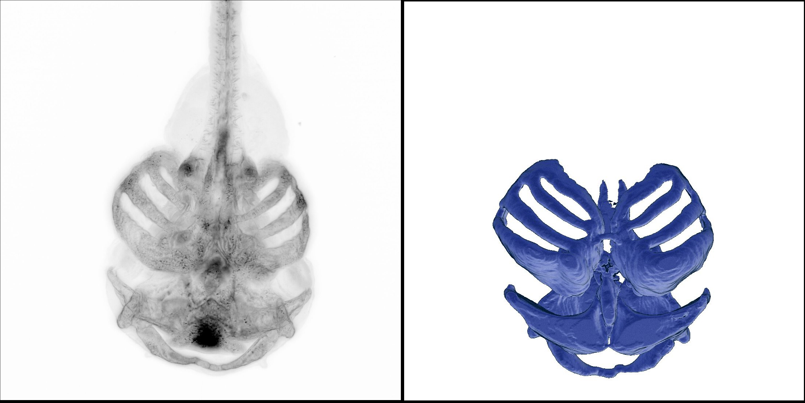

CranioNet <https://lienkamplab.org/deep-learning-models/>