Evaluation

Success of the solution

Fast to load, even on old systems, e.g. loaded in 1 second on Windows XP with 128MB of RAM. This runs without stuttering or lagging.
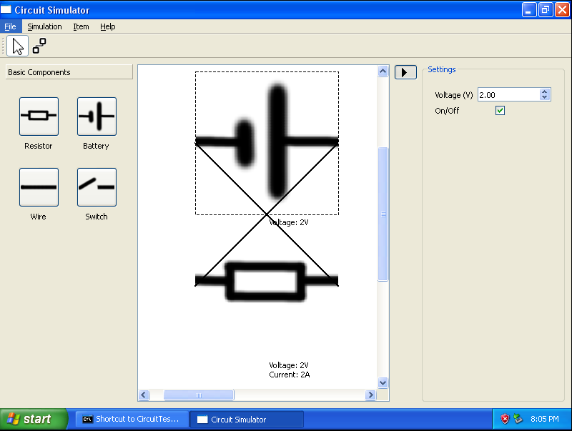
Easy to navigate, was rated 7/10 and 8/10 by the stakeholders.

Can save, load, import and export circuits to be stored for revision or sent to students for learning.

Usability features

Can change component settings during operation:

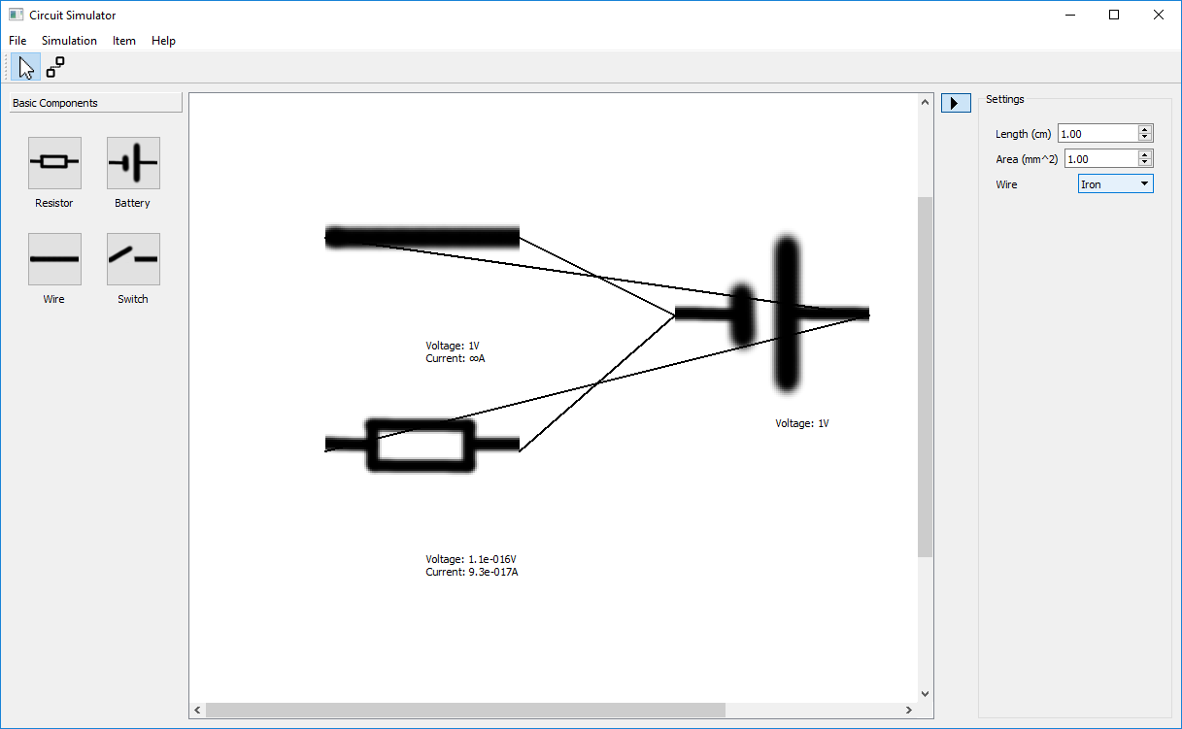
Can view circuit information at any point.
Not with ammeter/voltmeter like analysis stated but this will be worked on in the future.
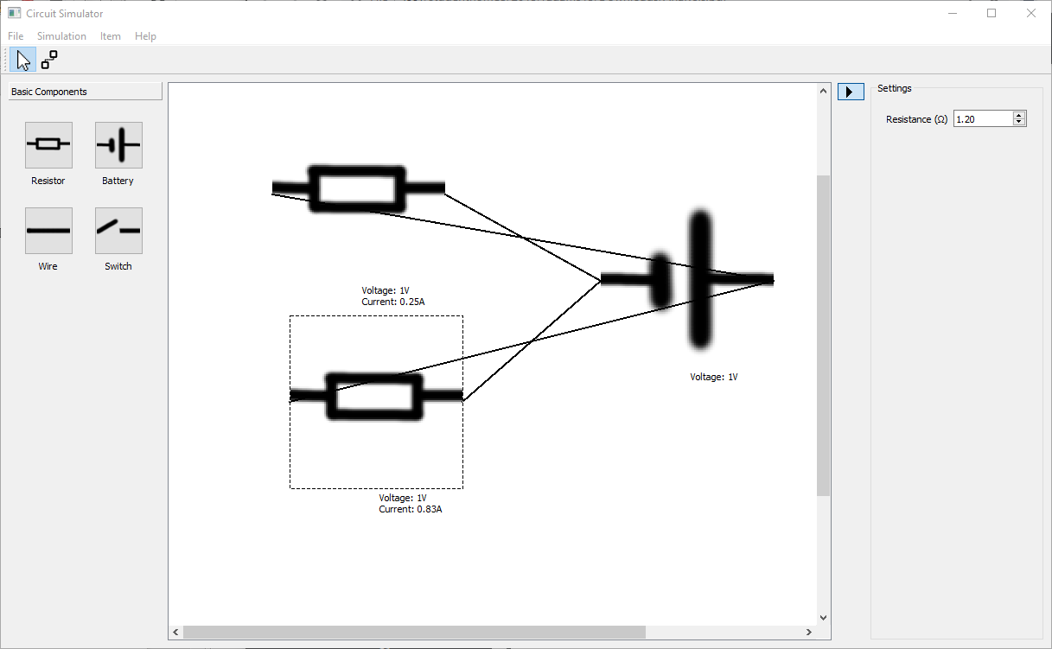

Can save and load circuits – could be improved using an easier-to-use interface but that is for the future.

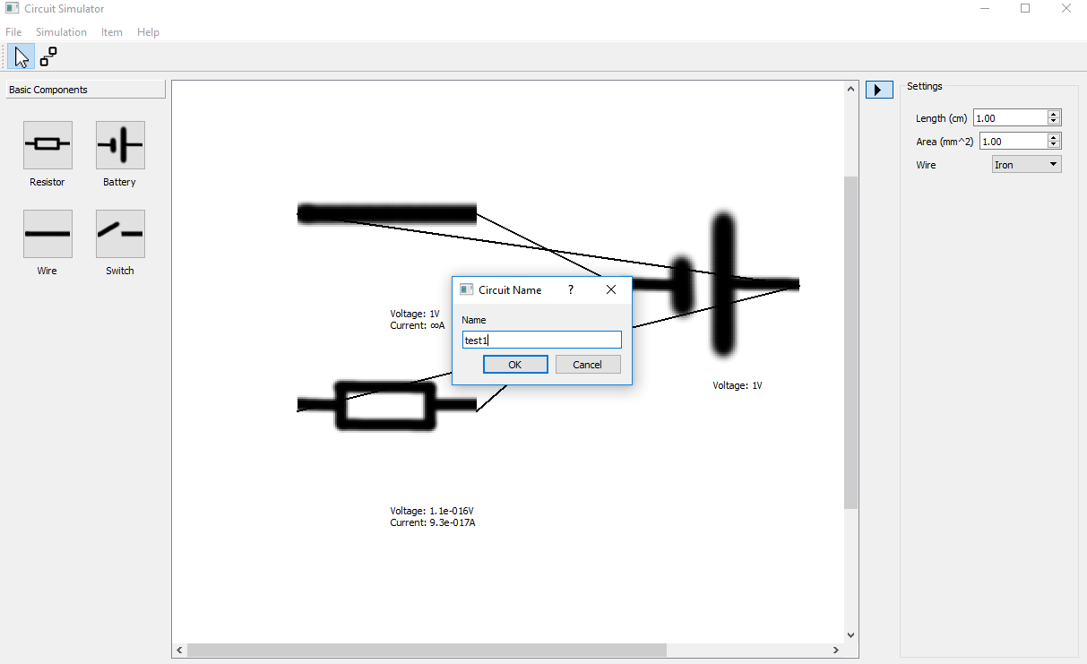

Can export/import circuits, saving them to any place on the PC as a .cir file.

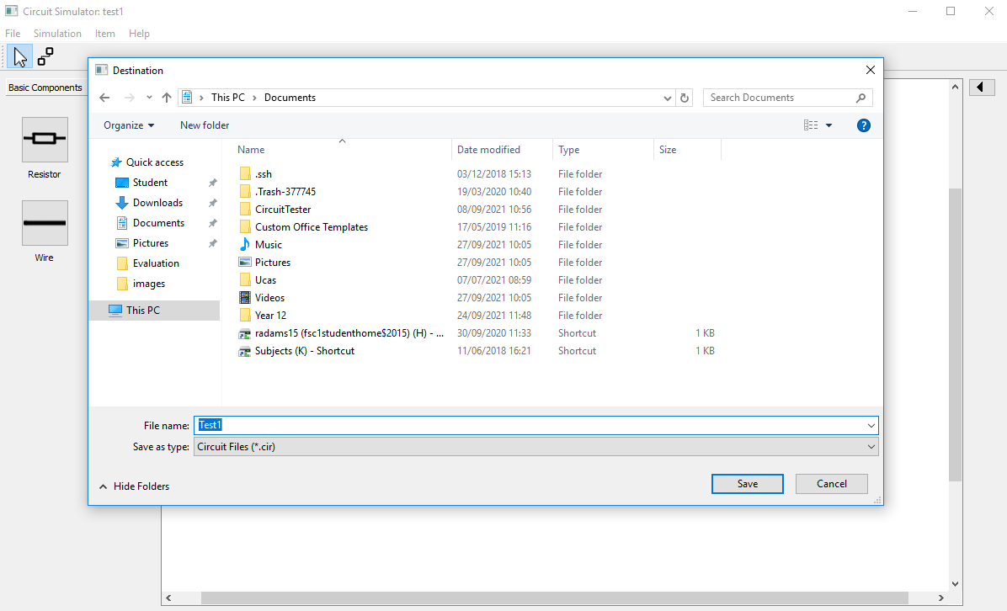
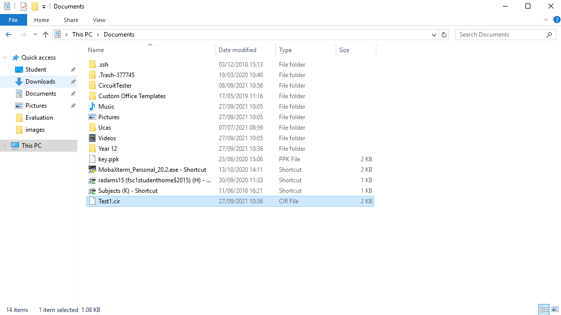

Can see here the file is saved in the Documents folder as specified above, .cir extension is added.

Maintainence

Very portable, can run on MacOS (10.8-10.11), Linux (Ubuntu 14.04-21.10), Windows (XP-10).

Needs to be updated to run newer QT versions when old ones are deprecated, e.g. Windows XP build uses the old, unsupported QT version 5.6, but windows 10 version uses the latest QT version 5.12.
If the user wants they can backup the save folder and load them onto a new PC, but this is difficult to do.

The only future technology this does not support is small devices with touchscreens, as the program only really works with devices that have a screen larger than 10". The program technically works with a touchscreen but is not optimal.

Future Development

Can add many things such as the voltmeter and ammeter which would be another ResistiveComponent class derivative with a low resistance.

Improve save box to prompt if the user overwrites an existing file name.

Improve load box to use a better dialog design similar to this, e.g. to show the user what they have saved so they can load them without remembering a file name.
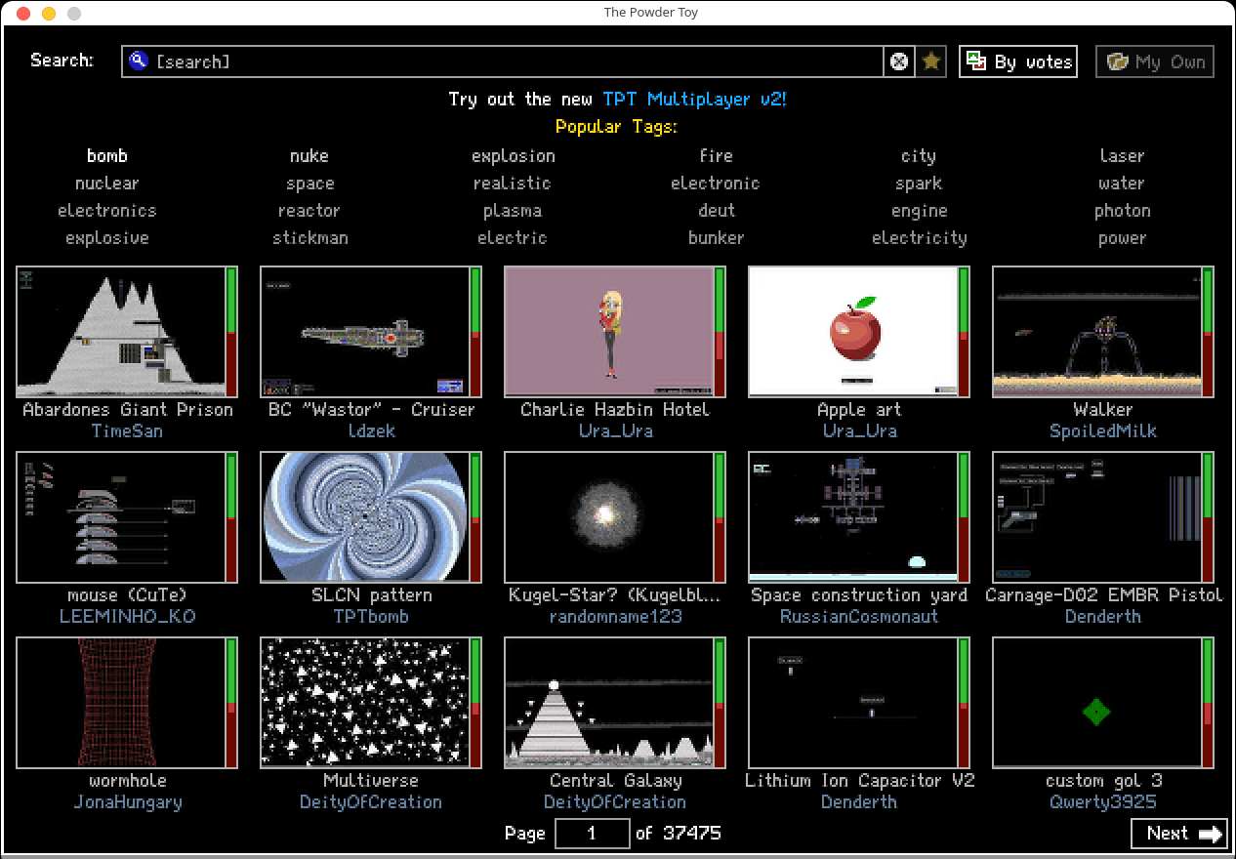
An alternative is a simple drop-down box with the saved circuits, which is easier to make but is harder for the user to understand and may get too big if too many circuits are saved.

Fix the bug with the lines drawing strangely by drawing lines between the two closest points, rather than from start to end, as this technique leads to crossed lines that look odd.

Make components rotatable to allow circuits to look better. Would need graphical updates and save/load updates to store the rotation.

