Proteins

Proteins are polymers of amino acids, also called a polypeptide.

An amino acid is:
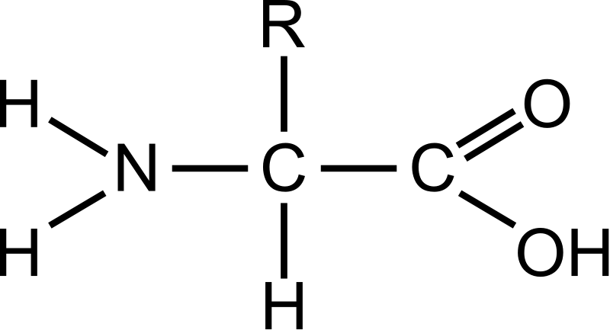
(Where R is variable)

A peptide bond can form between two amino acids to create a dipeptide (two bonded peptides), and a water molecule. The OH is from the carboxyl group (right), and the H is from the amino group (left).

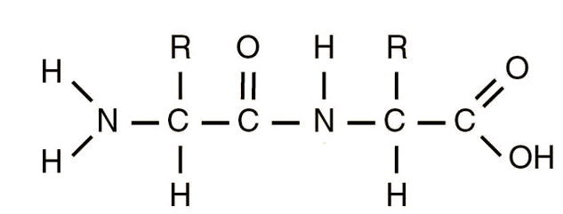
This forms the dipeptide, which has two ‘R’ groups which would be a variable molecule.

Roughly, more than 100 amino acids bonded together is called a protein.

Primary Structure
Is the order of different amino acids (because of the ‘R’ groups) joined by the peptide bonds. The sequence of this is essential to the function of the protein.

Secondary Structure
Caused by hydrogen bonds (H^{α+} and O^{α-}) between the CO groups and the NH groups in the polypeptide.

This can create either an α helix or a β pleated sheet.

Tertiary Structure
This is held together by:
- Disulphide bridges (S → S)
- Hydrogen bonds (H^{α+} and O^{α-})
- Ionic bonds/salt bridges (+ → -)
- Hydrophobic → Hydrophilic interactions.

Quarternary Structure
This is when more than one polypeptide chain is joined together
May have what is called a prosthetic group – such as the haem group in haemoglobin which is iron based.

β Pleated Sheets
Polypeptide chains are linked by a hydrogen bond to create sheets of rigid protein.
They can either run in the same or different directions.
They cannot be stretched – they are already extended as much as they can be.
These sheets can slide over each other – making them flexible.

Fibrous Proteins
This is caused by the secondary structure.
The α helix chains are twisted into a spiral.
These spirals can coil around other spirals to create long strands
An example is keratin.

Globular Proteins
Usually spherical – very tightly folded polypeptide chains.

Most globular proteins are soluble, in soluble globular proteins the hydrophobic groups are folded inside the protein, and the hydrophilic groups are on the outside, so they can dissolve in water.

Haemoglobin and myoglobin are examples of globular proteins – they are dissolved in our blood.

