Atherosclerosis

- The endothelium of the blood vessel is damaged by high blood pressures.
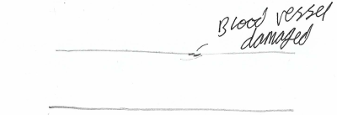
- White blood cells move to the damaged area, which clump together and fills the damaged area.
- Cholesterol also starts to build up inside the damaged area, this is called an atheroma
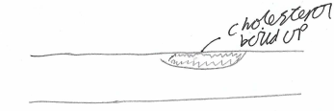
- Calcium salts and fibres build up inside the deposit, hardening the deposit. This is now a plaque.
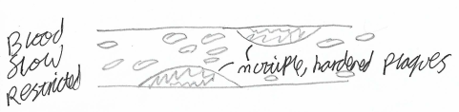
- The wall is now less elastic, and also narrower, which restricts blood flow and increases blood pressure.
- The higher blood pressure causes the endothelium to be more often damaged, which causes this cycle to repeat. This is positive feedback.

If the atheroma ruptures, the artery wall is damaged.
This causes rapid blood clotting at the at the damage.
This clot can block the artery, or be dislodged and block a different artery.
Either way, the blockage will severely restrict blood flow in the blocked area, causing strokes, heart attacks or deep vein thrombosis to occur.

