Screenshots:-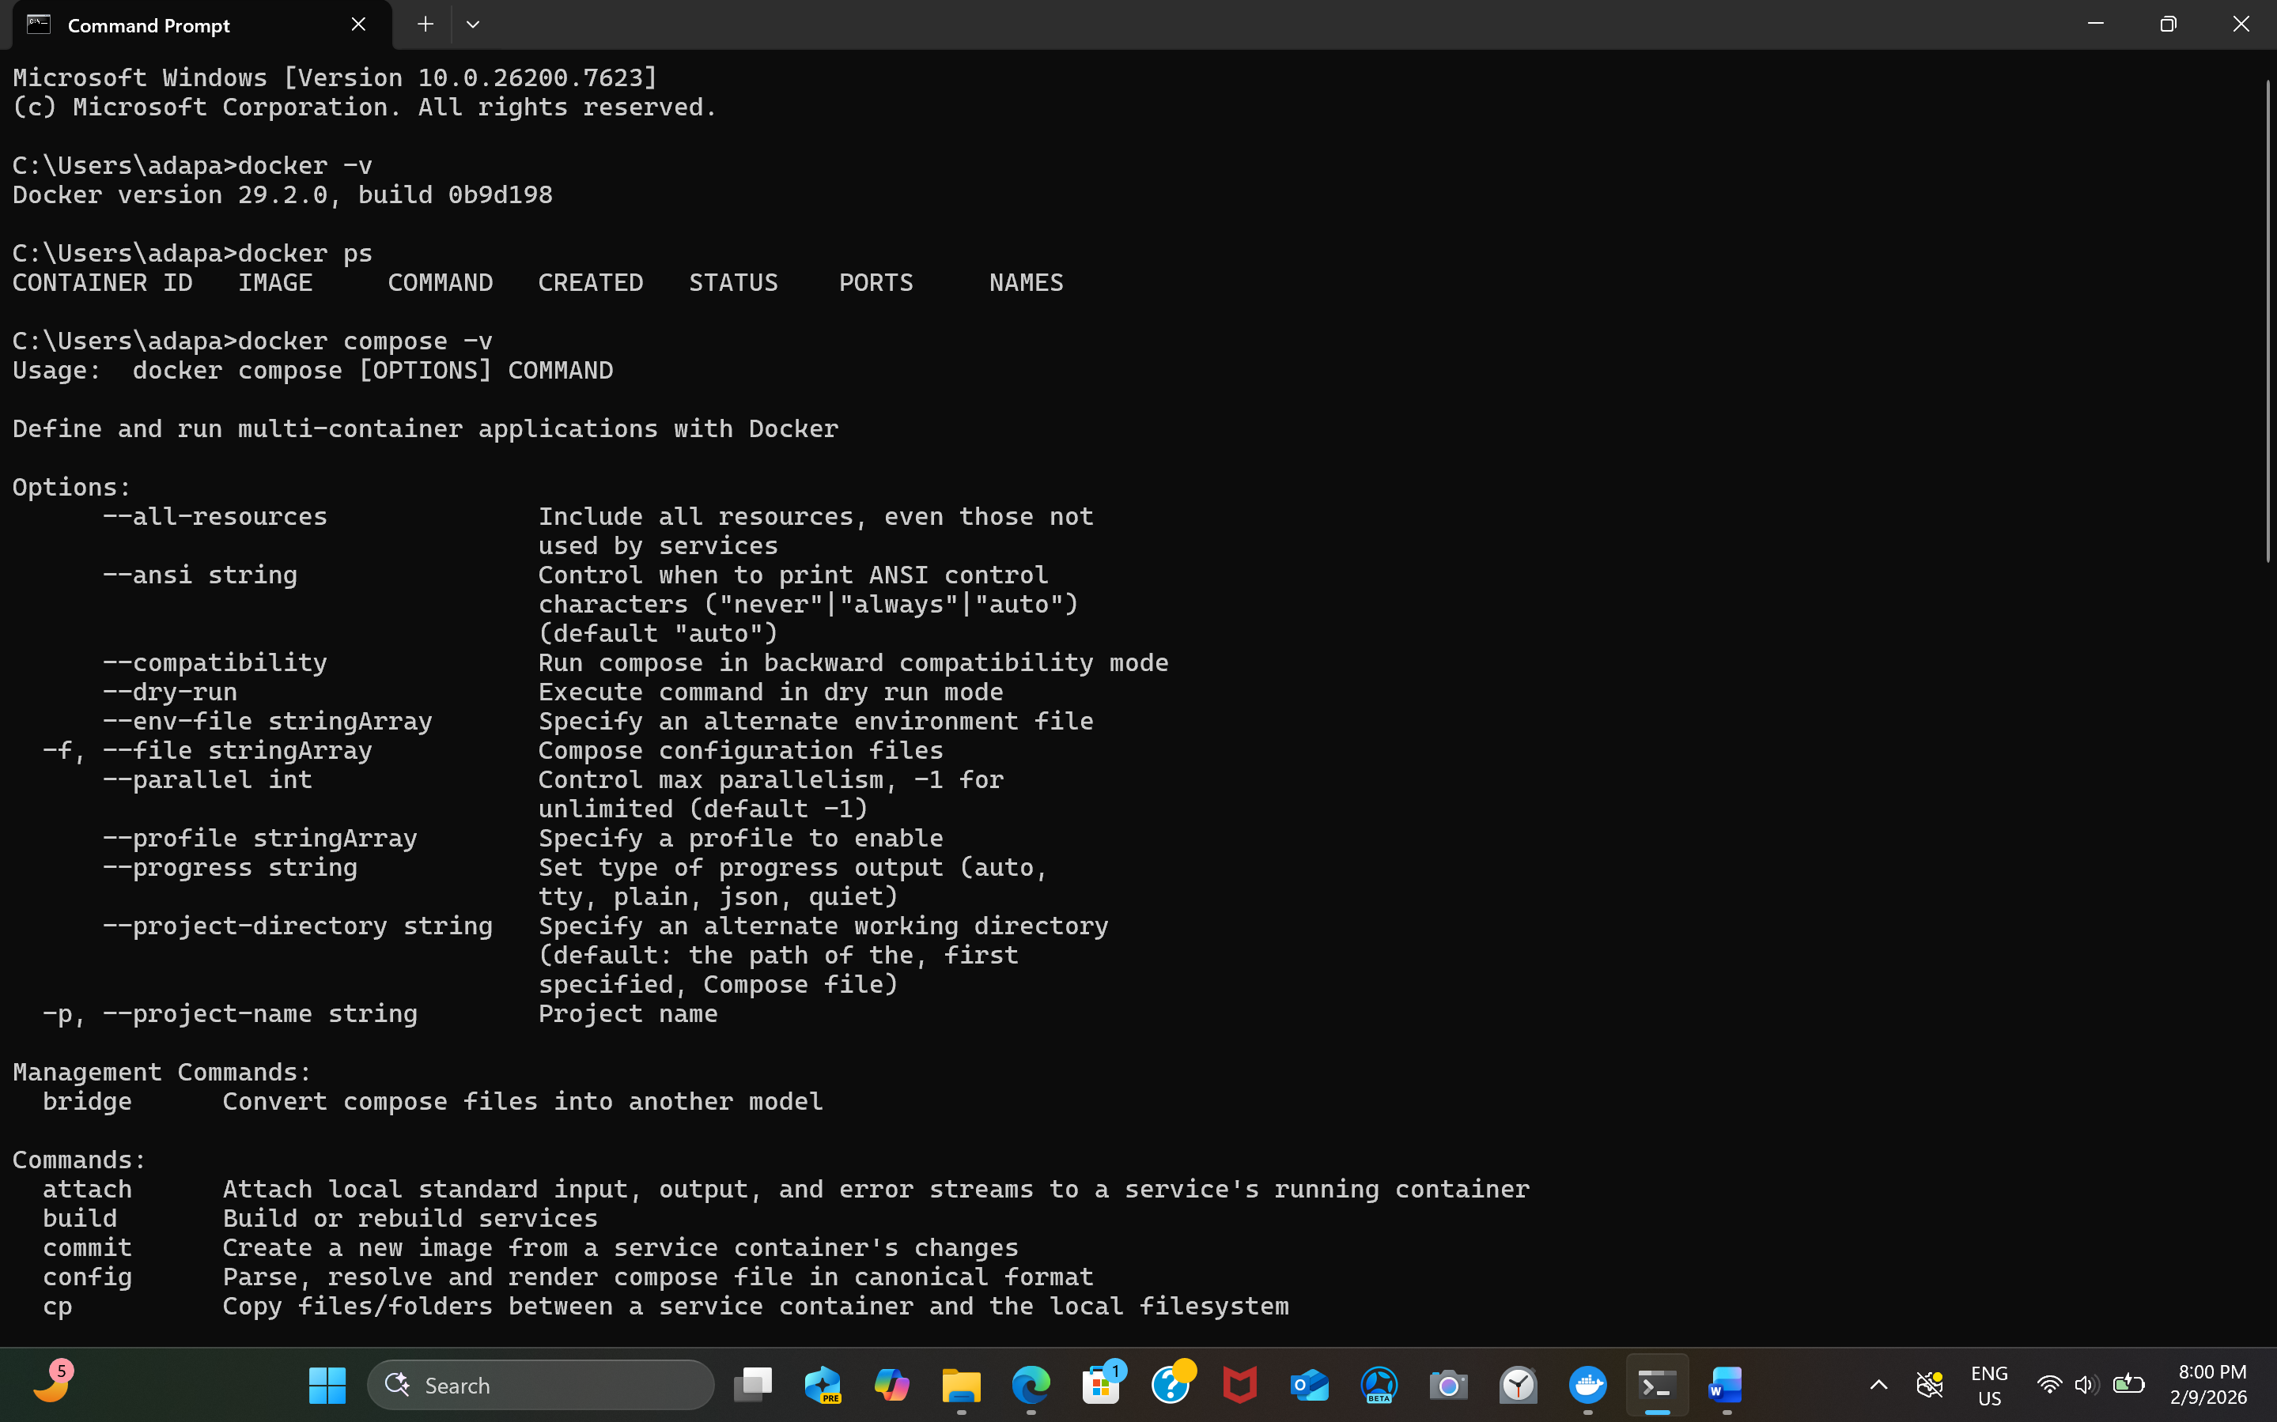
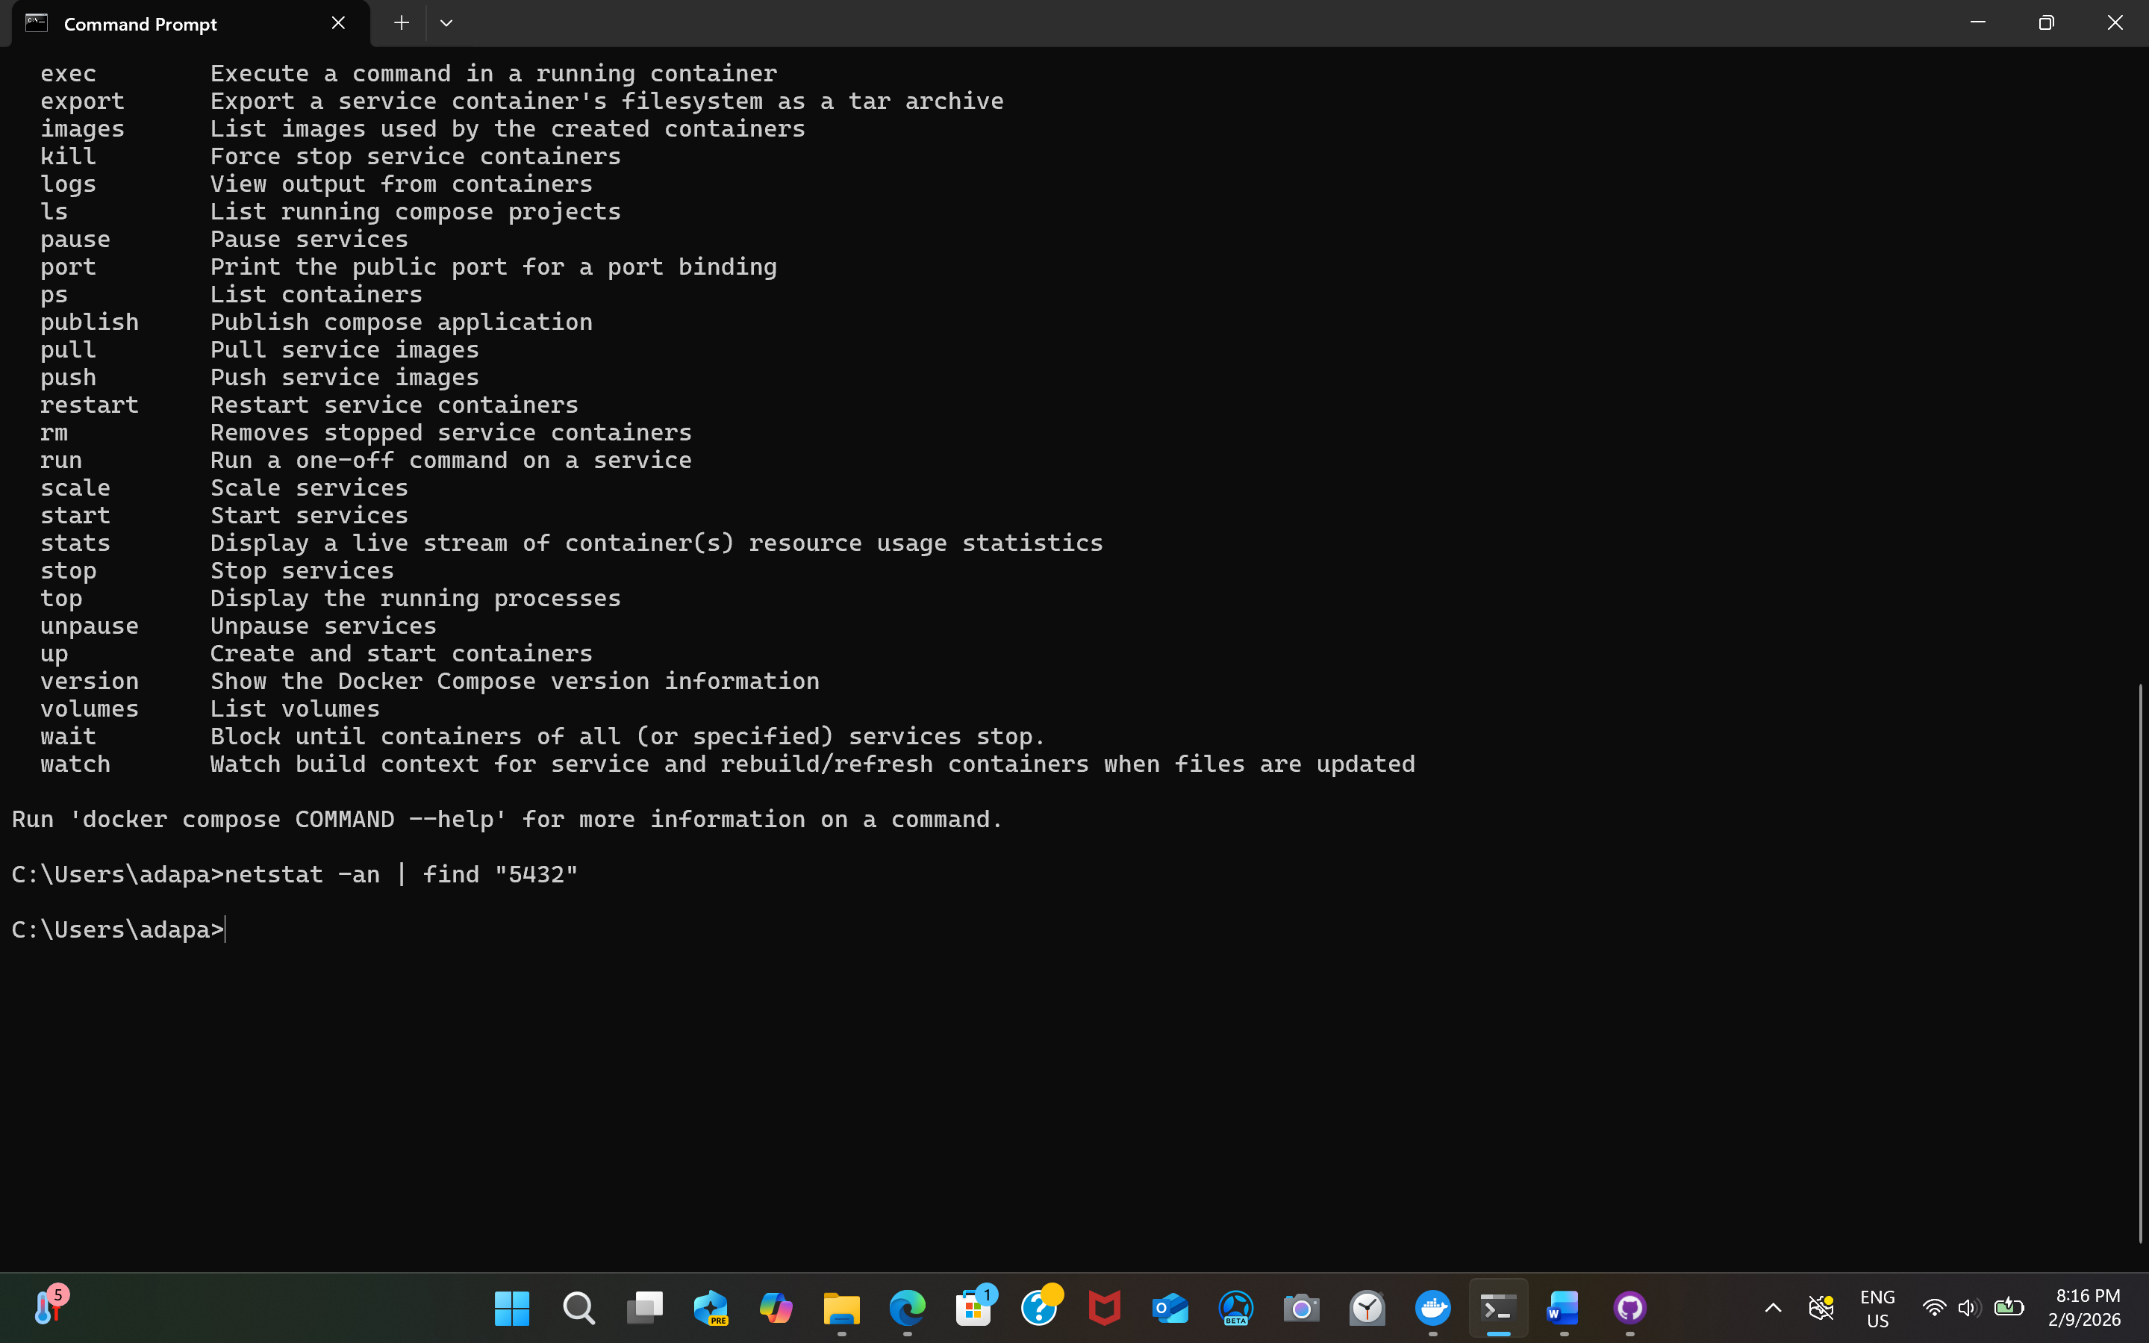
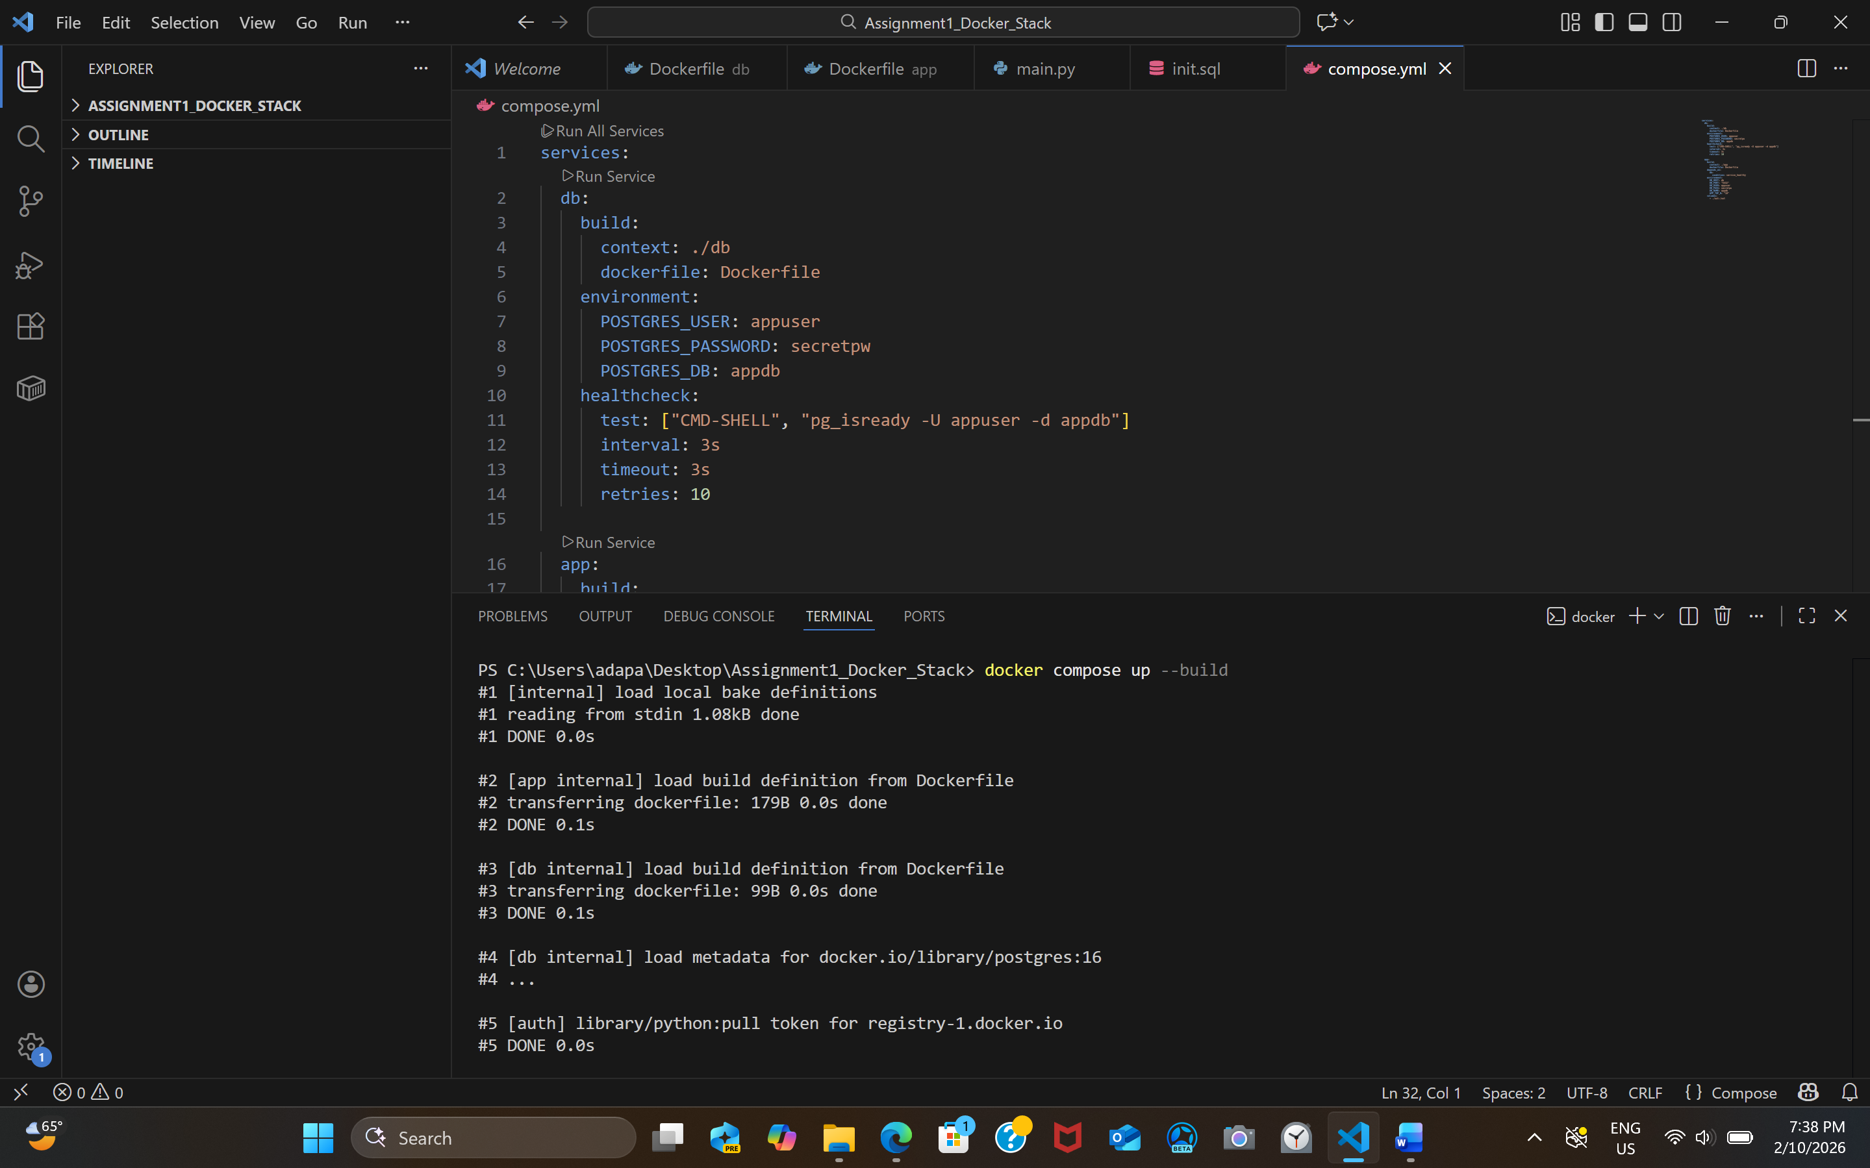
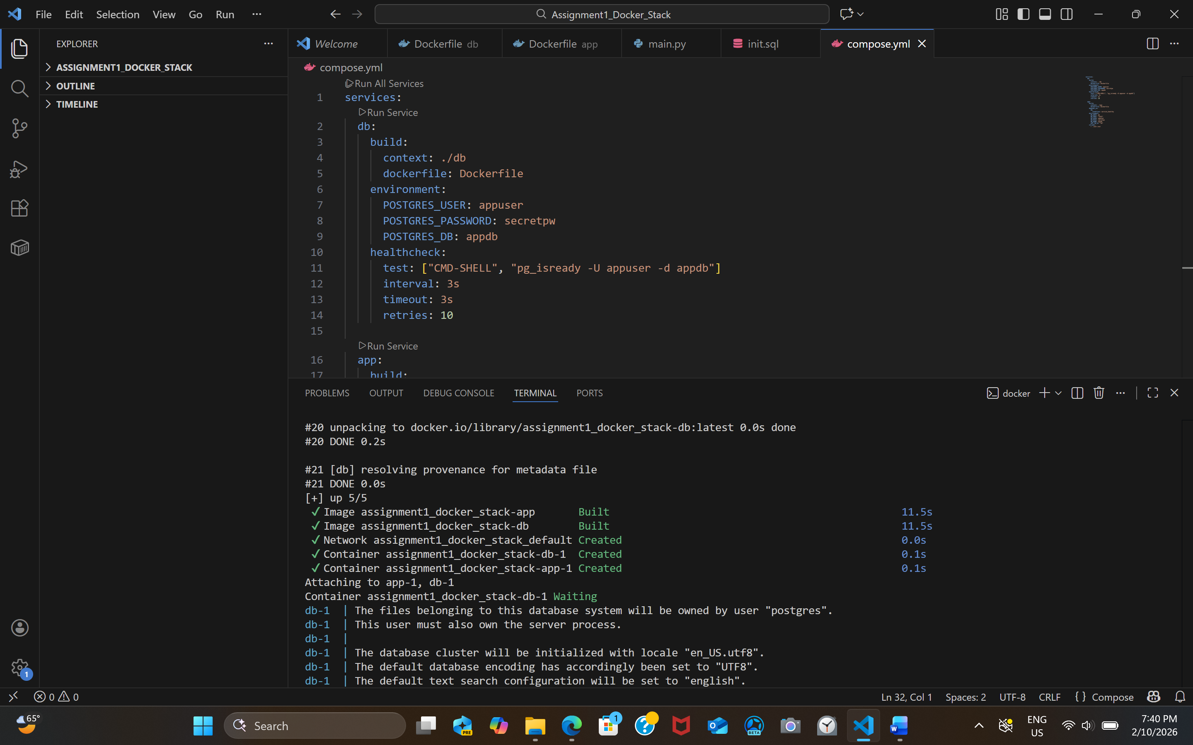
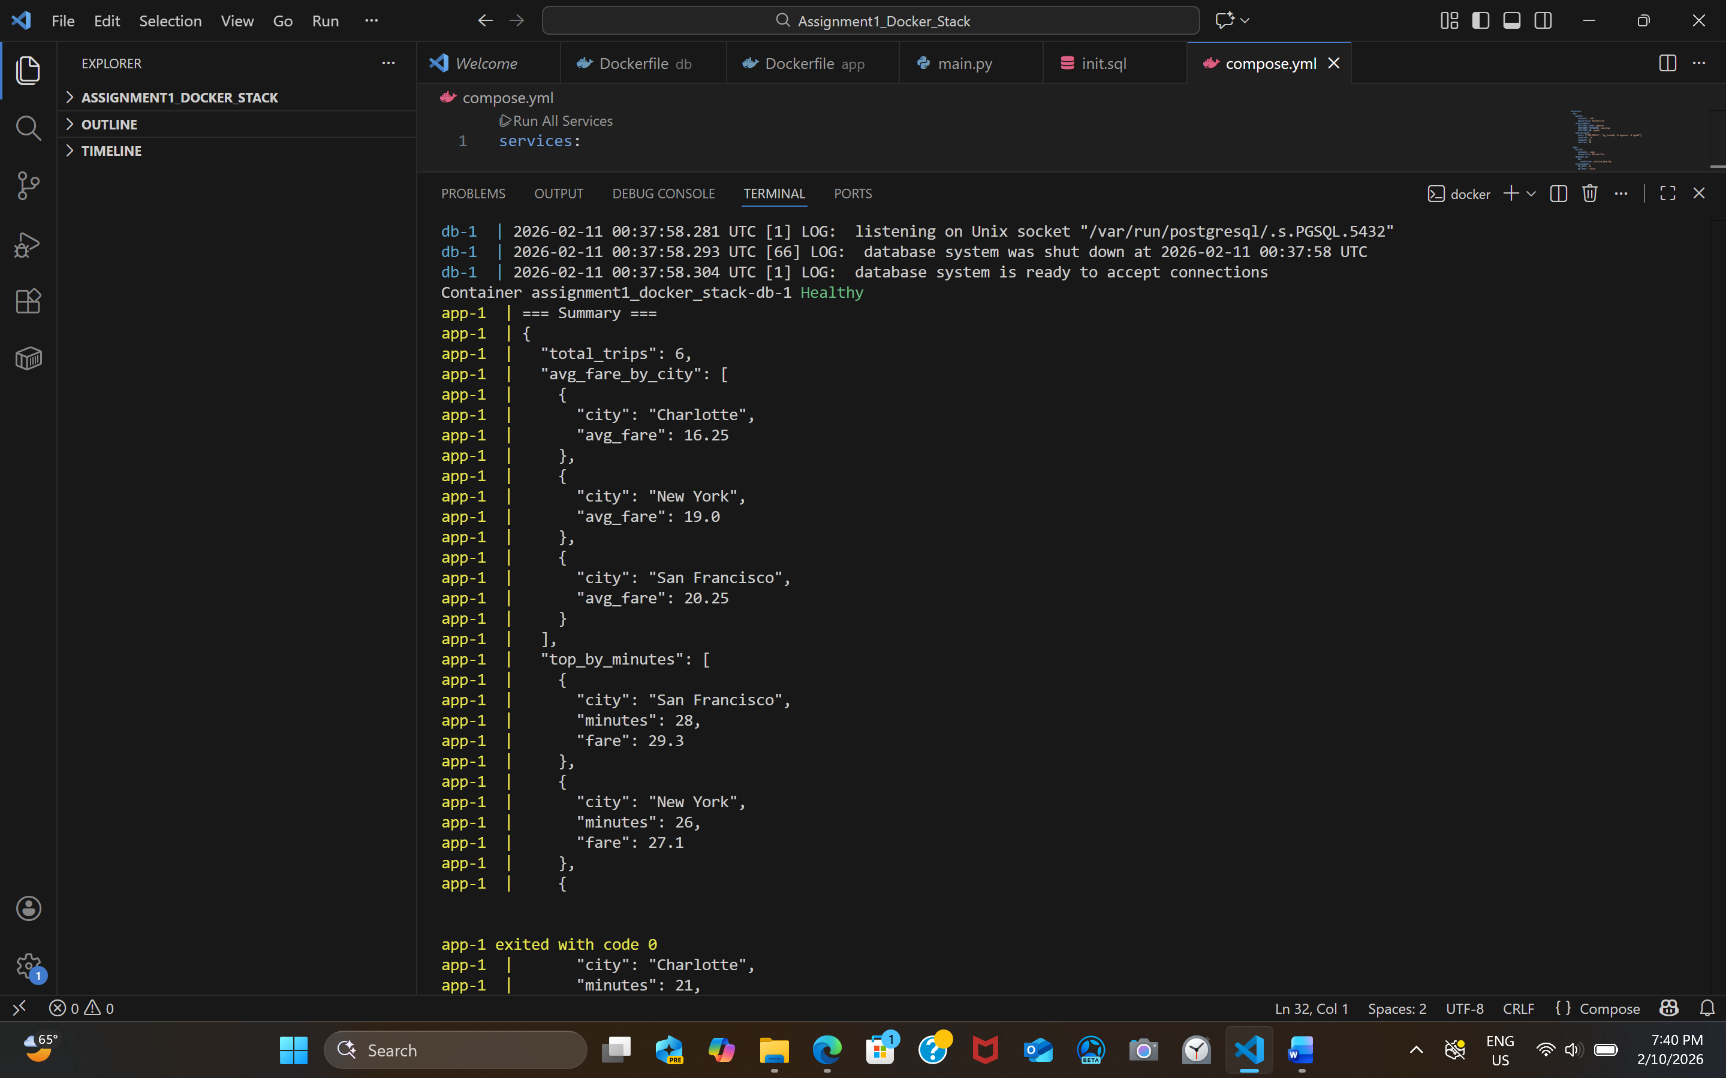
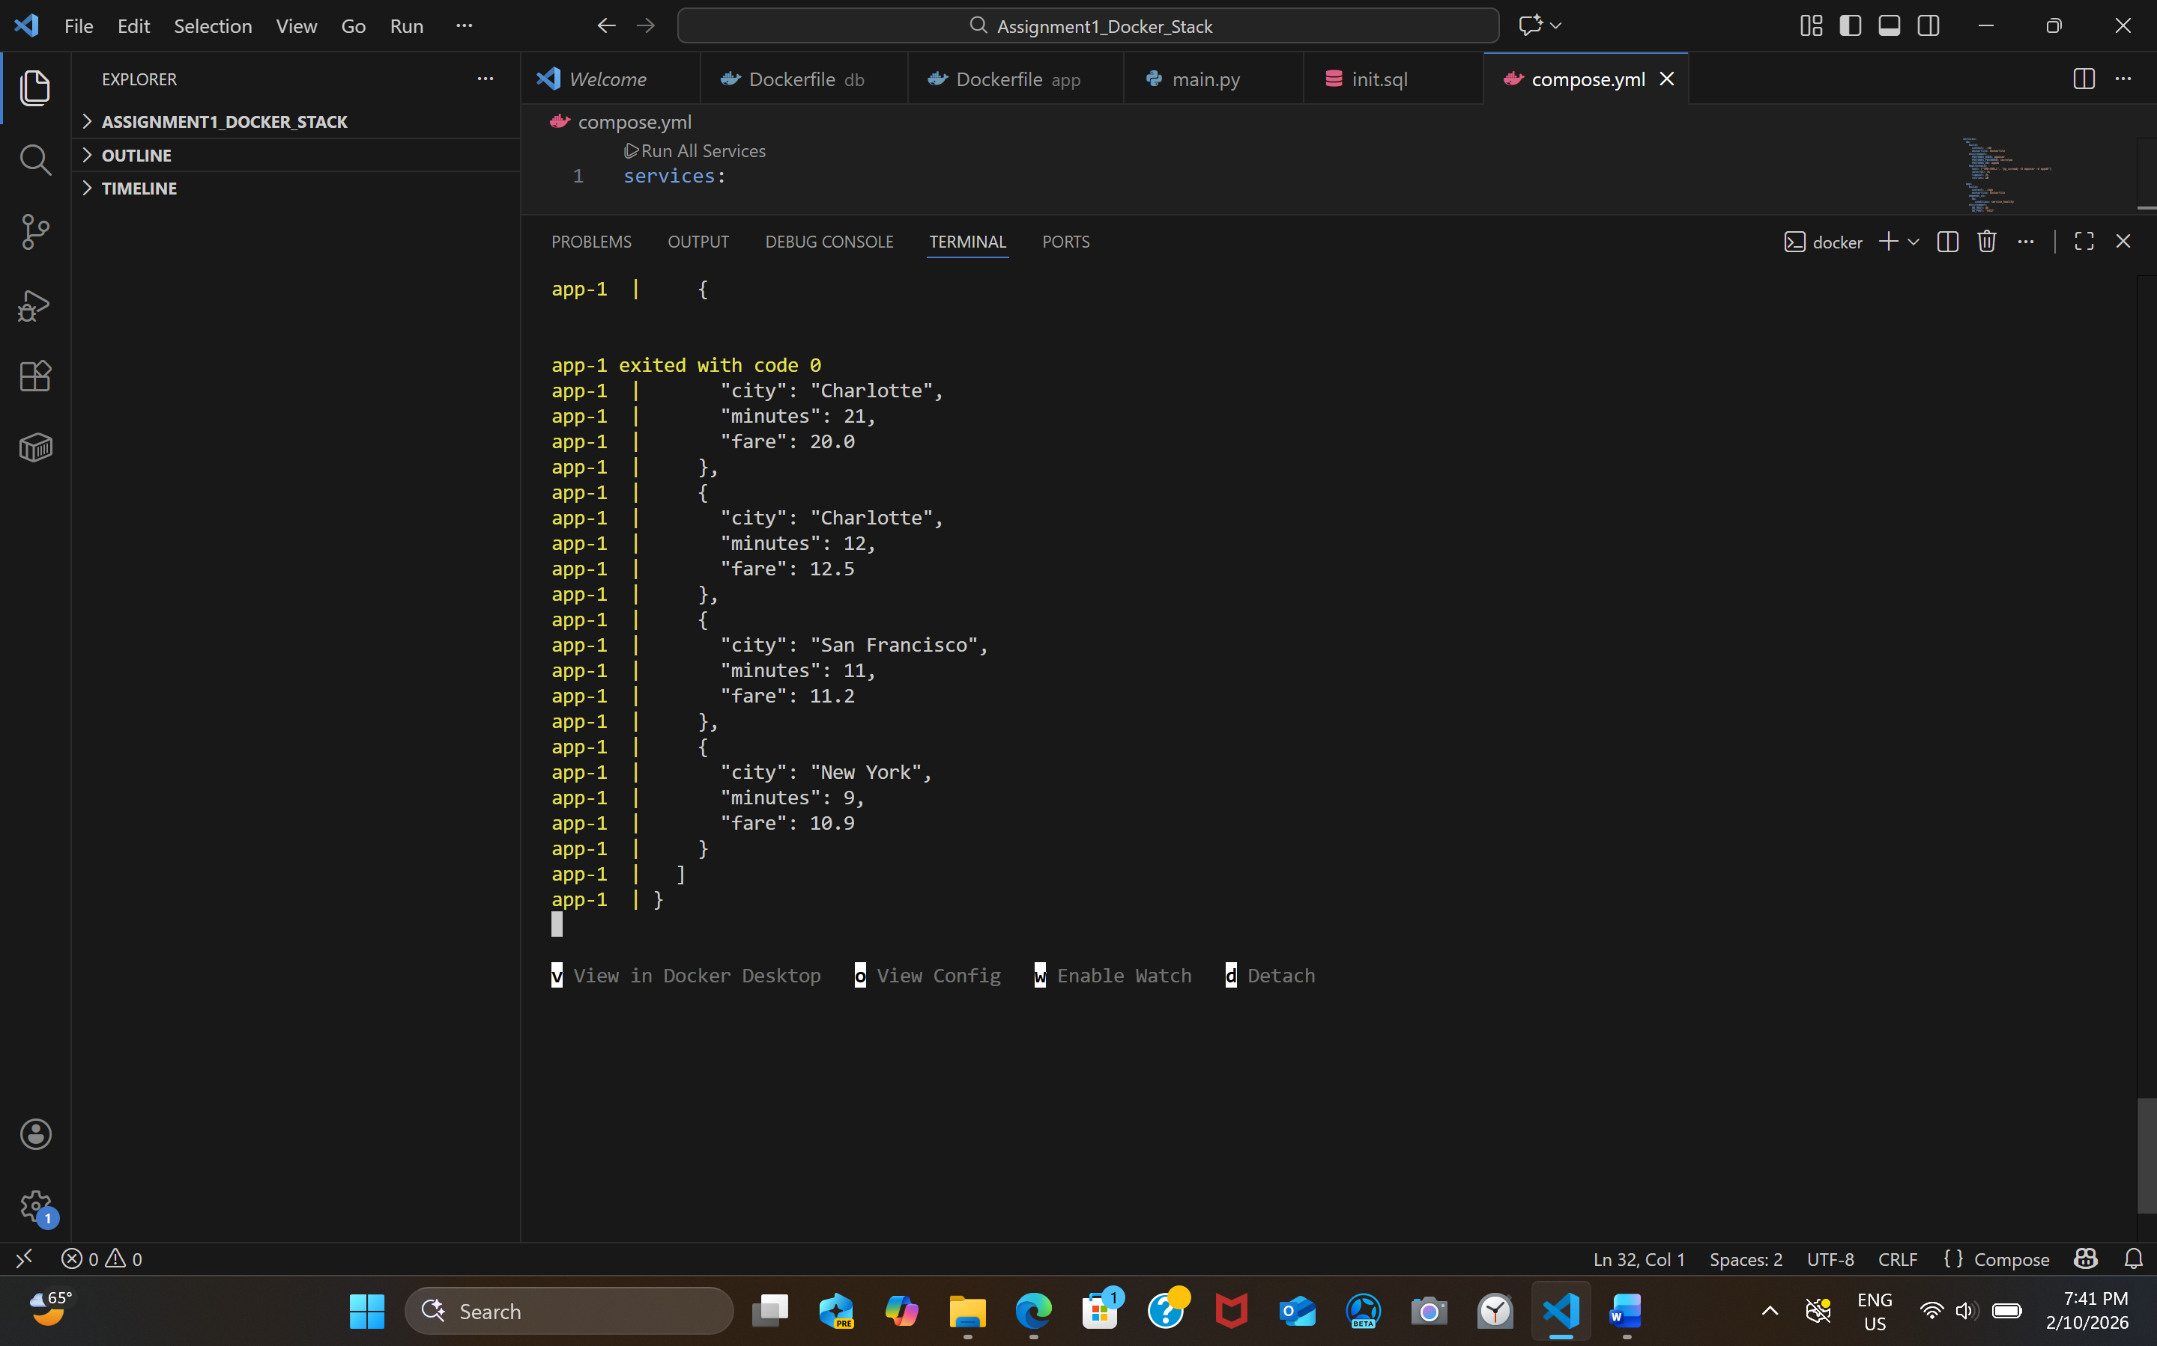
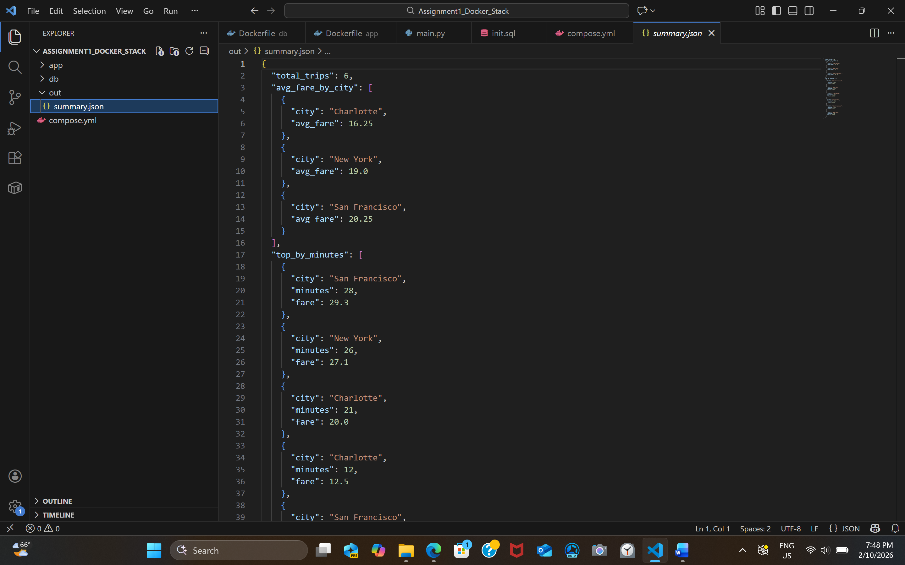
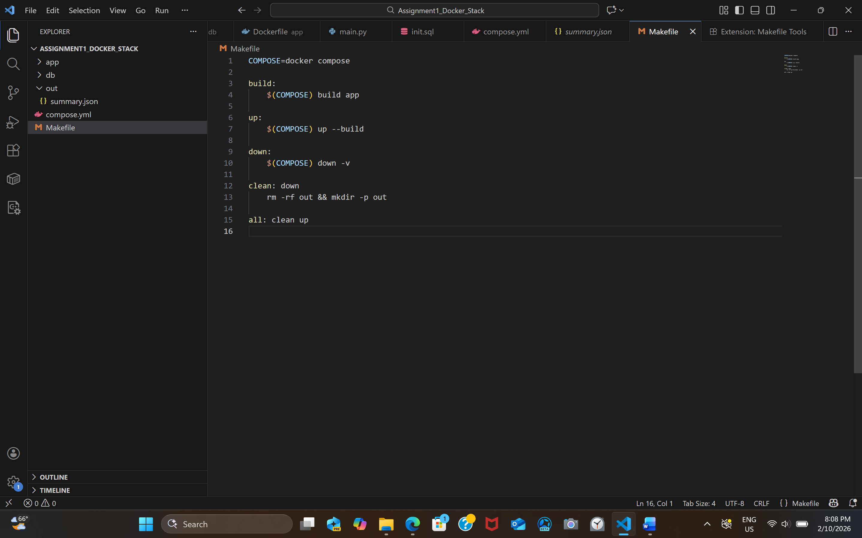

Short Reflection:-
Through this assignment, I learned how to build and manage a multi-container application using Docker and Docker Compose. I gained practical experience in writing Dockerfiles, configuring environment variables, and connecting two services through Docker networking. I understood how PostgreSQL can automatically initialize a database using an SQL script during container startup, which makes the setup reproducible and consistent. I also learned how Docker Compose handles service dependencies and health checks to ensure that containers start in the correct order. Overall, this assignment improved my understanding of containerization and how real-world applications can be packaged and deployed in a structured and reproducible way. If I were to extend this project further, I would add more complex queries, additional test data, and improve logging to make debugging easier.
Commands Used By Me Throughout this Project:-
Verifying Docker Installation
To confirm Docker was installed and working:
docker -v
docker ps
Checking PostgreSQL Port Availability
To ensure that port 5432 was not already in use:
netstat -an | find "5432"
Building and Running the Multi-Container Stack
To build the Docker images and start both the PostgreSQL and Python containers:
docker compose up --build
This command:
- Built both container images
- Started the database service
- Waited for the health check
- Ran the Python application
- Printed the JSON summary
- Generated out/summary.json
Stopping and Cleaning the Containers
After the JSON output appeared in the terminal:
Ctrl + C
Then to stop and remove containers and volumes:
docker compose down -v

