TASK_4 SCREENSHOT:-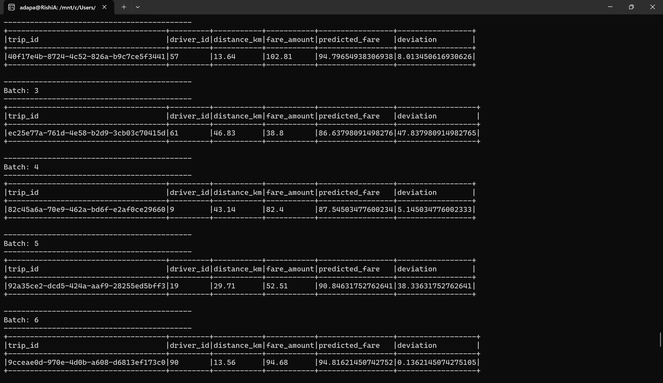

TASK_5 SCREENSHOT:-
