The Sorrow of the Statues Escape room challenge.

@ everyone At the Tatankan pen, a burst of magic makes a massive red flare in the air, visible from anywhere on the island.
Solving the clue will give access to a private escape room called “the sorrow of the statues.”

- Oleander’s Phylactery has been hidden in a demiplane accessed from within the Pen (now an unholy place tainted by evil). The curse that governs this place is as enigmatic as the Jackalich Druid himself.

- The room removes all of the players' items. Dungeoneers packs will be provided.

- The room is played out through 3 main puzzles, a fight and several mini puzzles that link a single narrative. This ends with the Pen being an accessible town.

Day 22

Arriving at the Pen, you see that the statues have all been draped in ropes that are made up of intricate knots. Some of the knots contain things like leaves, feathers, string, stones and occasionally stranger things, like a dagger and a broken key.

The spirits of the statues have delivered a story knot tatankan "writing" is all intricate knot tying. The spirits sway in front of the strings gripping them carefully with their eyes shut. The begin to tell their tale.
“Once, long ago.” says the first spirit. A juvenile male.
“Lago.” Says one. “Wendigo” Says another. “And Sasquatch.”
“Came to Roanoke”
“Then Came our Tinker”
“To set our way”
“Hiram was chased”
“By Croatoan”
“But He.” “He. he. HE.” Echo the voices.
“But He cannot be killed.”
“Changed”
“By he who walks above”
“By he who walks below”
“Lago Rebis Wendigo Jackalope.”
“And then Oro sent the Tatankans to Columbia.”
“And we guarded Hiram’s Forge.”
“And Came Columbia’s Kin of the Sea.”
“And of Fontaine Came the Uru who perch.”
“And in the day of he who walked behind”
“He whose name was carved.”
“The Tatankan were turned to stone.”
The Elders begin to weep.
And Then the children begin to wail.
And then the village mourns their loss anew at the recounting of their tail.

“But all is not lost.”
A cat screams at it’s shadow.

“The Lich who holds our curse, was himself cursed. Oleander the Jackalich was himself cursed by the Hags of Roanoke.” And it is in our Village that his Pylactory now resides. Unfortunately it is hidden in a labyrinth, a maze of incredibly complex puzzles that will likely require many attempts, risking both life and precious resources to do so.

Welcome to the Sorrow of the Statues, this year’s completely optional hardcore low magic dungeon crawl, group puzzle and cryptography challenges. Posted below is an image of tatankan story knotts. Not only will solving these challenges reward you with endless hours of fun, but they will also be a competition. First challengers to complete the adventure will finally discover the resting place of Oleander’s Phylactory. Destroying this will mean that if/when you fight him, he will permanently be dead and written out of the game.

These will be done as invitationals. DM BFDM to set one up.

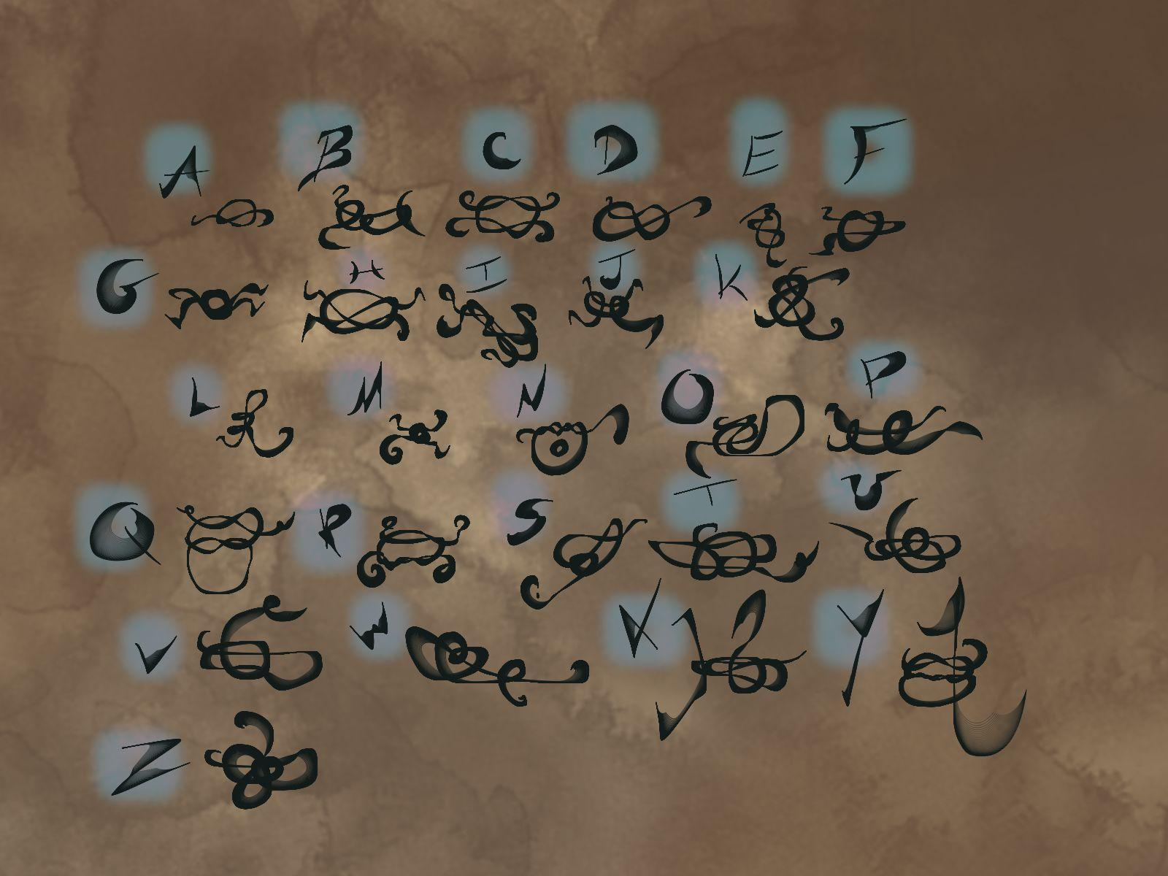


Day 23- Keep out the jackalopes
Astral projected into maze. Silver thread. To tie knots. One player may tie knots using their silver thread. Every incorrect knot removes a death save for the day. Any failed trap also removes a death save for the day.

There is something odd about the glowing lines on the floor. As you stare at them you feel something in the pit of your stomach like you are about to be pulled. What do you do?

You are equipped with nothing but starting equipment and a band of loyalty to which you are attuned until the end of this adventure.

A magic square puzzle appears on the entryway.
Solving the puzzle springs the trap.
Entryway trap:, you are hit by the spell scatter Wis DC 15
Conjuration
Scatter:
Level: 6
- Casting time: 1 Action
- Range: 30 feet
- Components: V
- Duration: Instantaneous
- The air quivers around up to five creatures of your choice that you can see within range. An unwilling creature must succeed on a Wisdom saving throw to resist this spell. You teleport each affected target to an unoccupied space that you can see within 120 feet of you. That space must be on the ground or on a floor.

You will not be able to summon creatures to the astral maze, or planeshift away for any reason.

Include other sensory descriptions to signal traps.

Room one is a maze. Characters will discover letters written in the maze.

The reward is the Verbal component of the spell needed to restore the Tatankans.

Clue 1: Ten Letters.

The word is: Deliquesce.
All answers must be submitted in Tatankan.
Death in the maze turns you to stone, until the whole trial is complete. Stone characters become lingering spirits according to mat mercers’ class.

Repeat for days

24
Clue 2: It is the opposite of petrify, to melt.
25
Clue 3: It begins with the fourth glyph.

Reward: Reskinned horn of the endless maze as Horn of the Amber Waves. That summons Tatankans instead of minotaur.

Day 26
Fight to claim the pen for the Tatankan
Oleander’s phylactery revealed in the pen, lychwood arms start bursting out of the ground.
Lichwood Treant. Mini Boss encounter. After the mini boss beaten, sudoku puzzle appears.

Solving puzzles today or tomorrow will make the phylactery appear in the real world as soon as the players return from the astral plane.

Reveal: Oleander’s Phylactery. Destroying this means that Oleander will not be returning to Roanoke. 50 hp. Does necrotic damage on strike. 1d10. 20 ft radius.

Day 27
New town is opening.
Get your knot tying badge here. Rp only, no shops.

Puzzle A:

Description: Nine pressure plates lay in a 3x3 grid on the floor. There are nine weighted stones. The weights are marked 1-9. You must rearrange the weights on the pressure plates in such a way that each row, column and diagonal add up to the same number.

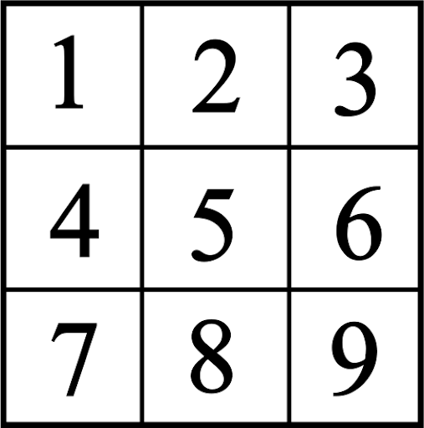

Puzzle B:

https://cracking-the-cryptic.web.app/sudoku/d8pD7tGQJB

Rules: Normal Sudoku rules apply. Each colored region is a magic square (using digits 1-9 each row, column and diagonal sums to the same number).

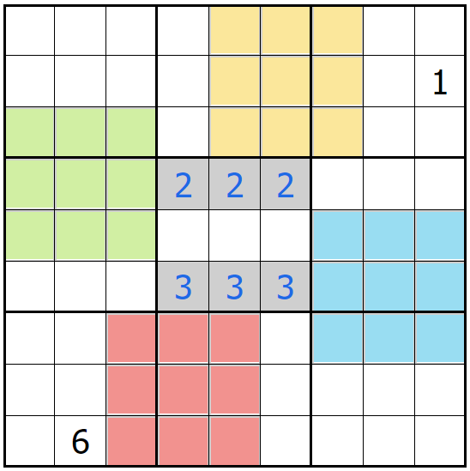
After solving the puzzle, to prove you have solved it, take the central 9x9 square, and give the difference of the top row and bottom row shown in gray. In the example, it would be 333 - 222 = 111 (one hundred eleven). This is the key to progress.

Puzzle C:

https://cracking-the-cryptic.web.app/sudoku/4RQ9rbpmjT

