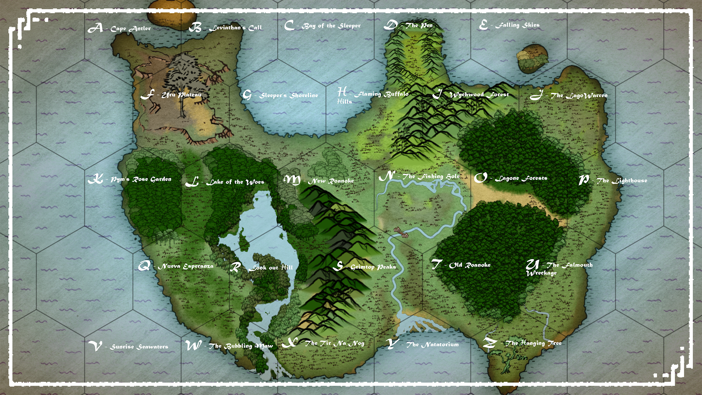

Hex Name Link
A Cape Antler Lode -Bahamut’s Folly
B Leviathan’s Call Half Wudgie hollow
C Bay of the Sleeper DM Freeplay Zone (entirely water zone)
D The Pen The Sorrow of the Statues
E Falling Skies Lode - SpellJammer
F Uru Plateau Roostloft
G Sleeper’s Shoreline Oleander's Rest
H Flaming Buffalo Hills Hiram’s Forge
I Wychwood Forest Hag Coven
J The Lagowarren The Lagowarren
K Pym’s Rose Garden The Rosecutter
L Lake of the Woes Island Olympics.
M Howling Woods Dm Freeplay Zone
N New Roanoke New Roanoke
O Lagone Forest s Myconid Nest
P The Lighthouse DM freeplay zone.
Q Nueva Esperanza Nueva Esperanza
R Look out hill Lode - Demiplane of grease
S Grimtop Peaks DM Freeplay Zone
T Old Roanoke
U The Falmouth Resources (un lettered hex)
Wreckage
V Sunrise Seawaters DM Freeplay Zone (entirely water zone)
W The Bubbling Maw DM Freeplay Zone
X Tir Na Nog Wreckage resources
Y The Natatorium Chinnokin relations
Z The Hanging Tree Game End. (I have a battle map for this)

