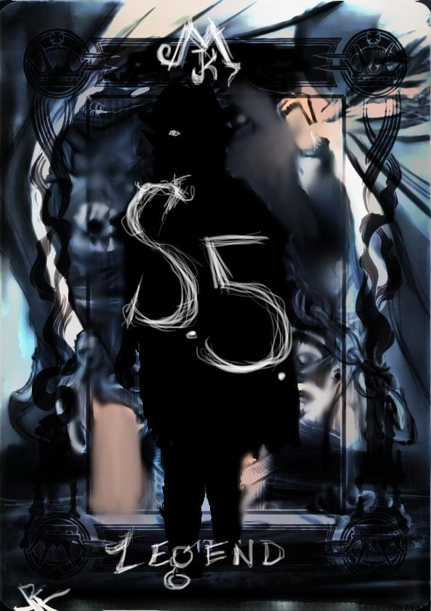

Welcome to Season 5.
Thank you all for playing this game with me.
Setting info:
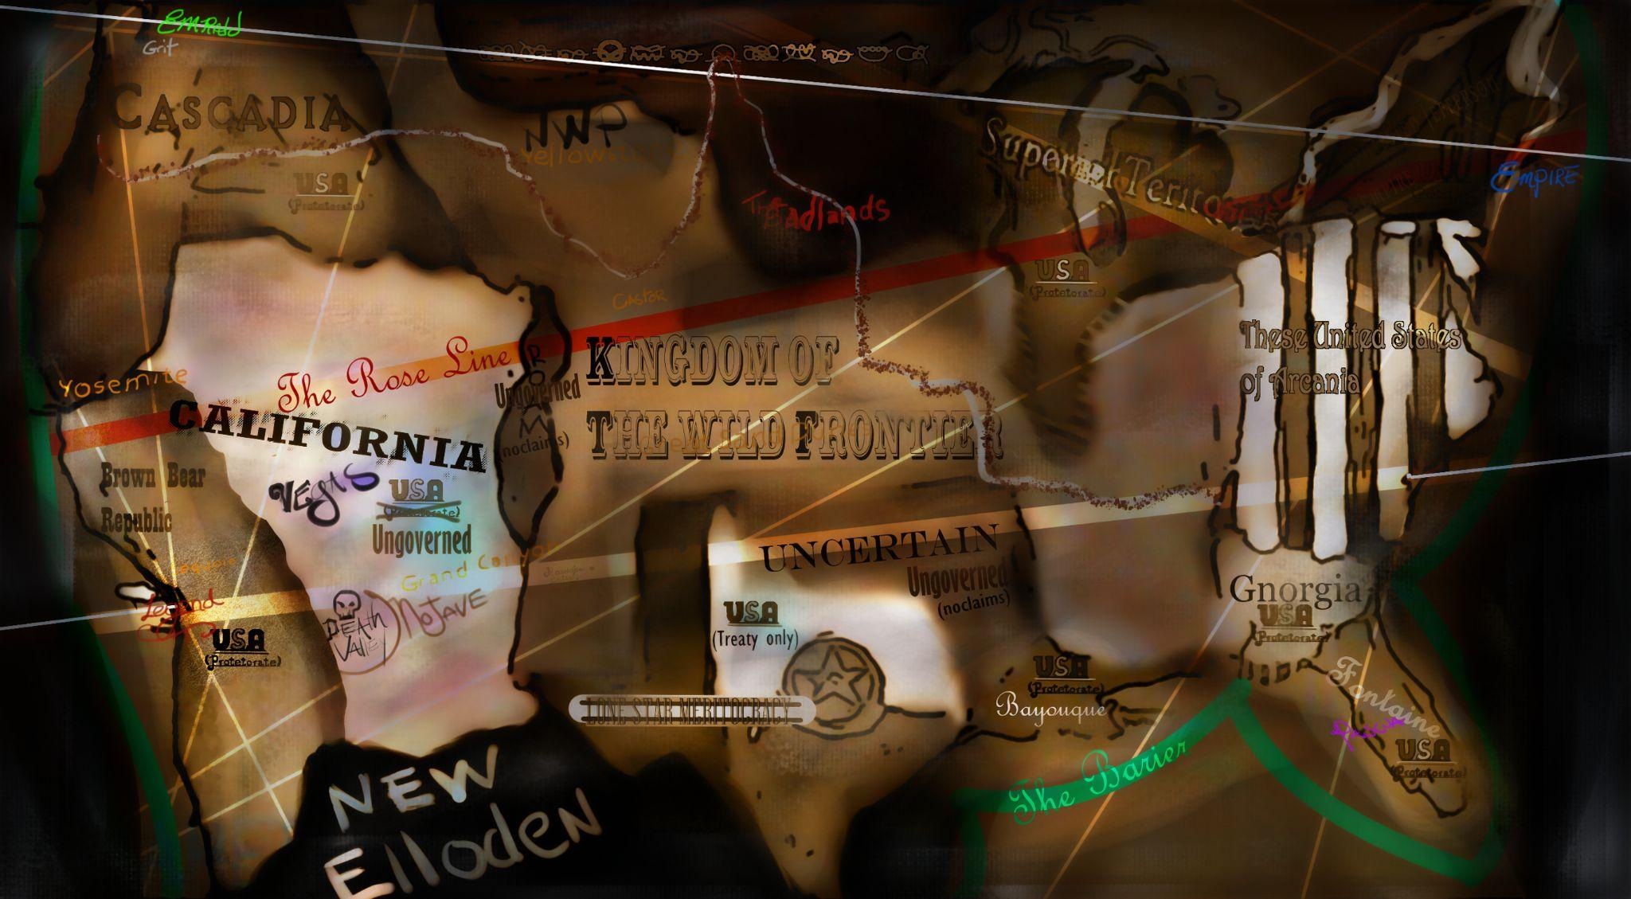

The official name for the country we will be in is the Brown Bear Republic.
Politics
TLDR: Our bear race the Bruneborn govern this country. Switch spanish to english for naming convention. San Gabriel -> Saint Gabriel.
The Brown Bear Republic is more or less governed by a series of city states, the largest of which is Idyllwyld (pronounced idle wild). For the purposes of the game, Saints will be a Bruneborn leaders (incase you are asked). The Brown Bear Republic is a merit-informed republic. Those who are found to be most capable in their field are submitted for leadership by subordinates or superior may be submitted. Peers may only submit a recommendation if they are in an expert in a field that does not include either superiors or subordinates (such as Artists or Artisans). They are then removed from society and sequestered by a council of elders.
A test of wisdom, a testament of character from colleagues, and remarks from the elders will be made available to the people.The people will then vote for their leaders based solely upon the information presented.
This is repeated for each of the city states.
Regional information and naming conventions:
An appropriate City State name that an npc is from would include any of the national parks in the state. Others in the area which are all in actually the same forest (listed with in-game names) include: The Golden City, Yoemitie, Death Valley, Mojave and The forest of the Fathers.
Because of the past seasons’ lore, we will be removing traces of Spain (Elloden) from the region. Thus San Diego becomes Saint Diego, Alcatraz Island would be Pelican Island ect.
The most important of these to our game is that the San Gabriel Mountains and the San Gabriel River be shortened to the Gabriel or Saint Gabriel river.
Area name= Area Map/Places of interest, prompts, item tables/stores, suggested monsters and foreshadowing needs. See first entries for examples. Breakdown Template.
First town: Days 1-3:
Bodfish Boomtown Bodfish Breakdown
First Wilderness:
Days 4-5 Sequoia
Ghost tree
And TBD
Day 5. 1st trading post
Days 6-7 King’s Canyon
King of the Halfwudgies
Second Town: Days 8-10 Calico.
Day11: Big Horn Mine
Days 12 and 13: The battle of 5 small armies/ Bridge fight.
Day 14

