The Story of The World is inscribed on an object called “The World’s Cornerstone.” Set in place by the first Mason, each campaign that we play is another attempt to end a conflict between the first mason and Croato*n (his full name, here is abbreviated as it is a taboo to write or speak it lest he become aware of you). Also called He Who Walks Behind, he is the wind which erodes and wipes clean the etchings of the first mason. The first mason goes into the world, which by his design is a tesseract folded into itself so that a portion of it can remain free of HWWB’s influence.
Roanoke island, Empire City, Puget Sound, Yellowstone, Death Valley, The Badlands… The battlefield changes, but the conflict never does. The Masons set the path of places and nations using a lesser form of the Masonic magic to inscribe lesser cornerstones at their founding. Their philosophy’s core tenant is that while intentions are enlightenment, reactions are sin.
There is a boundary between The New World of Arcania, and The Old World of Empyrean. Before the boundary contained him, HWWB consumed one third of the Gods of Empyrean. The ambiguous and unaligned pantheons of Gods whose morality was neither professed to be Good of Evil were taken from the old world leaving their domains unguarded. The remaining gods became factious and splintered into petty alliances bringing a cataclysmic event. The New World, sealed off by the intentions set in the World’s Cornerstone arose to be a place of refuge and sanctuary. Though by no means was it peaceful. The guardians of the New World champions, monsters, demigods and others, all of whom had denied the rite of apotheosis (the process by which one ascends to Godhood.) took up a mantle called Warden, and divided the countries by region to walk amongst them, give wisdom and protection and champion their own highest ideals.
The barrier itself is bound to a pair of floating islands that have a sort of spiritual counterbalance to one another. Roanoke and Elloden. Perfect mirrors of one another in physical form, they represent the only officially recognized path between worlds. 350 years ago, when the edges (called Ley Lines) of the World’s Cornerstone folded and created the Barrier, the two islands were linked, entangled by a pair of brothers named Solomon and Hiram. Each came to represent the ideals of the two. Aligned to Solomon on the Isle of Elloden, the Royal House of Kimvor, it’s Queen Mariposa Kimvor and her champion Torax the Red Ram seek to free HWWB from the confines of the New World that it might finish it’s feast and end the cataclysmic wars by consuming the remaining Gods of Empyrean. Their war torn land has no other hope in their eyes. To this end secret societies, spies and saboteurs grew in opposition to the Masons. The Golden Dawn, The Illuminati, The Knights Templar and other malefactors flock to their red banners.
Aligned with Roanoke however, the Masons, the Tinkers, the Order of the Rosecutter and other bands of heroes guard both the body and soul of the New World in hopes that HWWB can one day finally cease it’s relentless hunger.
In the past thousand years, the New World has come to be a thing that is far more than simply just a tool of the Masons. It is an untamed expanse of boundless wonder and horror. This year we are leaving the east coast and are headed west.
The Wardens:
The supernatural creatures of the New World including: the Cryptids, Wardens, and even Demigods who have also fled the Old World are far more real and tangible than in most settings. They do not reside in separate intangible planes of existence. They walk amongst us, most look like us. They cannot ever be true gods in this place, and do not (at least not openly) seek domination or worship. This is closely policed by the Wardens of Arcania.
The Wardens of Arcania are people or creatures who have been, or are capable of apotheosis (The process of ascending to godhood). They have, however, denied themselves of the exaltation. It is a level of humility and restraint demanded of those who govern the New World.

While there may be different wardens in different iterations of the Mason’s cornerstone, each embodies a virtue and is responsible for the oversight of a specific region.

Columbia, the warden of liberty governs the North East.
Her words are “Liberty above all.” Her emotions can be volatile. When Columbia loves a town, an idea or a hero, she has no reservations about heavily influencing situations. Columbia is the least omniscient of the wardens. She does not accept the worship or gifts of gratitude offered by those she guards, choosing to avoid even the appearance of domination. Her symbol is that of the uplifted torch, gold on teal background. It is the most popular decoration in her region.
Fontaine, the Warden of Life governs the South East.
Her words are ”We shall go on.” Life is sacred in the south east in the extreme. Fontaine does not suffer the death of her wards by any means of violence. Even animals cannot kill one another in her region. To eat meat in her region is to let the rest of the body of your prey or victim live on. There are those who revel in their near immortality. And there are those who languish, unable to perish. The Floridian jungles and swamps are bizarre in the extreme. None who take up residence there for more than a year may leave. When Fontaine counts you as hers, allowing you to leave is depriving you of your right to continue to be alive. Her symbol is an all seeing eye set in an orange blossom.
Cascadia, the Warden of the North West.
Her words are “Wanting is Joy. Having is death.” Recognizing Cascadia is remarkably hard. She lives a normal life. And she tends to the mundane needs of those around her. She does not interfere in the pursuit of happiness of others so long as that pursuit does not interfere with anyone else’s happiness. She walks with strangers, and is quick to make friends with a person in a pub. In the Wilds of her region, one is likely to find all manner of odd and reclusive persons pursuing things they could not elsewhere. Cascadia’s symbol is two hands. One reaching upward toward a blooming rose. The other reached downward clutching a wilted rose.
Oro, Warden of the South West.
Oro is one of the non-humanoid wardens in Arcania. His words are "None shall
attack us with impunity." The South Western regions of Arcania are the richest of the continent. The wealth of gold mines is money that can be picked up out of the earth by anyone determined or lucky enough to find it.
A wealth of fantastic creatures both sentient and monstrous. Some in great abundance. Others are rarer than treasure. Some are singular manifestations of myriad ley lines that traverse it from Death Valley to the Sentinels of Sequoia. Oro has no symbol, no home, and walks amongst the Cryptids Critters and Varmints of his domain with far fewer interactions with the humanoids who live there.
Davy Crockett, King of the Wild Frontier
While the term “King” is applied to Davy, he is not a true monarch. Davy is a Gold Dragon who acts as judge and protector of the midwestern portions of Arcania. Much of this region is populated by beautiful and terrifying creatures. Davy doesn’t consider himself a Warden, but his kind and fearsome nature makes him the de facto power for the region.
Sandigil, Warden of the waters, boundaries and borders. Residing in the Lakelands of the Superior region (the great lakes Michigan and Minnesota.) He is a Chinnokin (salmon folk) who died in battle, Sandigil was introduced to the other Wardens by Columbia after his subsequent resurrection. His concerns are his own, and he is not bound to a single place, but rather to a purpose known only to the Wardens.
Witch Woman Halle, The Warden of the Deep North.
To the north of the temperate nations of Arcania lies the vast frozen territory once called New Found Land. This term has fallen to the more recent colloquial of “Newfie.” The Warden and self proclaimed “Witch Woman” Halle protects the northern boundary and is the only Warden who lives in solitude and does not serve her people as judge or protector. The vast and empty land has a massive stretch of the barrier which she single handedly defends from disturbingly frequent and powerful attacks. Halle’s symbol is the all seeing eye set in a field of stars and the Aurora Borealis.

Other notable characters:

Anansi the demigod of stories governs a region called the Bayouque (Pronounced Bi-U-Kay) which is an analog to New Orleans. This region is also known to be the home to a race of massive lizard folk called the Baeshrean. Though reclusive and fearsome in battle, they are generally affable, kind hearted and loyal.

Calico the Death Valley Queen is a Bobcat Tabaxi. She is the self appointed law and Arbiter of Justice for the ungoverned desert territories. Riding the legendary Chupacabra she wears her sherif badge with pride and has become something of a living legend.

The Barons Vanderbilt, Rockafeller Dupont, Debeers, Walton, Kellog, and Ford are the founding members of Illuminati. This secret society is the worst kept secret of Empire City (our New York analog.) Empire is by far the most advanced city on the continent. Built on a convergence of 9 Ley lines, it has an overabundance of magic. The most wealthy and powerful are generally found here, and the Barons are no exception.

Map.
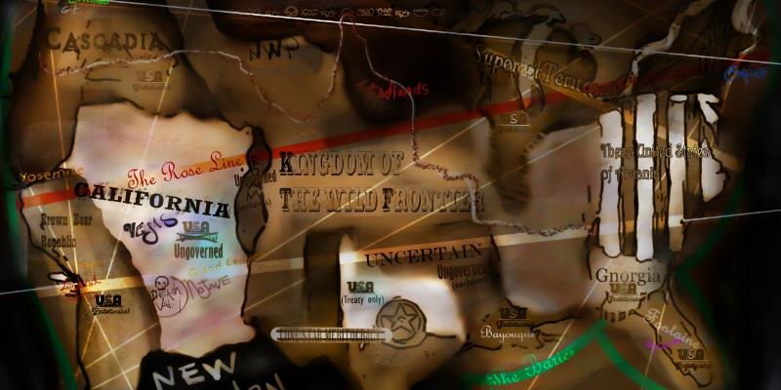
Season 5 specific regional lore:
The Brown Bear Republic is a Meritocracy inhabited chiefly by two races.

The settlements within the Brown Bear Republic are a series of city states not unlike ancient Greece or Rome. Their society is highly focused on trade, artisanship and methodical workmanship in their daily lives.The citizens of the BBR are dedicated to upholding their meritocracy
The population largely consists of Bruneborn, Noiren and Grizzled (bear people) Seraphs (our replacement for both Aasmiar and Tiefling) west coast Chinnokin (the Baja tribe, salmon based aquatic race) and a subrace of Hill Dwarves (called affectionately Hillbilly Dwarves.)
The destination (and titular) city called Legend is an analogue for Los Angeles (or its official name: Nuestra Señora La Reina de los Angeles de Porciuncula). The region that we will be exploring begins at the end of a Transcontinental Railroad built by the Barons Vanderbilt and Rockafeller. Originating in St. Louis at the Gateway to the West, the tracks end at a silver mining town called Bodfish Boom Town.
Originally Bodfish was just a small collection of 5 buildings and a telegraph office. Since Silver has been found, it has swelled from a population of 26 to well over 250. The single sheriff is woefully outnumbered by the tent city of miners and ranchers who have set up a tent city in a field to the north of town.

