The Arcanian Almanac
A play test document for the Roanoke RPE for Cascadia Gamers Alliance.

The Jackalopes.
Ostar, High priestess of the Lagowarren (an underground village to the north east of Roanoke Island) takes daily walks in the high grass fields that the Jackalopes tend to prefer. The top of her head stands a mere 3 feet from the ground, with her pink and grey ears rising another foot up when she stands them up. Most jackalopes wear their ears down when calm, but they can be quite animated when they are feeling strongly about something.

--The Naturalist JG Fitzsimmons

Somewhat Unreliable:
The diminutive and short lived creatures thrive in woods and typically have very large families. While many are lost to the brutal nature of Arcania, a successful family (especially those that excel in the use of magic, or the roguish arts) can sometimes have families who number in the hundreds.

With a life span that rarely passes 35 they tend to live in the moment and are not always careful planners, instead relying on their instincts and abilities instead of wisdom.

A plague of good cheer:
Jackalopes have integrated with colonies much quicker than the other native races. They understand the idea of trade, and are always seeking short term advantages. They have found that being entertaining and commedic can be a way to endear them to the newcomers to their shores, but a careful eye will notice that a Jackalope always has an angle to work. Its common to find them in taverns acting as fools or as street performers. It is also common to find your pockets a lot lighter than you intended if you happen to spend too much time with one.

Cute and cunning.
It may be that their non-threatening appearance has opened doors for the Jackalope that other races may not notice, or perhaps more easily forgive their natural avarice.

Humans: “Humans like us a lot. If you find their windows marked with the sign of the lago, or wearing our jewelry, its because they have given us good deals in the past.”

Elves: “Elves seem not to notices us as much. And they are much harder to deal with because they never think about what they want. Honestly if you want something, your better off just asking, and not trying to change their mind after.”

Dwarves: “Dwarves make the best stuff. And they like to drink. Bring them lots to drink and use them to distract anyone else to get whatever you want.”

Jackalope Names:
Speyfoot, Thwentwick, Spurkshin, Floofin, Hoppebur, Sootlyn, Boopwent, Whifour, Hawness.
Jackalope Traits:
Your Jackalope has a number of traits in common with all other Jackalope.

Ability Score increase
Your Dexterity increases by two
Your Charisma increases by one

Age
Jackalope rapidly age compared to other races, reaching adulthood at the age of 7 and generally lives no more than 40 years.

Alignment
Most Jackalope lean toward a neutral alignment. Although they have a propensity for avarice and self preservation, they are usually very outgoing and talkative. It can, at times be very difficult to get to know most Jackalopes, as they tend to answer most questions with a question of their own.

Size
Your size is small. Jackalope average a height of about 3 foot. Jackalope have ears with vestigial muscles that can lay flat, or stand up and can swivel, and powerful oversized feet. With their oversized feet extended and their ears up, they can usually extend themselves by standing on their toes have a toe-to-ear-tip height of 5 foot.

Speed.
Jackalopes are amongst the quickest of creatures with a speed of 40.

Be Nimble. Be Quick.
You can move through the space of any creature that is a size larger than yours.

Burst of Healing
As a bonus, you can draw power from your warren to spend one of your Hit Dice and revitalize yourself or a creature you touch. Roll the die, add your Charisma modifier, and the creature regains a number of hit points equal to the total. Once you use this trait, you can’t use it again until you finish a long rest.

Laughing at death
If your hitpoint counter falls to 0 you can use a hit die to revive yourself. Using this feat removes one of your death save attempts, however.

Flurry of Fur
Beginning at level 5, when you damage a creature with an attack or a spell and the creature's size is larger than yours, you can invoke the innate connection you possess to the New World to move through the ground. You gain the ability to use an extra amount of movement equal to your level. Your movement moves you through solid ground after your attack. This movement is instantaneous and does not provoke an attack of opportunity. Once you use this trait, you can't use it again until you finish a short or long rest.

Language
You speak read and write common as well as Woodland Arcanian.

The Tatankan.
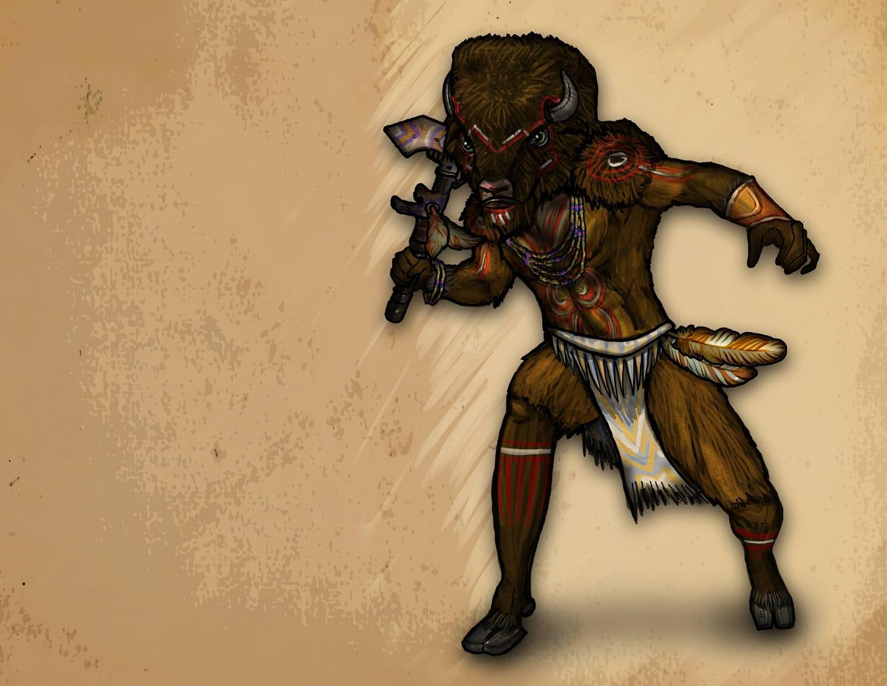
The Majesty of the Tatankan cannot be understated. Whether you meet one up close, or see the great heard from miles away, these Plainsmen are likely to leave a lasting impression. Their cities have no names that they have assigned to them. Any local designation is made by outsiders and referring to the city as any name other than “the Pen” is considered uncultured and borish.

Tatankan Race Details.

The herd is the core of life amongst the Tatankan. Rarely alone, the Tatankan people are very conscious of customs and decorum. Within your herd it is considered impolite to move faster than the slowest member, so as not to reveal who might be weak or sick or likely to be picked off by the enemies that threaten. The Tatankan are often misinterpreted as being dull or dim witted because they are brought up to move slowly, to be cautious and watchful. They are ever vigilant and care deeply about whatever causes they devote themselves to.

Possibly the best natural gamblers in existence.
It is a cultural attitude to keep quiet about both advantage and weakness. Their presence is menacing to their enemies and a relief to their allies. It is only a fool who would sit down at a card table to play against a group of Tatankan.

A flame ignited.
Sorcery is considered sacred amongst the Tatankan. Those who find it within themselves to be clever or powerful spellcasters without studying books or invoking a pact with a god or demon, or drawing your power from the balance of nature, sorcerers are considered automatically to be shaman, regardless of race. The Great and Fiery Buffalo Tatanka was said to once have been a sorcerer who could change his shape, and it is customary to make an offering of milk and wheat to any sorcerer you may encounter.

Tatankan Traits:
You have several traits in common with all other Tatankan.

Ability Score Increase
Your Strength score increases by 1, and your Constitution score increases by 2.

Age
While a large portion of their adolescent life is often devoted to a nomadic lifestyle, none of the members of a juvenile herd are considered adults until all of the members are mature enough to graduate into adulthood together. Typically this happens between the ages of 40 and 60, with Tatankans often living until they are 220. A mature Tatankan may leave her pen but many choose to stay with the members of their Juvenile herd. Departing from the herd is considered to be an extreme life style. Departing early from a Juvenile herd is considered to be obscene.

Alignment
Despite their penchant for gambling, Tatankan believe in the law of the herd. Though it is not a written law, and can change from region to region, it is very rare to find a Tatankan who is not Lawful Good.

Size
Tatankan are between 6 and 8 feet tall and weigh between 300 and 400 pounds with 1 to 2 foot horns if any. Your size is Medium.

Speed
Your speed is 15ft. However if 2 or more of your party members are dashing in the same direction you may take 60 feet of movement as a dash. Additionally if any of your party members become prone, restrained, grappled or incapacitated, you may charge upto 60 feet inorder to make a gore attack with your horns.

Enhanced smell
You can find any party member within 30 feet despite visual restrictions.

Powerful Build
You count as one size larger when determining your carrying capacity and the weight you can push, drag, or lift.

Slothlike Reputation
Due to their massive build and slow movement, the reputation of the Tatankan gain them a +2 to deception and +2 to perception.

Gore
A Tatankan can make an attack with his horns, causing 1d8 piercing damage plus his Strength modifier. If the target is a creature of the same size or smaller, it must succeed on a DC 12 + your Strength modifier Strength saving throw or be 5 feet away and knocked prone.

Language
You can speak Common write and read common. You can speak Tatankan. You can tie tatankan story knots and interpret them correctly.

The Chinookin.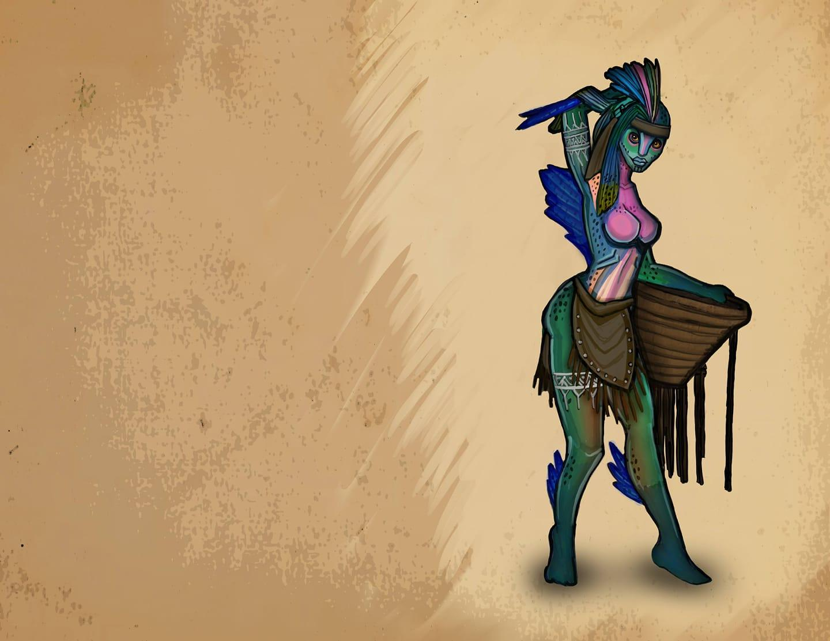
The salmon folk. This costal society is easily the most advanced of the native races. Most of their society is dedicated to preserving life from an evil eel like creature that waits beneath the waves to consume us all.

Chinnokin Race Details

After the storm subsided, our ship was run aground on a sandbar. As we waited for the tide to lift us, strange creatures could be seen playing in clear water below. Some of the men befriended them, and soon we were trading trinkets and food. They called themselves Chinnokin. They were friendly enough, but they seemed to assume everything we owned was fair game for trade. Only time will tell the true nature of these strange people, but I count it a good omen that we met them when we did.

— Admiral Timmond

Chinnokin are a race of aquatic creatures who travel the oceans in small tribes or alone.

Sleek and Playful
With their fishy features and scaly skin, these creatures are more at home in water than on land. They are slightly shorter than humans on average, ranging from well under 5 feet tall to just over 6 feet. They seem to grow larger as they age. They are fairly slim, weighing only 100 to 145 pounds. Males and females are about the same height and weight.

Chinnokin range in color from dark green to bright red, and many have a combination of both colors. Some have a shimmering silver or rainbow colored stripe running down their side.

Tribal Living
Most Chinnokin live out in the open ocean. But some tribes choose to live closer to the shallow waters near shore and trade with land dwellers. Seafaring vessels happen upon tribes of Chinnokin from time to time. They are usually friendly and eager to trade their treasures of the deep for novelty items, but some tribes have been known to be hostile to sailors.

Running of the Chinnokin
Chinnokin are seldom seen on land, but occasionally their curiosity gets the better of them, and they may take up residence in coastal cities. The main exception to ocean dwelling is when a Chinnokin has reached a point in their life cycle when they are ready to mate, somewhere around 50 years old. It is said they travel far inland to the streams and pools of their birth. Somehow, large numbers of them arrive at the same time, as if driven by a subconscious urging. Once the time is right, the females will congregate together in a large group. The males will be just upstream. A great battle will ensue for the males. They will fight savagely with each other and most will die. A small group will emerge victorious and join the females in a mating ritual that lasts for less than a day. The bodies of those fallen help to feed the new hatchlings. The adults move on and leave the young to fend for themselves as they swim downstream to the sea. These young are nearly indistinguishable from fish, and do not gain sentience, or assume humanoid form for many years. Eventually, they too will return to their spawning grounds to perform the ritual again. Males who have participated in more than one mating ritual are rare and highly regarded among their people.

Chinnokin Names
About 5 years after reaching the sea, Chinnokin children begin transforming into their adult form. They gradually increase in intelligence and seek out others of their kind. The tribe that accepts them will give them a name. They will also take on the name of their tribe as their family name.

Subrace
There are two main types of Chinnokin. Off the east coast of Arcania the most well known Chinnokin live. These have the most interaction with the other races. A lesser known, and more wild subrace of Chinnokin live off the western coast of Arcania and in the vast ocean beyond.
These Chinnokin are less intelligent and more hostile, and little is known about them. One key difference is that these mate only once in their life and then die shortly after.

Chinnokin Traits
Your Chinnokin character is an adaptable race at home in freshwater, salt water, and even ventures onto land on occasion.
Water Shaper
A child of the sea, you can call on the magic of elemental water. You know the cantrip shape water. Starting at 3rd level, you can cast wall of water with it, and starting at 5th level, you can also cast tidal wave with it. Once you cast one of these two spells with this trait, you can't do so again until you finish a long rest. Charisma is your spellcasting ability for these spells.

Ability Score Increase
Your Dexterity score increases by 2.

Your Constitution score increases by 1.

Age
Chinnokin live to be around 200 years old, but many die far sooner from dangers in the sea, or on their quest to mate.

Alignment
Chinnokin ply the open oceans and love their freedom. They are content living a carefree life. Then understand well that each moment may be their last, and thus are often chaotically good aligned.

Size
Chinnokin range from under 5 to over 6 feet tall and have slender builds. Your size is Medium.

Speed
Your base walking speed is 30 feet, and your swim speed is 30 feet.

Darkvision
Accustomed to the darkness of the deep sea, you have superior vision in dark and dim conditions. You can see in dim light within 60 feet of you as if it were bright light, and in darkness as if it were dim light. You can’t discern color in darkness, only shades of gray.

Soak
Chinnokin prefer to sleep submerged in water. When you take a long rest in water, you regain an extra hit die. In addition, you recover two levels of exhaustion instead of one. If you take a long rest out of water, gain one level of exhaustion up to the 4th level. You can not progress further due to this feature.

Languages
You can speak, read, and write Coastal Arcanian.

