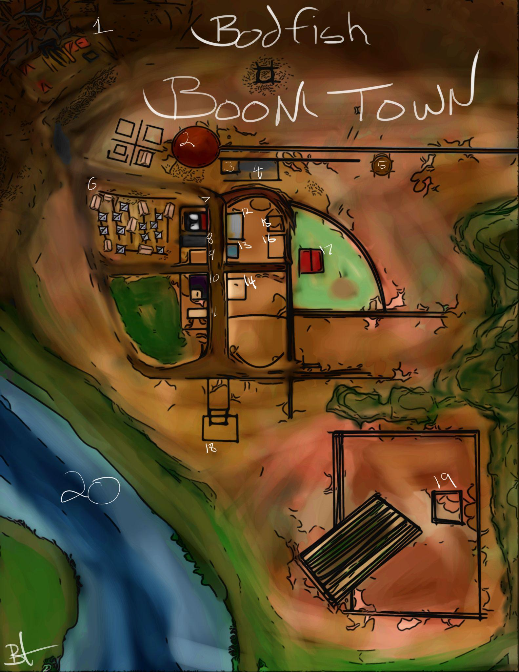
Bodfish Boom Town
1. The ole' silver mine.
2. The roundhouse. (It turns the train around)
3. Telegraph office.
4. End of the line, Vanderbuilt rail station.
5. That there water tower.
6. Paupers n coppers shanty town.
7. Pall and Knells Savings and Loan.
8. Hammond's General Store
9. Oakley's Barber Dentist and Surgeon.
10.The Painted Lady Bar and Gambling hall
11. A burnt down jail.
12. Pony Express catalog and show room.
13. Dapper Dan's Pomade and Elixer.
14. 3 Kobold's duster shop.
15. Prospector Snark.
16. Also just a building...
17. Epona Stables.
18. Chapel of the Calico.
19. Bodfish Ranch.
20. The Saint Gabriel River.
Break Down By Time:Link
4.End of the line, Vanderbuilt rail station.
This is the player’s entrance into the town.
19. Bodfish Ranch
Ranchers can sell cattle at half value to
Bodfish General Store
Prices in Copper

Misc goods:
Crate of wildly unstable TNT 2000 cp
A Crate of wildly unstable TNT is perfectly safe until opened. Once the player has made the choice to open the crate it is no longer perfectly safe.
There are 5 uses of TNT per crate. If, while carrying TNT, the player rolls a d20 for any reason other than a skill check, the player must then also roll a d4. On a 1, the TNT immediately detonates.

Tools:
Leatherworker's Tools 50
Carpenter's Tools 50
Smith's Tools 50
Climber's Kit 50
Tinker's Tools 50
Jeweler's Tools 50

Armor:
Light:
Second Hand Duster 300
(AC 12)
Studded Leather Duster 450
(AC 13)

Homebrew Clubs:
Clubs:
Black Jack 5
1d4 bludgeoning
(Club/light)

Tatankan knotted rope 5
1d4 bludgeoning
(Club/ light/finesse)

Instruments:These instruments replace all standard instruments. You may not have standard Wotc instruments.
(instruments) 30
Finger harp
Harmonica
Fiddle
Musical Saw.
Cigar box guitar.
Cowbell
Blown jug (Like, just a regular jug)
Spoons (Like normal spoons, but better?)
Washboard
Washtub bass
More cowbell 60
(Cures fever.)

Farrier/ Blacksmith
Metal Weapons
Knives:
Boot knife 10
1d4 piercing
(Dagger, finesse, light, thrown range 20/60)

Driftwood log.
(Great Club)

Bowie
(short sword)

Throwing Hatchet 15
1d6 Slashing
(Handaxe,light, thrown range 20/60

Barn:
Animals
Mule 100
Draft horse 150
Draft Horse with pack saddle 200
Camel 500

Gear:
Saddle 100
Saddle bags 50
Blinders 150
Allows mounts in combat
Padded Barding 150
11+dex mod (max 2)
Hide Barding
12+dex mod 300
Findable loot

