Cryptid writing.
Max cr 9 per 10 2nd level characters - week 1.
Max boss level cr 19

Max cr 15 per 10 7th level characters - week 5.
Max boss level 25

Guidelines for writing cryptids:

Cryptidis must be between CR 9 and CR15

Week 1 CR 9 CR 13 miniboss CR 19 boss
Week 2 CR 10 CR 14 miniboss CR 20 boss
Week 3 CR 11 CR 15 miniboss CR 21 boss
Week 4 CR 13 CR 17 miniboss CR 23 boss
Week 5 CR 15 CR 19 Miniboss CR 25 boss.

Pukwudgie
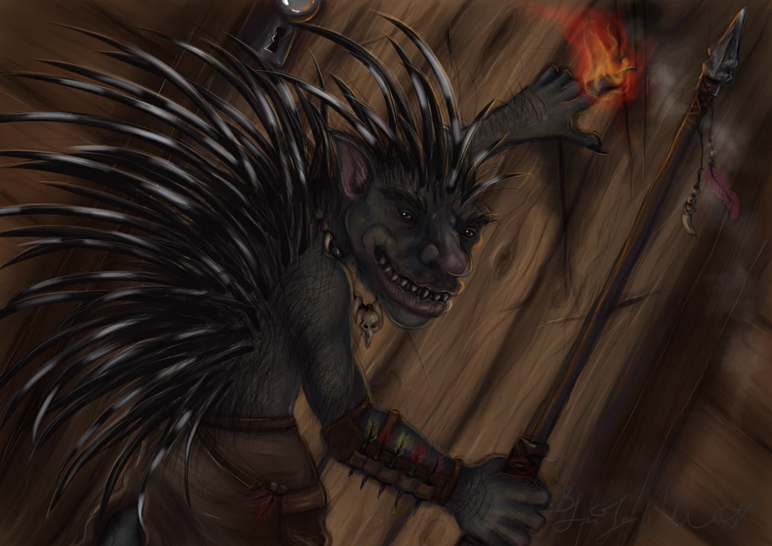
Pukwudgie are passive until threatened. These gentle cousins to the troll are less aggressive but much better defended. When faced with possible combat, the Pukwudgie raises the quills on its body and spins around, smashing an opponent with its quill-covered tail. If out of range of it’s opponent, it uses a javelin.

Size: Giant Armor Class 16
Hit Points (8d10+ 40)
Speed 30 ft. ft.
STR 18 (+4)
DEX 13 (+1)
CON 20 (+5)
INT 7 (-2)
WIS 9 (-1)
CHA 7 (-2)
Proficiency Bonus +3
Skills Perception +2
Senses darkvision 60 ft., passive Perception 12 Keen Smell: The Pukwudgie has advantage on Wisdom (Perception) checks that rely on smell.
Ranged: Attack.The Pukwudgie makes one attacks: one with its Javelin. Ranged weapon (Piercing)
range: 30/120
Melee Attack: Sticky Quill: Melee Weapon Attack: +4 to hit, reach 5 ft., one target. Hit: (1d6 + 4) piercing damage. When the Pukwudgie strikes with its back, it dislodges 1d6 quills that automatically break off and lodge in the opponent’s flesh. A lodged quill imposes a –1 circumstance penalty to attacks, saves, and checks. Each 1 round thereafter, the quill moves deeper into the opponent’s flesh, dealing 1d2 additional points of damage. Removing the quill takes 1 full round and deals 1d4 additional points of damage. If the quill has been embedded for more than 10 rounds, a Strength check at DC 10 is needed to remove the quill. For every minute after that, the DC to remove a lodged quill increases by +1. An unarmed or melee touch attack against a Pukwudgie causes 1d4 quills to break off and lodge in the attacker.
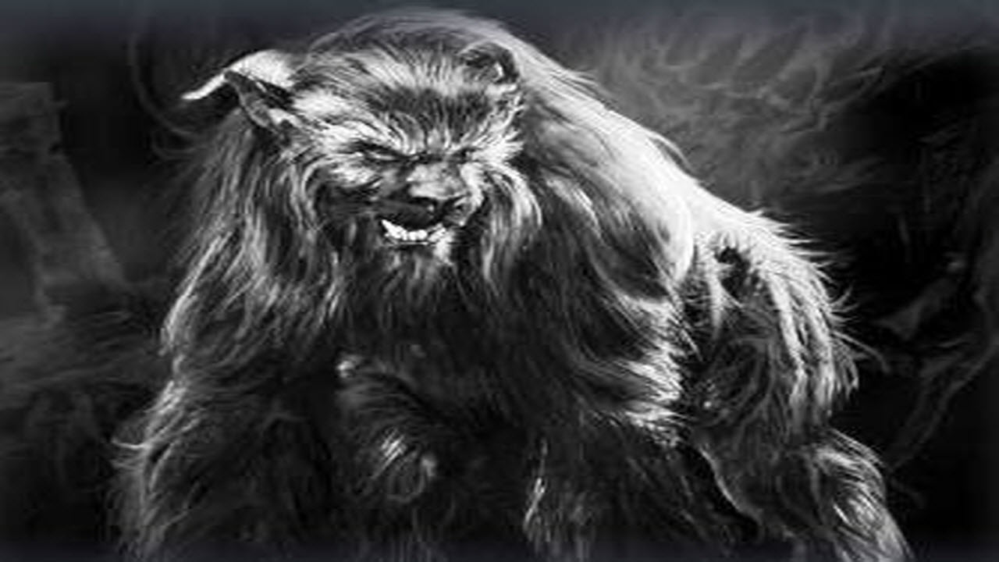
Armor Class 12
Hit Points 75
Speed 20 ft., fly 10 ft. (hover)
STR 22 (+6)
DEX 10 (+0)
CON 18 (+4)
INT 7 (-3)
WIS 11(+0)
CHA 20 (+5)

Saving Throws STR+ 6, Cha +5
Damage Resistances acid, fire, lightning, thunder; bludgeoning, piercing, and slashing from nonmagical attacks
Damage Immunities cold, necrotic, poison
Condition Immunities charmed, exhaustion, frightened, grappled, paralyzed, petrified, poisoned, prone, restrained
Senses darkvision 60 ft., passive Perception 10
Endurance. The Ozark Howler has advantage on Constitution saving throws against exhaustion.

ACTIONS
The howler can misty step 15 ft at will as her movement
Multiattack. The Ozark Howler makes three attacks: one with its bite and two with its claws.

Bite. Melee Weapon Attack: +9 to hit, reach 5 ft., one target. Hit: 10 (1d8 + 6) piercing damage. If the target is a Large or smaller creature, it is grappled (escape DC 20). Until this grapple ends, the Ozark Howler can't bite another target.

Claw. Melee Weapon Attack: +9 to hit, reach 5 ft., one target. Hit: 13 (2d6 + 6) slashing damage. A creature that is hit with two claw attacks in the same turn takes an extra 16 (2d6 + 9) slashing damage.

Wail (1/Day). The Ozark Howler releases a mournful wail, provided that she isn't in sunlight. This wail has no effect on constructs and undead. All other creatures within 30 feet of her that can hear her must make a DC 15 Charisma saving throw. On a failure, a creature drops to 1 hit points. On a success, a creature takes (3d6) psychic damage.

Mothman, Adult
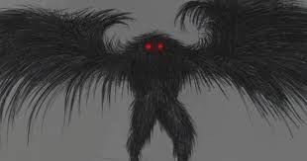
Mothman is described as a winged avian doppelganger with owl-like traits. Despite the similarities, he is in no way related to the doppleganger. His coloration varies from Black, gray, to even brown or white, although it is usually the darker shades. He is often reported to be about 7 feet tall, with a wingspan of about 10 to 15 feet or more. He is described by the few who have seen him as not having a head, with the two huge red eyes set in the chest. These eyes are reported to be glowing, or at least reflective. The details of his face and his feet have never been adequately described. One witness who saw the face clearly, could only say that the details were horrible and monstrous. She had terrible nightmares and nearly suffered a nervous breakdown..
Anyone who gets a close look at the Mothman seems to suffer from extreme fear and psychological distress, sometimes lasting for months or years afterwards. In particular, people say that a sense of pure evil overcomes them when they see Mothman's eyes.

STR 11 (+0)
DEX 18 (+4)
CON 14 (+2)
INT 11 (+0)
WIS 12 (+1)
CHA 14 (+2)
Armor Class 17
Hit Points 90
Speed 30 ft
Flying Speed 60
Senses: Mothman knows where you are, to him there is no difference between light or darkness. Magical darkness does not blind him, nor does it stop his glowing eyes from being seen. Passive Perception 18

Shapechanger: The Mothman can use its action to Polymorph into a Small or Medium humanoid it has seen, or back into its true form. Its Statistics, other than its size, are the same in each form. Any Equipment it is wearing or carrying isn't transformed. It reverts to its true form if it dies.
Read Thoughts: The doppelganger magically reads the surface thoughts of one creature within 60 ft. of it. The effect can penetrate barriers, but 3 ft. of wood or dirt, 2 ft. of stone, 2 inches of metal, or a thin sheet of lead blocks it. While the target is in range, the doppelganger can continue reading its thoughts, as long as the doppelganger's Concentration isn't broken (as if concentrating on a spell). While reading the target's mind, the doppelganger has advantage on Wisdom (Insight) and Charisma (Deception, Intimidation, and Persuasion) checks against the target.

innate spellcasting ability is Intelligence (spell save DC 15). It can innately cast the following spells, requiring no components mislead, phantasmal force.

Spell like ability: Altered Feeblemind (Recharge 5-6)
The Mothman blasts the mind of a creature that it can see within range, attempting to shatter its intellect and personality. The target takes 3d6+2 psychic damage and must make an Intelligence saving throw DC 19
On a failed save, the creature’s Intelligence and Charisma scores become 1. The creature can’t cast spells, activate magic items, understand language, or communicate in any intelligible way. The creature can, however, identify its friends, follow them, and even protect them.
At the end of every 15 minutes, the creature can repeat its saving throw against this spell. If it succeeds on its saving throw, the spell ends.
The spell can also be ended by greater restoration, heal, or wish.

Feathered Tentacles. Melee Weapon Attack: +5to hit, reach 10 ft., one creature. Hit: 15 (2d10 + 4) psychic damage. If the target is Medium or smaller, it is grappled (escape DC 15) and must succeed on a DC 15 Intelligence saving throw or be stunned until this grapple ends.

Skills Deception +6, Insight +3

Mothman, young.
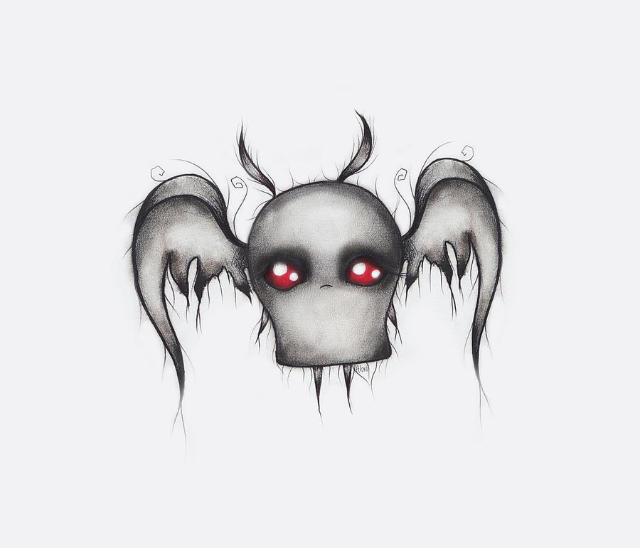
Tiny aberration, lawful evil
Armor Class 12
Hit Points 21
Speed 40 ft.
STR 6 (–2)
DEX 14 (+2)
CON 13 (+1)
INT 12 (+1)
WIS 11 (+0)
CHA 20 (+5)

Skills Perception +2, Stealth +4
Damage Resistances bludgeoning, piercing, and slashing from
nonmagical weapons
Condition Immunities blinded
Senses blindsight 60 ft. (blind beyond this radius),
Passive Perception 12
Languages understands Deep Speech but can’t speak,
telepathy 60 ft.
Detect Sentience. The Mothman Young can sense the
presence and location of any creature within 300 feet of it that
has an Intelligence of 3 or higher, regardless of interposing
barriers, unless the creature is protected by a mind blank spell.
Actions
Multiattack. The Mothman Young makes one attack with its
tentacles and uses Devour Intellect.
Tentecales. Melee Weapon Attack: +4 to hit, reach 5 ft., one target.
Hit: 7 (2d4 + 2) slashing damage.

Lychwood Tree
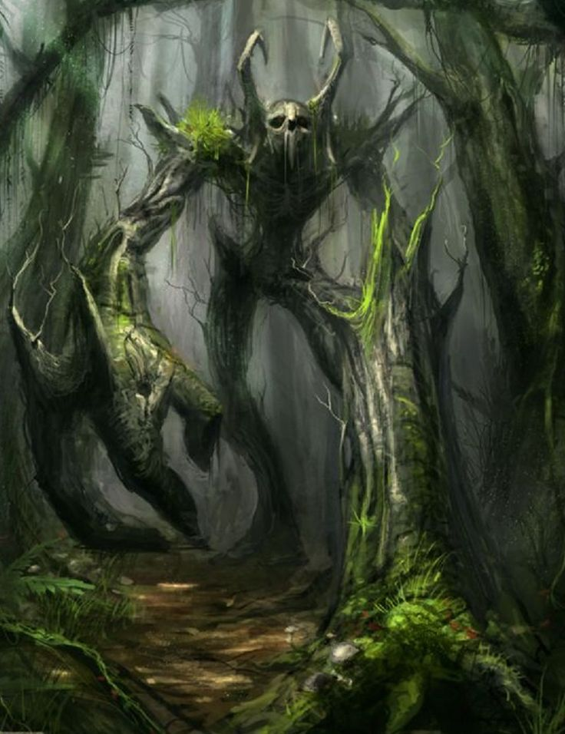
Huge undead plant, chaotic evil
Armor Class 17 (Natural Armor)
Hit Points 225
Speed 25 ft.
STR 23 (+6)
DEX 8 (-1)
CON 21 (+5)
INT 12 (+1)
WIS 16 (+3)
CHA 12 (+1)
Vulnerabilities Fire
Damage Resistance: all non magical attacks
Damage Immunity: Necrotic
Condition Immunities: charmed, exhaustion, frightened, paralyzed, poisoned
Passive perception 17
Languages Druidic, Woodland Arcanian, Sylvan

False Appearance. While the Lychwood Tree remains motionless, it is indistinguishable from a lightning struck dead tree.
Siege Monster. The Lychwood Tree deals double damage to objects and structures.
Actions
Multiattack. The Lychwood makes two slam attacks.
Slam. Melee Weapon Attack: +10 to hit, reach 5 ft., one target. Hit: (2d10 + 6) bludgeoning damage.

Fearful Spores (Recharge 5-6)
The Lychwood tree split trunk erupts with green glowing motes of dust. Each creature of the Lychwood tree’s choice that is within 120 feet of the Lychwood tree and aware of it must succeed on a DC17 Wisdom saving throw or become frightened for 1 minute. A creature can repeat the saving throw at the end of each of its turns, ending the effect on itself on a success. If a creature's saving throw is successful or the effect ends for it, the creature is immune to the Lychwood Tree’s Frightful Presence

Languid Spores (Recharge 5-6)
The Lychwood Tree’s split trunk erupts with blue glowing motes of dust. It’s branches begin fanning the dust in a 60-foot cone. Each creature in that area must succeed on a DC 17 Constitution saving throw. On a failed save, the creature can't use reactions, its speed is halved, and it can't make more than one Attack on its turn. In addition, the creature can use either an action or a Bonus Action on its turn, but not both. These Effects last for 1 minute. The creature can repeat the saving throw at the end of each of its turns, ending the effect on itself with a successful save.

Rending Roots (Recharge 5-6)
Melee Weapon Attack: +10 to hit, reach 5 ft., one target. Hit: 8 (2d6 + 1) bludgeoning damage, and if the target is a creature wearing armor, carrying a shield, or in possession of a magic item that improves its AC, it must make a DC 11 Dexterity saving throw. On a failed save, one such item worn or carried by the creature (the target’s choice) is covered in Lychwood sap, taking a permanent and cumulative −1 penalty to the AC it offers, and the Lychwood tree gains a +1 bonus to AC. Armor reduced to an AC of 10 or a shield or magic item that drops to a 0 AC increase is destroyed.
Legendary Resistance (3/Day)
If the Lychwood fails a saving throw, it can choose to succeed instead.

Also there is a winged owl bear every year, if you would like to draw that too. Its actually the symbol on the Roanoke Flag.

