Groundlings of the Globe
(An actor's life for me)
To Lord Chamberlain:

June 29th, 1613 was the day the greatest bardic college in all of England was revealed to be an private spy and smuggler organization run by the nefarious and heroic Christopher Marlow. Marlow’s theater was under protection from the Crown, as it was one of the Queen’s favorite forms of entertainment. Marlow, is now well known to be a master spy and assassin foiled an attempt on the Queen by sabotaging the foreign assassin's plan by setting off explosives as she planted them throughout the building. What remains of the building is charred timber and cratered earth. Sincerest apologies for your poodle Persimmon. From: Lord Chamberlain’s Men theater company, former custodians of the crater in the ground which was once your most auspicious creation. The ember of its smouldering ruins will live in our hearts the way the first rays of sun live in the hearts of the young and in-love..

Perhaps you were there that day. Or perhaps you only say you were. Perhaps you saw as the stagecoach dashed through the city. As Marlow ran across the horses’ backs. How he knocked the reins loose and used them to tie the driver’s head to the railing. Or perhaps you saw the kitten he caught as it lept from a burning building, and expertly landed into his waiting hat.
Either way, as the legend of Marlow grows, so too grow the deeds of the playwrights and minstrels.

The Groundlings of the Globe
You are one of the few, one of the dedicated suffering artists who is as likely to be paid in stew and ale for his art as he is to play for precious gems and sacks of gold from royalty. The Globe may be burnt to the ground, but the Groundlings of the Globe still live on in every audience member, in every rhyming couplet of iambic pentameter, is every brush stroke and every line penned. To be a Groundling is to accept that you are the master of the Craft that must constantly justify its own existence.

No one says to a carpenter “Show me a new way to build a house.” But a musician must constantly learn or write new songs. And a playwright cannot ask his actors to act out the same play everyday for all time. And so, they must continue to invent new worlds and characters to explore. To be a Groundling, you can be anyone one. But to be a true groundling, you cannot be anyone else. Forsake your trade, forsake your inheritance, there is only the spotlight and the knowledge that to chase it is more likely to lead you to ruin than fame. But for the groundlings who stay true through the lean times, there is a bond that is unshakable. The is a consistency of good character and a shared brotherhood between players and artists that cannot be compared. Artists who call themselves groundlings take care of one another, they share when they have nothing to give. And so long as it goes back into raising up the community to be better, they give even more when they have plenty.

Feature:Scribbles for nibbles.
A serf may live as well as a merchant if they secure patronage from an aristocrat. In exchange for a work of art, a play, or some other sort of performance, a Groundling may seek small favors from their patron. Additional help may be bartered if the Aristocrat wishes help in matters of arranging a marriage or a smear campaign to help influence politics.
You are headed to the New World. Are you following your patron? Do you want experience to draw from to adapt the story into a book or play? Are you a member of a troop of players (Talk to your DM to see if there are any other Groundlings looking to be part of a shared back story).

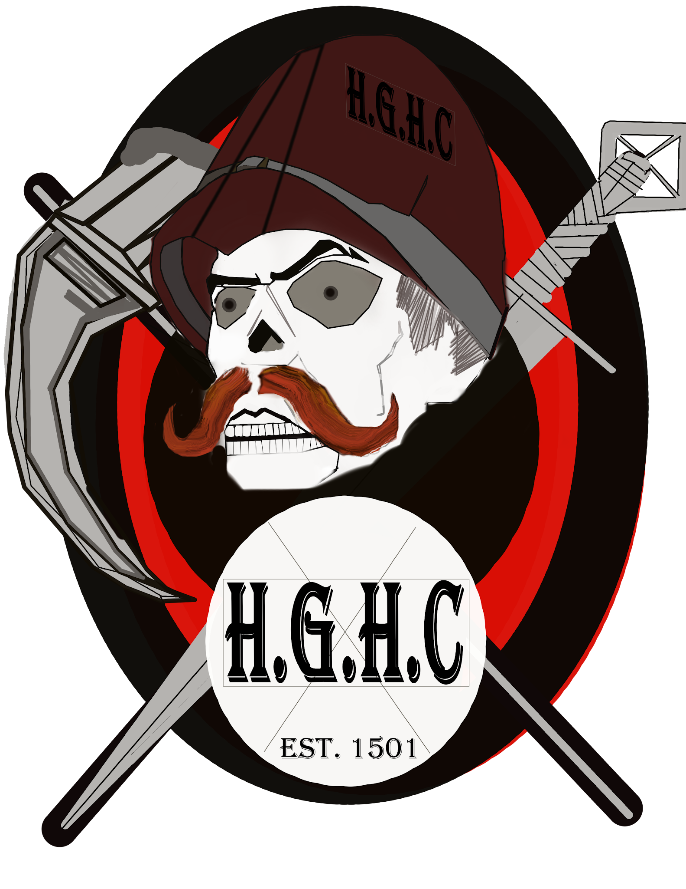

The Highgate Hunting Club
(Monsterslayers and Safari Hunters)
Highgate Cemetery is known as one the Magnificent Seven Cemeteries of London. It is from these majestic hallowed grounds that The Highgate Club takes its name.This well funded group of monster hunters is known through their tales as told in the Strand Magazine, a publication well known for its serial adventures and mysteries. It is chock full of eccentric and wealthy enthusiasts, crackpot theories, doomsday preppers and big game hunters, there is no challenge too dangerous for the Highgate Club.

A Card Carrying Member of The Highgate Hunter's Club

As a member of the club, you are likely to adorn any place you live with massive taxidermied monsters and glorious trophies of your hunt, or the hunters that you admire most. Your interactions with the club may be as well (possibly over) armed groups that are each complete with their own themes and dramatic trappings (such as ornate armor or a particular focus on a specific kind of Old World cryptid like vampires or werewolves).

Feature:Ballroom Brawlers
You are in contact with other eccentric members of the club. These people might be associated with the criminal underworld, the rough-and-tumble folk of the streets, or the vain glorious members of high society. This connection comes in the form of a contact in any city you visit, a person who can provide you with advantage on checks related to finding specific types of Monsters (non humanoid Beasts, Monsters, Aberrations and Cryptids)

The first Big Game hunters of The New World
Legends will be told amongst the Highgate Hunters Club for generations of the prowess of those who first dared to face the wild Arcanian Cryptids. After you have determined your character's background, be sure to include a list of goals and aspirations for your expedition into dangerous lands and the savage cryptids that await you. Remember, it's the killing stroke that counts toward personal glory in the Highgate Hunters Club!

Skill proficiencies: Survival, History.
Tool proficiencies: Your choice of one artisan tool.
Languages: Undercommon
Equipment: A utility belt that contains everything you would normally be carrying in a dungeoneers kit
<img src='https://i.imgur.com/2CXQ7Ew.png' Style
Your bond might involve other hunters or the organizations or individuals that employ you or whom you employee. Your ideal could be associated with your determination to always catch your quarry or your desire to maintain your reputation for being a great monster hunter.

Combat Field Scholar
(Academics, Servants and Flunkies)
Support your Slayer
You have spent your days in service of St. George the Dragon Slayer. And his guild of Combat Field Scholars. The Order's Combat Field Scholars are an organization whose founders were a group of adventurers who famously assisted the slaying of an ancient Green Dragon named Bwytawr ffwl (Fool Eater). Fool Eater was a brutal tyrant prone to cruelty who ruled over several Welsh hamlets with a careless gluttony for their livestock. Desperate to rid his parish of the terrible beast, Saint George turned to the scholars of the land and brought them together to find a way to overcome their oppressor. Famously, they were the first to try to use the Identify spell (a spell with the range “touch”) on a Dragon, in all the known world . Together they stealthily infiltrated his lair and ritually cast for hours while the dragon slept atop his horde pile. Once the knowledge was gained, Saint George himself Slew the wretched monster.
Since then the group has grown. And grown more organized along the way. There was little in their way to hamper their efficacy and self organization. Over time, their ranks began to swell with the clever middlemen content with their comfortable lives but capable of amazing acts of will. The order is a true meritocracy with only the most skilled making the decisions for the group, and the leader passing on their responsibilities when they are surpassed. Choose one of the Gods of the Round table and work with your DM to detail the nature of your service to the order. Are you a field researcher, or a cloistered scholar? Were you raised amongst the order? Or are you seeking sanctuary within it? Do you have rank within the organization, or are you but a humble monk? Perhaps you came from a village where you were the highest authority, only to find that upon coming to London your reputation isn’t nearly as distinguished as you had thought.
Why be powerful or famous when you can be close to those who are?
Who do you thank or blame for your station in life? Did your mother send you off to the school despite your father's concerns about your scrawny size? Did you get assigned a squireship to keep a king's third son (WULF the half ghast) from any more property damage? Do you sometimes envy the table scraps being given to pampered pets? Did you join because you wanted to be as near to the fame and glory of the most famous knights and nobility as you could? Or did you join in hopes of raising your station in life by catching someone's eye?
Everyone trusts a well spoken person with a clipboard.
Combat Field Scholars control the infrastructure of London. Despite being a private entity, they are the postal service, the town criers, they are your school masters, they handle the affairs of busy work and steadily entwine the country with silent help. As the country's news source, education, lines of communication, and bureaucracy, the Combat Field Scholars wield a sort of slow, silent pressure that influences so profoundly that no one notices.

Skill Proficiencies: Persuasion and (your choice of) history or religion.
Tool Proficiencies: Dragon chess
Languages: Draconic
Equipment:A holy symbol (a silver necklace depicting Saint George. A scholarly book or hymnal, 5 sticks of incense, scholar’s vestments, a set of common clothes, and a pouch containing 15 sp
Feature:
Your time spent learning how to squire, scholar and scrub has made you quite handy to have around in most situations. You have become adept at the humble art of please and thank you. As a reaction, you may retry a charisma based skill check that another player has failed. For example, you could use "Um, Excuse me, but you will have to pardon my friend, could I perhaps be of some assistance?" or other such humble query when role playing this feature.

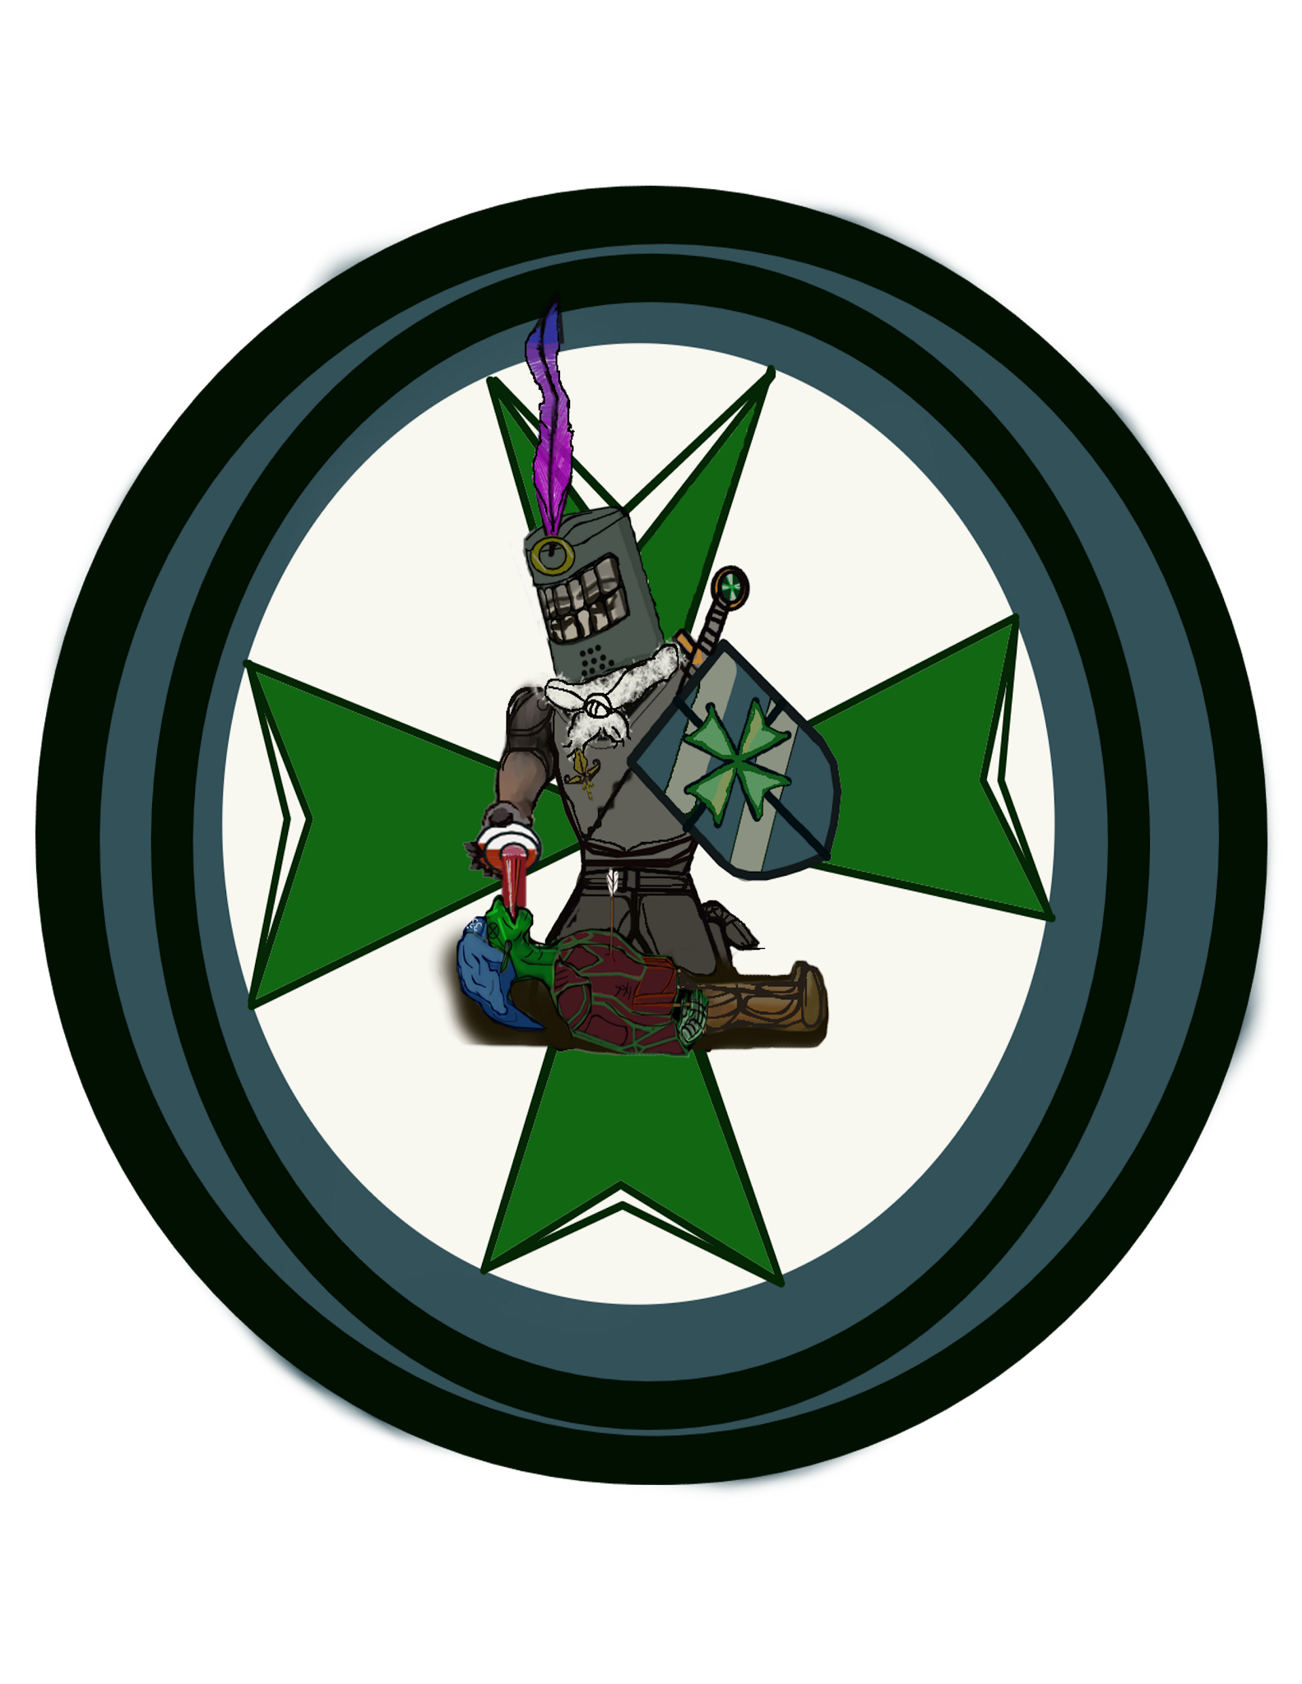

The Lazaurian Oath
(Unsung heroes and healers)
The Oath
“I will use my mind to restore the health of all creatures with sympathy, compassion and heedfulness.
I will use my hands to be able to prepare medicines well.
I will use my eyes to know what medicine is suitable and what is not. I will not give the unsuitable, only the suitable.
I will use my heart to minister to the sick with an attitude of love, not out of desire for gain.
I will use my legs to remain with the sick wherever they are.
I will use my lungs to instruct the novice and bring cheer to the ill.
And when all fails, and death arrives, it is I who will thank him for the peace given unto the wretched.”
Your pledge to the Oath of Lazarus is to the Oath and no other. And though many speak for the Oath takers, there is no one who governs you and no code but your own ethics. Those who have taken the Oath refer to themselves as the Afflicted as a mark of humility. You know that identifying with your patient is intended to serve the easing of their pain. You may have taken the oath early, perhaps you were too immature to understand the fullness of the implications of a lifetime of service. That you would take no family but the refugee, the meek and the ill fated.
But with this life comes a level of access not granted to the rest of the world. For upon the battlefields of war and politics there is no shield greater than the healer who bares the traditional cilice upon their leg.This ancient form of self atonement steadys the hand of the surgeon and merchant alike. For though one of the afflicted may hold any station in life, it is considered gravest taboo to refuse to help any who tug at its chain.
When any oath is made before one of the Gods of the Round Table, it has been decreed by Sir Cai any who are caught breaking it will be punished. Different chapters employ different methods, but discredited, denied treatment, tar and feathered, put on the rack, or even death may be invoked.
Choose a deity in whose name you will take the oath and work with your DM to work out your path amongst the afflicted. Do you wear the Cilice proudly, or have you grown tired of it as it bites its metal teeth into your flesh day after day? Did the order have a hand in raising you, or did you abandon a life of ease to lessen the guilt of a dark burden? Do you run into the fields of war to give succor despite the many dangers, or do you seek out those who hide their pain? While the origins of the Afflicted remain shrouded by the passing of generations, they have served in every conflict, every tragedy, every life in all of the Old World.

Feature: Burden of Life
Due to the Oath, you are expected to cure the Ill. This transcends morals, prejudice, the patient or target’s disposition toward who is helping them or the methods you use. It has been decreed by the King that it is an evil act to intentionally kill an Afflicted.It is equally heinous to impersonate one. Their elevated and protected status only protects them while they are physically in the act of healing, or the path two or from those in distress.
It is not unreasonable to assume that a guard could look the other way for an offending Afflicted particularly if that guard had ever been previously injured. A barkeep may waive some fees associated with their tavern for an Afflicted in return for dentistry or lancing boils..
Provided their reputation is unsullied and publicly the Oath is held, they may use any medical facility a populace has available (usually a Church, University, or Large Hall) as temporary residence for themselves, their patients, wards and companions (in that order) if there is room for them. Fellow Afflicted are typically civil to one another. And in the few moments they get to stumble across one another, the stories told over a glass of ale to one another are some of the best you will ever hear.
It falls to you, then, to carry the tradition on to the new world.
Specialty d6

1 Diagnostics
2 Apothecary
3 Surgeon
4 Chiropractic
5 Therapeutic
6 Research

The Vigant
(Vigilantes and the Morally self assured)
Before there was England there was the throne. Before the first of the angler tribe departed the main land of the Old World, there was the throne. At the dawning of the dragons, the green and the red, the white and the black laid claim to all of the land. A single gold dragon looked on the isles and wept for their future. And so Merlin the Golden Dragon, and 33rd degree mason, came to Wales. He set the capstone in Cardiff, of what would one day become Camelot. And Upon that place Merlin returned to make a throne for his King. Not the throne he would sit on, but a masonic machine of perfecting justice. The measuring tool upon which good is divided from bad. The Siege Perilous. Those who prefer no uncertain terms in life, rigidity, habit and discipline are likely to belong to a local chapter of the
A Cult of Vigilantism
You believe that the world is clearly and absolutely divided by Good and Evil. And the dividing line between them exacts a toll upon those who live their lives as anything less than good.The vigil of Siege Perilous seeks to safeguard Arthur’s kingdom in his absence by deed and song. The deeds done are recorded in a heraldic tome called the Y brenin unwaith ac yn y dyfodol (The Once and Future King). Any deed one wishes to record may be inscribed in the tome for a fee of 5 silver pieces. This has made the leadership of the Vigil both rich, and sure of the rightness of their deeds (however correct or misguided they may be). Talk to your DM. Work out where you fit in this rigid religious structure. Are you a shrewd and clever leader ready to lay claim to a mayoral race? or perhaps you are a hedge knight, roaming the king's roads in search of evil to punish. In most small towns a chapter of the Vigil chooses to self police their home and help protect their region against invasion. Were you an upstanding citizen of some hamlet assigned to town defense only to find that after a day's trip to the market, the home you returned to had been sacked by monsters leaving you to seek a new start in the world?
The fate of the New World relies on you
Decide the moral cause you will champion. Chastity, Temperance, Charity, Diligence, Patience, Kindness, or Humility. And a vice you wish to eliminate from the world: Lust, Gluttony, Greed, Sloth, Wrath, Envy, or Pride. Design a character with the two attributes in mind. Perhaps you are of the Charitable Vigil of the Siege Perilous’ wrath. Your character would then be pleased by charitable things, and quick to stand between a raging barbarian and his intended foe. Or perhaps your cause is Temperance and the sin you wish to cleanse the world of is lust. You may be a member of the Sober Vigil of the Siege Perilous’ harlot. Discuss with your DM what your chosen options do for your lifestyle and rp interactions.
Feature: Arbiter
Most rural leadership rely on Vigils to keep the peace. In times of minor conflict most peasants will trust a Vigil member to settle their agreements fairly and without bias.The traditional payment for such an arbitration is 5 gold, as decreed by a clever bard’s song many years ago.The symbol of the vigil is the manacles. And a member is never without them in case a threat presents itself.
Skill proficiencies: Intimidation, Insight.
Tool proficiencies: Calligraphy set. A Viol.
Languages: Dwarvish
Public lore introduction:
The story of worlds, both Old and New.
The Old world (Everything in the Eastern Hemisphere of real world geography) is the domain of the Gods. All Gods great and small have dominion over their land, their people and their religions. There is no escape from the impact this has on daily life in the Old World. The God’s feed on the faith and offerings of their devoted. Each of them embodying a different aspect of life, or championing their many conflicting causes.
Finding your place in the worlds:
As to the specific gods, our game concerns many pantheons of gods, including our Gods of the Round Table and their dominion of England. More information can be found here: (link) Other countries may be referenced, but for the time being this is an unwritten blank space for you to apply your imagination and research. The writing that exists in the game pulls from a wide variety of folklore (from the huldufolk of Icelandic Myth, to the Myths and legends of the Hermetic faiths that point to Egypt as their fictional backdrop. In other cases, our DM’s have free reign to use any assets (including pantheons) that are published by WOTC in their game crafting and lore that pertains to the stories they tell. Because we are writing collectively, the lore of Arcania can be amorphous and fluid at times. Speak to your DM about any ideas you might have about where your Character might be from, and what sort of folklore you may wish to adapt. Hopefully future iterations of the game will have more choices than just England.
There is a single narrative that weaves the fates of the Old World and the New World. This narrative is the story of the two brothers who founded the Occult traditions, The Golden Dawn and The Freemasons. They represent two ways to change the world. Hiram champions forethought and planning, and the magic of his Freemasons equate to having empathy for the struggles of those around you. The Golden Dawn represents a reactionary world. A world obsessed with outrage and entitlement. Solomon is selfish and lazy. He is a petty immortal charlatan who still pines for his brother Hiram’s throne, despite the kingdom of the Brunelocks falling beneath the sands of the Sahara well over 1000 years ago.
Coming to Arcania
The setting is in the first half of the 17th century. Nearly 100 years since Christopher Columbus stole the secrets to accessing the New World from a group of Masonic Vikings known as the Roseline Temple. Along with the other members of Roseline Temple, the First Arcanian Cryptid to set foot on the shores of The Old World was a Sasquatch named Bigfoot. He, along with the Roseline Temple leaders Hiram Abiff, the half Orc Pym “of the Rosecutter”, and many more of their ranks worked with the Wardens of the New World (of the Continent Arcania) Columbia, Cascadia, Fontaine And Oro to build a barrier between the two locations to prevent the Gods of the Old World from dominating the New World.
Despite the fact that roughly one third of the Gods are aligned to the ideas of good and benevolence, two thirds are either indifferent, or have dominating designs for the lesser beings beneath them. The dangers outweighed the possible benefits of opening their shores to the Cleric, Paladins and Warlocks of the Old World.
The New world (Everything in the Western Hemisphere of real world geography) is the home of Arcane magic. While Arcane magic is used around the world, it is pristine and unfettered by the will of the Gods of the Old World. Leylines carry Arcane magic from its source in Arcania to all other locations in the world. And this causes a subtle pull on all spell casters to journey to its source. The search for the point of origin for the nexus of all arcane magical power is called the search for the NorthWest Passage, and is the obsession of many Wizards, Sorcerers and other types of Arcane Casters.
Colonialism in the Worlds both Old and New.
Your reasons for traveling to the New World are yours and yours alone. Understanding your “coming to America” story starts with an understanding of the people who actually came here. It represents change. Change that can be either carefully thought out with good intentions and considerations for those around you, or change that can be brutal, violent and scar your heart. In this fantasy remimaging of early American History, you are what you bring with you from the Old World. Or in the case of a Native Race, you are left with the choice of how to deal with those who have come. This is not intended to follow history. It is intended to give you the chance to imagine being at the beginning of a new civilization. The conflicts you have in the game, and the resolutions you make are likely to inform the shape of the games to come.
Secret Societies.
As a player option, There are 4 secret societies in the world that play a function in how quests and (sometimes conflicting) objectives can be given out to players, allowing the group to have intrigue in and amongst their other daily role play options.

Occult (Hidden wisdom) societies:
1. The Freemasons:
Now, head of the New World Masons, Hiram Abiff stands every morning on the eastern shore of Roanoke island. Every morning he stares out over the water. The Golden Dawn rises every morning. And every morning he looks to the east for any sign of ships. Currently, the head of the Masons of the Old world is a Yeti named Archivist Daysong. He is the Tir na Nog’s naturalist and goes by his title of Archivist. His pretense is that he is in search of Bigfoot, and other Arcanian Cryptids.But in actuality, His reasons for traveling to the New World are intentionally obscured.
2. The Golden Dawn:
No information about the Golden Dawn will appear in print. If you want to be a part of them, too bad. They will recruit on their own, and in secret for their own nefarious plans.

Aristocratic and Philanthropic Orders:
3. The Knights du Roi Soleil:
The Knights represent everything Arcania fears, regardless of whether or not some of their fears are misguided. The will of the gods is vast and varied, but they existed to help and guide mortals through life. Giving them strength when they needed it, and hope when they were without it. Somewhere in the cycle of Croatoan years ago, the Day of the Black Sun arrived and all warmth that emanated from Machidiel's power was destroyed. One man's divine oath before all the living gods of good faith ignited a movement and passion inside the founding order: the Knights du Roi Soleil, the sun king.
4. The Order of Kairo:
After Columbus’ mission from Spain failed (through multiple iterations of colonies) to produce a long term foot hold in Arcania, the spanish crown simply denied that it ever happened. The loved ones of those who disappeared in the mysterious disappearance banded together to seek answers on their own. Kairo, a member of the British Museum has found a way to search for their families and those colonists who are believed to still be living on Roanoke island while still getting the government to pay for it.

For this section, a stretch goal (depending on how much time you have) would be to make it work with the WOTC OGL. Replacing proper nouns (any not appearing in the SRD- the free version of D&D) with more generic descriptions. We can also pare this down, if it feels like too many options.

The Gods of the Round Table
King Arthur Pendragon and his Knights of the round table are the Gods and Goddesses of England in Roanoke Season 3. What follows is an extensive tour of the drama and nuances of that world.

King Arthur
(Lawful Neutral, Aasimar)
The High King of England.
God of our Ancestors and God of our Descendants.
The Once and Future king is the king of a two edged sword. On one side, Excalibur is engraved with the words “Take me up”. On the other side is engraved the words “Cast me aside.” Arthur, despite being the main figure of the pantheon, is the God of the past and the future only. He is absent from the present. Nonetheless, all of the other Gods owe him fealty. The fear of being the one Arthur will return to slay no doubt lingers even now over the rest of the pantheon. Arthur was a man of decisive action, and shining Charisma. It is said that his absence is the reason the English skies weep with rain more often than not.

Considered missing only, and not seen as a dead god, Arthur’s clergy was tasked with carrying on his tradition of Knights Errant. Most of the religion is involved in virtuous living, attending sacred jousting tournaments, and ascending through the order’s rigid bureaucracy. The stated goal of those participating as the Knights Errant is to be the last and strongest line of defence the Kingdom can muster. Their glory would be to be the last to stand before the threat that Merlin prophesied would one day appear. The goal was to stand before a threat so great that Arthur must return to save the realm. To stand before it and fall while battling with all of their rage and might. Once the Knights errant was full of the nobles of England. Now the religion is full of isolated pockets of barbarians from the furthest reaches of the Kingdom. Each of them, regardless of race can trace their lineage through story knotts tied to their belts. And not a single one of them fails to mention at least one of the Gods as being an ancestor. Each was dreaming of the final foe.

Modern Englishmen under King Charles pay homage to Arthur in everyday life. The phrase “For God and King” is known to mean both as Arthur.

Guinevere
(Real name: Síabair Findabair. Wood Elf, Sun Elf and Drow. (Good, Neutral and Evil)

The Maiden Oracle
(Neutral Aspect)
Evidence has been gathered that Guinevere knew the details of her life, her marriages and her treason since early childhood. Journals and artistic renderings show details and reveal intimate portrayals of her future. This leads many to debate upon the nature of her character. Could someone who knows that they will betray the king marry him with a clear conscience and noble intention? Either way, the Maiden is always portrayed as a Wood Elf.
Followers of Guinevere as "The Maiden Oracle" have no organized religion. They believe in the duality of free will and fate.There is both a predestination to your life, and you are responsible for what you do. Both are true at the same time. The Nunnery of the Maiden is a staple of the community, they often teach local children a basic education and offer aid to those in need. Counterwise, the nuns of the Maiden Oracle teach that they are owed from those in power an equivalent courtesy. As if to say “we keep your country running, your work force fed, your soldiers healed.” This relationship has led to many surprising diplomatic ties and the group is known for their spycraft.

Modern opinion of the Nuns of the Maiden: It is known that this sisterhood is a last refuge for the women in England. Parents threaten it as punishment for wayward, immodest, and disobedient girls. And yet there is also a grave taboo hanging over the women who join over their own accord. They are seen by commoners as abandoning society, as the Nuns abandon all vestiges of identity and maintain the secrecy of their hierarchy by appearing to the untrained eye to be uniform in appearance and dress in a Nun's habit.

The Matron: High Queen of England
Upon ascension to the high throne, Guinevere completed Arthur’s kingdom. It is said that his apotheosis (his ascension to godhood) was only achieved by the creature known as the White Enchantress, an immortal copy of Guinevere in the form of a Sun Elf made to help govern the kingdom while Arthur was Questing. The White Enchantress is the most publicly accessible member of the Pantheon. She works tirelessly to arbitrate, give advice and aid the people. At one time she was made the Crown Regent in place of the true Guinevere on the eve of her betrayal.
Servants of the Matron have an affinity for constructs, for using logic and reason, and for tirelessly working for the benefit of others. They are often given liberties and trust not afforded to others, as would be given to a battlefield medic, or other good aligned specialist.

The Crone and Betrayer: Queen of the Lake
Though Guinevere was not an old woman when she betrayed Arthur, she matured to the point where she believed in her own happiness enough to pursue it. Guinevere was a woman of rare talent, and that image is often refuted by the other religions who depict her as an old ulgy crone. In fact, the Betrayer Queen of the Lake (despite appearing like a Dark Elf) was not evil, nor is it the badge of shame claimed by the followers of Arthur..
The followers of the Queen of the Lake take pride in their bluntness. They are a powerful network of influential women. They are direct, and well versed in the art of reading the faces and body language of those with whom they come in contact. They rarely fail to state an opinion. While they acknowledge their Lady’s betrayal, they do not hold it against her. The followers of the Crone believe in second chances. They also believe that Guinevere du Lac and the Lady of the Lake are one and the same.

Merlin (Magical Creature)
Primordial of the Arcane.
This ancient welsh dragon is the Great Architect of the current pantheon of Britain. In his human form he has influenced events in countless ways. Most tales of Merlin are apocryphal at best. All of them agree on certain points however. His particular gift appears to be the ability to prepare exactly the right spell or to come up with exactly the right plan for whatever the occasion calls for. And yet there is always an air of doubt. Some sort of lingering magic prevents religions from organizing around him. And yet it is not unheard of for white towers called Calders to appear in various locations to act as academies and colleges of the Arcane Arts. Merlin was last seen fully embracing his dragon form off the cliffs of Dover to aid in the defeat of an invading armada. The current calders are: The Globe, a Bardic College of Glamour, The Lyceum at Puzzlewood, The Academy of Tintagel, and the Mermaid’s Pool on Fisher King Island are said to claim Merlin as their founder.

Morgan Le Fey (Chaotic Neutral, Changeling)
Goddess, Sorceress, and Mistress of the Forge.
Morgan le Fey of Avalon was the only female to ever attain rank within the secret fraternal orders that once controlled England. As a Changeling she appeared to many people in different forms. And so much of her journey cannot be traced.
The one form she felt the most comfortable with was the shape of a male Duregar. The dark dwarf avatar of Morgan Le Fey was the craftsman who forged Arthur’s blade. Other aspects of Morgan Le Fay are said to be known to the Church’s leadership.
Followers of Morgan believe first and foremost that the serfs deserve the same rights as the aristocracy. She's created many magical tools and weapons, with the intention of helping those she equipped to live up to their potential. Worship of Morgan is strictly banned in England. Nevertheless, the Black Chapel of Le Fey is a robust religion centered around smithing and providing both tools and the truth to those in need.
The modern public opinion of Morgan Le Fey is one of scorn and public outcry. The inquisition long ago branded her a heretic and those that profess a faith in Morgan often find themselves at the center of a large pyre.

Sir Lancelot du Lac (Chaotic Good, Half-Elf)
God of Tragedy and Betrayals.
Sir Launcelot was born to a knowledge elemental now known as the Lady of the Lake. Sir Launcelot du Lac's choice to betray his King for the love of Guinevere is often considered to be the greatest love story of all time. This tale is often cited as being the reason that the college of Bards has proclaimed their devotion to him.
The followers of Sir Lancelot range from those deep in mourning, to those who covet to take power, possession, or passion. And the will to do whatever you set your mind to in the name of righteous power, reclaiming what was stolen, and to pursue true loves brightest embers.
The modern opinion of the followers of Sir Lancelot is that they are petulant children pursuing the cause of an uprising that fell long ago. Modern mystics and philosophers, however, take the tale of Sir Lancelot to represent their own bravery in the face of tyranny.

The Lady of the Lake (Knowledge Elemental)
See:The Crone entry under Guinevere. The followers of the Lady of the Lake are the Scriveners du Lac.

Sir Gawain (Lawful neutral, Half Orc)
The God of the Noontime.
Before his ascension, Gawain was a knight of the Orkney islands. Gawain's domain came about as a result of a curious power he possessed even as a mortal. Gawain's strength triples as the midday sun waxes and wanes at night. Making his power a turbulent tool to wield.
Gawain's greatest deed on earth was to run a sort of gauntlet of virtue tests at the hands of a shape shifting creature known as the King of the Green Chapel. This creature, known more commonly as The Green Man found nearly no flaw in the blameless knight’s courtesy, gallantry, and chivalry. Gawain accomplished this by first entering the celestial realm to burn all of the evil out of himself where he lost an eye, and his right hand was horribly disfigured.
The modern opinion of the followers of Sir Gawain is one of public adoration and private revulsion. A halo forms on any paladin or cleric of Gawain who takes an injury to the eye and right hand. The church has a formal process, a rite called Siege Perilous. Although, some cases have been known to happen by accident. Such a paladin or cleric is given the title of “of the Green”.

The Green man: (Lawful evil, Warforged)
God of Vengeance.
He cares for the Green and is the protector of the woodlands. He has even come to resemble a tree with bark like skin and leaves for hair. Not like a great oak, but like a man whose body is made of braided saplings. He is strong but can bend without breaking. He is a creature of quick and harsh judgement though he can not take retribution without having cause. In this way, he tests people and at the tiniest infraction beheads them with his great axe.
The Green man does not have followers amongst the non-monstrous races. He is seen as the father of the wild, and a protector who sends out rangers to protect the lost corners of the world where the strong get lazy, and the rich abuse the weak. The punishments are cruel and unusual for even minor offences.
The modern opinion of the Green Man is a matter of formalities to the aristocrat, and familial intimacy to the serf. Time spent sharing meals and where you lay your head are sacred to both the followers of the Green man and to the average citizen of England. Having your meals and your bed kept by servants reinforces to the aristocrat that the modern Englishman has thoroughly trounced nature and that her perils may be avoided by the practice of being more civilized than your neighbor.

Sir Percival (Chaotic Neutral, Halfling)
The God of Trickery.
Sir Percival was a Knight of cunning and prefered stealth or indirect influence to overcome adversity. He is best known for retrieving Excalibur from a roving warhost of pixies. And for being the Knight who bested the fisher king’s trial in order to retrieve the grail for Arthur. Both tasks were more than a match for anyone who approached the task directly.
Sir Percival’s religion is a religion of cunning. The Gunter Grifters are tolerated because they are registered with the government and are conscripted into every conflict. In this way, the Thieves’ Guild has flourished in England. Petty theft is largely ignored by the police, in return the thieves of England can pour into an enemy country unseen to undo a kingdom with never a single soldier unsheathing their blade.
The modern opinion of the followers of Sir Percival in Gunters Grifters is widely romanticized. There are few modern tales that don’t portray the members of the GG as swashbuckling heros or misunderstood anti heros, and thieves with hearts of gold.

Sir Galahad (Neutral Good, Firbolg)
God of the Forge.
One of the greatest Gods in the pantheon, his domain came from his ability to reforge excalibur during Arthur's grail quest when Arthur broke the blade in battle. Sir Galahad is in fact Arthur’s reaction to Morgan Le Fay’s claim to the forge domain.
Morgan and Galahad vie for their claims to the domain of the Forge. The Deities seem to wax and wane in power along with the waxing and waning of the full moon. Sir Galahad’s sacred night is the night of the new moon, in its darkness he can forge some of the worlds strongest weapons. It is noted however, that ever since Galahad claimed the domain of the Forge, no legendary items have been crafted. It is likely that so long as both Morgan and Galahad claim the Forge, neither will be able to produce items of Excalibur’s quality again.
The modern opinion of Sir Galahad is that his name is the correct choice for blacksmiths to invoke when trying to sell merchandise. But it is Morgan you want to invoke while crafting.

Sir Geraint (Neutral, Jackdaw Aarakocra)
The Fearless One. The Eternal Servant.
The widower God was the only god to refuse his wife's request to ascend with him. Just as he had gained his seat on the round table by overcoming his grief at the mysterious death of his first wife.
Later in life he remarried, but in order to be more like he was when he first joined the Knights of the Round, he refused to ascend his wife Amyrss. She declared it the ultimate act of loyalty to Arthur and in so doing, became the first cleric of his order.He was known for fearlessly throwing himself into dangerous situations without a care for his own personal safety. As are the fighters who abandon love and pride for the good of their country.
There is a small cult of Sir Geraint, this band of chastened monks take magical vows of humility that either remove all pigment from eyes, hair and skin, or completely saturate it with pigment to be inky black once higher levels within the church are attained.
The modern opinion of Sir Geraint is anyone attempting to one up some else, or someone who is likely to tattle on you is like Sir Geraint. His brand of loyalty feels antiquated to the average Englishmen. Like falsely believing that a grand gesture could fix things. Sir Geraint’s followers founded Scotland Yard.

Sir Gareth (Lawful Neutral, Werebear)
The God of Fortitude and Protection.
Sir Gareth gained his domain by being the final Knight standing between Aurthur and Lancelot when Aurthur was making his last stand. It was at this moment the Merlin cast the 11th level spell "change destiny" and the Knights of the Round (living and dead) were called forth to be the deities to govern the British Isles.
The followers of Gareth are often lycanthropes and bloodhunters. Theirs’ is a story much older than that of Arthur and is seen by the lycanthropes as the only pure part of the religion.
The crest of Sir Gareth can be branded into a lycanthrope in order to suppress the urge to turn. It is said that Sir Gareth is a remnant of the previous pantheon. (A wolf named Fenrir). In his new role however, the White Wolf has become synonymous with an order of blood hunters, gunslingers and artificers. Sir Gareth’s followers tend to be highly intelligent, and usually work together to alter their bodies, their weapons, and the battlefield. A group of Garetheans working togethers is a force to be reckoned with. They are always afforded the honor of standard bearer when riding to battle with an army.

Sir Gaharis (Lawful Evil, Tiefling)
The God of the Cold Flame.
At the last stand of King Arthur, Sir Gareth's brother the Executioner Sir Gaharis did not defend his King. Rather he was building a pyre to burn Lady Guinevere for her act of treasonous infidelity. But there was no malice in him toward her and he felt remorse for his part in her death. So now the flames of Gaharis give off no heat. Some legends say that he spared her from that final judgment with cold flame too. Other legends say the cold flame came from his remorse after the event. In any case, practitioners of the Cult of Cold Flame tend to be burdened with the weight of their choices. Sometimes called an old man’s church, much of the leadership is made up of former soldiers and retired knights. Those who have fought on foreign soil are venerated by wealthy aristocratic Gaharins.
His followers are often considered to be Arthur's and typically are not aware of the other members of their order. It is only by receiving direct instructions from Gaharis’s sacred messengers that a member may be confirmed. Secret knocks and handshakes are used to identify one another and the motivations of the group remain hidden, but trusted in by the clergy. The modern opinion of Sir Gaheris is largely to confuse him with Gareth. Or to see him as a mad man bent on killing a woman for daring to love. There is much hostility between followers of Morgan or Guinevere and followers of Gaheris.

Sir Bedivere (Neutral Good, Kenku)
God of Heraldry and Ale.
The first knight to pledge himself to Arthur, Bedivere was not a creature of great strength. He was heavy set, and slow to distrust. But his voice was the loudest and his laughter peeled like tiny thunderclaps through Camelot.
Bedivere, was a brewer before becoming a knight and when he ascended a group of Monks called the Brewers Brown Barrel Belly Brawlers dedicated to fist fighting and martial prowess took up the mantle of his trade. So now all his clerics, paladins and monks are brewers of the Golden Ale of Sir Bedivere.
The modern opinion of Sir Bedivere is largely a positive one, his name being invoked before nearly all manners of celebration, debauchery and good natured contests.

Sir Ector (Lawful neutral, Locathah)
God of Trade and Orphans.
Raised alongside Arthur, Sir Ector and the future King were both orphans adopted by a hedge knight who had been knighted, but had no Lord to whom he pledged fealty. Together their father and the two boys roamed the countryside battling evil and making money where they could. While Arthur took to the greater feats heroism, it was Sir Ector who managed their campaign, making friendships and alliances, and exploiting their fame for money.
A shrewd businessman man can keep a kingdom's blades sharp and its aim true. Sir Ector does not have an organized religion, but his paladins are typically migrant knights who follow the jousting circuit. Rangers and wizards both venerate Ector most commonly.

Sir Cai (Chaotic Neutral, Kobold)
God of Chaos.
‘Nine nights and nine days his breath lasted under water, nine nights and nine days he would be without sleep. A wound from Cai’s crooked dagger, no physician might heal. When it pleased him, he would be as tall as the tallest tree in the forest. When the rain was heaviest, whatever he held in his hand would be dry for a handbreadth before and behind, because of the greatness of his heat, and, when his companions were coldest, he would be as fuel for them to light a fire.’
Sir Cai was unmatched in armed combat, his strengths were adaptability and unpredictability, flying into a reckless rage of laughter and blood soaked glee. It was rumored that even the berzerker nords spoke his name in reverence. Barbarians and fighters both often claim his blessings, but rogues and sorcerers are more likely to receive them.
The modern opinion on followers of Sir Cai is one of intolerance. Followers of Sir Cai are either foolhardy warriors or the darker sorts of tricksters and arcane arts. They generally are treated as a problem waiting to happen if discovered before their machinations are complete or goals are revealed.

Sir Bors (Lawful Good, Human)
God of Virtue and Chivalry
While Sir Percival is credited for the retrieval of the Grail it was only Sir Bors who delivered it back to Camelot. Sir Bors the pure. Sir Bors the Chaste. Sir Bors' life was blameless. And so his tolerance for even minor flaws is notably limited.
Acolytes of Sir Bor typically wear clothes made with undyed cloth. The church is also well known for self flagellation and extensive painful self purification rituals.
The modern opinion on followers of Sir Bors is that they are antiquated to the point of being untouchable. When the “Power behind the throne” is discussed in the hushed corners of Court, it is usually in reference to a conspiracy theory of aristocratic purists who believe that England has lost her way.

Sir Lamorack (Chaotic Evil, Lizardfolk)
God of Animals
Sir Lamorack's renown was similar to Sir Cai. However, his advantage was in his dominion over beasts whom he used as a sword to strike down his foes and as a swarming shield of sacrifices to protect himself.
His abilities gained him advantages at the use of hounds, falconry, and above all the joust. Evil Druids venerate him, and pact of the chain warlocks have been known to make pacts with the animals who served him. Evil Beastmasters pay lip service and dream of his mastery and control over the beasts.
The modern opinion of the followers of Sir Lamorack is that they are a bunch of silly men standing in stone circles making animal noises on moon lit nights. The Limericks of Lamorack are a famous collection of animal themed insults. There is however the one true Limerick of Lamorack that can cause animals to laugh and humans to be brought low before the creatures they once mocked. Now, the telling of Limericks as Vicious Mockery on Lamorack’s day (April 1st) is a national pastime. The best bards compete using only this cantrip as their chosen weapon. The Globe in London has always been the center of this one and only religious observance of the followers of Sir Lamorack.

Sir Tristram (True Neutral, Shadarkai)
The Immortal.
When the Gods ascended Tristram was not granted the other divine powers. Tristam was once one of the greatest of the Knights of the Round Table. He fell from grace when he failed to collect a prize from a tournament he had won. The tournament's winner was to wed the Queen of Ireland to unite the kingdoms. Sir Tristram however fell in love with the captain's daughter on the short voyage across the Irish Channel. He did not marry and so, lost honor. But Arthur compromised for Tristram. Now, hundreds of years later, he is a broker of shadows and secrets, and a very valuable warlock pact patron.

Sir Agravain (Chaotic Neutral, Gnome)
Goddess of Fertility and Illusions.
Sir Agravain was often described as the most handsome of the knights. Until it was revealed that Sir Agravain was hiding beneath a fey shroud of illusion was in fact a female dark elf. Arthur nearly had her exiled until Merlin came to him and reminded him of her valor. Sir Agravain was allowed to retain her seat at the round table, and had special armor made to protect her through many pregnancies after her marriage to Sir Cai.
Priests and Priestesses of Sir Agravain are the true church of the people of England. There are more churches and priests in her name than in any other. The main concerns are the day to day worries, qualms, joys and griefs of peasant life. Secretly, the order seeks to undermine Sir Cai at every possible opportunity.

