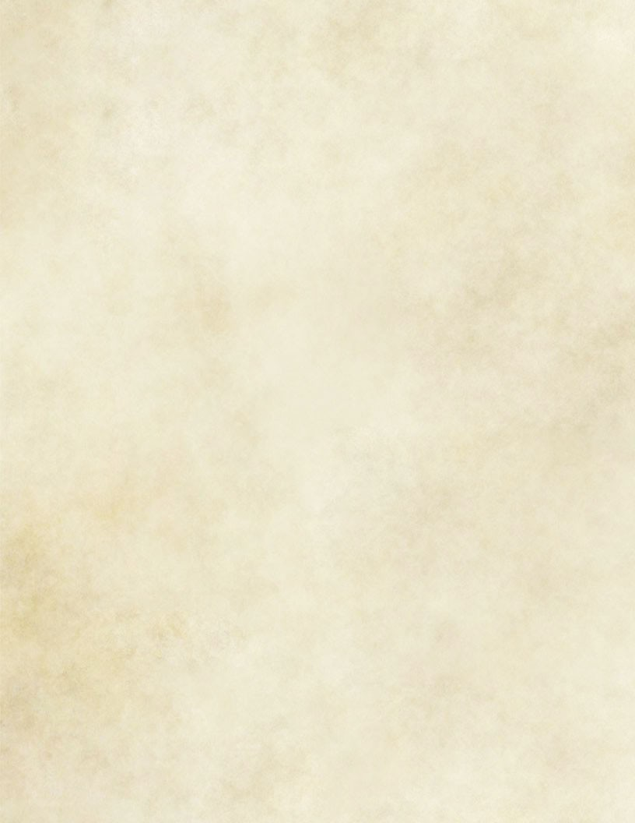
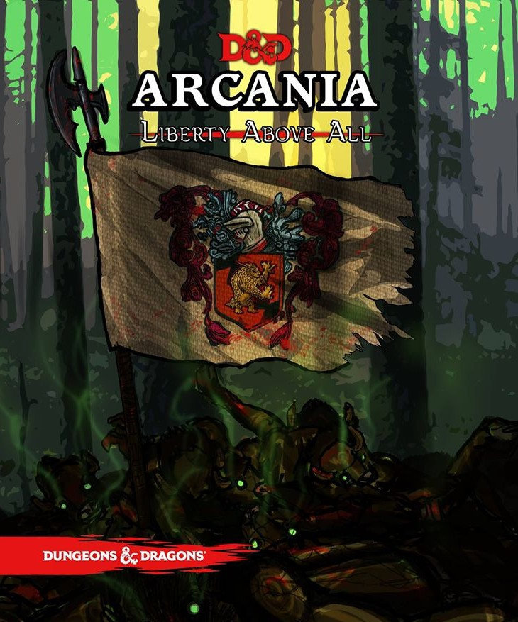

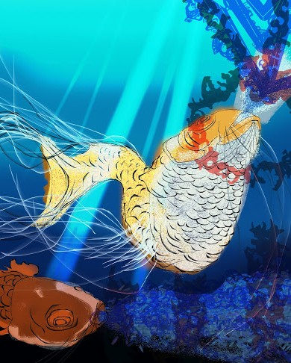

This document represents the story telling of four seperate DMs. Not only is it meant to help equip you and orient you to our world. It is also meant to help inform you about the very different playstyles your DM's will be presenting.

The story of worlds, both Old and New.
T

he Old world (Everything in the Eastern Hemisphere of real world geography) is the domain of the Gods. All Gods great and small have dominion over their land, their people and their religions. There is no escape from the impact this has on daily life in the Old World.
The God’s feed on the faith and offerings of their devoted. Each of them embodying a different aspect of life, or championing their many conflicting causes.

Finding your place in the worlds:
As to the specific gods, our game concerns many pantheons of gods, including our Gods of the Round Table and their dominion of England. More information can be found here. Other countries may be referenced, but for the time being this is an unwritten blank space for you to apply your imagination and research. The writing that exists in the game pulls from a wide variety of folklore (from the huldufolk of Icelandic Myth, to the Myths and legends of the Hermetic faiths that point to Egypt as their fictional backdrop. In other cases, our DM’s have free reign to use any assets (including pantheons) that are published by WOTC in their game crafting and lore that pertains to the stories they tell. Because we are writing collectively, the lore of Arcania can be amorphous and fluid at times. Speak to your DM about any ideas you might have about where your Character might be from, and what sort of folklore you may wish to adapt. Hopefully future iterations of the game will have more choices than just England.
There is a single narrative that weaves the fates of the Old World and the New World. This narrative is the story of the two brothers who founded the Occult traditions, The Golden Dawn and The Freemasons. They represent two ways to change the world. Hiram champions forethought and planning, and the magic of his Freemasons equate to having empathy for the struggles of those around you. The Golden Dawn represents a reactionary world. A world obsessed with outrage and entitlement. Solomon is selfish and lazy. He is a petty immortal charlatan who still pines for his brother Hiram’s throne, despite the kingdom of the Brunelocks falling beneath the sands of the Sahara well over 1000 years ago.

Coming to Arcania
The setting is in the first half of the 17th century. Nearly 100 years since Christopher Columbus stole the secrets to accessing the New World from a group of Masonic Vikings known as the Roseline Temple. Along with the other members of Roseline Temple, the First Arcanian Cryptid to set foot on the shores of The Old World was a Sasquatch named Bigfoot. He, along with the Roseline Temple leaders Hiram Abiff, the half Orc Pym “of the Rosecutter”, and many more of their ranks worked with the Wardens of the New World (of the Continent Arcania) Columbia, Cascadia, Fontaine And Oro to build a barrier between the two locations to prevent the Gods of the Old World from dominating the New World.
Despite the fact that roughly one third of the Gods are aligned to the ideas of good and benevolence, two thirds are either indifferent, or have dominating designs for the lesser beings beneath them. The dangers outweighed the possible benefits of opening their shores to the Cleric, Paladins and Warlocks of the Old World.
The New world (Everything in the Western Hemisphere of real world geography) is the home of Arcane magic. While Arcane magic is used around the world, it is pristine and unfettered by the will of the Gods of the Old World. Leylines carry Arcane magic from its source in Arcania to all other locations in the world. And this causes a subtle pull on all spell casters to journey to its source. The search for the point of origin for the nexus of all arcane magical power is called the search for the NorthWest Passage, and is the obsession of many Wizards, Sorcerers and other types of Arcane Casters.
Colonialism in the Worlds both

O ld and New.
Your reasons for traveling to the New World are yours and yours alone. Understanding your “coming to America” story starts with an understanding of the people who actually came here. It represents change. Change that can be either carefully thought out with good intentions and considerations for those around you, or change that can be brutal, violent and scar your heart. In this fantasy remimaging of early American History, you are what you bring with you from the Old World. Or in the case of a Native Race, you are left with the choice of how to deal with those who have come. This is not intended to follow history. It is intended to give you the chance to imagine being at the beginning of a new civilization. The conflicts you have in the game, and the resolutions you make are likely to inform the shape of the games to come.

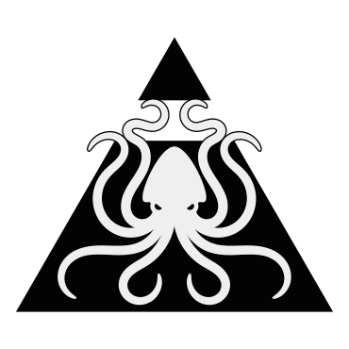Secret Societies.
The Golden Dawn:

No information about the Golden Dawn will appear in print. If you want to be a part of them, too bad. They will recruit on their own, and in secret for their own nefarious plans.
As a player option, There are 4 secret societies in the world that play a function in how quests and (sometimes conflicting) objectives can be given out to players, allowing the group to have intrigue in and amongst their other daily role play options.
Occult (Hidden wisdom) societies:

The Freemasons:
Now, head of the New World Masons, Hiram Abiff stands every morning on the eastern shore of Roanoke island. Every morning he stares out over the water. The Golden Dawn rises every morning. And every morning he looks to the east for any sign of ships. Currently, the head of the Masons of the Old world is a Yeti named Archivist Daysong. He is the Tir na Nog’s naturalist and goes by his title of Archivist. His pretense is that he is in search of Bigfoot, and other Arcanian Cryptids.But in actuality, His reasons for traveling to the New World are intentionally obscured.
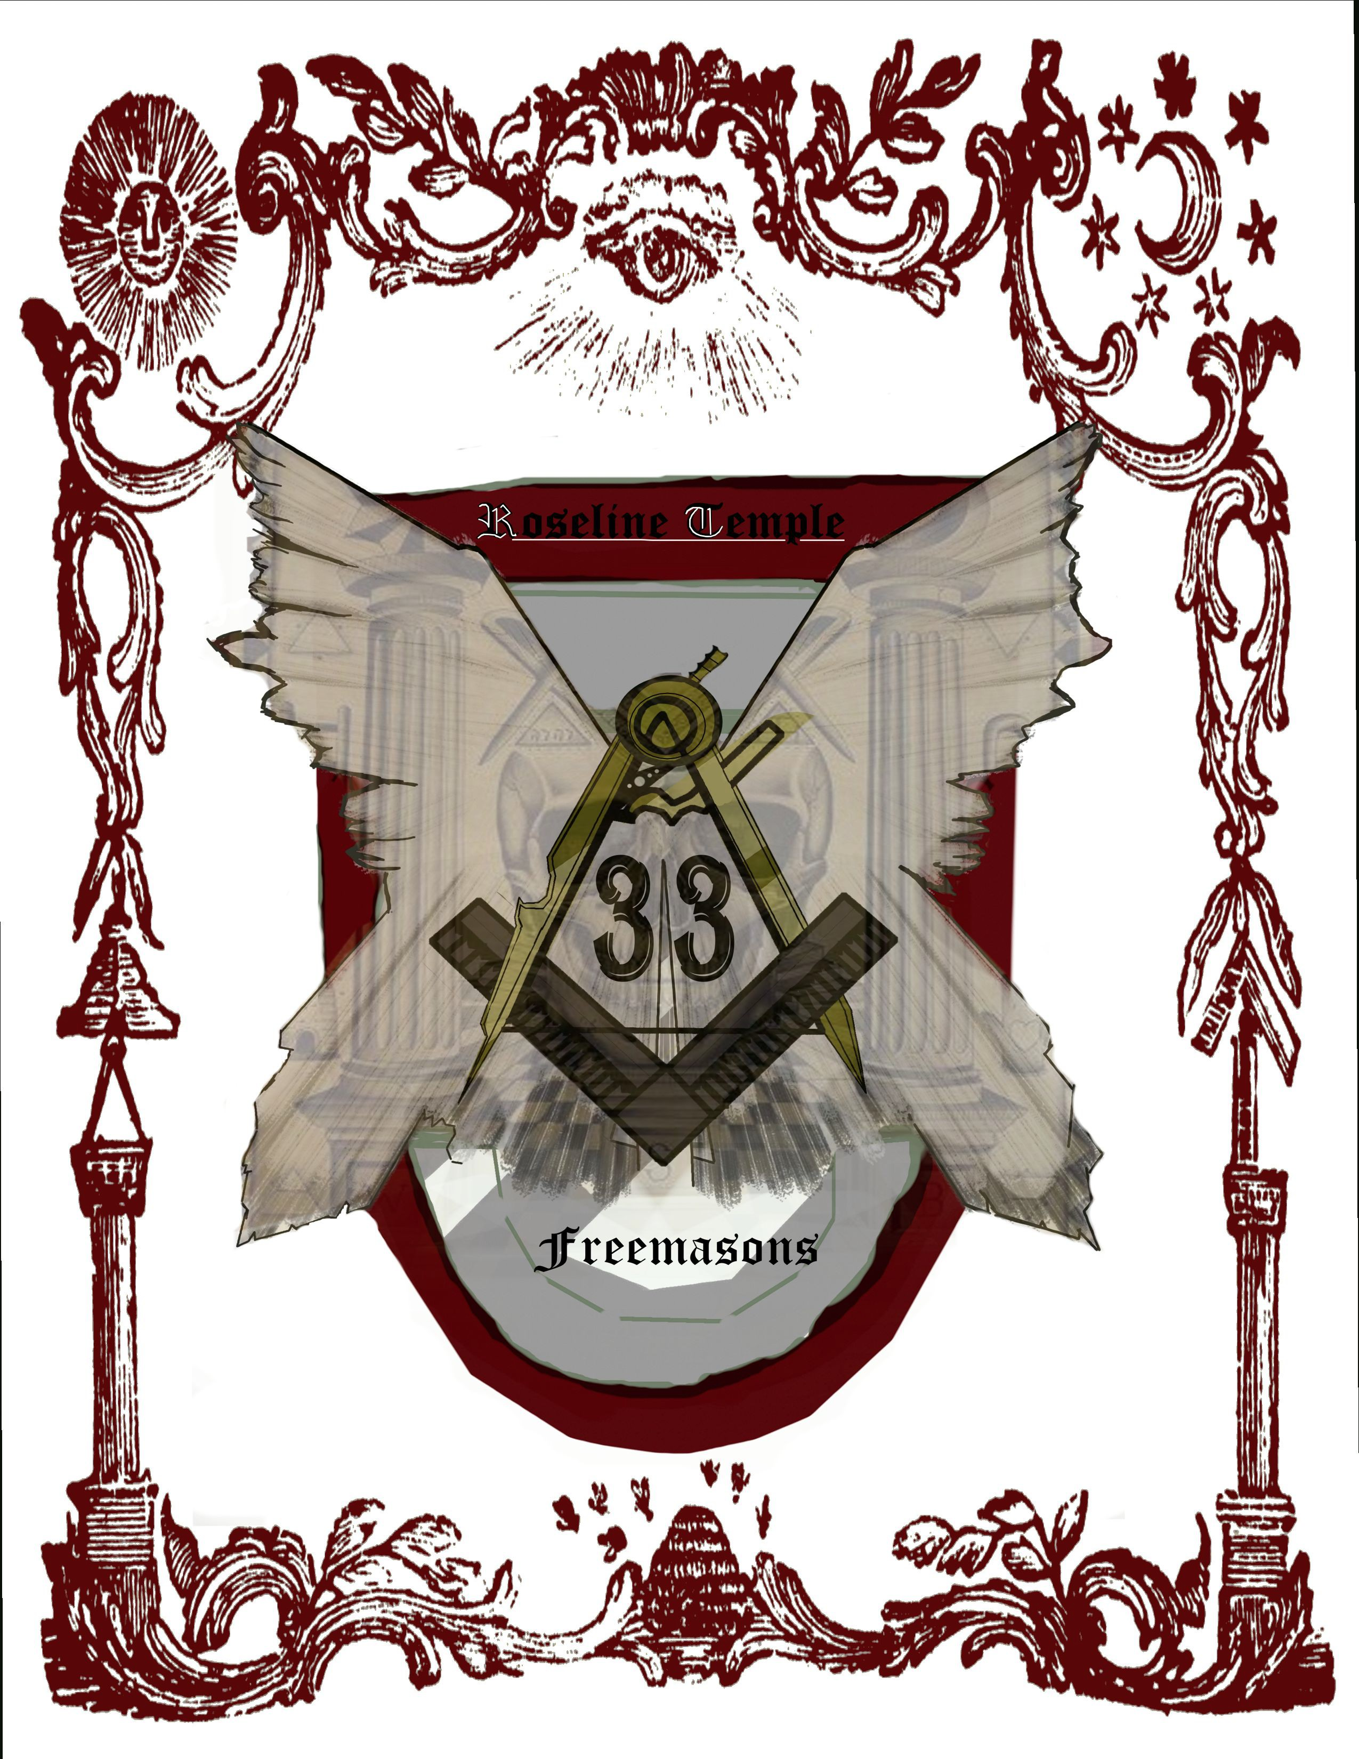

Aristocratic and Philanthropic
Orders:

The Knights du Roi Soleil:
The Knights du Roi Soleil represent everything Arcania fears (whether or not some of their fears maybe misguided if for the players to decide). The will of the gods is vast and varied, but the knights believe that they (the gods) existed to help and guide mortals through life. Giving them strength when they needed it, and hope when they were without it. Somewhere in the cycle of Croatoan years ago, the Day of the Black Sun commenced and all warmth that emanated from Machidiel's power was destroyed. One man's divine oath before all the living gods of good faith ignited a movement and passion inside the founding order: the Knights du Roi Soleil, the sun king.

The dark days did not cease however, as when tales of a

The Eclipse Knight who began the order has been lost to time, and the oral tradition of his myths and fables. However, his deeds were not forgotten as the Knights spread their ideals through their pure hearts and noble minds into the world. All those who gave their faith to any God of justice or nature could find sanctuary within their walls and a greater purpose within.

monstrosity so evil had been delivered unto the highest heights of the Celestial mountain palaces of the gods, a great battle took place. The battle of epic proportions could not be contained to that single plane, as the great evil hunger called upon its creations and followers, dividing the gods forces and luring them to the material plane. Catastrophic damage would have been done to all mortals had the gods not brought it to the abyssal Atlantic Ocean. Many gods here suffered casualties of grand proportion. An outcome too costly to be called a victory, for they gave their lives to only delay the inevitable in an unearthly prison, to let its hunger swell to insatiable size.
This pyrrhic success dubbed the Battle of the Atlantic Abyss led for many newer and younger gods to take up the mantle in attempts to guide others and answer upon divine call, however the last battle of the gods solidified the Knights du Roi Soleil's path. It is their belief and practice that through the combined conviction of man and the lost relics of the gods, they can face this ancient evil being and untwist the corrupted souls that follow it.

T he code:
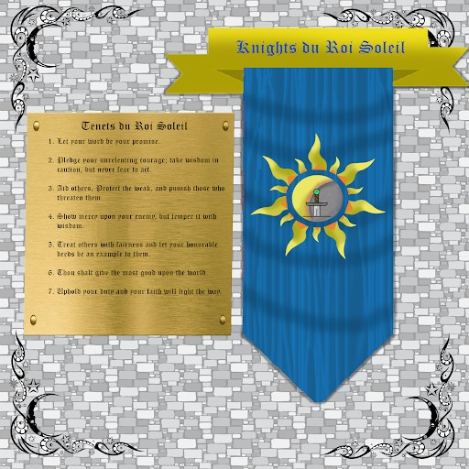

The Order of Kairo:
After the mission from Spain failed to produce a long term foot hold in Arcania, the Spanish crown simply denied that it ever happened. The loved ones of those who disappeared in the mysterious disappearance banded together to seek answers on their own. Kairo, a member of the British Museum has found a way to search for their families while still getting the government to pay for it.

The Origins of the Order of Kairo are shrouded in mystery. It is often believed to be the remnants of an intrepid group of adventurers who were among the first to try to colonize the island of Roanoke. Within the “Legend of Kairo” details are few and often seem incomplete at best, however it is regarded as the apocryphal account of the colonists that witnessed the death and supposed rebirth of one, Kairo the Kenku.

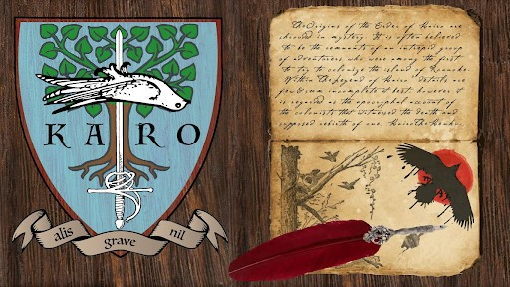

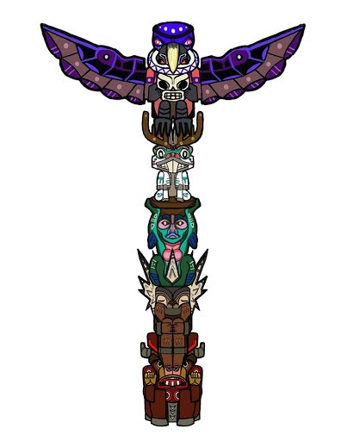
“Wardens”. The wardens are Columbia, Cascadia, Oro and Fontaine and are divided by physical location. Columbia is the Warden of the North East, and her District will one day become the capital of Arcania. Fontaine is the Warden of the South East and makes her home deep in the Floridian jungles.
Roanoke Island Lore
A
rcania, the New World is a vast and magical
place, long sealed off from the Old World by a magical barrier that sheltered it from the influence of divine magic. That Barrier fell during the course of the events of season 2.

Arcania is ruled by four powerful entities known as
Roanoke, being set in North Carolina in the 1630’s is at a midpoint between Fontaine, the warden of life and Columbia the warden of Justice. They are protectors and patrons of the Arcanian people.
The island itself is populated with 5 playable races:
The Urukocra
The End of Season 2 left the Uru as a largely untouched feature of the Island. This year they have been far more fleshed out, with their own city and strange politics. The Vulture men of the canopy are by far the most dominant force on the island, seeing their home in roostloft as the highest authority on the island.
The Jackalope
The End of Season 2 left the whereabouts of the Druid Lich Oleander unaccounted for. He and his Lychwood Treants are nowhere to be seen. The sly and obnoxiously cute vagabonds of the island, Jackalopes live in inaccessible warrens deep below the island.
The Chinnokin
The End of Season 2 left the Chinnokin in The Salmonfolk are two races that are in conflict this year. They may not be as passive as they have been in past seasons.
The Tatankan
The end of Season 2 left the fate of the Tatankan people in grave peril. This passive culture was turned to stone with but a single Tatankan left as guardian of the pen.
Physically, these are the most imposing people on the island. As herd animals and plainsmen, they are rarely seen alone.
The Halfwudgie
If the Uru were our Skeksis, then the halfwudgies would be our podlings. Our final race, and the only new race to this year’s campaign, the halfwudgies are medium sized humanoids covered in thick brown fur and long quills that can be used as natural weapons.

Week 3 Mayoral Race
B
eing the Mayor in the game is a special role.
Some of our best remembered players and now even one of our DM’s have been mayor of Roanoke. The political race lasts one week.
Players wishing to through their hat in the ring must be seconded by two of their friends this year. All players participating in the race will be
given an opportunity to participate in two town hall style
debates with both questions they present and questions taken from the audience. The subject will be “What will our town charter contain?”. The elected mayor may then adopt or amend their town charter before signing into law. Debates will be scheduled week 3’s wednesday and thursday with voting starting after the main event Thursday and remaining open until Friday after the voice event. All dates and times are scheduled around Pascific Standard Time. (PST is UST- 08:00) for our foriegn players.

