Edits:
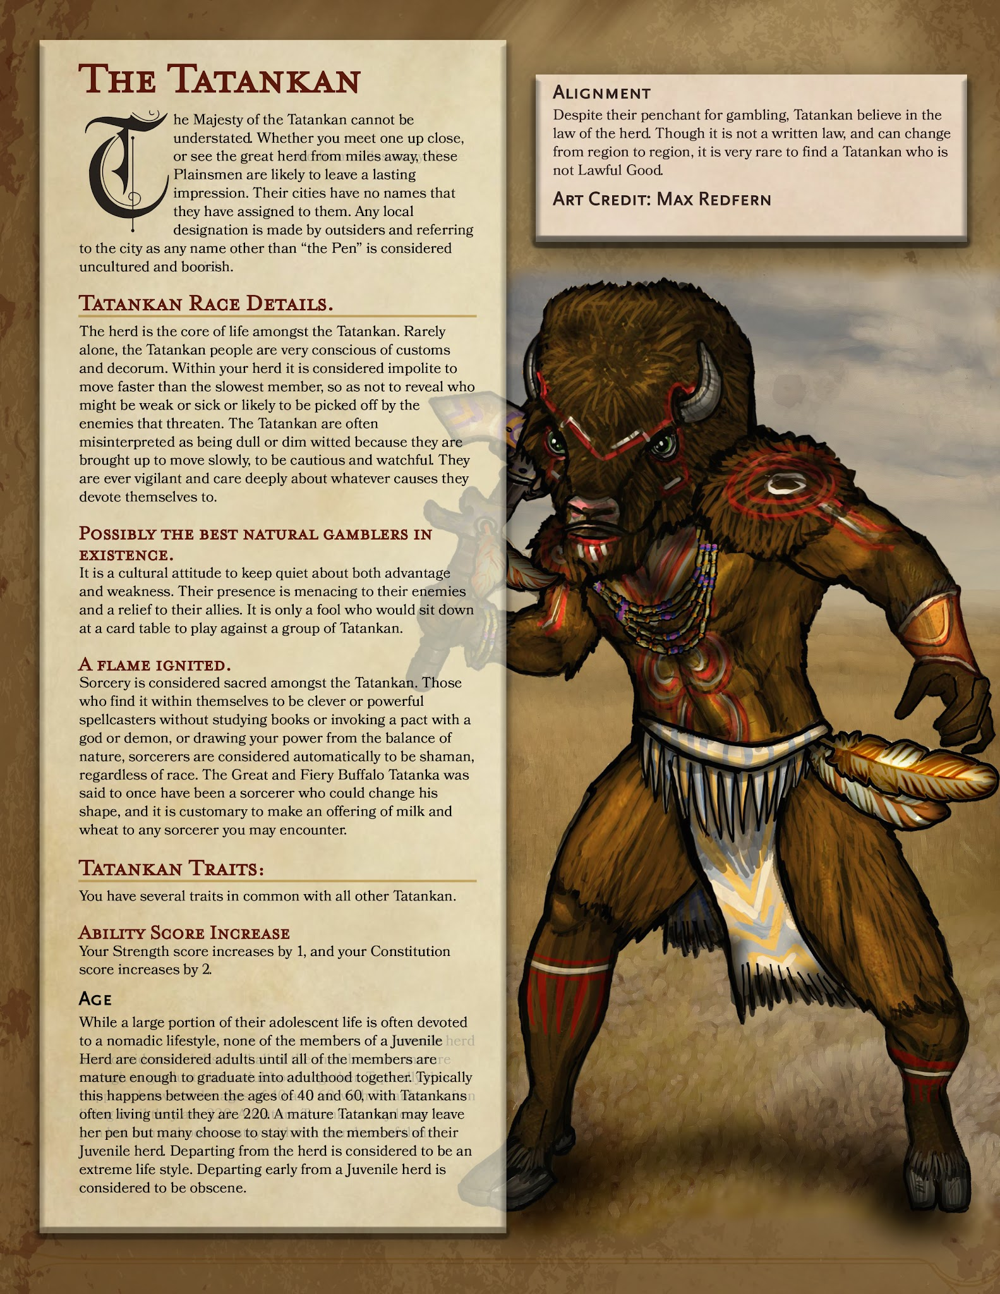

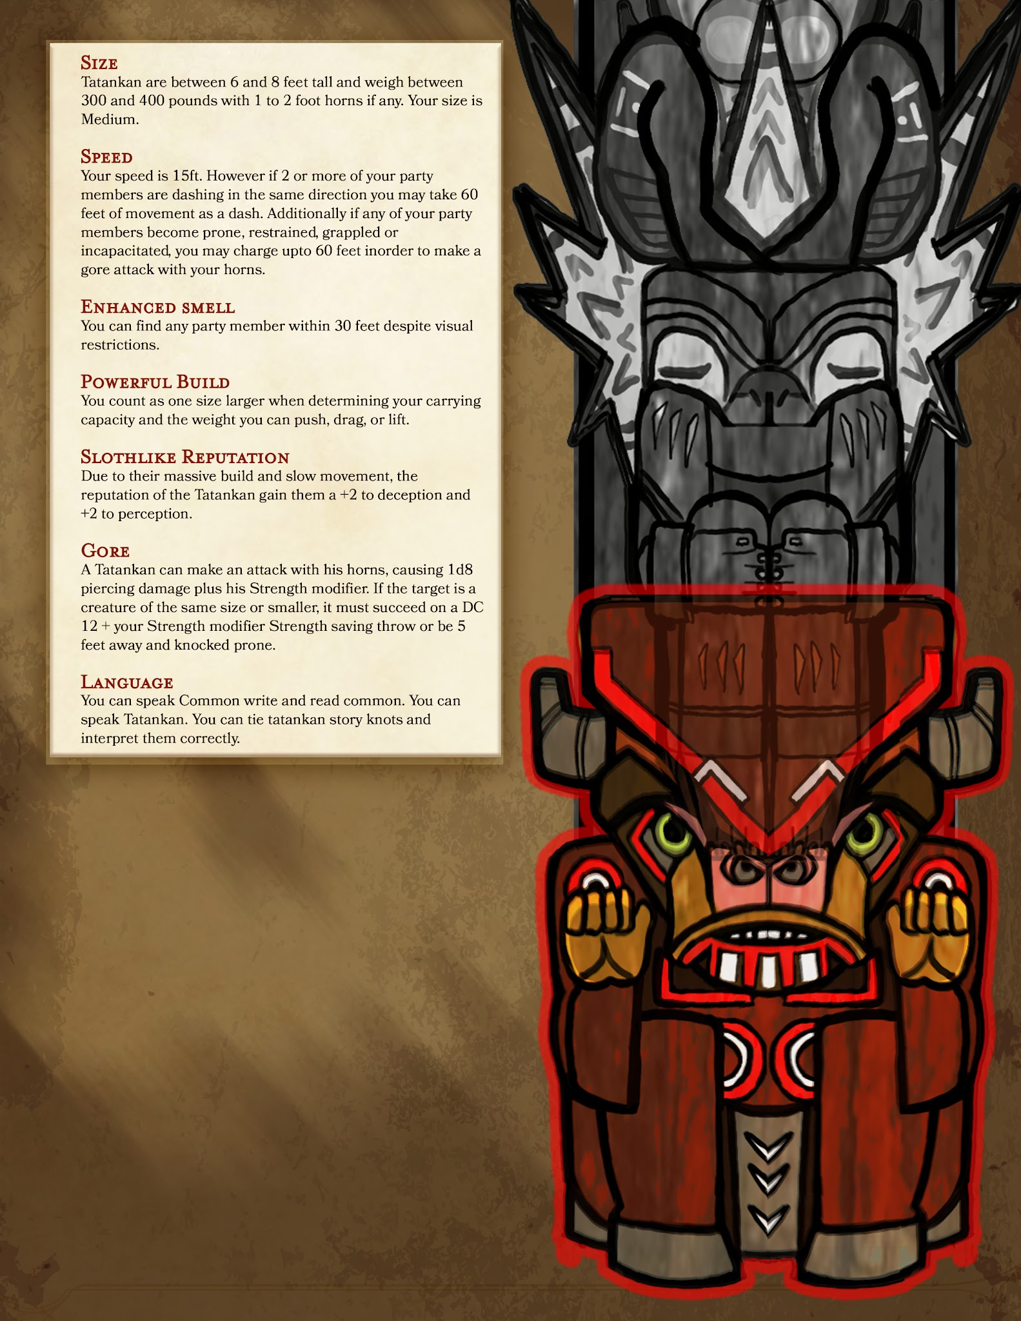

-----------------------------
TATANKAN

Change: Possibly the best natural Gamblers in existence into “The Buffalo who Buffalo at Buffalo in Buffalo.” Keep bluffing a part of the character while removing references to native analogs at indian casinos (not my intent, but it has been commented on).

Speed
Gore
- Specify that this occurs as the tatankan's reaction.
- Specify what attack roll the gore attack uses.
- Maximum distance 60 ft.

Slothlike Gentle Reputation
- Turn the flat +2 into a proficiency

Tatankin Verbatim:

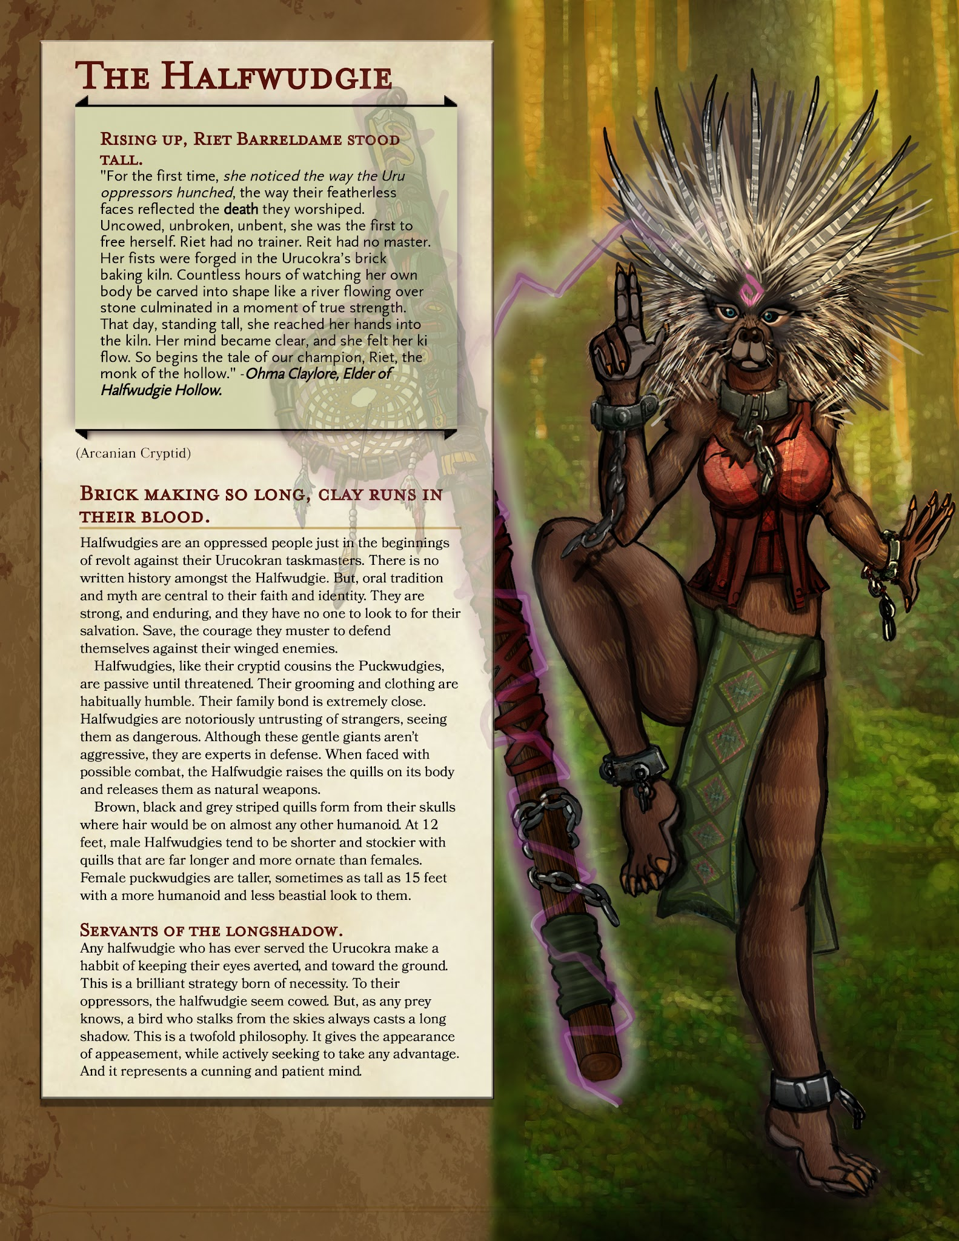
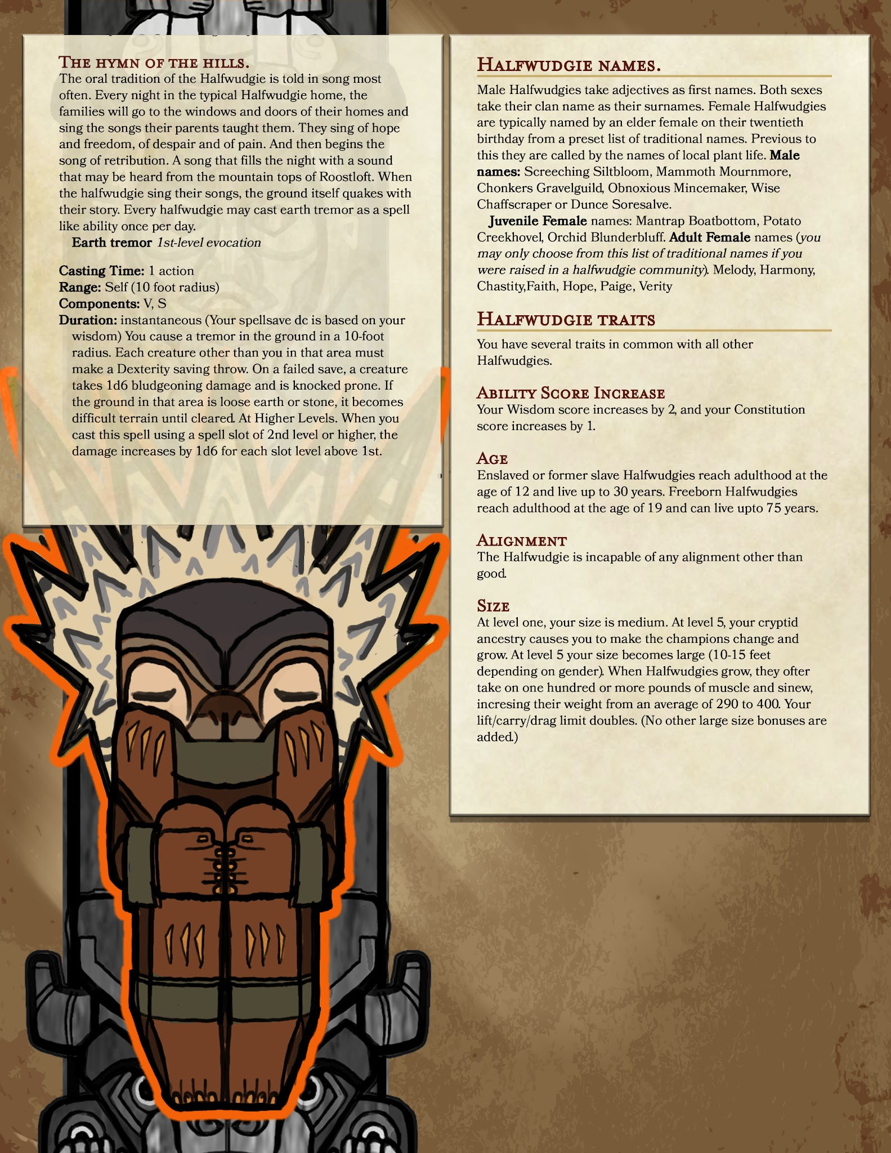

-----------------------------
HALFWUDGIE

- Grammar: in the juvenile names and an OR to the end of the list.

- Size: Reduce to medium, at level 3 gain powerful build

- Hymn of the Hills Kill the spell, convert to a performance proficiency

New feature:
- Courage: Once per turn, when you make an attack against an enemy that is within 5 feet of you, and no allies are within 5 feet of you or your target, you deal +1d6 damage.

Quills:
- At level 1
Quills:
- Your quills are particularly effective weapons. You can, as a bonus action, pull a long quill off your person and use it as a weapon. It counts as a javelin that only you are proficient in, and lasts until you take a long rest, at which time it is damaged and cannot be used anymore. At level 5, this quill counts as a magic weapon for the purposes of overcoming damage resistance. You may pull a quill out like this four times and you regain all uses after a long rest.

- At level 4:
Quill Barrage:
- You shake off your loose quills and shoot them at your enemies. When you do so each target in a 15 ft cone must make a Dexterity saving throw. The DC for this saving throw equals 8 + your Constitution modifier + your proficiency bonus. A creature takes 1d8 piercing damage on a failed save as well as suffering a -1 on all saving throws until the end of your next turn, and half as much damage on a successful one (and no penalty to their saving throws).The damage increases to 2d8 at 6th level, 3d8 at 11th level, and 4d8 at 16th level. After you use Quill Barrage, you can’t use it again until you complete a short or long rest.

Halfwudgie verbatim:

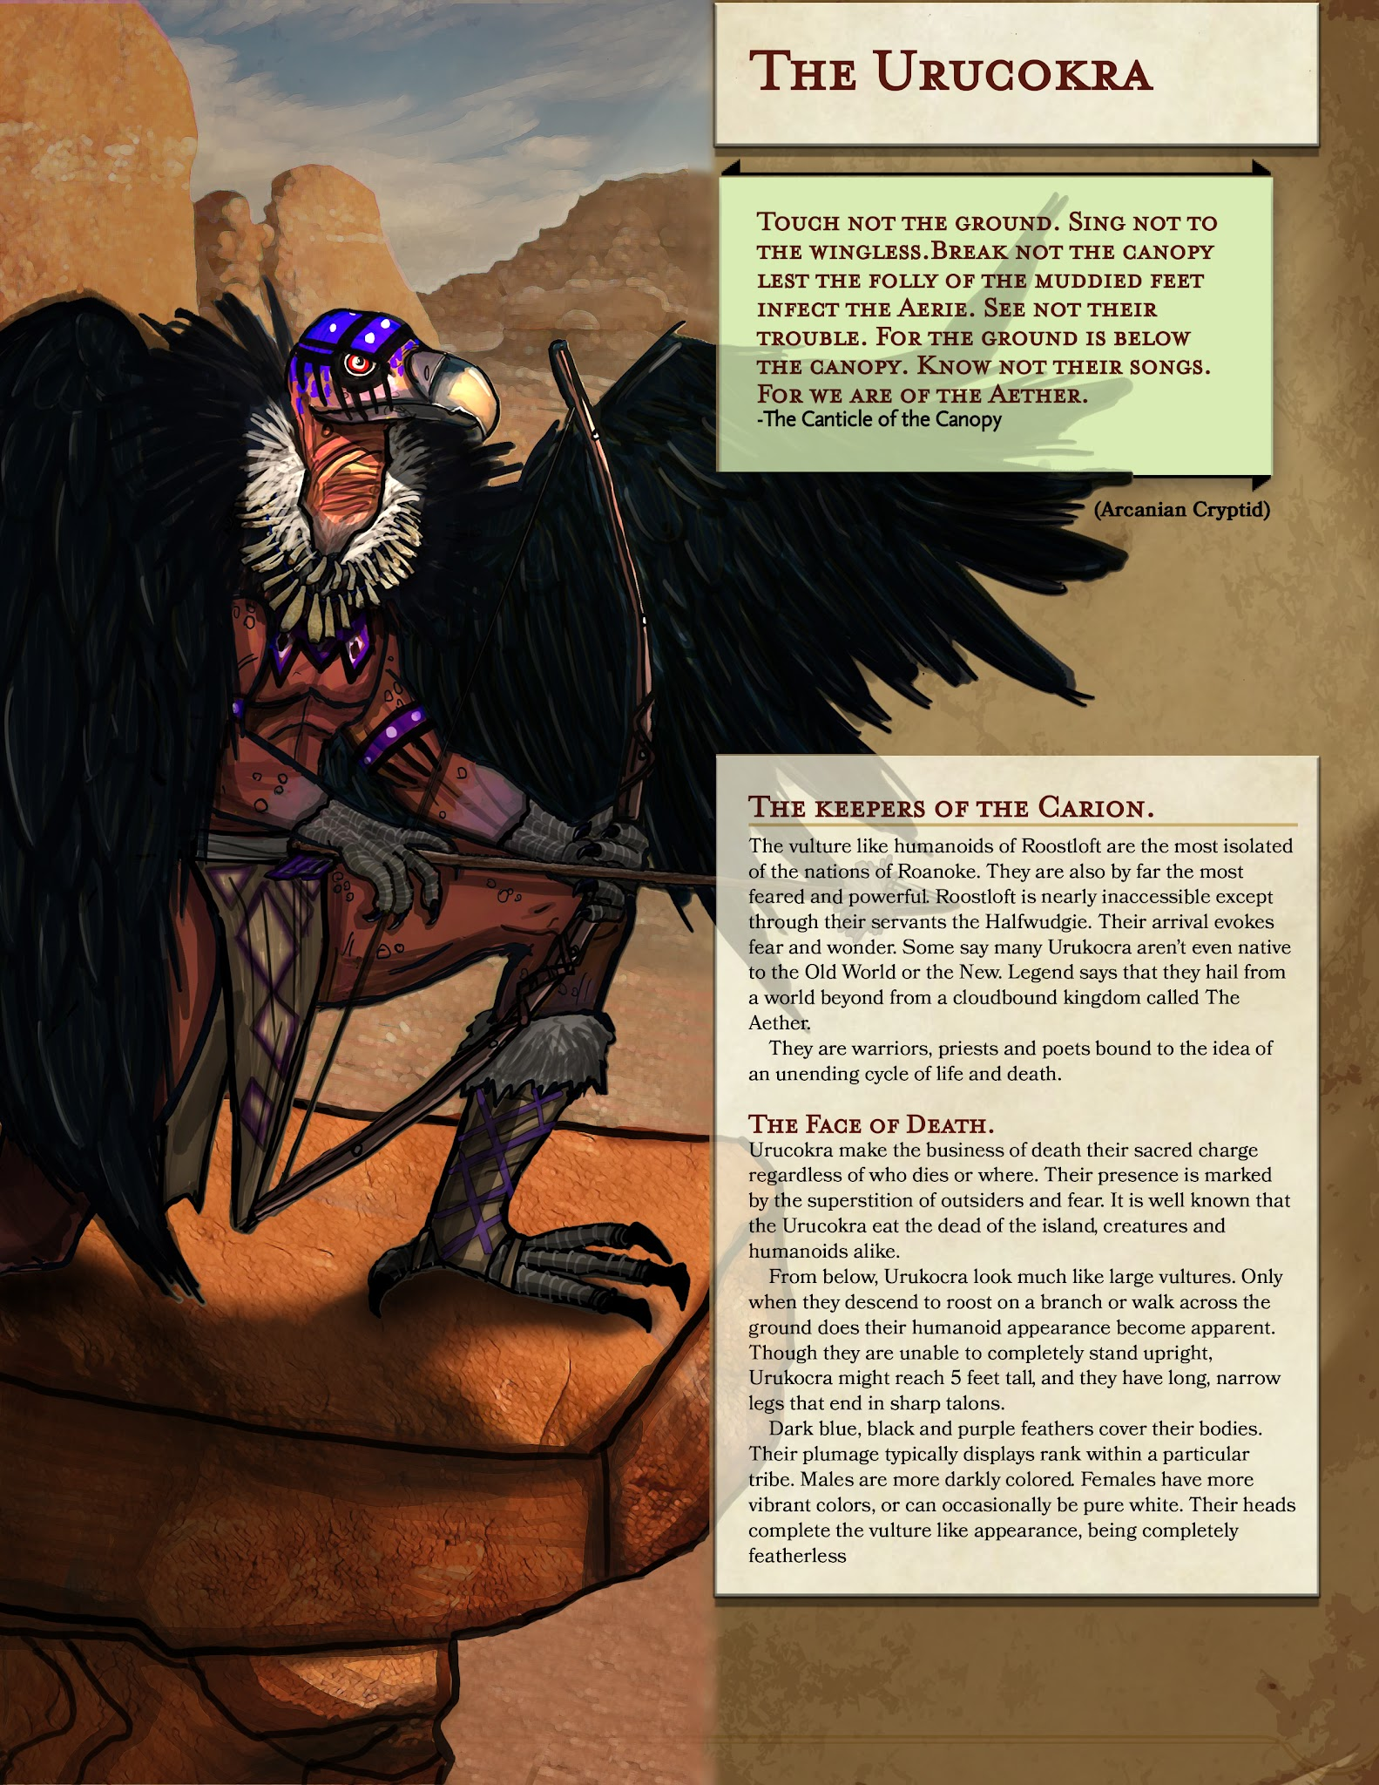

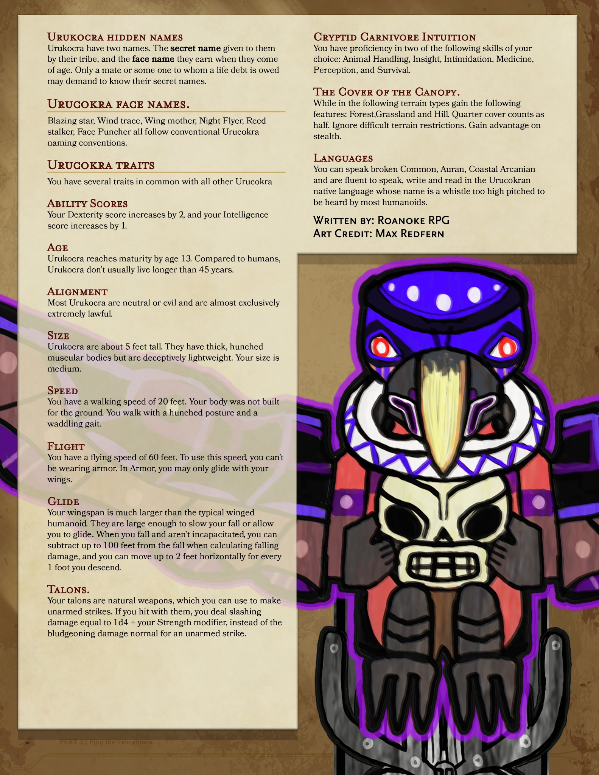

-----------------------------
URUCOKRA
- Grammar: In names: Capitalize the “S” in Stalker.
- Talons: Change damage type to slashing At level 6 this will be considered a magical attack.

- The Cover of the Canopy: Change to half cover, change to a choice of one of the terrains. Remove stealth advantage.
Flight:
- At Level 5 gain a flight speed:

Uru Verbatim

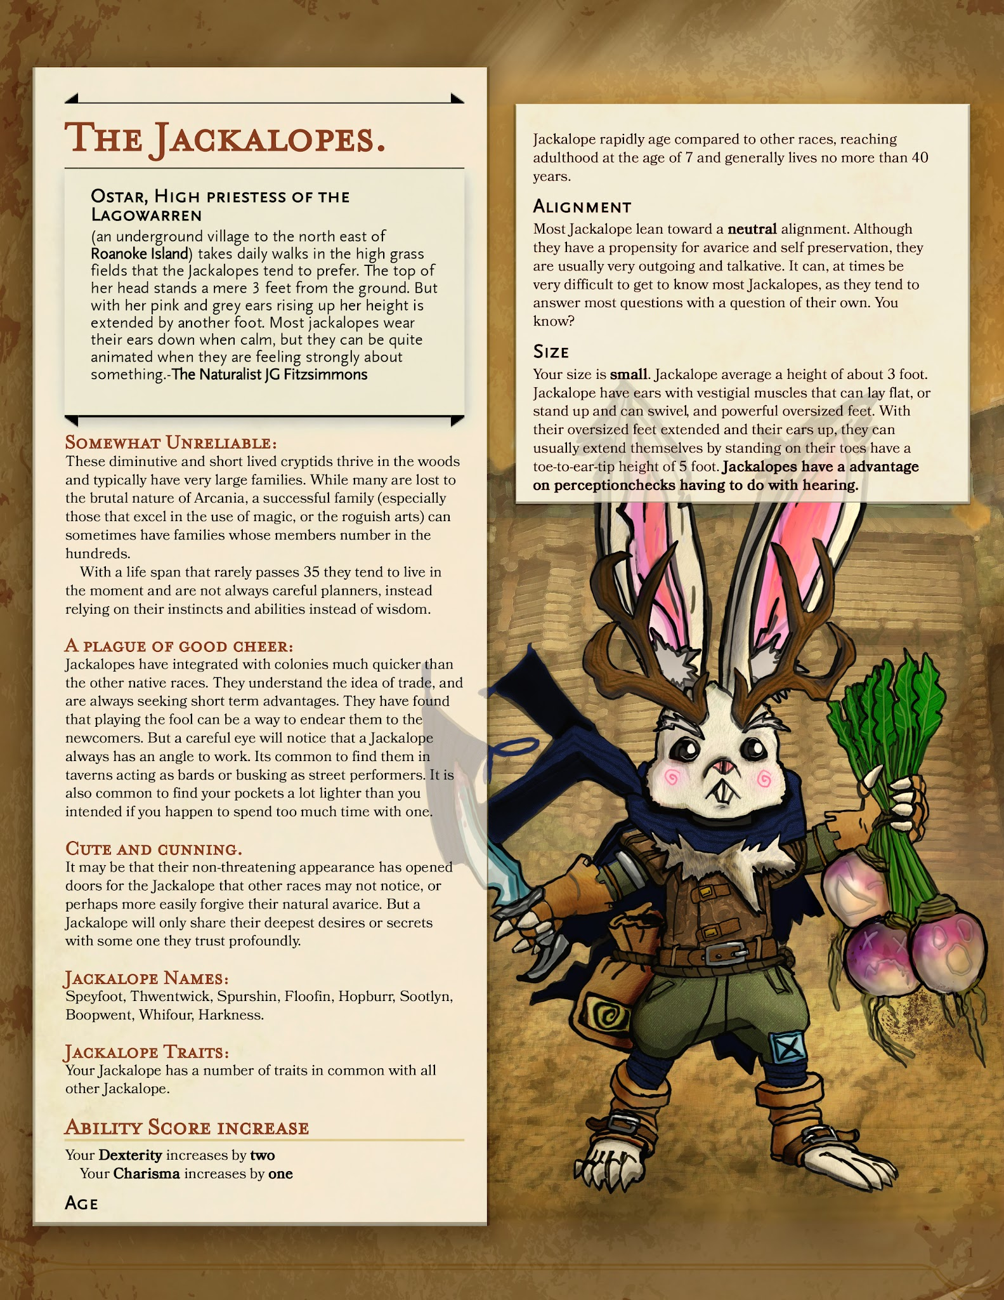

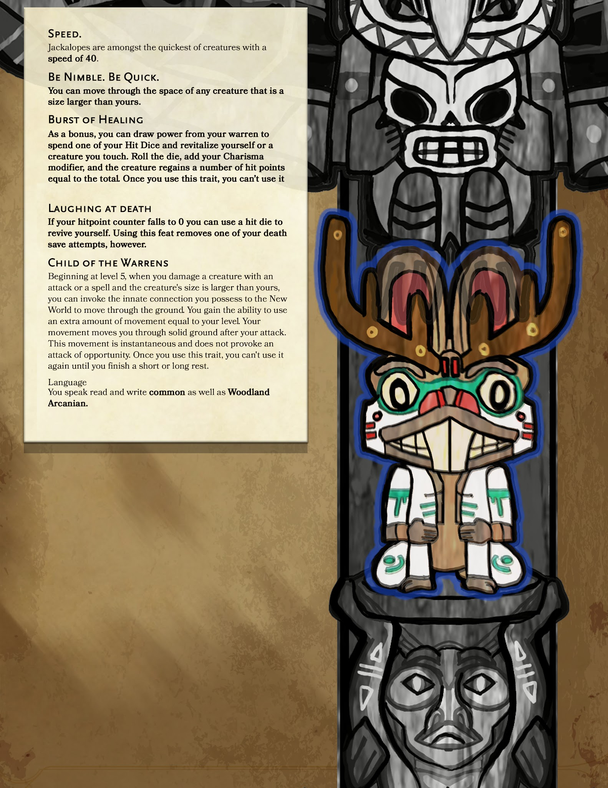

JACKALOPE
- Speed: Base movement speed of 30ft and your long jump is up to 20 feet and your high jump is up to 10 feet, with or without a running start.

New feature:
- Prairie Dweller: Living on the plains of Arcania has taught you to be ever diligent, you gain advantage on perception checks using hearing. You also gain a burrowing speed equal to half your movement speed.

Burst of Healing
- Change "bonus" to "bonus action" in the first line. You can’t use it again until after your next long rest. Remove the CHA bonus to healing for the Jackalopes.

Laughing at Death
When you make a death save, you may instead spend one of your remaining hit die to heal yourself back into the fight. However, this also permanently fails one death save per instance of your character being rendered unconscious until your next long rest.

Jacklope Verbatim

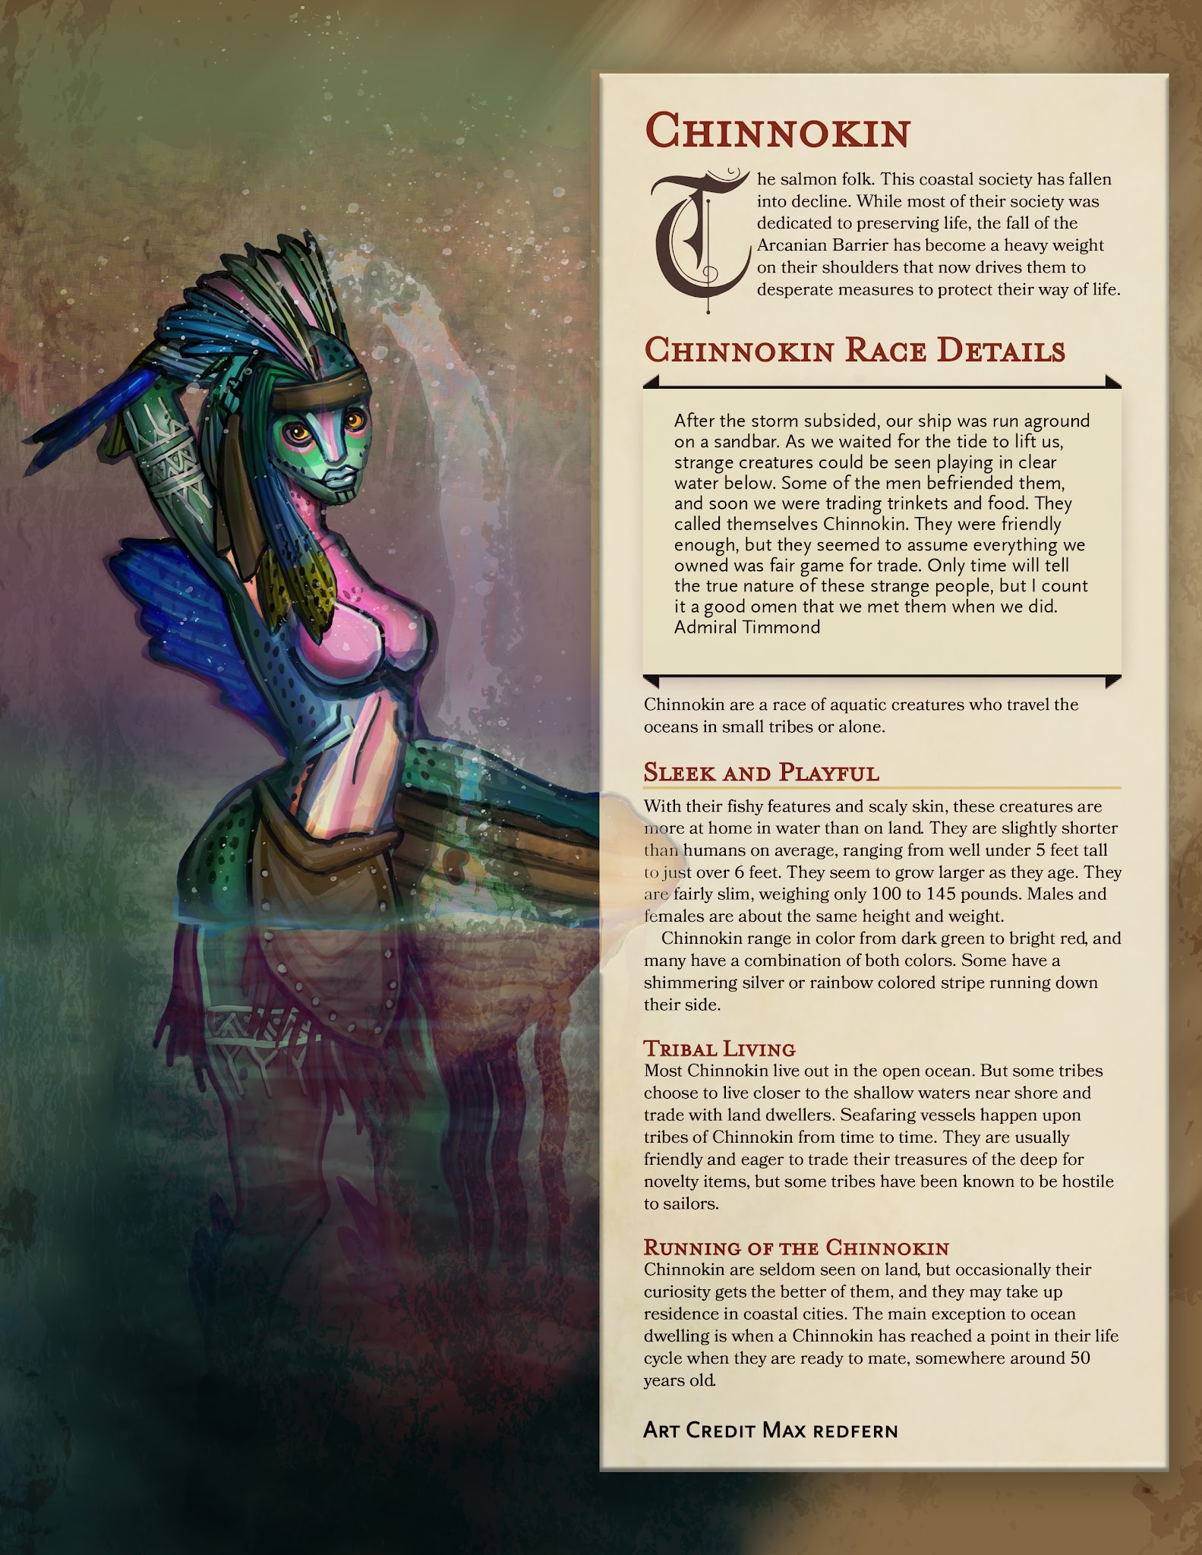

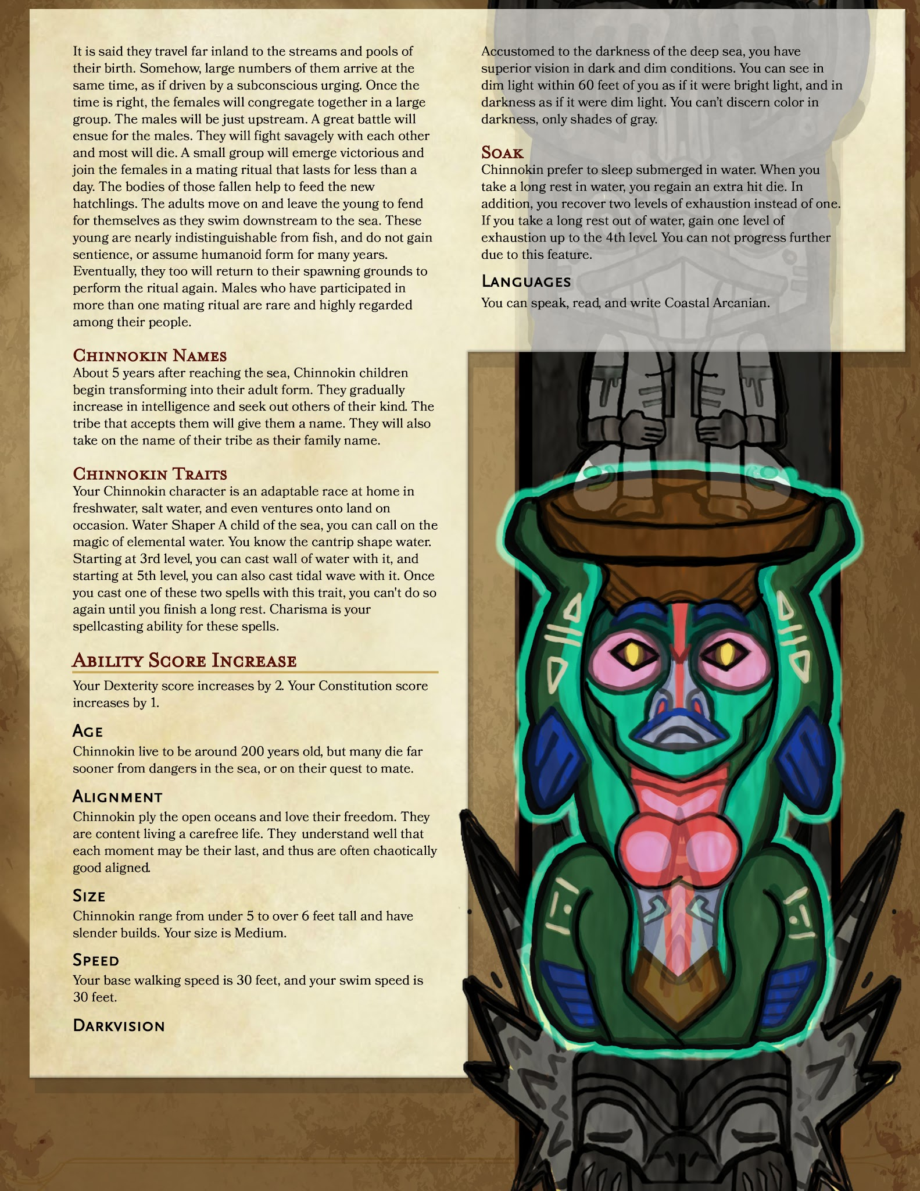

CHINNOKIN
- Add the ability to breathe underwater.

Chinnokin traits
Water Shaper
Move out of Chinnokin Traits. I almost missed it!

Add:
Dehydrate
- Level: Cantrip
Casting Time: 1 action
Range 60ft
Components, S, M (A few Grains of sand)
Duration, 1 minute (requires Concentration)
School: Necromancy
Attack/Save: CON save
Damage/Effect: Necrotic

You absorb the moisture within a target, causing them to take damage as they are quickly dried. The target must succeed a Constitution saving throw, or take 1d8 Necrotic damage immediately, and at the end of each of their turns. The spell ends as soon as the target succeeds on their saving throw.
This spell's damage increases by 1d8 when you reach 5th level (2d8), 11th level (3d8), and 17th level (4d8).

- Add Shape Water at first level, Create/Destroy Water 1/day, make casting mod CON.

New Feature:
Temperate Aquatic Habitat:
- As long as you have no levels of exhaustion, you have resistance to cold damage, and have advantage on any saving throw involving cold damage

Chinnokin Verbatim

