Software Requirements Specification

Version 1.0

16-01-2016

Stores and Purchase Management System

Submitted in partial fulfillment

Of the requirements of

CS 223 Software Engineering

This work is based upon the submissions of the course Software Engineering (CS223). The students who submitted this team projects were Parag Rahangdale , Anmol Singh, Indraneel Pise, Narender Kumar .

# Table of Contents

Table of Contents i

List of Figures ii

1.0. Introduction 1

1.1. Purpose 1

1.2. Scope of Project 1

1.3 Constraints 1

1.4 Assumptions and Dependencies 1

1.3. Glossary 1

1.4. References 1

1.5. Overview of Document 1

2.0. Overall Description 2

2.1 System Environment 2

2.2 Functional Requirements Specification 2

2.2.1 Use case 1 2

Use case: 2

2.3 User Characteristics 2

2.4 Non-Functional Requirements 2

3.0. Requirements Specification 3

3.1 Functional Requirements 3

3.1.1 << Name of the first feature>> 3

3.1.2 << Name of the second feature>> 3

3.3 Detailed Non-Functional Requirements 3

***3.4*** ***Logical Structure of the Data*** 3

4.0 Supporting information 3

4.1 Table of contents and index 3

4.2 Appendixes 3

# List of Figures

**No table of figures entries found.**

# 1.0. Introduction

## 1.1. Purpose

The purpose of this document is to present a detailed description of the Stores and Purchase Management System. It will explain the purpose and features of the system, the interfaces of the system, what the system will do, the constraints under which it must operate. This document is intended for both the stakeholders and the developers of the system.

## 1.2. Scope of Project

This software system will be designed for issuing resources for students and faculty from the institute inventory. The resources such as chairs, tables, printers, laboratory equipment’s etc. are currently issued manually. The aim of the project is to computerize these transactions. The resources to be issued should also be approved by the higher authority depending on the availability and the cost of the resource. This function will also be provided in the software. The inventory will be handled via a database which will be visible to all the users which will provide ease in issuing the resources. In case of unavailability of resources, an option to add them in the inventory will be provided post the approval of the concerned higher authority.

## 1.3 Constraints

## 1.4 Assumptions and Dependencies

* Simple design with only few important features available initially
* Multiple users (students)
* Users are already registered via the institute database
* Single Admin
* User hierarchy is predefined

Dependencies:-

* Inventory Data
* Student Data(Student’s department and mentor)

## 1.3. Glossary

|  |  |
| --- | --- |
| **Term** | **Definition** |
| Password | A sequence of alpha numeric symbols which will be used to confirm admin’s identity |
| Admin | The person who will monitor the store and purchase requirements and give approval for the same and also be responsible for management of database. |
| Database | Collection of all the information available monitored by this system |
| Resources | chairs, tables, cupboard |
| Student | Any student with valid UserID and password |
| Request | Any demand made for resources by students or people concerned involved |
| Mentor | Faculty mentoring Ph.D. and M.tech student |
| Faculty | Faculty members of IIT Jodhpur |
| UserID | Login name provided to all users |

## 1.4. References

IEEE. *IEEE Std 830-1998 IEEE Recommended Practice for Software Requirements Specifications.* IEEE Computer Society, 1998.

## 1.5. Overview of Document

The next chapter, the System environment section, of this document gives environment setting in which product can be used.

The third chapter, Requirements Specification section, of this document is written primarily for the developers and describes in technical terms the details of the functionality of the product.

## 2.1 System Environment

<< Keep blank for the time being >>

## 2.2 Functional Requirements Specification

. << Keep blank for the time being >>

### 2.2.1 Use case 1

#### 

#### Use case:

**Diagram:**

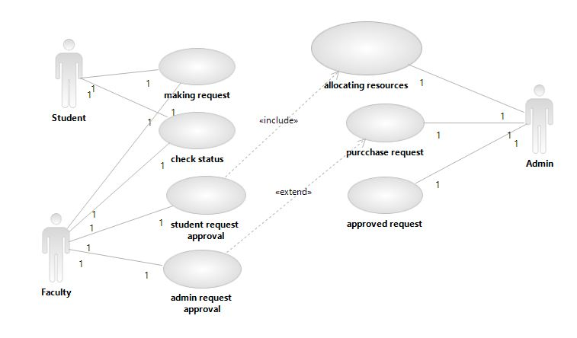

**Brief Description**

**Initial Step-By-Step Description**

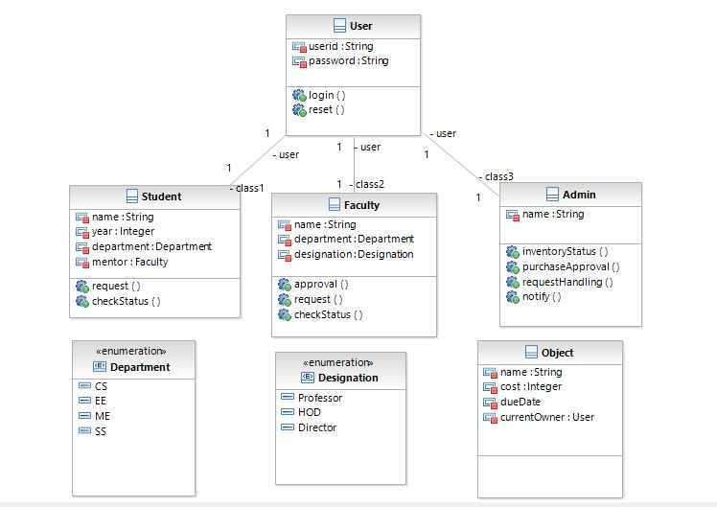

Sequence Diagram: Resource Request

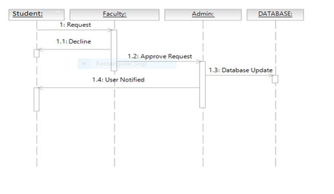

Sequence Diagram: Faculty request

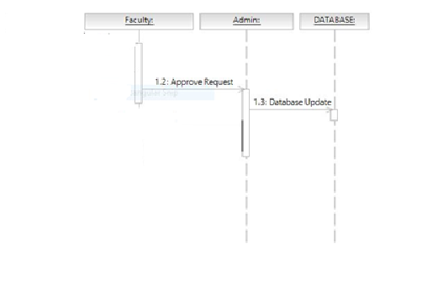

## 

Sequence Diagram: Purchase request

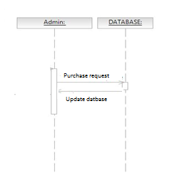

## 2.3 User Characteristics

The user of this software system needs to know how to use personal computer.

## 2.4 Non-Functional Requirements

# 3.0. Requirements Specification

## 3.1 Functional Requirements

For student

### 3.1.1 Making request

|  |  |
| --- | --- |
| **Use Case Name** | Making request |
| **Trigger** | Whenever student log into the software |
| **Precondition** | Software is connected to the internet/ login data is available |
| **Basic Path** | 1. Student opens the software 2. Student chooses to login using UserID and password under the category student. 3. If the password and UserID are correct student is taken to another window with option to make request. 4. Student select the request type and type remarks and submit the request. |
| **Alternative Paths** | If at step 2 student enter wrong password and roll no then student is taken to forgot password window which let student reset the password after verifying the students identity |
| **Postcondition** | Software is connected to the internet hence to the main database |
| **Exception Paths** | Student can close the software at anytime |
| **Other** | Request are stored in a database with loggers details |

### 3.1.2 Check Status

|  |  |
| --- | --- |
| **Use Case Name** | Check Status |
| **Trigger** | Whenever student log into the software |
| **Precondition** | Software is connected to the internet/ login data is available |
| **Basic Path** | 1. Student opens the software 2. Student chooses to login using UserID and password under the category student. 3. If the password and UserID are correct student is taken to another window with option to make request. 4. Student will get notification of completed request and item I added to his list. |
| **Alternative Paths** | If at step 2 student enter wrong password and roll no then student is taken to forgot password window which let student reset the password after verifying the students identity |
| **Postcondition** | Software is connected to the internet hence to the main database |
| **Exception Paths** | Student can close the software at anytime |
| **Other** | Request are stored in a database with loggers details |

### 

### For Faculty

### 3.1.3 Making request

|  |  |
| --- | --- |
| **Use Case Name** | Making request |
| **Trigger** | Whenever faculty log into the software |
| **Precondition** | Software is connected to the internet/ login data is available |
| **Basic Path** | 1. Faculty opens the software 2. Faculty chooses to login using UserID and password under the category student. 3. If the password and UserID are correct faculty is taken to another window with option to make request. 4. Faculty select the request type and type remarks and submit the request. |
| **Alternative Paths** | If at step 2 faculty enter wrong password and roll no then faculty is taken to forgot password window which let faculty reset the password after verifying the faculty identity |
| **Postcondition** | Software is connected to the internet hence to the main database |
| **Exception Paths** | Faculty can close the software at anytime |
| **Other** | Request are stored in a database with loggers details |

### 3.1.4 Student Request Approval

|  |  |
| --- | --- |
| **Use Case Name** | Request Approval |
| **Trigger** | Faculty log into the software |
| **Precondition** | Software is connected to internet/ login data is available |
| **Basic Path** | 1. Faculty opens the software 2. Faculty chooses to login using user ID and password under the category faculty. 3. If the password and user ID are correct Faculty is taken to another window with options. 4. Faculty is taken to a window with cells for ‘Pending request by student’, ’Pending request for purchase’, ‘Make request’, ‘Check Status’. 5. Faculty can choose to click on the pending request by student to get details of request made by student and chose to approve or disapprove the request. |
| **Alternative Paths** | If at step 2 faculty enter wrong password and user id then admin is taken to forgot password window which let admin reset the password after verifying the identity |
| **Postcondition** | Software is connected to the internet hence to the main database |
| **Exception Paths** | Faculty can close the software at anytime |
| **Other** | Request which are reviewed are marked,The request to be processed and to be discarded are categorized accordingly |

For Admin

### 3.1.5 Admin Request Approval

|  |  |
| --- | --- |
| **Use Case Name** | Request Approval |
| **Trigger** | Faculty log into the software |
| **Precondition** | Software is connected to internet/ login data is available |
| **Basic Path** | 1. Admin opens the software 2. Admin chooses to login using user ID and password under the category admin. 3. If the password and user ID are correct Admin is taken to another window with options. 4. Admin is taken to a window with cells for ‘Pending request by student and faculty’. 5. Admin can choose to click on the pending request for purchase to get details of request made for purchase and chose to approve or disapprove the request. |
| **Alternative Paths** | If at step 2 faculty enter wrong password and user id then admin is taken to forgot password window which let admin reset the password after verifying the identity |
| **Postcondition** | Software is connected to the internet hence to the main database |
| **Exception Paths** | Faculty can close the software at anytime |
| **Other** | Request which are reviewed are marked, The request to be processed and to be discarded are categorized accordingly |

### 3.1.6 Purchase request

|  |  |
| --- | --- |
| **Use Case Name** | Purchase request |
| **Trigger** | Admin log into the software |
| **Precondition** | Software is connected to internet/ login data is available |
| **Basic Path** | 1. Admin opens the software 2. Admin chooses to login using user ID and password under the category admin. 3. If the password and user ID are correct Admin is taken to another window with options. 4. Admin is taken to a window with cells for ‘Approved Request’ 5. Admin can choose to click on the ‘approved purchase requests’ to see purchase request and can then make according purchase request. |
| **Alternative Paths** |  |
| **Postcondition** | Software is connected to the internet hence to the main database |
| **Exception Paths** | Faculty can close the software at anytime |
| **Other** |  |

## 3.3 Detailed Non-Functional Requirements

### ***3.4 Logical Structure of the Data***

<< Keep this blank for the time being>>

# 4.0 Supporting information

## 4.1 Table of contents and index

## 4.2 Appendixes