IBM Cloud Pak for Automation

Lab instructions for

Business Automation Insights

Shutdown and restore of the lab environment

Authors: Radek Šulc

Version: 2.0.2

Table of Content

0 Introduction 3

0.1 Prerequisites 3

1 Shutting down the environment 4

1.1 Step by Step Instructions 4

# Introduction

This document describes:

* How to start a lab environment for the BAI workshop.
* How to restore BAI with HDFS to the original state.

## Prerequisites

* You need a link with a password for an environment running on Skytap.
* Or you can use your own deployment of the image based on your preference.

# Shutting down the environment

## Step by Step Instructions

The environment is a Windows Server-based virtual machine (VM) with BAW and ODM which contains also an embedded RHEL VM with BAI and HDFS.  
  
To shut the whole environment down properly you need to stop BAW, ODM and BAI with HDFS. Let’s assume all these components are up and running.

1. Open RUNTIMES folder on Windows Desktop.  
   
2. Double click “BAW Server Stop,cmd” and “ODM Server Stop.cmd”. Command windows will appear. Let them run.  
   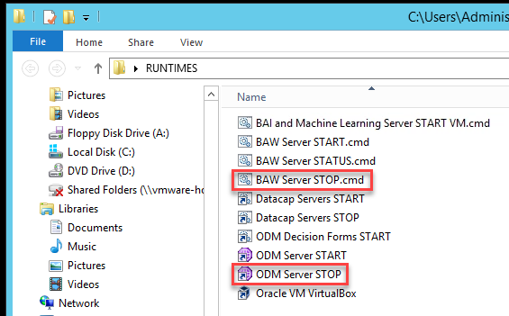
3. You are not going to work in this window. You can minimize it. We will access the VM using PuTTY SSH client.  
     
   **IMPORTANT – If you click on this window it will take over the focus and your mouse cursor disappears. To leave the window you can simply press Right Ctrl.**
4. Now you need to login to the RHEL image and stop BAI with HDFS. You do not need to wait for BAW and ODM to stop. Let’s connect to the VM using PuTTY SSH client. Click the PuTTY icon in the Windows taskbar.  
   
5. Double click the “mini” session in PuTTY window.  
   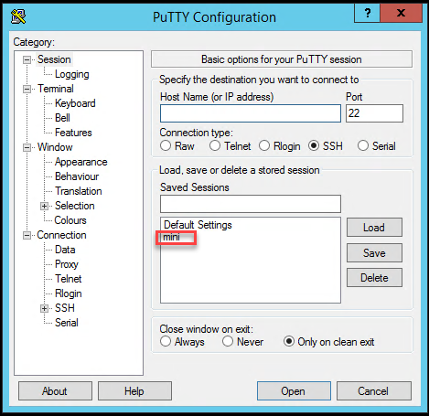
6. Type command “stop-bai-ml” and hit Enter to stop BAI and HDFS.  
   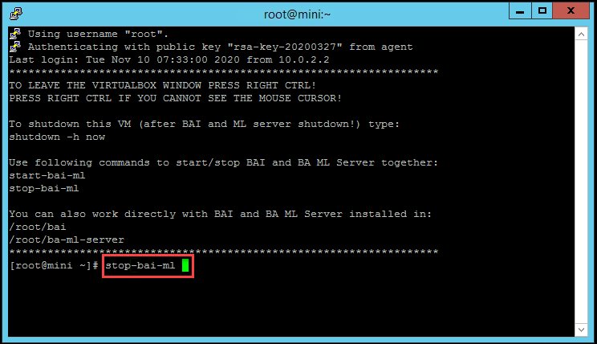
7. Wait until the script finishes completely (the red error in the screenshot below can be ignored) and type “shutdown -h now” to shutdown the VM.  
   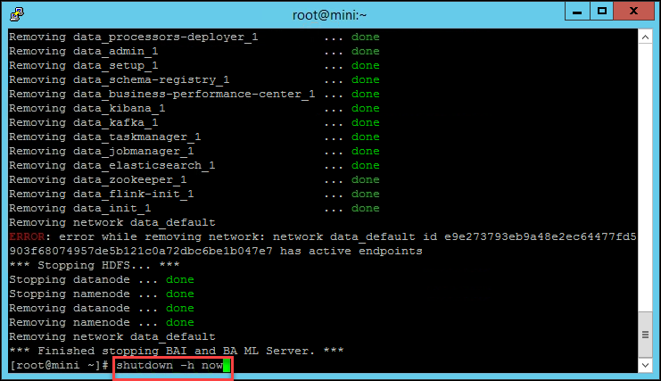
8. A dialog will appear which is fine. You can close it.  
   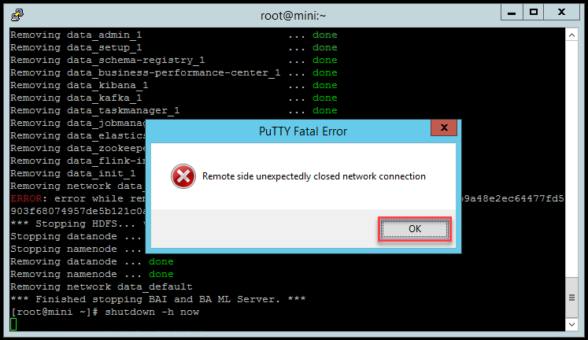
9. Once you see the RHEL VirtualBox window disappear, you can shutdown the main Windows VM.

# Restoring BAI with HDFS to its original state

## Step by Step Instructions

BAI with HDFS is running on embedded VM with RHEL. You can simply restore the latest snapshot of the VM in VirtualBox. You can also create new snapshots if you want to save your progress.

1. Make sure BAW, ODM, BAI with HDFS and the whole BAI VM are be stopped. Follow instruction above, just do not shutdown the whole Windows VM.
2. Open **RUNTIMES** folder on Windows desktop.  
   
3. Double click **Oracle Virtual Box**.  
   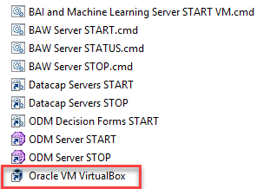
4. Right click the snapshot you want to restore (typically the latest one), select **Restore** and confirm.  
   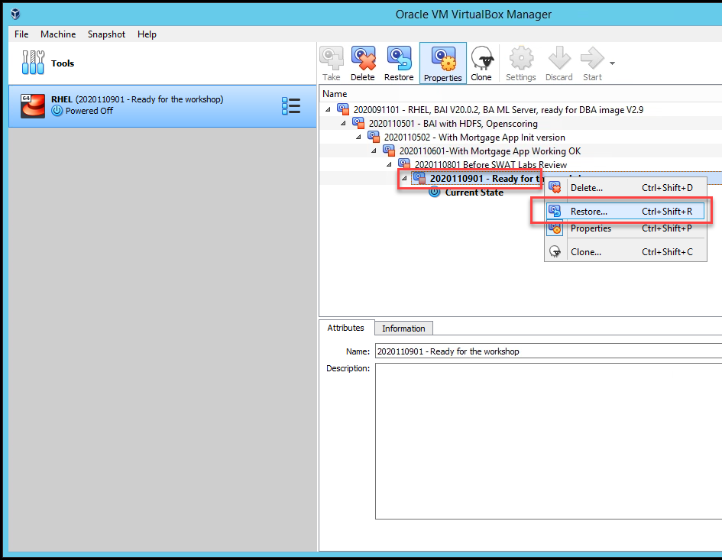
5. Now you can start BAI, BAW and ODM again.