IBM Cloud Pak for Automation

Lab instructions for

Business Automation Insights

Startup of the lab environment

Authors: Radek Šulc

Version: 2.0.2

Table of Content

0 Introduction 3

0.1 Prerequisites 3

1 Exercise: Getting Started 4

1.1 Getting Started – Step by Step Instructions 4

# Introduction

This document describes how to start a lab environment for the BAI workshop.

## Prerequisites

* You need a link with a password for an environment running on Skytap.
* Or you can use your own deployment of the image based on your preference.

# Exercise: Getting Started

## Getting Started – Step by Step Instructions

1. The environment is a Windows Server-based virtual machine (VM) with BAW and ODM which contains also an embedded RHEL VM with BAI and HDFS.
2. Start the VM using the play button  
   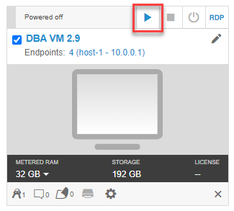
3. Wait until the Windows desktop appears.
4. Now you need to start all the components – BAI with HDFS, BAW and ODM.
5. Open RUNTIMES folder on Desktop.  
   
6. Double click the “BAI and Machine Learning Server START VM,cmd”  
   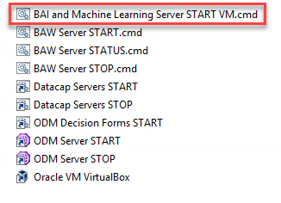
7. Wait until RHEL window with login appears.  
   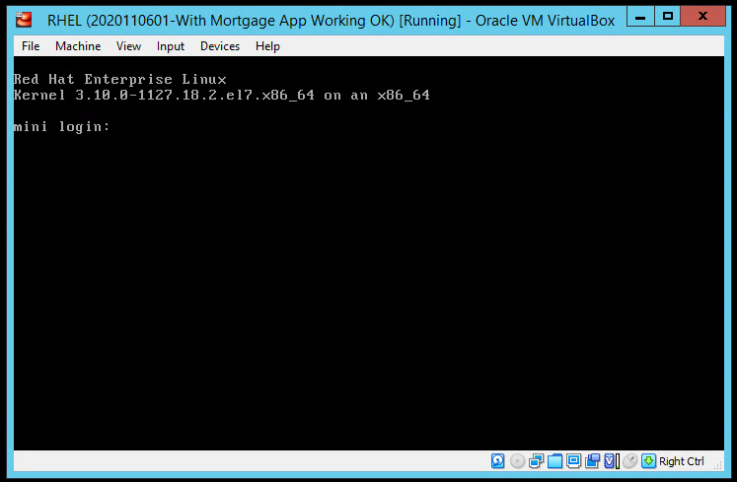
8. You are not going to work in this window. You can minimize it. We will access the VM using PuTTY SSH client.  
     
   **IMPORTANT – If you click on this window it will take over the focus and your mouse cursor disappears. To leave the window you can simply press Right Ctrl.**
9. Now you need to login to the RHEL image and start BAI with HDFS. Let’s connect to the VM using PuTTY SSH client. Click the PuTTY icon in the Windows taskbar.  
   
10. Double click the “mini” session in PuTTY window.  
    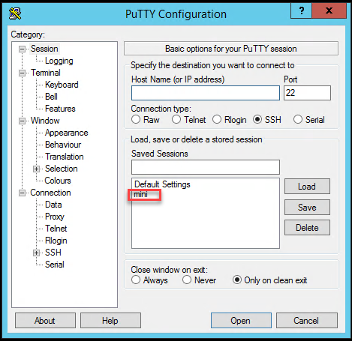
11. Type command “start-bai-ml” and hit Enter to start BAI and HDFS.  
    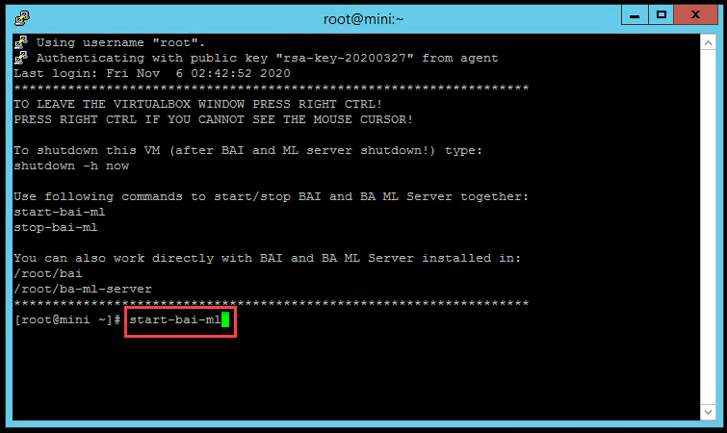
12. You can now start BAW and ODM while BAI with HDFS is starting.
13. Go back to the “RUNTIMES” folder on the desktop and double click both shortcuts “BAW Server Start” and “ODM Server Start”.  
    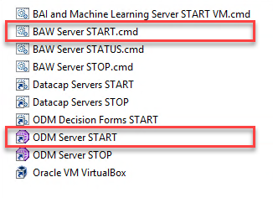
14. Starting all the components takes couple of minutes. Open Chrome web browser from the Windows taskbar.  
    
15. You can check that BAI is running by opening Kibana user interface in Chrome. In the Chrome’s bookmarks bar open “BAI > Kibana”  
    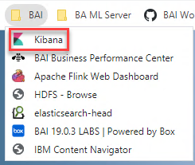
16. You can see Kibana login screen once it starts up.  
    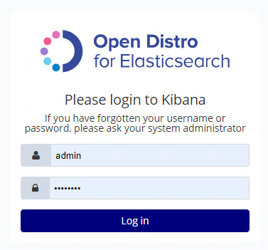  
    Now you can login with pre-filled credentials – admin / passw0rd.
17. BAW and ODM may still be staring in the background. You are now ready to start with the labs.