FACILITY OPERATIONS MANUAL
Cambrex – Durham Site

TABLE OF CONTENTS
A. Air Handlers (AHU)
B. Building Automation System (Desigo)
C. Chilled Water System
D. Exhaust Fans
E. Generator
F. Hot Water System / Heating

A. AIR HANDLERS (AHU)
The facility utilizes multiple air handling units (AHUs) to provide ventilation, temperature control, and airflow management. These systems are controlled via Desigo and adjust based on outside air temperature.
AHU-01: Mechanical Room 805 – Return fan setpoint based on outside temperature
AHU-02: Mechanical Room 805 – Return fan setpoint based on outside temperature
AHU-04: Mechanical Room 804 – Return fan setpoint based on outside temperature
AHU-05: Mechanical Room 804 – No return fan temperature-based control
AHU-06: Mechanical Room 182 – No return fan temperature-based control
Refer to attached AHU layout PDF for zoning and system coverage.
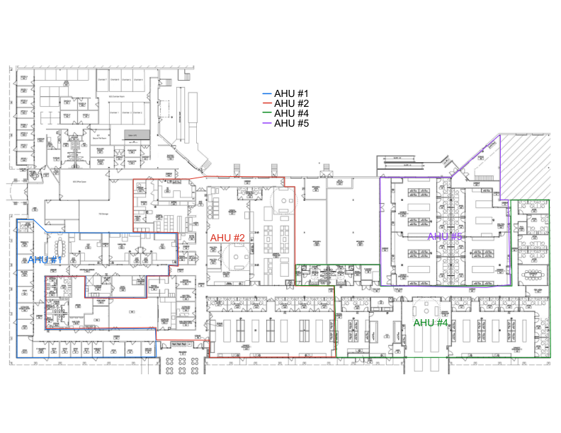
AHU System Layout:

B. BUILDING AUTOMATION SYSTEM (DESIGO)
Desigo is the building automation system for the facility.
It controls:
- Air handlers
- Chillers
- Boilers
- Exhaust fans
- Unit heaters
- Temperature control
- CAV/VAV systems
- Fume hoods (except Lab 400)
- Utility pumps
Operators can override setpoints, control equipment, and trend data for analysis.

C. CHILLED WATER SYSTEM
The facility operates two chillers:
- Trane Chiller (300 tons) – Primary
- York Chiller (400 tons) – Secondary
If the Trane chiller exceeds 95% capacity for more than 20 minutes, the York chiller is enabled.
Primary pumps circulate water through chillers.
Secondary pumps distribute chilled water to AHUs.
Secondary pumps are controlled via differential pressure transmitters to maintain system pressure.

D. EXHAUST FANS
Lab exhaust is controlled via duct static pressure using Desigo.
Pressure is regulated by actuating dampers on the roof. As pressure increases, dampers open to relieve pressure.
Fan Assignments:
- Fans 30 & 31: Biology labs and fume hoods
- Fans 25 & 26: Labs 415, 420, and sink in Lab 414
- Fans 27 & 28: Labs 450 and 460
- Fans 21 & 22: Labs 430 and 440
- Fans 10 & 11: Lab 400 and 505

E. GENERATOR
Cummins 500 kW generator with a 1200-gallon fuel tank.
Supports:
- Stability chambers
- UPS systems
- BAS
- Exhaust fans
- Lighting
Does NOT support:
- Boilers
- Chillers
- Air handlers

F. HOT WATER SYSTEM / HEATING
The site includes four gas boilers supplying hot water.
HWP-01 and HWP-02 circulate water to AHUs and VAV/CAV boxes for reheat.
Pumps are controlled by differential pressure transmitters to maintain loop pressure.
Three boilers in Mechanical Room 804 serve as lead units.
Boiler #04 is the lag boiler and is enabled when supply temperature drops.

G. UPS (UNINTERRUPTIBLE POWER SUPPLY)
The facility is equipped with a 200 kW UPS system that provides uninterruptible power to critical assets connected to UPS circuits.
In the event of a power outage:
- The UPS system immediately activates to maintain power to critical systems.
- Once the generator starts and stabilizes, the UPS transfers to generator power and begins recharging.
- The UPS currently provides approximately 40 minutes of runtime in the event the generator does not start.
This system ensures continuity of operations for critical equipment during power interruptions.

H. ACCESS CONTROL SYSTEM (ONGUARD)
The facility utilizes the OnGuard system for access control.
Capabilities include:
- Granting and removing badge access
- Printing and issuing badges
- Controlling door access
- Overriding doors to lock or unlock as needed
This system is used to manage personnel access and maintain site security.

I. CAV / VAV SYSTEM
The facility utilizes CAV (Constant Air Volume) and VAV (Variable Air Volume) boxes to control airflow and temperature within each zone.
Each zone is equipped with a thermostat that corresponds to a specific CAV/VAV box.
The system operates as follows:
- The thermostat monitors the temperature within the space.
- The CAV/VAV box adjusts airflow to maintain the desired temperature setpoint.
- In VAV systems, airflow is modulated based on demand.
- In CAV systems, airflow remains constant while temperature is controlled through reheat.
This allows precise environmental control across different areas of the building.

J. FUME HOODS
Fume hoods are controlled through the Desigo building automation system based on face velocity setpoints.
Key functions:
- Face velocity is maintained at a defined setpoint to ensure proper containment.
- The airflow setpoint can be adjusted within Desigo as needed.
- Each fume hood operates using a damper located above the unit, which modulates airflow.
This system ensures safe operation and proper exhaust of hazardous fumes within laboratory environments.

