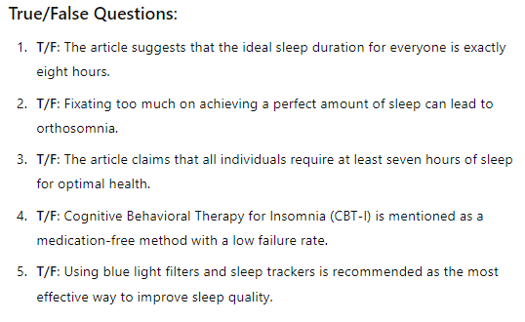

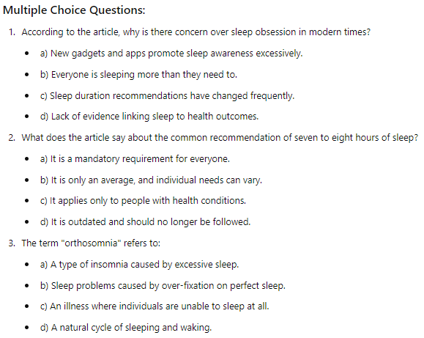

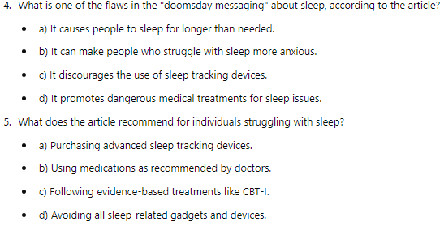

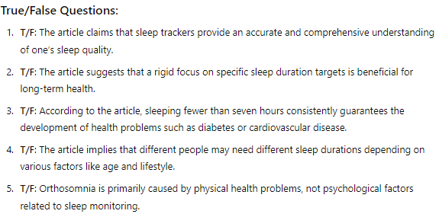

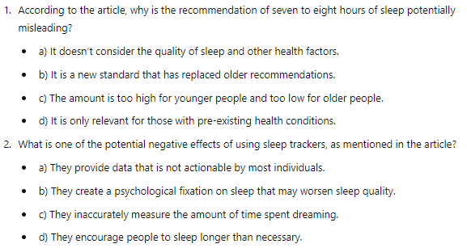

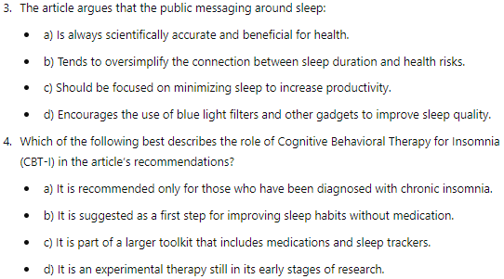

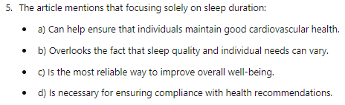

Sleep is so important. We need it to live. And when we can't sleep, we're desperate for help. But lately, our fascination with sleep feels as if it's taken on an urgency. Do a quick internet search for sleep and you'll find a slew of articles about how to make your sleep perfect. New gadgets, fancy alarm clocks, stay away from blue light. There are lots of services, products and advice columns that tell us we're sleeping wrong. Not enough, not quality sleep, wrong position. Even worse, you might find scary messaging claiming that if you're not sleeping right your life is going to be shorter; you're going to get all kinds of diseases. One of the biggest worries we have about our sleep is that we're not getting enough and that anything less than seven hours a night means that we’re doomed to bad health, everything from high blood pressure to Alzheimer’s disease. But there are two flaws with this kind of messaging. The first flaw is that it's not completely accurate. Seven to eight hours of sleep, while recommended for adults, is just an average. And while messages have to be simplified for health communication to the public, sometimes important nuances get lost. So yes, it's true that not getting enough sleep in the long term is associated with health problems like cardiovascular disease, diabetes and depression. But fixating solely on seven to eight hours ignores the fact that there's a range of sleep that people need. The duration of a good night's sleep can be different for different people. Some adults need eight, but some are just fine on six. The second flaw with this kind of doomsday messaging is that it can be counterproductive, especially for people who do have trouble sleeping. For instance, in 2019, it was estimated that 21 percent of adults in the US were wearing sleep tracking devices. And that number is probably growing. And I get it. It's fascinating to see how much sleep you've gotten each night and to know what part of your night was spent in deep sleep or dreaming. But having all of that sleep data is causing some people to become obsessed with it, so much so that it’s leading to a condition some call orthosomnia: a preoccupation with the constant need to achieve perfect sleep. And this condition, ironically, is causing more sleep problems. Now orthosomnia might be an extreme example, but the anxiety of not getting enough sleep is keeping some of us up at night. So here's what some experts are saying. Stop fixating on the number because that can lead to unrealistic expectations of sleep. According to Dr. Colleen Carney, a psychologist and the head of the Ryerson University Sleep Lab, the basic questions you should ask yourself are: Do I feel reasonably well-rested during the day? Do I generally sleep through the night without disturbances? Or, if I wake, do I fall back asleep easily? Can I stay awake through the day without involuntarily falling asleep? If your answers are yes to all three, you probably don't need to worry about your sleep.

And if you're struggling with your sleep, instead of buying expensive blue light filters or fancy sleep trackers, try talking with your doctor to make sure there aren't any medical conditions that need to be explored first. Then try evidence-based recommendations laid out by the American Academy of Sleep Medicine. What's really cool is that there's a highly effective therapy called cognitive behavioral therapy for insomnia, or CBT-I. It doesn’t have any medications involved. And it has a really low failure rate.

ANS

