COEN 275

**OO Analysis, Design and Programming Winter2014**

Instructor: Dr. Rani Mikkilineni

Santa Clara University

*Eco Recycle System*

**Deliverable 2**

By:

Pragati Shrivastava

Rachana Deolikar

**1. Functionalities completed in the Project**

* 1. **Multithreading:**
  2. **MVC**
  3. **Visualization**
  4. **Implementation of RMOS and RCM**
  5. **RMOS panels with different functionalities in detail**

**2. Diagrams**

**2.1 Class Diagram**

**2.2 Sequence Diagram for following Use Cases**

**2.2.1 Recycle item in RCM**

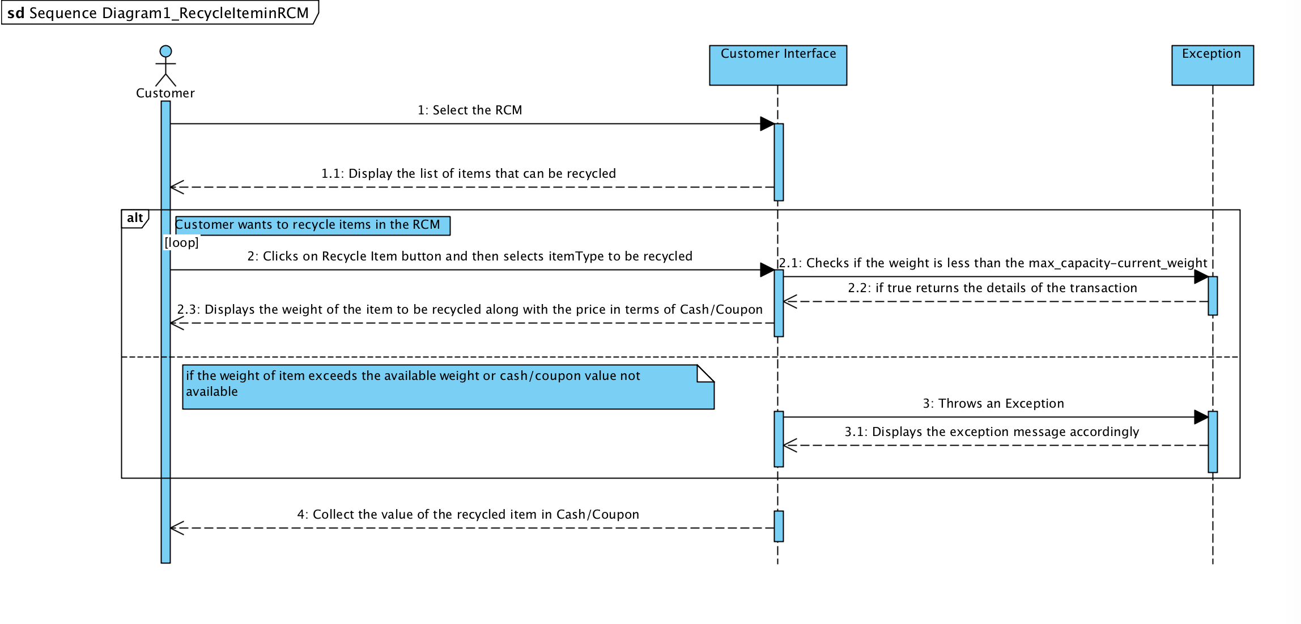

**2.2.2 Most Used RCM in the last month**

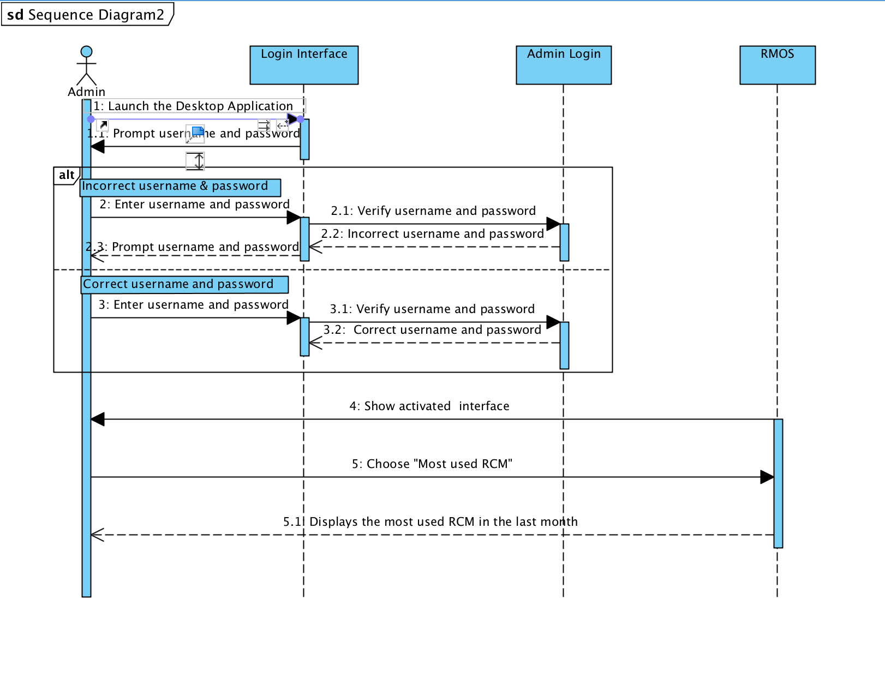

**2.3 State Transition Diagram**

**2.3.1 RCM status state diagram**

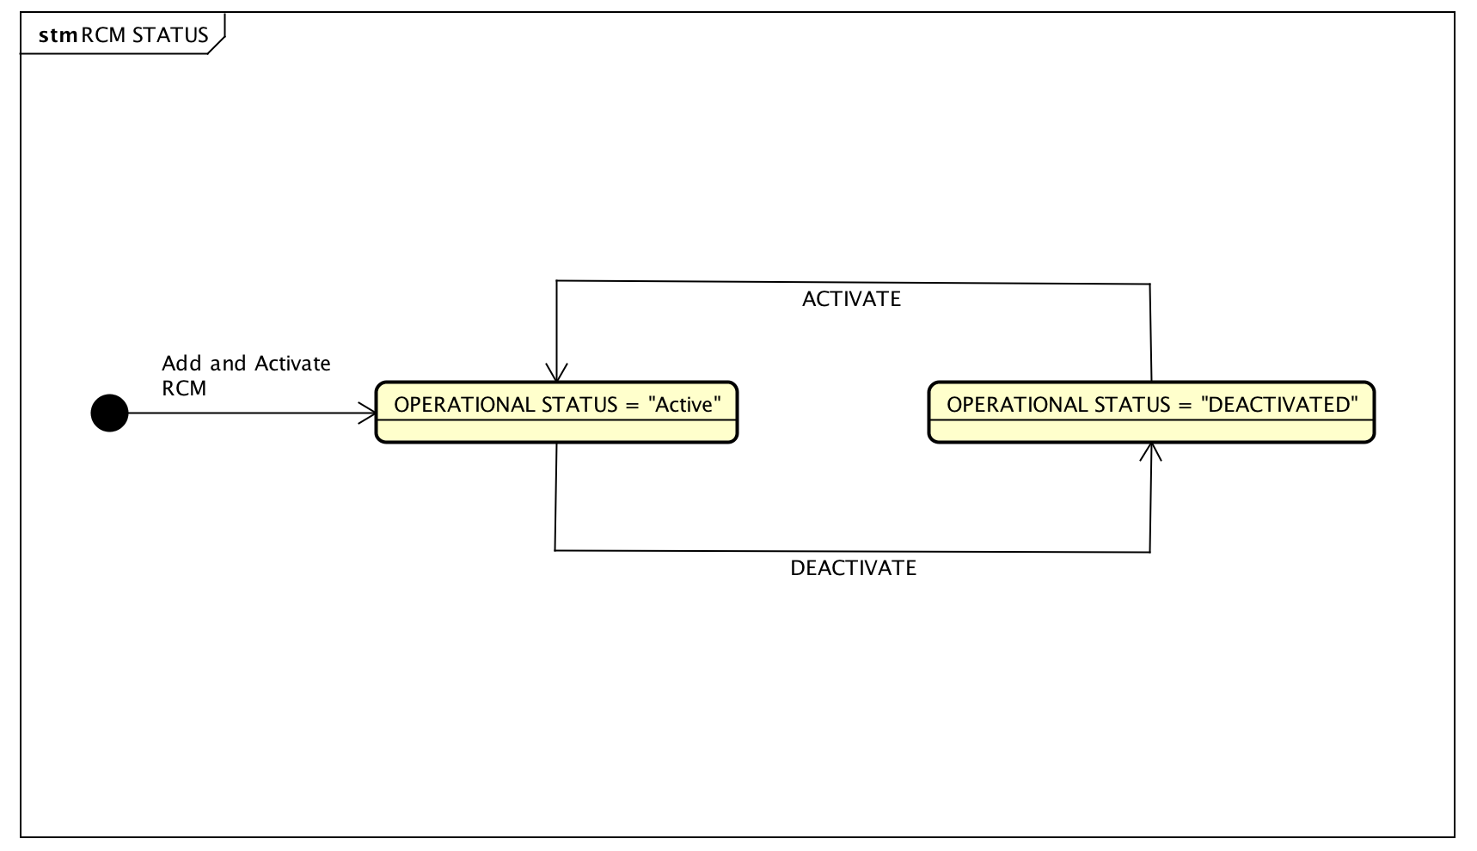

**2.3.2 Current weight of RCM state diagram**

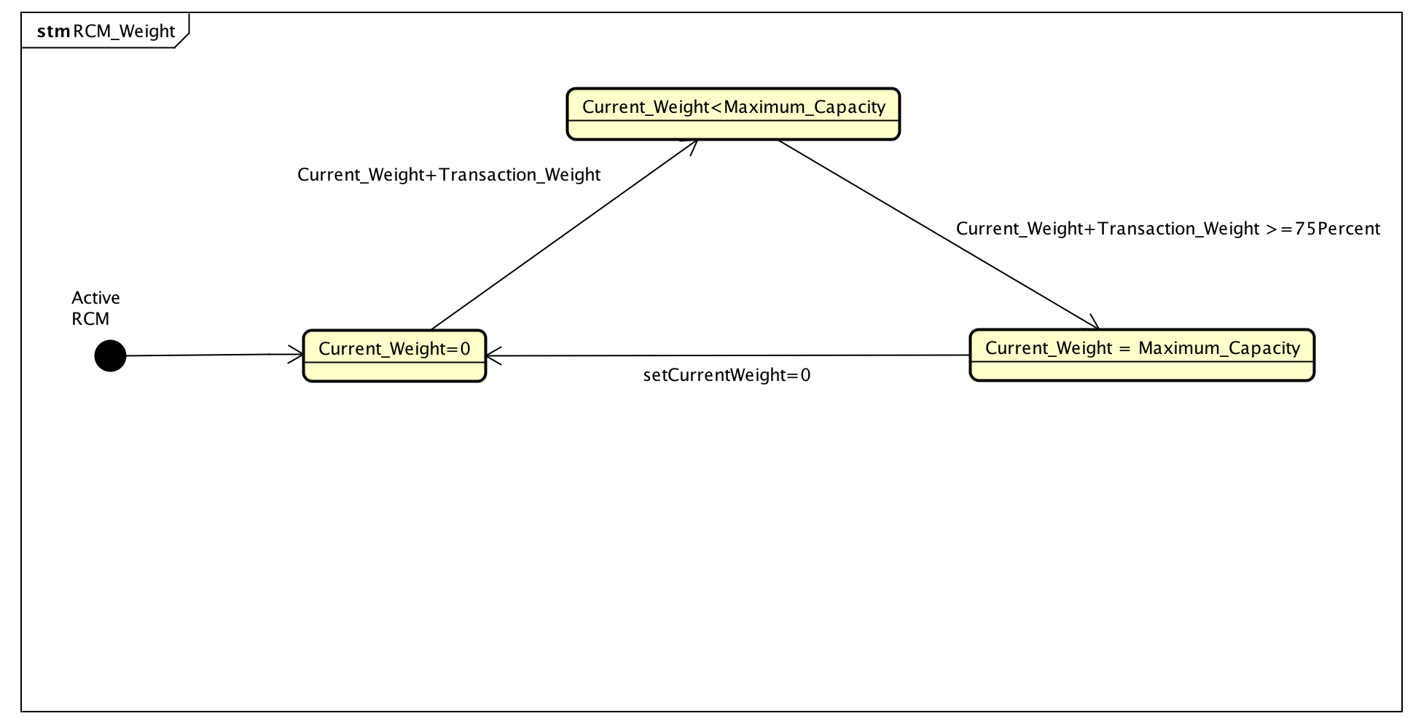

**2.4 UML Package**