IR Remote & Sensor Demo

Setup Guide

In your downloaded folder from Github (https://github.com/radeonxray/IRemoteDemo), you should see 2 folders and 1 file:

* IRemote (Folder)
* Sketch_IRemoteDemoCarMP3 (Folder)
* Setup-Tutorial.docx (This very guide you are currently reading!)

Step 1: Requirements

For this project, you will need the following from your Arduino kit:

* 3 x Wires (In this guide we are using 1xBlue, 1xYellow,1xGreen)
* 1 x Arduino Unit
* 1 x Cable connecting Mac or Windows to Arduino
* 1 x Breadboard
* 1 x IR Sensor
* 1 X IR Remote

Step 2: Setup of Cables and connections

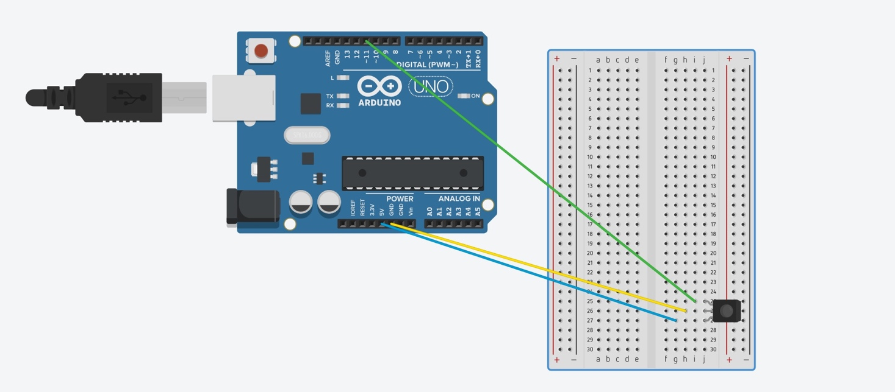

NOTE! On the Above picture sketch the IR sensor is facing towards the Arduino board! If you are placing the IR sensor facing away from the Arduino board, the you have to switch the Blue and Green cables around!

If IR Sensor is Facing inwards of the BreadBoard:

1. Green Wire Connection: 11 and the Left-leg of the IR Sensor
2. Yellow Wire Connection: GND and the Middle-leg of the IR Sensor
3. Blue Wire Connection: 5V and the Right-Leg of the IR Sensor

If the IR Sensor is facing away from the BreadBoard:

1. Green Wire Connection: 11 and the Right-leg of the IR Sensor
2. Yellow Wire Connection: GND and the Middle-leg of the IR Sensor
3. Blue Wire Connection: 5V and the Left-Leg of the IR Sensor

Final Setup (IR Sensor facing outwards of the Breadboard)

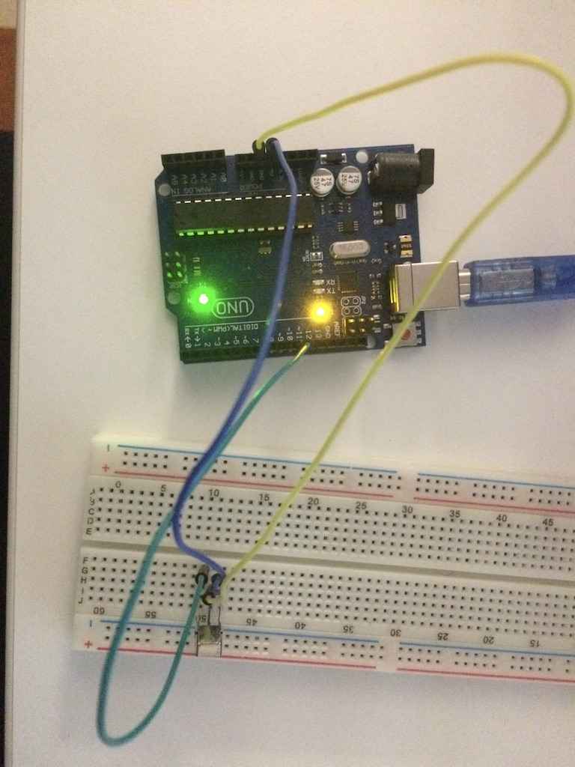

Step 3: Importing IRemote Library

1. Open the Arduino Software
2. Select “Sketch”
3. Select “Include Library”
4. Select “Add .Zip Library” (don’t panic, this will still read the folder we are going to locate, zipped or unzipped)
5. Locate and select the “IRemote”-folder that was included in the Github download.
   1. The Library-files are now added to your Library
   2. NOTE: There might occur an error in running the program if the library/folder “RobotIRemote” is present in your library. Please locate this folder on your Mac or Windows and temporally move it outside the library folder, should you encounter an error.
6. A new window will open with a template sketch, ignore this.

Step 4: Open and upload the IRemote Sketch

1. After having imported the Library files, locate the Sketch_IRemoteDemoCarMP3 (Folder)
2. Open the above mentioned folder
3. Run/Open the Sketch file: sketch_IRemoteDemoCarMP3.ino
4. A new Arduino window should open and show you the Code content of the file.
5. Upload the Sketch
6. Use your IR Remote to interact with the IR Sensor!
   1. Not all IR Remotes will give the same output in the program, due to coding!
   2. There have been some occurrences of the IR sensor reading the input from the IR Remote wrong.