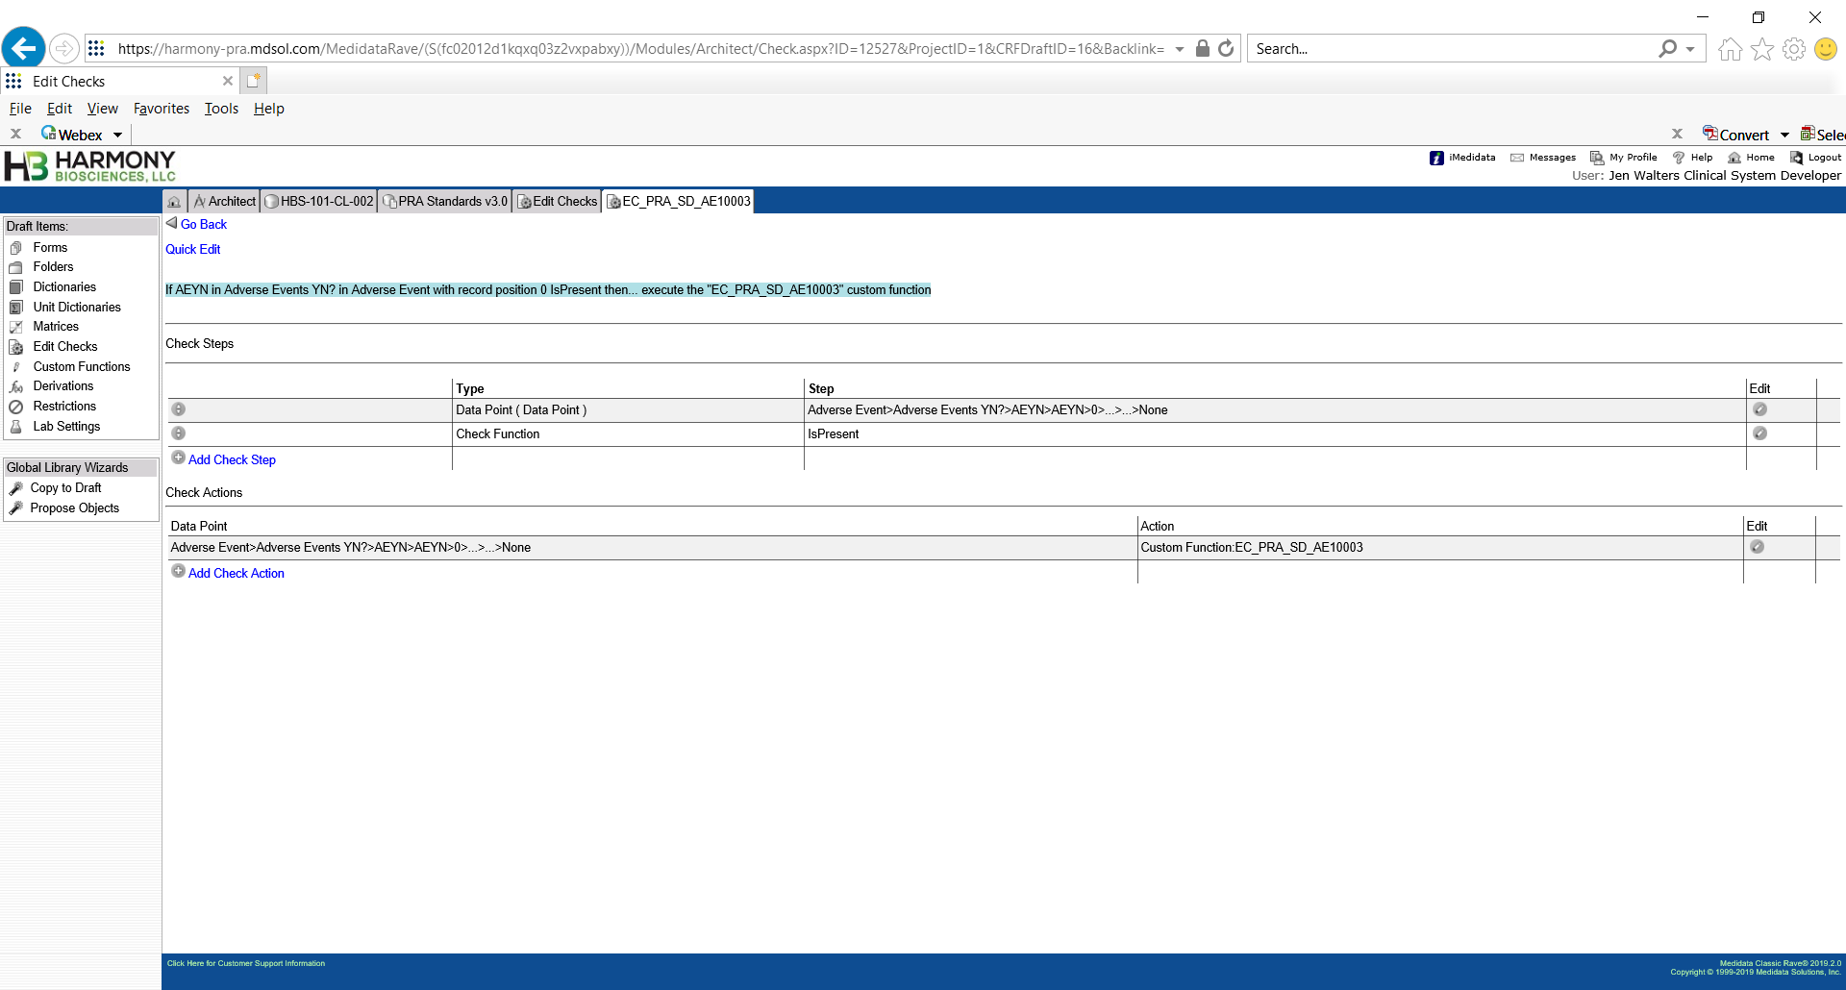

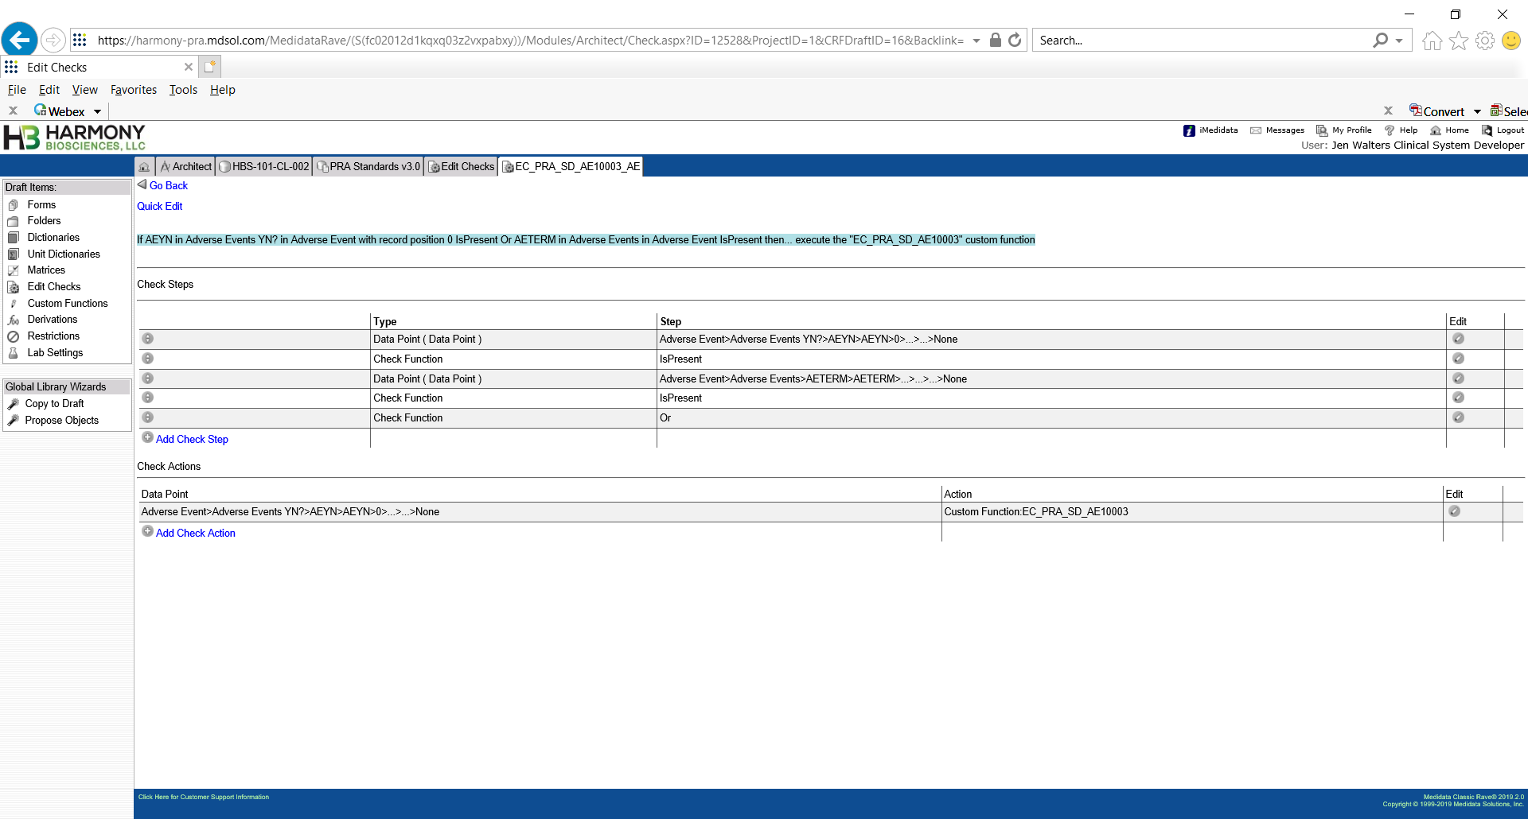

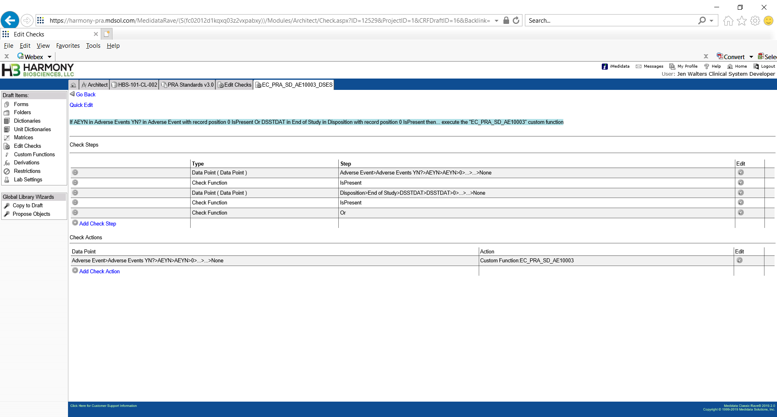

CF logic for EC_SD_AE10003 from Harmony study:

AEYN.AEYN = Y and End of Study form is present and no AE form has been submitted.

However, this c# does not compile when I try to add to an existing study?

// Developer: Ian Joyce

// Date: 20Jun2019

// Custom Function: EC_SD_AE10003

// Edit Check/s: EC_SD_AE10003,EC_SD_AE10003_AE, EC_SD_AE10003_DSES

// Short Description: AEYN.AEYN = Y and End of Study form is present and no AE form has been submitted.

ActionFunctionParams afp = (ActionFunctionParams)ThisObject;

Subject subj = afp.ActionDataPoint.Record.Subject;

DataPoint dpAction = afp.ActionDataPoint;

DataPages allPages = subj.DataPages;

Instance inst = dpAction.Record.DataPage.Instance;

DataPage dpgAE = inst.DataPages.FindByFormOID("AE");

int count = 0;

int countDSES = 0;

DataPoint dpDSSTDAT = null;

DataPoints dpsDSES = CustomFunction.FetchAllDataPointsForOIDPath("DSSTDAT", "DSES", "DS", subj);

-> FOR DOVA (("DSSTDAT", "DSET", "EOSET", subj);

for (int i = 0; i < dpsDSES.Count; i++)

{

dpDSSTDAT = dpsDSES[i];

if (dpDSSTDAT != null && dpDSSTDAT.Active && string.Compare(dpDSSTDAT.Data, string.Empty, true) != 0)

{

countDSES = 1;

break;

}

}

bool fireQuery = false;

string queryText = "Were any adverse events experienced? is Yes, however the Adverse Event form is missing. Please reconcile.";

int markingGroup = 1;

bool requiredResponse = false;

bool manualClose = false;

if (countDSES > 0 && dpDSSTDAT.Data != null && dpAction != null && dpAction.Active && string.Compare(dpAction.Data, "Y", true) == 0 )

{

if (dpgAE.Active && !dpgAE.IsNew)

{

DataPoints dps = CustomFunction.FetchAllDataPointsForOIDPath("AETERM", "AE", null, subj);

for (int i = 0; i < dps.Count; i++)

{

DataPoint dp = dps[i];

if ( dp.Record.RecordPosition > 0 && dp != null && dp.ChangeCount > 0)

{

count = 1;

break;

}

}

}

if (count == 0 && !dpgAE.IsUserDeactivated)

{

fireQuery = true;

}

}

CustomFunction.PerformQueryAction(queryText, markingGroup, requiredResponse, manualClose, dpAction, fireQuery);

return null;

