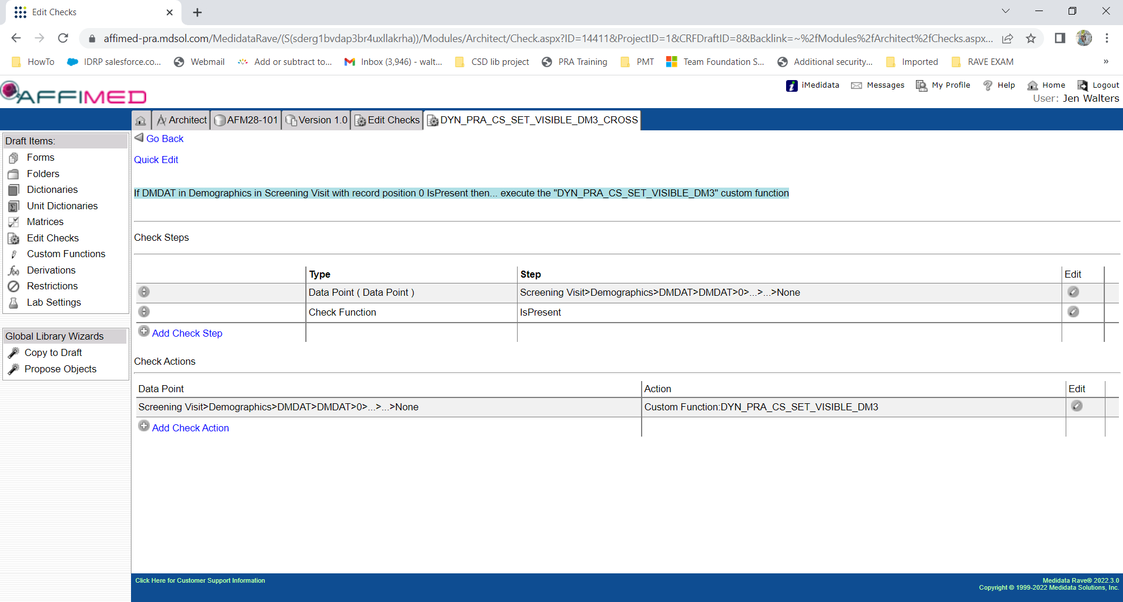

C#

/***********************************************************************

Created by : kolie.bolleurs@iconplc.com

Check Name : DYN_PRA_CS_SET_VISIBLE_DM3

Date Created : 27-OCT-2022

Desc :

If SUBJ.SUBJID does not contain 'FR-' and DM.DMDAT <> null, then Set Datapoint DM.RACE visible

********************************************************************/

ActionFunctionParams afp = (ActionFunctionParams) ThisObject;

DataPoint dpAction = afp.ActionDataPoint;

Subject sub = dpAction.Record.Subject;

bool blVisible = false;

if (dpAction != null)

{

DataPoint dpRACE = dpAction.Record.DataPoints.FindByFieldOID("RACE");

if (dpAction.Active && dpAction.Data.ToString() != string.Empty)

{

DataPage dpg = sub.DataPages.FindByFormOID("SUBJ");

if (dpg != null)

{

if (dpg.Active)

{

DataPoint dpSUBJID = dpg.MasterRecord.DataPoints.FindByFieldOID("SUBJID");

if (dpSUBJID != null)

{

if (dpSUBJID.Active && dpSUBJID.Data != string.Empty && !dpSUBJID.Data.Contains("FR-"))

blVisible = true;

}

}

}

}

if (dpRACE != null)

dpRACE.IsVisible = blVisible;

}

return null;