ST FRANCIS COLLEGE

Department of Computer Science and Application

**(AFFILIATED TO BENGALURU CITY UNIVERSITY)**

3rd Block,8th main, Koramangala, Bengaluru

**PROJECT REPORT**

ON

***CUSTOMER CHURN PREDICTION***

**Submitted By**

Keerthana S

U18IW22S0036

**Under the Guidance of:**

Mr. Akash, Data Scientist

PRINSTON SMART ENGINEERS

**Table of Contents:**

* Content
* Introduction
* Approach and Techniques
* Objective
* Scope
* Project Outcomes

**Content:**

Customer churn prediction is a machine learning approach used to identify customers likely to stop using a product or service. By analysing data such as customer demographics, transaction history, and engagement patterns, predictive models can uncover key indicators of churn. Techniques like data preprocessing, class imbalance handling, and feature selection improve model accuracy. With insights from these models, businesses can implement targeted strategies to retain high-risk customers, enhance customer satisfaction, and reduce revenue loss.

**Introduction:**

Customer churn is a significant challenge for businesses, particularly in competitive industries such as telecommunications, banking, and e-commerce. Churn occurs when customers stop using a company’s services, leading to revenue loss and increased acquisition costs. Predicting churn has become crucial for businesses aiming to improve customer retention. Machine learning techniques offer powerful tools for analyzing customer data to identify behavioural patterns and risk factors that indicate potential churn. By leveraging these insights, businesses can proactively engage with at-risk customers, implement retention strategies, and enhance overall customer satisfaction.

**Approach and Techniques:**

**Steps for Customer Churn Prediction Using Machine Learning**

1. **Data Collection:**

Gather customer data from relevant sources such as CRM systems, transaction logs, and user behavior records. Data may include demographics, purchase history, and service usage.

**2. Data Preprocessing:**

* Handle missing values using techniques like mean/mode imputation.
* Encode categorical variables (e.g., one-hot encoding or label encoding).
* Normalize or scale numerical features for consistency.
* Perform data cleaning to remove duplicates and irrelevant data.

**3. Exploratory Data Analysis (EDA):**

Analyze data patterns, visualize distributions, and identify correlations.

Identify key features that may influence customer churn

**4. Feature Engineering:**

* Create new features that capture meaningful customer behavior patterns.
* Perform feature selection to retain only the most important variables.

**5. Handling Imbalanced Data:**

Apply techniques like **SMOTE** or **Random Undersampling** to balance the dataset and improve model performance.

**6. Model Selection and Training:**

Choose suitable algorithms such as Logistic Regression, Decision Trees, Random Forest, or Gradient Boosting.

Train the models using the prepared data.

**7. Model Evaluation:**

Evaluate model performance using metrics like **accuracy**, **precision**, **recall**, and **F1 score** to ensure reliability.

**8. Model Tuning:**

Optimize hyperparameters using techniques like **Grid Search** or **Random Search** to enhance model performance.

**9. Prediction and Deployment:**

Implement the model in a production environment to make real-time predictions.

Develop dashboards or reporting tools to help stakeholders interpret the results.

**10.Monitoring and Maintenance:**

Regularly monitor model performance and update it as customer behaviour evolves to maintain accuracy.

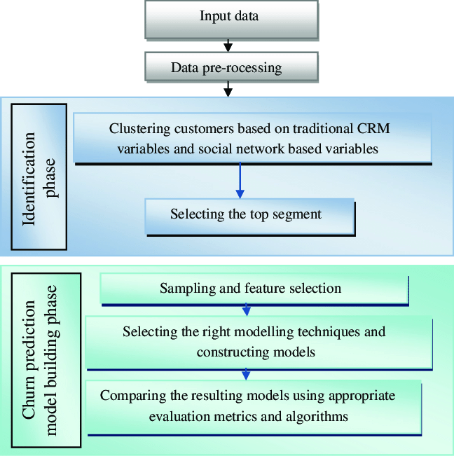

**Objectives:**

The primary objective of customer churn prediction is to accurately identify customers who are likely to discontinue using a product or service. By leveraging machine learning models, businesses can proactively detect at-risk customers, understand the key factors driving churn, and implement targeted retention strategies. This helps minimize revenue loss, improve customer satisfaction, and enhance long-term business growth.

**Scope:**

* Applicable across industries like telecommunications, banking, e-commerce, and subscription services.
* Utilizes customer data such as demographics, transaction history, and behavioural patterns.
* Supports businesses of all sizes, from startups to large enterprises.

Helps develop personalized marketing and retention strategies.

* Enables efficient resource allocation to focus on high-risk customers.
* Can be extended to forecast future trends and customer behavior.
* Aids in improving customer relationship management (CRM) for better decision-making.

**Project Outcomes:**

The customer churn prediction project delivers valuable insights that empower businesses to improve customer retention strategies. By accurately identifying at-risk customers, companies can proactively engage with them through targeted offers, personalized communication, and improved services. The model’s predictions enable businesses to reduce churn rates, enhance customer satisfaction, and increase revenue stability. Additionally, the insights gained from feature importance analysis help businesses understand key factors driving customer behavior, allowing for data-driven decision-making. Overall, the project provides a strategic advantage by improving customer loyalty and optimizing marketing efforts.

Additionally, the project refines property valuation models, ensuring more accurate assessments and reducing reliance on subjective methods. Ultimately, it enhances operational efficiency by streamlining the property evaluation process, saving both time and resources.