# Requirements Document

# User Stories and Tasks

The Application have initial 3 menus like Dietician, Customer and exit the application.

For the Dietician **user story**: As a dietician, I must want to create recipes so that app can show to anyone.

### Main Task Dietician: Create recipe

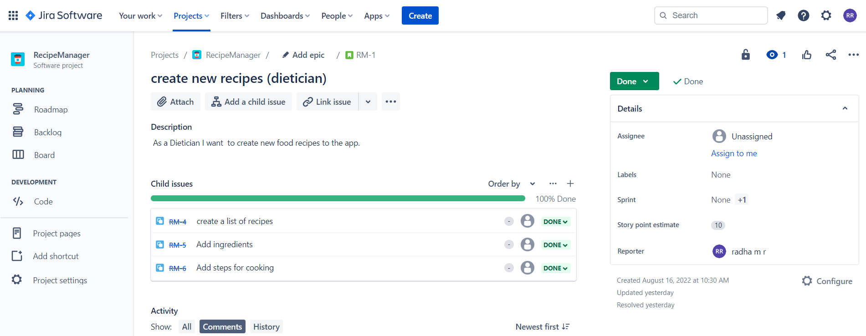

### The sub tasks:

1. create a list of recipes, which need recipe name,
2. list of ingredients,
3. list of steps

### Main Task User role: View recipe/Edit recipe

For both User roles have the view option

For Dietician have edit option (sub task)

### The sub tasks:

* Dietician – view recipe pool with all recipes and edit a ingredients and steps
* Customer – view specific recipe.

As a Dietician **user story**: Dietician must be able to view all recipes from recipe pool to have idea of adding or removing new things.

As a Dietician **user story:** Dietician must be able to edit recipe ingredients or recipe steps by adding or removing some.

As a customer **user story**: Customer must be able to read specific recipe to prepare with ingredients and cooking steps.

### Main Task Customer: Week wise recipes

As a customer **user story:** Customer must be able to generate week full of recipes and also able to view that generate recipes and its ingredients and steps.

### The sub tasks:

* Generate a week full of recipes
* View that week recipes name , ingredients and steps.

# UML Diagram

## Use Case:

****

## Class Diagram

Link :

//www.plantuml.com/plantuml/png/RLFRRk8y4BxtK\_Zo\_uNo0WXLfINi8hK54TYzHADuIgtwODcJhbPPtdtjE0a75d7X-UQRcMyEUGm4dXgjMAqW1Av1cfQn4qiFNXHBQuMs7bx1m15zpxf1USlsLRazRDSlPJLzaO5O8Oqa2OGBYIHh2MQfxA\_\_\_Zyxdfj0LgFlyKduQ6Zkd98raBGcGYUMVj8G-dUeSQow3-XR9cHm2dvliPOEGwGxRxMZv5nQ\_sIjGZ2ty2ecYuBdHlm09GKGTdKkC\_FPdwBWe-plO8H2\_m\_AqC30oAEv3MpPUhDRhT\_wkPIBrUwmBPzNc\_9mvIXgZq2Osqbp0Y6oyGPw05Rcw558D1Hwf29qtRl-i3RWsgNPTO17RR\_m9YA3Gr3SSrPzsykDw75dULVtnKR2DpJenpR2m5SMn0BVeL6qyVWbRHD-8dukWA1poz0jA65TkhlTfbF8IhS80dq5sYbih\_34tLYhMfP4ppBmCFKvoPM8S-BYYBqr6lSrDruQ6aSpgHM2hsgFQBh3hS4azIlZ6he3Aeh1nmIxbEK9Z46\_awHmnCvpF347zISSaMihKF7PR6cLGF\_mm5l6ULPpNcd42WCQfxa8AruHGkDnRoHDqJIQ5Q1jOsWQgyJu2OyDvdCQh4JDLZJcYPpD4-CiPU0NATDd\_XRFTxqyl9RpQhyja-Ih-RViMj35-VMdb6wlVq\_EQjBpWjiZmvrEmfaOxeZXWaXsdFU9fVyZ6j5ezHS0

## RLFRRk8y4BxtK_Zo_uNo0WXLfINi8hK54TYzHADuIgtwODcJhbPPtdtjE0a75d7X-UQRcMyEUGm4dXgjMAqW1Av1cfQn4qiFNXHBQuMs7bx1m15zpxf1USlsLRazRDSlPJLzaO5O8Oqa2OGBYIHh2MQfxA___Zyxdfj0LgFlyKduQ6Zkd98raBGcGYUMVj8G-dUeSQow3-XR9cHm2dvliPOEGwGxRxMZv5nQ_sIjGZ2ty2ecYuBdHlm09GKGTdKkC_FPdwBWe-plO8H2_m_AqC30oAEv3MpPUhDRhT_wkPIBrUwmBPzNc_9mvIXgZq2Osqbp0Y6oyGPw05Rcw558D1Hwf29qtRl-i3RWsgNPTO17RR_m9YA3Gr3SSrPzsykDw75dULVtnKR2DpJenpR2m5SMn0BVeL6qyVWbRHD-8dukWA1poz0jA65TkhlTfbF8IhS80dq5sYbih_34tLYhMfP4ppBmCFKvoPM8S-BYYBqr6lSrDruQ6aSpgHM2hsgFQBh3hS4azIlZ6he3Aeh1nmIxbEK9Z46_awHmnCvpF347zISSaMihKF7PR6cLGF_mm5l6ULPpNcd42WCQfxa8AruHGkDnRoHDqJIQ5Q1jOsWQgyJu2OyDvdCQh4JDLZJcYPpD4-CiPU0NATDd_XRFTxqyl9RpQhyja-Ih-RViMj35-VMdb6wlVq_EQjBpWjiZmvrEmfaOxeZXWaXsdFU9fVyZ6j5ezHS0 (1518×480)

