Machining & Manufacturing Profile - RS ENGINEERING
No.2, Perumal Kovil Street, Palayapudur,
Periyanaickenpalayam, Coimbatore - 641020
Email: rsengineering2089@gmail.com, muthuramalingamm0910@gmail.com
Mobile: 84897 88900, 77080 76324, 86675 06298
GSTIN: 33DKTPP1200F1ZE
Date: August 2023
To
Dear Sir/Madam,
We are pleased to introduce RS ENGINEERING as a manufacturer of precision-machined components, specializing in the machining of automobile parts. Operational since 2020, our company is managed by a team of qualified and experienced professionals in pump and automobile component manufacturing.
We humbly request you to consider RS ENGINEERING for vendor registration and include us as a supplier in your esteemed organization. We assure you of:
- - High-quality products
- - On-time delivery
- - Cost-effective pricing
- - Strict compliance with quality standards and your company procedures
We look forward to your valuable enquiries and the opportunity to serve you with the best of our capabilities.
Thank you for your consideration.
Yours sincerely,
R. Prathap & M. Muthuramalingam
For RS ENGINEERING

CNC - Machining Capabilities
CNC Turning Lathe – DOOSAN
Specification: Chuck: 200mm, X Axis: 280mm, Z Axis: 500mm

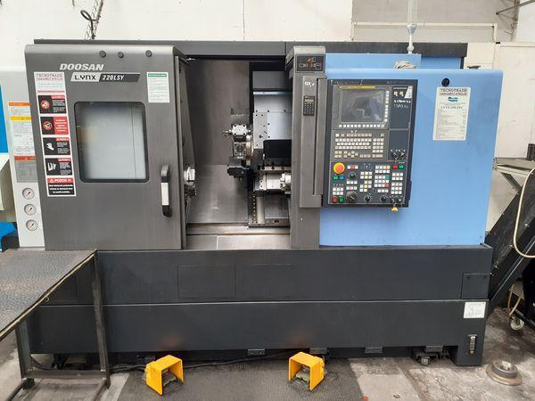
CNC Turning Lathe - LMW SmartTurn
Specification: Chuck: 165mm, X Axis: 200mm, Z Axis: 260mm

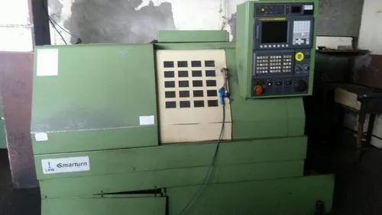

VMC - AMS MCV-400S
Specification: X Axis: 600mm, Y Axis: 400mm, Z Axis: 500mm
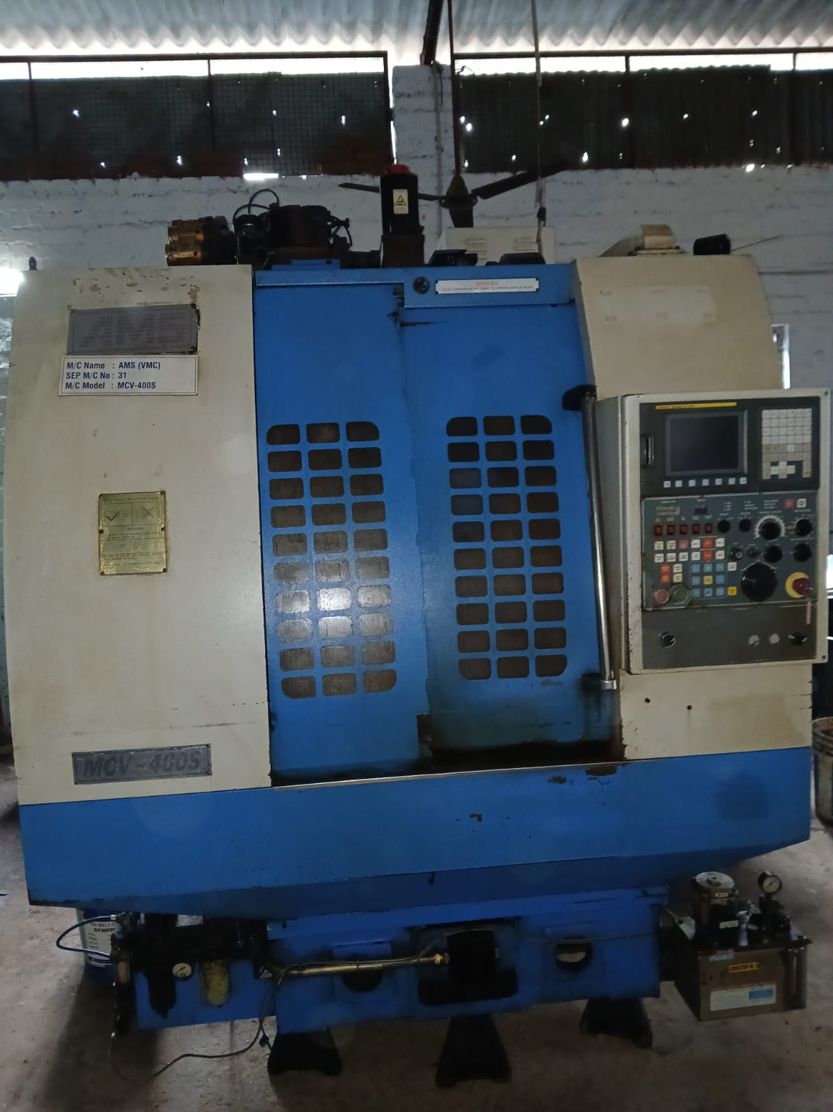

At RS ENGINEERING, our state-of-the-art CNC machines empower us to deliver high-precision components with consistent quality. Each machine is maintained under strict operational standards to ensure optimal performance and efficiency. From turning to milling, we are equipped to meet diverse client needs across various industries.

