**ETL: Extract, Transform, Load**

ETL stands for Extract, Transform, and Load, which are the key processes in data handling and preparation.

**1. Extract:**

**Definition**: Pull data from various data sources.

Common Data Sources:

* Excel files
* CSV files
* Text files
* Databases, etc.

**2. Transform:**

Definition: Process and clean the data to make it usable for analysis.

Key Actions:

* Data processing
* Data cleaning (handling NULL, missing, or duplicate values)

**3. Load:**

Definition: Load the processed data into a tool or platform for analysis and visualization.

**Steps to Perform ETL in Power BI**

**STEP 1:** Open Power BI Desktop Application

**STEP 2:** Click on Blank Report to start a new project.

**STEP 3:** Click on Get Data and select the appropriate data source (e.g., Text/CSV) to load the dataset into Power BI.

**STEP 4:** Transform Data

Click on Transform Data to open the Power Query Editor.

This step is used to Identify and remove NULL, missing, or duplicate values.

**STEP 5:** Handle Empty Columns

Identify any empty columns in the dataset and remove them, as they do not contribute to the visualization.

If you mistakenly remove a column, retrieve it from the Applied Steps pane located on the right-hand side of the Power Query Editor.

**STEP 6:** Explore Power BI Features

Return to Power BI Desktop, where you can access several views on the left-hand pane:

* **Report View:** Used for creating visualizations and dashboards.
* **Table View:** Displays the dataset, including the transformed data.
* **Model View:** Allows you to create relationships among different tables and map them together.
* **DAX Query View:** Enables advanced querying and calculations using Data Analysis Expressions (DAX).

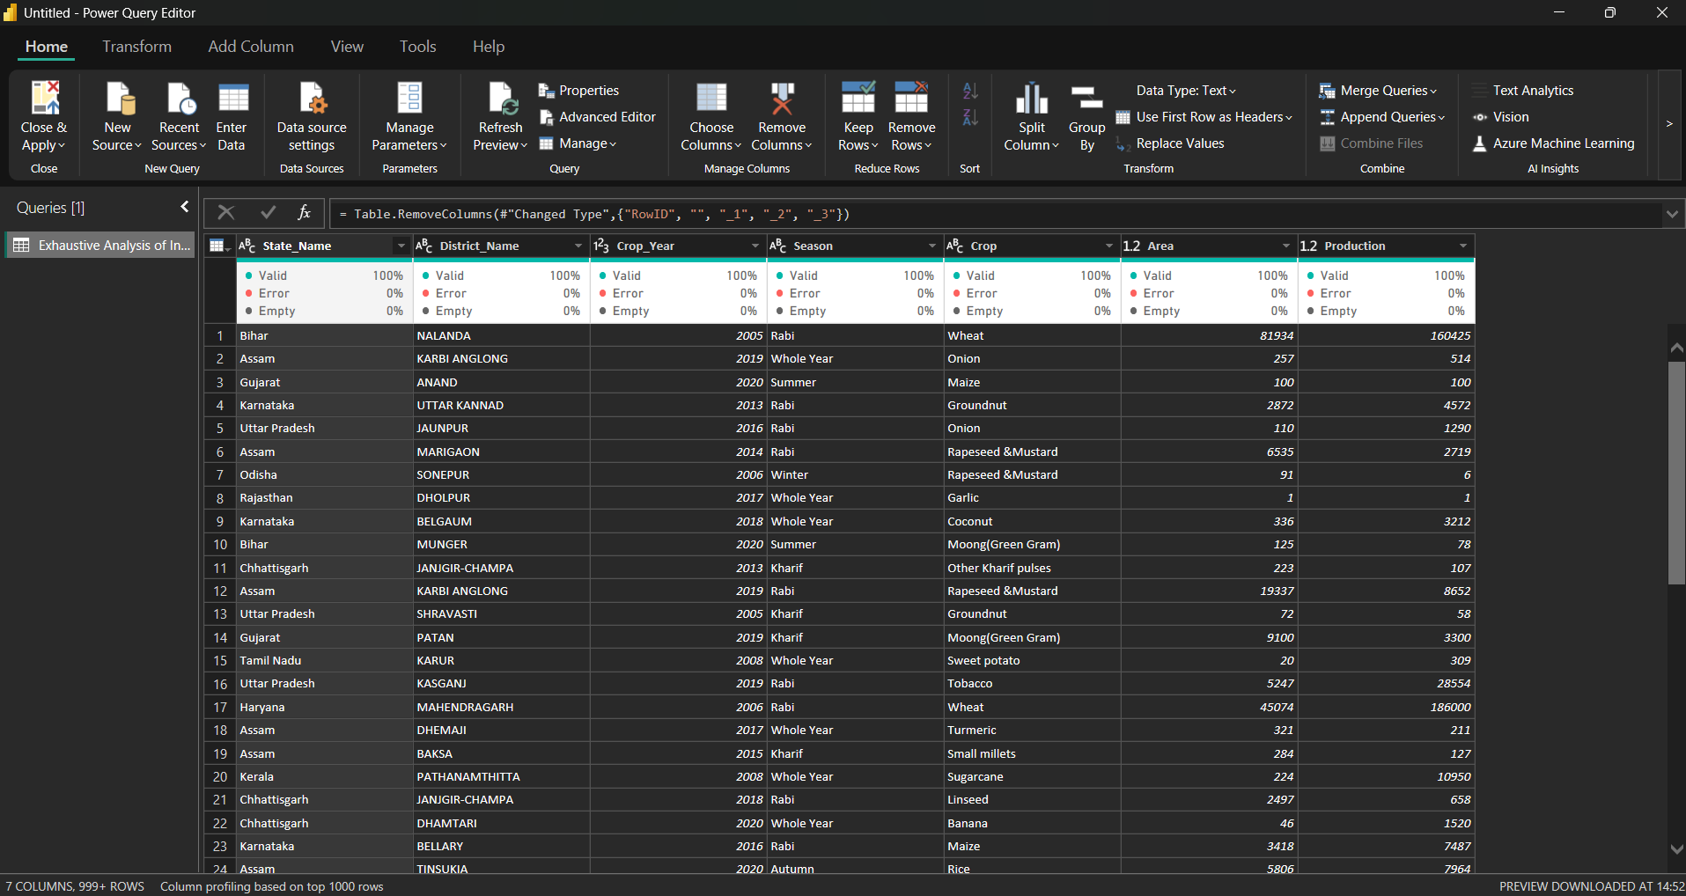

**Screenshot of transformed dataset**