Hackathon Team Formation and Ranking
Author: Radhasahithi Challa
1. Problem Statement
Develop a Python program to manage student teams participating in a hackathon. The program validates team sizes, records scores across multiple rounds, calculates total scores, and ranks teams according to predefined rules. If teams have equal scores, the program uses round-wise scores and alphabetical order to determine rankings.
2. Objectives
- Create teams and store student names.
- Validate team sizes.
- Record scores for multiple rounds.
- Calculate the total score of each team.
- Resolve tied rankings using predefined tie-break rules.
- Display the final ranking table.
3. Assumptions
- Each team must contain between 2 and 5 students.
- Team names must be unique.
- Student names must not be duplicated within a team.
- The tournament contains at least one team and one round.
- Scores must be non-negative whole numbers.
- Every team receives a score in every round.
- Teams are ranked according to:
  - Total score in descending order.
  - Final-round score in descending order.
  - Earlier-round scores, starting with the latest, in descending order.
  - Team name in alphabetical order.
4. Algorithm
- Start the program.
- Input the number of teams and rounds.
- Enter each team's name and student names.
- Validate that each team contains 2–5 students.
- Enter scores for each team in every round.
- Calculate the total score for each team.
- Sort teams by total score and the predefined tie-break rules.
- Display the rank, team name, round-wise scores, and total score.
- Stop.
5. Flowchart
START
Input number of teams and rounds
Enter team names and student members
Validate team size (2–5 students)
Input round-wise scores for all teams
Calculate total scores
Sort teams using tie-break rules
Display final rankings
STOP
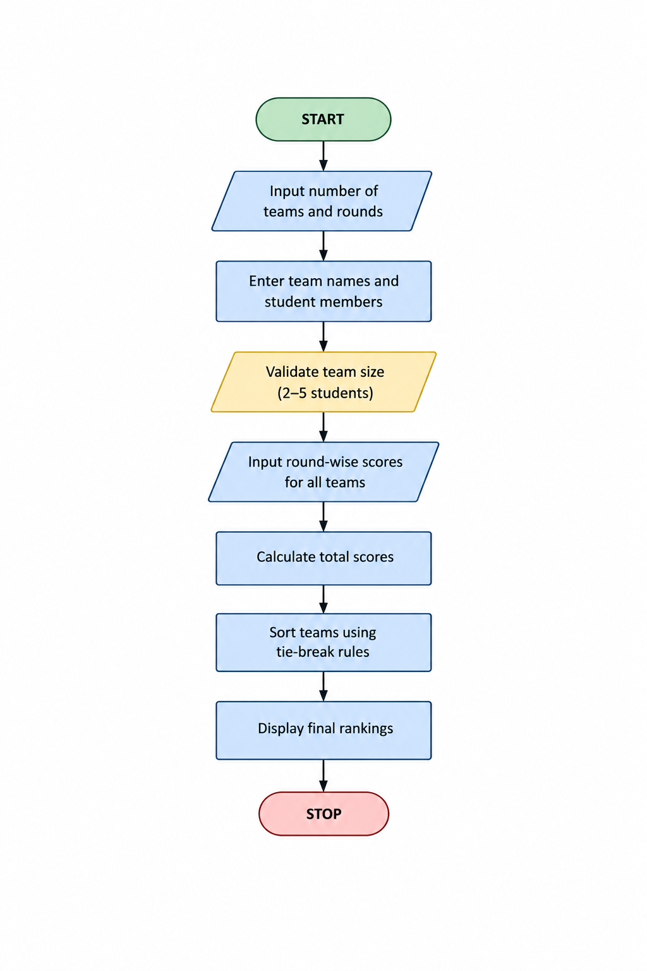

6. Pseudocode
BEGIN
INPUT number_of_teams
INPUT number_of_rounds
FOR each team:
INPUT team_name
INPUT student_names
WHILE team size < 2 OR team size > 5:
DISPLAY error message
INPUT student_names again
FOR each round:
FOR each team:
INPUT team score
VALIDATE score is non-negative
FOR each team:
total_score = SUM(round_scores)
SORT teams BY:
total score descending
final-round score descending
earlier-round scores descending
team name ascending
DISPLAY final ranking table
END
8. Line-by-Line Explanation
Code | Explanation
MIN_TEAM_SIZE = 2 | Sets the minimum team size.
MAX_TEAM_SIZE = 5 | Sets the maximum team size.
read_integer() | Accepts valid whole-number input.
number_of_teams | Stores how many teams participate.
number_of_rounds | Stores the number of scoring rounds.
used_names = set() | Tracks existing team names to prevent duplicates.
raw.split(",") | Splits student names entered with commas.
len(members) | Checks the number of students in a team.
teams.append(...) | Stores each team's details.
team["scores"].append(score) | Saves the score for a round.
sum(team["scores"]) | Calculates the team's total score.
teams.sort(...) | Sorts teams according to the tie-break rules.
enumerate(teams, start=1) | Assigns rank numbers beginning at 1.
print(...) | Displays the ranking table and team members.
9. Test Cases
Test | Input / scenario | Expected result
1 | Team contains 3 students | Team accepted
2 | Team contains 1 student | Invalid team size
3 | Team contains 6 students | Invalid team size
4 | Duplicate team name | User must enter a unique name
5 | Score entered as -4 | Invalid score; user is prompted again
6 | Team A total = 25, Team B total = 20 | Team A ranks higher
7 | Equal totals, but Team A scores higher in the final round | Team A ranks higher
8 | All score criteria are equal | Alphabetical order decides the ranking
10. Sample Output
Enter number of teams: 3
Enter number of rounds: 2
Enter name for team 1: CodeCrafters
Enter student names for CodeCrafters, separated by commas: Asha, Ravi
Enter name for team 2: ByteBuilders
Enter student names for ByteBuilders, separated by commas: Meera, John, Kiran
Enter name for team 3: LogicLegends
Enter student names for LogicLegends, separated by commas: Diya, Arun

--- Round 1 Scores ---
Enter score for CodeCrafters: 80
Enter score for ByteBuilders: 75
Enter score for LogicLegends: 80

--- Round 2 Scores ---
Enter score for CodeCrafters: 85
Enter score for ByteBuilders: 90
Enter score for LogicLegends: 85

========== HACKATHON RANKINGS ==========
Rank Team R1 R2 Total
1 ByteBuilders 75 90 165
2 CodeCrafters 80 85 165
3 LogicLegends 80 85 165

Team Members:
ByteBuilders: Meera, John, Kiran
CodeCrafters: Asha, Ravi
LogicLegends: Diya, Arun

My output
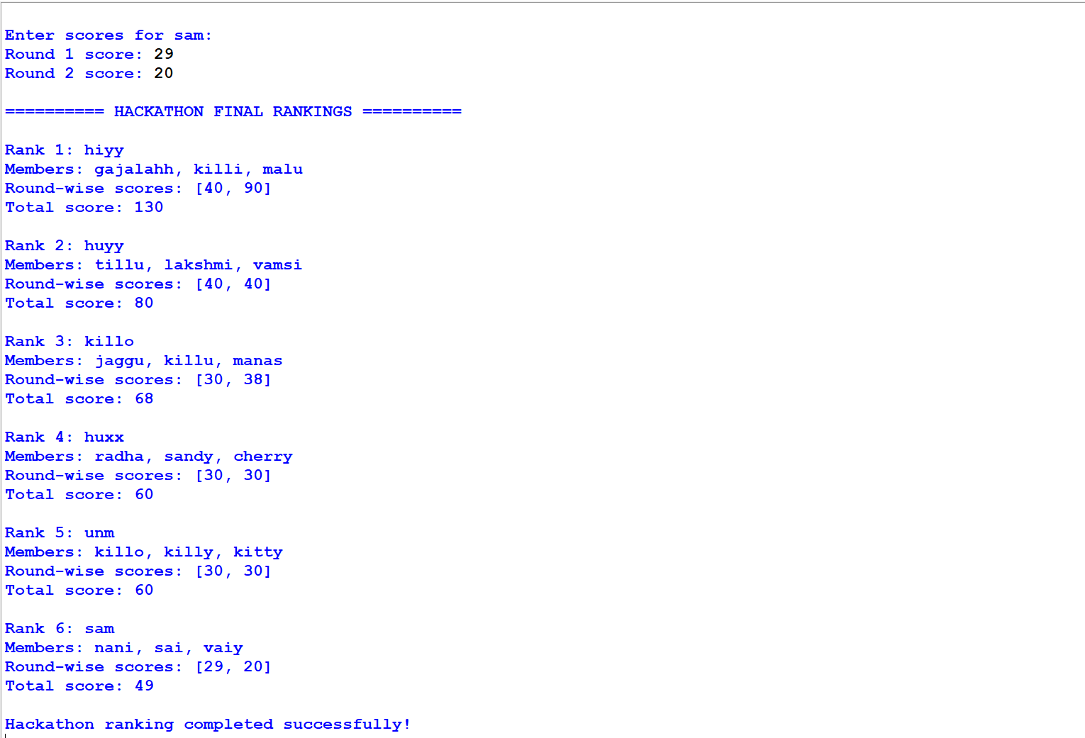
11. Conclusion
The Hackathon Team Formation and Ranking System validates team composition, records scores across multiple rounds, calculates total scores, and ranks teams using predefined tie-break rules. It demonstrates Python concepts such as lists, dictionaries, loops, input validation, aggregation, and sorting. The team-size limits and ranking rules can be modified according to the requirements of a real hackathon.

