**CNS TUTORIAL-1**

**IN-TUTORIAL:**

1. a) Shawn Mendes wants to send a message “97652 321875 @” to his friend. While sending the message he used character count Framing method in order to re-construct the same frames at receiver‟s end. Following is the data sent by Shawn Mendes after using Character Stuffing. Find the number of frames at received at the receiver‟s end and illustrate the independent frames.

Assume that the character count of frame-2 is changed to 6 instead of 7, due to bit errors. Now write the frames when there occurs an error in the character count.

|  |  |  |  |  |  |  |  |  |  |  |  |  |  |  |
| --- | --- | --- | --- | --- | --- | --- | --- | --- | --- | --- | --- | --- | --- | --- |
| **6** | 9 | 7 | 6 | 5 | 2 | **7** | 3 | 2 | 1 | 8 | 7 | 5 | **2** | @ |

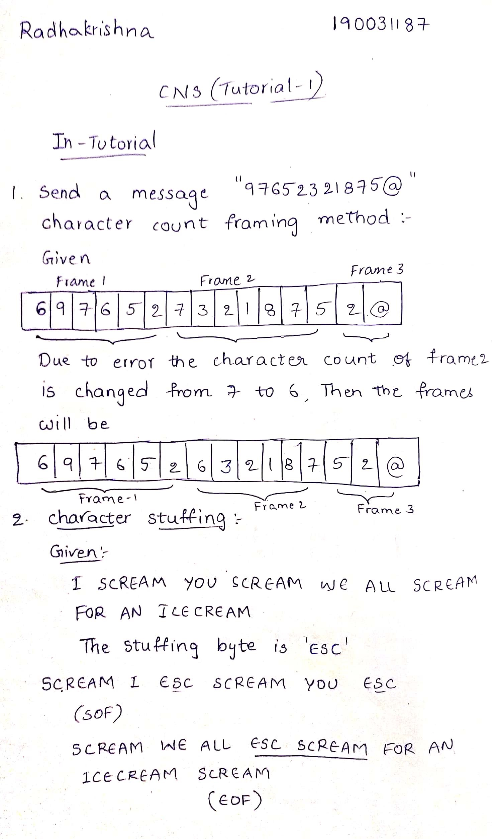



1. SCREAM indicates the beginning, and the ending of frames. Illustrate what happens if the sequence SCREAM is found in the message byte, and how this scenario is avoided with the help

of character stuffing.(Assuming the stuffing byte to be „ESC‟) Note: Neglect spaces between words.

Frame: I SCREAM YOU SCREAM WE ALL SCREAM FOR AN ICE CREAM



1. Codechef wants to send a message “Your Submission is flagged” to Millie. Below is the data after performing Character Stuffing. Find the data passed to Network Layer at receiver‟s side and also explain the greatest disadvantage in following the Character Stuffing, with the help of above example.

Start of Flag byte- FLAG STX

End of Flag byte- FLAG ETX

FLAG

STX

YOUR

SUBMISSION

IS

FLAG

FLAG

GED

FLAG

ETX

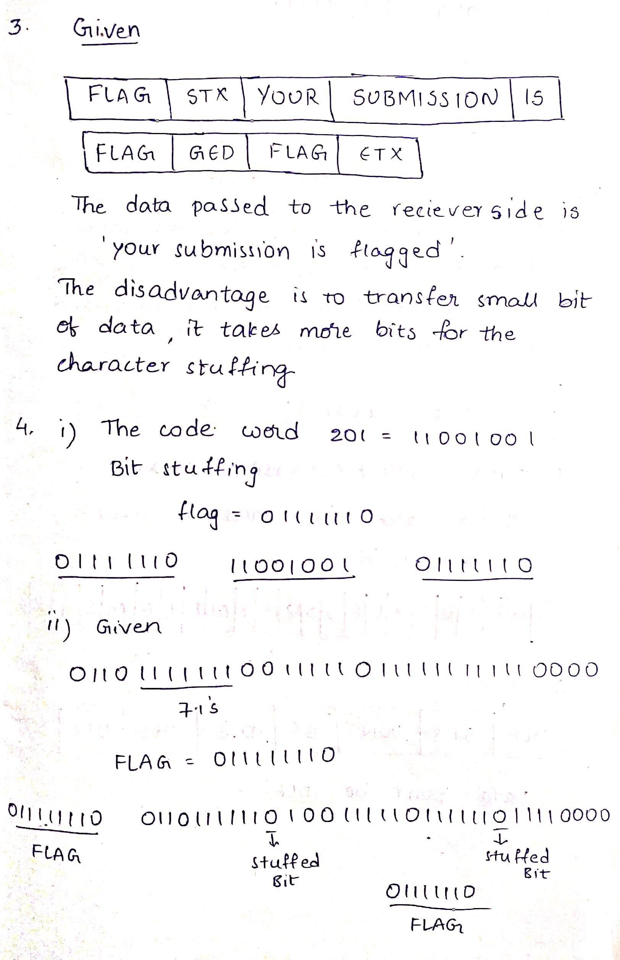

1. (i) Nemo lost her way and wants to send her friend Darla a code message which helps to explain Nemo‟s situation to her. The code word is 201.Perform bit stuffing on the above code word.(flag=01111110).
   1. INPUT STREAM = 011011111110011111011111111110000 and FLAG=011111110.

Perform bit stuffing.

* 1. Consider data = 011011111 and assume Flag=01110

Perform bit stuffing and write the final data after bit stuffing. Also explain the disadvantage in taking such type of Flag values.

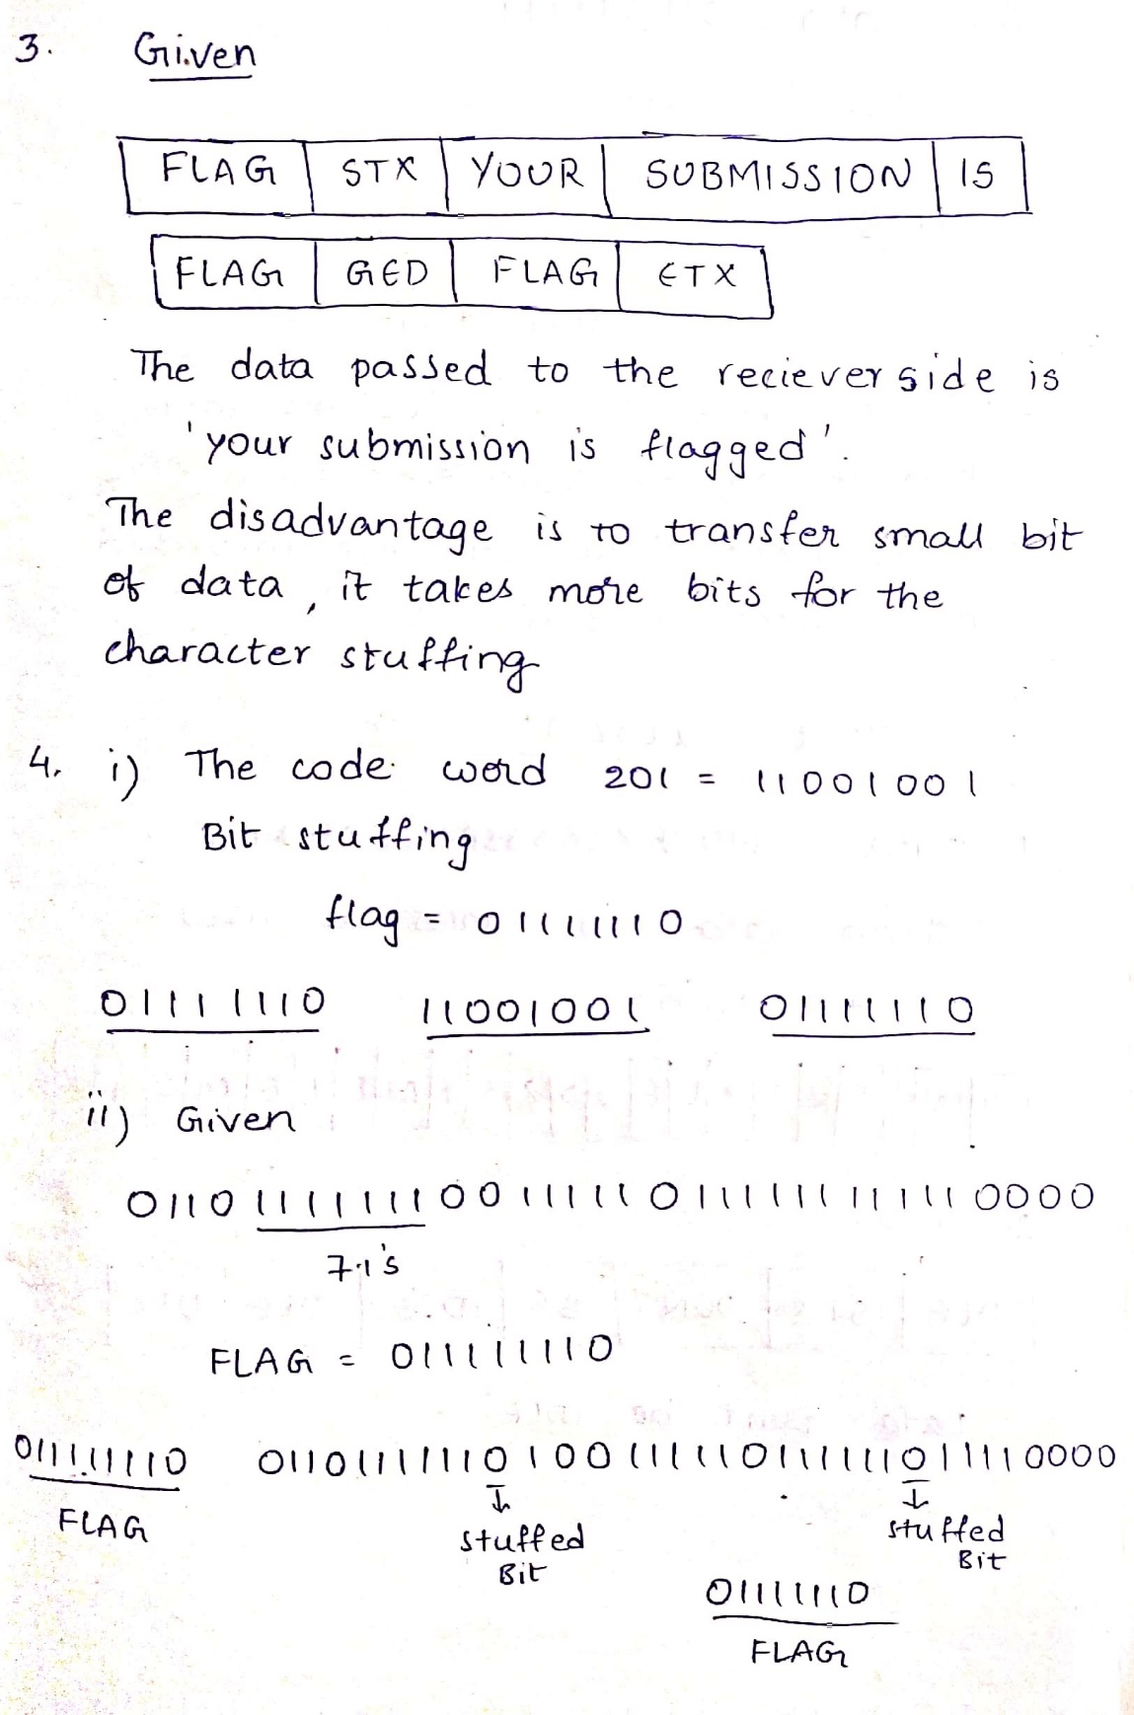

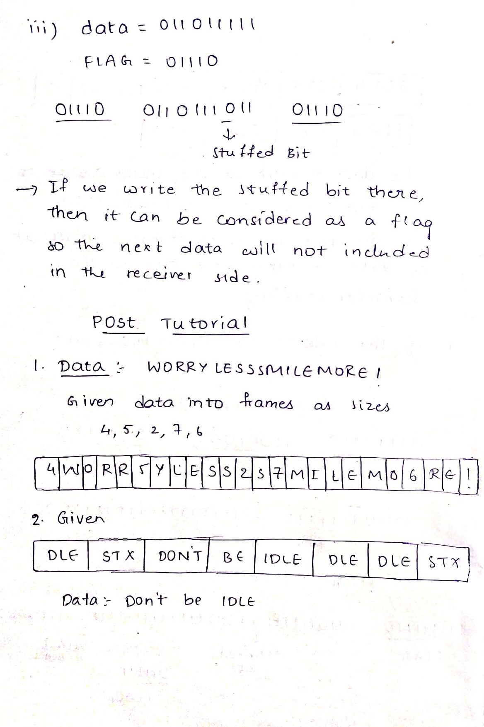

**POST-TUTORIAL:**

1. Hannah Baker sent a message to Clay Jensen. Divide the message(data) into frames of sizes 4, 5, 2, 7, 6 respectively using Character Count method and write the final data.

Data: **WORRY LESS SMILE MORE!**

Note: Neglect spaces between words.

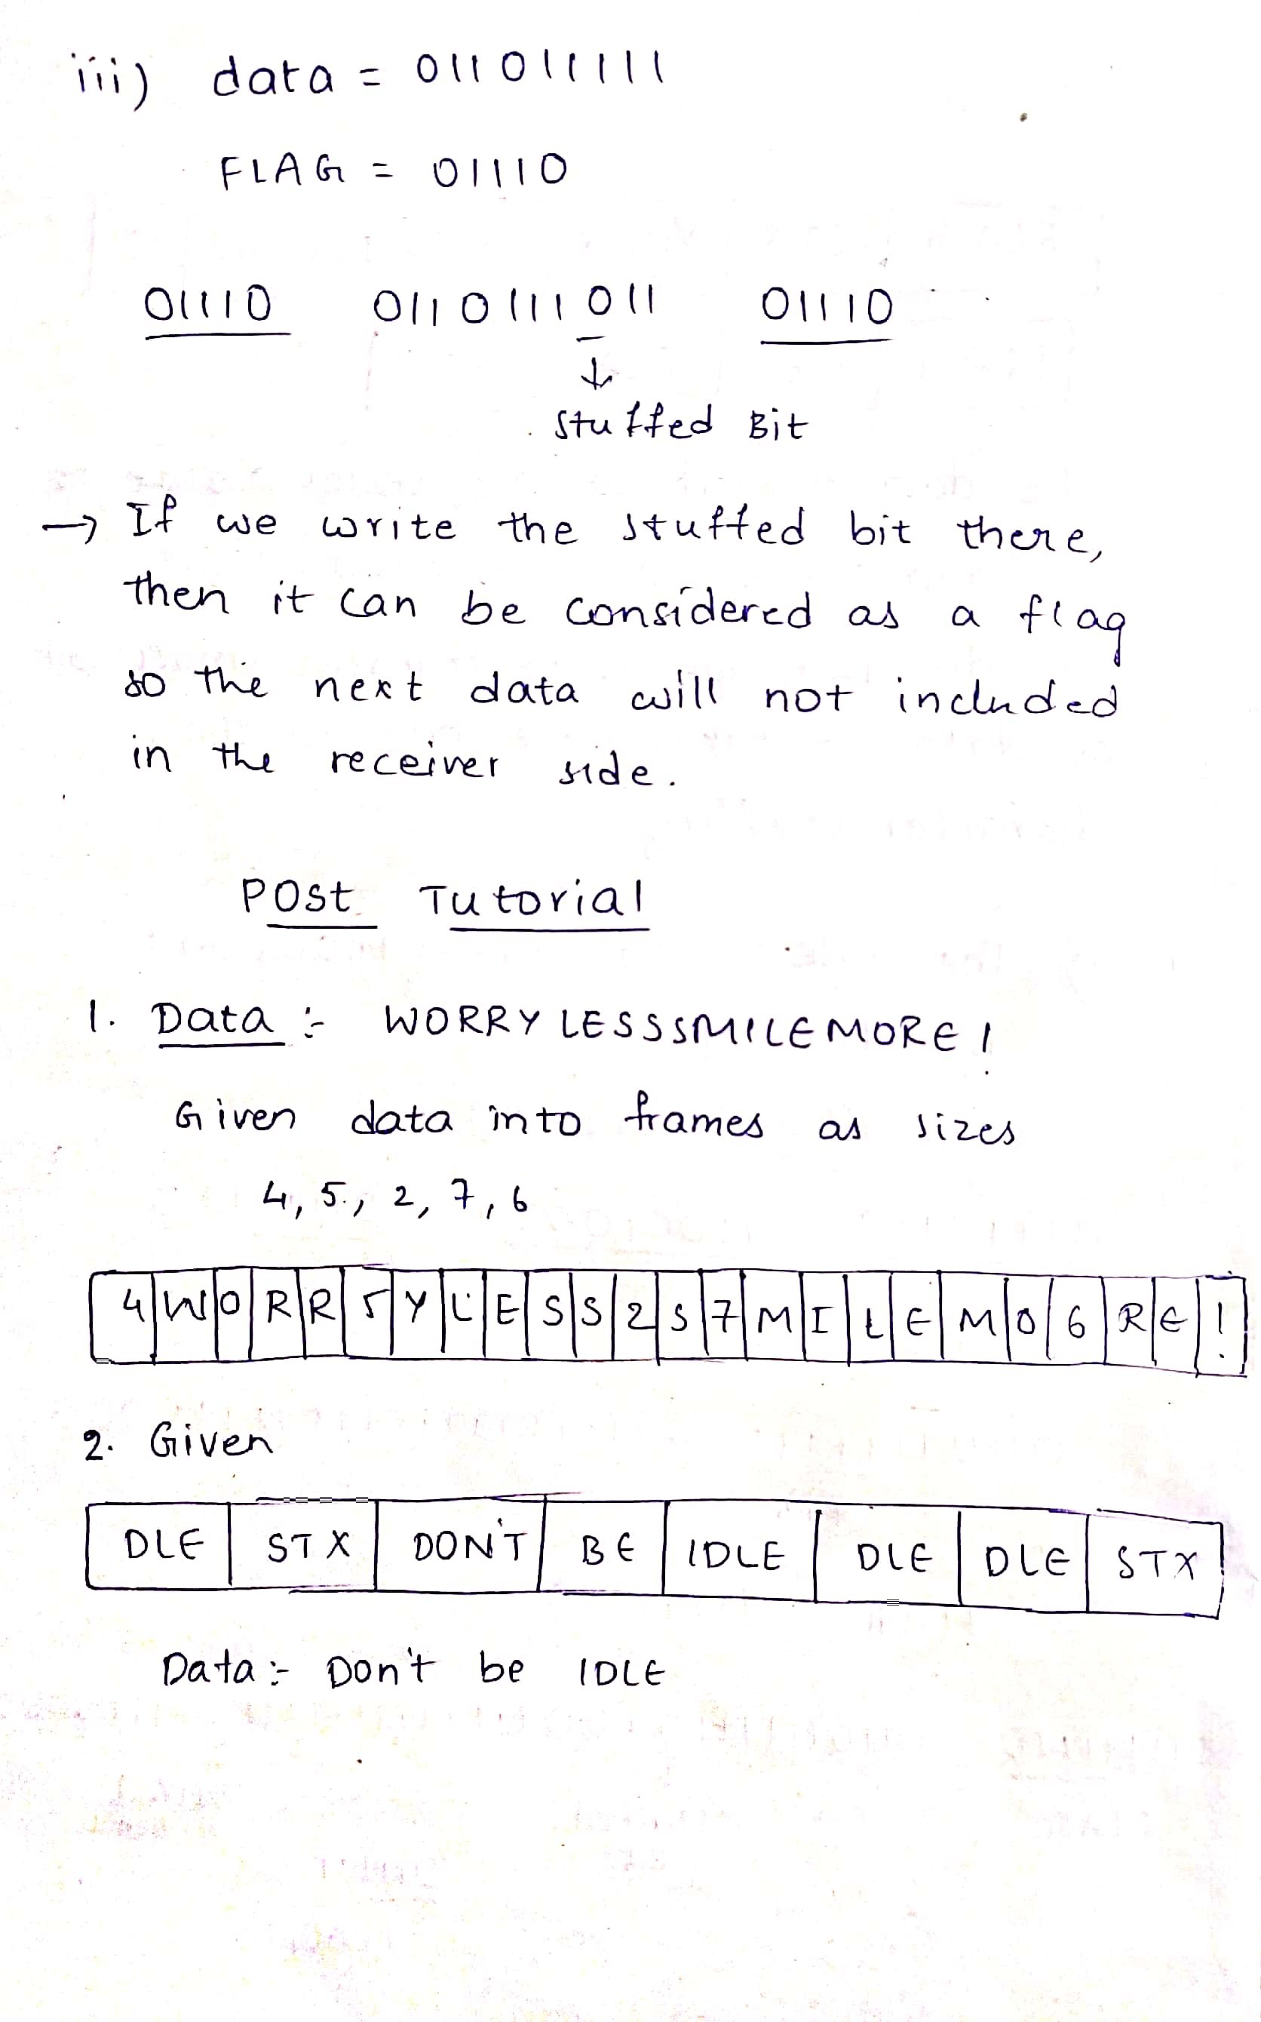

1. Donald noticed Mickey being lazy all the time. So he decided to send a message to Mickey. Data(message) after being character stuffed is given below. Find the data passed to network layer on the Mickey‟s side.

DLE

STX

DON‟T

BE

IDLE

DLE

DLE

ETX



1. Simba wants to send some data to Nala. So, here are the data bits:

Data = 1110001100111 and FLAGà 01111110

Now, find data after bit stuffing?

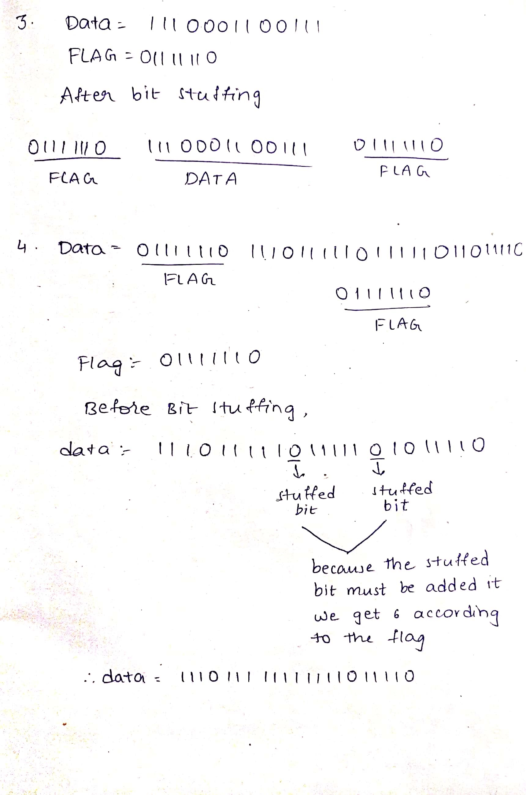

1. If STUFFED DATA = 01111110 11101111101111101011110 01111110 and FLAG = 01111110 then, find data before bit stuffing?

