**DEPARTMENT OF COMPUTER SCIENCE AND ENGINEERING**

**SUBJECT CODE: 19CS2109**

**COMPUTER NETWORKS AND SECURITY**

**ERROR DETECTION#2**

**Date of the Session: ___/___/___ Time of the Session: _____to______**

**Learning outcomes:**

* General idea of what Error Control is. [stanford.edu]
* Understand the Error Detection methods like CRC and parity.

**IN-TUTORIAL:**

1. The message 110010011 is to be transmitted using the generator polynomial x3+1 to protect it from errors. Find the final data to be transmitted after performing CRC.Also check for errors on the received data using CRC.

**Solution:**

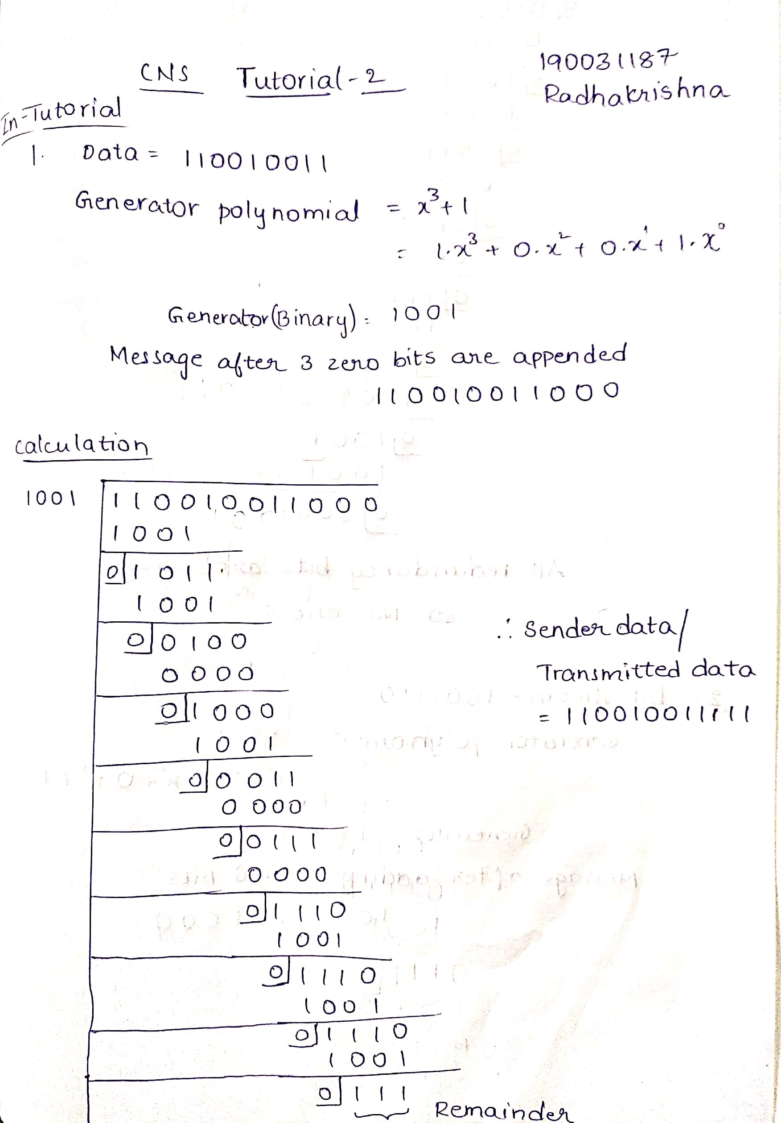

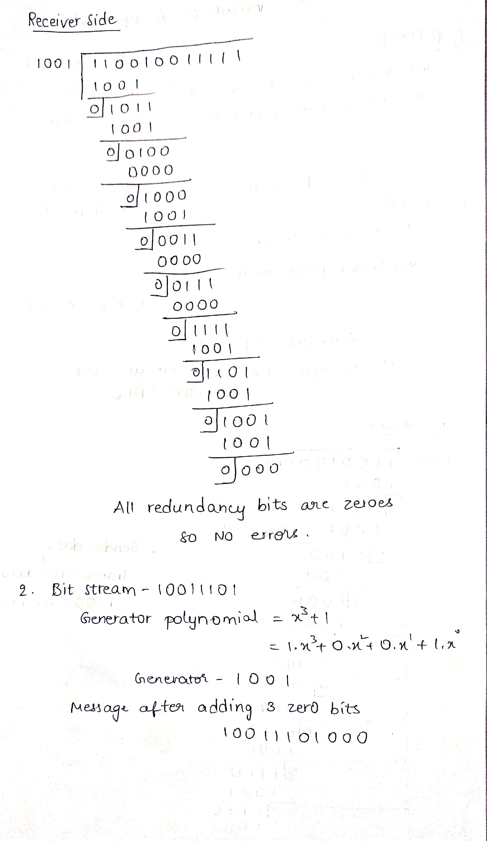

1. A bitstream 10011101 is transmitted using the standard CRC method. The generator polynomial is x3+1
   1. What is actual bit string transmitted?
   2. Suppose the third bit from the left is inverted during transmission. How will receiver detect the error?

**Solution:**



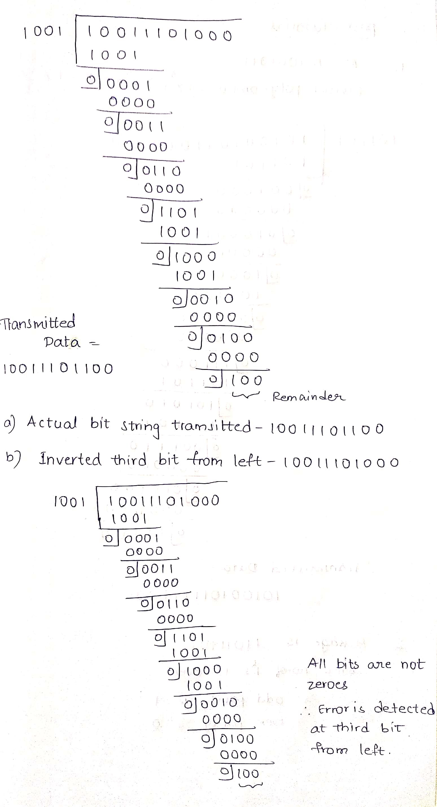

**POST-TUTORIAL:**

1. Consider the message M=101001011 and do the Cyclic Redundancy check for the above message using the following divisor polynomial x5 + x3+ x2+1.

**Solution:**

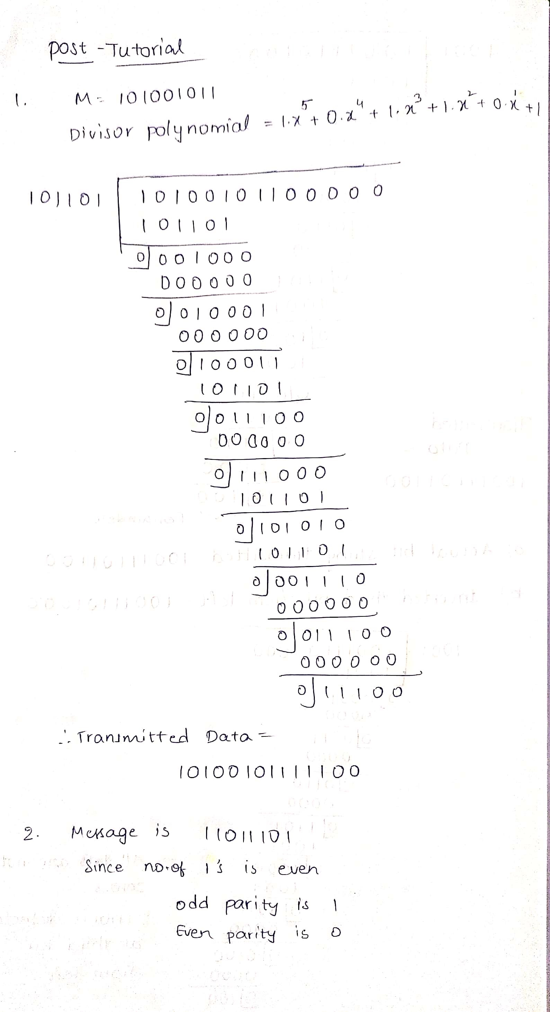

1. For the given message 11011101, find the even and odd parity and then write a python code.

**Solution:**



*(For Evaluator’s use only)*

|  |  |
| --- | --- |
|  | |
| |  | | --- | | Comment of the Evaluator (if  Any) | | Evaluator’s Observation  Marks Secured: _______ out of  ________    Full Name of the Evaluator:      Signature of the Evaluator Date of Evaluation: |