**DEPARTMENT OF COMPUTER SCIENCE AND ENGINEERING**

**SUBJECT CODE: 19CS2109**

**COMPUTER NETWORKS AND SECURITY**

**ERROR CORRECTION#3**

**Date of the Session: ___/___/___ Time of the Session: _____to______**

**Learning out comes:**

* General idea of what Error Correction is.
* Understand and apply Hamming Code and 2-D(Multiple) Parity. [GATE-CS-2017]

**IN-TUTORIAL:**

1. a) ISRO is transmitting data-1011 to Chandrayan-2. For security reasons, ISRO wishes to send data by implementing the Hamming Code technique for the sake of error detection and correction (if it is one bit error). Help ISRO in performing the above

1. A 7-bit hamming code is received as 1011101, assume Even parity and state whether received data is correct or not. If not locate the error bit?
2. Consider a binary code that consists only four valid codewords as given below.

00000, 01011, 10101, 11110

Let minimum Hamming distance of code be p and maximum number of erroneous bits that can be corrected by the code be q. The value of p and q are: _________. [GATE-CS-2017]

**Solution:**

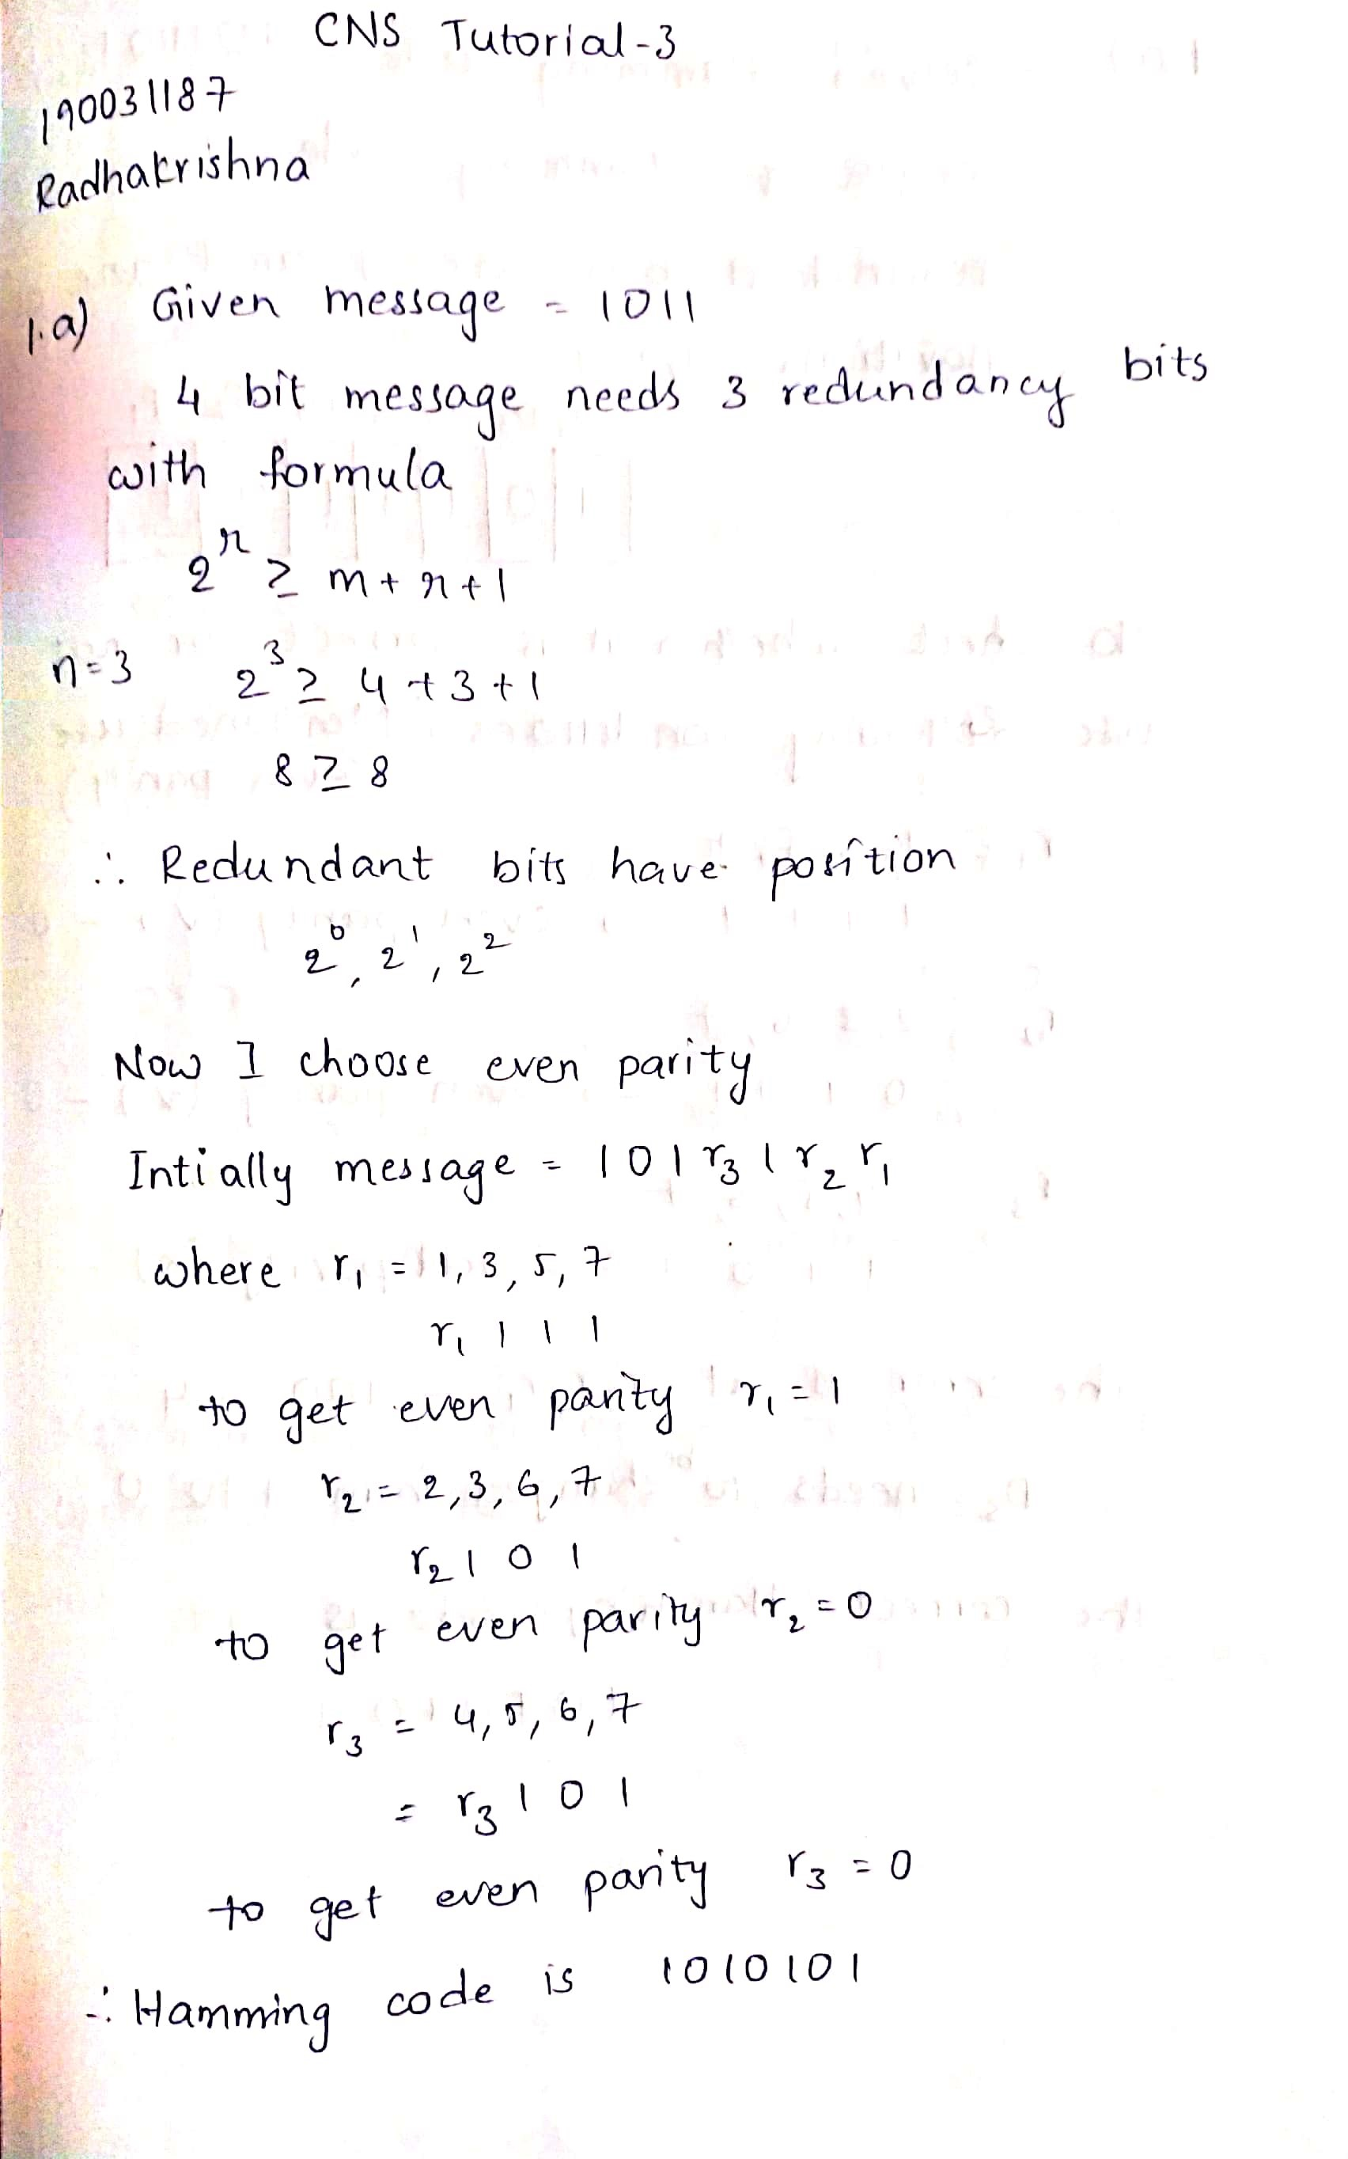

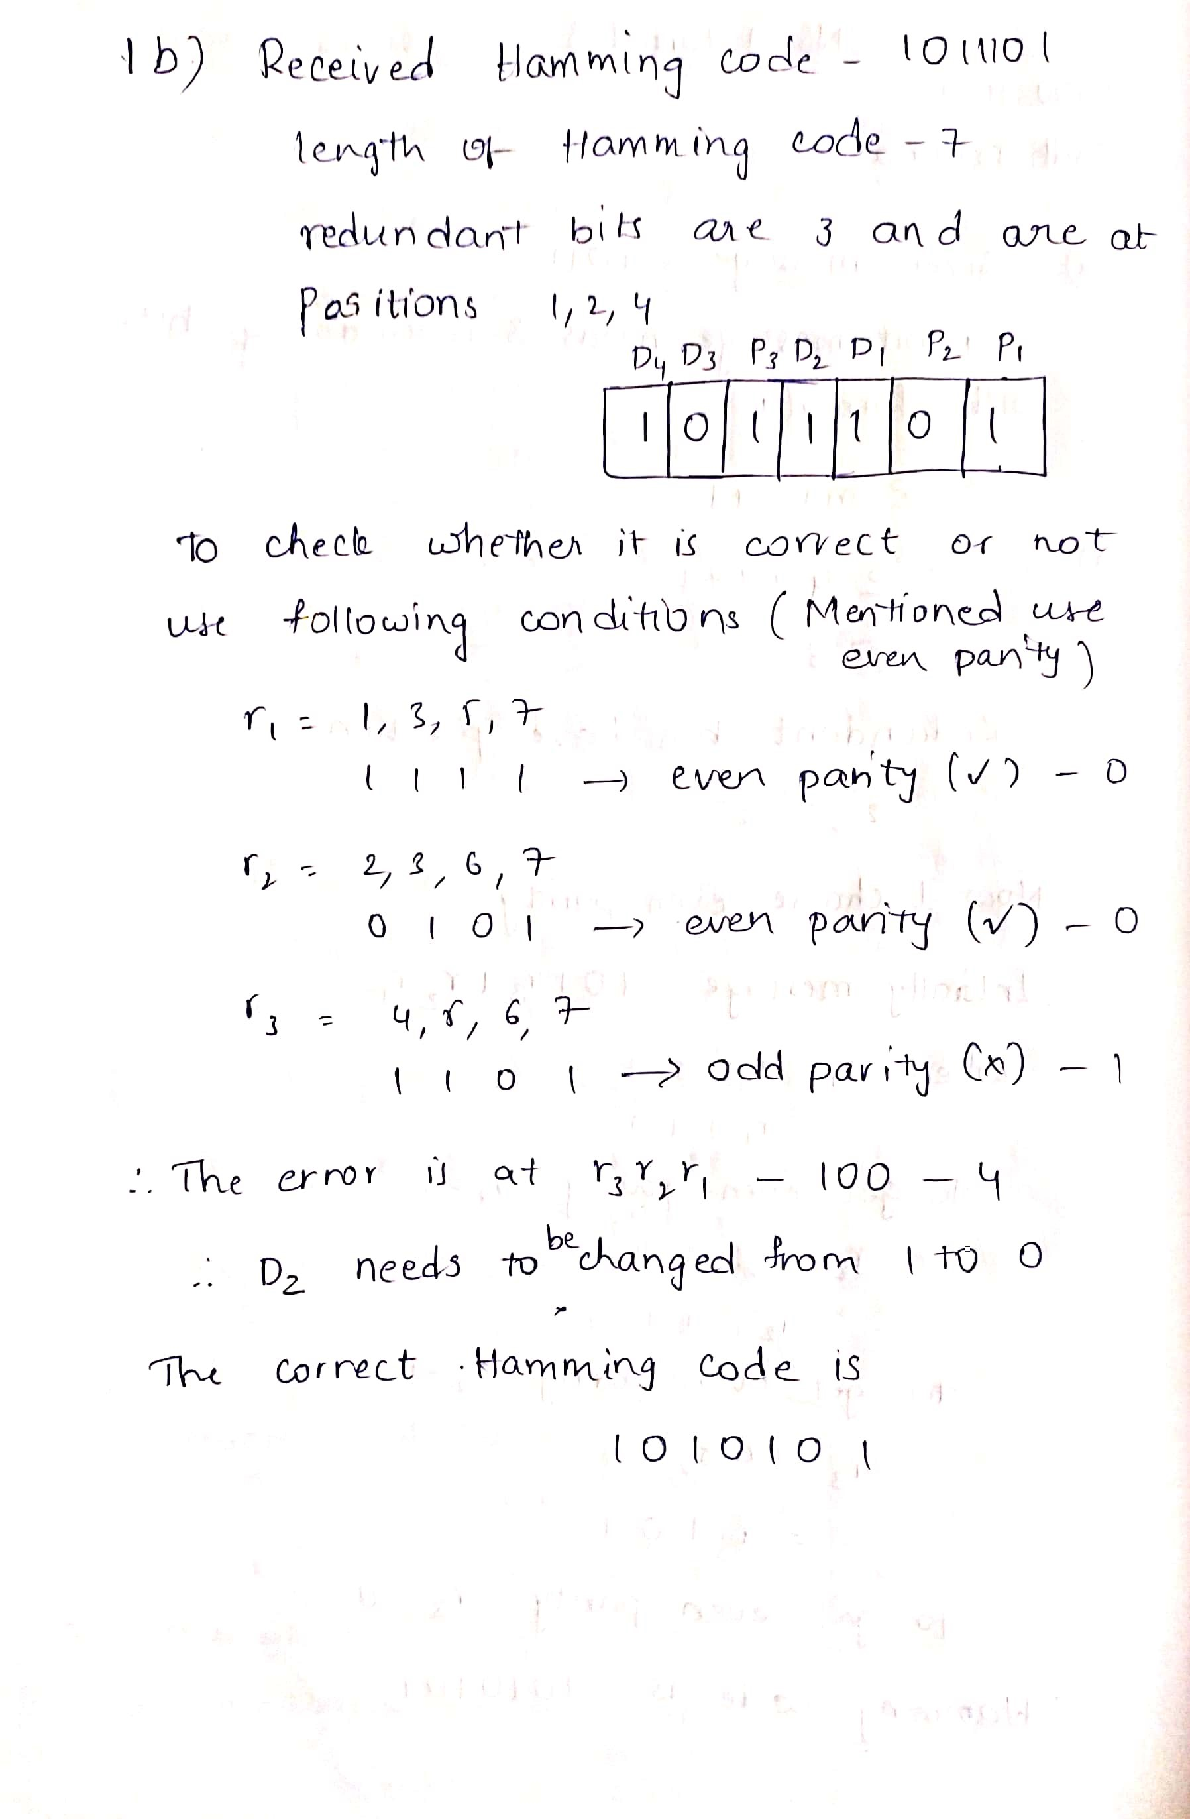

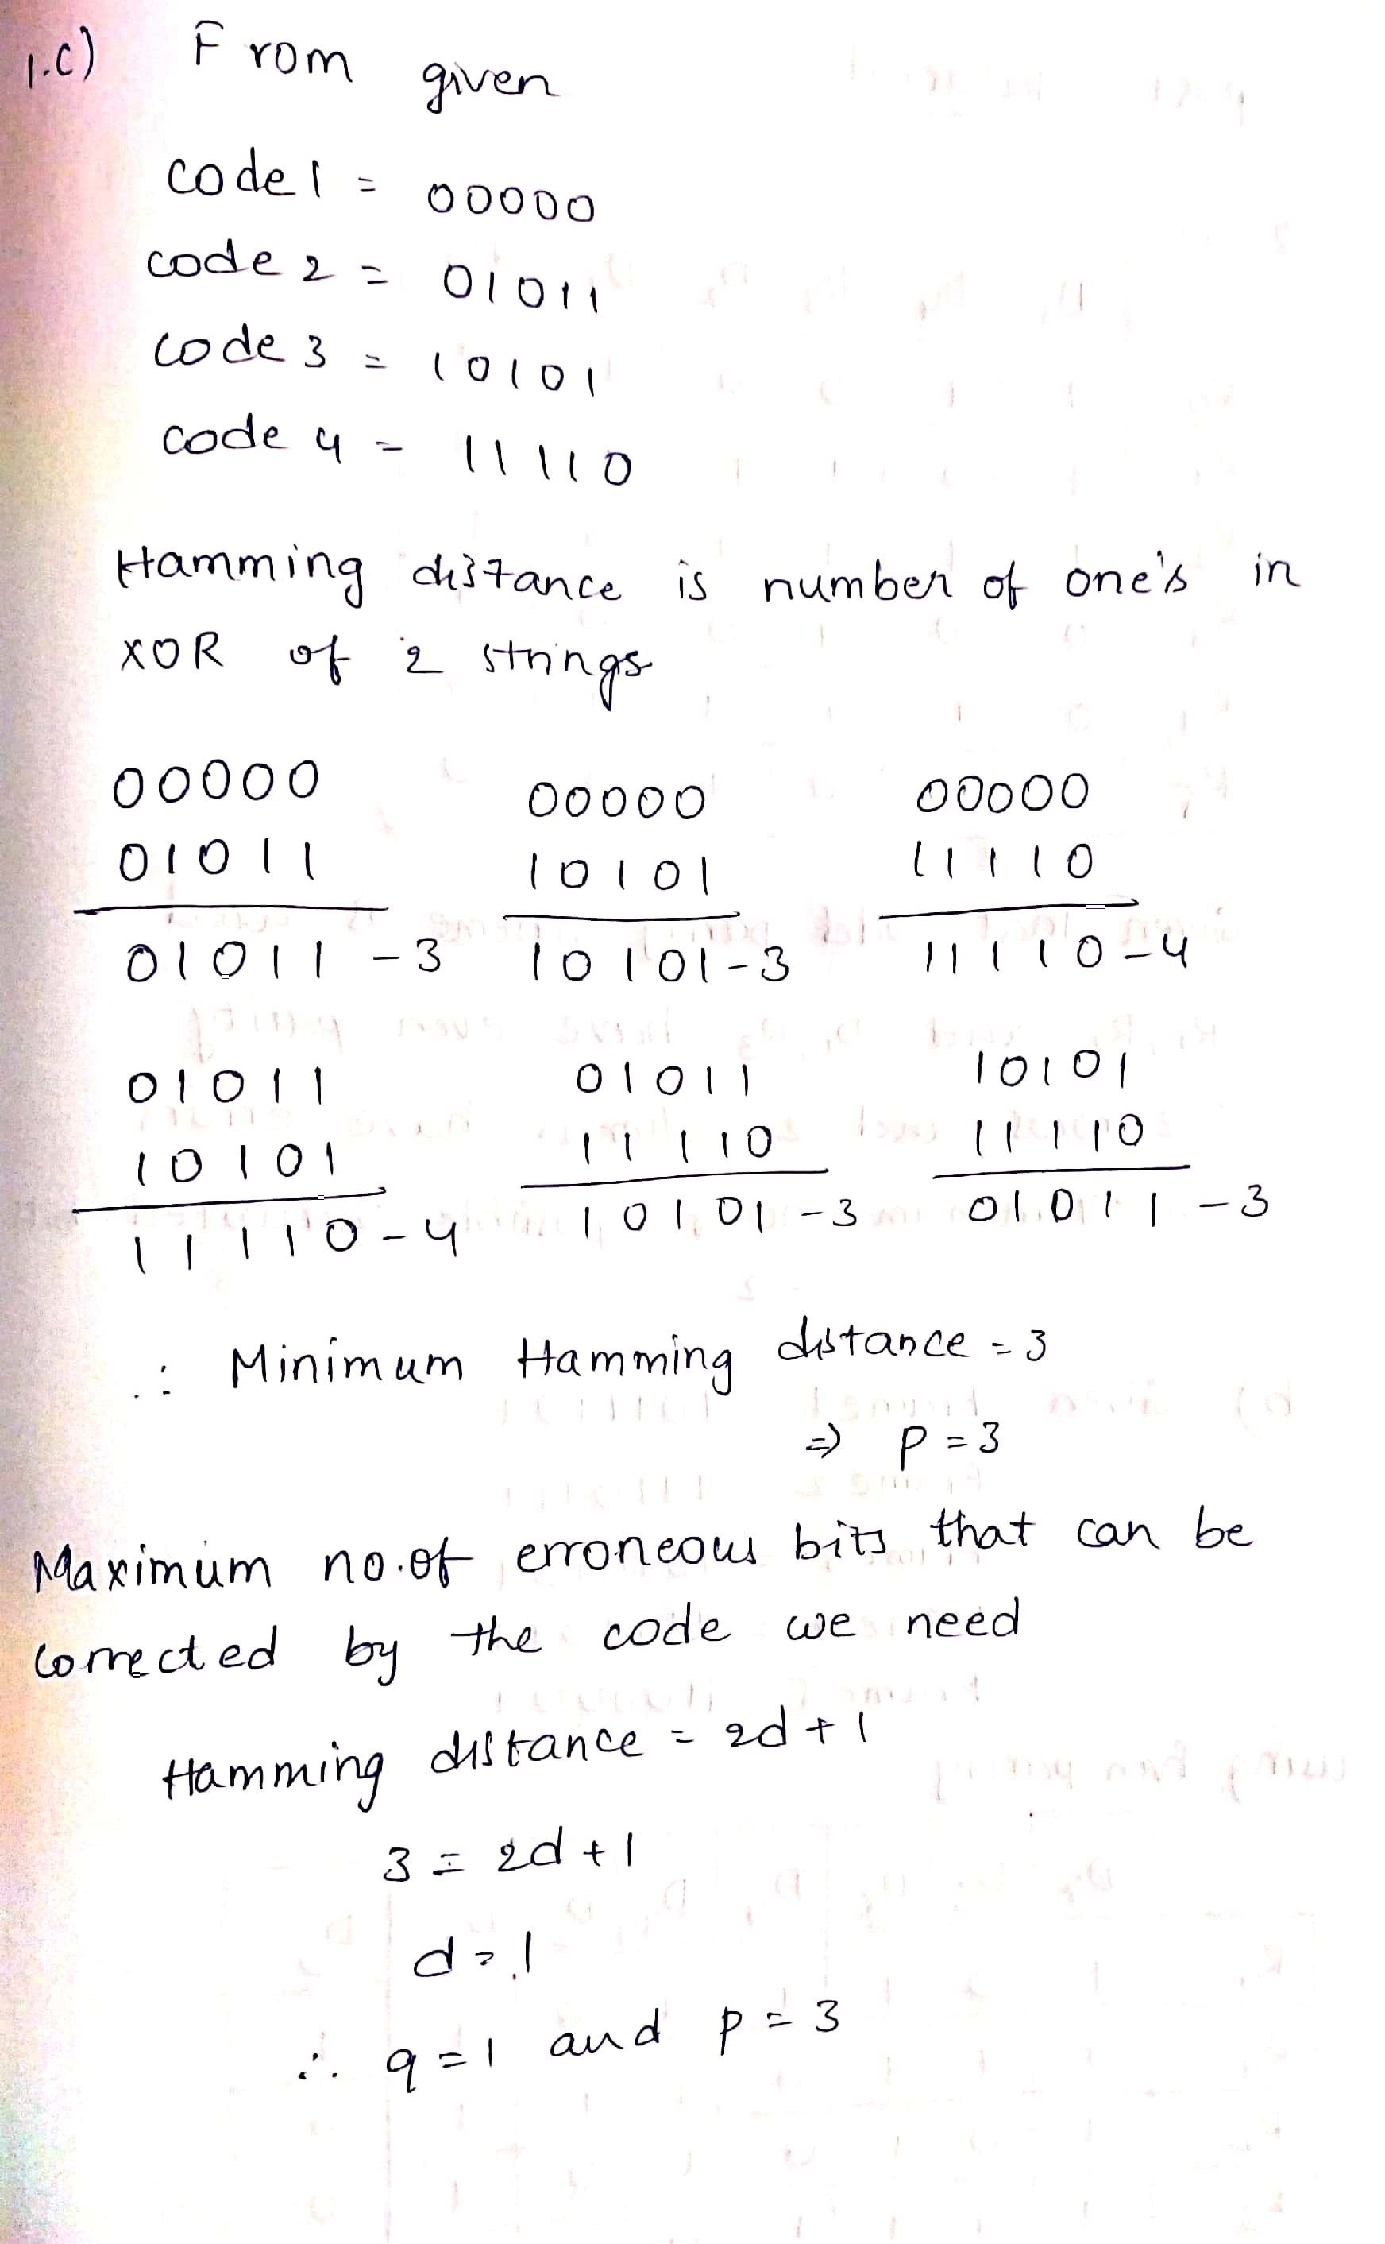

**POST-TUTORIAL:**

1. a) Data of 25 bits is arranged in 5X5 matrix (rows r0 to r4 and columns d5 to d1) and is padded with column d0 and row r5 of parity bits computed using odd party scheme. Each bit of column d0 (respectively row r5) gives the parity of the corresponding row (respectively, column). These 36 bits are transmitted over the data link.

|  |  |  |  |  |  |  |
| --- | --- | --- | --- | --- | --- | --- |
|  | D5 | D4 | D3 | D2 | D1 | **D0** |
| R0 | 1 | 1 | 0 | 0 | 1 | **0** |
| R1 | 1 | 0 | 1 | 1 | 1 | **0** |
| R2 | 1 | 1 | 1 | 0 | 0 | **1** |
| R3 | 0 | 0 | 1 | 0 | 0 | **0** |
| R4 | 0 | 1 | 1 | 1 | 0 | **0** |
| **R5** | **0** | **0** | **0** | **1** | **0** | **0** |

Check the above table and find the errors, if any. Write down the minimum possible number of corrupted bits.

b) Five packets of data, each packet containing 7 bits to be transmitted over the internet using the even parity. Append the parity bits using 2D parity with even parity, append all the parity bits to this following data. Given data is

Frame1: 1011101

Frame2: 1110111

Frame3: 1010101

Frame4: 1111011

Frame4: 1100001

**Solution:**

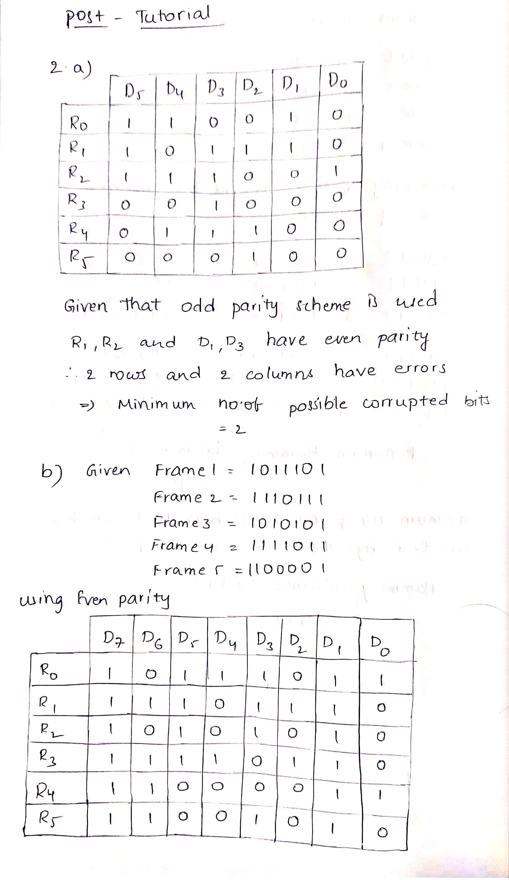

1. Write a Menu driven program to generate hamming code for the given data that is given and if any hamming code is given, you have to check the errors in the code and display the bit option=int (input('Press 1 for generating hamming code in Press 2 for finding error in hamming code\n\t Enter your choice:--\n'))

**Solution:**

*(For Evaluator’s use only)*

|  |  |
| --- | --- |
|  | |
| |  | | --- | | Comment of the Evaluator (if  Any) | | Evaluator’s Observation  Marks Secured: _______ out of  ________    Full Name of the Evaluator:    Signature of the Evaluator Date of Evaluation: |