**DEPARTMENT OF COMPUTER SCIENCE AND ENGINEERING**

**SUBJECT CODE: 19CS2107**

**ENTERPRISE PROGRAMMING WORKBOOK**

**XML #1**

**Date of the Session: ___/___/___** **Time of the Session: _____to______**

**Prerequisite:**

* **Basic understanding of HTML tags.**
* **Differences between HTML and XML and its uses.**
* **Idea on tags of XML.**

**Pre-Lab Task:**

1. As you’re in the very beginning stage of learning how to create a XML document.Write an XML to accept student details [Name, ID, Branch and CGPA] for minimum 5 students.

<class>

<student>

<name> ABC </name>

<id> 001 </id>

<branch> IT </branch>

<cgpa> 9 </cgpa>

</student>

<student>

**Prelab.xml**

<?xml version="1.0" encoding="UTF-8"?>

<class>

    <student>

        <name>RADHAKRISHNA</name>

        <id>190031187</id>

        <branch>CSE</branch>

        <cgpa>9.67</cgpa>

    </student>

    <student>

        <name>PAVAN</name>

        <id>190031134</id>

        <branch>CSE</branch>

        <cgpa>9.00</cgpa>

    </student>

    <student>

        <name>MOHITH</name>

        <id>190031249</id>

        <branch>CSE</branch>

        <cgpa>9.00</cgpa>

    </student>

    <student>

        <name>NAVNEET</name>

        <id>190031177</id>

        <branch>CSE</branch>

        <cgpa>9.00</cgpa>

    </student>

    <student>

        <name>KRISHNA VAMSI</name>

        <id>190031527</id>

        <branch>CSE</branch>

        <cgpa>9.00</cgpa>

    </student>

</class>

**CODE**

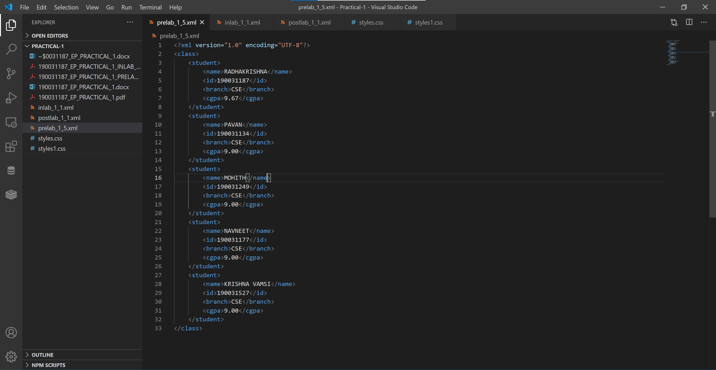

**OUTPUT**

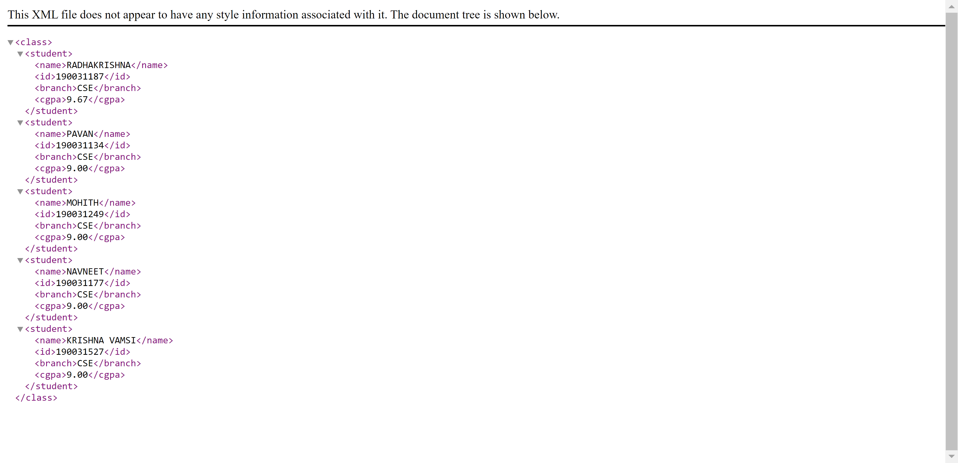

**In Lab Task:**

1. Write a program for Books store, and the XML file is created that contains the information about five books and displaying the XML file using CSS.

<books>

    <heading>Welcome To Enterprise Programming </heading>

    <book>

        <title>Title -: Web Programming</title>

        <author>Author -: Chrisbates</author>

        <publisher>Publisher -: Wiley</publisher>

        <edition>Edition -: 3</edition>

        <price> Price -: 300</price>

    </book>

….

….

<books>

**Inlab.xml**

<?xml version="1.0" encoding="UTF-8"?>

<?xml-stylesheet type="text/css" href="styles.css"?>

<books>

    <heading>Welcome To Enterprise Programming</heading>

    <book>

        <title>Title -: Web Programming</title>

        <author>Author -: Chrisbates</author>

        <publisher>Publisher -: Wiley</publisher>

        <edition>Edition -: 3</edition>

        <price> Price -: 300</price>

    </book>

    <book>

        <title>Title -: Discrete Maths</title>

        <author>Author -: Chrisbates</author>

        <publisher>Publisher -: Wiley</publisher>

        <edition>Edition -: 3</edition>

        <price> Price -: 300</price>

    </book>

    <book>

        <title>Title -: Programming with C</title>

        <author>Author -: Dennis Ritche</author>

        <publisher>Publisher -: BalaGuru</publisher>

        <edition>Edition -: 10</edition>

        <price>Price -: 1500</price>

    </book>

    <book>

        <title>Title -: Chemistry in Daily life</title>

        <author>Author -: Rutherford</author>

        <publisher>Publisher -: Atom</publisher>

        <edition>Edition -: 8</edition>

        <price>Price -: 700</price>

    </book>

    <book>

        <title>Title -: Harry Potter</title>

        <author>Author -: J.K. Rowling</author>

        <publisher>Publisher -: Ray</publisher>

        <edition>Edition -: 1</edition>

        <price>Price -: 1500</price>

    </book>

</books>

**CODE**

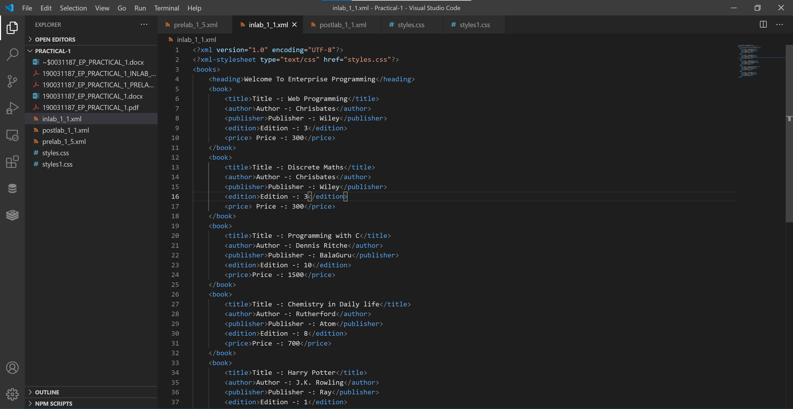

**styles.css**

heading{

    background-color:greenyellow;

    font-weight:bold;

    font-size:40px;

    display: block;

    text-align: center;

}

books{

    background-color:lightblue;

}

book{

    margin:10px;

    padding: 5px;

    border: 3px solid black;

    color:white;

    font-size:30px;

    display:block;

    align-content: center;

    float: left;

    width: 400px;

    background-color: coral;

}

title{

    font-size:25px;

    color:blue;

    background-color:grey;

    display:block;

    text-align: center;

}

author,publisher,edition,price{

    font-size:20px;

    display:block;

    text-align: center;

}

**Css CODE**

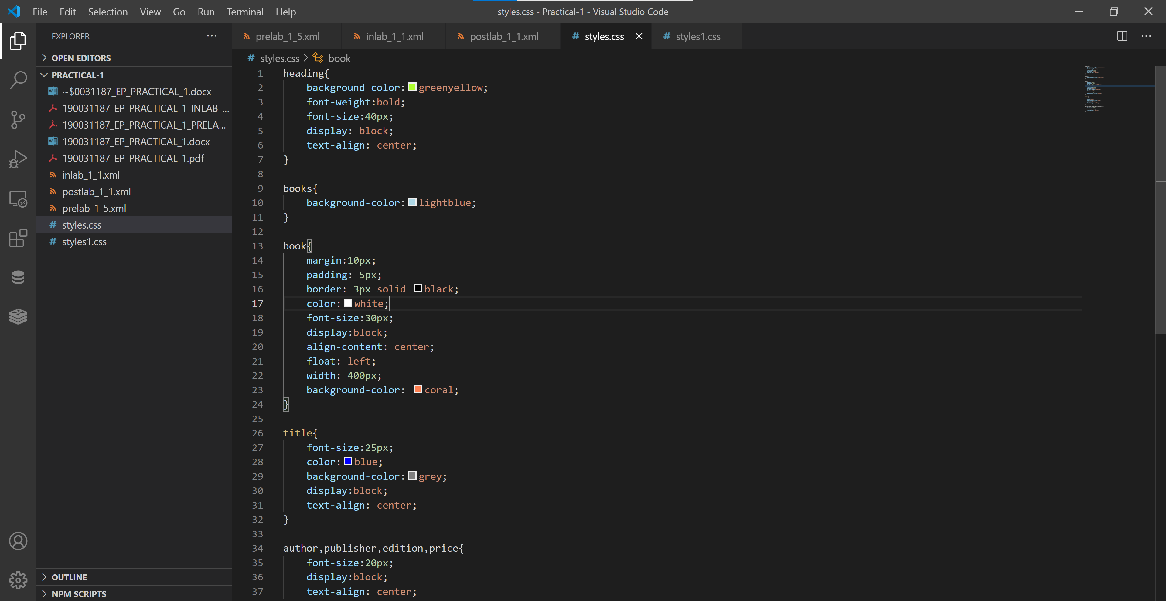

**OUTPUT**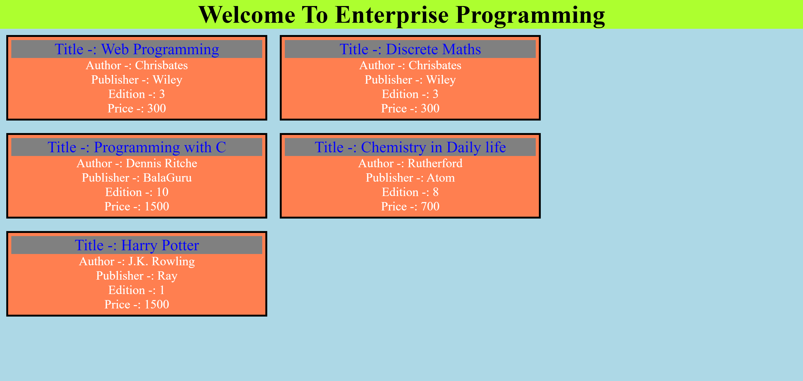

**Post Lab Task:**

Write a program for Books store, and the XML file is created that contains the information about five books of different categories and displaying the XML file using CSS.

* Action and **Adventure**.
* Classics.
* Comic Book or **Graphic Novel**.
* Detective and Mystery.
* Fantasy.
* Historical Fiction.
* Horror.
* Literary Fiction.

**Postlab.xml**

<?xml version="1.0" encoding="UTF-8"?>

<?xml-stylesheet type="text/css" href="styles1.css"?>

<books>

    <heading>Action and Adventure</heading>

    <book>

        <title >Title -: Sandstorm</title>

        <author>Author -: James Rollins</author>

        <publisher>Publisher -: Map of Bones</publisher>

        <price> Price -: 700</price>

    </book>

    <book>

        <title >Title -: The Call of the Wild</title>

        <author>Author -:  Jack London</author>

        <publisher>Publisher -: Santa Clara Valley</publisher>

        <price> Price -: 900</price>

    </book>

    <heading>Classics</heading>

    <book>

        <title >Title -: Lord of the Flies</title>

        <author>Author -:  William Golding</author>

        <publisher>Publisher -: Faber and Faber</publisher>

        <price> Price -: 600</price>

    </book>

    <book>

        <title >Title -:A Tale of Two Cities </title>

        <author>Author -: Charles Dickens </author>

        <publisher>Publisher -: Chapman and Hall </publisher>

        <price> Price -: 500</price>

    </book>

    <heading>Detective and Mystery.</heading>

    <book>

        <title >Title -: Murder on the Orient Express</title>

        <author>Author -: Agatha Christie </author>

        <publisher>Publisher -:Collins Crime Club </publisher>

        <price> Price -: 1000</price>

    </book>

    <book>

        <title >Title -: The Murder of Roger Ackroyd</title>

        <author>Author -: Agatha Christie  </author>

        <publisher>Publisher -: HarperCollins </publisher>

        <price> Price -: 900</price>

    </book>

    <heading>Historical Fiction.</heading>

    <book>

        <title >Title -: Wolf Hall </title>

        <author>Author -: Hilary Mantel </author>

        <publisher>Publisher -: HarperCollins </publisher>

        <price> Price -: 700</price>

    </book>

    <book>

        <title >Title -: The Pillars of the Earth</title>

        <author>Author -: Ken Follett  </author>

        <publisher>Publisher -:  The Evening and the Morning </publisher>

        <price> Price -: 900</price>

    </book>

    <heading>Horror.</heading>

    <book>

        <title >Title -: The Haunting of Hill House </title>

        <author>Author -: Shirley Jackson </author>

        <publisher>Publisher -: Shirley Jackson </publisher>

        <price> Price -: 800</price>

    </book>

    <book>

        <title >Title -: House of Leaves </title>

        <author>Author -: Mark Z. Danielewski   </author>

        <publisher>Publisher -:  The Whalestoe Letters </publisher>

        <price> Price -: 1100</price>

    </book>

</books>

**CODE**

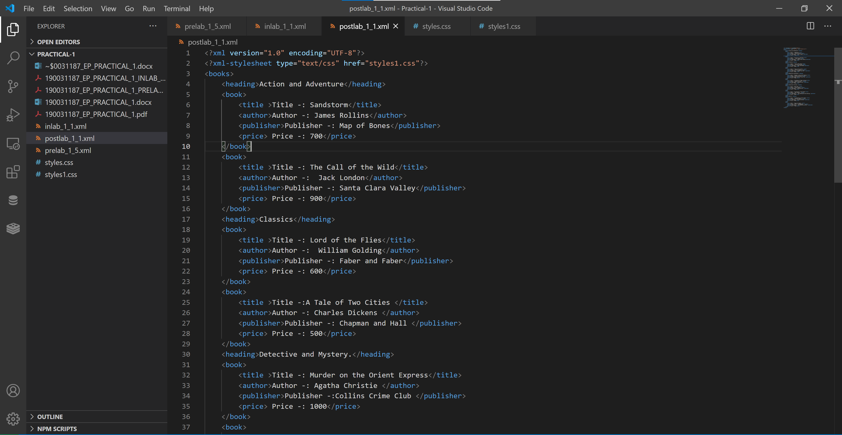

**styles1.css**

heading{

    background-color:greenyellow;

    font-weight:bold;

    font-size:40px;

    display: block;

    text-align: center;

}

books{

    background-color:lightblue;

}

book{

    margin:10px;

    padding: 5px;

    border: 3px solid black;

    color:white;

    font-size:30px;

    display:block;

    align-content: center;

    background-color: coral;

}

title{

    font-size:25px;

    color:blue;

    background-color:grey;

    display:block;

    text-align: center;

}

author,publisher,edition,price{

    font-size:20px;

    display:block;

    text-align: center;

}

**Css CODE**

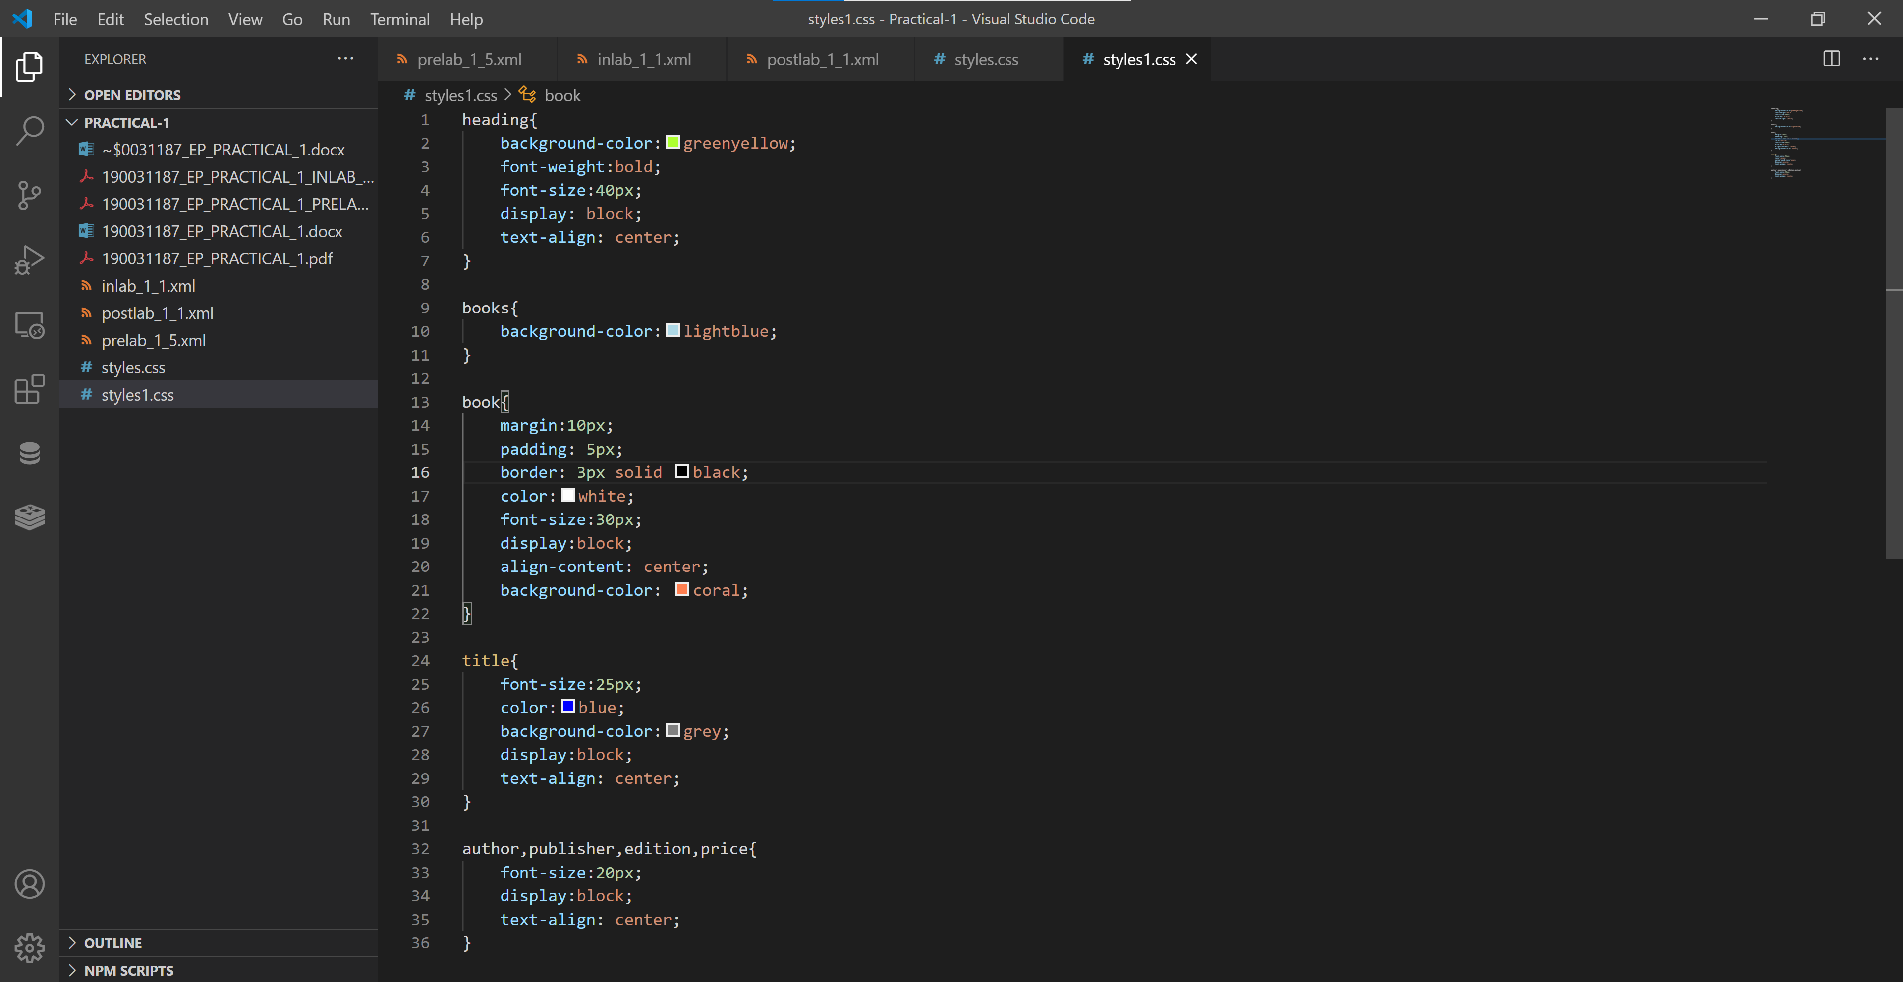

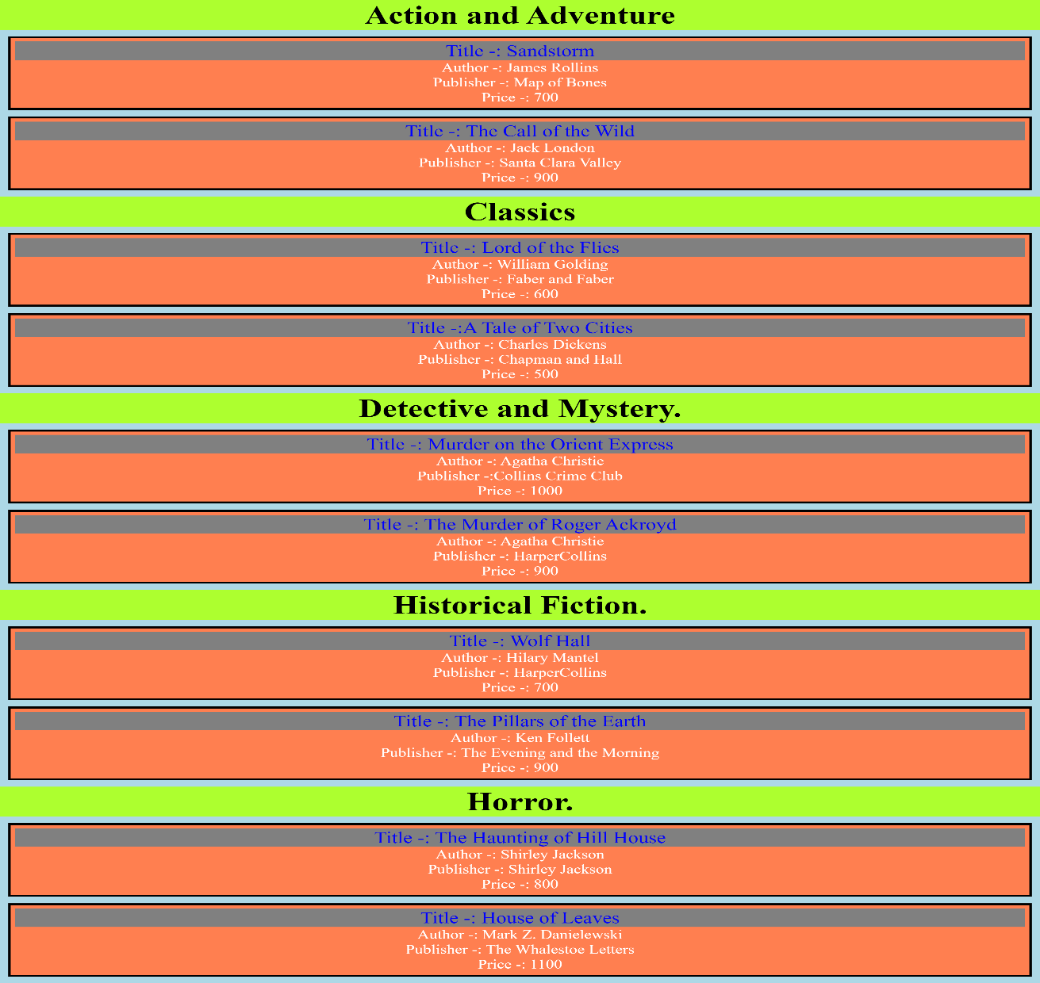**OUTPUT**