**DEPARTMENT OF COMPUTER SCIENCE AND ENGINEERING**

**SUBJECT CODE: 19CS2107**

**ENTERPRISE PROGRAMMING WORKBOOK**

**2.XML Validation #2**

**Date of the Session: ___/___/___** **Time of the Session: _____to______**

**Prerequisite:**

* **Basic idea on XML Tags.**
* **Designing of Well-formed XML documents**
* **Knowledge on XML document validation against DTD & XSD**

**Pre-Lab Task:**

**Problem Description**

1. Write a program for Students information, and the XML file is created that contains **Student [id, regno, name, avg, dob, time, mobileno, distinction**], the information about five students of different categories and displaying the XML file.

Sample Template:

<students_info>

<student>

<regno>170024</regno>

<name>ABC</name>

<avg>92</avg>

<dob>15-08-1992</dob>

<time></time>

<mobile no="9849984900"/>

<distinction>YES</distinction>

</student>

…

…

</students_info>

<?xml version=*"1.0"* encoding=*"UTF-8"*?>

<students_info>

<student>

<regno>190031187</regno>

<name>RK</name>

<avg>90</avg>

<dob>2002-06-20</dob>

<time>18:10:00</time>

<mobile no=*"7286009239"*></mobile>

<distinction>YES</distinction>

</student>

<student>

<regno>190031134</regno>

<name>PAVAN</name>

<avg>90</avg>

<dob>2001-11-18</dob>

<time>14:10:00</time>

<mobile no=*"9874652130"*></mobile>

<distinction>YES</distinction>

</student>

<student>

<regno>190031249</regno>

<name>MOHITH</name>

<avg>90</avg>

<dob>2002-05-19</dob>

<time>13:10:00</time>

<mobile no=*"6548972331"*></mobile>

<distinction>YES</distinction>

</student>

<student>

<regno>190031177</regno>

<name>NAVNEET</name>

<avg>90</avg>

<dob>2001-02-15</dob>

<time>15:10:00</time>

<mobile no=*"7852314695"*></mobile>

<distinction>YES</distinction>

</student>

<student>

<regno>190030004</regno>

<name>RITHIK</name>

<avg>90</avg>

<dob>2001-04-25</dob>

<time>17:10:00</time>

<mobile no=*"8654123692"*></mobile>

<distinction>YES</distinction>

</student>

</students_info>

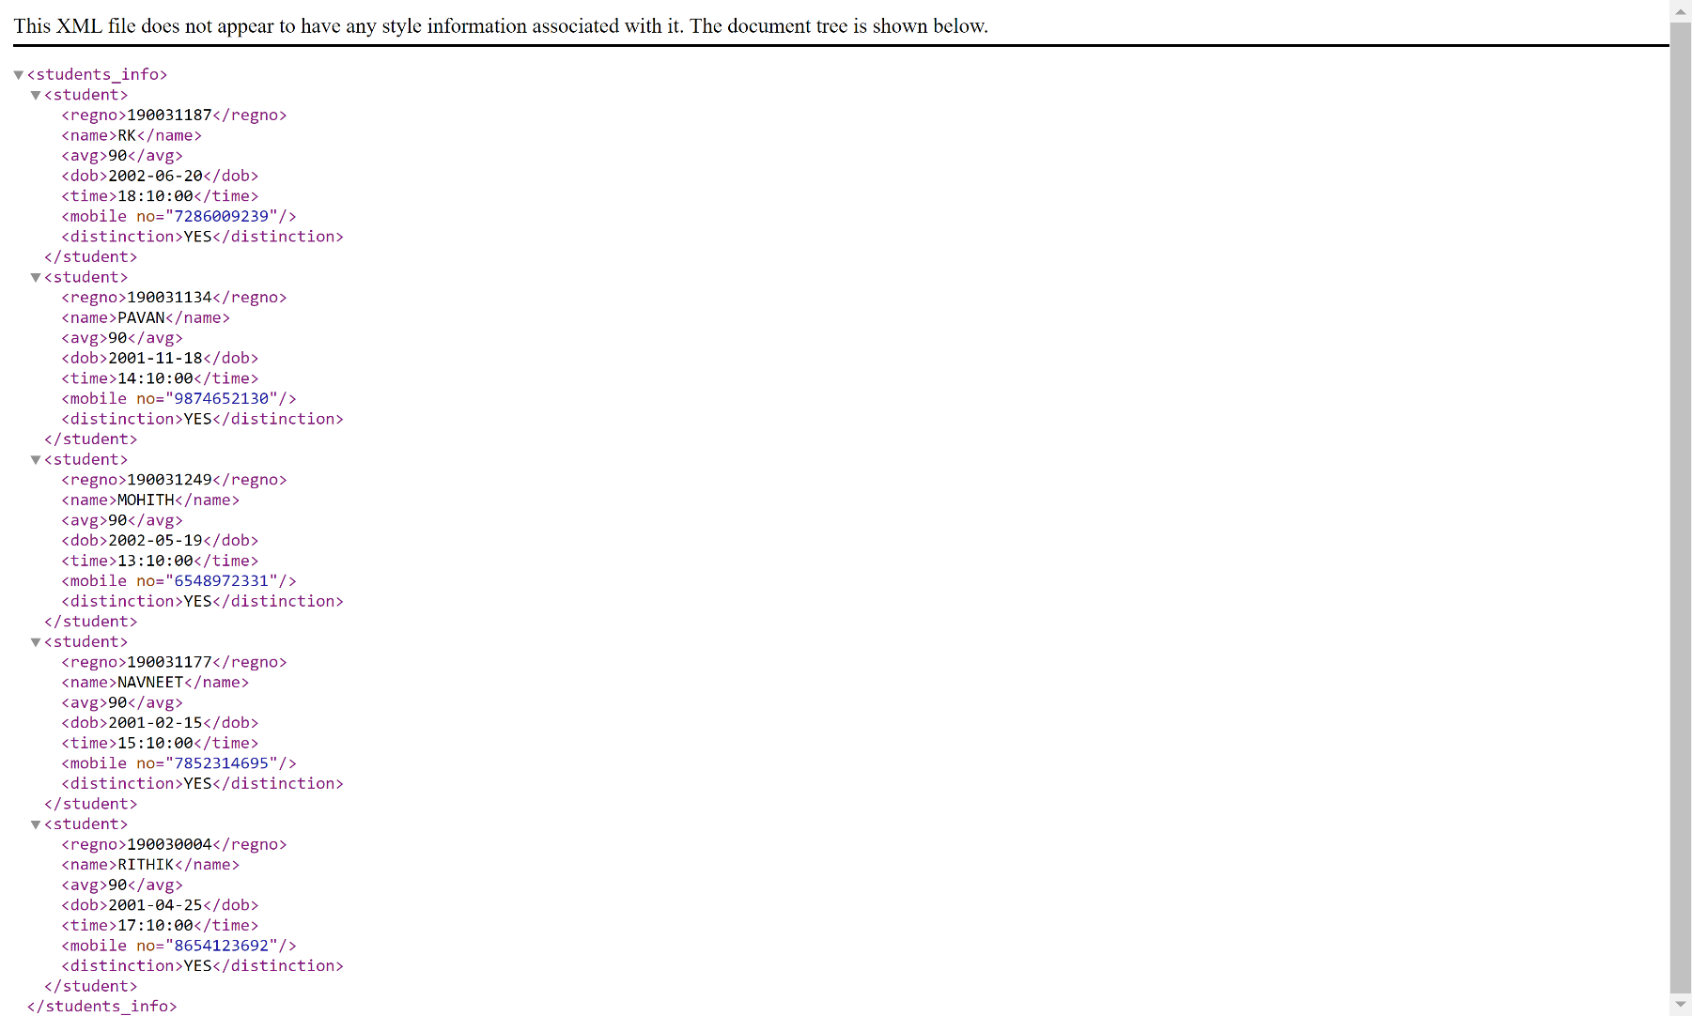

**In Lab Task:**

1. Create a DTD for Student information and the XML file contains,

**Student [id, regno, name, avg, dob, time, mobileno, distinction**], the information about five students of different categories and displaying the XML file.for minimum 5 students.

**DTD FILE**

<?xml version="1.0" encoding="UTF-8"?>

<!ELEMENT students_info (student)+>

<!ELEMENT student (regno,name,avg,dob,time,mobile,distinction)>

<!ELEMENT regno (#PCDATA)>

<!ELEMENT name (#PCDATA)>

<!ELEMENT avg (#PCDATA)>

<!ELEMENT dob (#PCDATA)>

<!ELEMENT time (#PCDATA)>

<!ELEMENT mobile (#PCDATA)>

<!ELEMENT distinction (#PCDATA)>

<!ATTLIST mobile no CDATA #IMPLIED>

**XML FILE**

<?xml version=*"1.0"* encoding=*"UTF-8"*?>

<!DOCTYPE students_info SYSTEM "inlab.dtd">

<students_info>

<student>

<regno>190031187</regno>

<name>RK</name>

<avg>90</avg>

<dob>2002-06-20</dob>

<time>18:10:00</time>

<mobile no=*"7286009239"*></mobile>

<distinction>YES</distinction>

</student>

<student>

<regno>190031134</regno>

<name>PAVAN</name>

<avg>90</avg>

<dob>2001-11-18</dob>

<time>14:10:00</time>

<mobile no=*"9874652130"*></mobile>

<distinction>YES</distinction>

</student>

<student>

<regno>190031249</regno>

<name>MOHITH</name>

<avg>90</avg>

<dob>2002-05-19</dob>

<time>13:10:00</time>

<mobile no=*"6548972331"*></mobile>

<distinction>YES</distinction>

</student>

<student>

<regno>190031177</regno>

<name>NAVNEET</name>

<avg>90</avg>

<dob>2001-02-15</dob>

<time>15:10:00</time>

<mobile no=*"7852314695"*></mobile>

<distinction>YES</distinction>

</student>

<student>

<regno>190030004</regno>

<name>RITHIK</name>

<avg>90</avg>

<dob>2001-04-25</dob>

<time>17:10:00</time>

<mobile no=*"8654123692"*></mobile>

<distinction>YES</distinction>

</student>

</students_info>



**Post Lab Task:**

1. Create a **XSD** for Student information and the XML file contains,

**Student [id, regno, name, avg, dob, time, mobileno, distinction**], the information about five students of different categories and displaying the XML file.for minimum 5 students.

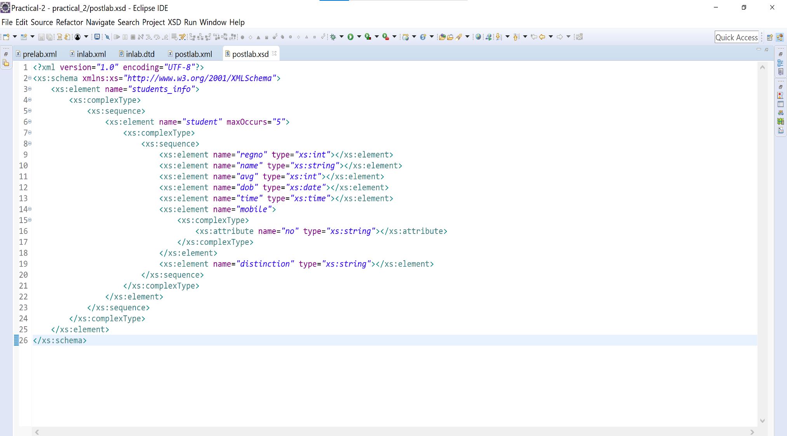**XSD FILE**

**XML FILE**

<?xml version=*"1.0"* encoding=*"UTF-8"*?>

<!DOCTYPE students_info SYSTEM "inlab.dtd">

<students_info>

<student>

<regno>190031187</regno>

<name>RK</name>

<avg>90</avg>

<dob>2002-06-20</dob>

<time>18:10:00</time>

<mobile no=*"7286009239"*></mobile>

<distinction>YES</distinction>

</student>

<student>

<regno>190031134</regno>

<name>PAVAN</name>

<avg>90</avg>

<dob>2001-11-18</dob>

<time>14:10:00</time>

<mobile no=*"9874652130"*></mobile>

<distinction>YES</distinction>

</student>

<student>

<regno>190031249</regno>

<name>MOHITH</name>

<avg>90</avg>

<dob>2002-05-19</dob>

<time>13:10:00</time>

<mobile no=*"6548972331"*></mobile>

<distinction>YES</distinction>

</student>

<student>

<regno>190031177</regno>

<name>NAVNEET</name>

<avg>90</avg>

<dob>2001-02-15</dob>

<time>15:10:00</time>

<mobile no=*"7852314695"*></mobile>

<distinction>YES</distinction>

</student>

<student>

<regno>190030004</regno>

<name>RITHIK</name>

<avg>90</avg>

<dob>2001-04-25</dob>

<time>17:10:00</time>

<mobile no=*"8654123692"*></mobile>

<distinction>YES</distinction>

</student>

</students_info>

